IEEE P802.11
Wireless LANs
TGnSync Proposal PHY Results
Date: 2005-07-08
Author(s):
Name | Company | Address | Phone | email
Syed Aon Mujtaba | Agere Systems | 555 Union Boulevard, Allentown, Pennsylvania 18109, U.S.A. | +1 610 712 6616 | mujtaba@agere.com
Abstract
This document contains simulation results for the TGn Sync proposal. These simulations establish compliance with CC59 and CC67. Additional simulations are provided to highlight the potential performance gains of various features of the TGn Sync proposal.
Notice: This document has been prepared to assist IEEE 802.11. It is offered as a basis for discussion and is not binding on the contributing individual(s) or organization(s). The material in this document is subject to change in form and content after further study. The contributor(s) reserve(s) the right to add, amend or withdraw material contained herein.

Release: The contributor grants a free, irrevocable license to the IEEE to incorporate material contained in this contribution, and any modifications thereof, in the creation of an IEEE Standards publication; to copyright in the IEEE’s name any IEEE Standards publication even though it may include portions of this contribution; and at the IEEE’s sole discretion to permit others to reproduce in whole or in part the resulting IEEE Standards publication. The contributor also acknowledges and accepts that this contribution may be made public by IEEE 802.11.

Patent Policy and Procedures: The contributor is familiar with the IEEE 802 Patent Policy and Procedures <http:// ieee802.org/guides/bylaws/sb-bylaws.pdf>, including the statement "IEEE standards may include the known use of patent(s), including patent applications, provided the IEEE receives assurance from the patent holder or applicant with respect to patents essential for compliance with both mandatory and optional portions of the standard." Early disclosure to the Working Group of patent information that might be relevant to the standard is essential to reduce the possibility for delays in the development process and increase the likelihood that the draft publication will be approved for publication. Please notify the Chair <stuart.kerry@philips.com> as early as possible, in written or electronic form, if patented technology (or technology under patent application) might be incorporated into a draft standard being developed within the IEEE 802.11 Working Group. If you have questions, contact the IEEE Patent Committee Administrator at <patcom@ieee.org>.
Table of Contents
1 Introduction 7
1.1 References 7
1.2 Scope 7
2 CC59 Smulations 8
2.1 Results for 20 MHz Channels 9
2.2 Results for 40 MHz Channels 11
3 CC67 Simulations 13
3.1 PHY-1 Simulations 14
3.1.1 Supported rates 14
3.1.2 CC67 Simulation parameters 14
3.1.3 Results for CC67 in 20MHz mode 14
3.1.4 Results for CC67 in 40MHz mode 16
3.2 PHY-2 Simulations 19
3.2.1 Description of Simulator 19
3.2.2 BASIC MIMO, 20MHz results 20
3.2.3 BASIC MIMO, 40MHz results 23
3.2.4 BEAMFORMING MIMO, 20MHz results 27
3.2.5 BEAMFORMING MIMO, 40MHz results 28
3.3 PHY-3 Simulations 30
3.3.1 Basic MIMO Results 30
3.3.2 Beamforming MIMO Results 33
3.3.3 BF MIMO Throughput vs SNR 36
3.3.4 Additional PER vs SNR Results with Basic MIMO 39
3.3.5 Additional PER vs SNR Results with BF MIMO 43
3.3.6 STBC Results 62
3.4 PHY-4 Simulations 66
3.5 PHY-4 Simulations 69

Table of Figures
Figure 2-1: 20 MHz, 1 spatial stream 9
Figure 2-2: 20 MHz, 2 spatial streams 9
Figure 2-3: 20 MHz, 3 spatial streams 10
Figure 2-4: 20 MHz, 4 spatial streams 10
Figure 2-5: 40 MHz, 1 spatial stream 11
Figure 2-6: 40 MHz, 2 spatial streams 11
Figure 2-7: 40 MHz, 3 spatial streams 12
Figure 2-8: 40 MHz, 4 spatial streams 12
Figure 3-1: Channel Model B, NLOS, 20MHz 15
Figure 3-2: Channel Model D, NLOS, 20MHz 15
Figure 3-3: Channel Model E, NLOS, 20MHz 16
Figure 3-4: Channel Model B, NLOS, 40MHz 17
Figure 3-5: Channel Model D, NLOS, 40MHz 17
Figure 3-6: Channel Model E, NLOS, 40MHz 18
Figure 3-7: Channel B-NLOS, 20MHz, (Full GI) 20
Figure 3-8: Channel D-NLOS, 20MHz, (Full GI) 21
Figure 3-9: Channel E-NLOS, 20MHz, (Full GI) 21
Figure 3-10: channel D-nLOS, with MCSs as many as possible 23
Figure 3-11: Channel B-NLOS, 40MHz, (Full GI) 24
Figure 3-12: Channel D-NLOS, 40MHz, (Full GI) 24
Figure 3-13: Channel E-NLOS, 40MHz, (Full GI) 24
Figure 3-14: channel D-nLOS, with MCSs as many as possible 26
Figure 3-15: Channel B-NLOS, 20MHz, (Full GI) 27
Figure 3-16: Channel D-NLOS, 20MHz, (Full GI) 27
Figure 3-17: Channel E-NLOS, 20MHz, (Full GI) 28
Figure 3-18: Channel B-NLOS, 40MHz, (Full GI) 28
Figure 3-19: Channel D-NLOS, 40MHz, (Full GI) 29
Figure 3-20: Channel E-NLOS, 40MHz, (Full GI) 29
Figure 3-21: Basic MIMO, Channel B 31
Figure 3-22: Basic MIMO, Channel D 32
Figure 3-23: Basic MIMO, Channel E 33
Figure 3-24: BF MIMO, Channel B 34
Figure 3-25: BF MIMO, Channel D 35
Figure 3-26: BF MIMO, Channel E 36
Figure 3-27: BF MIMO, Channel B 37
Figure 3-28: BF MIMO, Channel D 38
Figure 3-29: BF MIMO, Channel E 39
Figure 3-30: Basic MIMO 1x1 40
Figure 3-31: Basic MIMO, 2x2 41
Figure 3-32: Basic MIMO, 3x3 42
Figure 3-33: Basic MIMO, 4x4 43
Figure 3-34: BF MIMO, 2x2, MCS 0-7 44
Figure 3-35: BF MIMO, 2x2, MCS 8-15 45
Figure 3-36: BF MIMO, 2x2, MCS 33-43 46
Figure 3-37: BF MIMO, 4x2, MCS 0-7 47
Figure 3-38: BF MIMO, 4x2, MCS 8 -15 48
Figure 3-39: BF MIMO, 4x2, MCS 33-43 49
Figure 3-40: BF MIMO, 4x4, MCS 0-7 50
Figure 3-41: BF MIMO, 4x4, MCS 8-15 51
Figure 3-42: BF MIMO, 4x4, MCS 16-23 52
Figure 3-43: BF MIMO, 4x4, MCS 24-31 53
Figure 3-44: BF MIMO, 4x4, MCS 33-43 54
Figure 3-45: BF MIMO, 4x4, MCS 44-54 55
Figure 3-46: BF-MIMO, 4x4, MCS 55-63 56
Figure 3-47: BF MIMO, 4x4, MCS 64-71 57
Figure 3-48: BF MIMO, 4x4, MCS 72-83 58
Figure 3-49: BF MIMO, 4x4, MCS 84-94 59
Figure 3-50: BF MIMO, 4x4, MCS 95-106 60
Figure 3-51: BF MIMO, 4x4, MCS 107-116 61
Figure 3-52: BF MIMO, 4x4, MCS 117-126 62
Figure 3-53: STBC and STBC-SS, channel B 63
Figure 3-54: STBC and STBC-SS, channel D 64
Figure 3-55: STBC and STBC-SS, channel E 65
Figure 3-56: STBC and STBC-SS, channel B 66
Figure 3-57: STBC and STBC-SS, channel D 67
Figure 3-58: STBC and STBC-SS, channel E 68
Figure 3-59: BCC, channel B-NLOS, 20 MHz, full GI 69
Figure 3-60: LDPC codes, channel B-NLOS, 20 MHz, full GI 70
Figure 3-61: BCC, channel D-NLOS, 20 MHz, full GI 71
Figure 3-62:LDPC codes, channel D-NLOS, 20 MHz, full GI 72
Figure 3-63: BCC, channel E-NLOS, 20 MHz, full GI 73
Figure 3-64:LDPC codes, channel E-NLOS, 20 MHz, full GI 74

Introduction

References

[1] Syed Aon Mujtaba, IEEE802.11-04-0889, “TGn Sync Proposal Technical Specification,”.
[2] Syed Aon Mujtaba, IEEE802.11-04-0890, “TGn Sync Proposal FRCC Compliance,”.
[3] Adrian Stephens, IEEE802.11-03-0814-r31, “802.11 TGn Comparison Criteria,” July 12 2004.

Scope

This document provides PHY simulation results in support of the TGn Sync proposal for 802.11n as presented in the technical specification [1]. Simulations presented here establish compliance with CC59 (Section 2) and CC67 (Section 3) as defined in [3].

CC59 Smulations

CC59 requires ideal AWGN channel simulations with no impairments. In this section we provide PER curves for MCS (modulation coding scheme) 0-31 organized in charts according to the number of spatial streams. In each chart, the number of transmit antennas and the number of receive antennas are the same as the number of spatial streams.

For each SNR, the simulations were run until either least 500 packet errors were observed, or a total of 50,000 packets had been simulated. In call cases of PER ≥ 1%, 500 packet errors were observed, hence exceeding the 100 packet error requirement.

The MCS definitions and indexing, are defined in [1]. The same definitions are used for both 20 and 40 MHz channels. There is one exception. MCS 32 (not listed in the table) is a BPSK rate 1/2 duplicate format transmission mode that provides a 6 Mbps rate for 40 MHz channels. (The data rate for MCS 0 in 40 MHz is 13.5 Mbps.)

Table 1: MCS Definition
MCS Indices  for 1/2/3/4 Spatial Streams | Modulation | FEC Code Rate
0 / 8 / 16 / 24 | BPSK | 1/2
1 / 9 / 17 / 25 | QPSK | 1/2
2 / 10 / 18 / 26 | QPSK | 3/4
3 / 11 / 19 / 27 | 16 QAM | 1/2
4 / 12 / 20 / 28 | 16 QAM | 3/4
5 / 13 / 21 / 29 | 64 QAM | 2/3
6 / 14 / 22 / 30 | 64 QAM | 3/4
7 / 15 / 23 / 31 | 64 QAM | 5/6

Results for 20 MHz Channels

Figure 2-1: 20 MHz, 1 spatial stream

Figure 2-2: 20 MHz, 2 spatial streams

Figure 2-3: 20 MHz, 3 spatial streams

Figure 2-4: 20 MHz, 4 spatial streams

Results for 40 MHz Channels
Figure 2-5: 40 MHz, 1 spatial stream

Figure 2-6: 40 MHz, 2 spatial streams

Figure 2-7: 40 MHz, 3 spatial streams

Figure 2-8: 40 MHz, 4 spatial streams

CC67 Simulations

This section provides CC67 simulations from different simulators. Each simulation was created and managed by different engineering teams, utilising different algorithms for coping with the PHY impairments (e.g. acquisition and channel estimation algorithms) and in some cases introducing different additional blocks such as TX/RX filtering.

In compliance with CC67 we provide “Set 1” CC67 simulation results [3]. We do not provide the optional throughput simulation as specified in “Set 2”.

CC67 simulations are intended to establish the practicality of proposed transmission modes in the presence of impairments and acquisition errors. Clearly various aspects of receiver designs (such as filtering, acquisition algorithms, channel estimation algorithm, etc.) will vary across device manufacturers, so some variation in results is to be expected. Hence, showing results from multiple and disjoint modem engineering efforts only serves to strengthen the conclusions.

PHY-1 Simulations

Supported rates
According to CC67 the following 5 data rates are selected including the maximum and the minimum data rete. The data rates indicated by ( ) means the data rates with Half GI but it is not applied at this time.

In 6Mbps in 40MHz mode, the duplicate format is applied. The same data is transmitted both in the upper channel and the lower channel.

5 supported data rates in 20MHz mode

- 6.5Mbps (7.2Mbps) : 1x2x20, BPSK, R=1/2 coding
- 78Mbps (87Mbps) : 2x2x20, 16-QAM, R=3/4 coding
- 130Mbps (144Mbps) : 2x2x20, 64-QAM, R=5/6 coding
- 130Mbps (144Mbps) : 2x3x20, 64-QAM, R=5/6 coding
- 260Mbps (289Mbps) : 4x6x20, 64-QAM, R=5/6 coding

5 supported data rates in 40MHz mode

- 6Mbps (6.67Mbps) : 1x2x40, BPSK, R=1/2 coding, Duplicated Format
- 108Mbps (120Mbps) : 2x2x40, 16-QAM, R=1/2 coding
- 243Mbps (270Mbps) : 2x2x40, 64-QAM, R=3/4 coding
- 243Mbps (270Mbps) : 2x3x40, 64-QAM, R=3/4 coding
- 540Mbps (600Mbps) : 4x6x40, 64-QAM, R=5/6 coding

CC67 Simulation parameters

Table 2 Simulation Conditions for CC67
Sampling Rate | 80MHz in 20MHz mode  160MHz in 40MHz mode
Receiver Type | MMSE
PPDU Length | 1,000Bytes
Channel Model | B(NLOS), D(NLOS), E(NLOS)
Channel Estimation | Per tone estimation (no smoothing)
Timing Acquisition | Matched filtering by L-STF
Offset Compensation | Using L-LTF and pilot tones
Impairments in CC | IM1,2,4,5,6 (Output Back Off=8dB in IM1)

Results for CC67 in 20MHz mode
The following figures show the results of CC67.Figure 3-9, Figure 3-10 and Figure 3-11 show the results for Channel Model B, D and E, respectively. “FL” means fluorescent light.

Figure 3-9: Channel Model B, NLOS, 20MHz

Figure 3-10: Channel Model D, NLOS, 20MHz

Figure 3-11: Channel Model E, NLOS, 20MHz

Results for CC67 in 40MHz mode
Figure 3-12, Figure 3-13 and Figure 3-14 show the results for Channel Model B, D and E, respectively. “FL” means fluorescent light.

Figure 3-12: Channel Model B, NLOS, 40MHz

Figure 3-13: Channel Model D, NLOS, 40MHz

Figure 3-14: Channel Model E, NLOS, 40MHz

PHY-2 Simulations

This subsection provides CC67 simulation results for Basic MIMO. After here, when we write m x n, “m” is the number of Tx antennas (and it is identical to the number of spatial stream in basic MIMO case), and “n” is the number of Rx antennas.

Description of Simulator

Our simulator is fully CC compliant. Impairments include
- IM1 (PA non-linearity) is included. P=3 and OBO=8dB. Sampling clock is 200MHz for this module.
- IM2 (Carrier frequency offset) is included. Offset value is –13.675ppm, and sampling clock offset is also added. Actual timing acquisition is implemented.
- IM4 (Phase Noise) is included.
- IM6 (Antenna Configuration) is set to what IM6 of CC required, i.e., antenna configuration is linear array and distance between adjacent two antennas is a half λ.

Regarding channel model, we used the latest TGn Matlab code as it is.
- channel mode- B, D, and E.
- non-LOS models are used.
- Channel is varying during packet.
- Please note that our results don’t include fluorescent effect at the highest rate in channel-D

Other simulator descriptions are as follows;
- Our simulator includes
  - Analog filter model and other FIR filter at each sampling clock converting stage.
  - Packet detection without prior knowledge.
  - Frequency offset compensation and its tracking.
  - Time-of-arrival estimation, and sampling clock offset compensation and its tracking.
  - Actual channel estimation at receiver side (MMSE, without any successive cancellation).
  - Almost ideal AGC at L-STF and HT-STF.
- Our simulator doesn’t include
  - short GI
  - any advanced coding.
- Other parameters
  - Floating calculation
  - T₀=600[nsec] (From OFDM symbol edge to FFT window starting point)
  - Trace-back length of Viterbi decoder is 128.
  - No smoothing filter for channel estimation.
  - PPDU length is 1000 bytes, as CC specified.
  - SNR is calculated as ensemble averaged SNR.
  - When the number of packet error reaches to 100, then quit from this loop.
  - 10,000 seeds of channel realization are used

BASIC MIMO, 20MHz results

Note that in contrast to other results in this document, the simulation results for Model-B presented here use the full GI and not the optional half GI. Additionally, the simulations for MCS31 reported here are for a 4TX, 4RX confiuration, whilst those reported in other sections are for a 4TX, 6RX configuration.

Figure 3-15: Channel B-NLOS, 20MHz, (Full GI)

Figure 3-16: Channel D-NLOS, 20MHz, (Full GI)

Figure 3-17: Channel E-NLOS, 20MHz, (Full GI)

channel D-nLOS, with MCSs as many as possible

Figure 3-18: channel D-nLOS, with MCSs as many as possible

BASIC MIMO, 40MHz results

Figure 3-19: Channel B-NLOS, 40MHz, (Full GI)

Figure 3-20: Channel D-NLOS, 40MHz, (Full GI)
Figure 3-21: Channel E-NLOS, 40MHz, (Full GI)

channel D-nLOS, with MCSs as many as possible

Figure 3-22: channel D-nLOS, with MCSs as many as possible

BEAMFORMING MIMO, 20MHz results

Figure 3-23: Channel B-NLOS, 20MHz, (Full GI)

Figure 3-24: Channel D-NLOS, 20MHz, (Full GI)

Figure 3-25: Channel E-NLOS, 20MHz, (Full GI)

BEAMFORMING MIMO, 40MHz results

Figure 3-26: Channel B-NLOS, 40MHz, (Full GI)

Figure 3-27: Channel D-NLOS, 40MHz, (Full GI)
Figure 3-28: Channel E-NLOS, 40MHz, (Full GI)

PHY-3 Simulations

This section gives simulation results for both Basic MIMO and Beamforming MIMO. These results give performance for m×n MIMO configurations, where m is the number of transmit antennas and n is the number of receive antennas.

The simulation parameters are as follows:

- 4x4 and 2x2 system configurations
- 802.11n Channel models B, D, E
- Carrier frequency of 5.25 GHz
- PA nonlinearity is the Rapp model with P=3 and OBO of 11 dB for nodes with 2 transmit antennas, and 14 dB for nodes with 4 transmit antennas
- Carrier frequency offset and timing offset of 13.675 PPM
- Phase noise as specified in CC67
- Channel estimation and acquisition per packet
- PPDU length: 1000 bytes
- 52 data subcarriers, 4 tracking pilots, 4 μsec GI

Basic MIMO Results
The following additional simulation parameters apply to the results given below for basic MIMO performance

- Min. 500 packet errors per point
- The following rates were simulated

MCS 0 | 1x2 for DM  2x2 for SS | 6.5 Mbps
MCS 12 | 2x2 | 78 Mbps
MCS 15 | 2x2 | 130 Mbps
MCS 15 | 2x3 | 130 Mbps

Figure 3-29: Basic MIMO, Channel B

Figure 3-30: Basic MIMO, Channel D

Figure 3-31: Basic MIMO, Channel E

Beamforming MIMO Results

The following additional simulation parameters apply to the beamforming results given below.

- Min. 500 packet errors per point
- The following rates were simulated

MCS 1 | 2x2 | 13 Mbps
MCS 5 | 2x2 | 52 Mbps
MCS 33 | 2x2 | 78 Mbps
MCS 41 | 2x2 | 117 Mbps
MCS 1 | 4x4 | 13 Mbps
MCS 38 | 4x4 | 78 Mbps
MCS 65 | 4x4 | 156 Mbps
MCS 112 | 4x4 | 195 Mbps

Figure 3-32: BF MIMO, Channel B

Figure 3-33: BF MIMO, Channel D

Figure 3-34: BF MIMO, Channel E

BF MIMO Throughput vs SNR

The following section gives throughput versus SNR results for Beamforming MIMO when the full MCS set is available and fast link adaptation is operational

- 100 channel realizations
- 50 packets per realization

Figure 3-35: BF MIMO, Channel B

Figure 3-36: BF MIMO, Channel D

Figure 3-37: BF MIMO, Channel E

Additional PER vs SNR Results with Basic MIMO

The following additional simulation parameters apply to the results given below.

- 1x1, 2x2, 3x3, 4x4 system configurations
- Channel B only
- MCS 0-31

Figure 3-38: Basic MIMO 1x1

Figure 3-39: Basic MIMO, 2x2

Figure 3-40: Basic MIMO, 3x3

Figure 3-41: Basic MIMO, 4x4

Additional PER vs SNR Results with BF MIMO

The following additional simulation parameters apply to the results given below.

- 2x2, 4x2, 4x4 system configurations
- Channel B only
- All applicable MCS’s

2x2 System Configuration
Figure 3-42: BF MIMO, 2x2, MCS 0-7
Figure 3-43: BF MIMO, 2x2, MCS 8-15

Figure 3-44: BF MIMO, 2x2, MCS 33-43

4x2 System Configuration

Figure 3-45: BF MIMO, 4x2, MCS 0-7
Figure 3-46: BF MIMO, 4x2, MCS 8 -15

Figure 3-47: BF MIMO, 4x2, MCS 33-43

4x4 System Configuration
Figure 3-48: BF MIMO, 4x4, MCS 0-7
Figure 3-49: BF MIMO, 4x4, MCS 8-15

Figure 3-50: BF MIMO, 4x4, MCS 16-23

Figure 3-51: BF MIMO, 4x4, MCS 24-31

Figure 3-52: BF MIMO, 4x4, MCS 33-43

Figure 3-53: BF MIMO, 4x4, MCS 44-54

Figure 3-54: BF-MIMO, 4x4, MCS 55-63

Figure 3-55: BF MIMO, 4x4, MCS 64-71

Figure 3-56: BF MIMO, 4x4, MCS 72-83

Figure 3-57: BF MIMO, 4x4, MCS 84-94

Figure 3-58: BF MIMO, 4x4, MCS 95-106

Figure 3-59: BF MIMO, 4x4, MCS 107-116

Figure 3-60: BF MIMO, 4x4, MCS 117-126

STBC Results

This section gives simulation results for STBC with 4 transmit antennas and 2 receive antennas (2 data streams).

The simulation parameters are as follows:

- 4x2 system configuration
- 802.11n channel models B, D, E
- No impairments
- Perfect channel estimation and timing/frequency synchronization
- Walsh + CDD
- CDD delay of 50 ns per transmit antenna
- PPDU length: 1000 bytes
- 52 data subcarriers, 4 tracking pilots, 4 μsec GI
- The following rates were simulated:

MCS 9 | R=1/2, QPSK
MCS 11 | R=1/2, 16-QAM
MCS14 | R=3/4, 64-QAM

Figure 3-61: STBC and STBC-SS, channel B

Figure 3-62: STBC and STBC-SS, channel D

Figure 3-63: STBC and STBC-SS, channel E

PHY-4 Simulations

This section gives simulation results for STBC with 4 transmit antennas and 2 receive antennas (2 data streams).

The simulation parameters are as follows:

- 4x2 system configuration
- 802.11n channel models B, D, E
- No impairments
- Perfect channel estimation and timing/frequency synchronization
- Walsh + CDD
- CDD delay of 50 ns per transmit antenna
- PPDU length: 1000 bytes
- 52 data subcarriers, 4 tracking pilots, 4 μsec GI
- The following rates were simulated:

MCS 9 | R=1/2, QPSK
MCS 11 | R=1/2, 16-QAM
MCS14 | R=3/4, 64-QAM

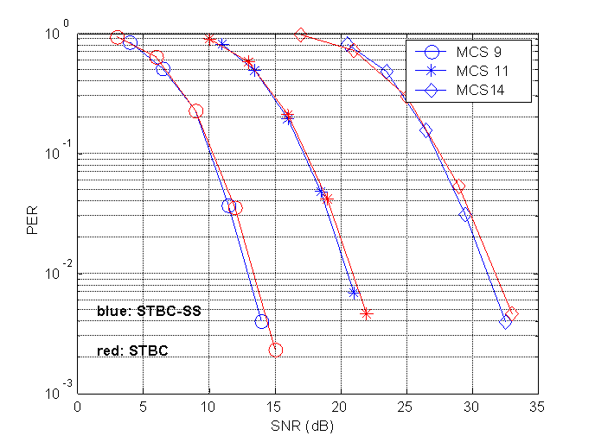
Figure 3-64: STBC and STBC-SS, channel B
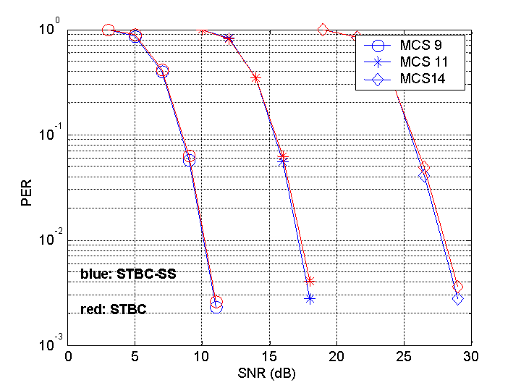
Figure 3-65: STBC and STBC-SS, channel D

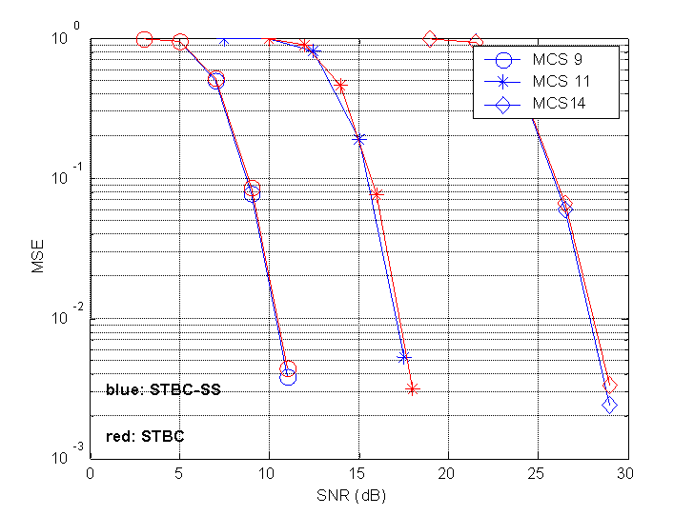
Figure 3-66: STBC and STBC-SS, channel E

PHY-5 Simulations

This subsection provides simulation results for CC 67. The performance is evaluated for B, D and E-NLOS channels and the results are presented as average Packet-Error-Rate (PER) versus Signal-to-Noise Ratio (SNR). The simulation set-up is given below:

- RF impairments: PA non-linearity (IM 1), carrier-frequency offset (IM 2), phase noise (IM 4) and antenna configuration (IM 6).
- PSDU length is 1000 bytes.
- Symbol and carrier frequency synchronization performed.
- Simple per tone channel estimation.
- No cyclic delay diversity (CDD).
- Channel coding:
  - Binary convolutional codes (BCC)
  - Advanced LDPC codes:
    - Layered Belief Propagation decoding algorithm
    - SISO message processing unit based on min-sum with one term correction
    - Maximum iterations = 15

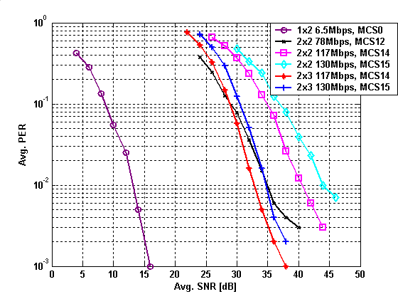
Figure 3-67: BCC, channel B-NLOS, 20 MHz, full GI

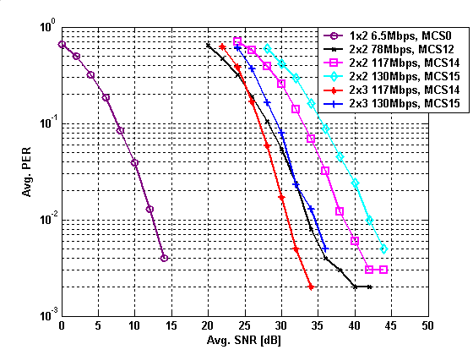

Figure 3-68: LDPC codes, channel B-NLOS, 20 MHz, full GI

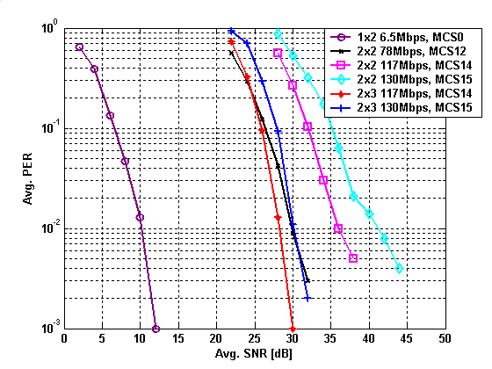
Figure 3-69: BCC, channel D-NLOS, 20 MHz, full GI

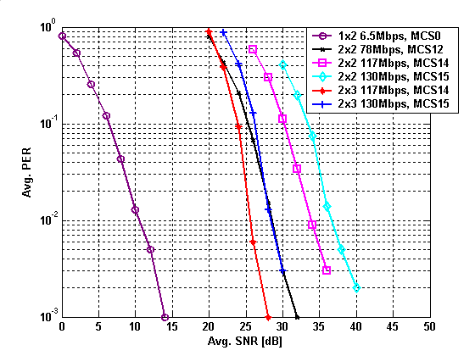
Figure 3-70:LDPC codes, channel D-NLOS, 20 MHz, full GI

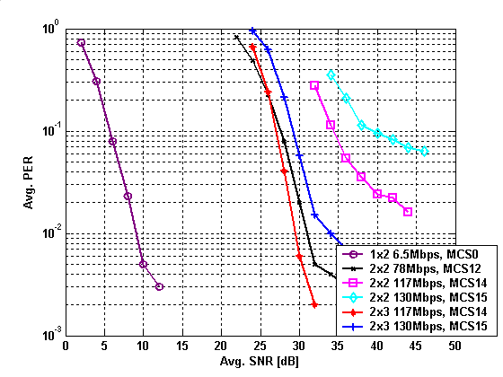
Figure 3-71: BCC, channel E-NLOS, 20 MHz, full GI

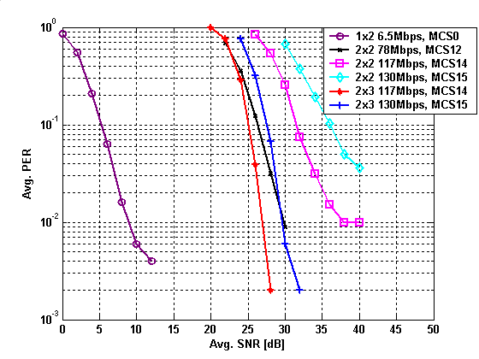
Figure 3-72:LDPC codes, channel E-NLOS, 20 MHz, full GI

