IEEE P802.11
Wireless LANs
WWiSE Proposal Response to Functional Requirements and Comparison Criteria
Date: September 9, 2004
Author: Christopher J. Hansen, et al
Broadcom Corporation
190 Mathilda Place, Sunnyvale, CA 94087 USA
Phone: +1 408 543 3378
Fax: +1 408 543 3399
e-Mail: chansen@broadcom.com
Abstract

This document describes the responses to the IEEE 802.11 TGn Functional Requirements (IEEE 802.11-02/813r12) and Comparison Criteria (IEEE 802.11-03/814r31). It is part of the documentation for the proposal in document IEEE 802.11-04/886.

Contributors

Name | Company | Address | Telephone | Email
Allert van Zelst | Airgo Networks | Straatweg 66-S  3621 BR Breukelen  The Netherlands |  | AllertVanZelst@airgonetworks.com
V.K. Jones | Airgo Networks | 900 Arastradero Road  Palo Alto, CA 94304 USA |  | VKJones@airgonetworks.com
Richard van Nee | Airgo Networks | Straatweg 66-S  3621 BR Breukelen  The Netherlands |  | RichardVanNee@airgonetworks.com
Christopher J. Hansen | Broadcom | 190 Mathilda Place  Sunnyvale, CA 94087 USA | +1 408 543 3378 | chansen@broadcom.com
Matthew Fischer | Broadcom | 190 Mathilda Place  Sunnyvale, CA 94087 USA | +1 408 543 3380 | mfischer@broadcom.com
R. Tushar Moorti | Broadcom | 190 Mathilda Place  Sunnyvale, CA 94087 USA |  | rtm@broadcom.com
Christopher Young | Broadcom | 190 Mathilda Place  Sunnyvale, CA 94087 USA |  | cyoung@broadcom.com
Jason Trachewsky | Broadcom | 190 Mathilda Place  Sunnyvale, CA 94087 USA |  | jat@broadcom.com
Bruce Edwards | Broadcom |  |  | bedwards@broadcom.com
David Hedberg | Conexant |  |  | dave.hedberg@conexant.com
Michael Seals | Conexant |  |  | michael.seals@conexant.com
Menzo Wentink | Conexant |  |  | menzo.wentink@conexant.com
Mark Webster | Conexant |  |  | mark.webster@conexant.com
Massimiliano Siti | STMicroelectronics | Via C. Olivetti, 2 - 20041 Agrate Brianza (MI) - Italy | (US) +1 619 278 8648 | massimiliano.siti@st.com
Filippo Spalla | STMicroelectronics |  |  | Filippo.Spalla@ST.com
Marco Odoni | STMicroelectronics |  |  | Marco.Odoni@ST.com
Stefano Valle | STMicroelectronics |  |  | Stefano.Valle@ST.com
Angelo Poloni | STMicroelectronics |  |  | Angelo.Poloni@ST.com
Godfrey DaCosta | STMicroelectronics |  |  | Godfrey.DaCosta@ST.com
Uberto Girola | STMicroelectronics |  |  | Uberto.Girola@ST.com
Sean Coffey | Texas Instruments |  |  | coffey@ti.com
Manoneet Singh | Texas Instruments |  |  | msingh@ti.com
Richard Williams | Texas Instruments |  |  | richard@ti.com
Dennis Connors | Texas Instruments |  |  | connors@ti.com
Srikanth Gummadi | Texas Instruments |  |  | sgummadi@ti.com
Xiaolin Lu | Texas Instruments |  |  | xlu@ti.com

Table of Contents
1 Contributors 2
2 Table of Contents 3
3 Coverage of Functional Requirements 4
4 Additional Disclosures 4
4.1 Reference Submissions 5
4.2 TCP Model Parameters 5
4.3 MAC Simulation Methodology 5
4.3.1 MAC Simulation Occupied Channel Width 5
4.3.2 PHY Modeling in MAC Simulation 5
4.4 Justification for low PLR Rates 8
5 Disclosure for Each Comparison Criteria 8
5.1 CC 15 Sharing with Legacy Devices 9
5.2 CC 18 12
5.2.1 Scenario 1 – HCCA 2x2 20MHz 12
5.2.2 Scenario 1+ – HCCA 2x2 40MHz 14
5.2.3 Scenario 1 – EDCA 2x2 20MHz 16
5.2.4 Scenario 1+ – EDCA 2x2 40MHz 18
5.2.5 Scenario 4 – HCCA 2x2 20MHz 20
5.2.6 Scenario 4 – EDCA 2x2 20MHz 22
5.2.7 Scenario 4 – EDCA 2x2 40MHz 24
5.2.8 Scenario 6 – HCCA 2x2 20MHz 26
5.2.9 Scenario 6 – EDCA 2x2 20MHz 28
5.2.10 Scenario 6 – EDCA 2x2 40MHz 29
5.3 CC19 30
5.3.1 Scenario 1 – HCCA 2x2 20MHz 30
5.3.2 Scenario 1 – EDCA 2x2 – 20MHz 41
5.3.3 Scenario 4 – HCCA 2x2 20MHz 48
5.3.4 Scenario 4 – EDCA 2x2 20MHz 50
5.3.5 Scenario 6 – HCCA 2x2 20MHz 52
5.3.6 Scenario 6 – EDCA 2x2 20MHz 54
5.4 CC20 57
5.4.1 Scenario 1 – HCCA 2x2 20MHz 57
5.4.2 Scenario 1 – EDCA 2x2 20MHz 57
5.4.3 Scenario 4 – HCCA 2x2 20MHz 58
5.4.4 Scenario 4 – EDCA 2x2 20MHz 59
5.4.5 Scenario 6 – HCCA 2x2 20MHz 59
5.4.6 Scenario 6 – EDCA 2x2 20MHz 60
5.5 CC24 61
5.6 CC27 and CC28 Throughput vs. Range Curves 62
5.7 CC42 - Preambles 70
5.8 Spectral Mask 73
5.9 AWGN PHY Performance 74
5.10 Non-AWGN PHY Performance 83
5.11 PHY Changes 90
6 Disclosure for Physical Layer Impairments 91
7 Appendix – Additional PHY Simulation Results 91
7.1 Results provided by STMicroelectronics 91
7.1.1 Simulation parameters 91
7.1.2 CC59 – AWGN PER performance 92
7.1.3 CC67 PER performance in non AWGN channels 95
7.1.4 Addional AWGN and Non-AWGN results with Binary Convolutional Coding 97
7.1.5 Comparison of LDPC and BCC Results 101
7.1.6 Note: IM1 (PA non-linearity) 103
7.2 Results provided by Airgo Networks 103
7.2.1 CC 59 AWGN Simulation Results 104
7.2.2 CC 67 Non-AWGN Results 104
8 Additional MAC Simulation Results 108
8.1 MAC Simulations from STMicroelectronics 108
8.1.1 Simulation Scenario 1 Single Destination Results 110
8.1.2 Simulation Scenario 1 Multiple Destination Results 111
8.1.3 Scenario 4 – Single Destination Results 112
8.1.4 Scenario 4 – Multiple Destination Results 113
8.1.5 Scenario 6 – Single Desitination Results 114
8.1.6 Scenario 6 – Multiple Destination Results 115
8.2 MAC Simulations from Texas Instruments 115
8.2.1 CC 18, 19, 20, and 24 for Simulation Scenario 1 using HCCA 115

Coverage of Functional Requirements
Our proposal is a complete proposal as documented in the table below.

Number | Name | Coverage (Yes/No) | Response and Results Reference
R1 | Single Link HT Rate Supported | Yes | See below for results from CC27.
R2 | HT Rate Supported in 20 MHz | Yes | See below for results from CC28.
R3 | Supports 5 GHz Bands | Yes | Section 20.1 of draft text.
R4 | .11a backwards compatibility | Yes | Section 20.1.2 of draft text.
R5 | .11g backwards compatibility | Yes | Section 20.1.2 of draft text.
R6 | Control of support for legacy STA from .11n AP | Yes | In our proposal, an AP can include at least one of the new .11n rates defined in clause 20 in the BSS_BASIC_RATE_SET parameter defined in section 10.3.10.1.2. Since a legacy station will not support .11n rates, it would not be able to associate.
R7 | .11e QOS Support | Yes | Our proposal allows and encourages stations to employ 802.11e QOS.
R8 | Spectral Efficiency | Yes | The highest mandatory rate in our proposal is 135 Mbps in a 20 MHz bandwidth, corresponding to a spectral efficiency of 6.75 bits per second per Hz. The highest optional rate in our proposal is 540 Mbps in a 40 MHz bandwidth, corresponding to a spectral efficiency of 13.5 bits per second per Hz.
R9 | Compliance to PAR | Yes | This proposal is compliant to the scope and purpose of the PAR for TGn (802.11-02/798r7) in that it defines an amendment to the 802.11 MAC and PHY layers that achieves more than 100 Mbps throughput. It further complies with Section 18 of the PAR in that it does not redefine mechanisms in the baseline that do not pertain to higher throughput. This proposal is compliant to the Five Criteria for TGn (802.11-02/799r6) in that it has broad market potential, compatibility, a distinct identity, technical feasibility, and economic feasibility.

Additional Disclosures

Reference Submissions

The proposal draft text is contained in IEEE-802.11-04/886.
A slide presentation summarizing the proposal is contained in IEEE 802.11-04/935.

TCP Model Parameters

We use the ns2 standard TCP model, with default parameter values.

MAC Simulation Methodology

The primary tool was the Ns2 simulator enhanced as described below.

MAC Simulation Occupied Channel Width
This information is contained in the simulation descriptions below.

PHY Modeling in MAC Simulation

To enable accurate MAC level simulations, a model of the PHY was developed to accurately predict the PHY performance. This model takes as inputs the range between stations, transmitter power, receiver noise, data rate, frame length, channel model, time. Its output is an estimate of frame error rate. This model is idealized, but its results are remarkably close to full PHY simulations.

The following text describes the PHY model in detail. It is followed by a comparison of the results produced by the model with those of a full PHY simulation.

The model is based on a MIMO-OFDM communication system that employs convolutional encoding and ideal interleaving. A block diagram of the PHY system model is presented below:

Channel
Encoder
Ideal
Interleaver
PAM/QAM
Symbol Mapper
IFFT
IFFT
FFT
FFT
Spatial
Equalizer
(MMSE)
PAM/QAM
Soft Demapper
Ideal
De-interleaver
Channel
Decoder
Figure 1 - PHY Model Block Diagram

The transmitter part of the block diagram is a close approximation to the mandatory configuration of the proposal. The most significant difference is that an idealized interleaver is used in the PHY model, while real interleaver is employed in the proposal. An idealized interleaver allows us to simplify the computations in the model. Its performance is very similar to the actual interleaver in the proposal. The MMSE (minimum mean square error) receiver was used to minimize simulation compuations yet provide performance that would meet the requirements. However, it should be noted that higher performance may be achieved with higher complexity receivers.

The PHY model computes the frame error rate using a union bound approach. We start with the code type and constellation for the rate that is transmitted. For each punctured convolutional code type we have computed and stored the weight spectra $w(d)$, defined as the number of error event paths at each Euclidean distance d. We also compute the cumulative distribution function of the log-likelihood ratio (llr) for bits that are transmitted using the specific constellation type,$F(z,\text{SNR})$. We define z as:
$z=b\text{log}(\frac{P[r|b\text{=+}1]}{P[r|b=−1]})$ Equation 1
where r is the received signal with signal-to-noise ratio SNR and b refers to a transmitted bit. Defining b as +/- 1 and multiplying by b simplifies the expression for z.
Using the TGn Channel Model (802.11-03/940r4) we generate a MIMO channel response function. For each OFDM subchannel, an MMSE solution is computed. The MMSE solution is used to generate an effective SNR on each subchannel. We can then compute a weighted llr distribution as:

$F_{z}\left(z\right)=\frac{1}{n}\sum_{i=1}^{n}{F_{z}}(z,{\text{SNR}}_{i})$ Equation 2

An error path of length d in the Viterbi decoder will have an llr that is the sum of single llrs:

$y_{d}=\sum_{i=1}^{d}{z_{i}}$ Equation 3

The probability density function of y, $p_{y(d)}(y)$, can be computed from the pdf of z by successive convolutions. The error probability can then be estimated by using the union bound over error events longer than the minimum distance of the code:

$P(\text{error})≤\sum_{d\text{min}}^{∞}{w(d)\int{p_{y(d)}}}(y)\text{dy}$ Equation 4

Using the probability of decoder error, the probability of a frame error is estimated. This result is used to weight a coin toss to determine whether or not a frame error has occurred.

The union bound approach can accurately estimate the slope of the PER versus SNR curve for the the PHY simulation. However, because it is a bound it can overestimate errors. Therefore, a small adjustment is made to the input SNR to match the results from the bound to the full PHY simulation.

Representative curves are given below to demonstrate the accuracy of this approach for PHY modelling. No channel estimation error or non-linear impairments are used in the simulation. As stated earlier, this PHY model employs only convolutional encoding and an MMSE receiver. Higher performance is acheivable with more complex receiver algorithms and the used of higher performance codes, such as the optional LDPC code in the proposal.
Figure 2 - PHY Model for Channel B
Figure 3 - PHY Model for Channel D

Figure 4 - PHY Model for Channel E

Justification for low PLR Rates

Using HCCA, the scheduler was able to service all devices within reasonable QOS time limits, thereby guaranteeing that all packets for all QOS flows were delivered within targeted latency times. Simulations were run for 16 to 20 seconds to insure that some channel errors did occur. The MAC channel error recovery mechanisms responded and were able to redeliver packets while still maintaining QOS objectives. Some errors did occur in the channel, and recovery was complete.

Disclosure for Each Comparison Criteria

Number | Name | Disclosure
CC2 | Regulatory  Compliance | There are no known problems with regulatory compliance of this proposal in the domains of USA, Europe, or China.
CC 3 | List Goodput results (CC20, metric 1) for scenarios 1, 4, and 6 | Scenario 1: 81 Mbps  Scenario 4: 92 Mbps  Scenario 6: 68 Mbps
CC11 | Backward Compatibility with 802.11-199 (Rev 2003) and 802.11g | Section 20.1.2 and 9.13 of the proposal define full backward compatible with these standards. It supports all DSSS, CCK, and OFDM rates in these standards.
CC 15 | Sharing of medium with legacy devices | See text section 5.1 for details below. T1 = 100 Mbps. T2 = 26 Mbps. T3 = 10 Mbps. T4 = 55 Mbps.

CC 15 Sharing with Legacy Devices

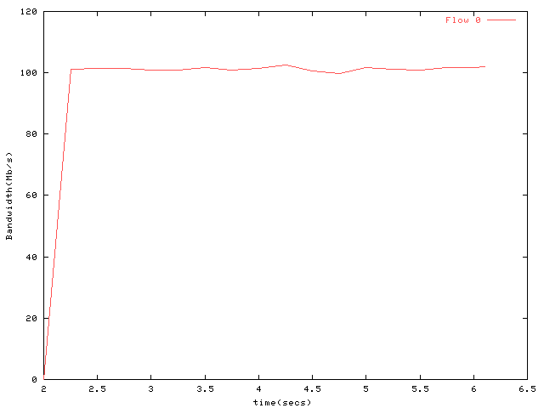
Figure 5 - Simulation Scenario 17 Goodput

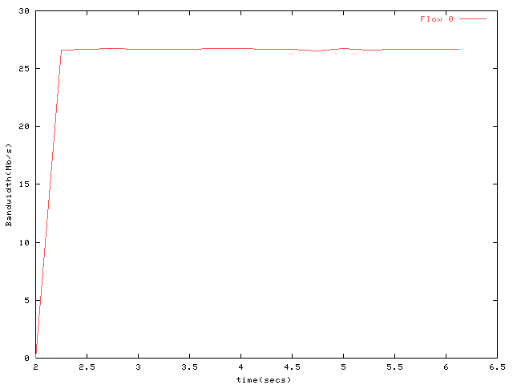
Figure 6 - Simulation Scenario 18 Goodput
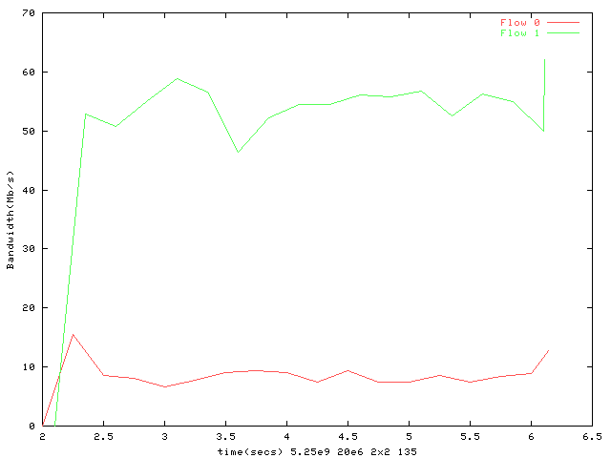
Figure 7 - Simulation Scenario 19 Goodput

CC18 | HT Usage Models 1, 4, and 6 (Non QOS) | See Section 5.2 below.
CC 19 | HT Usage Models 1, 4, and 6 (QOS) | See Section 5.3 below.
CC 20 | BSS Aggregate Goodput at the MAC data SAP | See Section 5.4 below.
CC 24 | MAC Efficiency | See Section 5.5 below.
CC 27 | Throughput Versus Range | See text section 5.6 below.
CC 28 | Throughput Versus Range (20 MHz) | See text section 5.6 below

CC 18

Scenario 1 – HCCA 2x2 20MHz

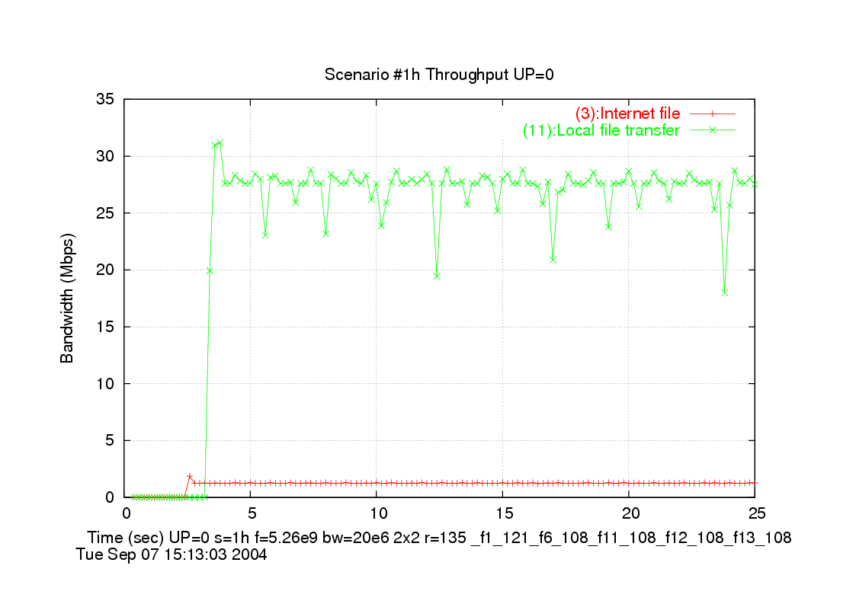

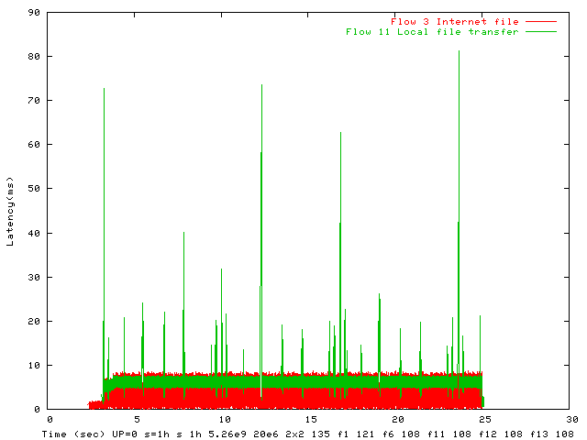

Non-QOS goodput = 27.88 Mbps
Non-QOS offered = 31.00 Mbps
Non-QOS percentage delivered = 89.95 %

Scenario 1+ – HCCA 2x2 40MHz

Scenario 1+ = Changed Flow 11 from 30 MPBS offered to 100 MBPS offered load.
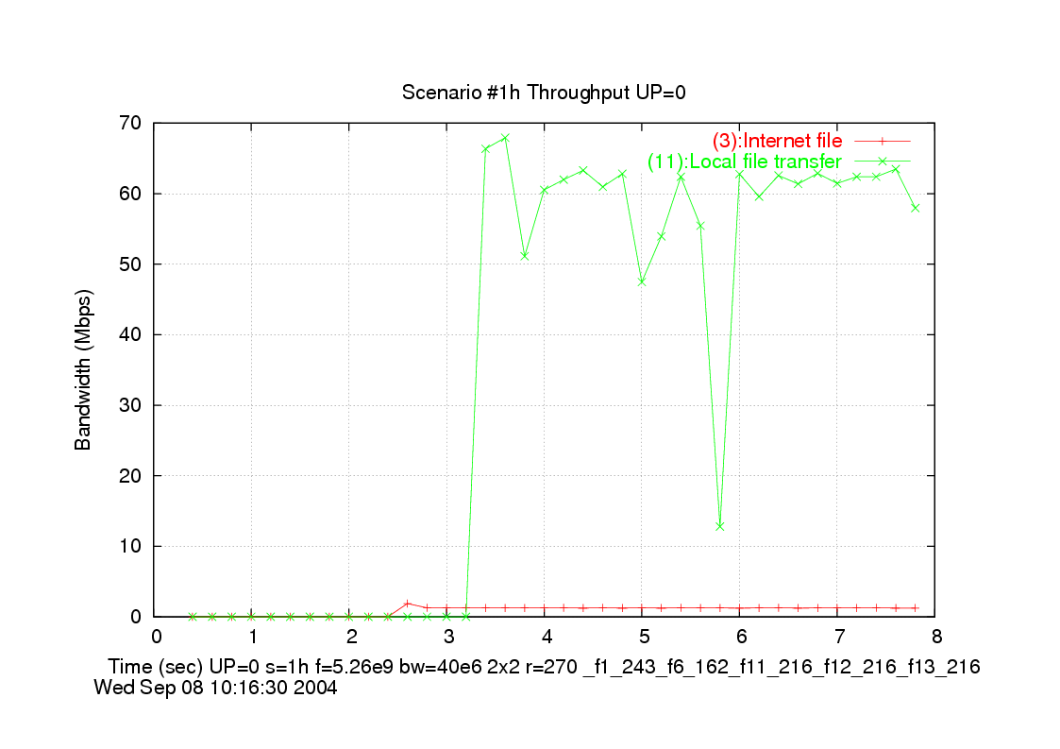

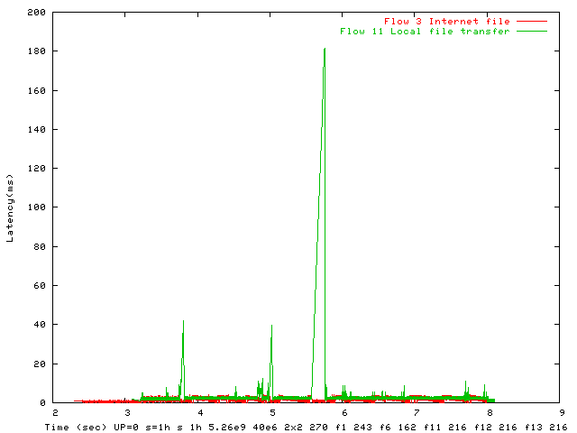

Non-QOS goodput = 58.09 Mbps
Non-QOS offered = 101.00 Mbps
Non-QOS percentage delivered = 57.51 %

Scenario 1 – EDCA 2x2 20MHz

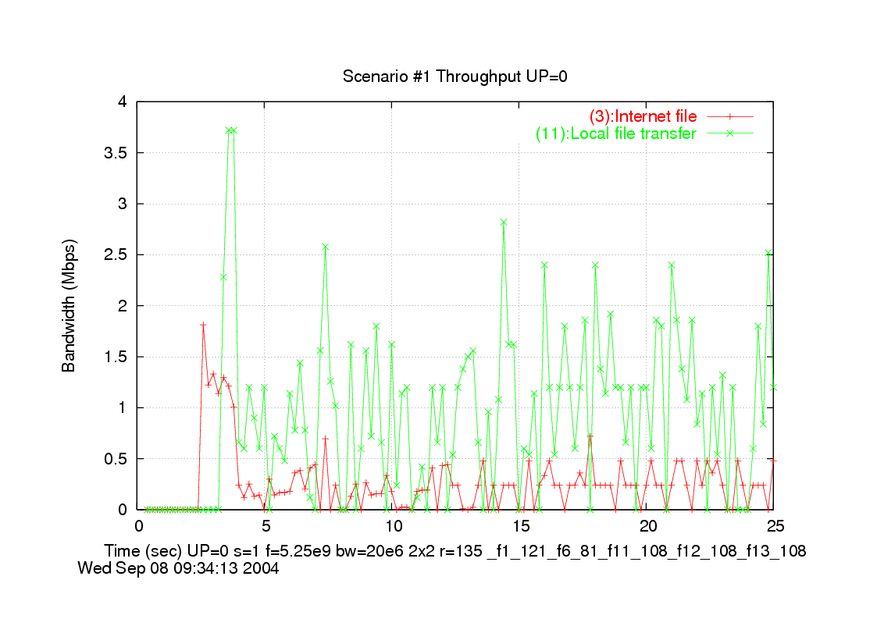

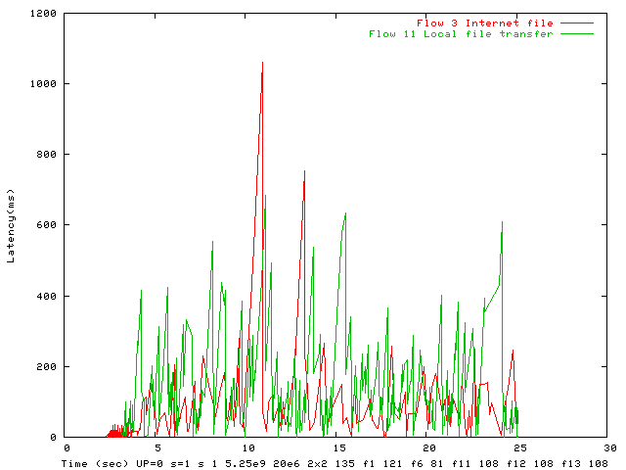

Non-QOS goodput = 1.55 Mbps
Non-QOS offered = 31.00 Mbps
Non-QOS percentage delivered = 5.01 %

Scenario 1+ – EDCA 2x2 40MHz
Scenario 1+ = Changed Flow 11 from 30 MPBS offered to 100 MBPS offered load.

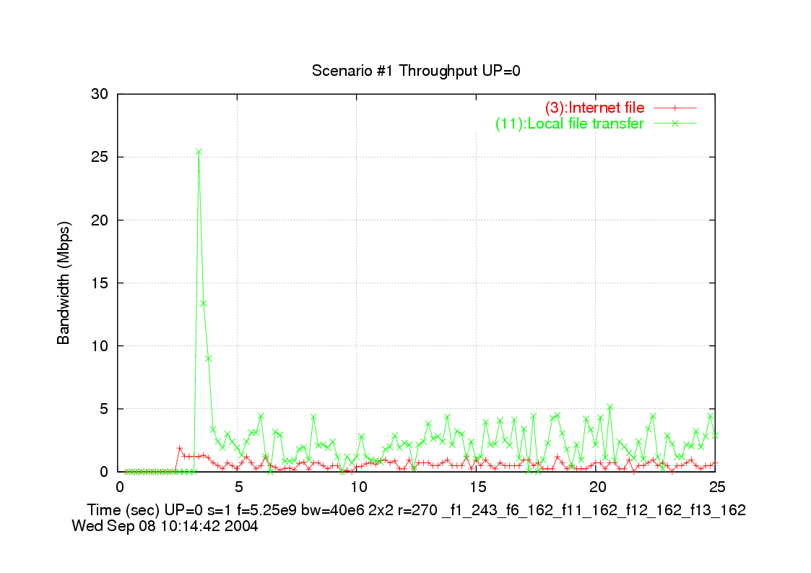

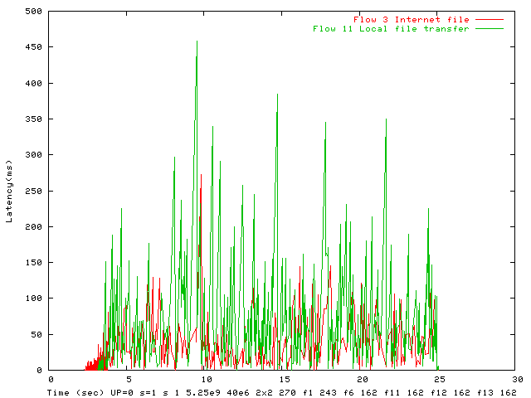

Non-QOS goodput = 3.47 Mbps
Non-QOS offered = 101.00 Mbps
Non-QOS percentage delivered = 3.44 %

Scenario 4 – HCCA 2x2 20MHz

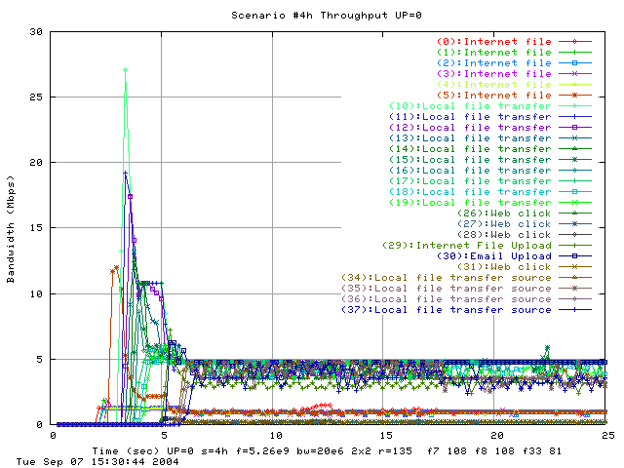

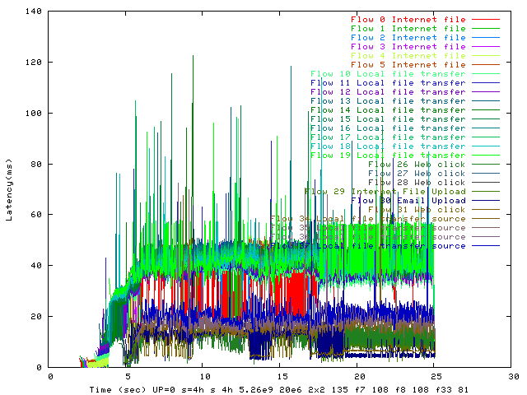

Non-QOS goodput = 76.18 Mbps
Non-QOS offered = 451.02 Mbps
Non-QOS percentage delivered = 16.89 %

Scenario 4 – EDCA 2x2 20MHz

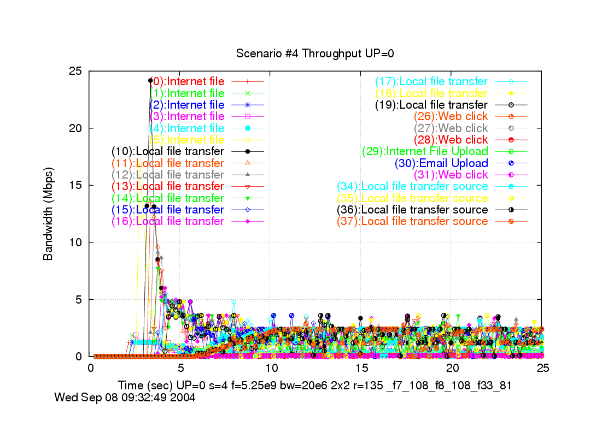

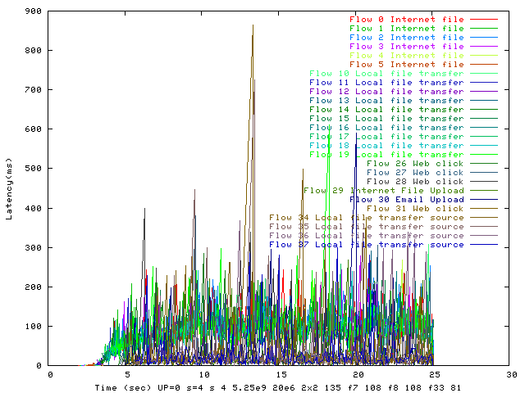

Non-QOS goodput = 34.26 Mbps
Non-QOS offered = 451.02 Mbps
Non-QOS percentage delivered = 7.60 %

Scenario 4 – EDCA 2x2 40MHz

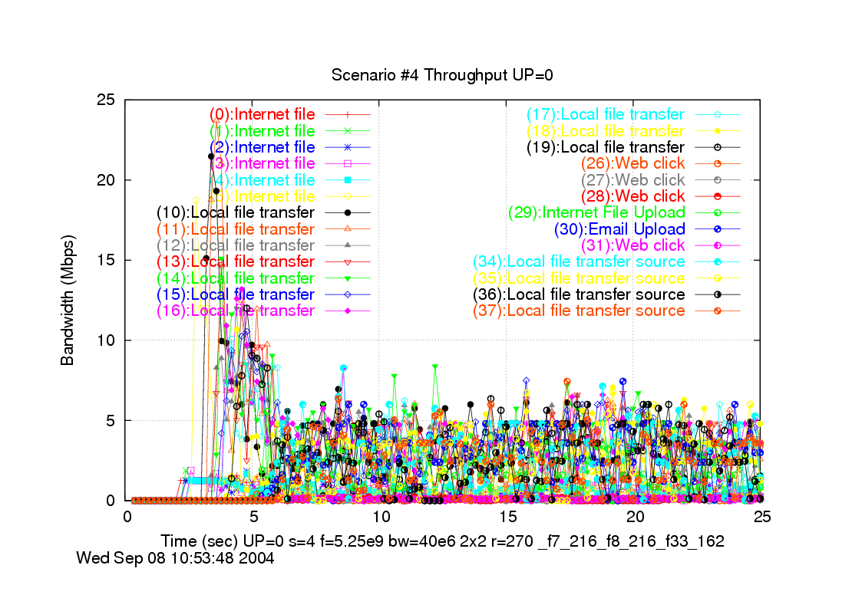

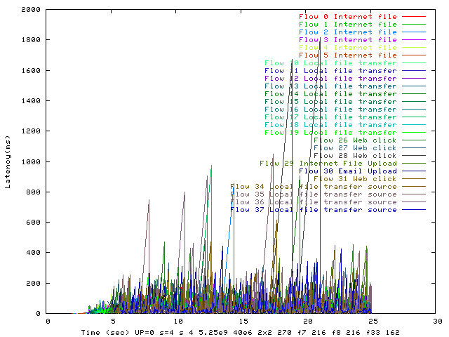

Non-QOS goodput = 55.89 Mbps
Non-QOS offered = 451.02 Mbps
Non-QOS percentage delivered = 12.39 %

Scenario 6 – HCCA 2x2 20MHz

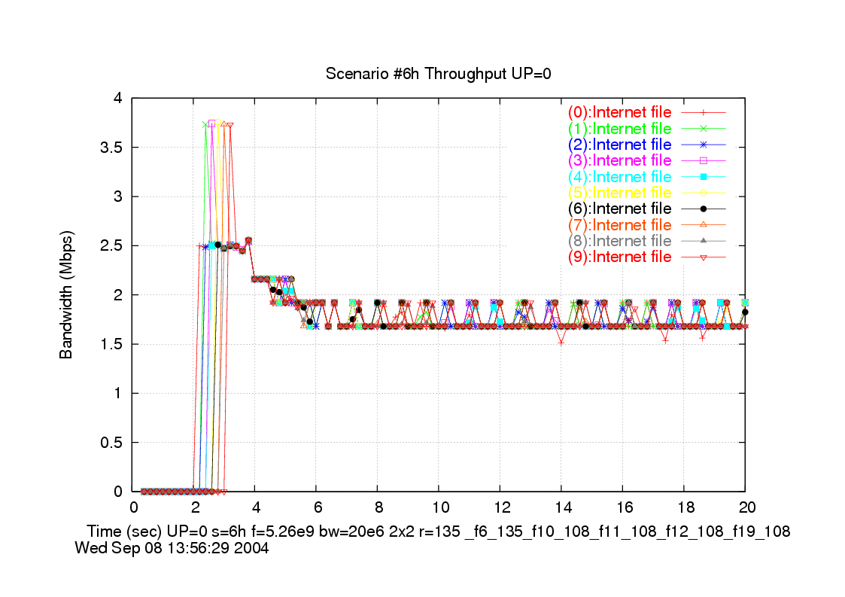

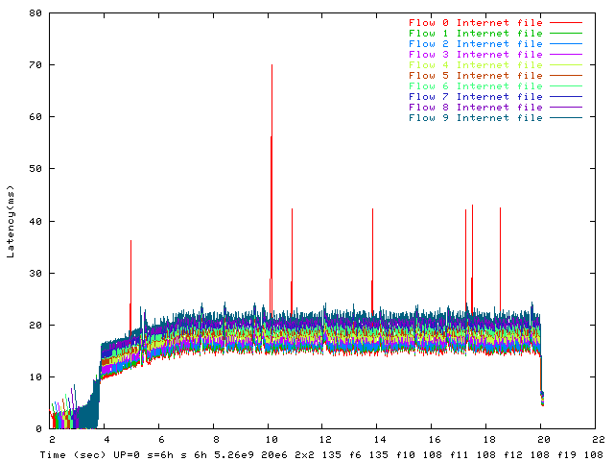

Non-QOS goodput = 18.54 Mbps
Non-QOS offered = 20.00 Mbps
Non-QOS percentage delivered = 92.72 %

Scenario 6 – EDCA 2x2 20MHz

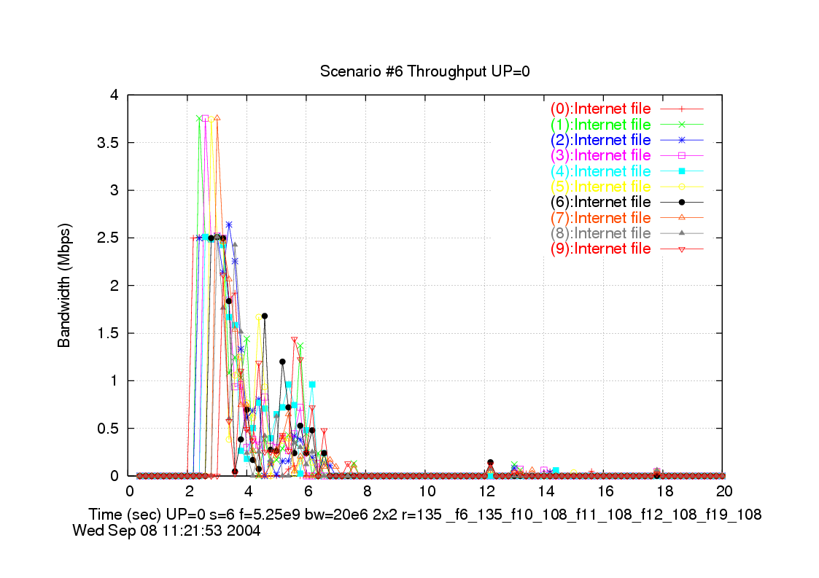

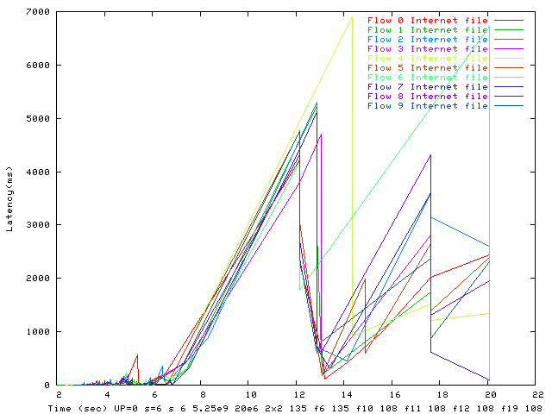

Non-QOS goodput = 2.11 Mbps
Non-QOS offered = 20.00 Mbps
Non-QOS percentage delivered = 10.57 %

Scenario 6 – EDCA 2x2 40MHz

CC19

Scenario 1 – HCCA 2x2 20MHz

- | - | - | - | - | - | - | - | - | - | - | - | MAX | MEAS | Q | LAT | MAC | fwd | - | -
- | src | dst | - | - | L4 | offd | dlvd | MSDU | MAX | MEAS | MEAS | PLR | PLR | drop | drop | drop | flow | - | QOS
Flow | node | node | label | UP | prot | BW | BW | SIZE | DLY | DLY95 | DLY100 | ppm | ppm | pkts | pkts | pkts | pkts | rate | met
0 | 0 | 1 | HDTV | 5 | cbr_udp | 19.2 | 19 | 1500 | 200 | 5 | 16 | 0.1 | 0 | 0 | 0 | 0 | 37298 | 135 | YES
1 | 0 | 3 | HDTV | 5 | cbr_udp | 24 | 23.75 | 1500 | 200 | 5 | 15 | 0.1 | 0 | 0 | 0 | 0 | 46419 | 121.5 | YES
2 | 0 | 4 | SDTV | 5 | cbr_udp | 4 | 3.96 | 1500 | 200 | 5 | 22 | 0.5 | 0 | 0 | 0 | 0 | 7703 | 135 | YES
3 | 0 | 4 | Internet_file | 0 | tcp | 1 | 1.22 | 300 | 0 | 8 | 9 | 0 | 0 | 0 | 0 | 0 | 11824 | 135 | na
4 | 0 | 7 | VoIP | 7 | cbr_udp | 0.1 | 0.11 | 120 | 30 | 4 | 8 | 50000 | 0 | 0 | 0 | 0 | 2712 | 135 | YES
5 | 0 | 8 | VoIP | 7 | cbr_udp | 0.1 | 0.11 | 120 | 30 | 5 | 8 | 50000 | 0 | 0 | 0 | 0 | 2701 | 135 | YES
6 | 0 | 9 | VoIP | 7 | cbr_udp | 0.1 | 0.11 | 120 | 30 | 4 | 13 | 50000 | 0 | 0 | 0 | 0 | 2688 | 108 | YES
7 | 0 | 10 | Internet_video | 4 | udp | 2 | 2.03 | 512 | 200 | 5 | 5 | 100 | 0 | 0 | 0 | 0 | 11332 | 135 | YES
8 | 0 | 11 | MP3_Audio | 4 | udp | 0.13 | 0.13 | 418 | 200 | 5 | 5 | 100 | 0 | 0 | 0 | 0 | 893 | 135 | YES
9 | 1 | 0 | VoD_control_channel | 7 | cbr_udp | 0.06 | 0.09 | 64 | 100 | 8 | 9 | 10000 | 0 | 0 | 0 | 0 | 3768 | 135 | YES
10 | 3 | 0 | VoD_control_channel | 7 | cbr_udp | 0.06 | 0.09 | 64 | 100 | 8 | 9 | 10000 | 0 | 0 | 0 | 0 | 3750 | 135 | YES
11 | 4 | 10 | Local_file_transfer | 0 | cbr_tcp | 30 | 26.66 | 1500 | 0 | 7 | 81 | 0 | 0 | 0 | 0 | 0 | 50057 | 108 | na
12 | 5 | 6 | Video_phone | 7 | cbr_udp | 0.5 | 0.51 | 512 | 100 | 8 | 21 | 10000 | 0 | 0 | 0 | 0 | 2770 | 108 | YES
13 | 6 | 5 | Video_phone | 7 | cbr_udp | 0.5 | 0.51 | 512 | 100 | 8 | 15 | 10000 | 0 | 0 | 0 | 0 | 2757 | 108 | YES
14 | 7 | 0 | VoIP | 7 | cbr_udp | 0.1 | 0.11 | 120 | 30 | 8 | 39 | 50000 | 771.6 | 0 | 2 | 0 | 2592 | 108 | YES
15 | 8 | 0 | VoIP | 7 | cbr_udp | 0.1 | 0.11 | 120 | 30 | 8 | 39 | 50000 | 774.9 | 0 | 2 | 0 | 2581 | 108 | YES
16 | 9 | 0 | VoIP | 7 | cbr_udp | 0.1 | 0.11 | 120 | 30 | 8 | 26 | 50000 | 0 | 0 | 0 | 0 | 2569 | 108 | YES
17 | 10 | 0 | Console_to_Internet | 7 | cbr_udp | 1 | 1.02 | 512 | 50 | 8 | 9 | 100 | 0 | 0 | 0 | 0 | 5412 | 108 | YES
18 | 11 | 10 | Controller_to_Consol | 6 | cbr_udp | 0.5 | 0.81 | 50 | 16 | 8 | 9 | 100 | 0 | 0 | 0 | 0 | 44167 | 135 | YES

Non-QOS goodput = 27.88 Mbps
Non-QOS offered = 31.00 Mbps
Non-QOS percentage delivered = 89.95 %
QOS goodput = 52.57 Mbps
QOS offered = 52.52 Mbps
QOS percentage delivered = 100.08 %
QOS percentage of flows meeting QOS goals 17/ 17 = 100.00 %
METRIC 1 - Total goodput all flows Qos + non-Qos: 80.45 Mbps
METRIC 2 - Aggregate goodput rate all QOS flows: 52.57 Mbps
METRIC 3 - QOS goodput for flows meeting QOS goals: 52.57 Mbps
MAC Efficiency = goodput for all QOS flows / average phy rate = 41.28 %
MAC Efficiency prime = goodput for all flows meeting QOS objectives (incl non-QOS)/ average phy rate = 63.27 %

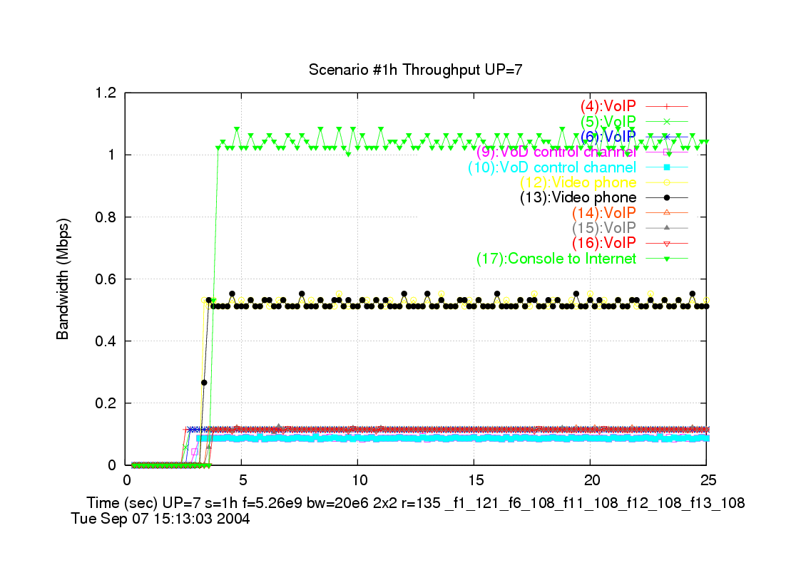

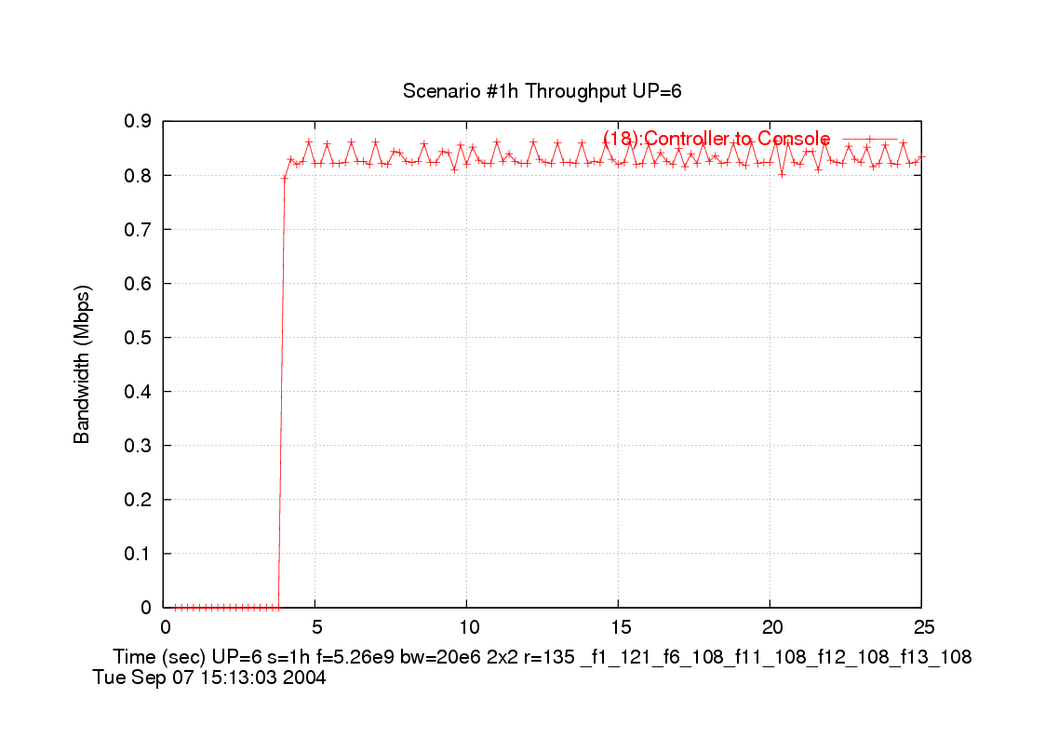

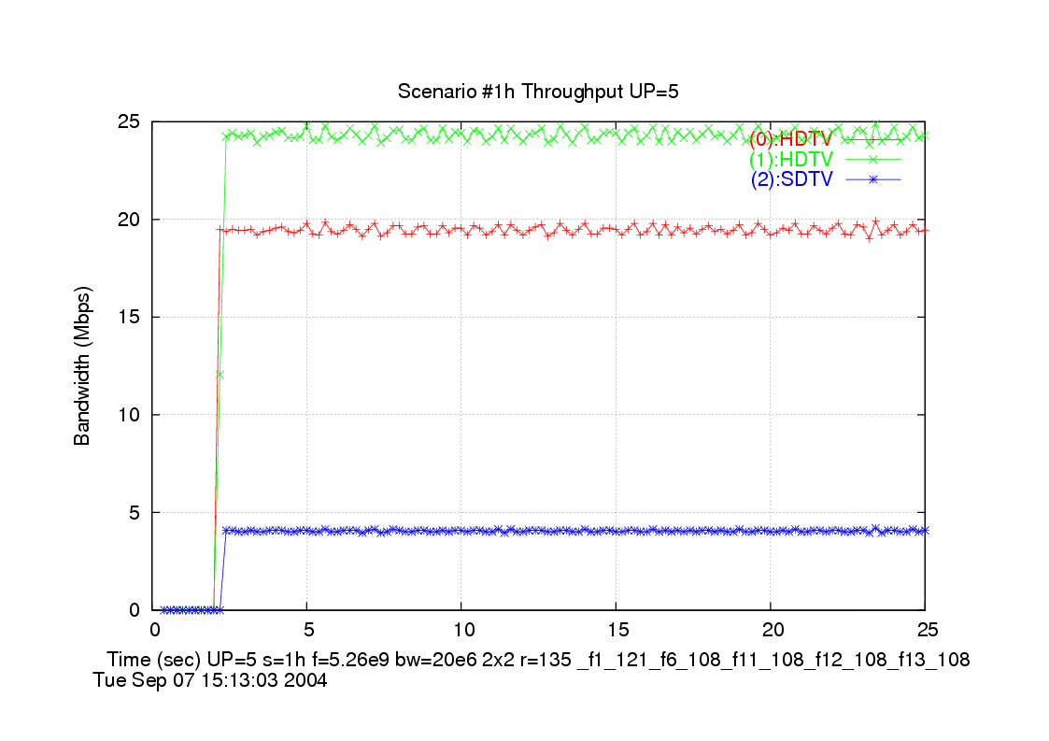

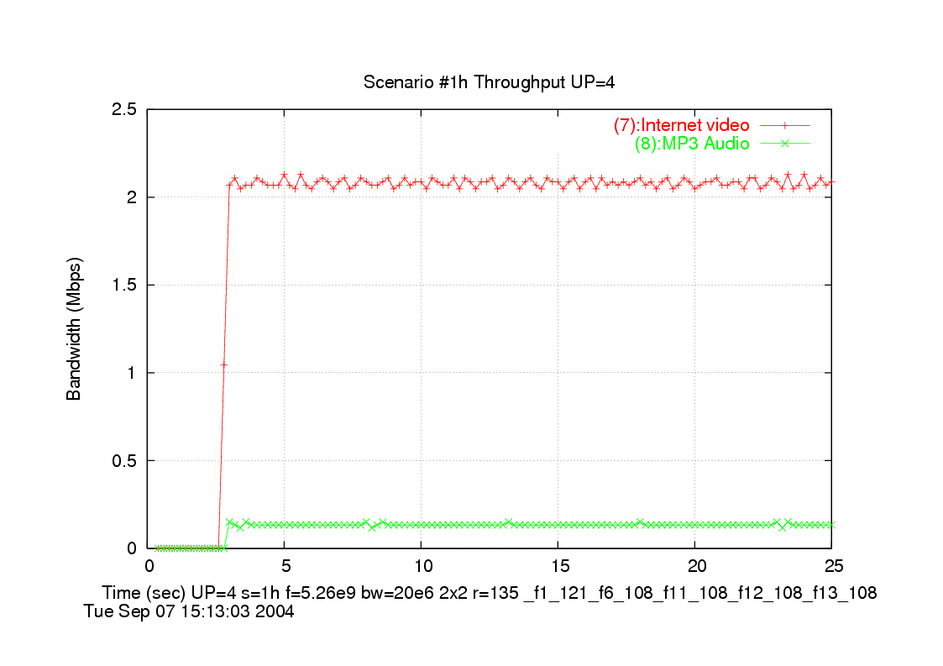

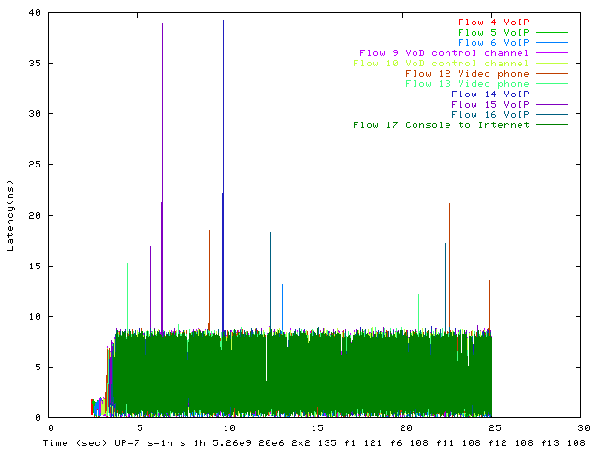
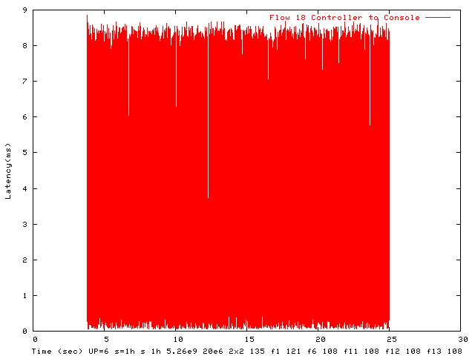

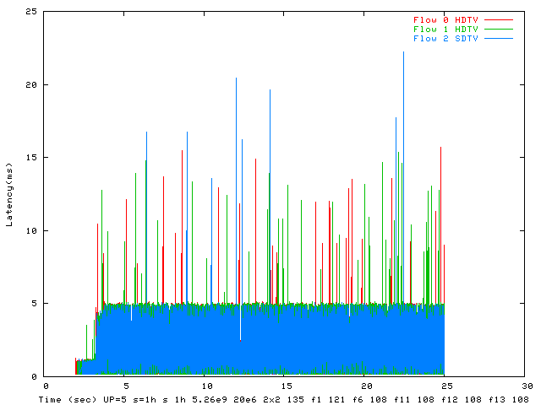

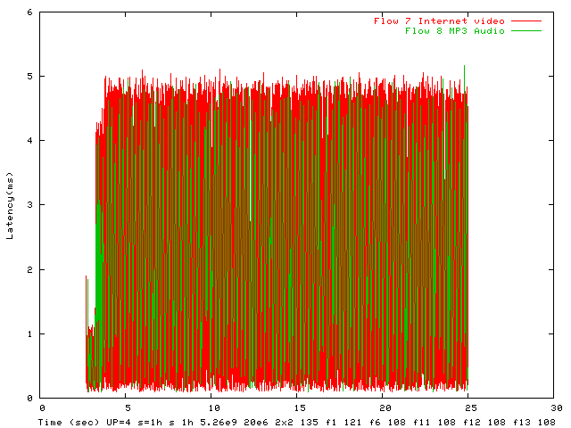

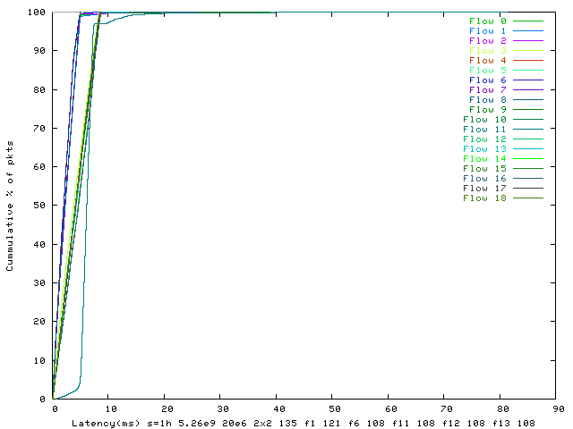

Scenario 1 – EDCA 2x2 – 20MHz

- | - | - | - | - | - | - | - | - | - | - | - | MAX | MEAS | Q | LAT | MAC | fwd | - | -
- | src | dst | - | - | L4 | offd | dlvd | MSDU | MAX | MEAS | MEAS | PLR | PLR | drop | drop | drop | flow | - | QOS
Flow | node | node | label | UP | prot | BW | BW | SIZE | DLY | DLY95 | DLY100 | ppm | ppm | pkts | pkts | pkts | pkts | rate | met
0 | 0 | 1 | HDTV | 5 | cbr_udp | 19.2 | 19 | 1500 | 200 | 13 | 53 | 0.1 | 0 | 0 | 0 | 0 | 37298 | 135 | YES
1 | 0 | 3 | HDTV | 5 | cbr_udp | 24 | 23.75 | 1500 | 200 | 15 | 42 | 0.1 | 0 | 0 | 0 | 0 | 46419 | 121.5 | YES
2 | 0 | 4 | SDTV | 5 | cbr_udp | 4 | 3.96 | 1500 | 200 | 13 | 72 | 0.5 | 0 | 0 | 0 | 0 | 7703 | 135 | YES
3 | 0 | 4 | Internet_file | 0 | tcp | 1 | 0.28 | 300 | 0 | 230 | 1062 | 0 | 0 | 0 | 0 | 0 | 2739 | 135 | na
4 | 0 | 7 | VoIP | 7 | cbr_udp | 0.1 | 0.11 | 120 | 30 | 6 | 15 | 50000 | 0 | 0 | 0 | 0 | 2712 | 135 | YES
5 | 0 | 8 | VoIP | 7 | cbr_udp | 0.1 | 0.11 | 120 | 30 | 6 | 15 | 50000 | 0 | 0 | 0 | 0 | 2701 | 135 | YES
6 | 0 | 9 | VoIP | 7 | cbr_udp | 0.1 | 0.11 | 120 | 30 | 6 | 15 | 50000 | 0 | 0 | 0 | 0 | 2688 | 81 | YES
7 | 0 | 10 | Internet_video | 4 | udp | 2 | 2.03 | 512 | 200 | 10 | 55 | 100 | 0 | 0 | 0 | 0 | 11332 | 135 | YES
8 | 0 | 11 | MP3_Audio | 4 | udp | 0.13 | 0.13 | 418 | 200 | 10 | 88 | 100 | 0 | 0 | 0 | 0 | 893 | 135 | YES
9 | 1 | 0 | VoD_control_channel | 7 | cbr_udp | 0.06 | 0.09 | 64 | 100 | 6 | 16 | 10000 | 0 | 0 | 0 | 0 | 3768 | 135 | YES
10 | 3 | 0 | VoD_control_channel | 7 | cbr_udp | 0.06 | 0.09 | 64 | 100 | 5 | 12 | 10000 | 0 | 0 | 0 | 0 | 3750 | 135 | YES
11 | 4 | 10 | Local_file_transfer | 0 | cbr_tcp | 30 | 1.27 | 1500 | 0 | 381 | 686 | 0 | 0 | 0 | 0 | 0 | 2390 | 108 | na
12 | 5 | 6 | Video_phone | 7 | cbr_udp | 0.5 | 0.51 | 512 | 100 | 5 | 17 | 10000 | 0 | 0 | 0 | 0 | 2770 | 108 | YES
13 | 6 | 5 | Video_phone | 7 | cbr_udp | 0.5 | 0.51 | 512 | 100 | 6 | 13 | 10000 | 362.7 | 0 | 0 | 1 | 2757 | 108 | YES
14 | 7 | 0 | VoIP | 7 | cbr_udp | 0.1 | 0.11 | 120 | 30 | 5 | 15 | 50000 | 0 | 0 | 0 | 0 | 2592 | 108 | YES
15 | 8 | 0 | VoIP | 7 | cbr_udp | 0.1 | 0.11 | 120 | 30 | 5 | 11 | 50000 | 0 | 0 | 0 | 0 | 2581 | 108 | YES
16 | 9 | 0 | VoIP | 7 | cbr_udp | 0.1 | 0.11 | 120 | 30 | 5 | 12 | 50000 | 0 | 0 | 0 | 0 | 2569 | 108 | YES
17 | 10 | 0 | Console_to_Internet | 7 | cbr_udp | 1 | 1.02 | 512 | 50 | 6 | 18 | 100 | 0 | 0 | 0 | 0 | 5412 | 81 | YES
18 | 11 | 10 | Controller_to_Consol | 6 | cbr_udp | 0.5 | 0.81 | 50 | 16 | 5 | 14 | 100 | 22.6 | 0 | 0 | 1 | 44167 | 135 | YES

Non-QOS goodput = 1.55 Mbps
Non-QOS offered = 31.00 Mbps
Non-QOS percentage delivered = 5.01 %
QOS goodput = 52.57 Mbps
QOS offered = 52.52 Mbps
QOS percentage delivered = 100.09 %
QOS percentage of flows meeting QOS goals 17/ 17 = 100.00 %
METRIC 1 - Total goodput all flows Qos + non-Qos: 54.12 Mbps
METRIC 2 - Aggregate goodput rate all QOS flows: 52.57 Mbps
METRIC 3 - QOS goodput for flows meeting QOS goals: 52.57 Mbps
MAC Efficiency = goodput for all QOS flows / average phy rate = 41.60 %
MAC Efficiency prime = goodput for all flows meeting QOS objectives (incl non-QOS)/ average phy rate = 42.78 %

STA: | 0 | 0 | cw_min | 31 |  | STA: | 1 | 0 | cw_min | 31
STA: | 0 | 0 | cw_max | 511 |  | STA: | 1 | 0 | cw_max | 511
STA: | 0 | 0 | aifs | 4 |  | STA: | 1 | 0 | aifs | 4
STA: | 0 | 0 | txop | 3.00E-03 |  | STA: | 1 | 0 | txop | 3.00E-03
STA: | 0 | 1 | cw_min | 31 |  | STA: | 1 | 1 | cw_min | 63
STA: | 0 | 1 | cw_max | 127 |  | STA: | 1 | 1 | cw_max | 127
STA: | 0 | 1 | aifs | 4 |  | STA: | 1 | 1 | aifs | 4
STA: | 0 | 1 | txop | 2.00E-03 |  | STA: | 1 | 1 | txop | 1.50E-03
STA: | 0 | 2 | cw_min | 15 |  | STA: | 1 | 2 | cw_min | 15
STA: | 0 | 2 | cw_max | 31 |  | STA: | 1 | 2 | cw_max | 31
STA: | 0 | 2 | aifs | 3 |  | STA: | 1 | 2 | aifs | 3
STA: | 0 | 2 | txop | 3.50E-03 |  | STA: | 1 | 2 | txop | 1.00E-03
STA: | 0 | 3 | cw_min | 7 |  | STA: | 1 | 3 | cw_min | 7
STA: | 0 | 3 | cw_max | 15 |  | STA: | 1 | 3 | cw_max | 15
STA: | 0 | 3 | aifs | 2 |  | STA: | 1 | 3 | aifs | 2
STA: | 0 | 3 | txop | 2.50E-03 |  | STA: | 1 | 3 | txop | 1.00E-03
 |  |  |  |  |  | STA: | 1 | 3 | rts-disabled | on
 |  |  |  |  |  | STA: | 1 | 3 | blockack-disable | on

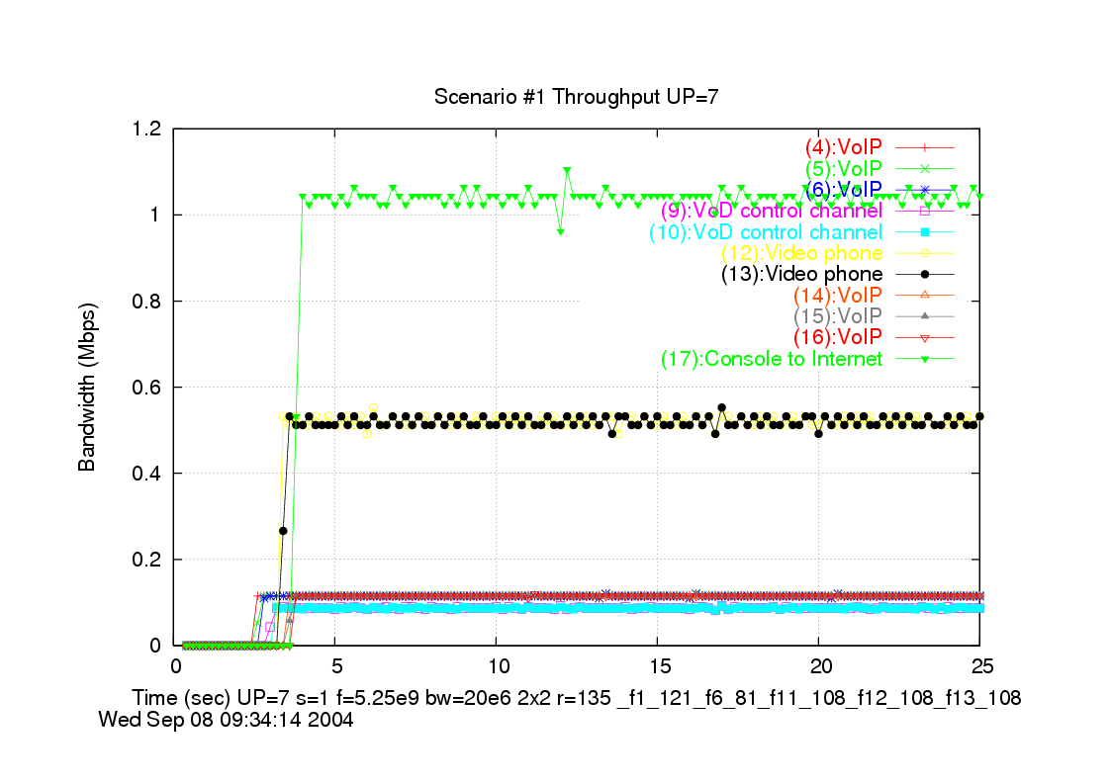
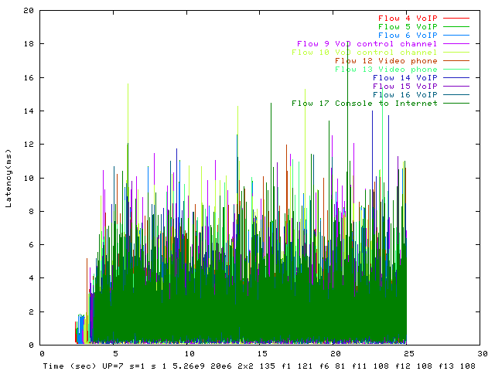
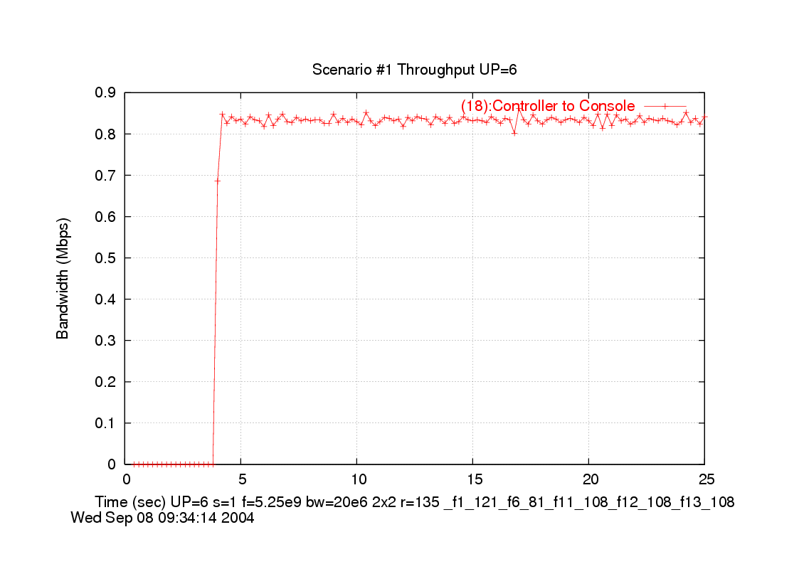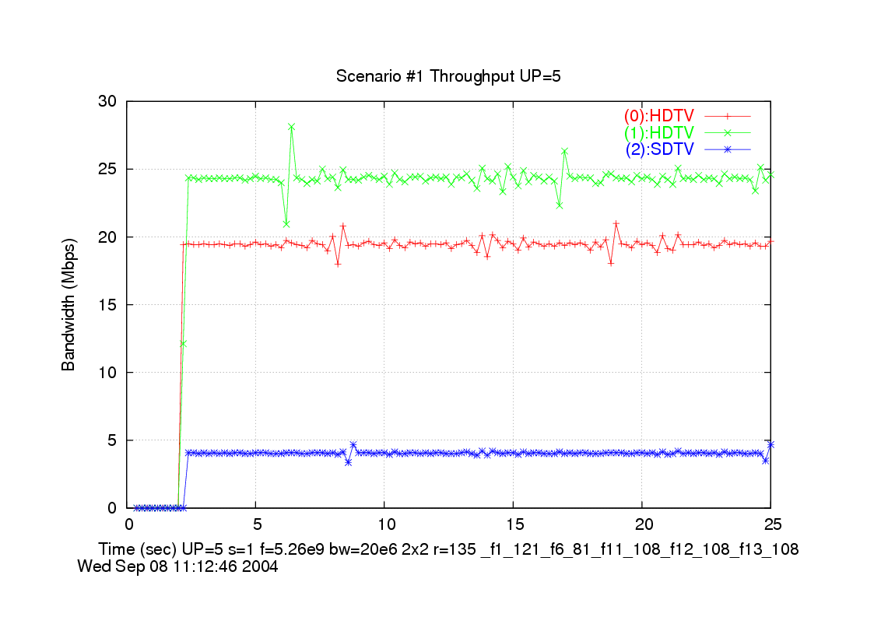
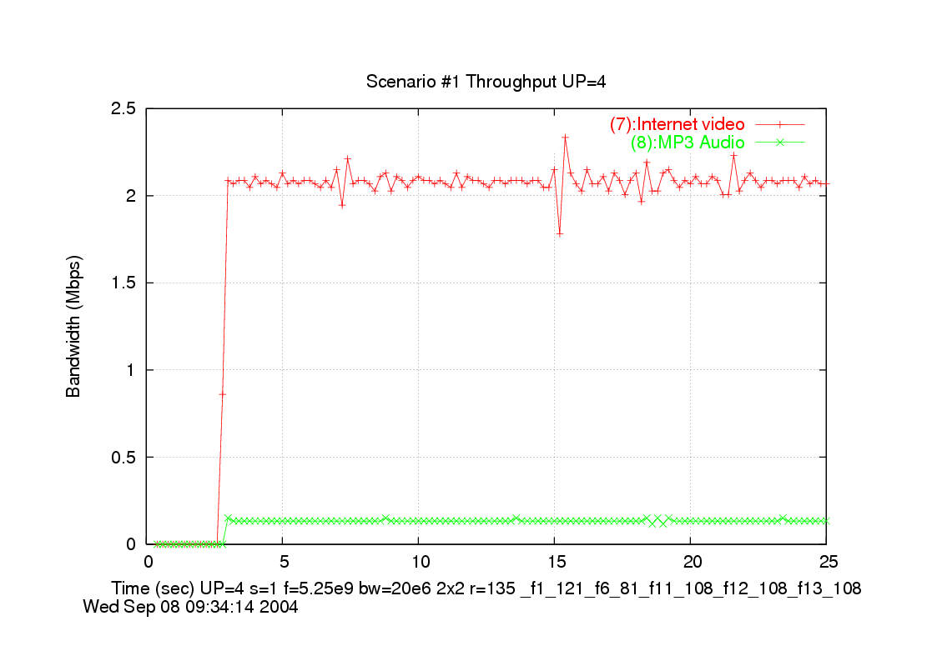

Scenario 4 – HCCA 2x2 20MHz

- | - | - | - | - | - | - | - | - | - | - | - | MAX | MEAS | Q | LAT | MAC | fwd | - | -
- | src | dst | - | - | L4 | offd | dlvd | MSDU | MAX | MEAS | MEAS | PLR | PLR | drop | drop | drop | flow | - | QOS
Flow | node | node | label | UP | prot | BW | BW | SIZE | DLY | DLY95 | DLY100 | ppm | ppm | pkts | pkts | pkts | pkts | rate | met
0 | 0 | 1 | Internet_file | 0 | tcp | 1 | 1.02 | 300 | 0 | 44 | 52 | 0 | 0 | 0 | 0 | 0 | 10048 | 135 | na
1 | 0 | 2 | Internet_file | 0 | tcp | 1 | 0.96 | 300 | 0 | 44 | 49 | 0 | 0 | 0 | 0 | 0 | 9445 | 135 | na
2 | 0 | 3 | Internet_file | 0 | tcp | 1 | 0.96 | 300 | 0 | 44 | 46 | 0 | 0 | 0 | 0 | 0 | 9363 | 135 | na
3 | 0 | 4 | Internet_file | 0 | tcp | 1 | 0.95 | 300 | 0 | 45 | 50 | 0 | 0 | 0 | 0 | 0 | 9287 | 135 | na
4 | 0 | 5 | Internet_file | 0 | tcp | 1 | 0.95 | 300 | 0 | 47 | 52 | 0 | 0 | 0 | 0 | 0 | 9151 | 135 | na
5 | 0 | 6 | Internet_file | 0 | tcp | 10 | 1.32 | 300 | 0 | 47 | 51 | 0 | 0 | 0 | 0 | 0 | 12718 | 135 | na
6 | 0 | 7 | Video_conferencing | 5 | cbr_udp | 1 | 1.02 | 512 | 100 | 17 | 29 | 100 | 0 | 0 | 0 | 0 | 5692 | 135 | YES
7 | 0 | 8 | Video_conferencing | 5 | cbr_udp | 1 | 1.02 | 512 | 100 | 17 | 27 | 100 | 0 | 0 | 0 | 0 | 5666 | 108 | YES
8 | 0 | 9 | Internet_Streaming_V | 4 | udp | 2 | 2.03 | 512 | 200 | 18 | 29 | 100 | 0 | 0 | 0 | 0 | 11281 | 108 | YES
9 | 0 | 10 | Internet_Streaming_V | 4 | udp | 2 | 2.03 | 512 | 200 | 18 | 30 | 100 | 0 | 0 | 0 | 0 | 11230 | 135 | YES
10 | 0 | 11 | Local_file_transfer | 0 | cbr_tcp | 30 | 5.31 | 1500 | 0 | 47 | 97 | 0 | 0 | 0 | 0 | 0 | 10026 | 135 | na
11 | 0 | 12 | Local_file_transfer | 0 | tcp | 30 | 5.11 | 1500 | 0 | 48 | 89 | 0 | 0 | 0 | 0 | 0 | 9605 | 135 | na
12 | 0 | 13 | Local_file_transfer | 0 | tcp | 30 | 5.03 | 1500 | 0 | 46 | 68 | 0 | 0 | 0 | 0 | 0 | 9375 | 135 | na
13 | 0 | 14 | Local_file_transfer | 0 | tcp | 30 | 4.81 | 1500 | 0 | 48 | 102 | 0 | 0 | 0 | 0 | 0 | 8927 | 135 | na
14 | 0 | 15 | Local_file_transfer | 0 | tcp | 30 | 4.67 | 1500 | 0 | 48 | 122 | 0 | 0 | 0 | 0 | 0 | 8619 | 135 | na
15 | 0 | 16 | Local_file_transfer | 0 | tcp | 30 | 4.59 | 1500 | 0 | 47 | 115 | 0 | 0 | 0 | 0 | 0 | 8431 | 135 | na
16 | 0 | 17 | Local_file_transfer | 0 | tcp | 30 | 4.5 | 1500 | 0 | 48 | 118 | 0 | 0 | 0 | 0 | 0 | 8256 | 135 | na
17 | 0 | 18 | Local_file_transfer | 0 | tcp | 30 | 4.46 | 1500 | 0 | 48 | 105 | 0 | 0 | 0 | 0 | 0 | 8137 | 135 | na
18 | 0 | 19 | Local_file_transfer | 0 | tcp | 30 | 4.33 | 1500 | 0 | 55 | 113 | 0 | 0 | 0 | 0 | 0 | 7853 | 135 | na
19 | 0 | 20 | Local_file_transfer | 0 | tcp | 30 | 4.12 | 1500 | 0 | 56 | 96 | 0 | 0 | 0 | 0 | 0 | 7464 | 135 | na
20 | 0 | 25 | VoIP | 7 | cbr_udp | 0.1 | 0.11 | 120 | 30 | 23 | 29 | 50000 | 0 | 0 | 0 | 0 | 2521 | 135 | YES
21 | 0 | 26 | VoIP | 7 | cbr_udp | 0.1 | 0.11 | 120 | 30 | 23 | 29 | 50000 | 0 | 0 | 0 | 0 | 2509 | 135 | YES
22 | 0 | 27 | VoIP | 7 | cbr_udp | 0.1 | 0.11 | 120 | 30 | 23 | 29 | 50000 | 0 | 0 | 0 | 0 | 2497 | 135 | YES
23 | 0 | 28 | VoIP | 7 | cbr_udp | 0.1 | 0.11 | 120 | 30 | 23 | 29 | 50000 | 0 | 0 | 0 | 0 | 2484 | 135 | YES
24 | 0 | 29 | VoIP | 7 | cbr_udp | 0.1 | 0.11 | 120 | 30 | 23 | 29 | 50000 | 0 | 0 | 0 | 0 | 2472 | 135 | YES
25 | 0 | 30 | VoIP | 7 | cbr_udp | 0.1 | 0.11 | 120 | 30 | 23 | 29 | 50000 | 0 | 0 | 0 | 0 | 2460 | 135 | YES
26 | 1 | 0 | Web_click | 0 | tcp | 0.26 | 0.22 | 64 | 0 | 17 | 18 | 0 | 0 | 0 | 0 | 0 | 9031 | 135 | na
27 | 2 | 0 | Web_click | 0 | tcp | 0.26 | 0.2 | 64 | 0 | 15 | 23 | 0 | 0 | 0 | 0 | 0 | 8311 | 135 | na
28 | 3 | 0 | Web_click | 0 | tcp | 0.26 | 0.2 | 64 | 0 | 15 | 18 | 0 | 0 | 0 | 0 | 0 | 8153 | 135 | na
29 | 4 | 0 | Internet_File_Upload | 0 | tcp | 5 | 3.08 | 1000 | 0 | 16 | 19 | 0 | 0 | 0 | 0 | 0 | 7949 | 135 | na
30 | 5 | 0 | Email_Upload | 0 | tcp | 10 | 4.51 | 1500 | 0 | 18 | 64 | 0 | 0 | 0 | 0 | 0 | 7725 | 135 | na
31 | 6 | 0 | Web_click | 0 | tcp | 0.26 | 0.19 | 64 | 0 | 16 | 20 | 0 | 0 | 0 | 0 | 0 | 7633 | 135 | na
32 | 7 | 0 | Video_conferencing | 5 | cbr_udp | 1 | 1.02 | 512 | 100 | 25 | 32 | 100 | 0 | 0 | 0 | 0 | 5031 | 135 | YES
33 | 8 | 0 | Video_conferencing | 5 | cbr_udp | 1 | 1.02 | 512 | 100 | 25 | 32 | 100 | 0 | 0 | 0 | 0 | 5006 | 81 | YES
34 | 21 | 0 | Local_file_transfer_ | 0 | tcp | 30 | 3.91 | 1500 | 0 | 22 | 75 | 0 | 0 | 0 | 0 | 0 | 6575 | 135 | na
35 | 22 | 0 | Local_file_transfer_ | 0 | tcp | 30 | 3.79 | 1500 | 0 | 23 | 71 | 0 | 0 | 0 | 0 | 0 | 6331 | 135 | na
36 | 23 | 0 | Local_file_transfer_ | 0 | tcp | 30 | 3.6 | 1500 | 0 | 25 | 72 | 0 | 0 | 0 | 0 | 0 | 5991 | 135 | na
37 | 24 | 0 | Local_file_transfer_ | 0 | tcp | 30 | 3.4 | 1500 | 0 | 26 | 71 | 0 | 0 | 0 | 0 | 0 | 5603 | 135 | na
38 | 25 | 0 | VoIP_phone | 7 | cbr_udp | 0.1 | 0.11 | 120 | 30 | 26 | 32 | 50000 | 3904.6 | 0 | 9 | 0 | 2305 | 135 | YES
39 | 26 | 0 | VoIP_phone | 7 | cbr_udp | 0.1 | 0.11 | 120 | 30 | 26 | 32 | 50000 | 3926.7 | 0 | 9 | 0 | 2292 | 135 | YES
40 | 27 | 0 | VoIP_phone | 7 | cbr_udp | 0.1 | 0.11 | 120 | 30 | 26 | 32 | 50000 | 4822.4 | 0 | 11 | 0 | 2281 | 135 | YES
41 | 28 | 0 | VoIP_phone | 7 | cbr_udp | 0.1 | 0.11 | 120 | 30 | 26 | 32 | 50000 | 4848 | 0 | 11 | 0 | 2269 | 135 | YES
42 | 29 | 0 | VoIP_phone | 7 | cbr_udp | 0.1 | 0.11 | 120 | 30 | 26 | 33 | 50000 | 3987.6 | 0 | 9 | 0 | 2257 | 135 | YES
43 | 30 | 0 | VoIP_phone | 7 | cbr_udp | 0.1 | 0.11 | 120 | 30 | 26 | 33 | 50000 | 4010.7 | 0 | 9 | 0 | 2244 | 135 | YES

Non-QOS goodput = 76.18 Mbps
Non-QOS offered = 451.02 Mbps
Non-QOS percentage delivered = 16.89 %
QOS goodput = 9.48 Mbps
QOS offered = 9.15 Mbps
QOS percentage delivered = 103.58 %
QOS percentage of flows meeting QOS goals 18/ 18 = 100.00 %
METRIC 1 - Total goodput all flows Qos + non-Qos: 85.66 Mbps
METRIC 2 - Aggregate goodput rate all QOS flows: 9.48 Mbps
METRIC 3 - QOS goodput for flows meeting QOS goals: 9.48 Mbps
MAC Efficiency = goodput for all QOS flows / average phy rate = 7.94 %
MAC Efficiency prime = goodput for all flows meeting QOS objectives (incl non-QOS)/ average phy rate = 65.60 %

Scenario 4 – EDCA 2x2 20MHz

- | - | - | - | - | - | - | - | - | - | - | - | MAX | MEAS | Q | LAT | MAC | fwd | - | -
- | src | dst | - | - | L4 | offd | dlvd | MSDU | MAX | MEAS | MEAS | PLR | PLR | drop | drop | drop | flow | - | QOS
Flow | node | node | label | UP | prot | BW | BW | SIZE | DLY | DLY95 | DLY100 | ppm | ppm | pkts | pkts | pkts | pkts | rate | met
0 | 0 | 1 | Internet_file | 0 | tcp | 1 | 0.44 | 300 | 0 | 159 | 266 | 0 | 0 | 0 | 0 | 0 | 4321 | 135 | na
1 | 0 | 2 | Internet_file | 0 | tcp | 1 | 0.47 | 300 | 0 | 134 | 229 | 0 | 0 | 0 | 0 | 0 | 4648 | 135 | na
2 | 0 | 3 | Internet_file | 0 | tcp | 1 | 0.42 | 300 | 0 | 153 | 254 | 0 | 0 | 0 | 0 | 0 | 4084 | 135 | na
3 | 0 | 4 | Internet_file | 0 | tcp | 1 | 0.46 | 300 | 0 | 135 | 278 | 0 | 0 | 0 | 0 | 0 | 4451 | 135 | na
4 | 0 | 5 | Internet_file | 0 | tcp | 1 | 0.43 | 300 | 0 | 133 | 268 | 0 | 0 | 0 | 0 | 0 | 4131 | 135 | na
5 | 0 | 6 | Internet_file | 0 | tcp | 10 | 0.75 | 300 | 0 | 126 | 217 | 0 | 0 | 0 | 0 | 0 | 7252 | 135 | na
6 | 0 | 7 | Video_conferencing | 5 | cbr_udp | 1 | 1.02 | 512 | 100 | 7 | 21 | 100 | 0 | 0 | 0 | 0 | 5692 | 135 | YES
7 | 0 | 8 | Video_conferencing | 5 | cbr_udp | 1 | 1.02 | 512 | 100 | 7 | 19 | 100 | 0 | 0 | 0 | 0 | 5666 | 108 | YES
8 | 0 | 9 | Internet_Streaming_V | 4 | udp | 2 | 2.03 | 512 | 200 | 7 | 19 | 100 | 0 | 0 | 0 | 0 | 11281 | 108 | YES
9 | 0 | 10 | Internet_Streaming_V | 4 | udp | 2 | 2.03 | 512 | 200 | 7 | 20 | 100 | 0 | 0 | 0 | 0 | 11230 | 135 | YES
10 | 0 | 11 | Local_file_transfer | 0 | cbr_tcp | 30 | 2.44 | 1500 | 0 | 135 | 308 | 0 | 0 | 0 | 0 | 0 | 4588 | 135 | na
11 | 0 | 12 | Local_file_transfer | 0 | tcp | 30 | 2.38 | 1500 | 0 | 135 | 204 | 0 | 0 | 0 | 0 | 0 | 4467 | 135 | na
12 | 0 | 13 | Local_file_transfer | 0 | tcp | 30 | 2.31 | 1500 | 0 | 138 | 218 | 0 | 0 | 0 | 0 | 0 | 4331 | 135 | na
13 | 0 | 14 | Local_file_transfer | 0 | tcp | 30 | 2.18 | 1500 | 0 | 138 | 290 | 0 | 0 | 0 | 0 | 0 | 4048 | 135 | na
14 | 0 | 15 | Local_file_transfer | 0 | tcp | 30 | 2.18 | 1500 | 0 | 132 | 217 | 0 | 0 | 0 | 0 | 0 | 4040 | 135 | na
15 | 0 | 16 | Local_file_transfer | 0 | tcp | 30 | 2.19 | 1500 | 0 | 142 | 216 | 0 | 0 | 0 | 0 | 0 | 4029 | 135 | na
16 | 0 | 17 | Local_file_transfer | 0 | tcp | 30 | 2.13 | 1500 | 0 | 140 | 238 | 0 | 0 | 0 | 0 | 0 | 3909 | 135 | na
17 | 0 | 18 | Local_file_transfer | 0 | tcp | 30 | 2.11 | 1500 | 0 | 138 | 257 | 0 | 0 | 0 | 0 | 0 | 3860 | 135 | na
18 | 0 | 19 | Local_file_transfer | 0 | tcp | 30 | 2.13 | 1500 | 0 | 139 | 241 | 0 | 0 | 0 | 0 | 0 | 3858 | 135 | na
19 | 0 | 20 | Local_file_transfer | 0 | tcp | 30 | 1.93 | 1500 | 0 | 153 | 610 | 0 | 0 | 0 | 0 | 0 | 3508 | 135 | na
20 | 0 | 25 | VoIP | 7 | cbr_udp | 0.1 | 0.11 | 120 | 30 | 6 | 19 | 50000 | 0 | 0 | 0 | 0 | 2521 | 135 | YES
21 | 0 | 26 | VoIP | 7 | cbr_udp | 0.1 | 0.11 | 120 | 30 | 6 | 19 | 50000 | 0 | 0 | 0 | 0 | 2509 | 135 | YES
22 | 0 | 27 | VoIP | 7 | cbr_udp | 0.1 | 0.11 | 120 | 30 | 6 | 19 | 50000 | 0 | 0 | 0 | 0 | 2497 | 135 | YES
23 | 0 | 28 | VoIP | 7 | cbr_udp | 0.1 | 0.11 | 120 | 30 | 6 | 19 | 50000 | 0 | 0 | 0 | 0 | 2484 | 135 | YES
24 | 0 | 29 | VoIP | 7 | cbr_udp | 0.1 | 0.11 | 120 | 30 | 6 | 19 | 50000 | 0 | 0 | 0 | 0 | 2472 | 135 | YES
25 | 0 | 30 | VoIP | 7 | cbr_udp | 0.1 | 0.11 | 120 | 30 | 6 | 19 | 50000 | 0 | 0 | 0 | 0 | 2460 | 135 | YES
26 | 1 | 0 | Web_click | 0 | tcp | 0.26 | 0.07 | 64 | 0 | 161 | 286 | 0 | 0 | 0 | 0 | 0 | 2940 | 135 | na
27 | 2 | 0 | Web_click | 0 | tcp | 0.26 | 0.08 | 64 | 0 | 135 | 380 | 0 | 0 | 0 | 0 | 0 | 3338 | 135 | na
28 | 3 | 0 | Web_click | 0 | tcp | 0.26 | 0.07 | 64 | 0 | 192 | 398 | 0 | 0 | 0 | 0 | 0 | 2814 | 135 | na
29 | 4 | 0 | Internet_File_Upload | 0 | tcp | 5 | 1.12 | 1000 | 0 | 152 | 267 | 0 | 0 | 0 | 0 | 0 | 2884 | 135 | na
30 | 5 | 0 | Email_Upload | 0 | tcp | 10 | 1.72 | 1500 | 0 | 175 | 590 | 0 | 0 | 0 | 0 | 0 | 2942 | 135 | na
31 | 6 | 0 | Web_click | 0 | tcp | 0.26 | 0.07 | 64 | 0 | 148 | 864 | 0 | 0 | 0 | 0 | 0 | 2853 | 135 | na
32 | 7 | 0 | Video_conferencing | 5 | cbr_udp | 1 | 1.02 | 512 | 100 | 8 | 50 | 100 | 0 | 0 | 0 | 0 | 5031 | 135 | YES
33 | 8 | 0 | Video_conferencing | 5 | cbr_udp | 1 | 1.01 | 512 | 100 | 9 | 46 | 100 | 0 | 0 | 0 | 0 | 5006 | 81 | YES
34 | 21 | 0 | Local_file_transfer_ | 0 | tcp | 30 | 1.61 | 1500 | 0 | 147 | 499 | 0 | 0 | 0 | 0 | 0 | 2709 | 135 | na
35 | 22 | 0 | Local_file_transfer_ | 0 | tcp | 30 | 1.48 | 1500 | 0 | 163 | 725 | 0 | 0 | 0 | 0 | 0 | 2459 | 135 | na
36 | 23 | 0 | Local_file_transfer_ | 0 | tcp | 30 | 1.55 | 1500 | 0 | 240 | 367 | 0 | 0 | 0 | 0 | 0 | 2566 | 135 | na
37 | 24 | 0 | Local_file_transfer_ | 0 | tcp | 30 | 1.54 | 1500 | 0 | 108 | 300 | 0 | 0 | 0 | 0 | 0 | 2538 | 135 | na
38 | 25 | 0 | VoIP_phone | 7 | cbr_udp | 0.1 | 0.11 | 120 | 30 | 4 | 13 | 50000 | 0 | 0 | 0 | 0 | 2305 | 135 | YES
39 | 26 | 0 | VoIP_phone | 7 | cbr_udp | 0.1 | 0.11 | 120 | 30 | 4 | 11 | 50000 | 0 | 0 | 0 | 0 | 2292 | 135 | YES
40 | 27 | 0 | VoIP_phone | 7 | cbr_udp | 0.1 | 0.11 | 120 | 30 | 4 | 11 | 50000 | 0 | 0 | 0 | 0 | 2281 | 135 | YES
41 | 28 | 0 | VoIP_phone | 7 | cbr_udp | 0.1 | 0.11 | 120 | 30 | 4 | 11 | 50000 | 0 | 0 | 0 | 0 | 2269 | 135 | YES
42 | 29 | 0 | VoIP_phone | 7 | cbr_udp | 0.1 | 0.11 | 120 | 30 | 4 | 13 | 50000 | 0 | 0 | 0 | 0 | 2257 | 135 | YES
43 | 30 | 0 | VoIP_phone | 7 | cbr_udp | 0.1 | 0.11 | 120 | 30 | 4 | 11 | 50000 | 0 | 0 | 0 | 0 | 2244 | 135 | YES

Non-QOS goodput = 34.26 Mbps
Non-QOS offered = 451.02 Mbps
Non-QOS percentage delivered = 7.60 %
QOS goodput = 9.48 Mbps
QOS offered = 9.15 Mbps
QOS percentage delivered = 103.55 %
QOS percentage of flows meeting QOS goals 18/ 18 = 100.00 %
METRIC 1 - Total goodput all flows Qos + non-Qos: 43.74 Mbps
METRIC 2 - Aggregate goodput rate all QOS flows: 9.48 Mbps
METRIC 3 - QOS goodput for flows meeting QOS goals: 9.48 Mbps
MAC Efficiency = goodput for all QOS flows / average phy rate = 7.94 %
MAC Efficiency prime = goodput for all flows meeting QOS objectives (incl non-QOS)/ average phy rate = 34.26 %

Scenario 6 – HCCA 2x2 20MHz

- | - | - | - | - | - | - | - | - | - | - | - | MAX | MEAS | Q | LAT | MAC | fwd | - | -
- | src | dst | - | - | L4 | offd | dlvd | MSDU | MAX | MEAS | MEAS | PLR | PLR | drop | drop | drop | flow | - | QOS
Flow | node | node | label | UP | prot | BW | BW | SIZE | DLY | DLY95 | DLY100 | ppm | ppm | pkts | pkts | pkts | pkts | rate | met
0 | 0 | 1 | Internet_file | 0 | tcp | 2 | 1.87 | 300 | 0 | 17 | 19 | 0 | 0 | 0 | 0 | 0 | 14431 | 135 | na
1 | 0 | 2 | Internet_file | 0 | tcp | 2 | 1.87 | 300 | 0 | 17 | 19 | 0 | 0 | 0 | 0 | 0 | 14327 | 135 | na
2 | 0 | 3 | Internet_file | 0 | tcp | 2 | 1.86 | 300 | 0 | 18 | 20 | 0 | 0 | 0 | 0 | 0 | 14223 | 135 | na
3 | 0 | 4 | Internet_file | 0 | tcp | 2 | 1.86 | 300 | 0 | 18 | 21 | 0 | 0 | 0 | 0 | 0 | 14117 | 135 | na
4 | 0 | 5 | Internet_file | 0 | tcp | 2 | 1.86 | 300 | 0 | 19 | 21 | 0 | 0 | 0 | 0 | 0 | 14013 | 135 | na
5 | 0 | 6 | Internet_file | 0 | tcp | 2 | 1.85 | 300 | 0 | 20 | 22 | 0 | 0 | 0 | 0 | 0 | 13909 | 135 | na
6 | 0 | 7 | Internet_file | 0 | tcp | 2 | 1.85 | 300 | 0 | 21 | 22 | 0 | 0 | 0 | 0 | 0 | 13805 | 135 | na
7 | 0 | 8 | Internet_file | 0 | tcp | 2 | 1.85 | 300 | 0 | 21 | 23 | 0 | 0 | 0 | 0 | 0 | 13701 | 135 | na
8 | 0 | 9 | Internet_file | 0 | tcp | 2 | 1.84 | 300 | 0 | 22 | 23 | 0 | 0 | 0 | 0 | 0 | 13597 | 135 | na
9 | 0 | 10 | Internet_file | 0 | tcp | 2 | 1.84 | 300 | 0 | 22 | 24 | 0 | 0 | 0 | 0 | 0 | 13493 | 135 | na
10 | 0 | 11 | Mid-Q_Streaming_A/V | 5 | udp | 2 | 2.03 | 512 | 200 | 9 | 15 | 100 | 0 | 0 | 0 | 0 | 8639 | 135 | YES
11 | 0 | 12 | Mid-Q_Streaming_A/V | 5 | udp | 2 | 2.03 | 512 | 200 | 9 | 14 | 100 | 0 | 0 | 0 | 0 | 8588 | 135 | YES
12 | 0 | 13 | Mid-Q_Streaming_A/V | 5 | udp | 2 | 2.03 | 512 | 200 | 9 | 15 | 100 | 0 | 0 | 0 | 0 | 8537 | 135 | YES
13 | 0 | 14 | Mid-Q_Streaming_A/V | 5 | udp | 2 | 2.03 | 512 | 200 | 9 | 15 | 100 | 0 | 0 | 0 | 0 | 8486 | 135 | YES
14 | 0 | 15 | High-Q_Streaming_A/V | 5 | udp | 8 | 8.13 | 512 | 200 | 9 | 15 | 100 | 0 | 0 | 0 | 0 | 33740 | 135 | YES
15 | 0 | 16 | High-Q_Streaming_A/V | 5 | udp | 8 | 8.13 | 512 | 200 | 9 | 15 | 100 | 0 | 0 | 0 | 0 | 33537 | 135 | YES
16 | 0 | 17 | High-Q_Streaming_A/V | 5 | udp | 8 | 8.13 | 512 | 200 | 9 | 15 | 100 | 0 | 0 | 0 | 0 | 33334 | 135 | YES
17 | 0 | 18 | SDTV | 5 | udp | 5 | 4.95 | 1500 | 200 | 9 | 15 | 0.5 | 0 | 0 | 0 | 0 | 6884 | 135 | YES
18 | 0 | 19 | SDTV | 5 | udp | 5 | 4.95 | 1500 | 200 | 9 | 14 | 0.5 | 0 | 0 | 0 | 0 | 6842 | 135 | YES
19 | 0 | 20 | VoIP | 7 | cbr_udp | 0.1 | 0.11 | 120 | 30 | 22 | 27 | 50000 | 0 | 0 | 0 | 0 | 1932 | 135 | YES
20 | 0 | 21 | VoIP | 7 | cbr_udp | 0.1 | 0.11 | 120 | 30 | 22 | 27 | 50000 | 0 | 0 | 0 | 0 | 1920 | 135 | YES
21 | 0 | 22 | VoIP | 7 | cbr_udp | 0.1 | 0.11 | 120 | 30 | 22 | 27 | 50000 | 0 | 0 | 0 | 0 | 1908 | 135 | YES
22 | 0 | 23 | VoIP | 7 | cbr_udp | 0.1 | 0.11 | 120 | 30 | 22 | 27 | 50000 | 0 | 0 | 0 | 0 | 1897 | 135 | YES
23 | 0 | 24 | VoIP | 7 | cbr_udp | 0.1 | 0.11 | 120 | 30 | 22 | 27 | 50000 | 0 | 0 | 0 | 0 | 1885 | 135 | YES
24 | 0 | 25 | VoIP | 7 | cbr_udp | 0.1 | 0.11 | 120 | 30 | 22 | 27 | 50000 | 0 | 0 | 0 | 0 | 1872 | 135 | YES
25 | 0 | 26 | VoIP | 7 | cbr_udp | 0.1 | 0.11 | 120 | 30 | 22 | 27 | 50000 | 0 | 0 | 0 | 0 | 1861 | 135 | YES
26 | 0 | 27 | VoIP | 7 | cbr_udp | 0.1 | 0.11 | 120 | 30 | 22 | 27 | 50000 | 0 | 0 | 0 | 0 | 1849 | 135 | YES
27 | 0 | 28 | VoIP | 7 | cbr_udp | 0.1 | 0.11 | 120 | 30 | 22 | 27 | 50000 | 0 | 0 | 0 | 0 | 1837 | 135 | YES
28 | 0 | 29 | VoIP | 7 | cbr_udp | 0.1 | 0.11 | 120 | 30 | 22 | 27 | 50000 | 0 | 0 | 0 | 0 | 1824 | 135 | YES
29 | 0 | 30 | VoIP | 7 | cbr_udp | 0.1 | 0.11 | 120 | 30 | 22 | 27 | 50000 | 0 | 0 | 0 | 0 | 1812 | 135 | YES
30 | 0 | 31 | VoIP | 7 | cbr_udp | 0.1 | 0.11 | 120 | 30 | 22 | 27 | 50000 | 0 | 0 | 0 | 0 | 1800 | 135 | YES
31 | 0 | 32 | VoIP | 7 | cbr_udp | 0.1 | 0.11 | 120 | 30 | 22 | 27 | 50000 | 0 | 0 | 0 | 0 | 1788 | 135 | YES
32 | 0 | 33 | VoIP | 7 | cbr_udp | 0.1 | 0.11 | 120 | 30 | 22 | 27 | 50000 | 0 | 0 | 0 | 0 | 1777 | 135 | YES
33 | 0 | 34 | VoIP | 7 | cbr_udp | 0.1 | 0.11 | 120 | 30 | 22 | 27 | 50000 | 0 | 0 | 0 | 0 | 1765 | 135 | YES
34 | 20 | 0 | VoIP_Phone | 7 | cbr_udp | 0.1 | 0.11 | 120 | 30 | 26 | 29 | 50000 | 0 | 0 | 0 | 0 | 1753 | 135 | YES
35 | 21 | 0 | VoIP_Phone | 7 | cbr_udp | 0.1 | 0.11 | 120 | 30 | 26 | 29 | 50000 | 0 | 0 | 0 | 0 | 1740 | 135 | YES
36 | 22 | 0 | VoIP_Phone | 7 | cbr_udp | 0.1 | 0.11 | 120 | 30 | 25 | 29 | 50000 | 0 | 0 | 0 | 0 | 1729 | 135 | YES
37 | 23 | 0 | VoIP_Phone | 7 | cbr_udp | 0.1 | 0.11 | 120 | 30 | 25 | 29 | 50000 | 0 | 0 | 0 | 0 | 1717 | 135 | YES
38 | 24 | 0 | VoIP_Phone | 7 | cbr_udp | 0.1 | 0.11 | 120 | 30 | 25 | 29 | 50000 | 0 | 0 | 0 | 0 | 1705 | 135 | YES
39 | 25 | 0 | VoIP_Phone | 7 | cbr_udp | 0.1 | 0.11 | 120 | 30 | 26 | 28 | 50000 | 0 | 0 | 0 | 0 | 1692 | 135 | YES
40 | 26 | 0 | VoIP_Phone | 7 | cbr_udp | 0.1 | 0.11 | 120 | 30 | 25 | 28 | 50000 | 0 | 0 | 0 | 0 | 1681 | 135 | YES
41 | 27 | 0 | VoIP_Phone | 7 | cbr_udp | 0.1 | 0.11 | 120 | 30 | 25 | 28 | 50000 | 0 | 0 | 0 | 0 | 1668 | 135 | YES
42 | 28 | 0 | VoIP_Phone | 7 | cbr_udp | 0.1 | 0.11 | 120 | 30 | 26 | 29 | 50000 | 0 | 0 | 0 | 0 | 1656 | 135 | YES
43 | 29 | 0 | VoIP_Phone | 7 | cbr_udp | 0.1 | 0.11 | 120 | 30 | 26 | 29 | 50000 | 0 | 0 | 0 | 0 | 1644 | 135 | YES
44 | 30 | 0 | VoIP_Phone | 7 | cbr_udp | 0.1 | 0.11 | 120 | 30 | 26 | 29 | 50000 | 0 | 0 | 0 | 0 | 1632 | 135 | YES
45 | 31 | 0 | VoIP_Phone | 7 | cbr_udp | 0.1 | 0.11 | 120 | 30 | 25 | 29 | 50000 | 0 | 0 | 0 | 0 | 1621 | 135 | YES
46 | 32 | 0 | VoIP_Phone | 7 | cbr_udp | 0.1 | 0.11 | 120 | 30 | 25 | 30 | 50000 | 0 | 0 | 0 | 0 | 1609 | 135 | YES
47 | 33 | 0 | VoIP_Phone | 7 | cbr_udp | 0.1 | 0.11 | 120 | 30 | 25 | 30 | 50000 | 0 | 0 | 0 | 0 | 1596 | 135 | YES
48 | 34 | 0 | VoIP_Phone | 7 | cbr_udp | 0.1 | 0.11 | 120 | 30 | 26 | 30 | 50000 | 631.3 | 0 | 1 | 0 | 1584 | 135 | YES

Non-QOS goodput = 18.54 Mbps
Non-QOS offered = 20.00 Mbps
Non-QOS percentage delivered = 92.72 %
QOS goodput = 45.79 Mbps
QOS offered = 44.88 Mbps
QOS percentage delivered = 102.03 %
QOS percentage of flows meeting QOS goals 39/ 39 = 100.00 %
METRIC 1 - Total goodput all flows Qos + non-Qos: 64.34 Mbps
METRIC 2 - Aggregate goodput rate all QOS flows: 45.79 Mbps
METRIC 3 - QOS goodput for flows meeting QOS goals: 45.79 Mbps
MAC Efficiency = goodput for all QOS flows / average phy rate = 33.92 %
MAC Efficiency prime = goodput for all flows meeting QOS objectives (incl non-QOS)/ average phy rate = 47.66 %

Scenario 6 – EDCA 2x2 20MHz

- | - | - | - | - | - | - | - | - | - | - | - | MAX | MEAS | Q | LAT | MAC | fwd | - | -
- | src | dst | - | - | L4 | offd | dlvd | MSDU | MAX | MEAS | MEAS | PLR | PLR | drop | drop | drop | flow | - | QOS
Flow | node | node | label | UP | prot | BW | BW | SIZE | DLY | DLY95 | DLY100 | ppm | ppm | pkts | pkts | pkts | pkts | rate | met
0 | 0 | 1 | Internet_file | 0 | tcp | 2 | 0.23 | 300 | 0 | 37 | 4218 | 0 | 0 | 0 | 0 | 0 | 1804 | 135 | na
1 | 0 | 2 | Internet_file | 0 | tcp | 2 | 0.3 | 300 | 0 | 71 | 5234 | 0 | 0 | 0 | 0 | 0 | 1960 | 135 | na
2 | 0 | 3 | Internet_file | 0 | tcp | 2 | 0.25 | 300 | 0 | 53 | 5309 | 0 | 0 | 0 | 0 | 0 | 1938 | 135 | na
3 | 0 | 4 | Internet_file | 0 | tcp | 2 | 0.26 | 300 | 0 | 66 | 4712 | 0 | 0 | 0 | 0 | 0 | 1695 | 135 | na
4 | 0 | 5 | Internet_file | 0 | tcp | 2 | 0.24 | 300 | 0 | 58 | 6904 | 0 | 0 | 0 | 0 | 0 | 1787 | 135 | na
5 | 0 | 6 | Internet_file | 0 | tcp | 2 | 0.2 | 300 | 0 | 86 | 4746 | 0 | 0 | 0 | 0 | 0 | 1493 | 135 | na
6 | 0 | 7 | Internet_file | 0 | tcp | 2 | 0.19 | 300 | 0 | 158 | 6718 | 0 | 0 | 0 | 0 | 0 | 1443 | 135 | na
7 | 0 | 8 | Internet_file | 0 | tcp | 2 | 0.16 | 300 | 0 | 73 | 5126 | 0 | 0 | 0 | 0 | 0 | 1213 | 135 | na
8 | 0 | 9 | Internet_file | 0 | tcp | 2 | 0.14 | 300 | 0 | 89 | 4310 | 0 | 0 | 0 | 0 | 0 | 1031 | 135 | na
9 | 0 | 10 | Internet_file | 0 | tcp | 2 | 0.14 | 300 | 0 | 425 | 4772 | 0 | 0 | 0 | 0 | 0 | 1035 | 135 | na
10 | 0 | 11 | Mid-Q_Streaming_A/V | 5 | udp | 2 | 2.03 | 512 | 200 | 6 | 19 | 100 | 0 | 0 | 0 | 0 | 8639 | 108 | YES
11 | 0 | 12 | Mid-Q_Streaming_A/V | 5 | udp | 2 | 2.03 | 512 | 200 | 6 | 19 | 100 | 0 | 0 | 0 | 0 | 8588 | 108 | YES
12 | 0 | 13 | Mid-Q_Streaming_A/V | 5 | udp | 2 | 2.03 | 512 | 200 | 6 | 18 | 100 | 0 | 0 | 0 | 0 | 8537 | 108 | YES
13 | 0 | 14 | Mid-Q_Streaming_A/V | 5 | udp | 2 | 2.03 | 512 | 200 | 7 | 105 | 100 | 0 | 0 | 0 | 0 | 8486 | 135 | YES
14 | 0 | 15 | High-Q_Streaming_A/V | 5 | udp | 8 | 8.13 | 512 | 200 | 26 | 56 | 100 | 0 | 0 | 0 | 0 | 33740 | 135 | YES
15 | 0 | 16 | High-Q_Streaming_A/V | 5 | udp | 8 | 8.13 | 512 | 200 | 29 | 70 | 100 | 0 | 0 | 0 | 0 | 33537 | 135 | YES
16 | 0 | 17 | High-Q_Streaming_A/V | 5 | udp | 8 | 8.13 | 512 | 200 | 21 | 51 | 100 | 0 | 0 | 0 | 0 | 33334 | 135 | YES
17 | 0 | 18 | SDTV | 5 | udp | 5 | 4.95 | 1500 | 200 | 7 | 40 | 0.5 | 0 | 0 | 0 | 0 | 6884 | 135 | YES
18 | 0 | 19 | SDTV | 5 | udp | 5 | 4.95 | 1500 | 200 | 7 | 63 | 0.5 | 0 | 0 | 0 | 0 | 6842 | 135 | YES
19 | 0 | 20 | VoIP | 7 | cbr_udp | 0.1 | 0.11 | 120 | 30 | 15 | 53 | 50000 | 4138.6 | 0 | 8 | 0 | 1933 | 108 | YES
20 | 0 | 21 | VoIP | 7 | cbr_udp | 0.1 | 0.11 | 120 | 30 | 15 | 53 | 50000 | 4164.5 | 0 | 8 | 0 | 1921 | 135 | YES
21 | 0 | 22 | VoIP | 7 | cbr_udp | 0.1 | 0.11 | 120 | 30 | 15 | 53 | 50000 | 4192.9 | 0 | 8 | 0 | 1908 | 135 | YES
22 | 0 | 23 | VoIP | 7 | cbr_udp | 0.1 | 0.11 | 120 | 30 | 15 | 53 | 50000 | 4219.4 | 0 | 8 | 0 | 1896 | 135 | YES
23 | 0 | 24 | VoIP | 7 | cbr_udp | 0.1 | 0.11 | 120 | 30 | 15 | 53 | 50000 | 4246.3 | 0 | 8 | 0 | 1884 | 135 | YES
24 | 0 | 25 | VoIP | 7 | cbr_udp | 0.1 | 0.11 | 120 | 30 | 15 | 53 | 50000 | 4273.5 | 0 | 8 | 0 | 1872 | 135 | YES
25 | 0 | 26 | VoIP | 7 | cbr_udp | 0.1 | 0.11 | 120 | 30 | 15 | 53 | 50000 | 4298.8 | 0 | 8 | 0 | 1861 | 135 | YES
26 | 0 | 27 | VoIP | 7 | cbr_udp | 0.1 | 0.11 | 120 | 30 | 15 | 53 | 50000 | 4326.7 | 0 | 8 | 0 | 1849 | 135 | YES
27 | 0 | 28 | VoIP | 7 | cbr_udp | 0.1 | 0.11 | 120 | 30 | 15 | 53 | 50000 | 4354.9 | 0 | 8 | 0 | 1837 | 135 | YES
28 | 0 | 29 | VoIP | 7 | cbr_udp | 0.1 | 0.11 | 120 | 30 | 15 | 53 | 50000 | 4383.6 | 0 | 8 | 0 | 1825 | 108 | YES
29 | 0 | 30 | VoIP | 7 | cbr_udp | 0.1 | 0.11 | 120 | 30 | 15 | 53 | 50000 | 4415 | 0 | 8 | 0 | 1812 | 108 | YES
30 | 0 | 31 | VoIP | 7 | cbr_udp | 0.1 | 0.11 | 120 | 30 | 15 | 53 | 50000 | 4444.4 | 0 | 8 | 0 | 1800 | 135 | YES
31 | 0 | 32 | VoIP | 7 | cbr_udp | 0.1 | 0.11 | 120 | 30 | 15 | 53 | 50000 | 4474.3 | 0 | 8 | 0 | 1788 | 135 | YES
32 | 0 | 33 | VoIP | 7 | cbr_udp | 0.1 | 0.11 | 120 | 30 | 15 | 53 | 50000 | 4502 | 0 | 8 | 0 | 1777 | 108 | YES
33 | 0 | 34 | VoIP | 7 | cbr_udp | 0.1 | 0.11 | 120 | 30 | 15 | 53 | 50000 | 4532.6 | 0 | 8 | 0 | 1765 | 135 | YES
34 | 20 | 0 | VoIP_Phone | 7 | cbr_udp | 0.1 | 0.11 | 120 | 30 | 10 | 29 | 50000 | 0 | 0 | 0 | 0 | 1753 | 135 | YES
35 | 21 | 0 | VoIP_Phone | 7 | cbr_udp | 0.1 | 0.11 | 120 | 30 | 10 | 23 | 50000 | 0 | 0 | 0 | 0 | 1740 | 135 | YES
36 | 22 | 0 | VoIP_Phone | 7 | cbr_udp | 0.1 | 0.11 | 120 | 30 | 10 | 28 | 50000 | 0 | 0 | 0 | 0 | 1729 | 135 | YES
37 | 23 | 0 | VoIP_Phone | 7 | cbr_udp | 0.1 | 0.11 | 120 | 30 | 10 | 21 | 50000 | 0 | 0 | 0 | 0 | 1717 | 135 | YES
38 | 24 | 0 | VoIP_Phone | 7 | cbr_udp | 0.1 | 0.11 | 120 | 30 | 10 | 20 | 50000 | 0 | 0 | 0 | 0 | 1704 | 135 | YES
39 | 25 | 0 | VoIP_Phone | 7 | cbr_udp | 0.1 | 0.11 | 120 | 30 | 10 | 22 | 50000 | 590.7 | 0 | 0 | 1 | 1693 | 135 | YES
40 | 26 | 0 | VoIP_Phone | 7 | cbr_udp | 0.1 | 0.11 | 120 | 30 | 10 | 20 | 50000 | 2381 | 0 | 0 | 4 | 1680 | 135 | YES
41 | 27 | 0 | VoIP_Phone | 7 | cbr_udp | 0.1 | 0.11 | 120 | 30 | 9 | 20 | 50000 | 599.5 | 0 | 0 | 1 | 1668 | 135 | YES
42 | 28 | 0 | VoIP_Phone | 7 | cbr_udp | 0.1 | 0.11 | 120 | 30 | 10 | 20 | 50000 | 603.9 | 0 | 0 | 1 | 1656 | 135 | YES
43 | 29 | 0 | VoIP_Phone | 7 | cbr_udp | 0.1 | 0.11 | 120 | 30 | 11 | 22 | 50000 | 607.9 | 0 | 0 | 1 | 1645 | 135 | YES
44 | 30 | 0 | VoIP_Phone | 7 | cbr_udp | 0.1 | 0.11 | 120 | 30 | 10 | 22 | 50000 | 612.7 | 0 | 0 | 1 | 1632 | 81 | YES
45 | 31 | 0 | VoIP_Phone | 7 | cbr_udp | 0.1 | 0.11 | 120 | 30 | 11 | 31 | 50000 | 1233.8 | 0 | 1 | 1 | 1621 | 135 | YES
46 | 32 | 0 | VoIP_Phone | 7 | cbr_udp | 0.1 | 0.11 | 120 | 30 | 11 | 26 | 50000 | 0 | 0 | 0 | 0 | 1609 | 135 | YES
47 | 33 | 0 | VoIP_Phone | 7 | cbr_udp | 0.1 | 0.11 | 120 | 30 | 10 | 20 | 50000 | 0 | 0 | 0 | 0 | 1597 | 108 | YES
48 | 34 | 0 | VoIP_Phone | 7 | cbr_udp | 0.1 | 0.11 | 120 | 30 | 11 | 22 | 50000 | 0 | 0 | 0 | 0 | 1585 | 135 | YES

Non-QOS goodput = 2.11 Mbps
Non-QOS offered = 20.00 Mbps
Non-QOS percentage delivered = 10.57 %
QOS goodput = 45.79 Mbps
QOS offered = 44.88 Mbps
QOS percentage delivered = 102.02 %
QOS percentage of flows meeting QOS goals 39/ 39 = 100.00 %
METRIC 1 - Total goodput all flows Qos + non-Qos: 47.90 Mbps
METRIC 2 - Aggregate goodput rate all QOS flows: 45.78 Mbps
METRIC 3 - QOS goodput for flows meeting QOS goals: 45.78 Mbps
MAC Efficiency = goodput for all QOS flows / average phy rate = 35.24 %
MAC Efficiency prime = goodput for all flows meeting QOS objectives (incl non-QOS)/ average phy rate = 36.84 %

CC20

Scenario 1 – HCCA 2x2 20MHz

Non-QOS goodput = 27.88 Mbps
Non-QOS offered = 31.00 Mbps
Non-QOS percentage delivered = 89.95 %
QOS goodput = 52.57 Mbps
QOS offered = 52.52 Mbps
QOS percentage delivered = 100.08 %
QOS percentage of flows meeting QOS goals 17/ 17 = 100.00 %
METRIC 1 - Total goodput all flows Qos + non-Qos: 80.45 Mbps
METRIC 2 - Aggregate goodput rate all QOS flows: 52.57 Mbps
METRIC 3 - QOS goodput for flows meeting QOS goals: 52.57 Mbps
MAC Efficiency = goodput for all QOS flows / average phy rate = 41.28 %
MAC Efficiency prime = goodput for all flows meeting QOS objectives (incl non-QOS)/ average phy rate = 63.27 %

Scenario 1 – EDCA 2x2 20MHz

Non-QOS goodput = 1.55 Mbps
Non-QOS offered = 31.00 Mbps
Non-QOS percentage delivered = 5.01 %
QOS goodput = 52.57 Mbps
QOS offered = 52.52 Mbps
QOS percentage delivered = 100.09 %
QOS percentage of flows meeting QOS goals 17/ 17 = 100.00 %
METRIC 1 - Total goodput all flows Qos + non-Qos: 54.12 Mbps
METRIC 2 - Aggregate goodput rate all QOS flows: 52.57 Mbps
METRIC 3 - QOS goodput for flows meeting QOS goals: 52.57 Mbps
MAC Efficiency = goodput for all QOS flows / average phy rate = 41.60 %
MAC Efficiency prime = goodput for all flows meeting QOS objectives (incl non-QOS)/ average phy rate = 42.78 %

Scenario 4 – HCCA 2x2 20MHz

Non-QOS goodput = 76.18 Mbps
Non-QOS offered = 451.02 Mbps
Non-QOS percentage delivered = 16.89 %
QOS goodput = 9.48 Mbps
QOS offered = 9.15 Mbps
QOS percentage delivered = 103.58 %
QOS percentage of flows meeting QOS goals 18/ 18 = 100.00 %
METRIC 1 - Total goodput all flows Qos + non-Qos: 85.66 Mbps
METRIC 2 - Aggregate goodput rate all QOS flows: 9.48 Mbps
METRIC 3 - QOS goodput for flows meeting QOS goals: 9.48 Mbps
MAC Efficiency = goodput for all QOS flows / average phy rate = 7.94 %
MAC Efficiency prime = goodput for all flows meeting QOS objectives (incl non-QOS)/ average phy rate = 65.60 %

Scenario 4 – EDCA 2x2 20MHz

Non-QOS goodput = 34.26 Mbps
Non-QOS offered = 451.02 Mbps
Non-QOS percentage delivered = 7.60 %
QOS goodput = 9.48 Mbps
QOS offered = 9.15 Mbps
QOS percentage delivered = 103.55 %
QOS percentage of flows meeting QOS goals 18/ 18 = 100.00 %
METRIC 1 - Total goodput all flows Qos + non-Qos: 43.74 Mbps
METRIC 2 - Aggregate goodput rate all QOS flows: 9.48 Mbps
METRIC 3 - QOS goodput for flows meeting QOS goals: 9.48 Mbps
MAC Efficiency = goodput for all QOS flows / average phy rate = 7.94 %
MAC Efficiency prime = goodput for all flows meeting QOS objectives (incl non-QOS)/ average phy rate = 34.26 %

Scenario 6 – HCCA 2x2 20MHz

Non-QOS goodput = 18.54 Mbps
Non-QOS offered = 20.00 Mbps
Non-QOS percentage delivered = 92.72 %
QOS goodput = 45.79 Mbps
QOS offered = 44.88 Mbps
QOS percentage delivered = 102.03 %
QOS percentage of flows meeting QOS goals 39/ 39 = 100.00 %
METRIC 1 - Total goodput all flows Qos + non-Qos: 64.34 Mbps
METRIC 2 - Aggregate goodput rate all QOS flows: 45.79 Mbps
METRIC 3 - QOS goodput for flows meeting QOS goals: 45.79 Mbps
MAC Efficiency = goodput for all QOS flows / average phy rate = 33.92 %
MAC Efficiency prime = goodput for all flows meeting QOS objectives (incl non-QOS)/ average phy rate = 47.66 %

Scenario 6 – EDCA 2x2 20MHz

Non-QOS goodput = 2.11 Mbps
Non-QOS offered = 20.00 Mbps
Non-QOS percentage delivered = 10.57 %
QOS goodput = 45.79 Mbps
QOS offered = 44.88 Mbps
QOS percentage delivered = 102.02 %
QOS percentage of flows meeting QOS goals 39/ 39 = 100.00 %
METRIC 1 - Total goodput all flows Qos + non-Qos: 47.90 Mbps
METRIC 2 - Aggregate goodput rate all QOS flows: 45.78 Mbps
METRIC 3 - QOS goodput for flows meeting QOS goals: 45.78 Mbps
MAC Efficiency = goodput for all QOS flows / average phy rate = 35.24 %
MAC Efficiency prime = goodput for all flows meeting QOS objectives (incl non-QOS)/ average phy rate = 36.84 %

CC24

SCENARIO 1 – HCCA 2x2 – 20 MHz
MAC Efficiency = goodput for all QOS flows / average phy rate = 41.28 %
MAC Efficiency prime = goodput for all flows meeting QOS objectives (incl non-QOS)/ average phy rate = 63.27 %

SCENARIO 1 – EDCA 2x2 – 20 MHz
MAC Efficiency = goodput for all QOS flows / average phy rate = 41.60 %
MAC Efficiency prime = goodput for all flows meeting QOS objectives (incl non-QOS)/ average phy rate = 42.78 %

SCENARIO 4 – HCCA 2x2 – 20 MHz
MAC Efficiency = goodput for all QOS flows / average phy rate = 7.94 %
MAC Efficiency prime = goodput for all flows meeting QOS objectives (incl non-QOS)/ average phy rate = 65.60 %

SCENARIO 4 – EDCA 2x2 – 20 MHz
MAC Efficiency = goodput for all QOS flows / average phy rate = 7.94 %
MAC Efficiency prime = goodput for all flows meeting QOS objectives (incl non-QOS)/ average phy rate = 34.26 %

SCENARIO 6 – HCCA 2x2 – 20 MHz
MAC Efficiency = goodput for all QOS flows / average phy rate = 33.92 %
MAC Efficiency prime = goodput for all flows meeting QOS objectives (incl non-QOS)/ average phy rate = 47.66 %

SCENARIO 6 – EDCA 2x2 – 20 MHz
MAC Efficiency = goodput for all QOS flows / average phy rate = 35.24 %
MAC Efficiency prime = goodput for all flows meeting QOS objectives (incl non-QOS)/ average phy rate = 36.84 %

CC27 and CC28 Throughput vs. Range Curves

The results for the point to point throughput test (Simulation Scenario 16) are plotted below for TGn channel models B and D, 2.4 and 5.5 GHz, and 20 and 40 MHz channels. The PHY part of the simulations were computed using the PHY model described in Section 4.3.2. In each case, the receiver was configured with the same number of antennas as the transmitter. An MMSE type receiver was employed. Transmitter power was +17 dBm in all cases. Degradation due to nonlinear amplifier characteristics was assumed to be negligible. Receiver noise figure was 10 dB. The simulation assumed perfect synchronization and channel estimation as specified in CC27 and CC28.

This simulation was run using burst transmission and block acknowledgement. The relevant MAC parameters are given in the table below.

Table 1 – MAC Parameters for Throughput vs Range Simulations
Parameter | Value
SIFS | 16 us
SLOT | 9 us
CWMIN | 15
CWMAX | 1023
DIFS | 34 us
Preamble | 16 us (2 antrenna modes) or 24 us (3 and 4 antenna modes)
phy header | 4 us
N_BURST | 14

Figure 8 - Model B, 2.4 GHz, 20 MHz Channel Results

Figure 9 - Model D, 2.4 GHz, 20 MHz Channel Results
Figure 10 – Model B, 5.5 GHz, 20 MHz Channel Results

Figure 11 – Model D, 5.5 GHz, 20 MHz Channel Results

Figure 12 – Model B, 2.4 GHz, 40 MHz Channel Results

Figure 13 – Model D, 2.4 GHz, 40 MHz Channel Results

Figure 14 – Model B, 5.5 GHz, 40 MHz Channel Results

Figure 15 – Model D, 5.5 GHz, 40 MHz Channel Results

CC 42 | Preambles | See text section 5.3 below.

CC42 - Preambles
The preambles are defined in section 20.3.3 of the draft text. The preambles include short training symbols and long training symbols similar to the IEEE 802.11a standard. For the 20 MHz modes, the short training symbols used are identical to the 802.11a short training symbol, except that in the case of multiple transmitters, a cyclic delay shift is used to minimize the cross correlation between the transmitted signals. Figures 1 and 2 show the correlation functions of the short training symbols used for the 20 and 40 MHz modes, respectively. It can be seen that for cyclic delays of 150 ns or more, the correlation sidelobes are down by about 15 dB or more. Our proposal uses cyclic delays that are multiples of 200 ns, which ensures cross-correlations between different transmit signals that are more than 15 dB down. The mean and standard deviations of the correlation sidelobes are 0.11 (-19dB) and 0.087 (-21dB) for the 20 MHz mode, respectively. For the 40 MHz mode, these values are 0.055 (-25dB) and 0.051 (-26dB), respectively. The Peak-to-Average Power Ratios for the short and long training sequences are 2.2 dB and 3.6 dB for the 20 MHz mode and 1.8 dB and 5.5 dB for the 40 MHz mode, respectively.

The first part of the mixed-mode preambles defined in section 20.3.3 of the draft can be received by legacy devices as this first part is identical to the 802.11a preamble, except for the presence of a cyclic delay shift. The mixed-mode preambles ensure that legacy devices will receive a valid Signal Field such that they will defer for 802.11n transmissions. In applications where there are no legacy devices, or if any other protection mechanisms are used, the greenfield preambles defined in 20.3.3 can be used.

Figure 16 - Cyclic auto-correlation function of the short training sequence used in all 20 MHz modes.

Figure 17 - Cyclic auto-correlation function of the 40-MHz-mode Greenfield short training sequence.

CC 46 | MAC Compatibility and Parameters | The WWiSE proposal requires the use of the .11e Block Ack mechanism to achieve high throughput. While not strictly required to meet the minimum requirements of the PAR, it is required for throughput beyond the minimum requirements. The WWiSE proposal utilizes the Block Ack mechansim to enable the transmission of bursts of data frames without intervening ACK frames. These frames are acknowledged later using one or more Block Acknowledgment frames.  The referenced sections are:  IEEE P802.11e/D9.0, Clauses: 7.2.1.7, 7.2.1.8, 7.4.4, 9.10, and 11.5  WWiSE Proposal (IEEE 802.11-04/886), Clause: 9.10
CC 47 | MAC Extensions | The extensions to the 802.11 MAC to provide HT operation are described in document 802.11-04/886.
CC 51 | Data Rates | Supported data rates for the proposal are given in Section 20.2. The mandatory rates are 6.75, 10.125, 13.5, 20.25, 27, 40.5, 54, 60.75, 81, 108, 121.5 and 135 MBps. The optional rates are 182.25, 202.5, 216, 243, 270, 324, 364.5, 405, 432, 486, and 540 Mbps.
CC51.5 | Channelization | The proposal has mandatory support for 20 MHz channelization and optional support for 40 MHz channelization.
CC 52 | Spectral Mask | The transmit spectral masks for the proposal are described below.

Spectral Mask
The spectral mask for the 20 MHz modes is given below. It is identical to the 802.11a spectral mask.

Figure 18 - 20 MHz TX Spectral Mask

The transmitted spectrum from each antenna shall have a 0 dBr (dB relative to the maximum spectral density of the signal) bandwidth not exceeding 18 MHz, -20 dBr at 11 MHz frequency offset, -28 dBr at 20 MHz offset, -40 dBr
at 30 MHz frequency offset and above. The transmitted spectral density of the transmitted signal shall fall within the spectral mask as shown in the figure above. The measurements shall be made using 100 KHz resolution-bandwidth and a 30 KHz video-bandwidth.

Attenuation Point | Frequency Offset
0 dBr | +/-9 MHz
-20 dBr | +/-11 MHz
-28 dBr | +/-20 MHz
-40 dBr | +/30 MHz

The spectral mask for the optional 40 MHz modes is given below.
Figure 19 - 40 MHz TX Spectral Mask

The transmitted spectrum from each antenna shall have a 0 dBr (dB relative to the maximum spectral density of the signal) bandwidth not exceeding 38 MHz, -20 dBr at 21 MHz frequency offset, -28 dBr at 30 MHz offset, -38 dBr
at 50 MHz offset, and -40 dBr at 52 MHz frequency offset and above. The transmitted spectral density of the transmitted signal shall fall within the spectral mask as shown in the figure above. The measurements shall be made using 100 KHz resolution-bandwidth and a 30 KHz video-bandwidth.

Attenuation Point | Frequency Offset
0 dBr | +/-19 MHz
-20 dBr | +/-21 MHz
-28 dBr | +/-30 MHz
-38 dBr | +/-50 MHz
-40 dBr | +/-52 MHz and beyond

CC 58 | HT Spectral Efficiency | For 100 Mbps throughput, a phy rate of 135 Mbps in a 20 MHz channel is employed. The corresponding spectral efficiency is 6.75 bits per second per Hz.
CC 59 | AWGN PER performance | The PHY performance on AWGN channels are given below.

AWGN PHY Performance

PHY simulations were performed according to definition and disclosure sections of comparison criteria 59. The results for the 6.75, 121.5, 135, 324, 486, and 540 Mbps per second are plotted below.
Figure 20 - 6.75 Mbps PER on AWGN Channel
Figure 21 - 121.5 Mbps PER on AWGN Channel
Figure 22 - 121.5 Mbps PER on AWGN Channel
Figure 23 - 135 Mbps PER on AWGN Channel
Figure 24 - 135 Mbps PER on AWGN Channel
Figure 25 - 324 Mbps PER on AWGN Channel
Figure 26 - 324 Mbps PER on AWGN Channel
Figure 27 - 486 Mbps PER on AWGN Channel
Figure 28 - 540 Mbps PER on AWGN Channel

CC 67 | PER performance in non AWGN channels | The PHY performance on non AWGN channels is give in the plots below.

Non-AWGN PHY Performance

PHY simulations were performed according to definition and disclosure sections of comparison criteria 67. The mandatory binary convolutional coding was used. Better performance could be achieved with the optional LDPC code. Unless otherwise marked, these simulations include impairments 1 – 6 as noted in Section 6. The results for the 6.75, 121.5, 135, 324, 486, and 540 Mbps per second are plotted below.

Figure 29 - 6.75 Mbps PER on Non AWGN Channel

Figure 30 - 121.5 Mbps PER on Non AWGN Channel

Figure 31 - 135 Mbps PER on Non AWGN Channel

Figure 32 - 324 Mbps PER on Non AWGN Channel
Figure 33 - 486 Mbps PER on Non AWGN Channel

Figure 34 - 540 Mbps PER on Non AWGN Channel

CC 67.2 | Offset Compensation | Channel E NLOS:  Channel E LOS
  Rate | CFO / SFO | PER | SNR
  6.75 Mbps | 0 ppm | 0.10 | 1.3 dB
   | +40 | 0.146 | 1.3
   | -40 | 0.132 | 1.3
  121.5 Mbps | 0 ppm | 0.10 | 32.9 dB
   | +40 | 0.25 | 32.9
   | -40 | 0.26 | 32.9
  135 Mbps | 0 ppm | 0.10 | 36.9 dB
   | +40 | 0.23 | 36.9
   | -40 | 0.23 | 36.9
  324 Mbps | 0 ppm | 0.100 | 26.8 dB
   | +40 | 0.32 | 26.8
   | -40 | 0.32 | 26.8
  486 Mbps | 0 ppm | 0.10 | 36.6 dB
   | +40 | 0.371 | 36.6
   | -40 | 0.40 | 36.6
  540 Mbps | 0 ppm | 0.10 | 40.5 dB
   | +40 | 0.403 | 40.5
   | -40 | 0.452 | 40.5
  Rate | CFO / SFO | PER | SNR
  6.75 Mbps | 0 ppm | 0.0 | 50 dB
   | +40 | 0.0 | 50
   | -40 | 0.0 | 50
  121.5 Mbps | 0 ppm | 0.003 | 50 dB
   | +40 | 0.015 | 50
   | -40 | 0.016 | 50
  135 Mbps | 0 ppm | 0.006 | 50 dB
   | +40 | 0.037 | 50
   | -40 | 0.039 | 50
  324 Mbps | 0 ppm | 0.0 | 50 dB
   | +40 | 0.0 | 50
   | -40 | 0.0 | 50
  486 Mbps | 0 ppm | 0.001 | 50 dB
   | +40 | 0.076 | 50
   | -40 | 0.079 | 50
  540 Mbps | 0 ppm | 0.010 | 50 dB
   | +40 | 0.173 | 50
   | -40 | 0.201 | 50
CC 80 | Required Changes to 802.11 PHY | PHY Changes are summarized in the section below.

PHY Changes
- 20.1 MIMO-OFDM (Multiple Input Multiple Output – Orthogonal Frequency Division Multiplexing) replaces OFDM. Multiple antennas are employed to increase the data rate.
- 20.1.1 Optional expanded bandwidth to 40 MHz.
- 20.2 Higher data rates and additional configuration parameters in TXVECTOR and RXVECTOR.
- 20.3 New preamble to accommodate MIMO-OFDM in both mixed environments and 802.11n only environments.
- 20.3.4 New SIGNAL field with additional bits to cover the new data rates and modes.
- 20.3.5.6 New puncturing for rate 5/6 binary convolutional code.
- 20.3.5.6 New interleaver to accommodate multiple antennas.
- 20.3.5.7 Optional high performance LDPC (Low Density Parity Check) coding.
- 20.3.5.9 New pilot tone configuration for phase and frequency tracking

- 20.3.4.7 Optional space time block coding to improve performance.
- 20.3.9.2 New TX spectrum mask defined for optional 40 MHz mode.
- 20.3.9.7 New TX modulation accuracy requirements.

Disclosure for Physical Layer Impairments
Number | Name | Disclosure
IM 1 | PA Non-linearity | - EIRP was +17 dBm. Equal power was transmitted by all antennas in each configuration. Each antenna was assumed to have a gain of 0 dB.  - Except as noted we assumed each TX path had an amplifier with Psat = +25 dBm. Total power was +17 dBm. Thus the backoff is 11 dB for 2 TX antennas, 12.8 dB for 3 TX antennas, and 14 dB for 4 TX antennas  - Psat = +25 dBm
IM 2 | Carrier Frequency Offset | -13.675 ppm as specified.
IM 4 | Phase Noise | As specified in the Comparison Criteria.
IM 5 | Noise Figure | A 10 dB noise figure was included in all MAC level simulations. This IM is not relevant for the PHY simulation results, since these are plotted as a function of SNR.
IM 6 | Antenna Configuration | As specified in the Comparison Criteria.

Appendix – Additional PHY Simulation Results

Results provided by STMicroelectronics

Simulation parameters

MIMO configurations | 2x2, 2x3
Carrier Freq. | 5 GHz
BW | 20 MHz
Codes | BCC, LDPCC
Modes | 16QAM rate 1/2 | 16QAM rate 3/4 | 64QAM rate 2/3 | 64QAM rate 3/4 | 64QAM rate 5/6
Packet size | 1000Byte
Detector | MMSE
Detector soft outputs | Max-log-MAP (i.e. reduced complexity log-MAP)
Antenna separation | 0.5 wavelength
PER/SNR | Averaged over the whole simulation length (target: 100 independent packet errors down to 10⁻² PER)
IMs:1-6 | All (expcet IM5, of no use here);  PA details provided in the last page.

CC59 – AWGN PER performance

CC67 PER performance in non AWGN channels

Addional AWGN and Non-AWGN results with Binary Convolutional Coding

Comparison of LDPC and BCC Results

Note: IM1 (PA non-linearity)

* Simulation should be run at an oversampling rate of at least 4x.
- We use 5x

* Use RAPP power amplifier model as specified in document 00/294 with p = 3.
- done

* Calculate backoff as the output power backoff from full saturation: PA Backoff
= 10 log10(Average TX Power/Psat).
- Average TX Power = 17dBm
Psat = 25dBm
10 log10(17dBm/25dBm) = PA Backoff = 8dB
- We use PA Backoff = 8dB

* Total TX power shall be limited to no more than 17 dBm.
- We use Ptot=17 dBm

*Disclose: (a) EIRP and how it was calculated, (b) PA Backoff, and (c) Psat per PA.
(a) EIRP and how it was calculated
- to be filled
(b) PA Backoff:
PA Backoff = 8dB
(c) Psat per PA:
- Psat = 25dBm

Results provided by Airgo Networks

CC 59 AWGN Simulation Results

CC 67 Non-AWGN Results

Simulation Paramters
- 2x2 and 2x3 simulations
- 3/4 and 5/6 rate coding; 64-state BCC
- 64-QAM
- PHY rates: 121.5 Mbps and 135 Mbps
- MMSE detection
- 1000-byte packets
- PER averaged over 10000 channel realizations

- In the simulations with channel models B15, D15, and E30 (i.e., B NLOS, D NLOS, and E NLOS), all impairments required by the TGn CC document are included, with:
  - PA backoff = 12dB
  - Oversampling factor = 4

Channel Model B NLOS

Channel Model D NLOS

Channel Model E NLOS

CC 67.2 Results

Additional MAC Simulation Results

MAC Simulations from STMicroelectronics

Ns-2 simulation preliminary results:
  - PHY real channel model
  - 802.11e:
      - EDCA
      - Cont TXOP
      - Direct Link
  - HTP Burst Transmission and MSDU aggregation
  - Scenario #1, #4, #6 (the last one still not available)
Simulations include:
  - HTP Burst Transmission with RIFS/ZIFS and no A-PPDU (indicated as nBurst+ in the following)
  - HTP Burst Transmission with A-PPDU, nBurst

Two burst aggregation policies simulated :
  - Single destination: each burst contains frames destined to the same RA
  - Multiple destination: a burst may contain frames destined to different RA.

- The simulator is based on ns2

- PHY
  - 802.11n real PHY channel model.
  - 20MHz MIMO 2x2 64QAM 3/4 (121.5Mbits/s) / 40MHz MIMO 2x2 64QAM 3/4 (243Mbits/s)
  - Preamble: 16us

- MAC features
  - EDCA
  - Direct Link
  - Continuation TxOP (no sharing)
  - MSDU Aggregation (up to 8k, depends on AC)
  - HT Burst
    - Immediate ACK policy
    - Single/multiple destination
    - ZIFS/RIFS

- Traffic features
  - For UDP used CBR source
  - For TCP: TCP Sack

- Miscellaneous
  - Each burst is protected by RTS/CTS
  - If the retry limit is reached for a RTS the first frame of
the protected burst is discarded

Simulation Scenario 1 Single Destination Results

Simulation Scenario 1 Multiple Destination Results

Scenario 4 – Single Destination Results

Scenario 4 – Multiple Destination Results

Scenario 6 – Single Desitination Results

Scenario 6 – Multiple Destination Results

MAC Simulations from Texas Instruments

CC 18, 19, 20, and 24 for Simulation Scenario 1 using HCCA

Simulation Description

Usage Model Simulation Scenario 1 (UM SS1) is a residential usage model. It corresponds to Scenario 1 from the 802.11n Usage Model Scenarios document, IEEE 802.11-03/802.

These results describe the performance of HCCA over Channel model B. The PHY layer rate is either 202.5 Mb/s or 270 Mb/s, depending on simulation case.

The TID for all non-QoS flows is 8. The TIDs for QoS flows are given in Table 2 TIDs per Application. The poll generation algorithm in the HC is based upon each TIDs delay bound, meaning the lower the delay bound (i.e. higher TID), the higher the priority. The average poll intervals for each flow is given in Table 3. Within a TID, the actual MPDU selected is selected based upon the expiry time.

Table 2 TIDs per Application
Application Description | TID | Delay Bound
HDTV, SDTV, streaming video | 11 | 200 msec
Video Phone, VOD control | 12 | 100 msec
Video console + Internet entertainment | 13 | 50 msec
VOIP | 14 | 30 msec
Video Gaming / MP3 Controller | 15 | 16 msec

Table 3. Poll Intervals per Flow
Flow ID | Traffic  Type | Offered Load | MSDU Size | Poll Interval (ms) | Poll Size (packets)
STA1-AP-VoDctrl | VoD ctrl | 60kbps | 64 | 68.27 | 8
STA3-AP-VoDctrl
STA4-STA10-FTP | Local FTP | 30Mbps | 1500 | Poll when TXOP available | 3
STA5-STA6-VPhone | Video Phone | 0.5 Mbps  0.15 Mb/s | 512  100 | 40.96 | 5
STA6-STA5-VPhone
STA7-AP-VoIP | VoIP
STA8-AP-VoIP
STA9-AP-VoIP
STA10-AP_SvidoeCtrl | Console | 1 Mbps | 512 | 24.58 | 6
STA11-STA10-MP3ctrl | Controller | 500 Kbps | 60 | 8 | 10
AP-STA1-HDTV | HDTV | 24Mbps | 1500 | All downstream flows are polled based on delay bound need and flexible interval | All downstream flows have flexible poll duration
AP-STA3-HDTV
AP-STA4-SDTV | SDTV | 4 Mbps | 1500 |  | All downstream flows have flexible poll duration
AP-STA10-Svideo | Streaming Video | 2 Mbps | 512 |  | All downstream flows have flexible poll duration
AP-STA11-MP3 | MP3 Audio | 128 Kbps | 418 |  | All downstream flows have flexible poll duration
AP-STA7-VoIP | VoIP | 0.15 Mb/s | 100 |  | All downstream flows have flexible poll duration
AP-STA8-VoIP
AP-STA9-VoIP

There are two cases presented for CCs 18-20, and 24. Case A is one where all of the STAs and the AP are using a PHY rate of 202.5 Mb/s. Case B is one where all of the STAs and the AP are using a PHY rate of 270 Mb/s, except VOIP STAs (STAs 7-9) which are using a PHY rate of 202.5 Mb/s. In both cases these PHY rates are achieved in 20 MHz.

Comparison Criteria 18

Table 4 Non-QoS Flow Goodput results, Case A
Flow ID | Per-flow offered load (Mbps) | Per-flow Goodput  Observed | Ratio of Goodput to Offered Load
AP-STA4-FileXfer | 1 | 0.0 Mbps | 0.0
STA4-STA10-FTP | 8 | 0.0 Mbps | 0.0
Aggregate | 9 | 0.0 Mbps | 0.0/9 = 0.0

Table 5 Non-QoS Flow Goodput results , Case B
Flow ID | Per-flow offered load (Mbps) | Per-flow Goodput  Observed | Ratio of Goodput to Offered Load
AP-STA4-FileXfer | 1 | 0.767 Mbps | 0.767
STA4-STA10-FTP | 8 | 0.503 Mbps | 0.0629
Aggregate | 9 | 1.27 Mbps | 1.27/9 = 0.1411

Comparison Criteria 19

Table 6. PLR and Delay Observed for Case A
Flow ID | PLR Target | PLR observed | Max target Delay (ms) | Avg. actual packet delay (ms) | % frames meet target  (1-PLR)
AP-STA1-HDTV | 10^-7 | 4.72% | 200 | 197.87 | 95.28%
AP-STA3-HDTV | 10^-7 | 4.54% | 200 | 197.81 | 95.46%
AP-STA4-SDTV | 5*10^-7 | 5.41% | 200 | 197.76 | 94.59%
AP-STA7-VoIP | 5% | 0.0% | 30 | 0.873 | 100%
AP-STA8-VoIP | 5% | 0.0% | 30 | 1.006 | 100%
AP-STA9-VoIP | 5% | 0.0% | 30 | 0.916 | 100%
AP-STA10-SVideo | 10^-4 | 5.1% | 200 | 197.76 | 94.9%
AP-STA11-MP3 | 10^-4 | 3.6% | 200 | 197.9 | 96.4%
STA1-AP-VoDCtrl | 10^-2 | 0.0% | 100 | 30.799 | 100%
STA3-AP-VoDCtrl | 10^-2 | 0.0% | 100 | 31.703 | 100%
STA5-STA6-Vphone | 10^-2 | 0.0% | 100 | 19.253 | 100%
STA6-STA5-Vphone | 10^-2 | 0.0% | 100 | 19.953 | 100%
STA7-AP-VoIP | 5% | 0.0% | 30 | 6.097 | 100%
STA8-AP-VoIP | 5% | 0.0% | 30 | 6.325 | 100%
STA9-AP-VoIP | 5% | 0.0% | 30 | 6.555 | 100%
STA10-AP-SvideoCtrl | 10^-2 | 0.0% | 50 | 10.958 | 100%
STA11-STA10-VgameCtrl | 10^-4 | 0.0% | 16 | 4.497 | 100%

Total number of flows that met the QoS objectives (delay and PLR target): 12
QoS objective met ratio: 12/17 = 70.59%

Table 7. PLR and Delay Observed for Case B
Flow ID | PLR Target | PLR observed | Max target Delay (ms) | Avg. actual packet delay (ms) | % frames meet target  (1-PLR)
AP-STA1-HDTV | 10^-7 | 0.0% | 200 | 2.351 | 100%
AP-STA3-HDTV | 10^-7 | 0.0% | 200 | 2.338 | 100%
AP-STA4-SDTV | 5*10^-7 | 0.0% | 200 | 2.428 | 100%
AP-STA7-VoIP | 5% | 0.0% | 30 | 0.915 | 100%
AP-STA8-VoIP | 5% | 0.0% | 30 | 1.005 | 100%
AP-STA9-VoIP | 5% | 0.0% | 30 | 1.096 | 100%
AP-STA10-SVideo | 10^-4 | 0.0% | 200 | 2.363 | 100%
AP-STA11-MP3 | 10^-4 | 0.0% | 200 | 2.387 | 100%
STA1-AP-VoDCtrl | 10^-2 | 0.0% | 100 | 30.79 | 100%
STA3-AP-VoDCtrl | 10^-2 | 0.0% | 100 | 31.7 | 100%
STA5-STA6-Vphone | 10^-2 | 0.0% | 100 | 19.183 | 100%
STA6-STA5-Vphone | 10^-2 | 0.0% | 100 | 19.844 | 100%
STA7-AP-VoIP | 5% | 0.0% | 30 | 6.130 | 100%
STA8-AP-VoIP | 5% | 0.0% | 30 | 6.326 | 100%
STA9-AP-VoIP | 5% | 0.0% | 30 | 6.593 | 100%
STA10-AP-SvideoCtrl | 10^-2 | 0.0% | 50 | 10.946 | 100%
STA11-STA10-VgameCtrl | 10^-4 | 0.0% | 16 | 4.531 | 100%

Total number of flows that met the QoS objectives (delay and PLR target): 17
QoS objective met ratio: 17/17 = 100%

Comparison Criteria 20

Given the following definitions, the metrics for CC20 are computed and shown in Table 9 and Table 11.

1. L1 Goodput: aggregate number of bits in MSDUs that are delivered at the Rx MAC SAP divided by the simulation duration (s).
2. L2 Goodput: aggregate number of bits in MSDUs that are delivered at the Rx MAC SAP within the specified delay bound of the QoS flow divided by the simulation time
3. Metric 1 Goodput: summation of L1 Goodput across all flows
4. Metric 2 Goodput: same as L2 Goodput
5. Metric 3 Goodput: summation of L2 Goodput across all flows that met QoS objectives (target delay and target PLR)

Table 8 L1, L2 Data Flow Goodput, Case A
Flow ID | Offered Load (Mbps) | L1 Goodput (Mbps) | Max delay  (ms) | L2 Goodput (Mbps) | PLR target | PLR observed  (note 0 => extremely small value)
AP-STA1-HDTV | 19.2 | 18.266 | 200 | 18.2945 | 10^-7 | 4.72%
AP-STA3-HDTV | 24 | 22.906 | 200 | 22.9115 | 10^-7 | 4.54%
AP-STA4-SDTV | 4 | 3.794 | 200 | 3.7836 | 5*10^-7 | 5.41%
AP-STA4-FileXfer | 1 | 0.0 | Non-QoS | 0 | Non-QoS | N/A
AP-STA7-VoIP | 0.096 | 0.096 | 30 | 0.096 | 5% | 0.0%
AP-STA8-VoIP | 0.096 | 0.096 | 30 | 0.096 | 5% | 0.0%
AP-STA9-VoIP | 0.096 | 0.096 | 30 | 0.096 | 5% | 0.0%
AP-STA10-Svideo | 2 | 1.906 | 200 | 1.8981 | 10^-4 | 5.1%
AP-STA11-MP3 | 0.128 | 0.1227 | 200 | 0.12339 | 10^-4 | 3.6%
STA1-AP-VoDctrl | 0.06 | 0.06 | 100 | 0.06 | 10^-2 | 0.0%
STA3-AP-VoDctrl | 0.06 | 0.06 | 100 | 0.06 | 10^-2 | 0.0%
STA4-STA10-FTP | 30 | 0.0 | Non-QoS | 0 | Non-QoS | N/A
STA5-STA6-VPhone | 0.5 | 0.5 | 100 | 0.5 | 10^-2 | 0.0%
STA6-STA5-VPhone | 0.5 | 0.5 | 100 | 0.5 | 10^-2 | 0.0%
STA7-AP-VoIP | 0.096 | 0.096 | 30 | 0.096 | 5% | 0.0%
STA8-AP-VoIP | 0.096 | 0.096 | 30 | 0.096 | 5% | 0.0%
STA9-AP-VoIP | 0.096 | 0.096 | 30 | 0.096 | 5% | 0.0%
STA10-AP_SvidoeCtrl | 1 | 1.0 | 50 | 1 | 10^-2 | 0.0%
STA11-STA10-VgameCtrl | 0.5 | 0.5 | 16 | 0.5 | 10^-4 | 0.0%

Table 9 Metric Goodput, Case A
Flows | Metric 1  Goodput | Metric 2  Goodput | Metric 3  Goodput
Aggregate QoS flows | 50.19 Mbps | 50.21 Mbps | 50.21 Mbps
Aggregate non-QoS flows | 0.0 Mbps | 0.0 Mbps | 0.0 Mbps
All flow Summation | 50.19 Mbps | 50.21 Mbps | 50.21 Mbps

Table 10 L1, L2 Data Flow Goodput, Case B
Flow ID | Offered Load (Mbps) | L1 (no qos drops) Goodput (Mbps) | Max delay  (ms) | L2 (qos drops) Goodput (Mbps) | PLR target | PLR observed  (Note: 0 => extremely small value)
AP-STA1-HDTV | 19.2 | 19.2 | 200 | 19.2 | 10^-7 | 0.0%
AP-STA3-HDTV | 24 | 24 | 200 | 24 | 10^-7 | 0.0%
AP-STA4-SDTV | 4 | 4 | 200 | 4 | 5*10^-7 | 0.0%
AP-STA4-FileXfer | 1 | 0.767 | Non-QoS | 0.767 | Non-QoS | N/A
AP-STA7-VoIP | 0.096 | 0.096 | 30 | 0.096 | 5% | 0.0%
AP-STA8-VoIP | 0.096 | 0.096 | 30 | 0.096 | 5% | 0.0%
AP-STA9-VoIP | 0.096 | 0.096 | 30 | 0.096 | 5% | 0.0%
AP-STA10-Svideo | 2 | 2 | 200 | 2 | 10^-4 | 0.0%
AP-STA11-MP3 | 0.128 | 0.128 | 200 | 0.128 | 10^-4 | 0.0%
STA1-AP-VoDctrl | 0.06 | 0.06 | 100 | 0.06 | 10^-2 | 0.0%
STA3-AP-VoDctrl | 0.06 | 0.06 | 100 | 0.06 | 10^-2 | 0.0%
STA4-STA10-FTP | 30 | 0.503 | Non-QoS | 0.503 | Non-QoS | N/A
STA5-STA6-VPhone | 0.5 | 0.5 | 100 | 0.5 | 10^-2 | 0.0%
STA6-STA5-VPhone | 0.5 | 0.5 | 100 | 0.5 | 10^-2 | 0.0%
STA7-AP-VoIP | 0.096 | 0.096 | 30 | 0.096 | 5% | 0.0%
STA8-AP-VoIP | 0.096 | 0.096 | 30 | 0.096 | 5% | 0.0%
STA9-AP-VoIP | 0.096 | 0.096 | 30 | 0.096 | 5% | 0.0%
STA10-AP_SvidoeCtrl | 1 | 1.0 | 50 | 1 | 10^-2 | 0.0%
STA11-STA10-VgameCtrl | 0.5 | 0.5 | 16 | 0.5 | 10^-4 | 0.0%

Table 11 Metric Goodput, Case B
Flows | Metric 1  Goodput | Metric 2  Goodput | Metric 3  Goodput
Aggregate QoS flows | 52.52 Mbps | 52.52 Mbps | 52.52 Mbps
Aggregate non-QoS flows | 1.27 Mbps | 1.27 Mbps | 1.27 Mbps
All flow Summation | 53.79 Mbps | 53.79 Mbps | 53.79 Mbps

Comparison Criteria 24

Case A MAC Efficiency = 24.8%

Case B MAC Efficiency = 20.2%

