IEEE P802.11
Wireless LANs
802.11 TGn High Throughput Proposal Compliance Statement
August 13, 2004
John Ketchum, Sanjiv Nanda, Rod Walton, Steve Howard, Mark Wallace,
Bjorn Bjerke, Irina Medvedev, Santosh Abraham, Arnaud Meylan, Shravan Surineni
QUALCOMM, Incorporated
9 Damonmill Square, Suite 2A
Concord, MA 01742
Phone: 781-276-0915
Fax: 781-276-0901
e-Mail: johnk@qualcomm.com
Abstract
This document is part of the complete proposal for high throughput extensions to 802.11 submitted by QUALCOMM to IEEE 802.11 Task Group N. It contains responses to all of the Functional Requirements and Comparison Criteria (FRCC) items in the documents “802.11 TGn Functional Requirements” (11-03-0813-12-000n) and “IEEE 802.11 TGn Comparison Criteria” (11-03-0814-31-000n).

The salient features of the proposal are:
- Maximum PHY data rates in 20 MHz:
  - 202 Mbps for stations with two antennas
  - 404 Mbps for stations with four antennas
- Highly reliable, high-performance operation with existing 802.11 convolutional codes used in combination with Eigenvector Steering spatial multiplexing techniques
- Backward compatible modulation, coding and interleaving
- Backward compatible preamble and PLCP. Extended SIGNAL field.
- Adaptation of rates and spatial multiplexing mode through low overhead asynchronous feedback. Works with TXOPs obtained through EDCA, HCF or ACF
- Two spatial multiplexing modes:
  - Eigenvector Steering (ES).
  - Spatial Spreading (SS).
- Calibration procedure for ES
- Up to four spatial streams
- Scalable antenna configurations (minimum 1, maximum 4 or more)
- Steered reference: Eigenvector Steered MIMO training sequence to reduce receiver complexity, e.g. at AP steering to dozens of STAs.
- Reduced OFDM symbol overhead through shortened guard interval and additional data subcarriers
- Flexible frame aggregation with limit on maximum aggregated PSDU size
- Mandatory 802.11e Block Ack and Delayed Block Ack
- Elimination of Immediate ACK for MIMO transmissions. Permits reduction in IFS.
- Adaptive coordination function (ACF): Low latency scheduled operation
- QoS-capable IBSS operation
- Mandatory 802.11h TPC and DFS

Through these features we are able to demonstrate excellent performance in a 20 MHz bandwidth for STAs with 2 transmit and 2 receive antennas. Even higher performance is achieved in networks where a subset of high capability, high throughput STAs and the AP are equipped with 4 antennas. The proposed system achieves high throughput and robust performance at increased range and lower power utilization. These features have been characterized, analyzed and implemented in an operational FPGA prototype.

The complete proposal submitted by QUALCOMM consists of the following four documents:
- 11-04-870 High Throughput System Description and Operating Principles.
  - Section 1 provides an overview of the proposed PHY and MAC enhancements
  - Section 2 provides a detailed description and proposed text for the MAC and PLCP enhancements.
  - Section 3 provides a detailed description and proposed text for the PHY enhancements.
  - Appendix A provides the mathematical background and operating principles for MIMO applicable to the proposal.
- 11-04-871 High Throughput Proposal Compliance Statement (this document.)
  - Section 1 addresses compliance with the functional requirements of 802.11n.
  - Section 2 addresses compliance with the PAR and Five Criteria of 802.11n.
  - Section 3 addresses Comparison Criteria of 802.11n.
- 11-04-872 Link Level and System Performance Results for High Throughput Enhancements.
  - Section 1 provides a brief summary of the performances results
  - Section 2 describes the system simulation methodology
  - Section 3 provides system performance results for the simulation scenarios defined in the 802.11n usage models document.
  - Section 4 describes the PHY simulation methodology
  - Section 5 provides link level simulation results for packet error rate and throughput.
  - Section 6 defines the link abstraction used to capture the packet error model in system level simulations and also provides model verification results.

- 11-04-873 High Throughput Enhancements Presentation – Features and Performance. Summary presentation of the proposal features and performance results.
  - PHY Features
  - MAC Features
  - Link Performance
  - System Performance

Functional Requirements
Coverage of functional requirements is summarized in Table 1-1. Details are given in sections 1.1 through 1.9, and in references provided in those sections.

Number | Name | Coverage (Yes/No) | Results Reference
R1 | Single Link HT rate supported | Yes | Section 1.1
R2 | HT rate supported in 20MHz channel | Yes | Section 1.2
R3 | Supports 5GHz bands | Yes | Section 1.3
R4 | .11a backwards compatibility | Yes | Section 1.4
R5 | .11g backwards compatibility | Yes | Section 1.5
R6 | Control of support for legacy STA from .11n AP | Yes | Section 1.6
R7 | .11e QoS support | Yes | Section 1.7
R8 | Spectral Efficiency | Yes | Section 1.8
R9 | Compliance to PAR | Yes | Section 1.9
Table 1-1: Coverage of Functional Requirements
  - FR1: Single Link HT rate supported
Requirement: Demonstrate at least one set of conditions under which 100 Mbps at the top of the MAC SAP can be achieved. Provide all relevant information to document this.

Compliance:

CC27 and 28 (Scenario 16). The throughput versus range for Channel Model B and Channel Model D are roughly similar. A throughput above the MAC of 100 Mbps is achieved at up to:
- 29 m for 2x2, 5.25 GHz
- 40 m for 2x2, 2.4 GHz
- 47 m for 4x4, 5.25 GHz
- 75 m for 4x4, 2.4 GHz

These results are for a bandwidth of 20 MHz.

  - FR2: HT rate supported in 20MHz channel

Requirement: Proposal supports at least one mode of operation that supports 100Mbps throughput at the top of the MAC SAP in a 20MHz channel. Provide all relevant information to document this.

Compliance:

Results for 20 MHz channel are given in for FR1 in section 1.1.
  - FR3: Supports 5GHz bands

Requirement: Protocol supports 5GHz bands (including those supported by .11a)

Compliance:

The proposal supports operation in the 5 GHz band and interoperability with 802.11a is defined in the proposal. See response to CC51.5 (section 3.1.22).
  - FR4: .11a backwards compatibility

Requirement: Some of the modes of operation defined in the proposal shall be backwards compatible with 802.11a.

Compliance:

Operation in the 5 GHz band and interoperability with 802.11a is defined in the proposal.

Preferably, MIMO OFDM transmissions are transmitted with protection from 802.11a STAs. For protection, an AP and STAs may use existing features: RTS/CTS, CTS-to-Self, or a CAP provided via Poll.

MIMO OFDM frame transmissions are transmitted with a backward-compatible Preamble and SIGNAL1 field that can be decoded by 802.11a STAs. 802.11a STAs observe an undefined RATE field and abort further decoding of the frame. See Section 2.3 of the companion System Description document 11-04-0870 [3].

To communicate with 802.11a STAs, the 802.11n STA uses the backward-compatible Preamble and SIGNAL fields and uses rate set of 802.11a.
  - FR5: .11g backwards compatibility

Requirement: If it supports 2.4 GHz operation, some of the modes of operation defined in the proposal shall be backwards compatible with 802.11g.

Compliance:

Operation in the 2.4 GHz band and interoperability with 802.11g is defined in the proposal. All modes of operation are interoperable with 802.11g.

Preferably, MIMO OFDM transmissions are transmitted with protection from 802.11g STAs. For protection, AP and STAs may use existing features: RTS/CTS, CTS-to-Self, or a CAP provided via Poll. If the BSS also contains legacy clause 18 STAs, then the control frames to establish protection must use long and short preambles as defined in clause 18.

MIMO OFDM frame transmissions are transmitted with a backward-compatible Preamble and SIGNAL1 field that can be decoded by 802.11g STAs. 802.11g STAs observe an undefined RATE field and abort further decoding of the frame. See Section 2.3 of the companion System Description document 11-04-0870 [3].

To communicate with 802.11g STAs, the 802.11n STA uses the backward-compatible Preamble and SIGNAL fields and uses rate set of 802.11g.
  - FR6: Control of support for legacy STA from .11n AP

Requirement: A .11n AP can be configured to reject or accept associations from legacy STA because they are legacy STA.

Compliance:

This capability is provided through the existing association mechanism. IEEE 802.11-1999 (R2003) Table 19 permits an AP to deny association to a STA. An existing status code, status code 12 is applicable or an additional status code may be defined.
  - FR7: .11e QoS support

Requirement: The proposal shall permit implementation of the 802.11e amendment within a .11n STA.

Compliance:

All mandatory and optional features of 802.11e D8.0 are permitted within a .11n STA. When a .11n STA associates with a 802.11e QAP, any implemented 802.11e feature that is supported by both the QAP and the STA may be used.
  - FR8: Spectral Efficiency

Requirement: The highest throughput mode of the proposal shall achieve a spectral efficiency of at least 3 bps/Hz for the PSDU.

Compliance:

On a link between an access point with four antennas and a station with four antennas, the highest achievable rate while operating in a 20 MHz occupied bandwidth is 336 Mbits/sec when using OFDM symbols with 802.11a/g format and eigenvector steering. This results in a spectral efficiency of 16.8 bits/sec/Hz. When using expanded OFDM symbols and 400ns cyclic prefix, the highest achievable rate operating in a 20 MHz occupied bandwidth is 404.4 Mbits/sec, resulting in a spectral efficiency of 20 bits/sec/Hz. See section 3.2 of the companion System Description document 11-04-0870 [3], and section 3.1.20 of this document..
  - FR9: Compliance to PAR

Requirement: The proposal complies with all the mandatory requirements of the PAR [1] and 5 Criteria [2]

Compliance:

The proposal complies with all mandatory requirements of the PAR and 5 Criteria. See sections 1.10 and 1.11.

PAR and Five Criteria
  - PAR Paragraph 18 Items

Scope

PAR Statement: The scope of the MAC and PHY enhancements assume a baseline specification defined by 802.11 and its amendments and anticipated amendments a, b, d, e, g, h, i and j. The enhancements shall be to support higher throughput. The amendment shall not redefine mechanisms in the baseline that do not pertain to higher throughput.

Compliance:

The scope of the MAC and PHY enhancements specified in this proposal assume a baseline specification defined by 802.11 and its amendments and anticipated amendments a, b, d, e, g, h, i and j. The proposal specifies a multiple-input multiple-output (MIMO) orthogonal frequency division multiplexing (OFDM) system or MIMO OFDM communication system to support higher throughputs. All proposed enhancements address high throughput operation.

Backwards Compatibility and Interoperability
PAR Statement: Some of the modes of operation defined in the HT amendment shall be backwards compatible and interoperable with 802.11a and/or 802.11g.

Compliance:

MIMO OFDM frame transmissions are transmitted with a backward-compatible Preamble and SIGNAL1 field that can be decoded by 802.11a/802.11g STAs. 802.11a/802.11g STAs observe an undefined RATE field and abort further decoding of the frame. See Section 2.3 of the companion System Description document 11-04-0870.

When communicating with 80211a/802.11g STAs, 802.11n STAs must implement and use the rate set specified in (and unchanged from) 802.11a/802.11g.

Spectral Efficiency
PAR Statement: In order to make efficient use of scarce spectral resources in unlicensed bands, the highest throughput mode defined by the HT amendment shall achieve a spectral efficiency of at least 3 bits per second per Hertz for the PSDU

Compliance:

See response to FR8 (section 1.8).
  - Five Criteria

Market Potential
Criterion: Broad Market Potential: Technology must have potential for a) Broad sets of applicability; b) Multiple vendors and numerous users; c) Balanced costs (LANS versus attached stations)

Compliance:

The scalability of QUALCOMM’s proposal makes it directly applicable to all markets currently served by 802.11. In addition, the technology enables new multimedia applications and services that require high data rate services with stringent QoS requirements.
Costs associated with both STA and AP configurations are proportional to the number of antennas the device supports. Our preliminary estimates of these costs suggest that they should fairly closely mimic the costs associated with 802.11b, a, and g as the technology matures. The slope of the price decline will be a function of the number of antennas the devices supports and largely driven by volume.

Compatibility
Criterion: Compatibility: IEEE 802 defines a family of standards. All standards shall be in conformance with the IEEE 802.1 Architecture, Management and Interworking documents as follows: 802. Overview and Architecture, 802.1D, 802.1Q and parts of 802.1f. If any variances in conformance emerge, they shall be thoroughly disclosed and reviewed with 802. Each standard in the IEEE 802 family of standards shall include a definition of managed objects, which are compatible with systems management standards.

Compliance:
The proposal conforms to the IEEE 802.1 Architecture, Management and Interworking documents. Managed objects to be defined will be compatible with systems management standards.

Distinct Identity
Criterion: Distinct Identity: Each IEEE 802 standard shall have a distinct identity. To achieve this, each authorized project shall be substantially different from other IEEE 802 standards.

Compliance:

QUALCOMM’s proposal is unique and separate from any of the existing 802 standards. QUALCOMM’s proposal employs novel spatial multiplexing capabilities which extend the spectral efficiency of existing 802.11 wireless technologies to greater than 20 bps/Hz on the PHY.

Technical Feasibility
Criterion: Technical Feasibility: At a minimum, the proposed project shall show a) Demonstrated system feasibility; b) Proven technology, reasonable testing; c) Confidence in reliability.

Compliance:

QUALCOMM has developed a fully operational hardware prototype of the 802.11n MIMO WLAN modem using FPGA technology. The prototype is configured with four antennas for transmit/receive and incorporates the functions described below:

- Acquisition, Phase and Timing Correction,
- FFT signal processing,
- Channel estimation and tracking,
- Spatial Processing,
- Modulation and Demodulation,
- Encoding and Decoding,
- Rate Adaptation,
- Clock generation and TDD Timing.

The modem processing functions are implemented using two Virtex-II Xilinx FPGAs. All of the signal processing is performed in real-time. The FPGA board has four channels that are digitized using four 12-bit A/D converters. The 12-bit digitized samples for each antenna port are generated at an IF sampling rate of 80 MHz. These are converted to complex baseband samples at 20 MHz for baseband processing. The FFT and spatial processing engines operate at a peak rate 250 kHz. The peak clock rate for the FPGA is 80 MHz, so parallel decoders are employed to achieve the high bit rates. Interfaces to the computer are provided to facilitate built-in-test functions and enable performance diagnostics. Based on the extensive measurements made, the modem performance meets or exceeds all of the design goals.

The channel estimation and tracking algorithms are fully operational in both stationary and low-mobility situations. The adaptive spatial processing algorithms are implemented in hardware. The rate adaptation algorithm performs dynamic rate adjustments in real-time, resulting in error free transmission even when the station is stationary and moving at walking speeds.

Economic Feasibility
Criterion: Economic Feasibility: For a project to be authorized, it shall be able to show economic feasibility (so far as can reasonably be estimated), for its intended applications. At a minimum, the proposed project shall show: a) Known cost factors, reliable data; b) Reasonable cost for performance: c) Consideration of installation costs.

Compliance:

The implementation of the 802.11n MIMO WLAN system represents an increase in complexity over 802.11 b,a,g modems. There are two primary areas of increased complexity associated with the MIMO WLAN system, namely RF and baseband processing.

The estimated die area used by a 4×4 MIMO OFDM implementation of the baseband processing is no larger today relative to what 802.11a was when it was introduced several years ago. Given the increase in transistor density that has already happened and is expected to continue, the baseband processing is not a significant cost driver for the next generation WLAN technology.
Additional RF receive and transmit chains are required to support MIMO. However, portions of the RF elements such as the local oscillator and clock generation circuitry are shared. In addition, the power amplifier requirements decrease in direct proportion to the number of antennas employed.
Regarding power consumption, the efficiency increases introduced by the MAC evolution provide enormous opportunities for power savings. Improved support for sleep and idle modes permit highly efficient power utilization for battery-powered devices, achieving charge cycles equivalent or better than what cell phones are capable of today.

Comparison Criteria
Complete results satisfying all of the mandatory comparison criteria are presented in this section, and in documents referred to in this section.
  - Additional Disclosures

AD1: Reference submissions
Requirement: A list of related IEEE submissions, both documents and presentations.

Compliance:

The QUALCOMM proposal consists of the following four documents:

- IEEE 802.11-04/0870r0: “System Description and Operating Principles for High Throughput Enhancements to 802.11” in file 11-04-0870-00-000n-802-11-ht-system-description-and-operating-principles.doc.
- IEEE 802.11-04/0871r0: “802.11 TGn High Throughput Proposal Compliance Statement” (this document), in file 11-04-0871-00-000n-802-11n-proposal-compliance.doc.
- IEEE 802.11-04/0872r0: “System Level and Physical Layer Simulation Methodologies and Results”, in file 11-04-0872-00-000n-link-level-and-system-performance-results-high-throughput-enhancements.doc.
- IEEE 802.11-04/0873r0: “802.11 High Throughput Enhancements: Features and Performance”, in file 11-04-0873-00-000n-high-throughput-enhancements-presentation-features-and-performance.ppt.

AD2: TCP Model Parameters
Requirement: Include a reference to the TCP protocol type (e.g. Reno) and the parameter values associated with that protocol used for all MAC simulations.

Compliance:

The version of TCP used in the simulations is TCP SACK with delayed ACK. This version of TCP is based on TCP Reno and therefore includes fast retransmit, fast recovery. In addition SACK TCP allows the transmission of delayed acknowledgements thus allowing multiple TCP segments to be recovered with the receipt of a single ACK packet . SACK TCP is used in the current versions of Windows [4] and Linux [5].

Due to the high data rate (>100Mb/s) available with 802.11n and delays of the order of hundreds of milliseconds, high application layer throughput can be obtained only if the TCP window is allowed to grow to a value larger than 65536 octets. In the simulations the TCP scale option [6] is used. This option allows the TCP windows to grow beyond 65KB. The scale option is available in Linux and Windows.

AD3: MAC simulation methodology
Requirement: Include a description of the simulation methodology used for MAC simulations, including a description of how the PHY and its impairments are modeled.

Compliance:

See Section 2 of companion Simulation Methodology and Results document 802.11-04/0872r0 [4].

AD4: MAC simulation occupied channel width
Requirement: For each MAC simulation, report the total channel width occupied.

Compliance:

All MAC simulation results are given for an occupied bandwidth of 20 MHz.

AD5: Justification of low PLR rates achieved

Requirement: For each application with a PLR < 10^-4, proposal shall justify that the proposed PLR could be met.

Compliance:

We determined that it was not possible to run simulations to provide an observed PLR of 10^-7 with a reliable statistic with a reasonable simulation duration.

In the simulation results for QoS flows presented in CC19 we observe that the HDTV and SDTV flows suffer no packet loss in the 31 seconds of simulated time. The total number of packets transmitted for the HDTV flows are 49600 and 61889, respectively. The number of packets transmitted in 30 seconds for the SDTV flow is 10333. Moreover, under the simulated conditions we notice that:
- The mean delay seen by HDTV flows is less than 10 ms. This reflects the scheduling delay for the HDTV flows.
- The maximum delay seen by an HDTV packet is 26.5 ms.
- The mean delay seen by the SDTV flow is less than 20 ms. This reflects the scheduling delay for the SDTV flow.
- The maximum delay seen by an SDTV packet is 97.3 ms.

Given a scheduling delay of 10-20 ms and a delay bound of 200 ms for HDTV and SDTV, it is clear that several more rounds of MAC layer retransmissions for these flows are possible to guarantee a residual PLR of less than 10^-7.
  - Comparison Criteria:

CC2: Regulatory Compliance (Mandatory)

Requirement: The proposal shall state any known problems with regulatory compliance with at least the following domains: USA, Japan, Europe, China.

Compliance:

The proposal does not have any known problems with regulatory compliance with the regulatory domains specified. Operation in countries not defined above may be subject to additional or alternative national regulations. (The proposal awaits the response from IEEE 802.18 group for the document IEEE 802.11-04/789r1- TGn questions for 802.18).

CC3: List of goodput results for usage models 1, 4 and 6 (Mandatory)

Requirement: List the goodput results (CC20, metric 1) for scenarios 1, 4 and 6. Impairments as defined for CC20.

Compliance:

MAC Goodput Results (Metric 2 of CC20):

Table 3-2 MAC Goodput Results
Notes:

OFDM Symbols:
- Standard: 0.8 μs Guard Interval, 48 data subcarriers
- SGI-52: 0.4 μs Shortened Guard Interval, 52 data subcarriers

MIMO Dimensionality
- 2x2
- 4x4
- Mixed
  - Scenario 1: the AP and the HDTV/SDTV displays are assumed to have 4 antennas; all other STAs have 2 antennas.
  - Scenario 6: AP and all STAs, except VoIP terminals have 4 antennas; VoIP terminals have 2 antennas.

Scenario 1 HT is an extension of Scenario 1:
- Additional FTP flow of up to 130 Mbps at 15.6 m from the AP for 2×2.
Scenario 1 EXT is an extension of Scenario 1:
- Additional FTP flow of up to 130 Mbps at 15.6 m from the AP for 2×2.
- Maximum delay requirement for all video/audio streaming flows is decreased from 100/200 ms to 50 ms.
- Two HDTV flows are moved from 5 m from the AP, to 25 m from the AP.

Scenario 6 EXT is an extension of Scenario 6:
- One FTP flow of 2 Mbps at 31.1 m from the AP is increased up to 80 Mbps for 4x4.

CC6: PHY Complexity (Optional)

Requirement: Give an indication of the PHY complexity, relative to current 802.11a PHYs (e.g. gate counts, MIPS, filtering, clock rate, etc.).

Compliance:

PHY complexity increase is governed primarily by the number of antennas on the STA. The majority of the baseband signal processing functions scale approximately linearly with the data rate. Furthermore, data rate scales approximately linearly with the number of spatial channels supported, which is dictated by the number of antennas on the device and the operating bandwidth. For a 4×4 operating in 20 MHz bandwidth, the peak data rate is approximately 400 Mbps. This is almost eight times the speed associated with existing 802.11a,g implementations operating in 20 MHz bandwidth.

The encoding/decoding and FFT/IFFT functions do not necessarily increase chip complexity substantially relative to 802.11a provided they can be clocked at the higher rates. If clock speed becomes an issue, then parallel engines can be used at the expense of increased die size. We estimate that a 4×4 operating with a 20 MHz bandwidth allocation does not present a problem using current day technology.

The spatial processing components do represent an increase in complexity over 802.11a. However, depending upon the modem architecture this increase can be quite modest, even for a 4×4. The complexity of the spatial processing function required for a 4×4 is roughly equivalent to that of the FFT engine and substantially less for a 2×2. This is supported by gate count estimates associated with our real-time FPGA implementation of the modem. A brute-force architecture requires an additional processing engine for computing the spatial processing weights used by the spatial processor. However, in many implementations the spatial processing engine used for the data path can be re-used to compute the spatial processing weights.

CC7: MAC Processing Complexity (Optional)

Requirement: Give an indication of the MAC processing complexity, relative to implementations of 802.11-1999 (Rev 2003), and published amendments (e.g. gate counts, MIPS, memory, clock rate, etc.)

Compliance:

The 802.11n MAC inherits functionality from the 802.11b/a/g. The adaptive coordination function (ACF) introduces additional firmware functionality primarily at the AP. The firmware impact at the STA is minimal.
MAC complexity at the STA is a function of the number of supported links, total data throughput supported by the STA and the number of QoS classes and flows supported at the STA. All these station attributes: number of links, QoS classes and throughput are dependent on the type of device/application. For example, different design choices would be made for a media store, a laptop and a PDA.

Primary contributors to increased MAC hardware complexity are: Frame Aggregation and Block Ack. We estimate an increase in hardware complexity of around 10% and an increase in buffer requirements of 25%. As mentioned above, these numbers are a function of the device type and application.

CC11: Backward compatibility with 802.11-1999 (Rev 2003) and 802.11g (Mandatory)

Requirement: Provide a summary description of the means, if any, by which backward compatibility with 802.11-1999 (Rev 2003) and 802.11g is achieved in the band(s) covered by the proposal, including references to the sections in the technical proposal document where the complete details are given.

Compliance:

Preferably, MIMO OFDM transmissions are transmitted with protection from 802.11a/802.11g STAs. For protection, AP and STAs may use existing features: RTS/CTS, CTS-to-Self, or a CAP provided via Poll. If the 802.11g BSS also contains legacy clause 18 STAs, then the control frames to establish protection must use long and short preambles as defined in clause 18.

MIMO OFDM frame transmissions are transmitted with a backward-compatible Preamble and SIGNAL1 field that can be decoded by 802.11a/802.11g STAs. 802.11a/802.11g STAs observe an undefined RATE field and abort further decoding of the frame. See Section 2.3 of the companion System Description document 11-04-0870 [3].

When communicating with 80211a/802.11g STAs, 802.11n STAs must implement and use the rate set specified in (and unchanged from) 802.11a/802.11g.

CC15: Sharing of medium with legacy devices (Mandatory)

Requirement: Goodput of legacy device in HT network and impact of legacy device on the goodput of the HT devices.
Report the following measurements :
--T1: the goodput reported in simulation scenario 17.
--T2: the goodput reported in simulation scenario 18.
--T3: the goodput reported for STA1 in simulation scenario 19.
--T4: the goodput reported for STA2 in simulation scenario 19.

Compliance:
Table 3-3 Legacy Sharing Results
ACF efficiently shares the medium with legacy STAs. With equal-time sharing of the medium, the legacy STA in CC15 achieves approximately half the throughput when the HT STA is present. The HT STA in the presence of the legacy STA achieves less than half the throughput compared to the case when the legacy STA is not present. After the medium is released by the legacy STA, the HT STA needs to ramp up its rate by reacquiring MIMO channel estimate.

When equal-time sharing with a legacy STA, the throughput achieved by the HT STA exceeds 60 Mbps for 2x2 and 100 Mbps for 4x4.

CC18: HT Usage Models Supported (non QoS) (Mandatory)

Requirement: This metric relates to the ability of the proposal to support the non-QoS application service level of each usage model, as defined by its simulation scenario.

For each simulated scenario:
Report Goodput per non-QoS flow.
Report aggregate goodput for non-QoS flows.
Report the ratio of aggregate Goodput for non-QoS flows to the total offered load for non-QoS flows.

Note, a flow that transits through an AP (i.e. is relayed within the BSS) is not counted as goodput at the AP. A flow that terminates at the AP is counted as goodput.

Note that backward TCP Ack flows shall be counted as non-QoS flows.

Simulation Scenarios 1, 4, and 6. Note that this is measured with QoS flows turned on. IM1,5,6.

Simulations should be conducted using perfect synchronization and perfect channel estimation

Compliance:

Table 3-4 Summary of Non-QoS Throughput Achieved
Note: Detailed per-flow results for several scenarios follow CC19.

Thirty-two detailed tables of per-flow results are provided in the companion document 11-04-872 containing simulation performance results.

CC19: HT Usage Models Supported (QoS) (Mandatory)

Requirement: This metric relates to the ability of the proposal to support the QoS application service level of each usage model, as defined by its simulation scenario.

For each QoS flow, the proposal shall report the packet loss rate (defined below) and compare it to the specified QoS objective.

The proposal shall also report the number of these flows that satisfy their QoS objective . Also report the fraction of QoS flows that satisfy their QoS objective.

For the purpose of this criterion, packet loss rate (PLR) for a QoS flow is defined as the number of MSDUs that are not delivered at the Rx MAC SAP within the specified delay bound, divided by the total number of MSDUs offered at the Tx MAC SAP for that flow during the simulation .

Simulation Scenarios 1, 4 and 6. Note, this is measured with non- QoS flows turned on. IM1,5,6.

Simulations should be conducted using perfect synchronization and perfect channel estimation

Compliance:

Table 3-5 Summary of QoS Flows Satisfied
Observations:
- Scenario 1 EXT imposes stringent delay (less than 50 ms for streaming) and range (HDTV flows at 25 m) requirements on QoS flows. When 2x2 is used, several QoS flows are not satisfied. In the Mixed case, by equipping the AP and the HDTV and SDTV displays with 4 antennas, more QoS flows are satisfied with an almost 50% increase in total throughput compared to 2x2.
- More QoS flows are satisfied with HCF than with EDCA. However, ACF is required to address stringent QoS requirements.
- QoS for uplink EDCA VoIP flows is not satisfied.
- All QoS Flows are satisfied for Scenario 4.

Note: Detailed per-flow results for several scenarios follow.

Thirty-two detailed tables of per-flow results are provided in the companion document 11-04-872 containing simulation performance results.

For each flow we show:
- Application
- Distance: from the Transmitter STA to Receiver STA
- Offered Load (Mbps)
- Delay Tolerance (seconds). For non-QoS (TCP) there is no delay bound specified and it is shown as ‘-1’ in the Tables.
- Achieved Throughput (Mbps) for the flow. Metric 2 as defined for CC 20.
- Mean Delay (ms) for packets from the flow.
- Packet Loss Rate (PLR) achieved. When the achieved PLR exceeds the permitted loss rate for the application it is shown in red.

Table 3-6 Scenario 1: 2x2, 2.4 GHz, SGI-52, ACF

Table 3-7 Scenario 4: 4x4, 2.4 GHz, SGI-52, ACF

Table 3-8 Scenario 6: Mixed, 5.25 GHz, Standard, ACF

CC20: BSS Aggregate Goodput at the MAC data SAP (Mandatory)

Requirement: Three aggregate goodput metrics are to be reported.

Metric 1 is defined as the sum of goodput across all flows in the simulation scenario.

Metric 2 is defined as the aggregate number of bits in MSDUs that are delivered at the Rx MAC SAP within the specified delay bound of the flow’s defined QoS, divided by the simulation duration.

Metric 3 is defined as the sum of goodput across all flows that meet their QoS objective in the simulation scenario.

Notes:
Metric 1 includes flows that fail to meet their QoS objectives.
Metric 2 excludes MSDUs that exceed the delay bound.
Metric 3 excludes all MSDUs from flows that fail to meet their QoS objectives.

Note, a flow that transits through an AP (i.e. is relayed within the BSS) is not counted as goodput at the AP. A flow that terminates at the AP is counted as goodput.

Simulation Scenarios 1, 4 and 6. IM1,5,6.

Simulations should be conducted using perfect synchronization and perfect channel estimation

Compliance:

NA: Not available
Table 3-9 Aggregate Throughput Results for Scenarios 1, 1 HT, 1 EXT, 4, 6 and 6 EXT for 2x2, 4x4 and Mixed
Observations:
- ACF provides highest total throughput compared to HCF and EDCA.
- ACF satisfies all QoS flows for Scenarios 1, 4 and 6 when SGI-52 symbols are used.
  - Only in the case standard symbols are used (giving reduced throughput) at 5.25 GHz (giving reduced range), the PLR requirement of gaming flows is not satisfied.
- No increase in throughput for EDCA with 4x4 compared to 2x2.
- Scenario 1 EXT imposes stringent delay (less than 50 ms for streaming) and range (HDTV flows at 25 m) requirements on QoS flows. When 2x2 is used, several QoS flows are not satisfied. In the Mixed case, by equipping the AP and the HDTV and SDTV displays with 4 antennas, more QoS flows are satisfied with an almost 50% increase in total throughput compared to 2x2.
- In Scenario 4, throughput achieved is over 120 Mbps with 2x2 and almost 240 Mbps with 4x4.

CC24: MAC Efficiency (Mandatory)

Requirement: MAC efficiency is defined as the aggregate Metric 2 goodput in CC20 divided by the average physical layer data rate.

Let r(n) denote the rate at which the nth successful Data MPDU is transmitted.
Let t(n) denote the PPDU transmission time of the nth successfully transmitted Data MPDU (i.e. including preamble, PLCP header).

Define the average PHY data rate r as

r = ∑ r(n)t(n)/ ∑t(n)

Simulation Scenarios 1, 4, and 6. IM1,5,6.

Simulations should be conducted using perfect synchronization and perfect channel estimation

Compliance:

Table 3-10 MAC Efficiency Results

Observations:
As defined, MAC Efficiency is meaningful only when the offered load for a scenario exceeds the carried load and there is always backlogged traffic at some flow. In the above table, the MAC Efficiency numbers are shown in red for the cases where the medium is forced idle due to no backlog. These numbers are not meaningful.
- For 2x2, the MAC Efficiency for ACF is between 0.65-0.7.
- For 2x2, the MAC Efficiency for HCF and EDCA is around 0.5.
- For 4x4, the MAC Efficiency for HCF and EDCA reduces to 0.4 and 0.2, respectively. ACF manages to sustain a MAC Efficiency around 0.6, even with 4x4.

CC27: Throughput/Range (Mandatory)

Requirement: Report curves of Goodput (bps) vs. range (m).

Also provide all MAC parameters and settings (e.g., interframe spacings, fragmentation thresholds etc.) and all PHY parameters and settings used to obtain the curves.

For the following channel models from [4]: Model B Residential; Model D Typical Office

Simulation Scenario 16. IM1,5,6.

Simulations should be conducted using perfect synchronization and perfect channel estimation

Compliance:

MAC and PHY Parameters:
- Bandwidth: 20 MHz.
- Frame Aggregation
- Fragmentation Threshold: 100 kB
- Delayed Block Ack
- Adaptive Rate Control
- Adaptive Coordination Function (ACF) as proposed.
  - 16 2.048 ms SCAP intervals are placed within a Beacon interval of 33.1 ms.
  - GIFS = 800 ns, between scheduled TXOPs.
- SGI-52 OFDM symbols: 0.4 μs Shortened Guard Interval, 52 data subcarriers
- Eigenvector Steering (ES)
- Adaptive Rate Selection

Figure 3-1 Throughput versus Range for Channel Model B

Figure 3-2 Throughput versus Range for Channel Model D

CC28: Throughput/Range in 20 MHz (Mandatory)

Requirement: Report curves of Goodput (bps) vs. range (m) , when operating in a 20 MHz bandwidth.

Also provide all MAC parameters and settings (e.g., interframe spacings, fragmentation thresholds etc.) and all PHY parameters and settings used to obtain the curves.

For the following channel models from [4]: Model B Residential; Model D Typical Office

Simulation scenario 16. IM1,5,6.

Simulations should be conducted using perfect synchronization and perfect channel estimation

Compliance:

Same as CC 27 above.

CC46: MAC Compatibility and parameters. (Mandatory)
Requirement: Provide a list of optional features of 802.11a/b/d/e/g/h/i/j that are required for HT operation, and a summary description of the manner in which they are used. Include references to the sections in the technical proposal document where the complete details are given.

Compliance:

Block ACK. Reception of MIMO OFDM transmissions requires greater receiver complexity than 802.11a and 802.11g. Instead of further increasing the SIFS or the signal extension it is preferable to exploit the 802.11e features: Block Ack and Delayed Block Ack (see 802.11e D8.0 Section 9.10) to eliminate the Immediate ACK requirement and actually shrink the require IFS between MIMO OFDM transmissions. We propose that the 802.11e Block ACK mechanism be made mandatory for 802.11n. See Section 2.2.10.7 of the companion System Description document 11-04-0870 [3].

Direct Link Protocol (DLP). The proposed Managed Peer-to-Peer mode of operation in the ACF is an extension of DLP (see 802.11e D8.0 Section 7.4.3). For high throughput devices, e.g. a high definition video screen, DLP operation should be mandatory. See Section 2.2.16.6 of the companion System Description document 11-04-0870 [3].

Distributed Frequency Selection (DFS) and Transmit Power Control (TPC). The proposed usage models and applications for 802.11n impose strict latency and packet loss requirements. For example, to achieve a reliable video link, i.e., less than one packet lost or delayed beyond 200 ms per two hours, interference management from devices not within the same BSS is critical. Robust mechanisms for DFS and TPC must be standardized, implemented and tested for interoperability and compliance. Both DFS and TPC, as specified in 802.11h, should be mandatory.

CC47: MAC extensions. (Mandatory)

Requirement: Provide a summary description of MAC extensions beyond 802.11a/b/d/e/g/h/i/j that are required for HT operation. Include references to the sections in the technical proposal document where the complete details are given.

Compliance:

A high performance MAC is required to effectively leverage the high data rates enabled by the MIMO WLAN physical layer. The key attributes of the MAC are:
- Rate adaptation of the PHY rates and transmission modes to effectively exploit the capacity of the MIMO channel. See Section 2.2.15.1 of the companion System Description document 11-04-0870 [3].
- Low latency operation to service the PHY and to provide low end-to-end delays to address the requirements of high throughput and multimedia applications. See Section 2.2.16 of the companion System Description document 11-04-0870 [3].
- High MAC efficiency and low contention overhead achieved through scheduling as well as through aggregation of multiple higher layer packets (e.g. IP datagrams) into a single MAC frame. See Sections 2.2.14 and 2.2.16 of the companion System Description document 11-04-0870 [3].
- QoS handling. The high data rates enabled by the PHY permit simplified QoS handling, e.g., scheduled operation with two priority classes. See Section 2.2.16 of the companion System Description document 11-04-0870 [3].
The proposed MAC enhancements are designed to address the above performance criteria in a manner that is backward compatible with 802.11g and 802.11a. We build on the features that are included in the draft standard 802.11e, including mandatory features such as TXOP and Direct Link Protocol (DLP), as well as the optional Block Ack mechanism.

A brief description of the proposed MAC enhancements is provided here.
- Frame aggregation permits the encapsulation of one or more MAC frames (or fragments) within an aggregated frame transmitted as a single PPDU. See Section 2.2.14 of the companion System Description document 11-04-0870 [3].
- Eliminate Immediate ACK for MIMO OFDM Transmissions. Reception of MIMO OFDM transmissions requires greater receiver complexity than 802.11a and 802.11g. Instead of further increasing the SIFS or the signal extension it is preferable to exploit the 802.11e features: Delayed ACK and Block ACK to eliminate the Immediate ACK requirement and actually shrink the require IFS between MIMO OFDM transmissions. Also, Control frames that require an immediate response from the receiving STA (e.g. RTS) are not transmitted using a MIMO OFDM PPDU. Instead they are transmitted using the underlying legacy PPDU, i.e. Clause 19 in the 2.4 GHz and Clause 17 in the 5 GHz band. See Sections 2.2.10.7 and 2.2.16.5 of the companion System Description document 11-04-0870 [3].
- Extended SIGNAL Field. Several new PPDU types are introduced. For backward compatibility with 802.11a and 802.11g STAs, the RATE field in the SIGNAL field of the PLCP Header is modified to a RATE/Type field. Unused values of RATE are designated as PPDU Type. These values of the RATE/Type field are undefined for legacy STAs. Therefore, legacy STAs will abandon decoding of the PPDU after successfully decoding the SIGNAL1 field and finding an undefined value in the RATE field. MIMO OFDM stations will use the SIGNAL field as described in Clause 17 when communicating with legacy OFDM stations. See Section 2.3 of the companion System Description document 11-04-0870 [3].
- Rate Adaptation. Explicit rate adaptation allows stations to quickly and accurately maximize their transmission rates, dramatically improving efficiency of the system. Low latency is key, however feedback opportunities need not be synchronous. Transmission opportunities may be obtained in any manner: contention-based, as in EDCA; polled, as in HCF; or scheduled as in the proposed Adaptive Coordination Function (ACF). See Section 2.2.15.1 of the companion System Description document 11-04-0870 [3].
- Compressed Block ACK. Three compressed BlockAck frames are defined to allow compression of the 128 octet Block ACK Bitmap from 802.11e. See Section 2.1.2.1.8 of the companion System Description document 11-04-0870 [3].
- Adaptive Coordination Function (ACF). The Adaptive Coordination Function is an extension of the HCCA and EDCA that permits flexible, highly efficient, low latency scheduled operation suitable for operation with the high data rates enabled by the MIMO PHY. See Section 2.2.16 of the companion System Description document 11-04-0870 [3].
  - SCHED Frame and SCAP. The SCHED message is a Multiple Poll message that assigns one or more AP-STA, STA-AP and STA-STA TXOPs for the duration of a Scheduled Access Period (SCAP). Use of the SCHED message permits reduced polling and contention overhead, as well as eliminates unnecessary IFS. When only MIMO STAs are present, the NAV for the SCAP can be set through the Duration field in the SCHED frame. If protection from legacy STAs is desired, the AP may precede the SCHED frame with a CTS-to-Self to establish the NAV for the SCAP at all STAs in the BSS. See Section 2.1.2.1.9 of the companion System Description document 11-04-0870 [3].
  - Reduced Inter-Frame Spacing. Consecutive scheduled AP transmissions during a SCAP are transmitted with no minimum IFS. Consecutive scheduled STA transmissions (from different STAs) are transmitted with an IFS of at least Guard IFS (GIFS). The default value of GIFS is 800 ns. Consecutive MIMO OFDM PPDU transmissions from the same STA (TXOP bursting) are separated by a Burst IFS (BIFS). When operating in the 2.4 GHz band, the BIFS is equal to the 10 µs and the MIMO OFDM PPDU does not include the 6 µs OFDM signal extension. When operating in the 5 GHz band, the BIFS is 10 µs. Frames that require an immediate response from the receiving STA are not transmitted using a MIMO OFDM PPDU. Instead they are transmitted using the underlying legacy OFDM PPDU, i.e. Clause 19 in the 2.4 GHz band and Clause 17 in the 5 GHz band. See Section 2.2.16.5 of the companion System Description document 11-04-0870 [3].
  - Protected Contention. The SCAP may also contain a portion dedicated to FRACH transmissions and/or a portion where MIMO STAs may use EDCA procedures. These contention-based access periods are protected by the NAV set for the SCAP. See Section 2.2.16.1 of the companion System Description document 11-04-0870 [3].
  - Enhanced Power Save. Each assignment scheduled by the SCHED message specifies the transmitting STA AID, the receiving STA AID, the start time of the scheduled TXOP and the maximum permitted length of the scheduled TXOP. Inclusion of the transmitting and receiving STA in the assignment elements permits efficient power-save at STAs that are not scheduled to transmit or receive during the SCAP. See Section 2.2.16 of the companion System Description document 11-04-0870 [3].
- RRBSS Operation. The RRBSS is an enhancement of the IBSS that permits low-latency, reduced contention, distributed scheduling suitable for the high data rates enabled by the MIMO PHY. Distributed low-latency scheduled access is provided for QoS flows through a round-robin (RR) token passing service discipline. RR STAs follow a round-robin order and are able to transmit round-robin transmit opportunities (RR TXOPs) during a portion of the beacon interval known as the RR period or RRP. Only STAs with QoS flows are permitted to join the RR schedule and access the medium during the RRP. Best effort flows continue to access the medium using DCF in the CP. Robust operation with distributed STAs is achieved through the following features:
  - Procedures to join, leave and reinsert in RR schedule to maximize connectivity.
  - Short and Long Token PPDUs and Explicit Token Passing
  - RR Schedule Shuffling. A single STA is not the “master” or designated AP.
  - Distributed Bandwidth Sharing to accommodate different bandwidth requirements from STAs.
See Sections 2.2.17 of the companion System Description document 11-04-0870 [3].

CC51: Data rates. (Mandatory)

Requirement: A list of PHY layer data rates, and for each data rate, specify the used modulation techniques, number of Tx antennas, coding rate and bandwidth.

Specify which of the rates are mandatory and which are optional.

For adaptive rate proposals, specify the range of achievable rates or, if possible, state the achievable rates in a closed form expression.

Compliance:

The proposed 802.11n system supports multiple PHY data rates on multiple spatial streams. The total achievable data rate is determined by the number of spatial streams in use, which is a function of the number of transmit and receive antennas, as well as the current channel conditions. The maximum number of streams proposed is four. The data rates on each spatial stream range from 6 Mbps to 101.1 Mbps and are selected by an adaptive rate and mode control scheme that seeks to maximize the data rate under the current channel conditions. The individual data rates are achieved by combining a modulation format from the set {BPSK, QPSK, 16-QAM, 64-QAM, 256-QAM} with a code rate from the set {1/2, 7/12, 5/8, 2/3, 3/4, 5/6, 7/8}, as shown in Table 3-11. The code rates are obtained by puncturing a rate-1/2 convolutional code. These rates can be used with either the standard 802.11a-compatible OFDM symbol with 48 data subcarriers, or the expanded OFDM symbol that uses 52 data subcarriers and a 400 ns guard interval, resulting in the family of rates shown in Table 3-11. The minimum data rate is 6 Mbps (single spatial stream, BPSK, R=1/2, 64-OFDM), and the maximum achievable data rate is 404.4 Mbps (four spatial streams, 256-QAM, R=7/8, expanded OFDM symbols).

For a given set of rates, in units of bits per modulation symbol, , where is the number of spatial streams; number of data subcarriers, , in an OFDM symbol; and OFDM symbol duration, , the achieved effective data rate is

.
The OFDM symbol duration, , includes the guard interval, and can take on values of 4 µs for the standard OFDM symbols, and 3.6 µs with the shortened guard interval (SGI). The number of data subcarriers can be either 48 or 52.

Note: the R=5/6, 64-QAM rate shall be used only when the system does not support 256-QAM, in which case none of the 256-QAM rates shall be used. When 256-QAM is supported, the R=5/8, 256-QAM rate should be used instead of the R=5/6, 64-QAM rate.
A more detailed description can be found in Section 3.2 of the companion System Description document 11-04-0870 [3].

Rate # | Bits per symbol | Code rate | Modulation format | Data rate (Mbps/spatial chan)
 |  |  |  | 48 subcarriers | 52 subcarriers + SGI
0 | 0.5 | 1/2 | BPSK | 6 | 7.22
1 | 0.75 | 3/4 | BPSK | 9 | 10.83
2 | 1.0 | 1/2 | QPSK | 12 | 14.44
3 | 1.5 | 3/4 | QPSK | 18 | 21.67
4 | 2.0 | 1/2 | 16 QAM | 24 | 28.89
5 | 2.5 | 5/8 | 16 QAM | 30 | 36.11
6 | 3.0 | 3/4 | 16 QAM | 36 | 43.33
7 | 3.5 | 7/12 | 64 QAM | 42 | 50.56
8 | 4.0 | 2/3 | 64 QAM | 48 | 57.78
9 | 4.5 | 3/4 | 64 QAM | 54 | 65.00
10a | 5.0 | 5/6 | 64 QAM | 60 | 72.22
10b | 5.0 | 5/8 | 256 QAM | 60 | 72.22
11 | 6.0 | 3/4 | 256 QAM | 72 | 86.67
12 | 7.0 | 7/8 | 256 QAM | 84 | 101.11
Table 3-11: Coded modulation rates in bits per modulation symbol, and the resulting data rate per spatial channel for standard and expanded OFDM symbols.

CC42: Preambles. (Mandatory)

Requirement: Specify the proposed preambles. Summarize the important properties of each part the proposed preambles. Include references to the sections in the technical proposal document where the complete details are given. Specify how the use of any new preamble affects reception by legacy STA.

Reference to section in technical specification defining preambles.
For each preamble type supported:
Mean and std dev of peak to sidelobe ratio of the autocorrelation function ,
PAPR values.
Description and evaluation of cross-correlation properties.

Compliance:

The proposed PLCP preamble is based on the existing 802.11a PLCP preamble, consisting of a short training sequence and a long training sequence. The short training sequence consists of the first 7.2 μs of the standard 802.11a short training sequence (t1 to t9), followed by one inverted short training symbol (-t10). The total duration of the short training sequence is 8 μs. The short training sequence is generated as described in section 17.3.3 (PLCP preamble) of 802.11-1999 (Reaff 2003), with the exception that the final 0.8 μs are computed using in place of in equation (12) of section 17.3.3 (PLCP preamble) in 802.11-1999 (Reaff 2003).
Although receiver processing techniques are not specified, using in place of in the final 0.8 μs should not degrade the short training sequence detection performance of legacy devices since the amplitude statistics for either delay-multiply processing or correlation processing are unchanged. Coarse frequency offset estimation will be affected if the lastshort training symbol is included since the introduces an additional π phase shift in addition to the phase shift between short training symbols because of the frequency offset. This would have the affect of cancelling one of the other differential phase shift values, and therefore reduce the SNR of the resulting accumulated phasor. As long as the resulting frequency offset after applying the coarse frequency estimate is less than +/- 156 kHz (one-half the OFDM subcarrier spacing), the fine frequency estimate using the long train sequence will correct the remaining frequency offset and demodulation of the signal field can be performed.

The long training sequence consists of a 1.6 μs guard interval followed by the 3.2 μs long training symbol repeated twice, as defined in the 802.11a standard.

Both the short training sequence and the long training sequence are subject to cyclic transmit diversity in STAs with more than one antenna. This involves introducing a cyclic delay of seconds on transmit antenna k, where .

For details on the proposed PLCP preambles, see Section 3.2.2 of the companion System Description document 11-04-0870 [3].

In addition to the short and long training sequences, MIMO training sequences are introduced to facilitate estimation of the MIMO channel. The MIMO training sequences are part of the PLCP header, occurring immediately after the SIGNAL field. The number of OFDM symbols in the MIMO training sequence is equal to the number of transmit antennas.

The MIMO training sequence used in data frames is referred to as a dedicated MIMO training sequence, and can be either of two types:

- MIMO OFDM Training Sequence, or
- Steered MIMO OFDM Training Sequence

For details on the proposed dedicated MIMO training sequences, see Section 3.2.4 of the companion System Description document 11-04-0870 [3].

The MIMO training sequence used in SCHED frames is referred to as a common MIMO training sequence, and is the same as the MIMO OFDM Training Sequence option used in data frames.

For details on the proposed common MIMO training sequence, see Section 3.3.4 of the companion System Description document 11-04-0870 [3].

The sequences used to generate the MIMO OFDM Training Sequence and the Steered MIMO OFDM Training Sequence are given in Appendix B of the companion System Description document 11-04-0870 [3]. There are four sequences given in Appendix B of [3] that used for the MIMO OFDM training sequence when standard OFDM symbols with 48 data subcarriers are used (), and four sequences that are used when expanded OFDM symbols with 52 data subcarriers are used (). The Steered MIMO OFDM Training Sequence uses up to four of these sequences, while the MIMO OFDM Training sequence only uses the first of the sequences ( or ). and are nonzero for all data and pilot subcarriers, while the remaining sequences are set to zero in the pilot subcarrier positions, because when eigenvector steering is used, the pilot subcarriers are transmitted on the principal eigenvector only. See Sections 3.2.5.4.6 and 3.2.5.4.7 of [3] for details.

A set of Calibration training sequences is also defined. There are four types of calibration training sequences, with 4, 16, 52, and 56 subcarriers. The 52-subcarrier and 56-subcarrier sequences are the same as and referred to above. The 4-subcarrier and 16-subcarrier sequences are given in Appendix B of the companion System Description document 11-04-0870 [3]. For details see Section 3.5 of [3].

Training Sequence Statistics

Max PAPR, mean peak-to-sidelobe ratio, and the standard deviation of the peak-to-sidelobe ratio are given in Table 3-12 through Table 3-17 for all the training sequences discussed.

Max PAPR | 2.1 dB
mean peak-to-sidelobe ratio | -0.07
standard deviation of peak-to-sidelobe ratio | 0.14
Table 3-12: Short training sequence statistics

Max PAPR | 3.2 dB
mean peak-to-sidelobe ratio | -0.02
standard deviation of peak-to-sidelobe ratio | 0.06
Table 3-13: Long training sequence statistics
Max PAPR | 2.5 dB
mean peak-to-sidelobe ratio | -0.02
standard deviation of peak-to-sidelobe ratio | 0.49
Table 3-14: Statistics for the four-subcarrier calibration training sequence
Max PAPR | 3.0 dB
mean peak-to-sidelobe ratio | -0.02
standard deviation of peak-to-sidelobe ratio | 0.22
Table 3-15: Statistics for the 16-subcarrier calibration training sequence

 | Seq 0 | Seq 1 | Seq 2 | Seq 3
Max PAPR | 2.1 dB | 2.1 dB | 2.2 dB | 2.2 dB
mean peak-to-sidelobe ratio | -0.02 | -0.02 | -0.02 | -0.02
standard deviation of peak-to-sidelobe ratio | 0.06 | 0.07 | 0.07 | 0.07
Table 3-16: MIMO training sequence statistics

 | Seq 0 | Seq 1 | Seq 2 | Seq 3
Max PAPR | 2.2 dB | 2.2 dB | 2.2 dB | 2.3 dB
mean peak-to-sidelobe ratio | -0.02 | -0.02 | -0.02 | -0.02
standard deviation of peak-to-sidelobe ratio | 0.05 | 0.06 | 0.06 | 0.06
Table 3-17: Expanded MIMO training sequence statistics

The autocorrelation function of the short training sequence is shown in Figure 3-3. The autocorrelation function of the long training sequence is shown in Figure 3-4. The autocorrelation function of the first MIMO training sequence for standard OFDM symbols (-labeled as 48 subcarrier) and for the remaining three training sequences for standard OFDM symbols (-labelled as 52 subcarrier) are given in Figure 3-5. The autocorrelation of long training sequence and for are the same since they both use the same 52 subcarriers with equal power. The autocorrelations of are also the same because they use the same 48 subcarriers with equal power.

The autocorrelation function of the first MIMO training sequence for expanded OFDM symbols (-labeled as 52 subcarrier) and for the remaining three training sequences for standard OFDM symbols (-labelled as 56 subcarrier) are given in Figure 3-6.

The autocorrelation functions of the 16-subcarrier and 4-subcarrier calibration training sequences are shown in Figure 3-7 and Figure 3-8.

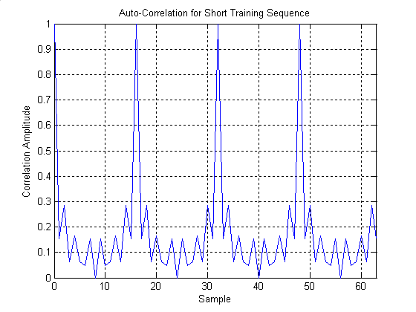
Figure 3-3: Autocorrelation function of the short training sequence

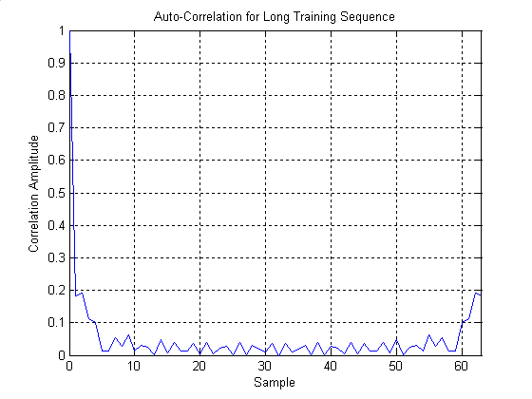
Figure 3-4: Autocorrelation function of the long training sequence
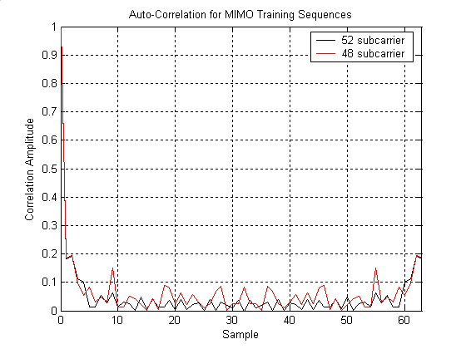
Figure 3-5: Autocorrelation function for MIMO training sequences for standard OFDM symbols
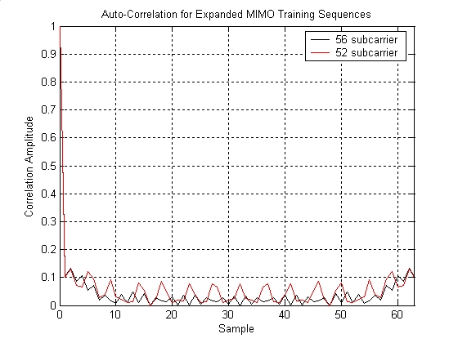
Figure 3-6: Autocorrelation function of MIMO training sequences for expanded OFDM symbols
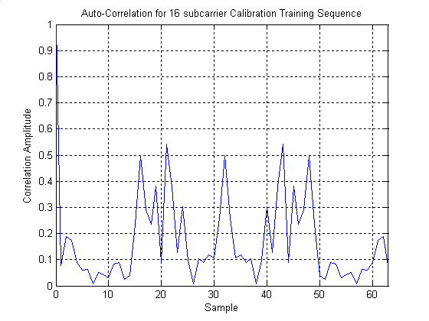
Figure 3-7: Autocorrelation function of the 16-subcarrier calibration training sequence
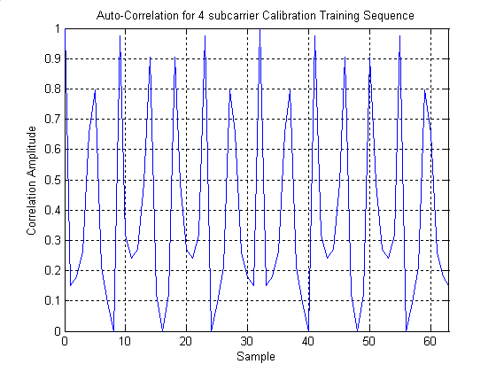
Figure 3-8: Autocorrelation function of the 4-subcarrier calibration training sequence

The six cross-correlation functions resulting from the four MIMO training sequences for the standard OFDM symbol, taken in pairs, are shown in Figure 3-9. The six cross-correlation functions resulting from the four MIMO training sequences for the expanded OFDM symbol, taken in pairs, are shown in Figure 3-10.
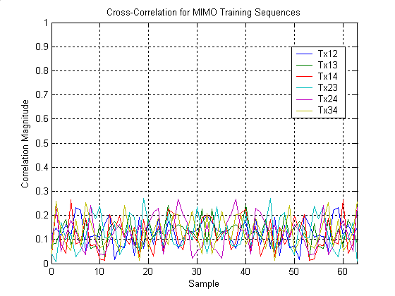
Figure 3-9: Cross-correlation functions of MIMO training sequences for standard OFDM symbols
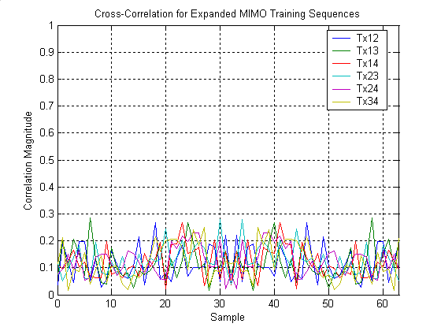
Figure 3-10: Cross-correlation functions of MIMO training sequences for expanded OFDM symbols

CC51.5: Channelization. (Mandatory)

Requirement: Specify the channelization – i.e. the adjacent channel spacing. Minimum channel spacing for all operational modes.

Compliance:

All operational modes proposed operate in a 20 MHz channelization with the same 20 MHz channel spacing used in 802.11a, b, g.

CC52: Spectral Mask (Mandatory)

Requirement: Define the transmit spectral mask requirements for each channelization of the proposal. This must be under the same PA backoff used for performance simulations.

For each channelization: graph of spectral output (dBm) vs. frequency offset from center frequency (MHz).

Compliance:

The proposed spectral mask is unchanged from the spectral mask given in 802.11a, shown here in Figure 3-11.

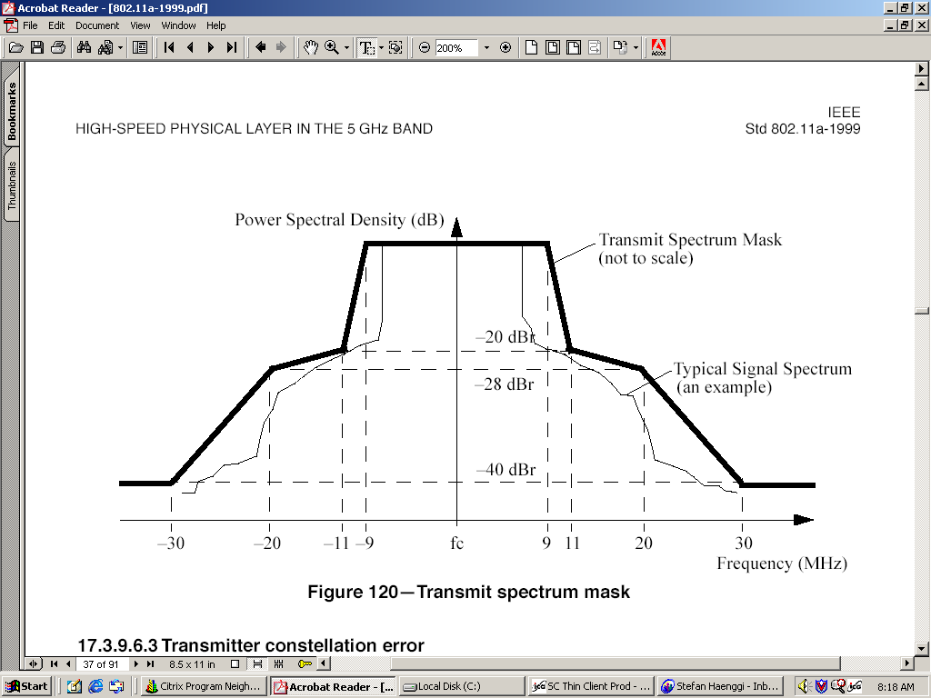
Figure 3-11: 802.11a spectral mask
Figure 3-12 shows the power spectral density, averaged over four transmit antennas, of a simulated MIMO OFDM waveform in a data frame that includes the PLCP preamble, SIGNAL fields, and a 1000 byte data burst transmitted over four spatial channels using eigenvector steering. Rates used are rate 7/8 coded 256 QAM (7 bits per symbol) on two spatial channels rate ¾ coded 256 QAM (6 bits per symbol) on one spatial channel, and rate ¾ coded 16 QAM (3 bits per symbol) on one spatial channel, resulting in an overall data rate during the data portion of 276 Mbits/sec.
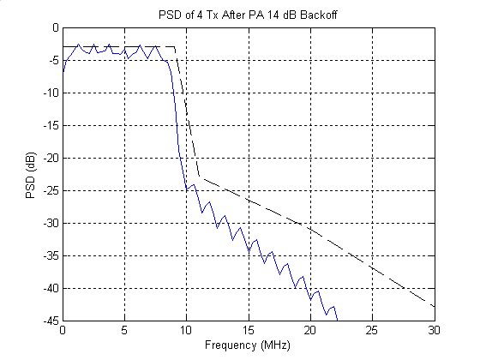
Figure 3-12: PSD of MIMO OFDM waveform with 52 data subcarriers and four spatial channels using eigenvector steering, with 802.11a spectral mask.

CC58: HT Spectral Efficiency (Mandatory)

Requirement: The number of bps/Hz during the PSDU carrying a Data MPDU when demonstrating a goodput value of at least 100Mbps. Specify the phy data rate used during this test.

Using simulation scenario 16 defined in [3]. IM1,5,6.

Compliance:

At 100 Mbps MAC Goodput, the spectral efficiency is ~5.9 bps/Hz.

Table 3-18 Spectral Efficiency at 100 Mbps MAC Goodput

This corresponds to a MAC Efficiency of 0.85 for this case of a single AP-STA link.

CC59: AWGN PER performance (Mandatory)

Requirement: Identify the performance in an idealized channel for a PSDU length of 1000B. The rows or columns of the channel shall be orthogonal to each other as follows: take the first Nr x Nt elements of the Fourier matrix with dimension max(Nr,Nt). Show PER versus SNR curves for 5 supported data rates representative of the proposal's rate set, including the maximum and minimum rates. If the proposal supports fewer than 5 data rates, all supported data rates should be shown.

Averaging should occur over a minimum of 100 packet errors down to 1% PER

Refer to [7] for a definition of the Fourier matrix.

Note: SNR is defined in section 2.

No simulation scenarios, no impairments.

Simulations should be conducted using perfect synchronization and perfect channel estimation

For proposals which have any mode generating 2 or more independent streams, show 4 graphs for the values Nr=Nt from 1 to 4.
For proposals that do not have any mode generating 2 or more independent streams, show a single graph for Nr=Nt=1.

For each graph:
Plot a curve of log PER vs. SNR (dB) for each of 5 supported data rates on the same axes.

Compliance:

The performance in AWGN with perfect synchronization and channel estimation, and with PSDUs of length 1000 B has been simulated with the following system configurations: Nr×Nt = 1×1, 2×2, 3×3, and 4×4. PER vs. SNR curves are provided for the following five representative data rates on each of the Nr spatial channels available:
- BPSK, R=1/2 (6 Mbps per stream)
- QPSK, R=3/4 (18 Mbps per stream)
- 16-QAM, R=3/4 (36 Mbps per stream)
- 64-QAM, R=3/4 (54 Mbps per stream)
- 256-QAM, R=7/8 (84 Mbps per stream)
The first rate represents the system’s minimum rate and the last rate represents the maximum rate. The data rates are fixed, i.e., adaptive rate control is not active, and each spatial stream j (j=1,2,…,min{Nt,Nr}) is assigned the same rate. 100 packet errors were collected for each SNR point in order to determine the average PER.

Figure 3-13 shows the AWGN performance for the 4×4 configuration in Eigenvector Steering mode. AWGN performance in Eigenvector Steering for the other three configurations is discussed in Section 5.1.1 of the simulation methodology and results document [4].

Additionally, PER vs SNR curves are provided for the expanded OFDM symbol, which has 52 data subcarriers, with the short guard interval. The following five representative data rates are used:
- BPSK, R=1/2 (7.22 Mbps per stream)
- QPSK, R=3/4 (21.67 Mbps per stream)
- 16-QAM, R=3/4 (43.33 Mbps per stream)
- 64-QAM, R=3/4 (65 Mbps per stream)
- 256-QAM, R=7/8 (101.11 Mbps per stream)

Figure 3-14 shows the AWGN performance for the 4×4 configuration in Eigenvector Steering mode with short guard interval and the expanded OFDM symbol with 52 data subcarriers. AWGN performance in Eigenvector Steering for the other three configurations is discussed in Section 5.3.1 of the simulation methodology and results document [4].

AWGN performance in spatial spreading is discussed for all four configurations in Section 5.2.1 of the simulation methodology and results document [4].

Figure 3-13: AWGN performance for 4×4 Eigenvector Steering mode

Figure 3-14: AWGN performance for 4×4 Eigenvector Steering mode, short guard interval, 52 subcarriers

CC67: PER performance in non AWGN channels (Mandatory)

Requirement: Show either or both of the following two sets of performance curves:

1.) Show the PER curves for 5 supported data rates representative of your rate set including your maximum and minimum rates. If the proposal supports fewer than 5 data rates, all supported data rates should be shown. Plot PER versus SNR averaged over time per receive antennas for PSDUs of length 1000B. Averaging should occur over a minimum of 100 MPDU errors down to 1% PER. Each packet should use an independent channel realization.

2.) Show curves for both achieved average physical layer data throughput and PER, as a function of total SNR for 1000B PSDUs. These results should be generated with a rate selection algorithm active. Data throughput is defined as the total number of bits successfully received in the data portion of the PPDU, divided by total transmission time, not including overheads such as preamble and backoff. The throughput shall be averaged over at least 100 independent realizations of the channel, each realization long enough to allow simulation of rate adaptation with subsequent transmission of one or more PPDUs while the Doppler process evolves. The same number of PPDUs shall be simulated for each channel realization. In addition a minimum number of PPDUs, equal to 100 divided by the target FER, shall be simulated to determine throughput.

No simulation scenarios. Impairments IM1-IM6.

For each of channel models B, D and F:

Plot a curve of log PER vs. SNR (dB) for each of 5 supported data rates.

Additionally, for channel model D:
Plot a curve of log PER vs. SNR (dB) for the highest supported data rate incorporating the Fluorescent effect on the same graph as the other curve for channel model D.

Compliance:

The performance achieved in fading channels B, D, and E, and with PSDUs of length 1000 B has been simulated for a variety of system configurations, and with the full set of impairment models applied. Two sets of performance results are presented below: 1) average PER vs SNR performance achieved for a set of fixed data rates representative of the multitude of data rates that the system is capable of, and 2) average physical layer throughput and associated average packet error rate vs total receive SNR achieved with adaptive rate selection. Both uplink and downlink results are provided, and the results also include distributions of throughput and packet error rates. A detailed description of the simulation methodology and a complete set of physical layer simulation results can be found in Section 4 of [4]. A brief summary and selected results are given below.

Basic system configurations simulated:
- 2×2, 4×4, and 4×2 Eigenvector Steering mode
- 2×2, 4×4, and 4×2 Spatial Spreading mode
- 2×2, 4×4, and 4×2 Eigenvector Steering mode, shortened guard interval, and 52 data subcarriers

Additional system configurations simulated:
- 2×2 Spatial Spreading mode, shortened guard interval, and 52 data subcarriers
- 4×2 Spatial Spreading mode without cyclic transmit diversity

PER vs SNR

These results are obtained by simulating the transmission of a single packet per channel realization and collecting a minimum of 100 packet errors. Each channel realization spans 6 ms (4 ms for the Spatial Spreading mode) in order to allow realistic simulation of rate adaptation prior to the transmission of the data carrying packet while the channel Doppler process evolves.

Figure 3-15 shows PER vs SNR results obtained with a 4×4 system operating in Eigenvector Steering mode in channel B. Additional results obtained with other system configurations and channels can be found in Section 4 of the simulation methodologies and results document [4]. Results addressing the fluorescent effect can also be found in that document.

The following data rates were used for the results in Figure 3-15:
- 1 spatial stream - BPSK, R=1/2 (6 Mbps)
- 2 spatial streams - 16-QAM, R=3/4; QPSK, R=3/4 (54 Mbps)
- 3 spatial streams - 256-QAM, R=7/8; 256-QAM, R=5/8; QPSK, R=3/4 (162 Mbps)
- 4 spatial streams - 256-QAM, R=7/8; 256-QAM, R=3/4; QPSK, R=3/4; BPSK, R=1/2 (180 Mbps)
- 4 spatial streams - 256-QAM, R=7/8; 256-QAM, R=7/8; 256-QAM, R=3/4; 16-QAM, R=3/4 (276 Mbps)
- 4 spatial streams - 256-QAM, R=7/8; 256-QAM, R=7/8; 256-QAM, R=7/8; 256-QAM, R=7/8; (336 Mbps)

Figure 3-15: Performance in channel model B, 4×4, Eigenvector Steering, fixed rates

Average throughput vs SNR

These results are obtained by simulating the transmission of 400 packets per channel realization (random data, random noise processes), and averaging the data rates achieved over 100 independent channel realizations. Each channel realization spans 6 ms (4 ms for the Spatial Spreading mode) in order to allow realistic simulation of rate adaptation prior to the transmission of the data carrying packet while the channel Doppler process evolves. Average throughput and PER, as well as distributions of throughput and PER for a given SNR are then calculated.

Shown below in Figure 3-16 - Figure 3-19 are a set of simulation results obtained with the Eigenvector Steering mode of operation in channel B. Figure 3-16 and Figure 3-17 show results with 2×2 and 4×4 system configurations and the standard 802.11a/g OFDM symbol. Figure 3-18 and Figure 3-19 show results with 2×2 and 4×4 system configurations and the shortened guard interval OFDM symbol (with 52 data subcarriers).

Figure 3-16: Throughput and Average PER vs SNR for channel model B, 2×2, Eigenvector Steering
Figure 3-17: Throughput and Average PER vs SNR for channel model B, 4×4, Eigenvector Steering
Figure 3-18: Throughput and Average PER vs SNR for channel model B, 2×2, Eigenvector Steering, SGI-52
Figure 3-19: Throughput and Average PER vs SNR for channel model B, 4×4, Eigenvector Steering, SGI-52

CC67.2: Offset Compensation (Mandatory)

Requirement: Provide the impact on PER of carrier frequency offset and symbol clock offset by comparing to the PER achieved at the lowest average SNR that achieves a 10% PER for PSDUs of length 1000 bytes in channel E (NLOS) with no carrier and symbol clock offset. The symbol clock shall have the same relative frequency offset as the carrier frequency offset.

Also, provide that same impact on PER using an SNR of 50dB in channel E (LOS).
The carrier offset difference at the receiver relative to the transmitter shall be -40ppm and +40ppm.

The results shall be presented in such a manner that it is clear whether there are specific values of offset for which the proposed system has better or worse performance relative to no offset.

Simulations shall be performed under the same conditions as those in CC 59 & 67.

No simulation scenarios. IM1- IM5.

Compliance:

Complete results for this Comparison Criterion are given in Section 4 of the simulation methodologies and results document [4]. Here we provide a subset of those results for a 2×2 system and a 4×4 system using the Eigenvector Steering mode of operation.

Impact of carrier frequency and symbol clock offset on PER at low SNR, channel E:

Figure 3-20 illustrates the impact of carrier frequency and symbol clock offsets on the PER for a 2×2 system and a 4×4 system in channel E. With no carrier frequency or symbol clock offsets, the lowest average SNR at which a 10% PER is achieved is approximately 2 dB for the 4x4 system and approximately 6 dB for the 2x2 system. Both are achieved with the lowest data rate (rate #0, BPSK, R=1/2 – 6 Mbps). There is very little difference in performance when operating with +/- 40 PPM carrier frequency and symbol clock offsets at the same SNRs.

Figure 3-20: Impact of carrier frequency and symbol clock offset for 2×2 and 4×4, Eigenvector Steering, channel model E

Impact of carrier frequency and symbol clock offset on PER at SNR=50 dB, channel E (LOS):

Table 3-19 shows the impact of carrier frequency and symbol clock offsets on the PER for a 2×2 system and a 4×4 system, respectively, operating at an SNR of 50 dB in channel E (LOS). The following data rates, which are typical of operation at this SNR, are used:
- 2×2: two active spatial streams with rates #11 and 5 (102 Mbps)
- 4×4: four active spatial streams with rates # 12, 12, 8, 3 (234 Mbps)
The table shows the PER performance achieved with 0 PPM and +/-40 PPM carrier frequency and symbol clock offsets. The differences between the three cases are insignificant.

 | Data rate | 0 PPM | + 40 PPM | - 40 PPM
2×2 | 102 Mbps | 1.80e-2 | 1.00e-2 | 2.10e-2
4×4 | 234 Mbps | 1.44e-1 | 1.13e-1 | 1.34e-1
Table 3-19: Impact of carrier frequency and symbol clock offsets in channel E (LOS) at 50 dB

CC80: Required changes to 802.11 PHY (Mandatory)

Requirement: Give a summary description of changes to a legacy 802.11 PHY. Give references to sections in your specification that give the complete details.

Compliance:

This proposal specifies the MAC and PHY entity for multiple-input multiple-output (MIMO) orthogonal frequency division multiplexing (OFDM) system. The MIMO OFDM system provides a wireless LAN with data payload communication capabilities, on each of up to four spatial channels, of 6,9,12,18,24,30,36,42,48,54,60,72 and 84 Mbit/s using a 52 subcarrier OFDM system similar to the legacy 802.11 system, and data rates of 7.22, 10.83, 14.44, 21.67, 28.89, 36.11, 43.33, 50.56, 57.78, 65, 72.22, 86.67 and 101.11 Mbit/s using a 56 subcarrier OFDM system that uses Expanded OFDM symbols. The subcarriers in the system are modulated using binary or quaternary phase shift keying (BPSK/QPSK), 16-quadrature amplitude modulation (QAM), 64-QAM or 256-QAM. MIMO OFDM communication uses spatial processing. The two spatial processing modes are eigenvector steering (ES) and spatial spreading (SS). Forward error correction coding (convolutional coding) is used with coding rates 1/2, 2/3, 3/4, 5/6, 5/8, 7/8 and 7/12.

The following sections give a summary description of the changes that have to be made to a legacy 802.11 (OFDM) PHY to accommodate MIMO OFDM high throughput operation.

- MIMO OFDM Communication: The system described in this proposal uses multiple-input, multiple-output (MIMO) communication, in which the transmitter and the receiver may be equipped with multiple antennas to support multiple spatial streams. In this proposal, each transmitting and receiving entity is equipped with up to four antennas. Higher throughputs are achieved by using spatial processing techniques. Refer to sections 1.2 and 1.3 of [3] for details.

- Short Guard Interval OFDM symbol: In order to reduce physical layer overhead, the proposed 802.11n system introduces an optional Short GI (SGI) OFDM symbol. The SGI symbol is 3.6 µs in duration and is extended with a 0.4µs guard interval. Refer to sections 1.3.1.7 and 2.2.15.6 of [3].

- Expanded OFDM symbols: To reduce physical layer overhead in a legacy OFDM symbol an Expanded OFDM symbol is introduced, by increasing the number of data subcarriers from 48 to 52. Refer to sections 1.3.1.7, 2.2.15.5, 3.1.2 of [3].

- Changes to OFDM PLCP sublayer

  - PLCP frame format: The PLCP header is extended and new fields are introduced to accommodate the MIMO OFDM parameters. The SIGNAL field in the legacy 802.11 OFDM PHY is extended and fields in the extended SIGNAL are denoted as SIGNAL1, SIGNAL2. The SIGNAL1 field is one OFDM symbol in length and is similar to the SIGNAL field in the legacy 802.11 OFDM PHY for backwards compatibility. The SIGNAL2 field may contain 1, 2 or 4 OFDM symbols depending on the frame type and is used to convey MIMO OFDM parameters. Refer to sections 2.3.1, 2.3.2, 2.3.3, 2.3.4, 2.3.5, 2.3.6 and 2.3.7 of [3] for details.

  - PPDU encoding process: The PPDU encoding process follows similar steps as of legacy 802.11 OFDM PHY, with additional spatial processing steps required for MIMO OFDM communication. Refer to sections 3.2.1.1, 3.3, 3.4 and 3.5 of [3] for details.

  - Spatial Processing: Spatial processing is essential in MIMO OFDM communication. The proposal supports two types of spatial processing modes to achieve higher data rates: steered spatial multiplexing, in which the transmitter has full channel characterization and performs eigenvector steering (ES), and unsteered spatial processing, in which the transmitter has partial channel characterization (e.g. SNR per spatial channel). Refer to sections 1.2.2, 1.3.1, 1.3.1.4 of [3].

  - Rate dependent parameters: New data rates and rate dependent parameters are required to enable MIMO OFDM transmission and to achieve higher throughput. Refer to sections 3.2.1.2 and Table 3-1 of [3] for details.

  - Timing Related Parameters: The SIGNAL field in a legacy 802.11 OFDM PHY is extended and will contain two fields SIGNAL1 and SIGNAL2 depending on the type of the frame. Timing related parameters are changed to reflect this change in the SIGNAL field. Refer to sections 3.2.1.3 and Table 3-2 of [3] for further details.

- Changes to the PLCP preamble
The PLCP preamble defined for the legacy 802.11 OFDM PHY is modified to enable MIMO OFDM transmission. Refer to section 3.2.2 of [3] for details. Refer to the response to CC42 (section 3.1.21 of this document) for details about the properties of the proposed preambles
- SIGNAL field: The legacy 802.11 OFDM PHY SIGNAL field is extended to support the MIMO OFDM parameters. The extended SIGNAL field contains two fields: SIGNAL1, which is one OFDM symbol in length, and SIGNAL2, which may be 1, 2, or 4 OFDM symbols in length. The contents of the SIGNAL1, and SIGNAL2 fields, and the number of OFDM symbols in the SIGNAL2 field depend on the type of MIMO OFDM frame being transmitted. The encoding procedure, which includes convolutional encoding, interleaving, subcarrier modulation mapping, spatial spreading transmission mode processing, pilot insertion, and OFDM modulation, follows the steps described in 3.2.5.4.2, 3.2.5.4.4, 3.2.5.4.5, 3.2.4.6.2, 3.2.4.7.2, 3.2.4.8 and 3.2.5.4.9 of [3], as used for transmission of a single stream of data at the 6 Mbit/s rate. Refer to sections 1.3.5, 2.3.2.1, 2.3.2.2, 2.3.2.3, 2.3.2.4 and 2.3.2.5 of [3] for the details of the SIGNAL field, its contents, and their meaning.
  - RATE field: The RATE field is modified as a RATE/TYPE field for MIMO STAs, which indicates the type of the MIMO OFDM header that follows the RATE/TYPE field. The contents of the RATE field are further explained in section 2.3.2 and Table 2-3 of [3].
  - Data Rate Vector (DRV): The MIMO OFDM system may be equipped with up to four antennas, which allows for multiple spatial streams. The spatial streams may be transmitted at the same rate or different rates. A data rate vector field (DRV) is introduced in the PLCP SIGNAL2 field to indicate the data rate on each of the spatial streams. The DRV field is described in more detail in section 2.3.2.1 of [3].

    - Dedicated MIMO Training Sequence: A dedicated MIMO training sequence is introduced in the MIMO OFDM communication system. It follows the SIGNAL symbols and is used for channel estimation by the receiving entity. The dedicated MIMO OFDM training sequence contains MIMO OFDM training symbols or steered MIMO OFDM training symbols. The number of OFDM symbols making up the Dedicated MIMO training sequence is equal to the number of transmit antennas, , when . STAs with only one antenna do not transmit a Dedicated MIMO Training Sequence. The MIMO training sequence depends on the spatial processing mode used. Refer to section 3.2.4 of [3] for details.

    - Changes to the DATA field: An additional FEEDBACK field is introduced in the DATA field and is appended to the SERVICE field. The data field contains the SERVICE field, the FEED BACK field, the PSDU, the TAIL bits and the PAD bits.

      - FEEDBACK Field: The data rate vector feedback field (DRVF) provides feedback to the peer station regarding the sustainable rate on each of up to four spatial modes. The details of the DRVF field and its encoding are explained in section 2.3.2.1 of [3].

      - Convolutional Encoder: In addition to the legacy 802.11 OFDM code rates of 1/2, 2/3 and 3/4, new code rates 5/6, 5/8, 7/8 and 7/12 are introduced. The convolutional encoder shall use the industry standard generator polynomials, {133,171} of rate 1/2, as defined in the legacy 802.11 OFDM PHY. Higher rates are derived from it by employing puncturing. In addition to the puncturing patterns defined in legacy 802.11 OFDM PHY, new puncturing patterns are introduced. Refer to sections 3.2.5.4.3 and Table 3-4 of [3] for details.

      - Data Interleaving: Legacy OFDM symbols in each spatial stream are interleaved using the interleaver specified for legacy 802.11 OFDM PHY. A modification of the legacy interleaver is introduced for the expanded OFDM symbols with 52 data subcarriers. Refer to 3.2.5.4.4 of [3] for details.

      - Subcarrier modulation mapping: 256-QAM modulation is proposed in addition to BPSK, QPSK, 16-QAM and 64-QAM to achieve higher throughputs. The modulation dependent normalization factor, constellation bit encoding and the encoding table for 256-QAM modulation are defined and further explained in section 3.2.5.4.5, Table 3-5, Table 3-6, Table 3-7, Table 3-8, Table 3-9 and Table 3-10 of [3].

      - Pilot Subcarriers: Similar to the legacy 802.11 OFDM PHY, in each OFDM symbol, four of the subcarriers are dedicated to pilot signals. Additional spatial processing is involved in generating the pilot subcarriers for each of the spatial streams. The generation of pilot subcarriers and the associated spatial processing is detailed in section 3.2.5.4.8.2 of [3].

      - OFDM modulation: Each stream of complex numbers corresponding to the data subcarriers is divided into groups of N_{SSD} = 48 complex numbers for standard OFDM symbols, similar to legacy 802.11 OFDM PHY and N_{SSD} = 52 for extended OFDM symbols. The processing of data and pilot subcarriers of each spatial stream into OFDM symbols is explained in sections 3.2.5.4.9

References

[1] IEEE 802.11-02/798r7, Draft PAR for High Throughput Study Group
[2] IEEE 802.11-02/799r6, Criteria for Standards Development (HTSG 5 Criteria Document)
[3] IEEE 802.11-04/870r0, System Description and Operating Principles for High Throughput Enhancements to 802.11.
[4] IEEE 802.11-04/872r0, System Level and Physical Layer Simulation Methodologies and Results

