IEEE P802.11
Wireless LANs
Use EAPOL-Key frames for 11k for protected requests and reports
Date: May 10, 2004
Author: Tim Moore
Microsoft
1 Microsoft Way, Redmond, WA
Phone: 425-703-9861
Fax:
e-mail:timmoore@microsoft.com
Abstract

EAPOL-Key messages are sent by the SME and received by the SME. The information when received by the SME is inserted in one or more MIB and so is available to everyone.
Since in 802.11k the SME initiates the measurement requests, this document describes a proposal to use the EAPOL-Key frames from 802.11i to send measurement and site requests and to send measurement ans site reports. This document describes a proposal to use the EAPOL-Key for only protected frames. EAPOL-Key frames can be protected directly or via the data frame protection since EAPOL-Key frames are data frames. The EAPOL-Key frame protection is sued when setting up the securiy association since at that time no data link protection exists.

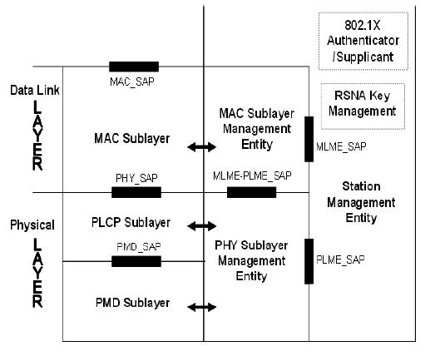
When a SME wants to request for a measurement report, it sends a measurement request using EAPOL-Key frame formats, the receiving SME uses the MLME-MEASURE primitive to make the measurements and then sends a measurement report response containing the measurements.
EAPOL-Key frames are sent and received by the the RSNA Key Management entity within the SME.

Requestor SME Requestee MAC Requestee SME
-----------------------------------------------------------------------------------------------------------------------------------------------------------→
Measurement Request
←------------------------------------
MLME-MEASURE.Request

------------------------------------→
MLME-MEASURE.Confirm
←----------------------------------------------------------------------------------------------------------------------------------------------------------
Measurement Report

Add to Table 26 (802.11i)

00-0F-AC 5 Action

Add to 8.5.2 after Figure 96 (802.11i)

The format of the Action KDE is as follows:

Category | Action | Dialog Token
1 Octet | 1 Octet | 1 Octet
Figure 97 – Action Key Data Encapsulation format

Category shall be set according to Table 19a.
Action shall be set according to Table 20f.
Dialog Token shall be as defined in clause 7.4.1.1.

Add before 3rd paragraph from end of section 8.5.2

Action Message: This is an EAPOL-Key frame with the Key Type subfield set to 0. The Key Data field shall contain an Action KDE and any IEs as specified in clause 7.4.2. The KDEs and IEs sent for this message do not need the KeyData field to be encrypted. The EAPOL-Key frame may or may not be MICed.

