IEEE P802.11
Wireless LANs
Use EAPOL-Key frames for 11k
Date: May 10, 2004
Author: Tim Moore
Microsoft
1 Microsoft Way, Redmond, WA
Phone: 425-703-9861
Fax:
e-mail:timmoore@microsoft.com
Abstract

EAPOL-Key frames are sent by the SME and received by the SME. The information when received by the SME is inserted in one or more MIB and so is available to everyone.
Since in 802.11k the SME initiates the measurement requests, this document describes a proposal to use the EAPOL-Key frames from 802.11i to send measurement and site requests and to send measurement ans site reports. This document describes a proposal to use the EAPOL-Key for both protected and unprotected frames. EAPOL-Key frames can be protected directly or via the data frame protection since EAPOL-Key frames are data frames. The EAPOL-Key frame protection is sued when setting up the securiy association since at that time no data link protection exists.
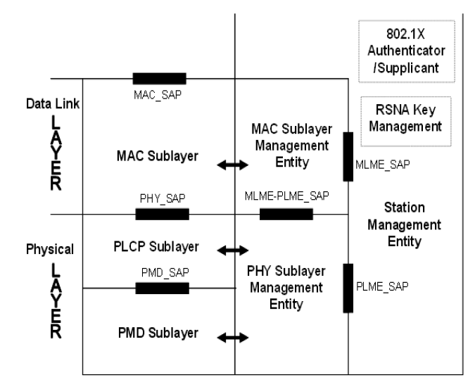
When a SME wants to request for a measurement report, it sends a measurement request using EAPOL-Key frame formats, the receiving SME uses the MLME-MEASURE primitive to make the measurements and then sends a measurement report response containing the measurements.
EAPOL-Key frames are sent and received by the the RSNA Key Management entity within the SME.

Requestor SME Requestee MAC Requestee SME
-----------------------------------------------------------------------------------------------------------------------------------------------------------→
Measurement Request
←------------------------------------
MLME-MEASURE.Request

------------------------------------→
MLME-MEASURE.Confirm
←----------------------------------------------------------------------------------------------------------------------------------------------------------
Measurement Report

Delete section 5.7.8, 5.7.9 from 11k

Delete section 7.4.2 from 11k

Add to Table 26 (802.11i)

00-0F-AC 5 Action

Add to 8.5.2 after Figure 96 (802.11i)

The format of the Action KDE is as follows:

Category | Action | Dialog Token
1 Octet | 1 Octet | 1 Octet
Figure 97 – Action Key Data Encapsulation format

Category shall be set according to Table 19a.
Action shall be set according to Table 20f.
Dialog Token shall be as defined in clause 7.4.1.1.

Add before 3rd paragraph from end of section 8.5.2 (11i)

Action Frame: This is an EAPOL-Key frame with the Key Type subfield set to 0. The Key Data field shall contain an Action KDE and any IEs as specified in clause 8.5.5.4. The KDEs and IEs sent for this frame do not need the KeyData field to be encrypted. The EAPOL-Key frame may or may not be MICed.

Add section 8.5.5.4 (11k)

8.5.5.4 Action Frame
Several Action frames are defined for Radio Measurement purposes. The Category field is set to the value from Table 19a. An Action field, in the octet field immediately after the Category field, differentiates the five formats. The Action field values associated with each frame format is defined in Table 20f.
Table 20f—Radio Measurement Action field values
Action field value | Description
0 | Measurement Request
1 | Measurement Report
2 | Reserved
3 | Reserved
4 | Site Report Request
5 | Site Report Response
6-255 | Reserved

8.5.5.4.1 Measurement Request frame format
The Measurement Request frame uses the EAPOL-Key frame format and is transmitted by a STA requesting another STA to measure one or more channels. The format of the frame shall be:
Descriptor Type = N – See Clause 8.5.2
Key Information.
Version Number = 1 (RC4 encryption with HMAC-MD5) or 2 (NIST AES key wrap with HMAC-SHA1-128), See Clause 8.5.2.
Key Type = 0 (Group)
Install = 0
Key Ack = 0
Key MIC = 0/1 – MIC is optional for this frame
Secure = 0/1 - set to 1 if a security association exists between the 2 STAs, set to 0 if no security association exists between the 2 STAs.
Error = 0
Request = 0 / 1 - 0 if frame is sent from AP STA, 1 if frame is sent from a non-AP STA.
Encrypted Key Data = 0 / 1 – Encryption is optional for this frame
Reserved = 0
Key Length = 0
Key Replay Counter = n – Current Replay Counter
Key Nonce = 0
Key IV = 0 (Version 2) or random (Version 1, if KeyData is encrypted)
Key RSC = 0
Key MIC = 0 / MIC(KCK, EAPOL) – if MIC protection is used
Key Data Length = Length of Key Data, including encryption if used
Key Data = optionally encrypted, Action KDE, one or more Measurement Request IEs
The Category field in Action KDE shall be set to indicate the Radio Measurement category according to Table 19a.
The Action field in Action KDE shall be set to indicate a Measurement Request according to Table 20f.
The Dialog Token in Action KDE and Measurement Request Information Elements shall be as defined in clause 7.4.1.1. The number and length of Measurement Request Elements in a Measurement Request frame is limited by the maximum allowed size of the KeyData field.

8.5.5.4.2 Measurement Report frame format
The Measurement Report frame uses the EAPOL-Key frame format and is transmitted by a STA in response to a Measurement Request frame or by a STA autonomously providing measurement information. The format of the frame shall be:
Descriptor Type = N – See Clause 8.5.2
Key Information.
Version Number = 1 (RC4 encryption with HMAC-MD5) or 2 (NIST AES key wrap with HMAC-SHA1-128), See Clause 8.5.2.
Key Type = 0 (Group)
Install = 0
Key Ack = 0
Key MIC = 0/1 – MIC is optional for this frame
Secure = 0/1 - set to 1 if a security association exists between the 2 STAs, set to 0 if no security association exists between the 2 STAs.
Error = 0
Request = 0 / 1 - 0 if frame is sent from AP STA, 1 if frame is sent from a non-AP STA.
Encrypted Key Data = 0 / 1 – Encryption is optional for this frame
Reserved = 0
Key Length = 0
Key Replay Counter = n – Current Replay Counter
Key Nonce = 0
Key IV = 0 (Version 2) or random (Version 1, if KeyData is encrypted)
Key RSC = 0
Key MIC = 0 / MIC(KCK, EAPOL) – if MIC protection is used
Key Data Length = Length of Key Data, including encryption if used
Key Data = optionally encrypted, Action KDE, one or more Measurement Request IEs
The Category field in the Action KDE shall be set to indicate the Radio Measurement category according to Table 19a.
The Action field in the Action KDE shall be set to indicate a Measurement Report according to Table 20f.
The Dialog Token in the Action KDE and Measurement Request Elements fields shall be as defined in clause 7.4.1.2. The number and length of Measurement Request Elements in a Measurement Request frame is limited by the maximum allowed size of the KeyData field.

8.5.5.4.3 Site Report Request frame format
The Site Report Request frame uses the EAPOL-Key frame format and is transmitted by a STA requesting the information in the Site Report about neighboring AP’s. The format of the Site Report Request frame shall be:
Descriptor Type = N – See Clause 8.5.2
Key Information.
Version Number = 1 (RC4 encryption with HMAC-MD5) or 2 (NIST AES key wrap with HMAC-SHA1-128), See Clause 8.5.2.
Key Type = 0 (Group)
Install = 0
Key Ack = 0
Key MIC = 0/1 – MIC is optional for this frame
Secure = 0/1 - set to 1 if a security association exists between the 2 STAs, set to 0 if no security association exists between the 2 STAs.
Error = 0
Request = 0 / 1 - 0 if frame is sent from AP STA, 1 if frame is sent from a non-AP STA.
Encrypted Key Data = 0 / 1 – Encryption is optional for this frame
Reserved = 0
Key Length = 0
Key Replay Counter = n – Current Replay Counter
Key Nonce = 0
Key IV = 0 (Version 2) or random (Version 1, if KeyData is encrypted)
Key RSC = 0
Key MIC = 0 / MIC(KCK, EAPOL) – if MIC protection is used
Key Data Length = Length of Key Data, including encryption if used
Key Data = optionally encrypted, one Action KDE, one SSID IE
The Category field in the Action KDE shall be set to the value indicating the Radio Measurement category, as specified in Table 19a in 7.3.11.
The Action field in the Action KDE shall be set to the value indicating Site Report Request, as specified in Table 20f in 8.5.5.4.
The Dialog Token field in the Action KDE shall be set to a non-zero value chosen by the STA sending the site report request to identify the request/report transaction.
The STA specifies the ESS for the required site report using the SSID element. If the field is omitted, the Site Report Response will contain the Site Report element for the current SSID the STA is associated with. If the SSID is present in the Site Report Request, the Site Report Response will contain the Site Report for the SSID requested.

8.5.5.4.4 Site Report Response frame format
The Site Report Response frame uses the EAPOL-Key frame format and is transmitted by a STA in response to a Site Report Request frame or by a STA autonomously providing Site Report information. The format of the Site Report Response frame shall be:
Descriptor Type = N – See Clause 8.5.2
Key Information.
Version Number = 1 (RC4 encryption with HMAC-MD5) or 2 (NIST AES key wrap with HMAC-SHA1-128), See Clause 8.5.2.
Key Type = 0 (Group)
Install = 0
Key Ack = 0
Key MIC = 0/1 – MIC is optional for this frame
Secure = 0/1 - set to 1 if a security association exists between the 2 STAs, set to 0 if no security association exists between the 2 STAs.
Error = 0
Request = 0 / 1 - 0 if frame is sent from AP STA, 1 if frame is sent from a non-AP STA.
Encrypted Key Data = 0 / 1 – Encryption is optional for this frame
Reserved = 0
Key Length = 0
Key Replay Counter = n – Current Replay Counter
Key Nonce = 0
Key IV = 0 (Version 2) or random (Version 1, if KeyData is encrypted)
Key RSC = 0
Key MIC = 0 / MIC(KCK, EAPOL) – if MIC protection is used
Key Data Length = Length of Key Data, including encryption if used
Key Data = optionally encrypted, Action KDE, zero or more Site Report IEs
The Category field in the Action KDE shall be set to the value indicating the Radio Measurement category, as specified in Table 19a in 7.3.1.11.
The Action field in the Action KDE shall be set to the value indicating Site Report Response, as specified in Table 20f in 8.5.5.4.
The Dialog Token field in the Action KDE shall be set to the value in any corresponding Site Report Request frame. If the Site Report Response frame is not being transmitted in response to a Site Report Request frame then the Dialog token shall be set equal to zero.

The Site Report Elements field shall contain the Site Report elements described in 7.3.2.26. If the STA has no information in response to the Site Report Request, the Site Report element will be omitted.

Delete section 10.3.12, 10.3.14 (11k)

