IEEE P802.11
Wireless LANs
1 Message Attack on the 4-Way Handshake
Date: May 2004
Author ChangHua He
Stanford University
changhua@stanford.edu
John C. Mitchell
Stanford University
mitchell@cs.stanford.edu

Abstract
This submission describes a denial-of-service attack against the IEEE 802.11i 4-Way Handshake. The attack involves forging initial messages from the authenticator to the supplicant. We consider two repairs, one introducing a queue to allow the supplicant to proceed with several instances of the handshake, and the other adding authentication to the initial message. Based on several considerations, the second repair appears preferable.

Introduction
IEEE 802.11i standard [1] defines a Robust Security Network Association (RSNA) to provide better authentication and confidentiality than WEP [2] in wireless networks, based on IEEE 802.1x [3] authentication architectures. The entities involved in the authentication process are called the Supplicant, Authenticator and Authentication Server. Generally successful authentication means the supplicant and authenticator verify each other’s identity and generate some shared secret for subsequent secure data transmissions. The authentication server can be implemented either in a single device with the authenticator residing in the Access Point (AP), or using a separate server, assuming the link between the authentication server and the authenticator is physically secure.
The typical process to establish a RSNA consists of handshakes between the supplicant and the authenticator (security capability discovery and 802.1x conversations), between the authenticator and the authentication server (RADIUS [4] de facto), between the supplicant and the authentication server (EAP-TLS [5] de facto, the authenticator serves as a relay). After these handshakes the supplicant and the server have authenticated each other and shared some secret, from which a Pair-wise Master Key (PMK) is derived in the supplicant side, and AAA key materials are generated in the server side and moved to the authenticator securely to generate the same PMK. The PMK shared by any pair of authenticator and supplicant is never transmitted over a vulnerable network, It is also possible for the supplicant and the authenticator can to configure a static Pre-Shared Key (PSK) for the PMK without above handshakes, according to manual or hard-coded configurations.
Whether the PMK is generated from handshakes or from a PSK, a 4-way handshake protocol must be executed subsequently for successful authentication. This key management protocol, following the establishment of PMK, confirms the existence of the PMK and the selection of cipher suites, generate a fresh Pair-wise Transient Key (PTK) for each session, synchronizes the installation of PTKs into the MAC, and transfers the Group Transient Key (GTK) from the authenticator to the supplicants in case of multicast applications.
With correct execution of the 4-way handshake protocol, each pair of supplicant and authenticator is supposed to have only one on-going protocol instance and share one valid PTK for the data transmission or GTK delivery in the following session. However, in order to proceed with the protocol in the event of packet loss or intrusion, the supplicant must allow multiple protocol instances to execute in parallel. The intruder can interfere with the handshakes very easily by flooding message 1. This causes more severe vulnerabilities than expected. This report addresses the problem in some detail and proposes several possible solutions.
The report is organized as follows: section 2 describes the idealized 4-way handshake protocol, section 3 analyzes the influence of packet loss, and discusses the implementation inadequacy proposed in the standard, section 4 proposes and analyzes several possible solutions to the problem, and finally section 5 concludes our findings. The analysis summarized in this report was carried out in part with the use of an automated protocol verification tool.

4-way handshakes
After PMKs are agreed upon by the supplicant and authenticator, the authenticator initializes a 4-way handshake protocol by itself or upon the request from the supplicant. The purpose of this handshake is to confirm the possession of the PMK and derive a fresh PTK for the following session. At the same time, the authenticator makes decisions about the cipher suites with the supplicant and delivers the encrypted GTK to the supplicants if necessary.
Abstracting from the detailed message formats, we write the idealized protocol as shown in Figure 1.

Message 1 (A->S):
AA, ANonce, Sequence(n), msg1
Message 2 (S->A):
SPA, SNonce, Sequence(n), msg2, MIC_{PTK}{SNonce, Sequence(n), msg2}
Message 3 (A->S):
AA, ANonce, Sequence(n+1), msg3, MIC_{PTK}(ANonce, Sequence(n+1), msg3}
Message 4 (S->A):
SPA, Sequence(n+1), msg4, MIC_{PTK}{Sequence(n+1), msg4}

Figure 1. 4-way handshake protocols
In Figure 1, S represents the Supplicant and A represents the Authenticator; SPA and AA, SNonce and ANonce represent the MAC address and nonces of the supplicant and authenticator, respectively; msg1, 2, 3, 4 are indicators of different message type; PTK is calculated from PRF-X(PMK, "Pairwise key expansion", AA||SPA||ANonce||SNonce) and divided into KCK (Key Confirmation Key), KEK (Key Encryption Key) and TK (Temporary Key); MIC_{PTK}{…} represents the MIC (Message Integrity Code) calculated for the content {…} with the PTK. Note that actually MIC is calculated with KCK, which is only part of PTK, however, we won't distinguish them here because there are no confusions for the authentication process. Also note that in the original protocols, RSN IE fields are included in Message 2 and Message 3 to negotiate cipher suites, and encrypted GTK are sent in Message 3 in multicast applications.
The goal of this protocol is to confirm the existence of PMK in the peers and to derive a fresh PTK for the subsequent session. The authenticator can refresh the PTK periodically or upon the request from the supplicant through initializing the 4-way handshake protocol sequentially without changing PMK. However, at anytime, only one protocol instance is running, thus only one fresh PTK is valid for data communications or GTK delivery between the supplicant and the authenticator. Although this is a reasonable scenario, the supplicant must be able to run multiple protocol instances in parallel to avoid protocol blocking by packet loss, which is very general in wireless networks. The details and possible solutions are discussed in the following sections.

Sequential vs parallel
We assume that an intruder may intercept messages and possibly interfere with the delivery of messages.
It is feasible for the authenticator (initiator) to have at most one current instance of the handshake in process with each supplicant. The authenticator expects the correct response for every message sent out. It may discard an unexpected response and resend the former message or terminate the process if the expected response is not received during a given time range, say, due to packet loss.
However, the supplicant (responder) cannot use a similar strategy. More specifically, if the supplicant is configured to only participate in only one instance of the handshake, packet loss or actions of an attacker may interfere e with the protocol. The following arguments are intended to clarify this statement. Assume the supplicant discards unexpected messages in the intermediate stage of a protocol execution. Consider the case that the supplicant accepts message 1 and sends out message 2 but this message is lost. The authenticator will never get the expected response (message 2), thus it resends message 1 after some waiting time. However, the supplicant will discard this resent message 1, thus never completing the protocol. To avoid this, assume the supplicant expects both message 3 and the resent message 1, which has the same nonce as last received message 1. This will not work because the intruder can simply initialize an instance of the protocol by sending message 1 to cause the supplicant blocked for the valid message 1 from the authenticator. Therefore in the intermediate stage of a protocol instance, the supplicant must allow any message 1 to insure the protocol proceeds.
The above arguments show the supplicant must allow multiple protocol instances to run in parallel, say, accepting message 1 at any state. From the documentation of 802.11i standard, the designers seem aware of possible problems associated with message 1, and propose a solution to deal with it. However, they neglect the possibility of multiple parallel instances, which causes their solution to be incomplete and still vulnerable.

Possible attacks and defense
Because the intruder is capable of easily composing message 1, impersonating the authenticator and sending to the supplicant, there is a simple attack that causes PTK inconsistency. The intruder sends message 1 to the supplicant after the 4-way handshake has completed between the supplicant and the authenticator. The supplicant will calculate a new PTK based on the nonce in newly received message 1, causing the subsequent data transmission or GTK delivery to be blocked because this PTK is different from the one in the authenticator. The designers propose a solution to deal with this problem. The supplicant stores both a Temporary PTK (TPTK) and a PTK, and updates TPTK upon receiving message 1, updating PTK only upon receiving message 3 with valid MIC. With this solution the intruder cannot drive the supplicant to change its PTK because message 3 is infeasible to forge. However, this works only when different protocol instances (one between the supplicant and the authenticator, others are between the same supplicant and an intruder) are executed sequentially. As we discussed in Section 3, however, the supplicant must allow different instances run in parallel. When the supplicant is running an instance with the authenticator, say, sending out message 2, the intruder sends message 1 to the supplicant. This easily breaks the TPTK/PTK solution because the supplicant cannot verify the MIC in message 3 from the authenticator correctly. The intruder can know the suitable time to send out message 1 through monitoring the network traffic or just flooding message 1 frequently.
The proposed solution in the documentation uses one extra unit of storage (TPTK) and partially solves the problem when several instances are sequential. In case that more instances might be intervened, the supplicant should use more extra units of storage to store the states (nonces or derived PTKs) corresponding to each received message 1. In order to assure the protocol is non-blocking with the present authenticator, the supplicant must store all the states until it finishes the instance with the authenticator. Once the supplicant receives message 3, it tries all possible PTKs and chooses the one that verify the MIC of the message. This does not lead to a CPU exhaustion attack if hash calculations are not computationally expensive. However, a memory exhaustion attack exists because the number of message 1s can be theoretically unbounded. Though the memory exhaustion attack happens in the supplicant side, which is not as severe as if it were the server, this is still a problem because it is quite easy to forge and flood message 1.
We assume the intruder can compose Message 1 with a forged MAC address and send it to a victim easily. When the supplicant (victim) sends out Message 2 as a response to a “good” Message 1 from the authenticator, or after the supplicant has finished 802.1x authentication (EAP_SUCCESS message received) but before Message 1 is received, the intruder can send out “bad” Message 1, which easily block the protocol as we discuss before. Considering that it might be hard to catch the protocol process at a precise time slot, the intruder may just send out Message 1 periodically. This is different from a trivial network jamming or frequency jamming and it is hard for the administrator to eliminate it because the intruder sends regular messages in a regular way. The following calculations indicate why this attack is practical and how it is different from a network jamming.
Assume a basic Message 1 is sent (only PMKID included in the Key Data field of the frame) through 802.11b [6] networks. 117 bytes EAPOL-Key frame, 30 bytes MAC header, together with 4 bytes checksum are given to physical layer to transmit. Consider the short PLCP frame and 11Mbps data rate, the DSSS preamble and header are transmitted in 96 us, the data are transmitted in 110 us. Even more count in DIFS (40us), SIFS (10us) and ACK (96us + 10us), Message 1 is sent and ACKed in 362 us. Assume TimeOut is set to 100 ms for both the intervals before Message 1 and after Message 1, during these two intervals 552 Message 1 can be sent. (The number will be smaller if backoff time is considered.) Among this possible number of Message 1s, the intruder only need to have one of them to reach the supplicant and block the protocol. If the intruder sends Message 1 periodically, the period can be relatively long thus looking like regular data transmissions, instead of a noticeable network jamming. We will propose two possible approaches to fix this vulnerability. One possible fix uses a queue, and another fix adds a MIC to message 1 based on the shared PMK.

Random-Drop Queue Solution
The problem is similar to the well-studied TCP SYN flooding DoS attacks [7, 8, 9], which can be mitigated in known ways. The supplicant can keep a queue of all initiated but incomplete protocol instances. However, from above calculations, the queue size must be fairly large, and the situation becomes worse if a longer TimeOut is implemented. Thus an improvement would be to implement a queue with random-drop policy. The supplicant maintains a certain size of queue to store the states, once the queue is full one of the entries is randomly replaced by the new state. The advantage of this queue-based approach is that it keeps the protocol unchanged, and could protect against a few malicious messages. However, more calculations show that even a queue of size 10 is not going to help very much, as shown in the following Figure 2.
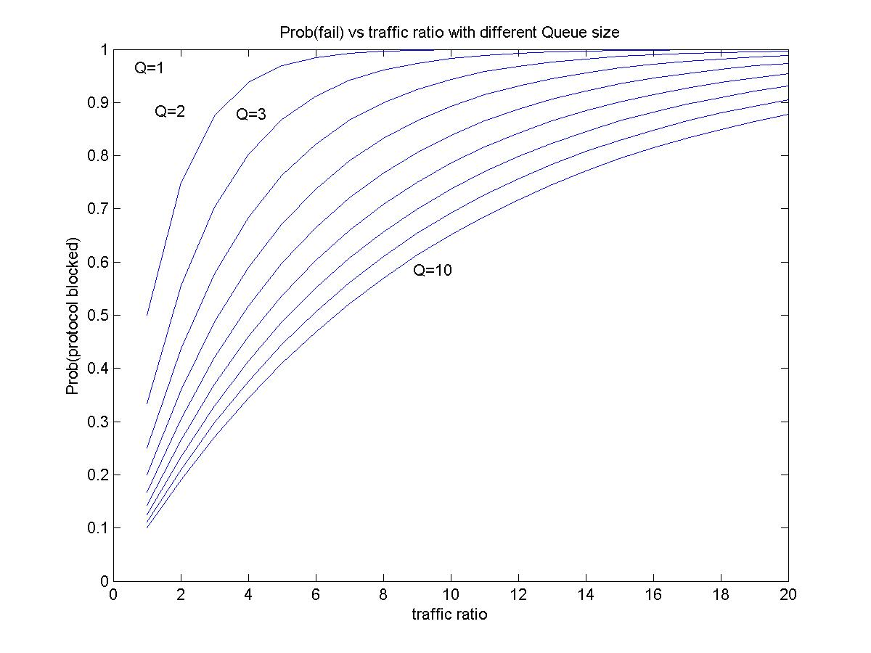
Figure 2. Effectiveness of queue solution
In Figure 2, the horizontal axis represents the number of forged Message 1, in proportion to the “good” one sent by the authenticator, and the vertical axis represents the probability that the intruder can block the protocol. When Q=1, the intruder can block the protocol with probability one under any traffic ratio. When Q increases, the intruder needs to send out more traffic in order to block the protocol with a high probability. However, even a queue size of 10 does not help much because the intruder can block the protocol with probability above 0.8 by sending out about 16 messages. That is a trivial number of messages, in comparison with the total possible number 522 of Message 1. The detailed derivation and calculation for this figure will be added to the report later.

Fix Message 1 with MIC
The other approach is to add a MIC to Message 1, which will prevent an intruder from forging Message 1. The MIC can be calculated using the existing PMK. In case that PMK is dynamically generated through the 802.1x authentication process, this may solve the problem because PMK and the Sequence Counter can assure Message 1 is authentic and not a replayed message. On the other hand, it is also possible to use a PSK as PMK, in which PMK can be static for a long term. To defend against replay in this situation, the authenticator can keep a monotonically increasing sequence counter. One global sequence counter per authenticator appears to work for all supplicants. Replays can be detected by the supplicant by comparing the count of a message received against the count of the largest-numbered previous message. The requirement that the counter must be monotonically increasing appears feasible since there are apparently 8 octets set aside for this sequence counter. In fact, there appears to be sufficient space in the message format that clock time could be used as the counter value, eliminating the possible problem of counter rollover. Because the sequence counter is also used elsewhere in the standard, we are continuing to examine the implications of this possible modification to the protocol. Additional discussion will be provided in a later version of this report.

Conclusion
802.11i 4-way handshake protocol is studied in this report. The protocol is supposed to have only one on-going instance and generate a shared PTK between a pair of supplicant and authenticator. However, after analysis we show the supplicant side must allow multiple instances to execute in parallel in order to assure the protocol completes for the present authenticator under the circumstance of packet loss and intruder existence. The proposed implementation in the current documentation appears significantly vulnerable to message 1 flooding attacks.
In order to defend against this kind of attack, the supplicant must store all the states until it finishes an instance of the handshake with the authenticator. This leads to a general memory exhaustion attack. As in TCP SYN flooding defense, we can adopt “random drop” in a certain size of queue to avoid memory exhaustion, without changing the protocol. However, our calculations suggest that the protocol remains significantly vulnerable with reasonable queue sizes. In a more significant change, a MIC calculated from the PMK can be added to Message 1 to prevent the forged messages, with a monotonically increasing sequence counter implemented in the authenticator to prevent replay attacks. The local clock time of the authenticator appears to be a simple increasing counter that would do the job and prevent the form of attack described in this report.

References
[1] IEEE Standard 802.11i/D7.0, “Draft Amendment to STANDARD FOR Telecommunications and Information Exchange Between Systems – LAN/MAN Specific Requirements”, October 2003.
[2] Nikita Borisov, Ian Goldberg and David Wagner, “Intercepting Mobile Communications: The Insecurity of 802.11”.
[3] IEEE Standard 802.1X-2001, “IEEE Standard for Local and metropolitan area networks – Port-Based Network Access Control”, June 2001.
[4] C. Rigney, S. Willens et al, “Remote Authentication Dial In User Service (RADIUS)”, RFC 2865, June 2000.
[5] B. Aboba, D. Simon, “PPP EAP TLS Authentication Protocol”, RFC 2716, Oct. 1999.
[6] IEEE Standard 802.11b-1999, “Supplement to IEEE Standard for Information technology – Telecommunications and information exchange between systems – Local and metropolitan area networks – Specific requirements – Part 11”, Sept. 1999.
[7] C. L. Schuba, I. V. Krsul and M. G. Kuhn, “Analysis of a Denial of Service Attack on TCP”, Proceedings of the 1997 IEEE Symposium on Security and Privacy.
[8] L. Ricciulli, P. Lincoln and P. Kakkar, “TCP SYN Flooding Defense”, CNDS 1999.
[9] C. Meadows, “A Formal Framework and Evaluation Method for Network Denial of Service”.

