IEEE P802.11
Wireless LANs
Managing the performance of multihop mesh networks
Date: Mar13, 2004
Author: Francis daCosta
Meshdynamics
1299 Parkmoor Ave, San Jose, CA 95126
Phone: (408) 373-7700
Fax: (408) 516-8987
e-Mail: fdacosta@meshdynamics.com
Abstract
An approach using 2 radios to achieve high performance in multihop mesh networks is introduced. The advantages of frequency re-use, reduced channel interference over 1 radio approaches is discussed. An ESS mesh built as a meshed network of Access Points (AP), each supporting a separate and distinct BSS is described. Finally the need to support both 2 radio systems - for infrastructure mesh needs - and 1 radio ad hoc mesh systems – for peer-to-peer connectivity needs is described in the context of emergency response systems.

The Challenges of Mission Critical Multihop Mesh Networks
There is increasing interest in employing one network to support video, voice and data traffic. Currently, the video, voice and data networks are distinct since each addresses differing latency and bandwidth requirements. The challenge lies in providing - within the same network - the ability to address potentially conflicting latency and throughput needs of diverse applications.
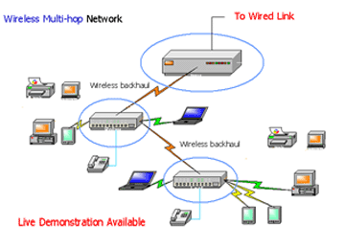
Fig. 1: A two radio wireless-wireless network

For example, voice needs to be transmitted with low delay (latency). Occasional lost voice packets, while undesirable, are not fatal for voice transmissions. Conversely, data transmissions mandate delivery of all packets and while low latency is desirable it is not essential. In essence, transmission across the wireless network should ideally be driven by the needs of the application. The table below lists some types of applications and their latency requirements.

Application | Latency Requirements
Email, etc. | No constraints on delivery time ("elastic")
Streaming | Data is jitter-sensitive, but requirements flexible in terms of delays
Web surfing | Delays noticeable but not adversely affecting usability or functionality
Voice/Video | Time-sensitive: delays adversely affect usability
Mission critical | Data delivery delays disables functionality (e.g. Emergency Response Systems)

Building a reliable wireless network comes with other constraints specific to the wireless medium. Some routing paths may be best for voice, others for data. In a wired LAN, separating applications by routing paths is more easily accomplished since each port on the LAN is connected to one client machine. Each node may be configured to provide the performance characteristics required by that application. Thus, if all computing devices were wired, each could have a different Quality of Service (QoS) setting.

This level of granularity is not possible in wireless networks. Radio is a shared medium. It is prone to interference from other radio transmissions in the vicinity. A direct repercussion of radio interference is that a separate Access Point (AP) for each client machine is not practical. An AP can interfere with other APs and there are not enough non-interfering channels to go around. Further, while each additional radio may increase bandwidth capacity, it may also cause more interference between radios – perhaps even reducing the overall capacity of the network.

Channel interference is addressed by limiting the number of APs in the network. But by having multiple clients share an AP, we are forced to examine issues related to servicing multiple clients, each with differing performance requirements.

These problems are exacerbated by the fact that radio is a shared medium. Transmissions over air to and from clients accessing the AP need to follow a strict protocol to avoid collisions. The CSMA/CA protocol requires short periods of silence between transmissions, thereby reducing the usable bandwidth available. Performance begins to rapidly deteriorate as more clients join the network.

The challenge lies in enabling each Access Point node to support differing application requirements with a one “”channel” of transmission and ensuring that the aggregate demand of each Access Point be addressed without an appreciable loss in performance for individual clients. Additionally, if the network configuration needs to change to support mobility and new performance requirements then changes to network topology must occur in a stable and scalable manner.
Managing Network Topology to meet performance requirements
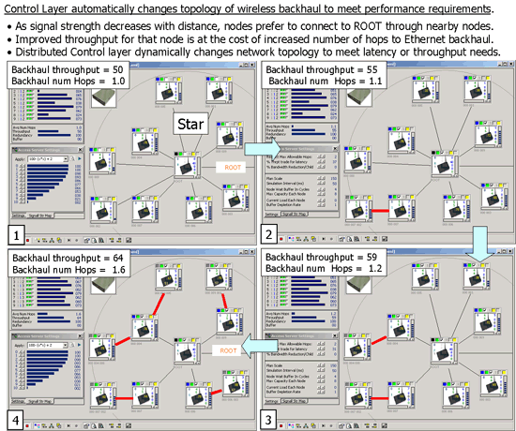
Fig. 2: Dynamically changing network topology to improve throughput, at the cost of latency

Managing the dynamics of wireless networks requires a distributed control system approach - to judge network conditions correctly at each node of the network and make adjustments to both traffic flow and the overall topology of the network. Since the radio transmission quality is inherently dynamic in nature, the control layer needs to operate in each node of the network. This is critical to assure a stable and scalable mesh network. Some reasons why a distributed control system approach is needed for wireless (as opposed to wired):
- In the world of wireless, signal strength varies inversely with distance, dropping off rapidly as you move away from the transmitter. Reduced signal strength results in transmission error, which in return affects throughput. In contrast, physical distance is not as pertinent in the wired world.

- 2-Since signal strength affects throughput significantly, the throughput of a relay node may be higher connecting to another relay node in closer proximity to the backhaul than a direct connection. Connecting to an intermediate node may increase throughput but it also increases latency - you have additional hops. Some applications need low latency (e.g. voice) while others need high throughput and some need both (e.g. video).

- 3-One AP may be servicing multiple client applications, each with differing performance requirements. The choice of the backhaul must therefore be driven by the performance characteristics of the aggregate demand.
Aggregate demand may be expressed as a range of acceptable latency and throughput values. Note that latency and throughput are often conflicting objectives. Low latency (least number of hops) may cause low throughput. And high throughput may require increased latency. Changing the latency/throughput requires gradually changes network topology - as shown in Fig 2.

Figure 2 is made up of four individual sections, labeled 1 through 4. In each of these sections, the main area shows a number of radio devices configured in a specific mesh topology. The radio devices are part of the backhaul – each of them is therefore both an Access Point (AP) and a bridge to the backhaul, through other APs. Each node in the figure represents a 2-radio system where one interface is “ down” providing connectivity to client stations and other APs connecting to the backhaul through it. The second radio provides the backhaul path “up” to the wired backbone

The AP/bridge connected to the wired backbone is labeled, the “Root”. (There is only one root in this topology, though that is not a requirement. All that is required is that the number of root be greater than or equal to one.) The other nodes must transmit their packets to the root in order to have them placed onto the wire. The solid lines between nodes and the root represent the mesh topology.
Each of the four sections also is labeled with the “Backhaul throughput” – which for the simulation is measured as a inverse relationship to proximity. The relationship between throughput and proximity is modeled as in inverse square law based on experimental data. The curve is shown in the lower left hand corner of section 4 in figure 2. The simulation environment includes the ability to change the throughput-distance relationship for differing radios and wireless cards.

Each section is also labeled with the “backhaul number of hops”, which represents the average number of hops that a packet in that network will have to make in order to reach the root. The sections should be examined beginning in the upper left, and proceeding clockwise. The important results are:
- In section 1, the network is configured in order to optimize latency, that is, in order to minimize the total number of hops that packets will need to make. All nodes transmit their packets directly to the root. However, of all the possible configurations this has the lowest total throughput, because some of this one-hop links will be of low data rate due to physical separation between the nodes.
- In section 2, a tradeoff is starting to be made between latency (hops) and throughput. As the network is directed to emphasize throughput, it begins to make changes to the topology such that a larger number of hops is used in order to make sure that each mesh connection is at a higher data rate. A single change has been made in this case, as shown by the solid red line. Data from this node must now pass through an intervening node before reaching the root.
- Section 3 shows even more of an emphasis on throughput, with an additional node now using a two hop path to the root, and the throughput rate increasing from 55 to 59.
- Section 4 shows a mesh topology with a high emphasis on throughput, less on latency. Five of the nodes are now using two hop paths to reach the route, increasing the throughput to 64, but increasing to latency as well, since the average number of hops is now 1.6.

Limitations of Single Radio Ad Hoc Mesh Networks


Fig 3: A one-radio ad hoc mesh for typical home networking needs.

Figure 2 depicted a mesh topology was we label as an Infrastructure Mesh. The purpose of the infrastructure mesh is to mesh separate and distinct Basic Service Sets (BSS) to provide an Extended Service Set (ESS) meshed topology. Each node is an infrastructure element – an AP as opposed to a client to the network such as the devices shown in Figure 3.

Figure 3 depicts an Ad hoc mesh networks supporting peer-to-peer connectivity and requires only one radio - since all the nodes of the network are on the same BSS. While ideal for home networking requirements, Ad hoc meshes are unsuitable in mission critical situations because:

Peer-to-peer connectivity assumes that all nodes can reach all other nodes on the network, either directly or through intermediate nodes that route the traffic. Thus, the camcorder reaches the printer through the laptop and camera (Fig. 3). From the perspective of the camcorder, the printer is no longer reachable if either the camcorder-laptop connection or the laptop-camera connection or the camera-printer connection is lost, and if no alternate paths are available to take over. Some observations on ad hoc mesh networks:

- Peer-to-peer connectivity cannot be assured unless there are alternate routing paths, especially in highly mobile environments. That is, peer-to-peer connectivity is a valid assumption when there are a very large number of devices all located near each other in a specific area.

- Peer-to-peer connectivity is not a good assumption when the number of devices is limited, and when in given areas the number of devices available to route traffic may drop to zero. This, however, is the most likely case. Most deployments will have, possibly, tens of devices participating in a meshed network, and with these numbers of devices, it is probable that not all devices will be able to reach all other devices through peer-to-peer communication. While this may be acceptable in a home, consumer scenario, it is most definitely NOT acceptable in a mission critical situation.
However, this is not the case in an Infrastructure Mesh solution, which we define to be a set of APs that are meshed together in order to support various clients.. In an infrastructure mesh , the camcorder would be talking to an AP and the AP would – if needed, through other intermediary APs – route traffic to the printer. AP units do not move - they are part of the solution, not part of the problem. In a mission critical application, the infrastructure mesh would provide a self-configuring, self-healing, dynamic yet stable backbone to support the network no matter what mobility pattern the client devices exhibit.
Running in infrastructure mode, also encourages simplicity, since the routing and management of the dynamics of the network is managed by the infrastructure APs and not each device. Removing the AP from the equation requires that every device on the ad hoc network know about all other devices and how to connect to them. This rapidly consumes computing resources and uses up network traffic to keep updates current, especially in high mobility environments.

With one-radio units all devices are on the same Basic Service Set (BSS) - bandwidth is reduced to half with each successive hop in the network. The reason is that radio is a shared medium – every device has to stay silent when a re-transmission from one hop to another hop (within the same BSS) occurs. This makes bandwidth available at the end of the 3rd hop 1/8 of the available bandwidth. This is unacceptable for high performance requirements in either enterprise infrastructure networks or mission critical application requirements e.g. emergency response systems.
Two Radio Multihop Mesh Networks for Bandwidth

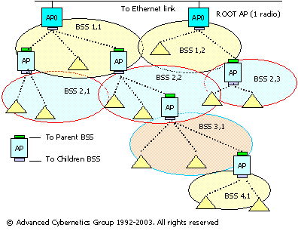
Fig 4. A two-radio ESS mesh addresses limitations of 1 radio ad hoc mesh.
Wireless Equivalent of an 802.1D switch stack: Fig. 4 shows the infrastructure mesh we have been discussing in a topology with a 2-radio unit in a multiple hop wireless network. The rectangular icons in this figure represent the APs, which have formed a mesh in order to support clients. The triangular icons represent these clients. At the top of the figure are the root APs (two, in this example) that have a direct connection to the wired backbone. Each of these APs creates a separate BSS using a separate RF channel.
The BSSs (Basic Service Sets) are labeled as BSS [hops], [index], so BSS 1,1 indicates that this is the first BSS for which one hop is needed to reach the wired backbone. For the non-root APs, one radio serves as an AP to its clients; the other radio acts as a backhaul. The radio interface colored green (on top) acts as a connection to the " Parent" - the backhaul. It operates in station mode: it appears as a client, no different from other clients shown as triangles. The backhaul and AP radio, colored gray (on the bottom), operates in AP mode: it services clients, including other Access Points accessing it as clients, through their second radio operating in station mode. In the lower layers, a description such as BSS 2,3 means that this is the third AP for which two hops are required to reach the wire.
The multiple radio approach supports high performance and scalability. As mentioned, radio is a shared medium where only one device can be "talking" at a time. As networks grow, performance degrades rapidly as the same AP services more clients. The AP’s BSS becomes unmanageable. The need to split up the network into smaller groups becomes essential to the health of a network.
A classic solution is to split up the wireless network into smaller groups (BSS), each of which is operating on a non-interfering channel with other groups (BSS). Simultaneous "conversations" are now possible in each BSS. This solution, however, is not available in an ad-hoc (peer-to-peer) mesh solution, because such a solution must, by definition, create a single, large, BSS.

Each BSS shown in the infrastructure mesh of Fig. 4, however, is not interfering with other transmission channels allocated to neighboring BSSs. Channel Interference is contained and spatial re-use is possible. Two-radio solutions are therefore more impervious to noise than their 1-radio counterparts. Channels can automatically be re-allocated to avoid unpredictable sources of interference such as radar or unauthorized transmissions that may be present in emergency or military situations.

In a two-radio approach shown in Figure 4, one radio supports the clients in the BSS, while the other provides backhaul services to link each BSS to each other. Together, the two-radio system supports the high performance and scalability needs for an Extended Service Set (ESS) Mesh.
Mission Critical Applications Requirements

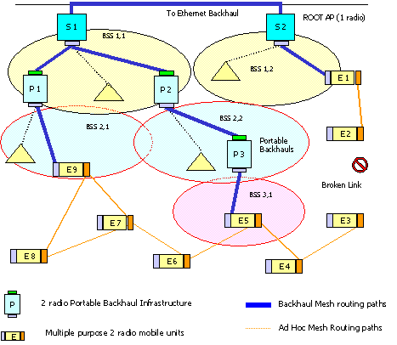
Fig. 5: Hybrid Mesh addresses deficiencies of 1 radio Ad-hoc Mesh Solutions
1-radio vs. 2-radio approaches While our software control layer (described later) supports one-radio solutions, those solutions are inferior to multiple radio solutions in multihop situations. In the case of 1 radio systems available bandwidth is reduced by 50% with each hop: the bandwidth available at the 3rd hop is 1/8 of the available capacity.
Conversely, 2-radio infrastructure mesh solutions are ideal for multihop situations - with no restrictions on the number of hops. They are also more reliable since the AP is intended to be stationary and therefore provide dependable service in its coverage area. But they are not intended for peer-to-peer connectivity in standard 802.11 modes of operation. In standard 802.11, radios are either configured to act as an AP, a STA or in ad hoc mode.
Mission critical applications (e.g. emergency response) need high bandwidth - regardless of how many hops you are away from the backbone- to be able to download maps or upload video. And they must also be assured of connectivity at all times – every node must be able to route traffic to all other nodes in the network.
Infrastructure backhaul addresses robust connectivity. In Figure 5, above, the ad hoc wireless link between E2 and E3 has been lost due, say, to excessive distance or an intervening obstruction – typical of dynamic, uncertain or hostile environments. With no 2-radio backhaul support, Nodes E1 and E2 are stranded, that is, they have no way of communicating with the other mobile radio units, at least in ad-hoc mode. The backhaul link now becomes their lifeline. Two-radio portable backhauls are thus essential in emergency response systems where the team may be scattered over large areas, and yet not made up of a very high number of actual devices.

A single radio ad hoc mesh is not sufficient, since all E nodes are intended to be mobile, their movement cannot be restricted to operate within coverage from another E unit. Further, redundant routing configurations (E7-E8-E9) cannot be assured, and the string of pearls pattern (E3-E4-E5-E6-E7) is too tenuous a connectivity chain for mission critical applications.
Hybrid mesh topologies One radio mobile ad hoc network connectivity (for peer-to-peer connectivity) combined with two radio infrastructure backhaul support provides the best of both worlds: ubiquitous connectivity with multiple levels of redundancy. To simplify production issues, the 2-radio Portable backhaul and mobile units can be the same hardware but dynamically configured to operate differently.
The backhaul radios are configured to have one radio in AP mode and the other is STA mode. The 2 radio mobile units are configured to have one radio in STA mode (to talk to the backhaul) with another radio in ad hoc mode to talk with peers. Either unit can fill in for the other – changes are software based and dynamically configurable. This favors economies of scale - the same hardware services both peer-to-peer and infrastructure requirements.
Distributed Control Layer Approach

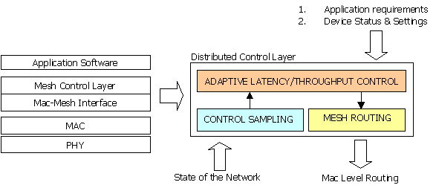
Fig 6. Small footprint software control layer manages network performance.
Managing the dynamics of wireless mesh networks requires a distributed control system approach - to judge network conditions correctly and adjust both the traffic flow and the overall topology of the network to meet the differing application requirements of multiple clients being serviced by the same AP.
The distributed software control layer approach addresses dynamic control of the network topology ensuring consistent performance despite changes in the environment: new clients added to the network, client mobility, temporarily overloaded nodes, changed applications set with an new set of latency/throughput requirements, failure of nodes etc.

