IEEE P802.11
Wireless LANs
Virtual Access Point Definition
Date: Feb 15, 2004
Author:
Graham Melville
Symbol Technologies Inc
6480 Via Del Oro, San Jose, CA, 95119
Phone: 408 528 2762
e-Mail: gmelville@symbol.com

Abstract

The objective of this paper is to convey a comprehensive description of a Virtual Access Point and what the effects on the end user experience are.

This paper references the original IEEE 802.11 specification. It is also useful to have read the document from Bernard Aboba of Microsoft that looks at the pros and cons of different ways of trying to achieve a virtual Access Point. (The document number is: IEEE 802.11-03/154r1.) The key difference between this paper and B. Aboba’s paper is that this paper looks at the standards specification to draw conclusions on the fact that a shared BSSID is clearly disallowed whereas B. Aboba’s paper focuses more on comparing how well or poorly the different approaches work without delving into detail regarding what standards specification dictates. Both papers however do conclude that using multiple BSSIDs, which is the standards-based implementation, is the optimal and preferred route.

Some access points available today provide for multiple SSIDs by sharing a single BSSID, others provide service by having multiple BSSIDs to support these multiple SSIDs on a one for one mapping. This paper will start by taking a closer look/review of the IEEE 802.11 specification to distinguish between these two important concepts and understand why sharing a BSSID does not just lead to a poor user experience, but is also clearly “illegal” from an IEEE standards perspective.

Basic Service Sets – The Building Blocks of a WLAN.

The IEEE 802.11 specification, after some introductory sections, starts with a general description in Clause 5 of a WLAN. The second sub clause starts by defining the Basic Service Set as the basic building block of an 802.11 LAN as shown below.

Clause 5.2 Components of the IEEE 802.11 architecture

The IEEE 802.11 architecture consists of several components that interact to provide a wireless LAN that supports station mobility transparently to upper layers.

The basic service set (BSS) is the basic building block of an IEEE 802.11 LAN. Figure 1 shows two BSSs, each of which has two stations that are members of the BSS.

It is useful to think of the ovals used to depict a BSS as the coverage area within which the member stations of the BSS may remain in communication. (The concept of area, while not precise, is often good enough.) If a station moves out of its BSS, it can no longer directly communicate with other members of the BSS.

The Basic Service Set Identifier (the BSSID) is a critical part of an access point and is used for communication once a device is associated. All stations communicating to an access point send to the BSSID. The BSSID is a standard IEEE 802 48-bit address.

Clause 7.1.3.3.3 BSSID field

The BSSID field is a 48-bit field of the same format as an IEEE 802 MAC address. This field uniquely identifies each BSS. The value of this field, in an infrastructure BSS, is the MAC address currently in use by the STA in the AP of the BSS.

The value of this field in an IBSS is a locally administered IEEE MAC address formed from a 46-bit random number generated according to the procedure defined in 11.1.3. The individual/group bit of the address is set to 0. The universal/local bit of the address is set to 1. This mechanism is used to provide a high probability of selecting a unique BSSID.

The value of all 1s is used to indicate the broadcast BSSID. A broadcast BSSID may only be used in the BSSID field of management frames of subtype probe request.

As the clause above shows, the MAC address of the Access Point is the same as the BSSID and must be unique. There are very good reasons why this must be unique which we will get to later.

What is the SSID for?

If we go back to the basic building block of the WLAN, the BSS, and consider how it functions in a multi cell site, we can see there may be potential problems as units move from cell to cell. For a Portable Station as defined in Clause 3.38 below, there is not a problem. It is safe to assume it will only communicate with one Access Point and therefore one BSSID.

3.38 portable station: A type of station that may be moved from location to location, but that only uses network communications while at a fixed location.

However, the IEEE 802.11 specification was not simply a way of removing Ethernet cables from Portable Laptop computers; it was designed for mobile users as well, as defined in Clause 3.34.

3.34 mobile station: A type of station that used network communications while in motion.

When a Mobile Station moves around, it will need to change the Access Point that it is communicating with. To achieve this the 802.11 specification has a separate Distribution System (DS) to connect the Access Points together. This is shown in the figure below.

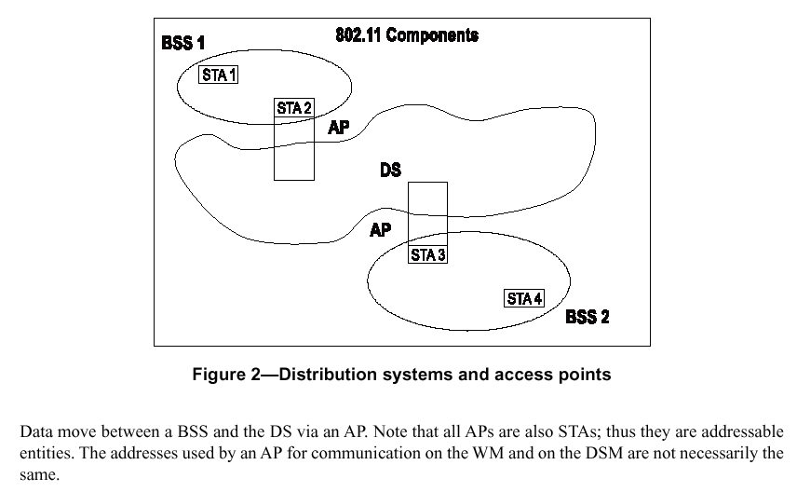
- Clause 5.2.2 The Distribution System

While nothing is assumed about the Physical location of the connected BSSs, typically there are overlapping coverage areas to seamlessly cover a site. The DS and BSSs together allow a network to be created of arbitrary size and complexity which is referred to as the Extended Service Set (ESS). The ESS allows a station to moving about the Wireless LAN to move from BSS to BSS in a way that makes it appear to be the same network to the logical link control in the users Mobile Unit.

The Extended Service Set Identifier (ESSID) is named the Service Set Identifier (SSID) and defined in the figure below. Products in the market place refer to SSID to as ESSID, SSID or NetID.

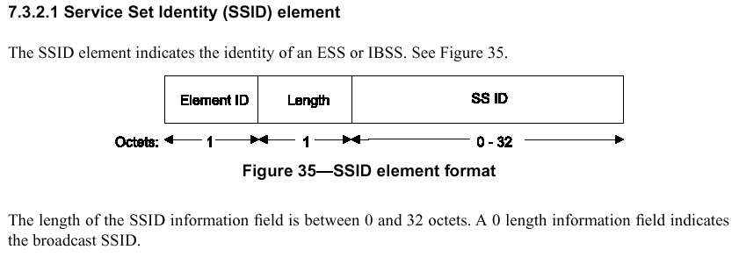
- Clause 7.3.2.1 Defining the Extended Service Set Identifier

For completeness, the complete 802.11 Architecture is show in the figure below.

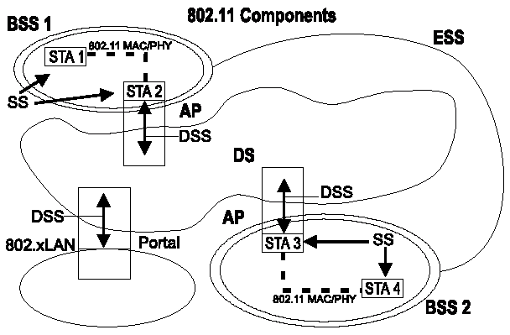
- The complete 802.11 Architecture
Beacons, Broadcasts and Power Save Mode

The next concept that needs to be understood is the Beacon.

11.1.2.1 Beacon generation in infrastructure networks

The AP shall define the timing for the entire BSS by transmitting beacons according to the aBeaconPeriod attribute within the AP. This defines a series of TBTTs exactly aBeaconPeriod time units apart. Time zero is defined to be a TBTT with the beacon being a DTIM and transmitted at the beginning of a CFP. At each TBTT, the AP shall schedule a beacon as the next frame for transmission. If the medicum is determine by the carrier-sense mechanism (see 9.2.1) to be unavailable, the AP shall delay the actual transmission of a beacon according to the basic medium access rules specified in Clause 9. The beacon period is included in Beacon and Probe Response frames, and STAs shall adopt that beacon period when joining the BSS.

The Beacon is a special frame that is transmitted to synchronize all the attached stations. The Station (STA) can be considered equivalent to the end user devices although it is not technically the same.

11.1.1 Basic approach

A timing synchronization function (TSF) keeps the timers for all STAs in the same BSS synchronized. All STAs shall maintain a local TSF timer.

11.1.1.1 TSF for infrastructure networks

In an infrastructure network, the AP shall be the timing master and shall perform the TSF. The AP shall initialize its TSF timer independently of any simultaneously started APs in an effort to minimize the synchronization of the TSF timers of multiple APs. The AP shall periodically transmit special frames called beacons that contain a copy of its TSF timer to synchronize the other STAs in a BSS. A receiving STA shall always accept the timing information in beacons sent from the AP servicing its BSS. If a STA’s TSF timer is different from the timestamp in the received beacon, the receiving STA shall set its local timer to the received timestamp value.

Beacons also contain the Traffic Indication Map (TIM) this is an element that tells all of the associated stations (end user devices) that are in power save mode (typically battery operated devices) if they have traffic queued up and ready for transmission. Remember this TIM is tied to the Beacon, which is tied to the BSS. Therefore if the BSS is supporting multiple ESSs, the different SSIDs traffic will be queued up together in one big lump. This will degrade the performance of the mobile devices on the network.

7.2.2.5 The TIM

The traffic-indication virtual bitmap, maintained by the AP that generates a TIM, consists of 2008 bits, and is organization into 251 octets such that bit number N (0 ≤ N ≤ 2007) in the bitmap corresponds to bit number (N mod 8) in octet number [N / 8] where the low-order bit of each octet is bit number 0, and the high order bit is bit number 7. Each bit in the traffic-indication virtual bitamp corresponds to traffic buffered for a specific station within the BSS that the AP is prepared to deliver at the time the beacon frames is transmitted. Bit number N is 0 if there are no directed frames buffered for the station whose Association ID is N. If any directed frames for that station are buffered and the AP is prepared to deliver them, bit number N in the traffic-indication virtual bitmap is 1. A PC may decline to set bits in the TIM for CF-possible stations it does not intend to poll (see 11.2.1.5).
The PC may transmit data or management frames to non-CF-Pollable, non-power-save STAs during the CFP. These STAs shall acknowledge receipt with the ACK frames after a SIFs, as with the DCF. The PC may also transmit broadcast or multicast frames during the CFP. Because the Beacon frame that initiates the CFP contains a DTIM element, if there are associated STAs using power-save mode, the broadcast and multicasts buffered shall be sent immediately after any beacon contain a TIM element with a DTIM count field with a value of 0.

One of the biggest problems with sharing a BSSID is that all the broadcast and multicast traffic is also queued and sent out after a special beacon at the DTIM interval. By sharing a BSSID among multiple ESSIDs in order to form virtual networks, all the broadcast and multicast from the multiple virtual networks will be concatenated at a single point after the DTIM. This can be disastrous for battery life on mobile stations and the quality of voice. Even very low broadcast multicast background levels on a 100Mb wired network can stop mobile stations from receiving vital frames that they need, potentially causing DHCP failures, or even application failures.

Shared PHY bandwidth

There is an argument from some corners of the industry that since it is all in the same PHY airspace, does it matter if they are all together sharing one BSSID or separated? Infact doesn’t sending extra beacons just use more airspace? Hopefully by reading this quick summary of the specification and understanding that the 802.11 specifications were designed for mobile devices such as PDA’s and voice handsets, it can be seen that performcnce is significantly impacted when concatenating broadcast domains on the air at the weakest point in the system. Lab testing that fully supports this theory of operation is available by request.

Conclusion

The IEEE802.11 specification in clauses such as 7.2.1.4 states that the BSSID is the address of the station contained in the Access Point.

7.2.1.4 Power-Save Poll (PS-Poll) frame format

…..The BSSID is the address of the STA contained in the AP. The TA is the address of the STA transmitting the frame. The AID is the value assigned to the STA transmitting the frame by the AP in the association response frame that established that STA’s current association.

A Station (STA) is any device that contains an 802.11 conformant MAC and PHY, access point of Network interface card of a portable or mobile station. Where there are multiple APs, real or virtual, clearly there needs to be multiple STAs and therefore a requirement for there to be multiple BSSIDs. A BSSID is a unique address to an individual Access point. By implication, any device that breaks the rules is not conformant. So while there is no explicit ban on sharing a BSSID among multiple SSIDs, the specification implicitly denies it.

The definition of a virtual Acess Point is therefore one that fully complies to the 802.11 MAC standard especially in the regard of having a unique BSSID (MAC address) per SSID. Having more than one ESSID per BSSID clearly violates the basic design principles of the 802.11 standard.

