IEEE P802.11
Wireless LANs
HW Implementation of Indoor MIMO WLAN Channel Models
Date: November 6, 2003
Authors: Tommi Jämsä, Janne Kolu, Pekka Kyösti
Elektrobit Ltd
Tutkijantie 7
FIN-90570 Oulu
FINLAND
Phone: +358 40 344 2127
Fax: +358 8 551 4344
e-Mail: tommi.jamsa@elektrobit.com
Abstract

This paper discusses hardware implementation aspects of indoor MIMO WLAN channel models. Real-time hardware simulation of the channel models is needed to accelerate algorithm design and system development and to verify the performance of real WLAN products. Hardware simulation offers great advantages for system developers, but some important points shall be taken into account. These points include delay accuracy, amplitude and phase accuracy as well as other hardware related issues.

Introduction

It has been well recognized that MIMO is a key technology to fully exploiting multipath propagation in broadband wireless communication systems. Spatial multiplexing gain can be obtained via the potential decorrelation between the channel coefficients of MIMO radio channel. However, the spatial multiplexing gain depends on the multipath richness, since non-fading channel doesn’t include decorrelation and neither MIMO capacity gain. Also, channel model with zero correlation would give too optimistic results, since in field the correlation is rarely zero. Hence, it is important to have realistic channel model in evaluating the real MIMO performance.

The proposed Indoor MIMO WLAN Channel Models [1] can be used for development and comparison of transceiver algorithms, baseband implementation as well as performance analysis of final WLAN products. Transceiver algorithms can be evaluated with software simulation tools. However, more accurate verification of those algorithms may require high-speed hardware calculation. This is especially the case when very low bit error rates (down to 10⁻⁶ or lower) are measured. It is obvious that hardware simulation/emulation is needed in real-time verification of baseband implementation and performance tests of final products.

Purpose of this document is to study how the proposed indoor WLAN MIMO model can be implemented in a real time radio channel simulator/emulator. We will also show some results obtained when implementing the proposed model to a Multichannel fading simulator.

HW Simulation

The main benefit of hardware simulation is the huge increase of simulation speed (real-time calculation). Other important advantage is the possibility to verify the performance of real product (not only software model of the product).

It is important that the same channel model is used in all development phases from early algorithm research to performance and approval tests of final product. Nevertheless, hardware implementation of the Indoor MIMO WLAN Channel Models differs significantly from the software implementation. Software implementation is very flexible, but features are limited in calculation rate. Hardware implementation enables real-time simulation and testing. HW emulation environment gives possibility to increase the system complexity and reality. Real devices can be verified with realistic HW channel emulation. However, the test results between SW and HW simulations may differ. The difference is mostly caused by RF/IF impairments, sampling and quantization of hardware simulators. Also the device under test may differ from its software model.

One of the main questions is path delay modeling. Path delays in the radio channel model should correlate with real field scenarios. Radio channel model sampling can be different than the actual system sampling. The natural path spacing in HW simulator is often different from the path spacing of channel model or WLAN transceiver (see Figure 1). T_{c} is the time interval of WLAN receiver sampling. Original delay of the model may be in between the two adjacent HW simulator delay positions. The easiest way in approximating the delay is to move the path to the closest position in simulator HW raster. (There are also more advanced methods in approximating the channel such as interpolation, but it is not further discussed in this document.)

Figure 1. Shifted path delay due to the delay resolution of hardware simulator.

Implementation of the models
Channel model was created by using the Matlab program by L. Schumacher [2]. Table 1 summarizes the used parameters.

Table 1. Used parameters in MatLab program
Number of TX antennas | 2
Number of RX antennas | 2
AP antenna configuration | ULA (λ spacing)
Client antenna configuratio | ULA (λ/2 spacing)
Center frequency | 5.29 GHz

Channel coefficients (impulse responses) from Matlab program were then loaded to digital fading simulator.

Measurement Results

This section shows the measurement results obtained by using PROPSim C8 Wideband Multichannel Simulator (sub-sections 4.1 and 4.5) and simulation results obtained by using MatLab (other sub-sections).

Several measurements were done for two or three different delay accuracies. The accuracy is calculated from the maximum delay deviation between first path (0 ns) and any other path. Let’s code these accuracies to three accuracy categories (I, II and III):
- 0.5 ns delay accuracy (not rounded, the remaining inaccuracy is caused by insignificant “implementation losses” of real hardware)
- 5 ns delay accuracy (rounded to 12.5 ns grid)
- 20 ns delay accuracy (rounded to 50 ns grid)

RF Amplitude and Phase Accuracy
For realistic performance evaluation of different signal processing methods utilizing AoA and AoD estimates the phase accuracy of the fading simulator is the most critical parameter. We measured the phase and amplitude deviation for 2x4 MIMO case. There are two inputs and four outputs, which means eight channels in total. Table 2 and Table 3 show the maximum simulator RF phase and amplitude deviation, respectively, in relative to those with channel 1. Measurement was performed by measuring the scattering function S21 indicating the phase and amplitude responses of the each channel, using the commercially available network analyzer (Rohde&Schwarz ZVRE). Center frequency of the simulator was 2.2 GHz (f₀), and thus available band was between 2165-2235 MHz.

Table 2. Phase accuracy [°] at band f₀ ± 10 MHz.
 | Output 1 | Output 2 | Output 3 | Output 4
Input 1 | 0,20 | 0,77 | 1,20 | -0,20
Input 2 | 1,31 | 2,13 | 2,29 | 1,87

Table 3. Amplitude accuracy [dB] at band f₀ ± 10 MHz.
 | Output 1 | Output 2 | Output 3 | Output 4
Input 1 | -0,10 | 0,10 | 0,15 | -0,12
Input 2 | -0,15 | -0,12 | -0,15 | -0,21

Amplitude response
This analysis shows a typical deviation of frequency response for single impulse response. Frequency band has been limited to 20 MHz. The comparison is made between delay accuracies of ±0.5 ns and ±5 ns (categories I and II) in Figure 2 and between ±0.5 and ±20 ns (categories I and III) in Figure 3, respectively.

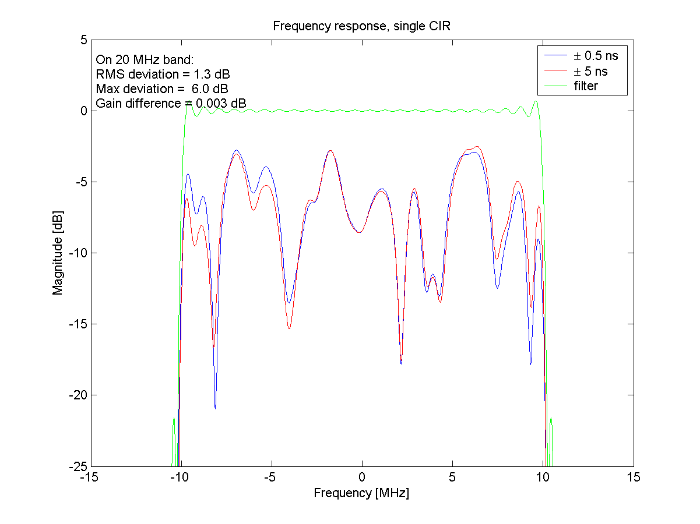
Figure 2: Frequence response of a single CIR, model F, I and II categories.

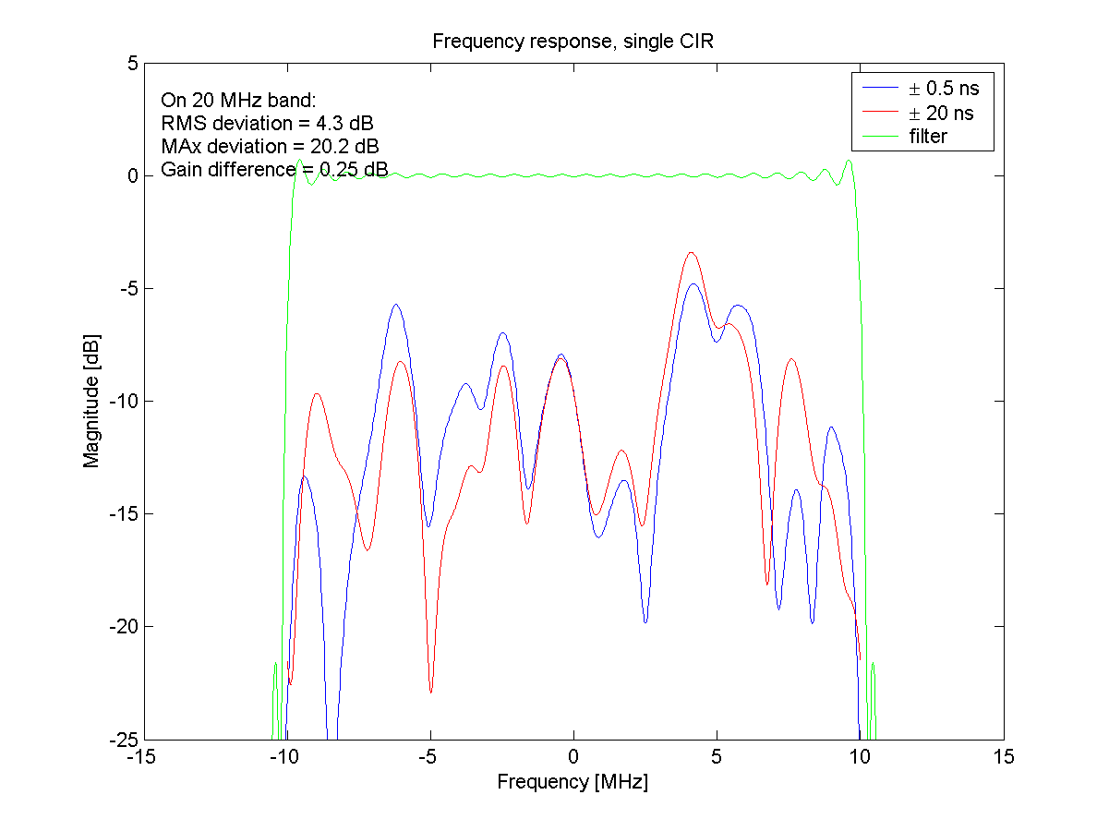
Figure 3: Frequence response of a single CIR, model F, I and III categories.

The following figure shows average gain of the channel (Figure 4). It was calculated by averaging over 100 000 impulse responses. Theoretical average curve should approach asymptotically flat line, when the channel includes a number of decorrelated Rayleigh taps. The simulated average curves are not flat due to finite length of the simulation. It can be seen that there is no important difference between categories I and II. Green curve is frequency response of a single CIR.

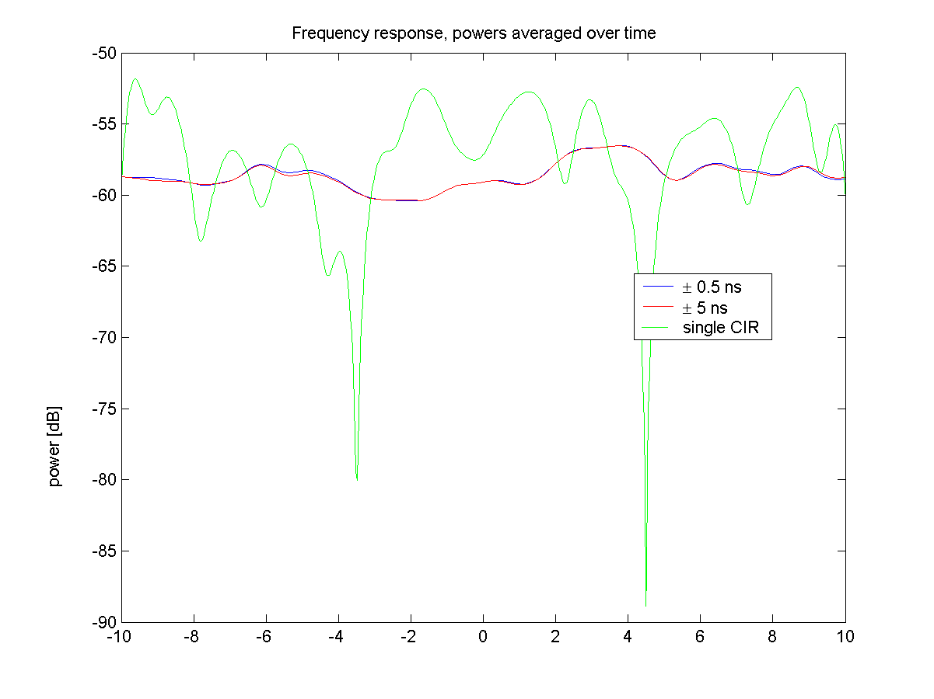
Figure 4: Frequency response, powers averaged over 100 000 impulse resonses, categories I and II.
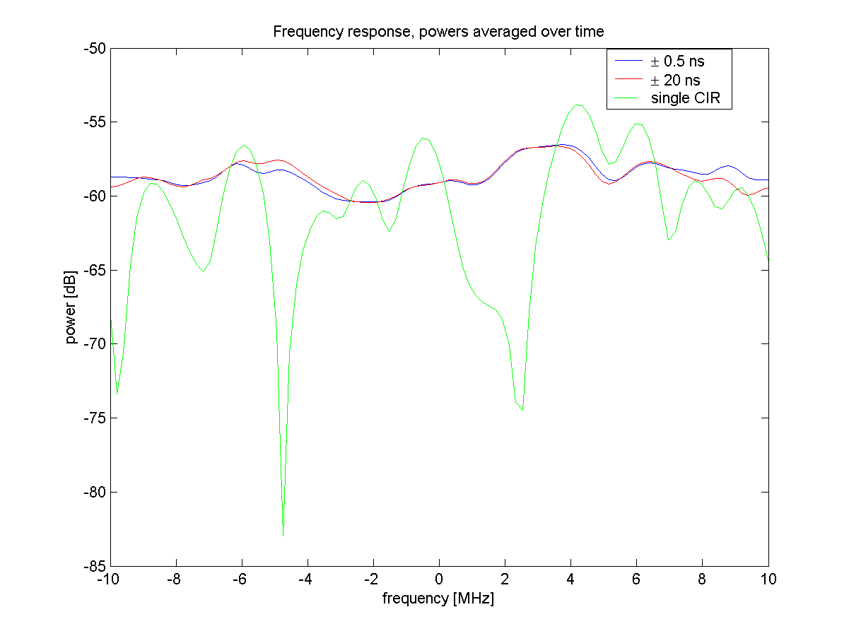
Figure 5: Frequency response, powers averaged over 100 000 impulse resonses, categories I and III.

Frequency correlation
Frequency correlation was calculated for categories I and II. The method on calculating the correlation is based on [4].
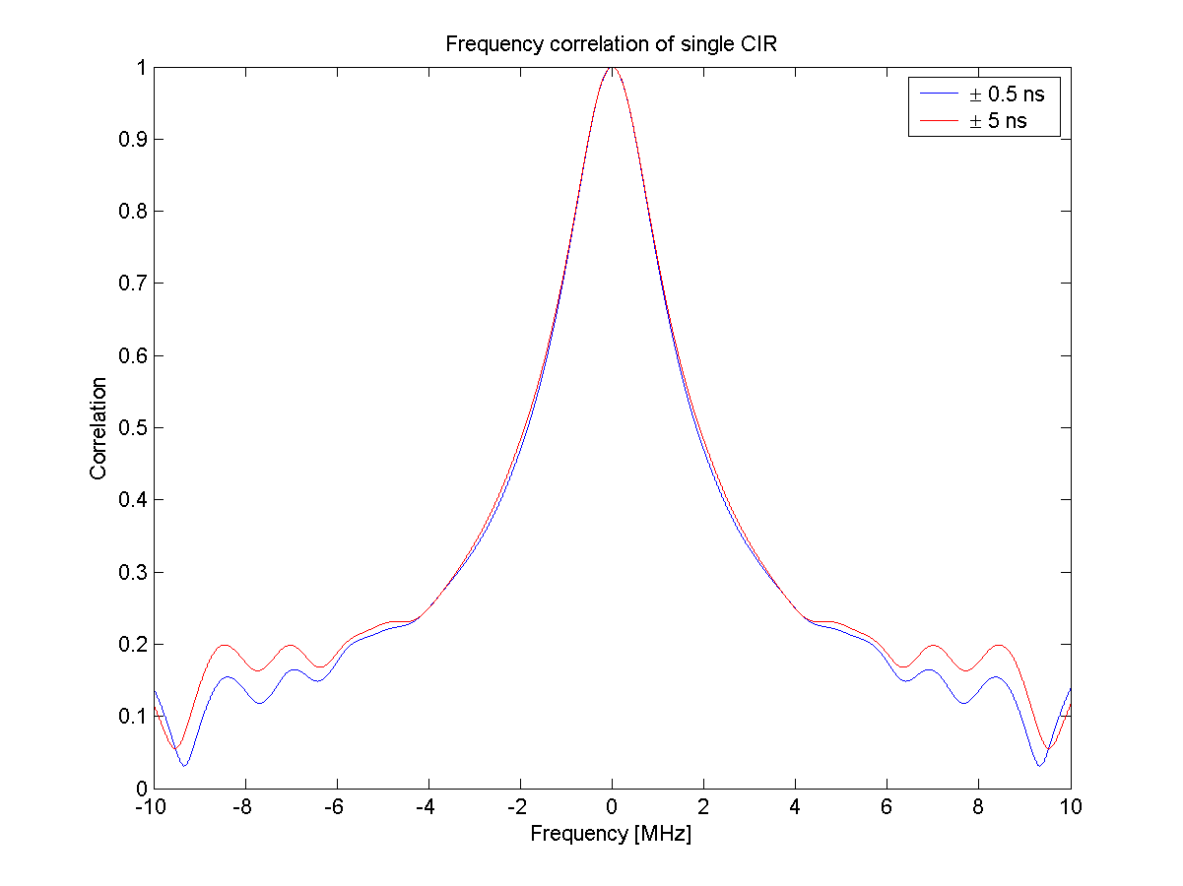
Figure 6: Frequence correlation of model F, categories I and II.
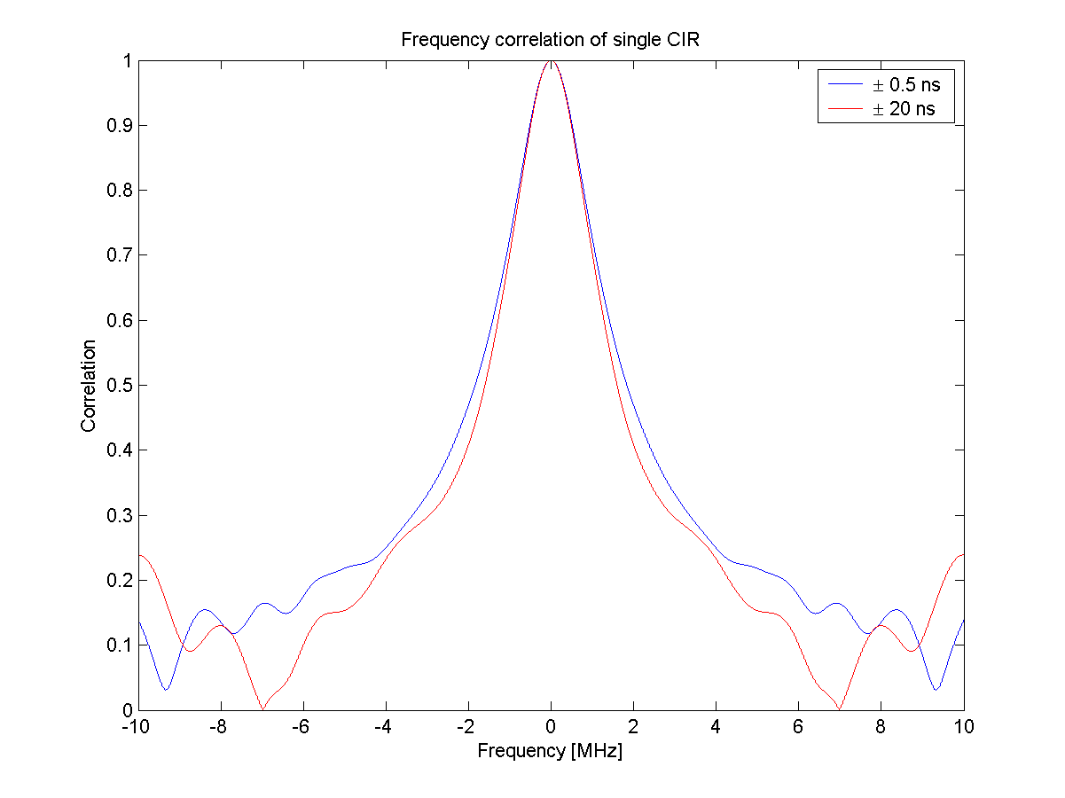
Figure 7: Frequence correlation of model F, categories I and III.

PDF and CDF
This sub-section shows density and distribution functions for both single frequency and averaged over full 20 MHz band. Figure 8 shows the magnitude PDF of CDF at single frequency (+4 MHz offset from band center) for categories I and II. Figure 9 shows same functions averaged over the full 20 MHz frequency band. It can be easily seen that there may be slight difference of PDF and CDF of categories I and II at single frequency, but the overall average distributions are very close.
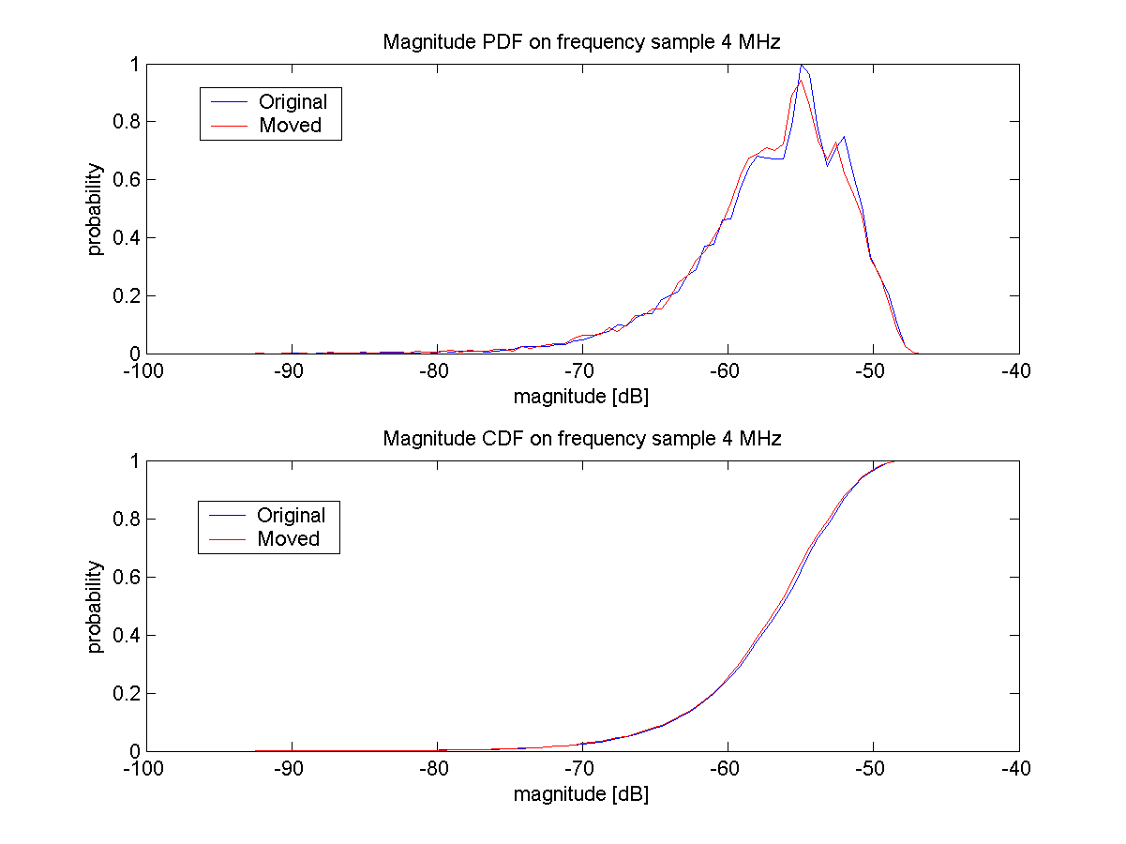
Figure 8: Magnitude PDF and CDF on single frequency sample (4.0 MHz offset), categories I and II.

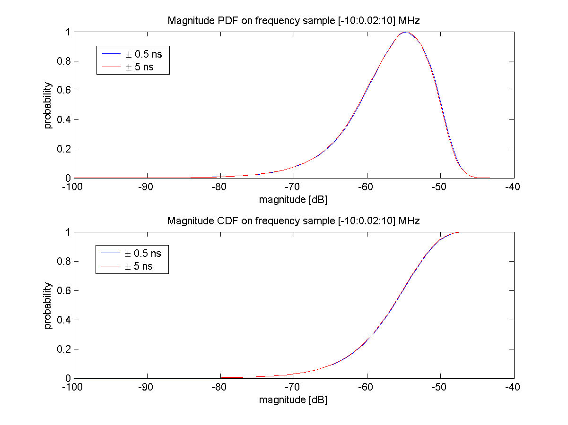
Figure 9: Magnitude PDF and CDF on frequencies –10 MHz to 10 MHz with 2 kHz sampling, categories I and II.

Figure 10 shows the magnitude PDF of CDF at single frequency (+4 MHz offset from band center) for categories I and III. Figure 11 shows same functions averaged over the full 20 MHz frequency band. It can be easily seen that the difference between categories I and III is larger than between categories I and II.

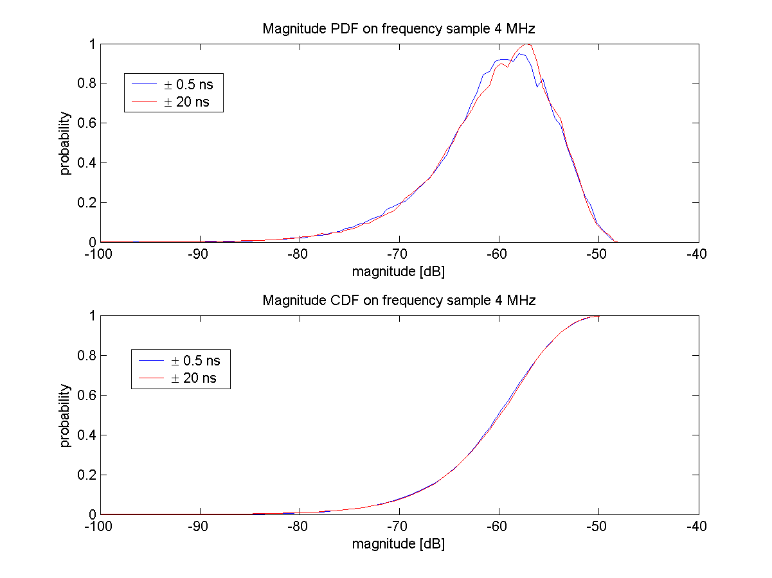
Figure 10. Magnitude PDF and CDF on single frequency sample (typical one).

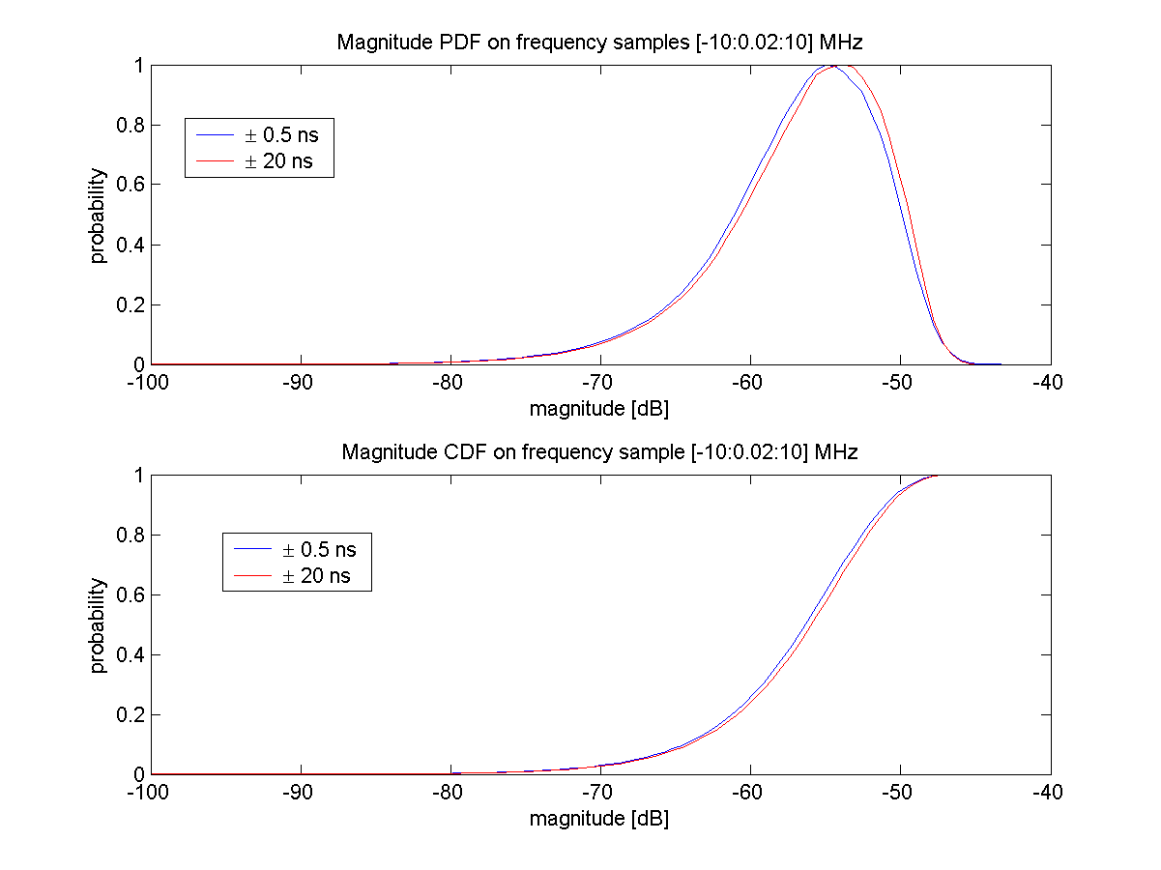
Figure 11: Magnitude PDF and CDF on frequencies –10 MHz to 10 MHz with 2 kHz sampling, categories I and III.

BER results
BER was measured using an experimental SW radio platform system and PROPSim C8 fading simulator. Selected air interface was OFDM with 52 subcarriers and 312.5 kHz subcarrier spacing. OFDM symbol duration was 3.2 μs and guard period was 0.8 μs.

Figure 12. Measured BER with the real time evaluation system.

The measurement result shows that there is not important difference in the BER curves. However, BER result depends strongly on receiver structure. Some receivers may be more sensitive to multipath delays.

Proposal for Specification Update

We propose a new section describing hardware simulation/emulation of MIMO channel models. The proposed section could include the following items:
- Implementation aspects of hardware channel simulation
- Block diagram of typical MIMO test setup (Figure 13)
- Signal levels
- Basic requirements for hardware channel emulation, for example
    - Delay accuracy: ±5 ns
    - RF phase accuracy after calibration: ±5°
    - RF amplitude difference between channels after calibration: ±0.5 dB

Figure 13. MIMO test setup for WLAN MIMO system performance evaluation.

Conclusion and Possible Further Actions

The importance of hardware simulation is obvious in testing real products and prototypes. Recently, complexity of new systems such as WLAN MIMO has increased dramatically. Hardware simulation offers significant reduction of simulation speed in research and early product design. This paper studied the impact of delay accuracy to system performance. Based on our simulations and measurements it seems that ±5 ns delay accuracy is acceptable. ±20 ns seems to be too high error for accurate measurements. We proposed a new chapter to the Indoor MIMO WLAN Channel Models document ([1]). In addition, more investigation and testing are needed for analysing other channel simulator performance criteria such as sample density, word length and simulation length.

References

- Erceg V., et al., IEEE 802.11 document 03/161r2 ”Indoor MIMO WLAN Channel Models”, September 12, 2003
- “WLAN MIMO Channel Matlab program,” download information: http://www.info.fundp.ac.be/~lsc/Research/IEEE_80211_HTSG_CMSC/distribution_terms.html
- J. Kolu, T. Jämsä, “A Real-Time Simulator for MIMO Radio Channels”, Proc. WPMC’02 Honolulu, Hawaii, 2002
- Parsons J. D.: ”The Mobile Radio Propagation Channel”, 2nd edition, Wiley 2001.

