IEEE P802.11
Wireless LANs
802.11 TGn Channel Model Special Committee
Simulation of the Spatial Covariance Matrix
Date: October 30, 2003
Author: Antonio Forenza, David J. Love and Robert W. Heath Jr.
The University of Texas at Austin
Department of Electrical and Computer Engineering
Wireless Networking and Communications Group
1 University Station C0803
Austin, TX 78712-0240
Phone: +1-512-425-1305
Fax: +1-512-471-6512
E-mail: forenza@ece.utexas.edu, djlove@ece.utexas.edu, rheath@ece.utexas.edu
Abstract
This document describes a new method to simulate the spatial covariance matrix for MIMO channel modelling to reduce simulation run time. This method is based on approximation, yielding a simple closed form solution for the correlation coefficients. Analysis and performance results are presented that show that the approximation holds for most angle spreads and the computation time is substantially reduced.

Contributors
(This will grow to reflect those providing email contributions / review comments of this document)
Name | Company | Address | Phone | Fax | Email

Revision History
Revision | Comments | Date

Introduction
We propose a new method to simulate the spatial covariance matrix. This method is based on approximation, yielding a simple closed form solution for the correlation coefficients. With this method the computational time for the correlation coefficients is dramatically reduced compared to the method currently proposed by the standard 802.11 TGn [1]. We refer to this new approach to generate the covariance matrix R as “Fast-R”. Performance results of “Fast-R” are discussed and compared to the current 802.11n.

Analytical Model
We derived a closed form solution for the coefficients of a given channel tap’s spatial correlation matrix, characterized by a certain angular spread (AS) and angle of arrival (AoA). We assumed the channel tap to exhibit Laplacian power azimuth spectrum (PAS) defined in the range [-$π$,$π$], as reported in [1]. The Laplacian pdf is given by the following formula:

$p(φ)=\frac{1}{\sqrt{2}σ}e^{−\left|\sqrt{2}φ/σ\right|}$ (1)

where $φ$ is the AoA offset with respect to the mean AoA ($φ_{0}$) of the tap, and $σ$is the standard deviation (RMS) of the PAS.

The received signal at the m-th sensor of the array antenna can be written as:
$r_{m}(t)=s(t)⋅\sum_{i=1}^{N}{g_{i}}(t)⋅\text{exp}(\text{jDm}\text{sin}(φ_{0}−φ))$ (2)
where m=1,…M, M is the number of sensors in the array,$D=2{πd}/λ$, d is the spacing in between the array elements, λ is the wavelength, and N is the number of rays for a given tap. Whereas, s(t) is the transmitted signal (with $E\left\{|s(t)|^{2}\right\}=1$), and g_{i}(t) is the complex Gaussian fading coefficient (with variance N₀=1), assumed to be independent over time and from ray to ray.

Computing the cross-correlation of the signals at the sensors m and n, from (2) we get:
${\left[R(φ_{0},σ)\right]}_{m,n}≈\int_{−∞}^{+∞}{\text{exp}(\text{jD}(m−n)\text{sin}(φ_{0}−φ))}⋅p(φ)dφ\text{.}$ (3)
We assume that the per-tap RMS AS is small, and therefore $φ≈0$. We discuss later in this report the impact of this approximation over the spatial correlation coefficients. More details are provided in [5]. Applying the definition of the Fourier transform to (3), we can derive the closed form for the correlation coefficients (assuming Laplacian distribution):

$R(φ_{0},σ)≈\left[a(φ_{0})⋅a^{H}(φ_{0})\right]⊗B(φ_{0},σ)$ (4)

where $⊗$ denotes the Shur-Hadamard (or elementwise) product [4], $a(φ_{0})$ is the array response (column vector) for the mean azimuth AoA ($φ_{0}$), and B is a matrix with coefficients depending on the AoA and AS of the tap.

Performance Results
For the performance analysis we consider three different models: the sum-of-ray model (which we will refer to as “3GPP”, since it is an analogous model to that used in the standard 3GPP-SCM [2]), the “802.11n” model (based on an approximation with Bessel functions of the first kind as in [1]), and the model using the approximation in (4) (which we will refer to as “Fast-R”). The 3GPP model is used as reference, since it is the most “physical” of the three models and does not use any approximation.

In these simulations we considered a MIMO four transmit and four receive antenna system, with antennas spaced $λ/2$ apart. We applied eigenvalue decomposition of R generated through the three methods as:
$R⋅v=λ⋅v\text{.}$ (5)

Then we compared the dominant eigenvalue obtained from the 802.11n model and Fast-R, against the one obtained through the 3GPP model. We calculated the normalized mean squared error (NMSE) defined as:
$\text{NMSE}=\frac{E\left\{{\left|λ_{1}−λ_{2}\right|}^{2}\right\}}{E\left\{{\left|λ_{2}\right|}^{2}\right\}}$ (6)
where $λ_{1}$ is the dominant eigenvalue obtained with the 802.11n or the Fast-R models, whereas $λ_{2}$ is comes from the 3GPP method.
The results are depicted in Fig.1. It is easy to see that as the (RMS) AS increases, the performance of Fast-R degenerates, due to the approximation used at equation (4). However, for values of AS<15º, the error is low. We choose this value as reference for the next results.
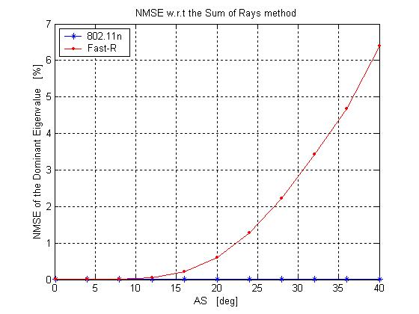
Fig.1 - NMSE of the dominant eigenvalue of R for the 802.11n and Fast-R methods.

In Fig.2 we plotted the MSE of the dominant eigenvector, defined as:

$\text{MSE}=E\left\{{\left|v_{1}−v_{2}\right|}^{2}\right\}$ (7)

where $v_{1}$ is the dominant eigenvector obtained with the 802.11n or the Fast-R models, whereas $v_{2}$ comes from the 3GPP method. The interpretation of these results is analogous to the one for Fig.1.
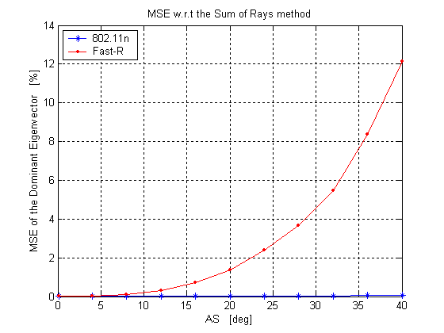
Fig.2 - MSE of the dominant eigenvector of R for the 802.11n and Fast-R methods.

Then, we simulated R for AS<15º, and compute the CDF of the mutual information as well as the ergodic capacity.

In Fig.3 it is depicted the CDF of the mutual information for SNR=15dB. It is possible to see that the mean value matches for all three methods. However, for the Fast-R, the CDF exhibits slightly higher variance. This is due to the fact that the eigenstructure of R simulated through Fast-R differs from the one generated through the other two methods, when the AoA approaches the endfire direction with respect to the alignment of the array elements.

In Fig.4 it is shown the ergodic capacity as function of the SNR. We can see that the three methods provide the same results for values of SNR<15dB. For higher values of SNR the capacity loss of the Fast-R method is about 0.3bps/Hz (at SNR=25dB).

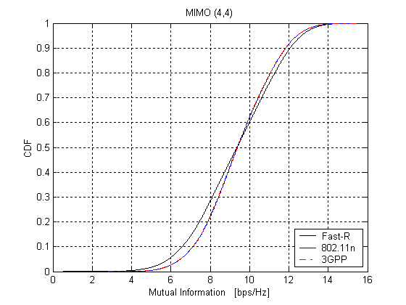
Fig.3 - CDF of the Mututal Information for AS<15º and SNR=15dB.

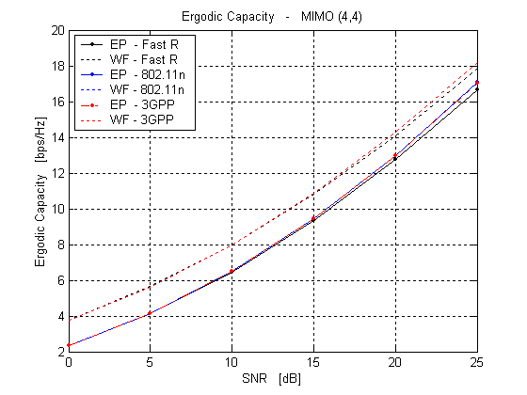
Fig.4 - Ergodic Capacity for AS<15º. EP: equal power, WF: waterfilling

We conclude that it is possible to use the Fast-R method as long as the Per-Tap AS is below the value of 15º. With this in mind, we need to modify one issue of the current standard 802.11n, if we desire to use the Fast-R method.

In particular, in [1] it is reported that the Per-Tap-AS coincides with the Per-Cluster-AS. The only reference reporting this result, however, is [3]. Here it is reported that the equivalence of the two values of AS holds for AS13º. Then the question is: does it hold for higher AS, as well? We could not find any reference at this regard. Therefore, if we assume that the Per-Tap-AS is around 13º even when the Per-Cluster-AS is 40º (the highest value considered in [1]), the Fast-R method is applicable.

Finally, we show the dramatic improvement in computational time obtained with Fast-R method as opposed to 802.11n model.

We simulated both the algorithms in Matlab with a 700MHz PC. We considered 18taps/user (model C) and 34taps/user (model F), and variable number of users. We calculated the computational time for both the methods and the results are depicted in Fig.5. As a reference we plotted the computational time required by the 3GPP model assuming to simulate 5000 rays (to converge to Laplacian distribution). It is possible to see that the Fast-R method is almost 200 times faster than the 802.11n method.

Now, let us consider the context of a network simulator, where we want to carry out capacity analysis for different scenarios. Let us assume there are around 50 users in the network to simulate, with worst case scenario of 34taps/user (model F). By referring to Fig.5 we would get the computational time needed to calculate only the matrix R (without considering the generation of the other channel parameters). Then, it is evident the gain of using Fast-R method instead of the 802.11n model allows covariances for multiple users to be generated simultaneously. This is critical because link and network level simulations must be conduced over long snapshots to measure average system performance.

In conclusion, the Fast-R method is a practical alternative to computing the covariance R using [1]. The Fast-R method seems to generate covariances that are close to that generated by [1], for angle spreads less than 15 degrees. The computational reduction is significant. Further work is needed to investigate any differences between correlation functions in terms of bit error rate.

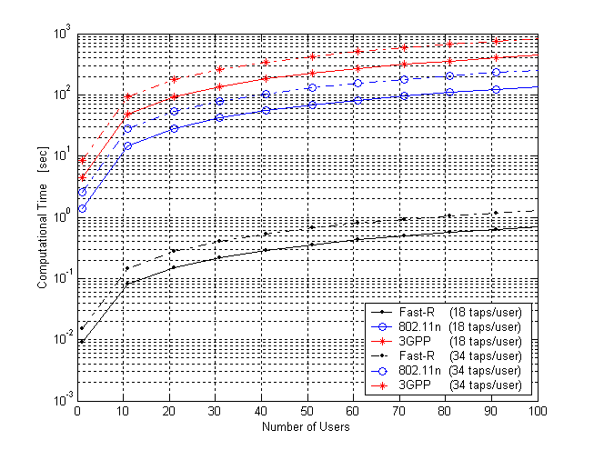
Fig.5 - Computational time for Fast-R and 802.11n model.

References
[1] IEEE 802 11-03/161r2, TGn Indoor MIMO WLAN Channel Models
[2] 3GPP TS Group,”Spatial Channel Model, SCM-121 Text V3.3, Spatial Channel Model AHG (Combined ad-hoc from 3GPP and 3GPP2), March 14, 2003
[3] Q. Li, K.Yu, M. Ho, J. Lung, D. Cheung, and C.Prettie, “On the tap angular spread and Kronecker structure of the WLAN channel model,” Presentation, July 2003.
[4] R. A. Horn and C. R. Johnson. Matrix Analysis. Cambridge University Press, New York,
March 2001.
[5] A.Forenza, D.J.Love, and R.W.Heath Jr., “Simulation of the Spatial Covariance Matrix for MIMO Systems”, WNCG Tech. Report, Sept.2003 (also submitted to VTC Spring 2004).

