IEEE P802.11
Wireless LANs
Tentative Minutes for the TGk Teleconferences
Date: August 13, 20, 2003
Author: Harry Worstell
AT&T
180 Park Avenue Phone: 973-236-6915
e-Mail: hworstell@research.att.com
Paul Gray

Wednesday, August 13, 2003

Chair: Richard Pain
Secretary: Harry Worstell

- Call to order
- Attendance
Richard Pain
Harry Worstell
J Kim
Karl Miller
Kue Wong
Leo Monteban
Malik Audeh
Marty Lefkowitz
Tamara Shelton
Vann Hasty
Victoria Poncini
Walter Johnson

Patrick Worfolk
- Agenda
  - Review the Victoria Poncini Document 03/490r3
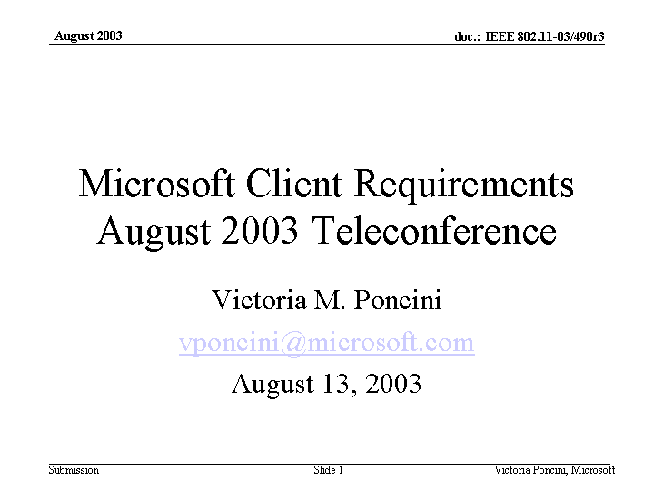

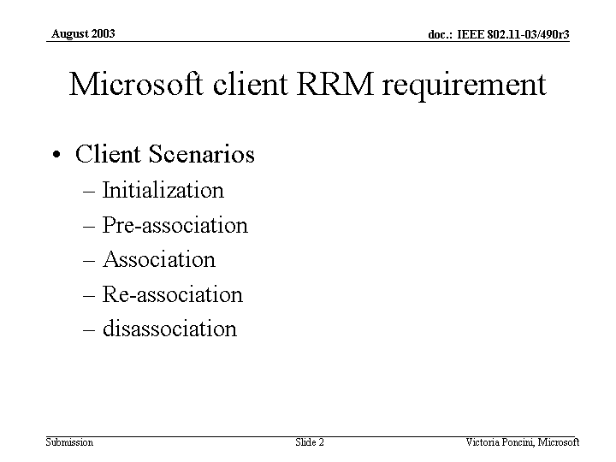

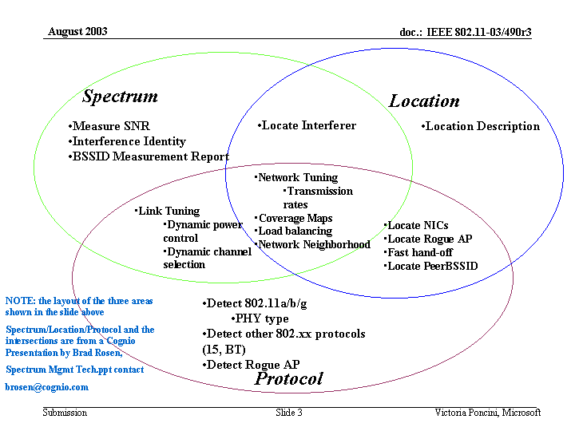
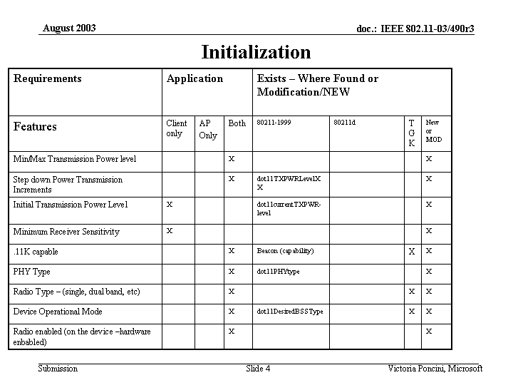

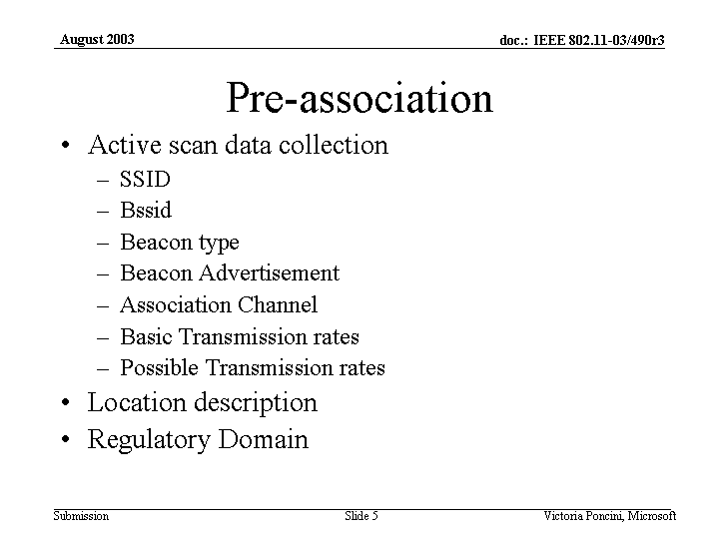

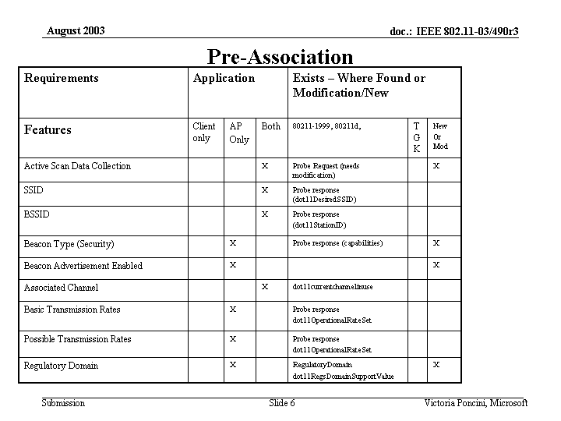
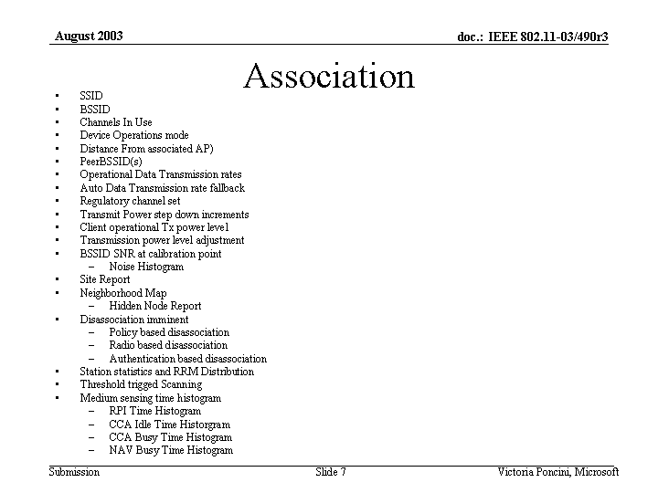

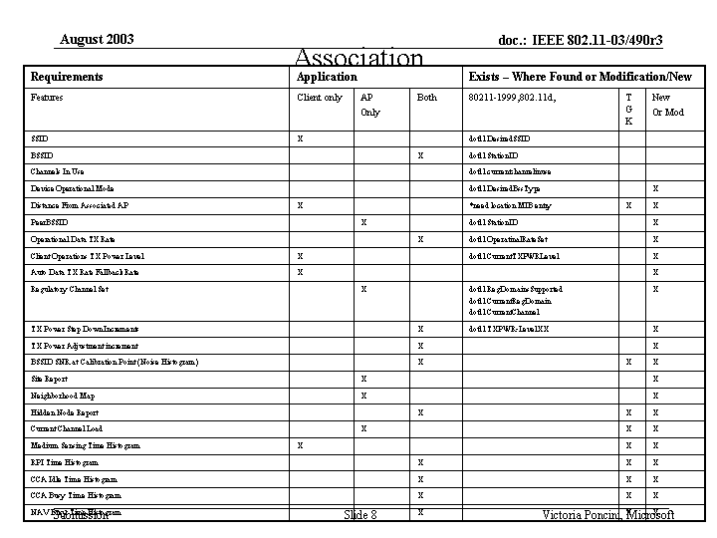
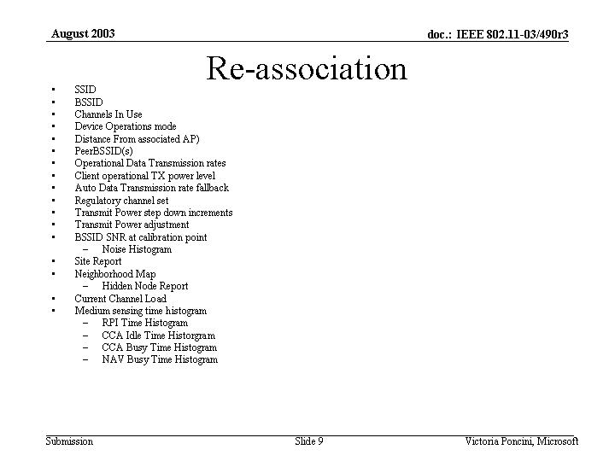
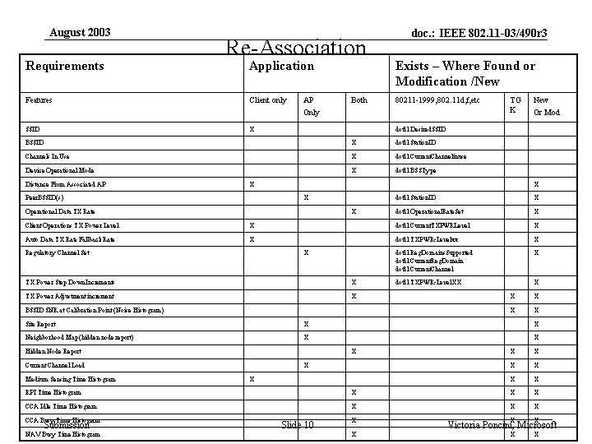

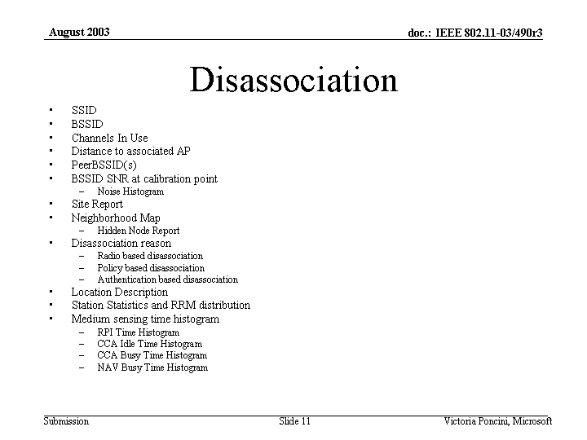
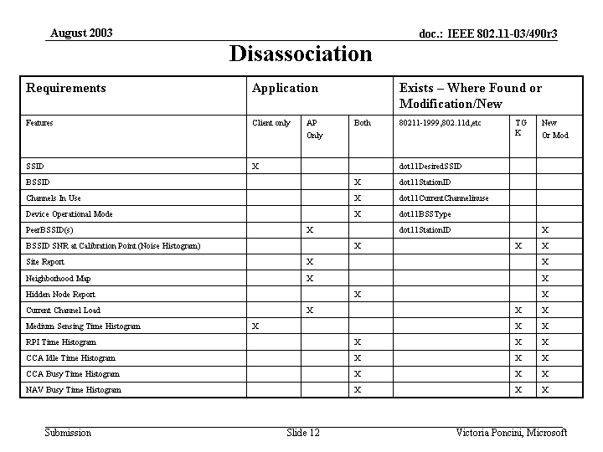

- Discussion

Added a TGk column to Victoria’s presentation
Step down increments per already supplied levels
Need to Add initial power level to spec for client
Default state of NIC card should be a specified level
May have some conflict with TGh…..will need to investigate
Device operational mode … bridge, AP
Radio Enabled means radio on
May want to add things to probe response area
SSID and BSSID are for client and AP
New or mod for is general standard issues and TGk would be for “k”
Beacon type is to specify things like WPA or TGi
Operational rate set changes may not be needed, already there - not new or mod
Victoria will provide definitions of each requirement
need a location MIB entry
peer BSSID entry

Wednesday, August 20, 2003

Chair: Richard Pain
Secretary: Harry Worstell

- Call to order
- Attendance
Richard Paine
Harry Worstell
Paul Gray
Kelly McClellen
Walter Johnson
Malik Aude
Marty Lefkowitz
Fred Heist
TK Tan
Tony Collins
J Kim
Joe Kwak
Tim Olson

- Agenda
  - Plan for Singapore
  - and Letter ballot
- Discussion
  - Need a complete set of MIB variable and define how to deliver to the upper layers
  - Victoria to provide definitions to 03/490r3 General Microsoft Requirements
  - The Xs in the TGk column are the entries for dot 11 k capable
  - The radio type is needed for i.e. dual band …
  - PHY type is already in the 1999 spec (a/b/g)
  - The stuff marked in red are needed yet
  - There are no Xs in the TGk column of association area
  - The group will define the complete needs….this is a Microsoft document
  - BSSID SNR needs modified
  - PHY type is a table in the 99 MIB (dot11PHY operation Table)
  - Victoria will be on the call next week
  - Joe Kwak is completing simulations on PSNI (Maybe a frame report)
  - Joe and David Skellern need to work on definition
  - Neighbourhood graph is taken care of by the site report
  - Neighbourhood map is not defined is needed for TGk and needs more interpretation
  - Arbaugh has shown a set of measurements as a graph
  - Need to have capability to get information between APs
  - Don’t want to place application things into the MAC area
  - SNMP will extract the information from the MIBs
  - Simons Black gets info from STA to AP and now needs to store the info in the AP(expanding tables)…..need the information but why store them in the MAC or is this application specific and should be stored above the MAC
  - Some MIB entries are not yet defined that need to be.
  - Tables of associated clients should be place out side the MAC
  - Should not need to pull client information from AP to AP
  - Doesn’t believe there is enough information to determine location
  - Needs either timing or RF power measurements for this information

Minutes from 11k Teleconference

August 27, 2003

Secretary: Paul Gray
Attendees: Paine, Gray, Johnson, Oslon, Pope, Audeh, Durand, Poncini, Guldmann, Kim, Zhong, Chindapol, Kwak, Worfolk, Sophia

The first item of discussion revolved around Victoria’s presentation of Microsoft’s Requirements Document. There was a question regarding the use mW instead of dB. Victoria based here decision on another specification she had read.

There was a discussion on whether Victoria felt modifications to the probe request/response where needed. Victoria was not sure, but provided a place holder in the document for future discussion.

Victoria asked if Neighborhood Map was slated for inclusion in 11i. 11i is discussing the possibility of including the Neighborhood Graph (don't know for sure the distinction between map and graph), although the graph definitely caches information about all the APs around it.

Victoria noted that she needs the Hidden Node Report included in the specification. She also requested reason codes for DisassociationImminent which is not specified in the current draft. Victoria volunteered to enhance the definition of DisassociationImminent.

There was a discussion regarding PeerBSSID and the difficulty of producing the report. The Beacon Report contains most of this information required for PeerBSSID except for repeater/bridge information.

A question was raised about the purpose of Victoria’s document. It is a starting point for text we want to get into the draft. The goal of the document was to present a client perspective.

Second item of discussion was J Kim’s document on MIB Tables for Beacon Report number 11-03-666. J Kim noted that he added dot11BeaconReqstStartTime and dot11BeaconRqstInterval to enhance human readability. There was a question to the necessity of these OIDs since a NMS can convert to human readable output. J Kim agreed but wanted feedback from the hardware guys on the difficulty of implementing the human readability enhancements.

Tim commented that the API appears to define individual requests. He would rather see a framework defined (table) that would encompass all requests. J Kim responded that a framework could be built for all requests, but not reports. He also noted the current API matches exactly what is defined in the draft. We can always update the API as the draft changes. Joe Kwak commented on the minimization of memory by overwriting the old request, because once a new one is issued the old request is no longer valid. The topic of periodic measurements was brought up, but deferred to a later time due to lack of specification in current draft.

Richard asked who on the ad-hoc MIB group will be in Singapore. It does not appear that any of the current members will attend the Singapore meeting. Roger Durand was nominated (unofficially) to take responsibility for MIB presentation in Singapore

Richard asked how many more MIB entries are required. J Kim’s response was several. Richard asked the Ad-hoc group to proceed with setting up a framework for a single request table.

The next meeting will continue the presentation from J Kim on the proposed MIB additions to the draft specification.

Minutes from 11k Teleconference
September 3, 2003

Secretary: Paul Gray
Attendees: Paine, Gray, Johnson, Olson, Kwak, Kim
The first item of discussion focused on how to create a common Request Information MIB. We can easily create an extensible Request which would cover almost every request with the ability to add new requests in the future.

There was a suggestion to create a header specification for requests and reports. Jay suggested that all requests share ~80% commonality, but there could be a potential problem on how to correlate the header and detail.

Richard stated a concern that the information specified in document 6.6.6 is based on SNMP access. Richard posed the questions “Will tables impose a problem for Microsoft at the NDIS/WMI layer and are there other definitions which work better for client/OS implementations?”

J’s response was that there is more flexibility in the driver or NDIS/WMI layer (structures) and Microsoft should be able to work within the SNMP specification. The information does not have to be represented in the SNMP structure for the driver, merely presented to the SNMP interface in the predefined format.

There was a suggestion to use dynamic table creation for requests. J was not sure this could be implemented correctly in the SNMP v2 specifications. J would research for next meeting.

Richard stated a concern about building a framework prior to the meeting in Singapore. Somebody needs to present the three approaches and get the needed response. The three approaches are: separate MIB for each request approach, header detail approach, and dynamic table creation approach.

The next meeting will continue the presentation from J Kim on the proposed MIB additions to the draft specification.

Minutes from 11k Teleconference
09/10/03

Secretary: Paul Gray
Attendees: Paine, Gray, Johnson, Olson, Pope, Kim, Durand, Audeh, Lefkowitz, Barber, Johnson, Zhong, Kwak
The opening discussion focused on how Roger could present J Kim’s MIB changes in Singapore. It was first believed that Roger could have J or another MIB committee member on the phone during the presentation. It turns out that none of the rooms contain phones.

Richard asked the OEMs “Think about how you would implement the 802.11k framework in your products?”

J Kim presented the updated MIB document. In reviewing the new changes J’s expressed concern over Dot11BeaconRqstStartTime OID. Dot11BeaconRqstStartTime is based on SysUptime (standard in the MIB II specification) which has not been a standard part of 802.11. Theoretically Dot11BeaconRqstStartTime should provide accuracy in the 10 ms range. Request Start Time specifies an absolute point in the future. It is the responsibility of the individual SME implementers to control when the packets go out.

There was a long discussion on the necessity of including Request Time in the MIB. Marty made the suggestion that TSF with an offset should be available and could provide more precise timing than SysUptime. Tim said that it is difficult to impossible to expose TSF to the SME.

J posed the question, Should we continue defining the framework in SNMP or opt for the packet level definitions only? Simon stated that SNMP might not be the correct protocol to design this framework. Perhaps LWAPP or the SIM model would be a better method to provide this information. Others did not believe LWAPP was the proper framework and most of the alternative suggestions were outside the scope of 802.11k.

There was a suggestion made and agreed upon for a conference call tomorrow at 8:00 AM PDT to finish today’s conversation. Richard will setup the conference and email details.

There was a suggestion made and agreed upon for an ad-hoc meeting between Singapore and Albuquerque to be held at Boeing from 10/14 through 10/16. Richard will confirm and email details.

