IEEE P802.11
Wireless LANs
Minutes of the High Throughput Study Group Channel Model Special Committee Teleconference on 28 August 2003
Date: August 28, 2003
Author: Colin Lanzl
Aware, Inc.
40 Middlesex Turnpike, Bedford, MA 01730-1432
Phone: 781-687-0578
Fax: 781-276-4001
e-Mail: clanzl@aware.com

Abstract

This document is the minutes of the meeting of the August 28, 2003 teleconference meeting of the Channel Model Special Committee.

Channel Model Special Committee Teleconference Meeting Minutes

28 August 2003

Vinko Erceg, chair
Colin Lanzl, secretary

Call to order for meeting at 8:35AM PT

Minutes from last meeting 03/656r0 with abridged text sent to reflector.

Agenda

- Doppler modeling
2) Make plan for model validation with actual measurements and published results.
- Additional scenarios from Usage Model committee
- Open discussion

Agenda accepted unanimously.

Item 1: Doppler modeling
- Nir’s document FlourescentAndWLAN.doc: channel measurements over 100msec using 2x2 MIMO system; see 03/515r0. Found channel modulation due to differing reflectivity of fluorescent tubes, suggested that effect should be included in channel models, provided suggested model.
- Chair suggested that we include in models D and E (office environements).
- Nir volunteered to work with Dr. Schumacher; he asked why only 3 taps modulated: effect is frequency selective, wanted to model this effect as well.
- Comment on why we should include this as the reported effects were very close to the fluorescent lamps: in realistic scenarios, this effect should be small.
- Response: some measurements used omni antennas, effect was shown; quantities in 03/515 and FlourescentAndWLAN.doc are realistic (-35dB below peak)
- Comment: -35dB is pretty small, should we include this?
- Response: Histogram shows a variety of peaks, some as high as –20dB.
- Comment: asked for documentation on how CDF was generated: Nir will do that.
- Chair asked for results showing AM on omni (not directional) antennas: about 1.0dB p-p median; C/I at 90% is about –30dB.
- Chair asked if all 64 tones were used: time domain was used, filtering out all below 50Hz, averaged, compared to total energy in time domain.
- Discussion on coefficients: clarified from FlourescentAndWLAN.doc.
- Comment: asked for doc number for FlourescentAndWLAN.doc: Lior will handle this with Harry.
- Chair thanked Dr. Schumacher for his efforts: the model looks very close to the data gathered at his company.

Item 2: Plan for Model Validation
- Chair is validating with in-house experimental data (Zyray) and requested data from Intel, Philips, TI and Metalink, all agreed to provide something for September’s meeting.
- Individuals needing access to the Matlab model should contact Dr. Schumacher directly.

Item 3: Additional scenarios from Usage Model committee
- Usage model has added two open outdoor environments, including stadia.
- Question on any literature on this: chair indicates that for there is micro-cellular data for outdoor hot-spots, but not for arenas.
- Comment: the regions of scattering will probably be different: it is quite a lot of additional work.
- Suggestion: place these potential models on the future work list, as the work may impact simulations
- Chair will work with chair of usage model committee to determine whether these new environments are critical to proposal comparison and need immediate work or if they can be deferred.

Item 4: Open Discussion
- Chair asked question of Dr. Schumacher on sampling: 16k samples doesn’t appear to be long enough to track Doppler fading: what is the number of iterations of the channel that will give consistent results? Probably need to study this: may be as much as 100k. Suggested that several people do this once and store the file. However, it will then take a HUGE amount of time to perform packet error rate simulations.
- General agreement that this is a problem; could generate 100k once and pick every 10th sample to get independent channels; there may well be huge channel data files.
- Suggestion to generate a single .mat file that everyone can use to simulate from the same data; second suggestion to hard-code in Matlab file, again so everyone uses the same data.
- Water-filling systems will need the full Doppler instantiation.
- Dr. Schumacher: covering 100-200 fades doesn’t need 100k samples: could try to find parameters that cover the fades without the large number of samples.
- Chair notes that PER tests are required to figure this out;
- Comment that the number of fades needed is related to the tails of the distribution: 99% coverage needs 10k realizations.
- Chair notes that this topic is pretty important: we need to resolve this soon. Alexi volunteered to begin this work: independent channel realizations and how many realizations needed, may depend on type of system.
- Chair notes that usage model group may require lower PERs than is normal for current 802.11 systems: maybe 1% PER or less.
- There is a tradeoff between MAC efficiency and PER: this may require significant work between both the usage model committee and the channel model committee.
- Comment that this is actually something that can only be resolved in the full task group.
- Chair asks for input on antenna spacing: lambda half linear array between antennas?
- Comment that this will be a non-starter: most systems won’t do this; also linear array may not be best performance: circular or square tends to be better.
- But need simulations fixed for comparisons between proposals: how do we specify the antenna array?
- Suggestion that antennas must be placed within a particular volume and leave it at that.
- Unlikely that a standard will specify antenna configurations
- Suggestion: do sims at half-lambda and lambda and show that spacing doesn’t matter very much (but can’t be 10 lambda for portable gear).
- Chair notes that k-factor may differ depending on polarization; comment that polarization is an optimisation, not a PHY specification. Maybe a note needed in these channels that polarization may dramatically affect performance.
- Chair notes two issues: how many independent channels and what is the sensitivity to antenna spacing (vertical polarization only for now).
- Comment: saw quite some difference due to polarization and alignment in line-of-sight antennas: circular or square topologies may provide big performance advantages in short ranges.
- Chair notes that only comparison is needed; the current model uses line-of-sight impinging at 45 degrees to linear array.
- Chair asking for input by 5 Sept for inclusion in 03/161 for Singapore.

Meeting adjourned at 9:50 PT.

Next meeting will be in Singapore and one follow-up two weeks after Singapore.

Action List:

- Nir Tal will work with Dr. Schumacher to incorporate his work into the Matlab model in scenarios D and E.
- Chair will work with chair of usage model committee on priority of new outdoor scenarios.
- Alexi volunteered to begin work on number of independent channel realizations needed.
- Chair asked for input on antenna geometry / spacing by 5 September for inclusion in 03/161 before the 802.11 September interim meeting.
- Next meeting in Singapore.

Documents:
FlourescentAndWLAN.doc (Lior promised to get a real document number and get the document up on the web, the text will be provided here).

Attendees:

Vinko Erceg, Zyray
Laurent Schumacher, University of Namur
Irina Medvedev, Qualcomm
Cliff Prettie, Intel
Jan Boer, Agere
Tim Schenk, Agere
Bjorn Bjerke, Qualcomm

Eric Jacobsen, Intel
Qingang Sun, Atheros
Won-Joon Choi, Atheros

Tomer Bentzion, Metalink

Nir Tal, Metalink

Lior Kravitz, Metalink
Dov Andelman, Envara
Steven Howard, Qualcomm
Srikanth Gummadi, TI

Kai Yu, Royal Institute of Technology
Salvador Iranzo, DS2
Massimiliano Siti, ST Microelectronics
Devis Gati, ST Microelectronics
Keith Baldwin, Intersil
Mark Webster, Intersil
Ravi Narasimhan, Marvell Semiconductor
Colin Lanzl, Aware

Fluorescent Light-Bulb Interaction with Electromagnetic Signals

Version 1.0

Nir Tal

Eran Gerson

Lior Kravitz

Amir Leshem

Metalink Ltd.

26/8/03

Abstract
WLAN systems such as 802.11a/g are designed on the premise that the indoor channel, however frequency selective, varies slowly at Doppler frequencies of around 10Hz. The omnipresence of fluorescent lights creates an environment where reflections are being created and removed at twice the mains frequency (120 Hz in the US, 100 Hz in Europe). Measurements demonstrating this effect, and experimental and analytic study of its aspects and magnitude are presented, as well as a suggested model compatible with the MIMO channel model developed for IEEE 802.11n ([1]).

Introduction
The development of WLAN systems for indoor use has shown rapid and accelerated growth in the last years. IEEE's latest PHY standards, namely 802.11a and 802.11g, employ OFDM modulation in order to handle the highly frequency selective indoor channel. For each packet within the standard a preamble is transmitted, which allows the receiver to estimate the channel frequency response and its phase.
Common indoor wireless channel models ([1]) use a series of impulses to model the reflections from objects and a "slow" (f<10Hz) Doppler spectrum to model their variation. It has been assumed that this Doppler spectrum is the biggest contributor to channel variability over time. This assumption, under close scrutiny, has been shown to be somewhat over-simplistic.
Office environments, in which WLAN systems are common, use fluorescent bulbs as their main source for light. These systems, coupled with magnetic ballast circuits, flicker, synchronized with the AC mains frequency, and create an interaction with the incident electromagnetic waves ([2], [3], [4], [5]). It is this interaction, manifested by AM-like modulation of the received signal that creates a large impact on the channel variability.
The object of this paper is to summarize a series of experiments held in a typical office scenario, which prove the origins of this phenomenon to be fluorescent lights and quantify its magnitude. Finally, a model is suggested, which could be seamlessly integrated into [1].

Experiments

Experiment 1: Channel Time Variability

Measurement Setup
Nearly 1000 measurements of wireless channels at the 5GHz band were taken within a typical office space (60% fluorescent lighting). Figure 1 shows the 2 by 2 MIMO measurement setup for this experiment.
The transmit setup consists of two identical chains, each of them driven by arbitrary signal generators transmitting modulated PN sequences with a bandwidth of over 20MHz at a center frequency of 5.2 GHz. These signals are amplified by two power amplifiers going into 2 omni-directional transmit antennae. The receive setup consists again of two identical chains, with a pair of omni-directional receive antennae going into two LNA’s, used to amplify the signal, while maintaining a reasonable system noise figure. The signal then goes into a pair of spectrum analyzers used as down converters to an intermediate frequency (IF). The signals are then demodulated into base-band (I&Q), sampled and stored on a hard disc for offline processing.

Figure 1 - Channel Variability Experiment Setup

Offline Processing- Channel Derivation
The offline processing included two PN sliding correlators. The result was the cross correlation between received signal and transmitted signal, which is the channel impulse response. The system was carefully calibrated using a coaxial cable to make sure that effects such as system noise figure and up and down converter frequency response were compensated for.
The channel measurements were carried out over a period of 100ms with 480 measurements taken during this time period.

Results
Figure 2 shows a representative frequency response obtained through experiment 1 at a distance of 26m, in a non line-of-sight scenario. The four plots represent the measured frequency response between each pair of transmit and receive antennae. The plots are overlaid with the 480 measured channel frequency responses as measured over the 100ms period. A selective fading pattern is evident with nulls at different frequencies for the 4 channels. It is also evident that over the measurement time some of the channels frequency responses change considerably (up to 10dB outside nulls).

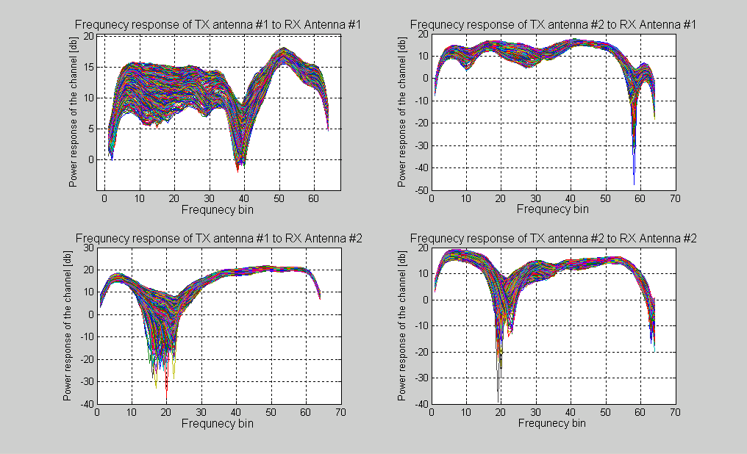
Figure 2 - Frequency Response of a Typical Indoor Wireless Channel

Figure 3 shows the variation of the channel between transmit antenna #1 and receive antenna #1 (the upper left channel in Figure 2) over time. In this 3 dimensional plot the independent axes are the time (from 0 to 100ms) and the frequency bins (0-64 representing the frequency from -10 to 10MHz around the center frequency). The dependent axis is the amplitude of the frequency response in dB.
Figure 4 shows the frequency response for 4 selected bins (#10, #26, #42, #58) vs. time.

The effects that can clearly be seen from Figure 3 and Figure 4 are:
- Selective fading – bin #40 and its surrounding bins are within a destructive interference. The indoor reflections have summed up out of phase creating a 10-15 dB null.
- "Slow" channel variability – bin #20 and its surrounding bins vary slowly with a variance of several dB. The period of these changes is around 5 Hz. These changes can be accounted for by the indoor Doppler effect and its bell shaped spectrum (see [1], section 4.7). The Doppler frequencies exhibited in these measurements tend to support the assumption that the Doppler characteristic frequency () is around 6Hz.
- "Rapid" channel variability – The frequency response at bin #10 and its surrounding bins change rapidly during the measurement. The period of these changes is about 100Hz (i.e. 10 cycles during 100ms). This "modulation" is clearly shown in Figure 4 for bin #10.

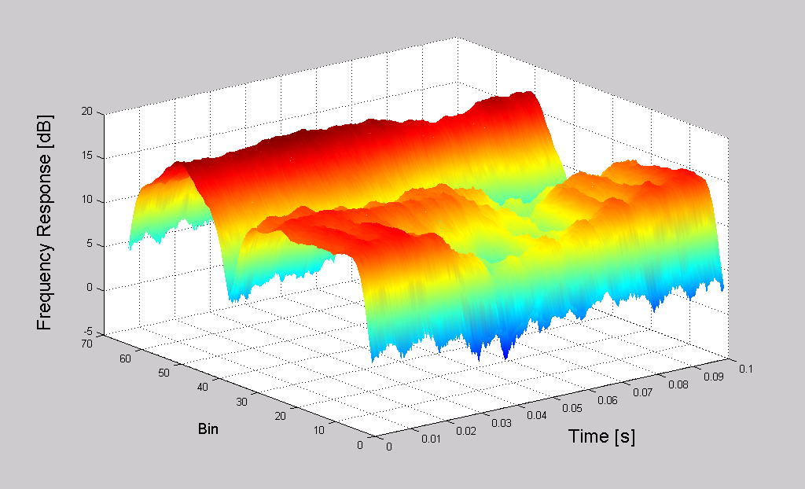
Figure 3 – Channel Frequency Response over Time

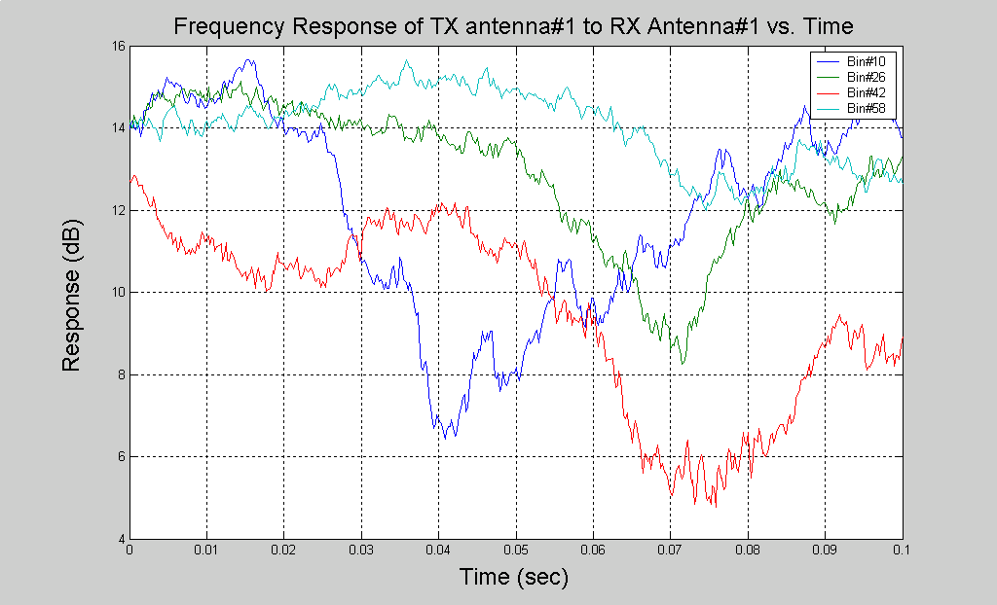
Figure 4 - Selected Bins Frequency Response vs. Time

The above variability characteristics have been observed over numerous measurements in various locations, scenarios and measurement conditions.
As selective fading and slow channel variability (indoor Doppler effects) have been subjects for much research ([1]), it was the rapid channel variability, which became the focus of this study.

Statistical Characteristics of AM Modulation of the received signal
The following section provides a statistical analysis of the magnitude of this effect. The measured data includes hundreds of measurements at different locations, as described in §. For the analysis shown, a high pass at 50Hz was taken in order to omit the standard Doppler effect.
Figure 5 shows the CDF of the signal to interference ratio (the ratio of the AM modulation to the total impulse response power). The median value is obtained for –35dB and 90% probability is obtained for –28dB.
Figure 6 shows the CDF for the peak-to-peak magnitude of the AM modulation (the ratio between the maximal impulse response energy and minimal one). The median value is obtained for a peak-to-peak variation of 0.8dB and 90% probability is obtained for a value of 1.5dB.
Figure 7 shows the CDF for the standard deviation of the AM variation with respect to the to total impulse response energy). The mean value is obtained for a standard deviation of 0.15dB and a 90% probability is obtained for a value of 0.27dB.

Figure 5 - CDF of the Signal to Interference Ratio of the AM interference

Figure 6 - CDF of the Peak-to-Peak magnitude of the AM interference

Figure 7 - CDF of the Standard Deviation (in dB) of the AM Interference Amplitude

Experiment 2: Fluorescent Light Interaction with Indoor Wireless Systems

Objective
The objective of this experiment was to isolate and ascertain the rapid channel variability effect and the assumption that it originates in common office fluorescent lights.

Measurement Setup
A single continuous wave (CW) generator was connected to a directional antenna (antenna gain of 23dBi, 5° aperture). The transmitted signal propagated through a rack of several fluorescent lights bulbs. The signal was then picked up by an identical antenna, amplified using an LNA and fed into a spectrum analyzer. Two variations of this setup were used- one in which the receiving and transmitting antennae were facing each other, with the fluorescent lights in the LOS path, and another in which the rack was used as a reflector, and the antennae were placed at an angle. Figure 8 shows both setup arrangements. A photograph of setup no. 1 is shown in Figure 9.
Three scenarios were tested:
- Fluorescents Off – The signal was transmitted through the fluorescent lights while they were not lit.
- Fluorescents On – Without changing the setup, the fluorescent lights were lit.
- Tin Foil Wrapped Lit Fluorescent – In order to distinguish between radio frequency interference (RFI) and other types of interactions (e.g. reflection), an ungrounded tin foil was wrapped around the fluorescent. This conductive tin foil is assumed not to suppress any emissions that might emanate from the bulb (due to it not being grounded), but to reflect a significant portion of the transmitted electromagnetic wave reaching the light bulb.

Figure 8 -Experiment #2 Measurement Setup

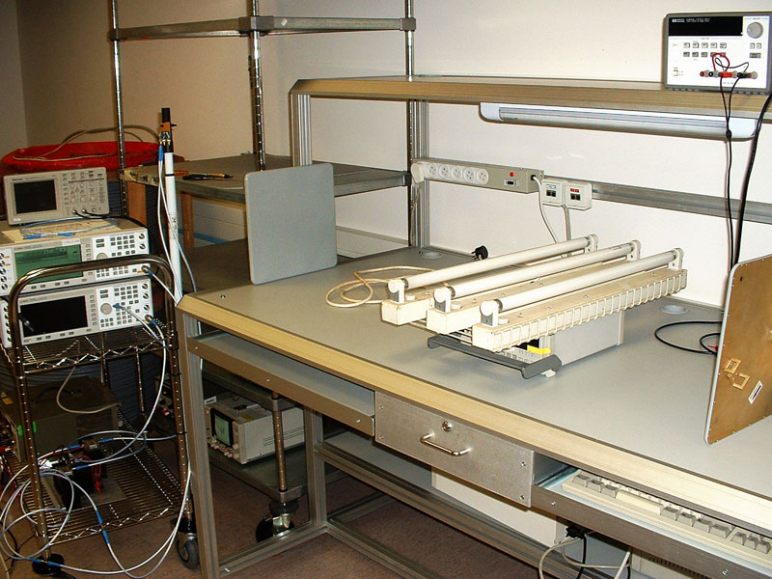
Figure 9 - Experiment #2 Measurement Setup

Results
Figure 10 depicts a spectrum analyzer screen capture from the three scenarios (blue – fluorescents off, red- fluorescents on, green- tin foil).
When the fluorescents were off (blue trace), a CW spectrum is shown with insignificant side lobes (67 dB down) at 100Hz offset. This modulation can be a residue of active fluorescent lighting in the setup vicinity entering the side lobes of the directional antenna.
When the fluorescents were on (red trace), dominant (25 dB) AM modulation-like side lobes are evident. The "modulating signal" is a series of odd harmonics of 100Hz (i.e. 100, 300, 500). The 50Hz mains frequency is also evident, but at significantly lower amplitudes (20-30dB lower than the 100Hz harmonics). This is probably due to a slight imbalance in the mains voltage waveform.
With the introduction of the tin foil, while the fluorescent was on (green trace), the effect diminished to its original level, very similar to the scenario when the fluorescents were off.

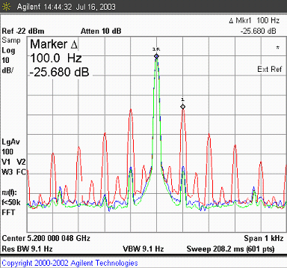
Figure 10 - Spectrum Analyzer Results from Experiment #2

Figure 11 depicts a time domain "zero span" type measurement. In this mode the spectrum analyzer demodulates the input signal and displays its power in the time domain.
A clear amplitude modulation is evident, where the amplitude variation is approximately 3dB peak to peak. It is worthwhile noting that the actual shape of the modulation could be easily changed by slightly modifying the geometry (e.g. wave angle of incidence to fluorescents).

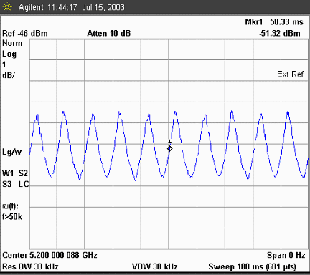
Figure 11 - AM Modulation on Received Signal

Physical Interpretation
Experiment #2 provides compelling evidence that the rapid channel variability shown in experiment #1 is in fact a result of electromagnetic wave interaction with the fluorescent lights. The stark difference between the spectrum of the received signal obtained by turning the fluorescence on leaves very little doubt as to the origin of the phenomenon.
In fact, this phenomenon, rediscovered by the authors, was reported in the literature as early as 1992 ([4]). With very similar experiments (at a wider range of frequencies) Melançon et al have reached similar conclusions.
Due to the fact that fluorescent lights become conductive twice every mains AC cycle, they reflect the incident electromagnetic wave. Between periods of fluorescence, when the voltage across the tube is not enough to ionize the gas inside the lamp, the fluorescent conductivity dies out leaving the bulb almost transparent to incident electromagnetic waves. This phenomenon can be envisioned as metal shutters being drawn and retracted at a certain frequency, thereby changing the electromagnetic reflective multi-path scenario at a rate of twice the mains power cycle (100Hz Europe, 120Hz US).
Having the ungrounded tin foil wrapped around the fluorescent bulbs eliminates the phenomenon due to the fact that most of the time varying fluorescence reflection is prevented by the outer conductive surface. If this modulation was somehow caused by electromagnetic waves emitted from the fluorescent bulb, the effect should have remained at comparable levels with the “on” scenario.
In [5] Vogel et al have computed the conductivity of fluorescent lights at both their states using ionized gas theory. It has been shown that for the standard GE T12 light bulb at frequencies above 1GHz the effective dielectric constant exceeds 82.0 (lossy conductor) during the “on” state and is very close to 1.0 during the “off” state. This effectively means that the fluorescent bulb will reflect most of the incident electromagnetic wave in the “on” state, and become transparent to it during the “off” state.
Gilbert et al (Atheros) have recently showed similar results ([3]) as part of the IEEE 802.11 High Throughput Study Group (HTSG) confirming this study’s findings. AM-like-modulation was obtained with both directional and omni-directional antennae.

Experiment 3: Electronic Ballast Systems

Objective
The objective of this experiment was to check whether the same phenomenon exists in fluorescent lights using electronic ballast systems.

Measurement Setup
The same setup, as in experiment 2, was used except that the magnetic ballast fluorescent lamps were replaced with two 27W electronic ballast lamps, which fit in normal E27 type sockets.

Results
Figure 12 depicts a spectrum analyzer screen capture, showing a number of AM modulation peaks created by the interface with the electronic ballast lamps. The relative power of these peaks ranges from –40dB to –60dB, around a 5.47GHz carrier. The rack was fitted with two electronic ballast lamps, and their different oscillation frequencies can be easily discerned- about 75kHz and 90kHz. Multiples of these frequencies are also evident. Dynamic measurements support the hypothesis that these oscillators are free running, with frequency variance in the range of ±10kHz.

.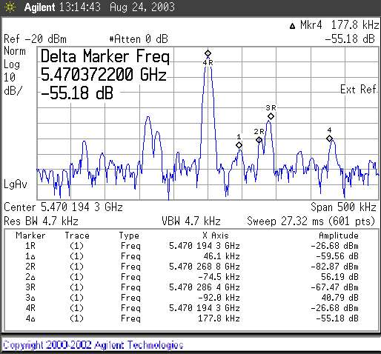
Figure 12 - Modulation Peaks Produced by PL (electronic ballast) Fluorescent Lamps.

Since the different lamps have independent ballasts, and therefore independent oscillation frequencies, a C/I measurement cannot provide accurate quantification of the magnitude of the interference. As opposed to the magnetic ballast lamps, where all “reflectors” are turned on and off at virtually the same time, each electronic ballast lamp generates an independent set of AM modulation frequencies, and a band-power integration has to be performed. Figure 13 shows a band-power measurement for the interference spectrum, compared with the peak power of the transmitted sine wave:

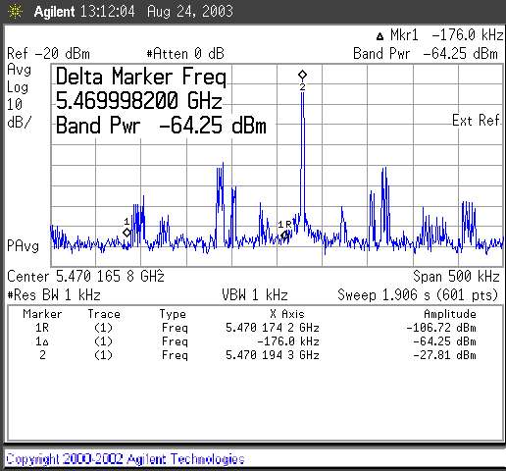
Figure 13 - Band Power of the electronic ballast lamp interference.

After correcting for thermal noise, the single-sideband interference measures to be at a C/I ratio of –36.5dB. This is around 4dB higher than the result suggested by the single peak C/I measurement.
Because of the very rapid nature of this phenomenon, AM magnitude measurements and statistical analysis were not possible under the scope of this study.

Physical Interpretation
Unlike magnetic ballast systems, which rely on the AC mains cycle to generate the voltage required to ionize the gas inside the fluorescent bulb, electronic ballast systems use a crude oscillator, usually driving a power JFET device, which draws current from the AC power. This crude oscillator generates a high frequency signal (usually at 40-100KHz) that drives the system. Along with improved efficiency, the electronic ballast systems are better in the ergonomic sense because of their design not to switch off completely the fluorescent at any part of the cycle.
Since the fluorescent remains conductive, the electromagnetic reflection environment is hardly changed throughout the cycle and the equivalent AM modulation created is significantly smaller (-40dB in this experiment). Furthermore, the free-running nature of these oscillators, as opposed to the AC synchronized magnetic ballast systems, would mean that the residual AM modulation may be averaged out in a situation where many fluorescent lights are involved, while still creating a higher noise floor and degrading performance.

Proliferation of Electronic and Magnetic Ballast Systems

Since the AM modulation effect is extremely prominent in magnetic ballast and much smaller with electronic ballast systems, it seems natural to try and assess the proliferation of electronic ballast systems in comparison to magnetic ones.
According to [6] the amount of electronic ballasts sold in Q1 2003 in the USA were 13,232,000 (about 57%) whereas the amount of magnetic ballasts sold in the same period was 9,662,000 (about 43%). The electronic ballast systems only reached 50% of new shipments during Q3 2000, and the existing installation base of magnetic ballast systems is still very wide. Figure 14 shows a graphic summary of the US Census results appearing in [6]:

Figure 14 - Yearly Shipments of Fluorescent Ballasts

It is important to note, that in many cases electronic ballast fluorescent lamps are used as a replacement for E27 tungsten lamps, and that the real decline in the share of magnetic ballast fluorescent lights is in fact smaller. Since the lifespan of a T12 (magnetic ballast) light bulb is about 2 years in continuous operation, it is safe to assume that the office environment is still mainly lit by magnetic ballast fluorescent lamps, and that this situation will not change drastically during the coming years.

Suggested Model
The results of this study can be incorporated into the work of the HTSG special committee on channel models ([1]) in a straightforward manner.
Since the model suggested in [1] is a discrete tap clustering approach, we suggest modulating several taps in order to artificially introduce an AM modulation. The modulating function should be randomized to yield AM distortion amplitudes similar to measured results, as well as various period shapes caused by random phasing of its spectral components. Furthermore, it seems adequate that the effect be introduced into [1] models D, E (Typical Office, Large Office) as these seem to have omnipresent fluorescent lighting, and will be affected the most from fluorescent effects.

Let:

Where:
 | The modulating function
 | Relative harmonic amplitudes
 | The mains AC frequency
 | A series of IID phase RV's
t | Time

We have chosen to model the fundamental tone and 2 odd harmonics (100Hz, 300Hz, 500Hz in the European case), as this seems to be a good enough approximation of the modulating signal.
The suggested amplitudes shall be as follows:

Coefficient | Value [dB]
 | 0
 | -15
 | -20

The interferer to carrier energy ratio shall be driven from the following random variable:

Where:

Wherein the first figure is the mean of the Gaussian, and the second is the variance (the standard deviation squared). Figure 15 shows the CDF of the modeled I/C in green, and the measured experimental results in blue. This plot shows excellent correlation to the measured I/C.

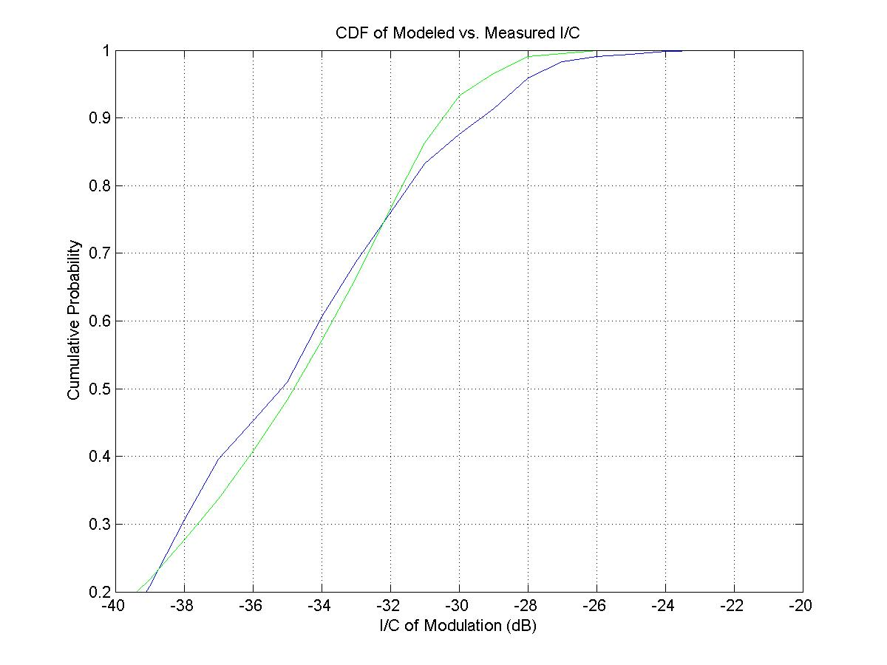
Figure 15 - CDF of Modeled I/C vs. Measured I/C

Once this variable has been drawn, we now suggest modulating 3 taps in each model by the modulating function in accordance with the drawn I/C. The time value of each one of these coefficients shall be:

Where:

Original tap value
Modified tap value
The modulating function
Normalization constant

The value of shall be determined such that the total modulation energy (modulation in the modulated taps, compared with the entire channel response) matches the drawn random I/C.
The following taps shall be modulated:

Model | Cluster | Tap numbers
D | 2 | 2,4,6
E | 1 | 3,5,7

Conclusions
Extensive measurements of WLAN MIMO channels in a typical office environment were performed and presented, and various modulation effects, incorporated into known channel models, were noted. In addition, a rapid-variation AM-like modulation of the channel response was observed. Further experiments were performed, verifying that this effect originates in reflections from fluorescent lamps. This phenomenon, though previously described in the literature, was not incorporated into WLAN channel models until this time. Being a significant phenomenon, especially where high-throughput, state-of-the-art systems are involved, an addition to the channel model is suggested, which can be seamlessly incorporated into existing models and simulations, and is in excellent agreement with measured data.

Acknowledgement
Special thanks is given to Zohar Livny for his extraordinary insight into physics and RF wave propagation, which helped us greatly in unraveling this unusual phenomenon.

References
[1] Vinko Erceg et al, "Indoor MIMO WLAN Channel Models", IEEE 802.11-03/161r3
[2] Nir Tal, "Time Variable HT MIMO Channel Measurements", IEEE 11-03-0515-00-htsg.
[3] Jeff Gilbert et al,
"Quick-Fluorescent-Measurements", IEEE 11-03-0631-00-htsg
[4] P. Melançon and J. Lebel, "Effects of Fluorescent Lights on Signal Fading Characteristics For Indoor Radio Channels", IEEE Electronic Letters, Vol. 28 No. 18, August 1992.
[5] W. J. Vogel, Ling, Torrence, "Fluorescent Light Interaction With Personal Communication Signals", IEEE Transactions on Communications, Vol. 43, No. 2/3/4, Feb/ Mar/Apr 1995
[6] US Census Beauro, “Fluorescent Lamp Ballasts: First Quarter 2003”, May 2003, and “Fluorescent Lamp Ballasts: Summary 1997”, June 1998, Report No. MQ335c.

