IEEE P802.11
Wireless LANs
Tentative Minutes for the TGk July 2003 Session
Date: July 21-25, 2003
Author: Harry Worstell
AT&T
180 Park Avenue Phone: 973-236-6915
e-Mail: hworstell@research.att.com

Monday, July 21, 2003
3:30 PM – 5:30 PM

Chair: Richard Pain
Secretary: Harry Worstell

- Call to order
- Attendance

- Agenda
Approve Agenda

Review IEEE802 & 802.11 Policies and Rules

IP Patent Policy

Voting

Roberts Rules
Approve May 2003 DFW Meeting minutes
Approve the teleconference minutes
Set/ Review Objectives
Update On Teleconferences
Matrix Review
Technical Presentations
Break
Technical Presentations
Recess until Tuesday, July 22

Move to Approved the agenda
Approved by unanimous consent

Reviewed the IP Patent Policy with the group.
Reviewed Inappropriate topics for IEEE meetings
Reviewed document rules
must be on the server before presentation
Reviewed voting policy for status
Must follow Robert’s Rules of Order

- Chairs comments
Reviewed scheduled for the week
- Approval of the May 2003 minutes

Motion:
Move to approve the minutes of the May 2003 DFW session.
Approved Unanimously

Motion:
Moved to defer the approval of the minutes of the May-June-July 2003 teleconferences until Thursday at the 1:00PM session.
Moved Marty Lefkowitz
Second J Kim
Approved 18 Disapproved 0 Abstain 1

6) Set Objectives for the week

Meet the technical requirements for
Scenarios
Work Matrix
EVM vs. PSNI Quality measurement

Site Reporting

Adding measurements
Framework for fast roaming and MIBs

Later in week Pat Calhoun will present
Will attempt to get Bob O’Hara to speak
Make sure the measurements are in place for fast roaming
Make sure that the draft is technically complete before going to letter ballot

- Teleconference update were covered
  - Scenarios
  - Start up issues
  - updated the matrix
- Covered the matrix document 427r7 with revisions _ Document not available on server
  - Pre-association Services
    - Need more bits Doc 338 by Simon Black
  - Channel Map
    - new proposal by Simon Black
  - Initialisation
    - How do you determine the county code for mobile application
    - Get information out with out loading the beacon (Simon and Joe will present)
  - RCPI
    - Already in draft
  - S/N - Data quality
    - Dave to present (Doesn’t believe we can produce a measurement)
    - Joe Kwak to present opposite view
  - Neighbourhood Map
    - most is already in site report (Arunesh Mishra will present for Bill Arbough)
  - Site Report
    - In draft
      - Might need Byte counters
  - Unsolicited reports
    - Needs to be incorporated in the draft text ( From the Microsoft presentation)
  - MAC MIBs
    - Changes may be presented this week – J Kim
    - Actions-request and reports need a place to be stored so that they can be qued up to an AP
  - STA statistics table
    - Debatable as to need
  - SMT MIB for configuration Parameters
    - Open Issue
  - Neighbourhood maps are necessary in every category
  - Security management frame
    - out of scope
  - Distribution service of RRM info to STA and AP
    - Still needed – Simon Black will address
  - AP and STA statistics gathering service
    - Joe Kwak to offer text
  - Commanded STA action service
    - Only 2 is the beacon report and action report need to be reworded
  - Threshold trigger
    - Hassa Sinivaara to present
  - Add the Hidden Node Report to 13.7
    - Patrick to do
- Technical Presentations - Call for Papers
  - Site reporting - Simon Black -Tuesday AM
  - Sta Stats - Simon Black -Tuesday AM
  - Adaptive beacon - Simon Black -Tuesday AM
  - Site Reporting - Arunesh Mishra - Monday evening ~7:00
  - Review of current status – J Kim – Monday Evening
  - Periodic measurement normative text - Joe Kwak – Tuesday
  - concept of PHY measurements from 11H - Joe Kwak – Tuesday
  - Concept broadcast of neighbour list/maps - Joe Kwak – Tuesday
  - MIB - Joe Kwak – Tuesday evening
  - MIB - Joe Kwak – Tuesday evening
  - MIB - Joe Kwak – Tuesday evening
  - MIB - Joe Kwak – Tuesday evening
  - MIB - Joe Kwak – Tuesday evening
  - EVM simulations - Joe Kwak – Tuesday evening
  - Normative text New MAC measurements - Joe Kwak – Thursday evening
  - Normative text New MAC measurements - Joe Kwak – Thursday evening
  - MIB – J Kim – Wednesday – PM
  - 531 – EVM vs Packet error rate results - Dave Skellern – Monday evening
  - Patrick Worfolk – Wednesday PM
- Moved to recess by Harry
unanimous

Monday, July 21, 2003
7:00 PM – 9:30 PM

- Call to order
- Attendance 31
2) Dave Skellern presented 531

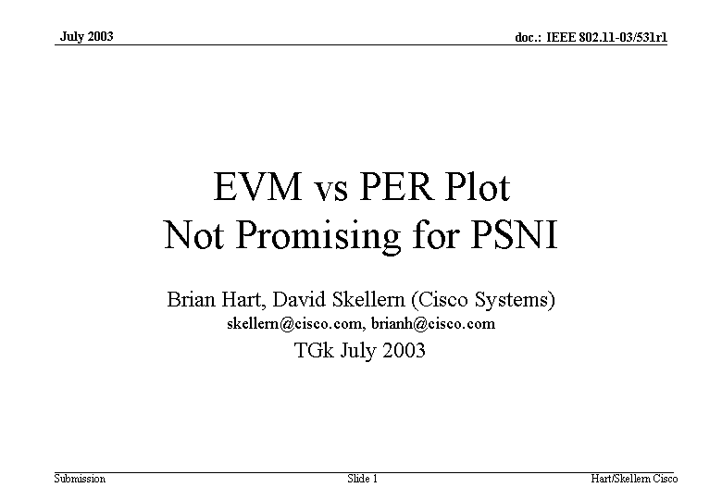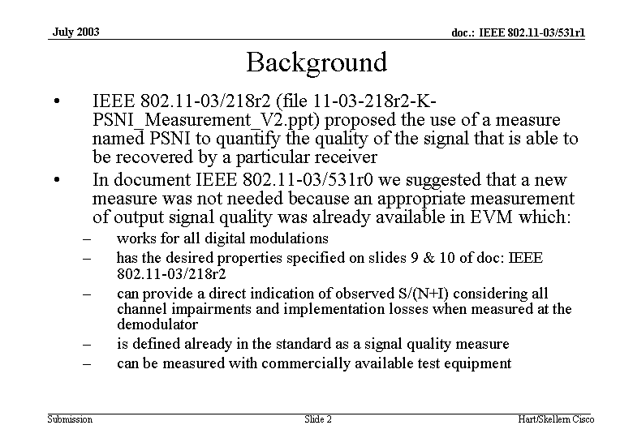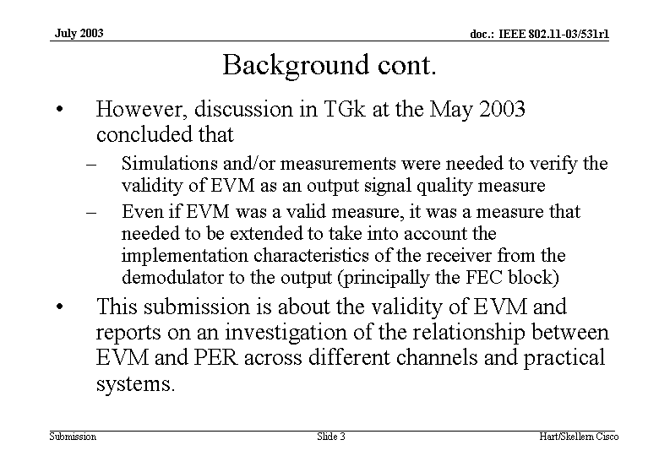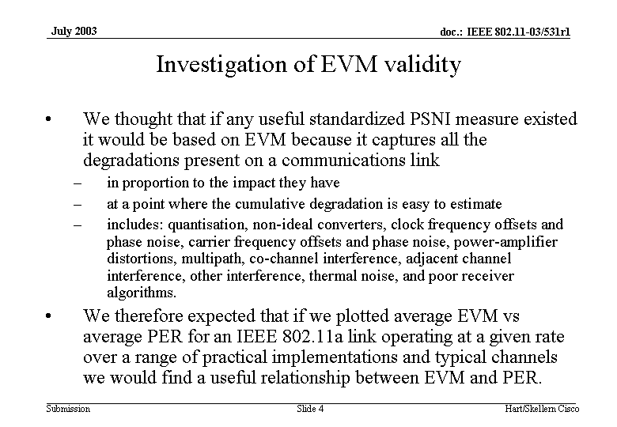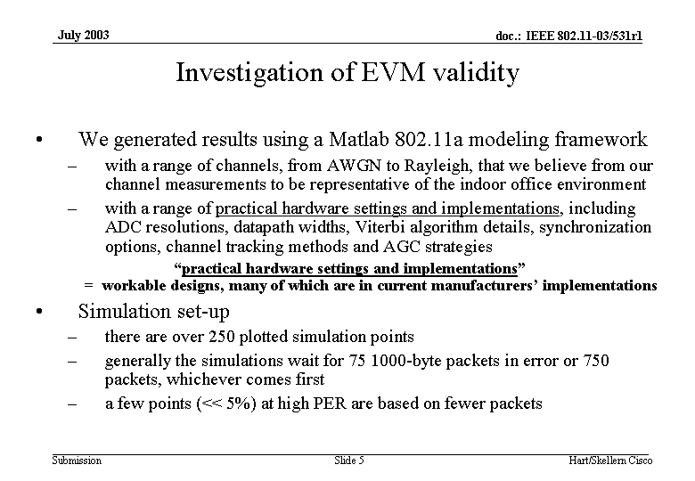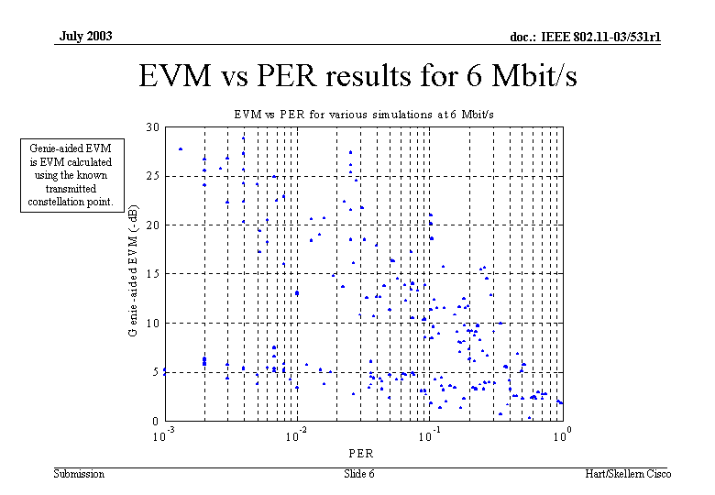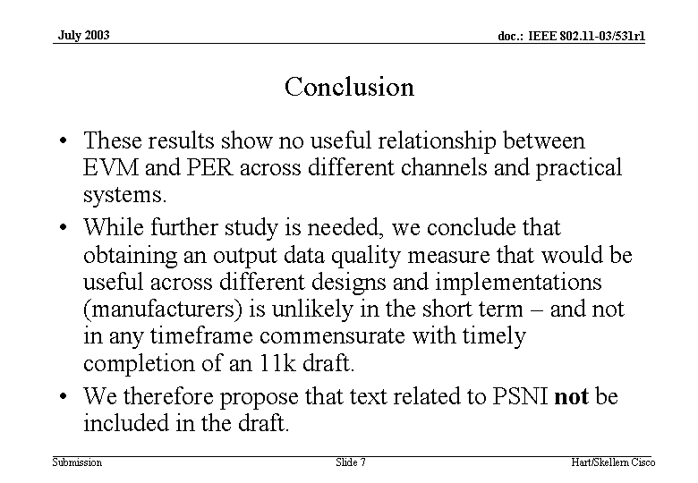

Conclusion indicated that EVM and PSNI would not be sufficiently accurate for measurements over different receivers. Channel models varied the delay spread different Doppler rates, used Rician and Rayleigh fading. The Packets were a 1000 byte packet (8000 Bits). Has a very complicated sync algorithm in the receiver. Can’t resolve the issue in a reasonable time for TGk. The is about 20 to 1000 packets per sample.

Comment: this doesn’t correlate with theory.
If synchronization fails (timing off) the error will be very large.
Comment:Agreed that failed packets will have a very high EVM. Weak tones will be amplified. It will not correlate with data.

Other ways are measure over all before the ??:? but not practical to do…very complicated to do.
Can get quality measure on average but not on a packet by packet basis. Better to measure error correction rate. May want to look at FEC?

Arunesh Mishra presented 03/541 inclusion of “Optimal-Channel Time parameter into Beacon Request and Site Reporting Elements in TGk”

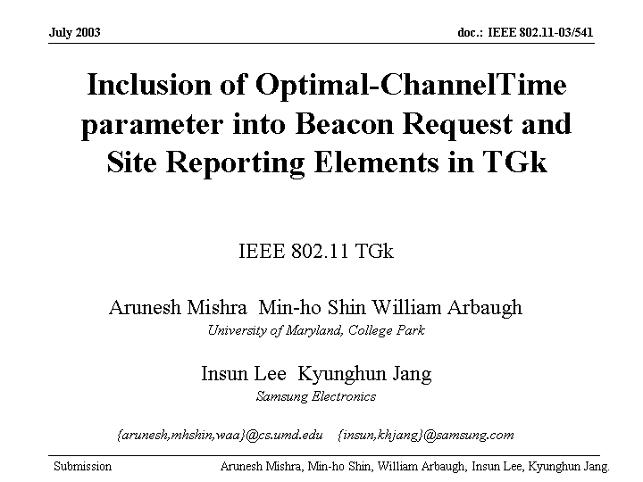

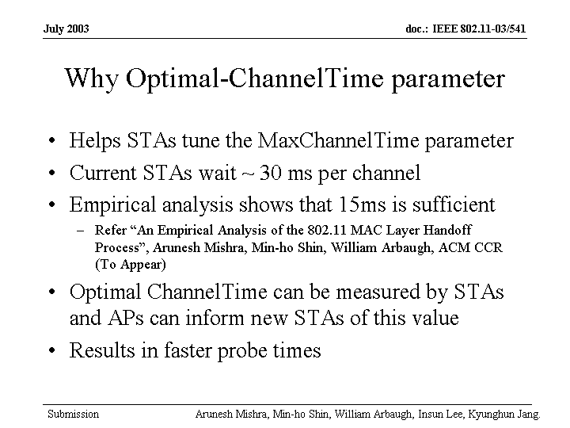
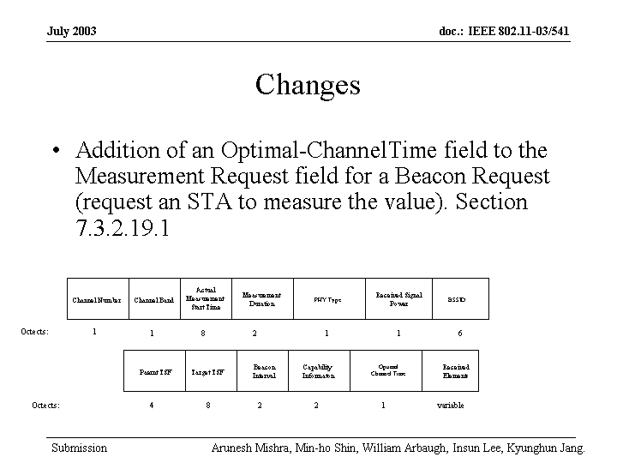

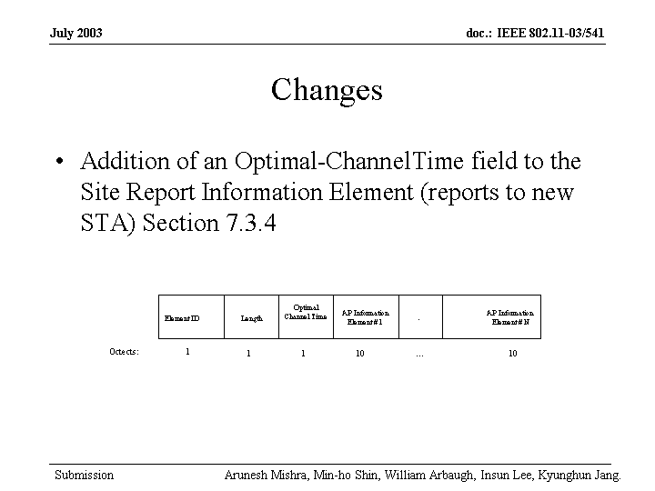

Parameters vary from 5mS to 50 mS for Max channel time. Slow active scan and is measured dynamically.
Comment: If this is used manufacturer will not be able to differentiate themselves. For beacon report have the STA measure the time to last probe response.

Had number of AP up to 7 and varied the traffic load and found that 15 mS was the max and the data load was 4Mbit/s. So the number of APs is the factor.

Comment: STAs will have a significant effect so it is the number of contending stations.
Comment: Questions the value of this and should not be too aggressive to minimize the channel time due to the number of probe request and waists channel bandwidth.

Comment: By the time the data is collected to adjust the time the STA will be behind….This assumes a slowly changing channel.

Comment: would like to see simulations
Comment Should be called Optimal max channel time

Arunesh Mishra Persented 540 “Fast Handoffs Using Fixed Channel Probing”

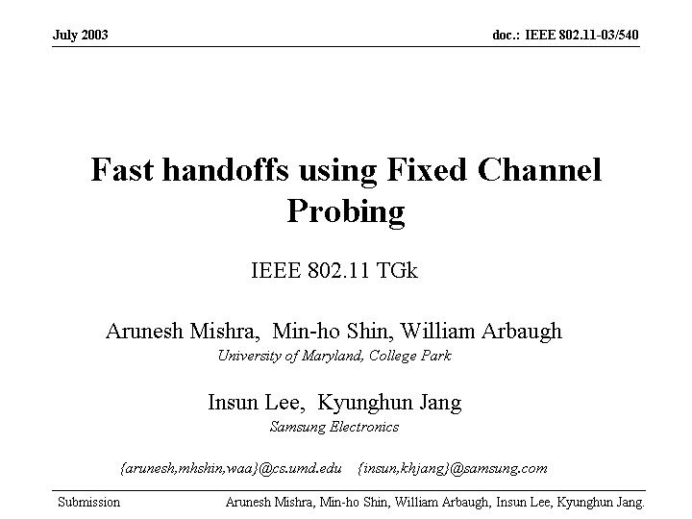

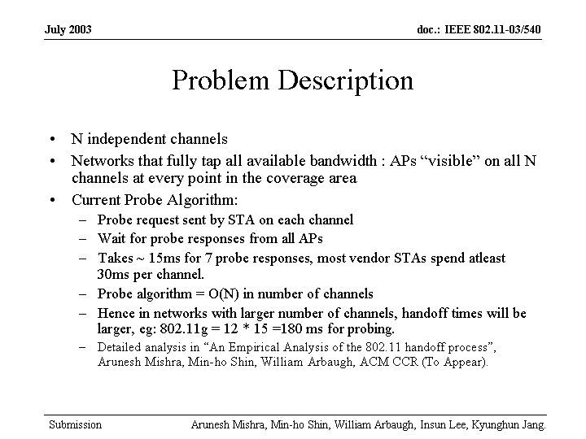

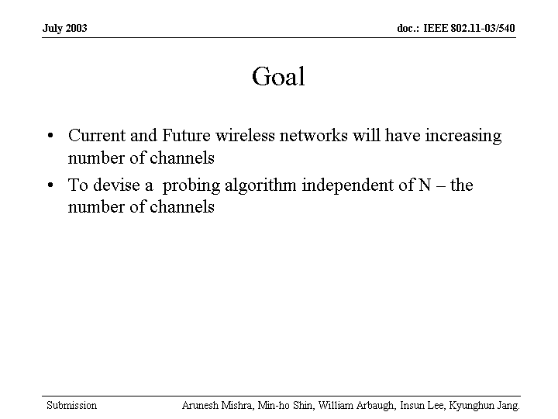

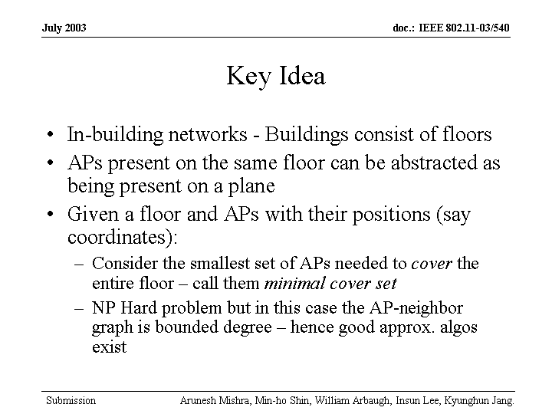

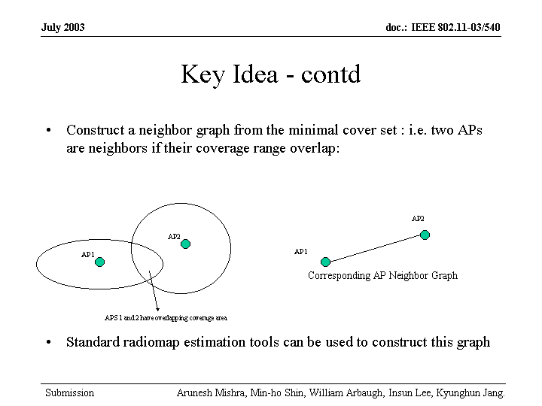

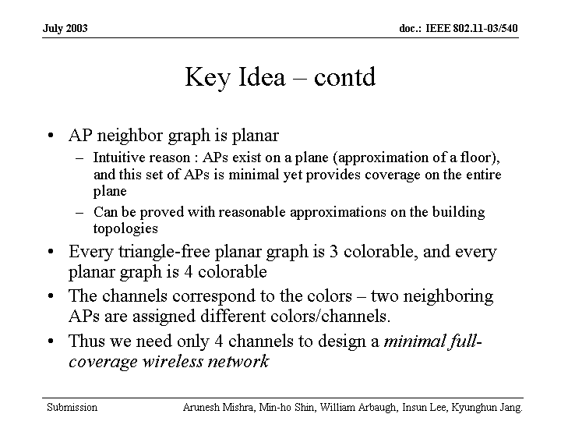

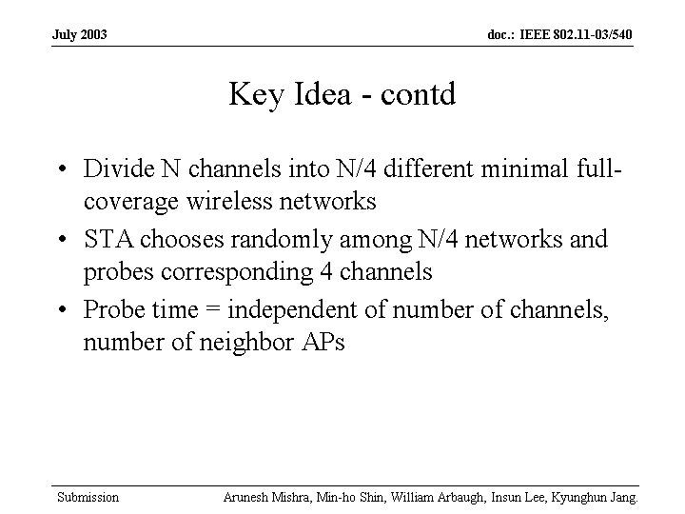

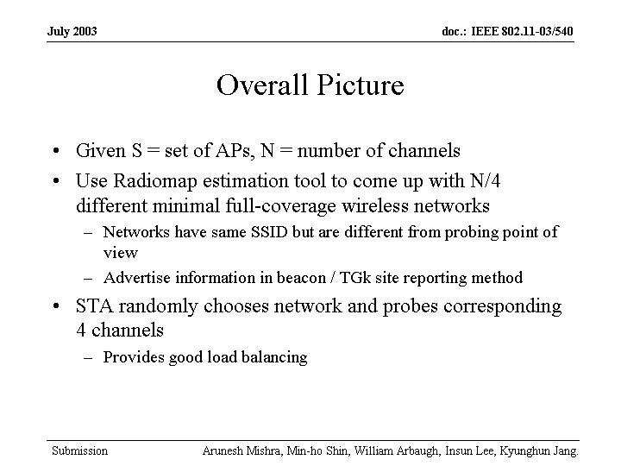

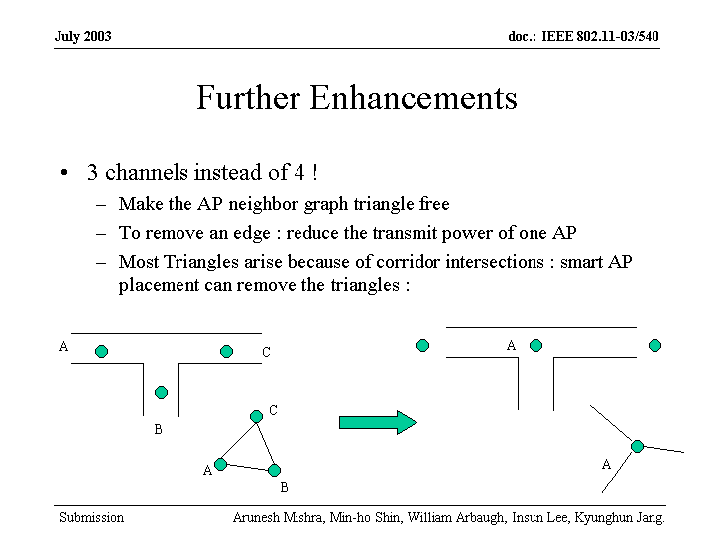

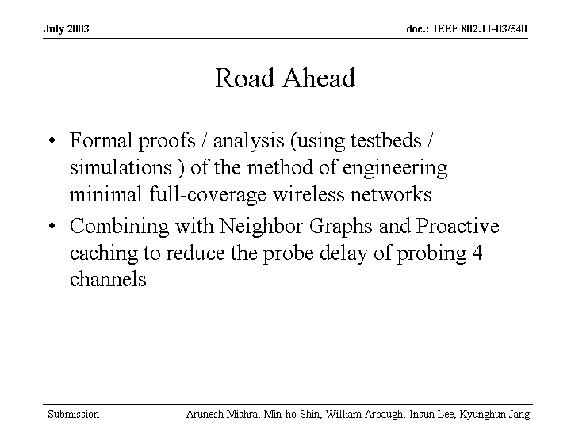

Comment: Requires the customer deploy a system the same way
Comment: will not have enough channels to operate in 2GHz area only 5GHz –not enough sets even in A
Comment: More channels will be in the 5GHz band expanding to another 11 channels.

Chair was handed to Marty Lefkowitz

J Kim presented 03/536 “RRM feature and Function”



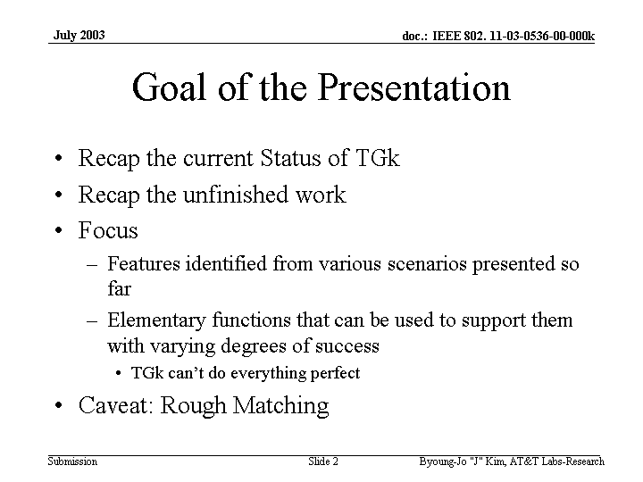

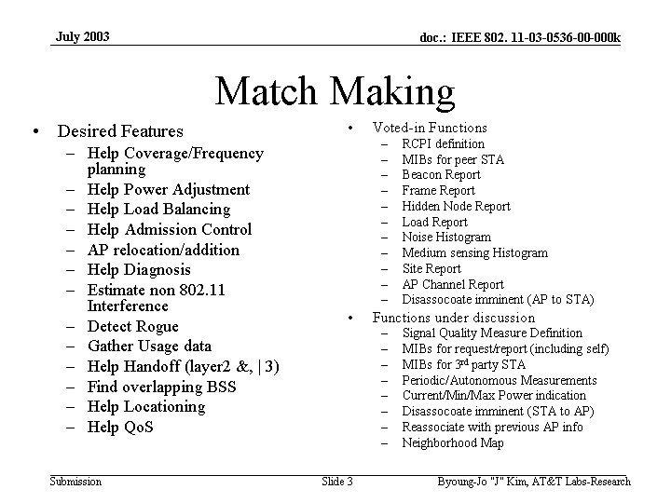

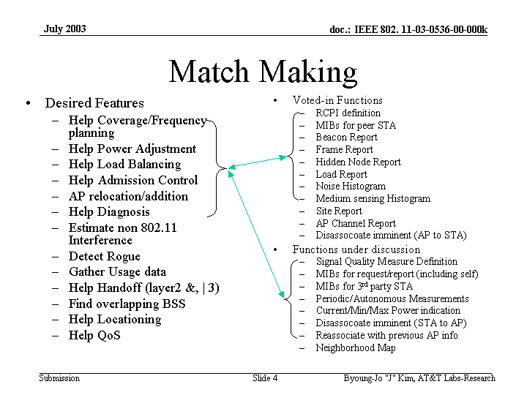

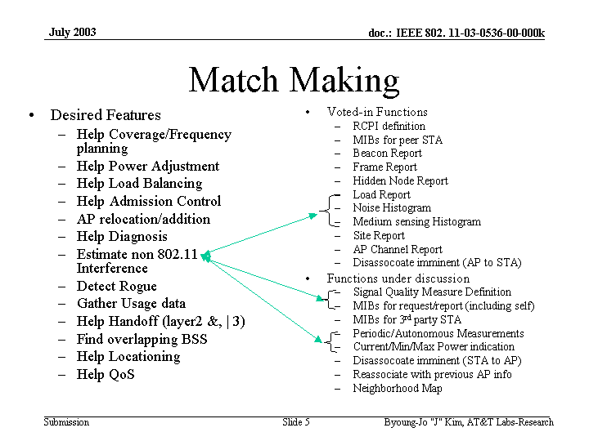
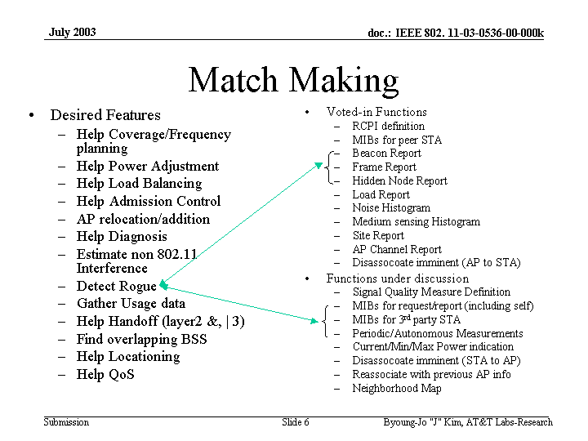

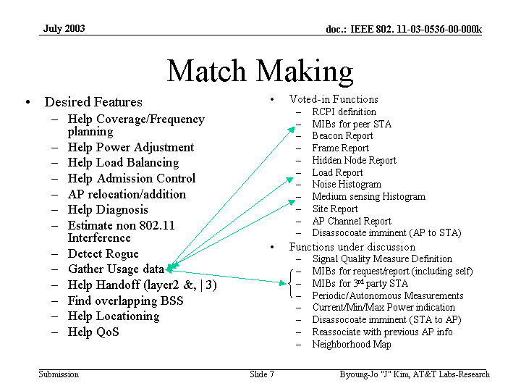

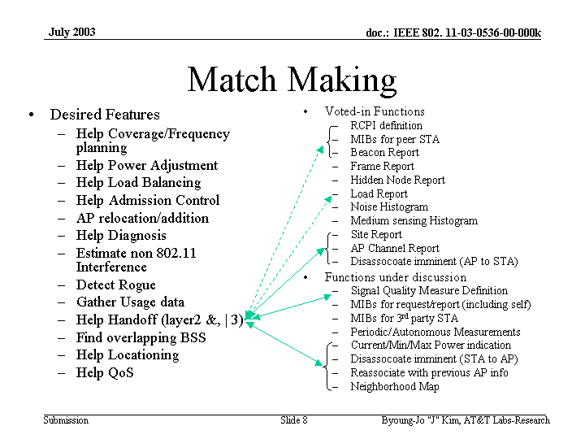

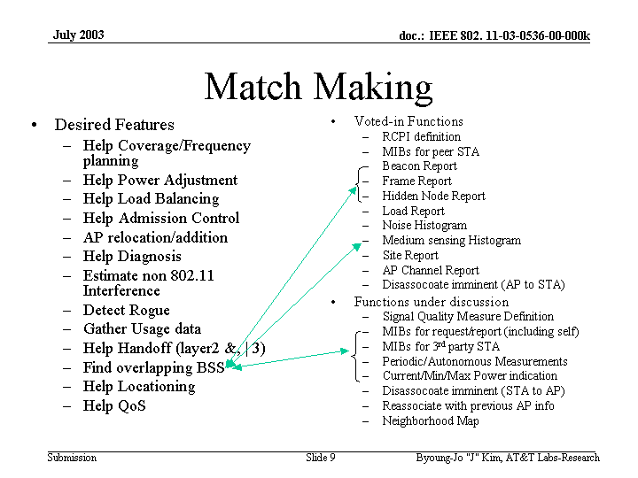

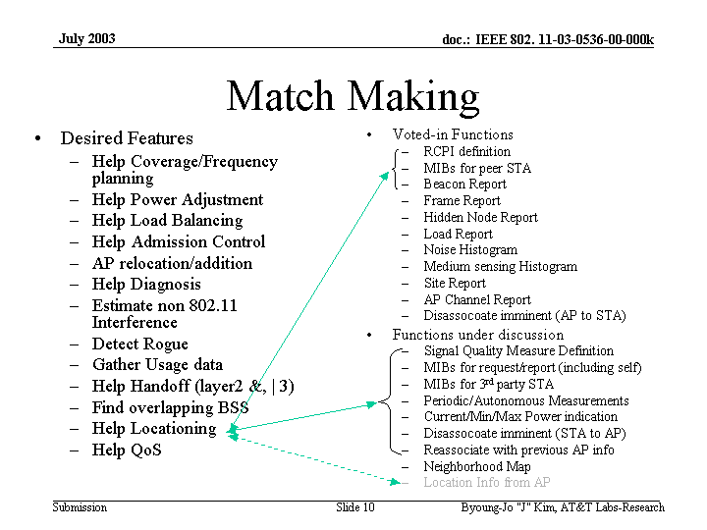

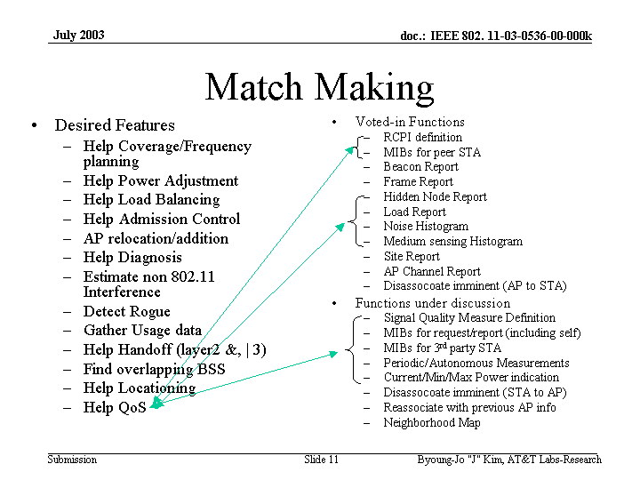

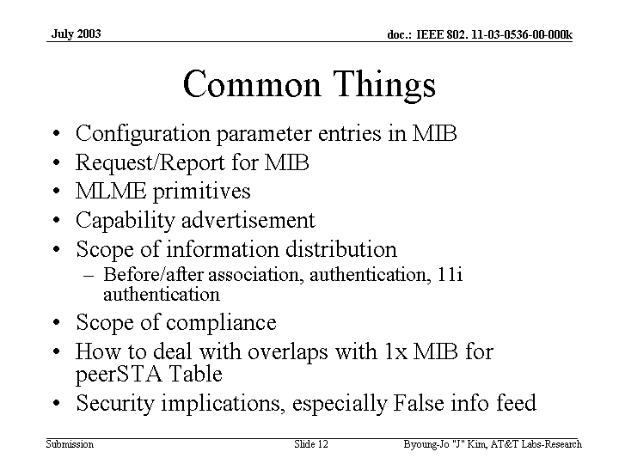

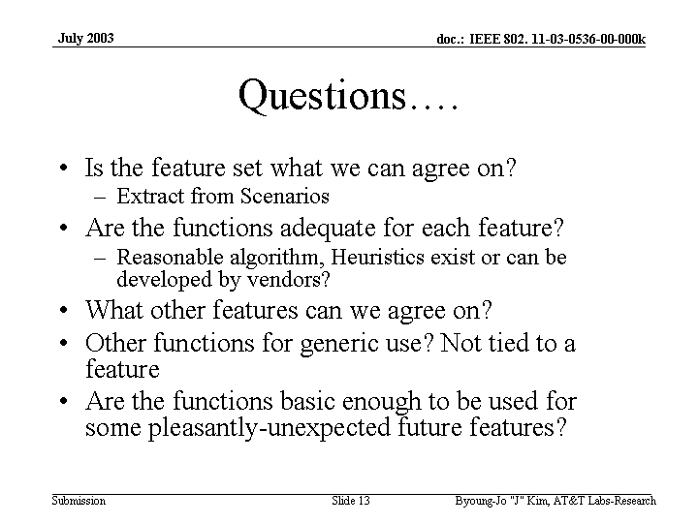

Chair was handed to Richard Pain

Chair ask for a team to look a MIBs
Develop a chart scenarios to measurements
Recess unanimous

Tuesday, July 22, 2003
8:00 AM – 10:00 AM
Chair: Richard Pain
Secretary:

Tuesday, July 22, 2003
1:00 PM – 3:00 PM
Chair: Richard Pain
Secretary: Harry Worstell

Call to order

Straw Poll :
Document 03/537r0
Should we draft normative text along these lines to incorporate 11h TPC into TGk.
Yes 11 No 2 Abs 30

Is this to incorporate TPC in the entire standard, i.e. 2.4GHz and 5GHz? It will be already in “a”
by virtue of TGh.

Joe Kwak presented 03/408 “Proposed text for periodic Measurements”

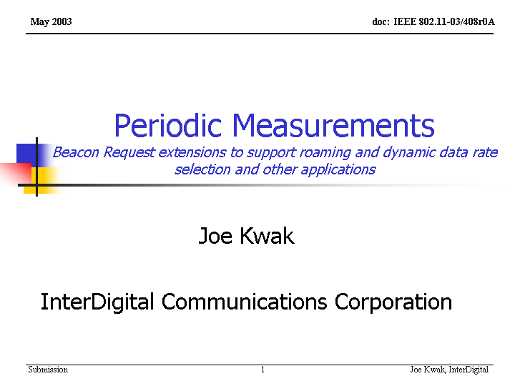

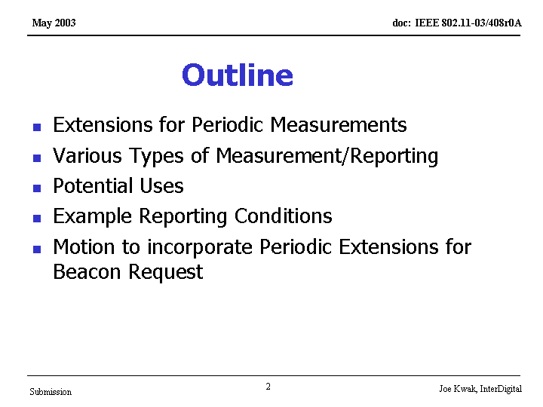

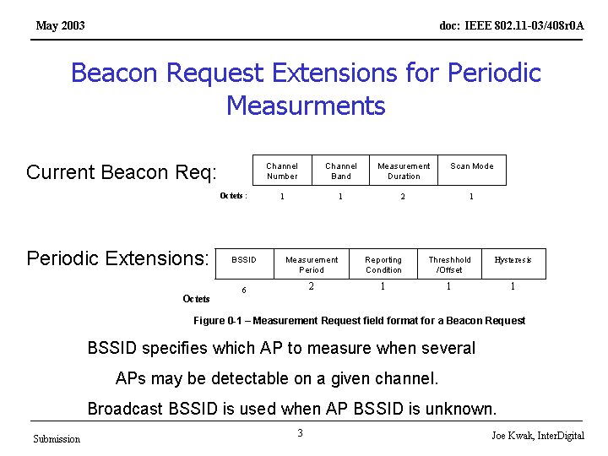

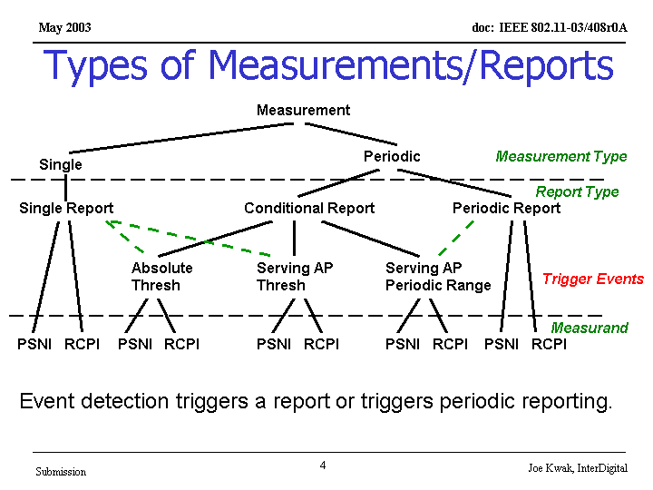
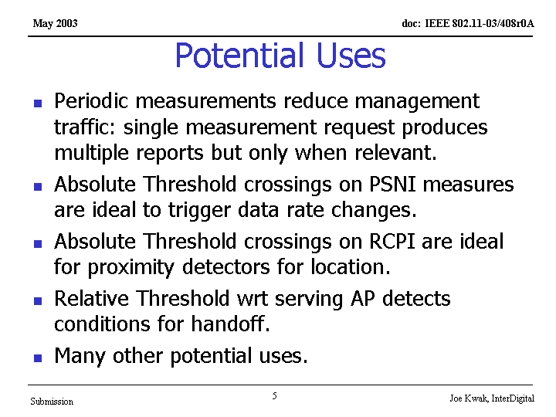

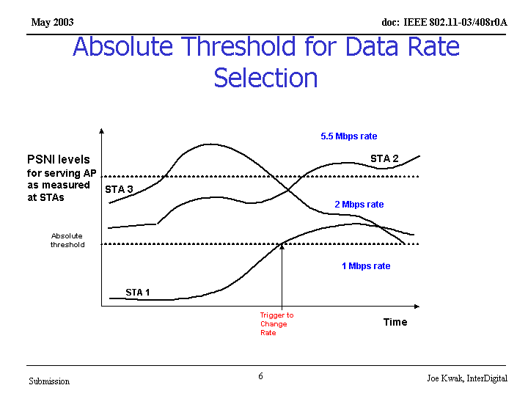
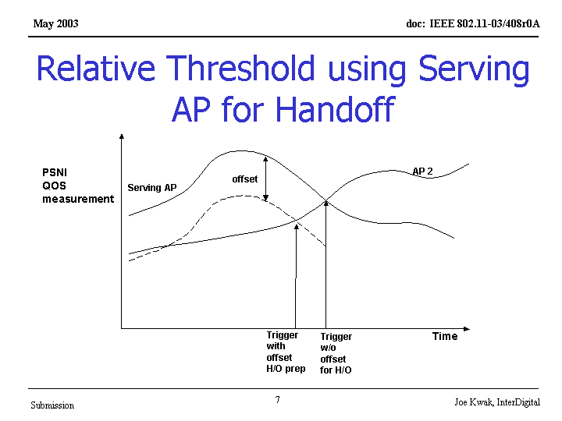

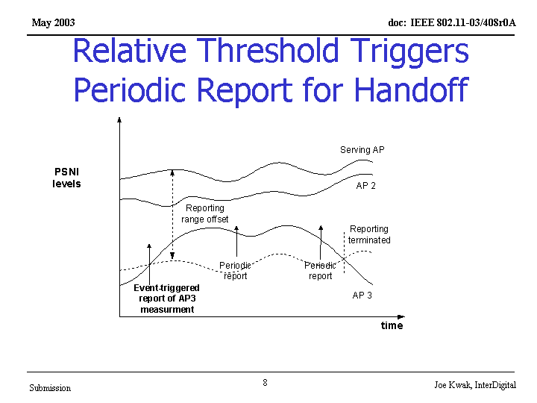
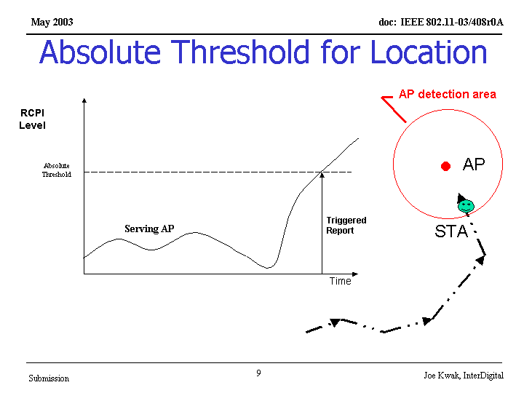
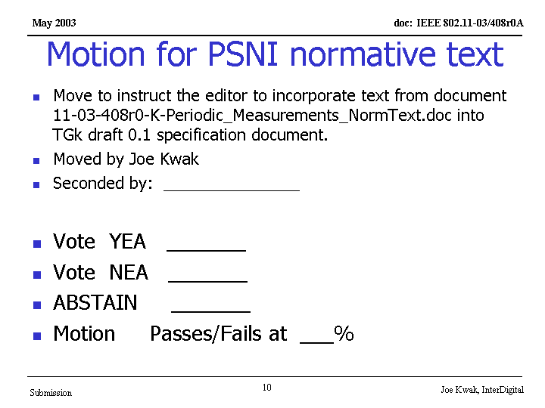

Comment: is this optional
Comment: Only the periodic functions is optional but the fixed values are not
bins are used for radar detection

Comment: Is there a way to disable this function and tie this into the scanning function?
Comment: The STA may miss the periodic measurement due to traffic, scanning, or something else. Not clear?
Traffic will take precedence

Straw poll :
Would you support the text in document 03/549 be place into the draft?

Yes 2 No 9 abs 31

Joe Kwak presented document 03/554 “Retrieving MIB contents from STA”

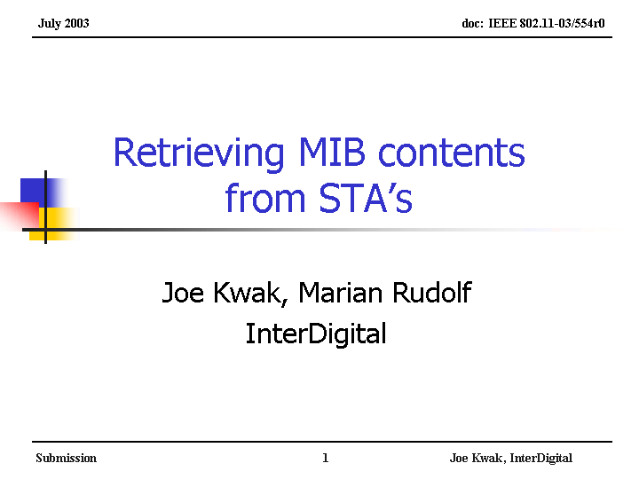

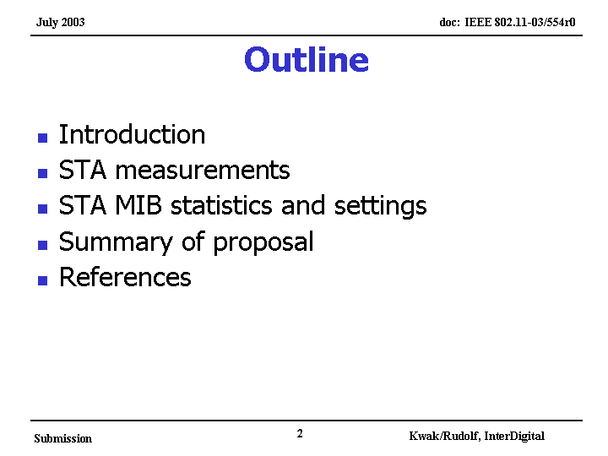

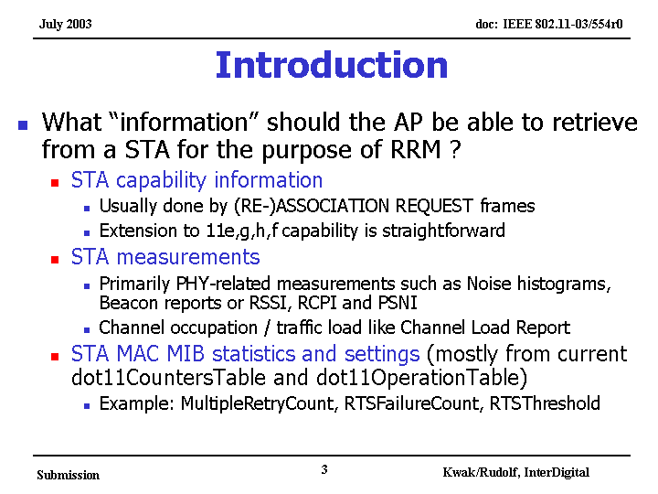

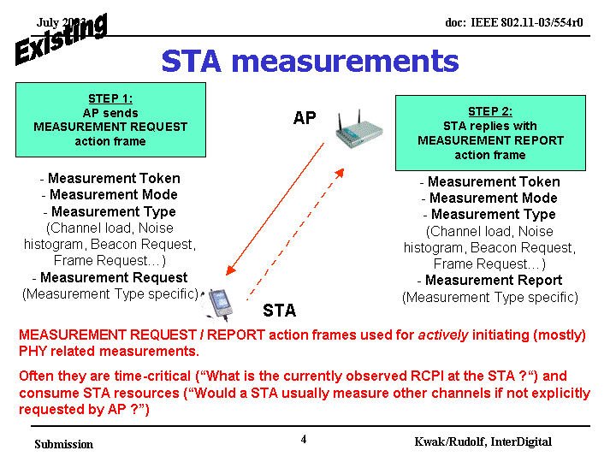
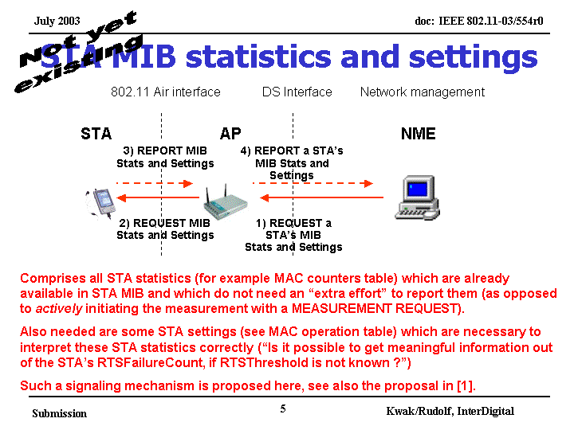

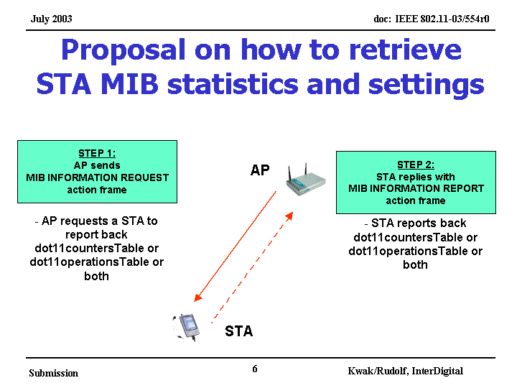

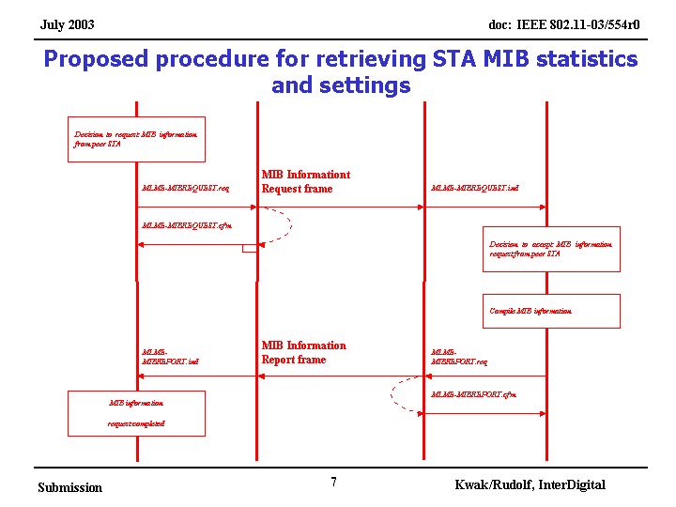

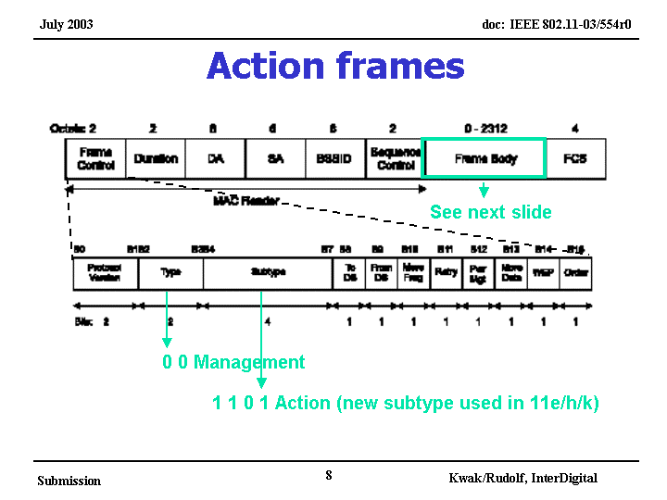

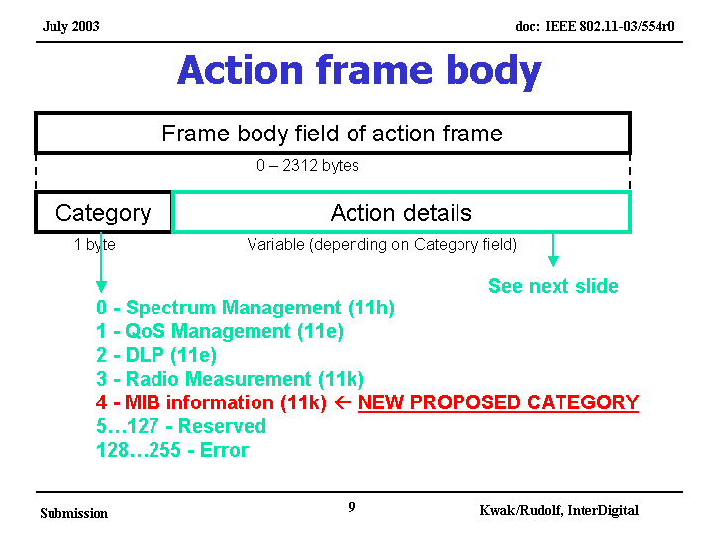

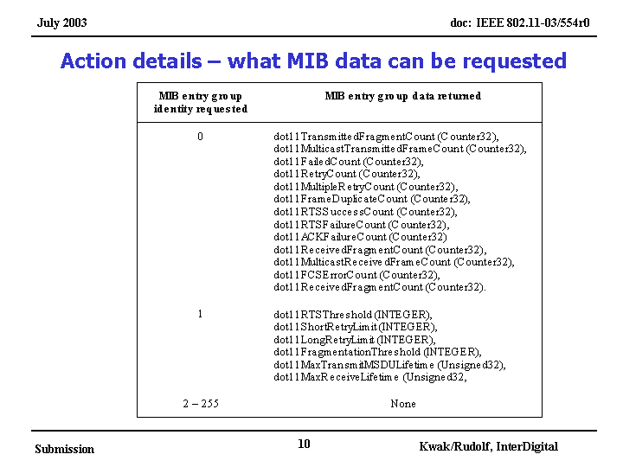

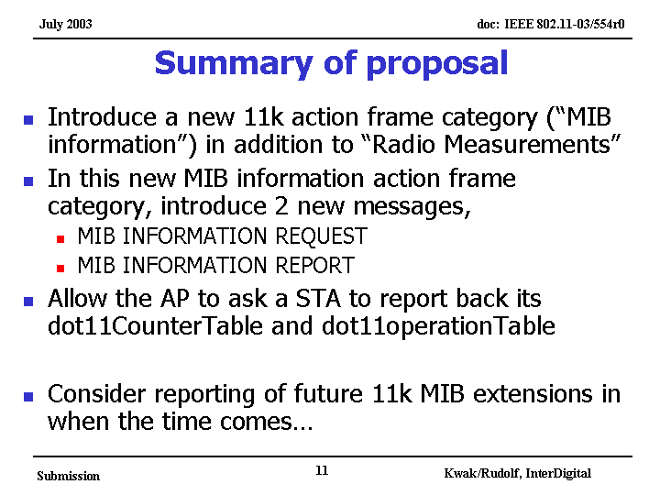

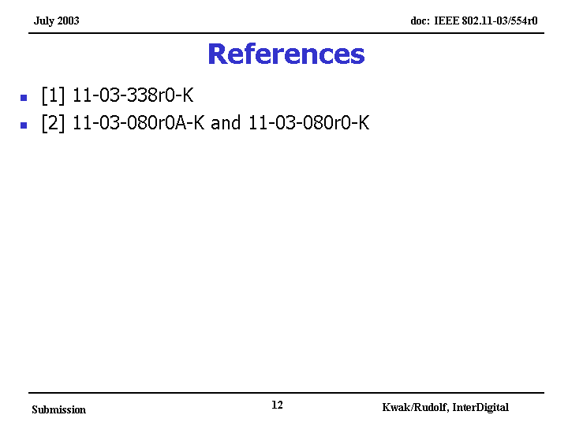

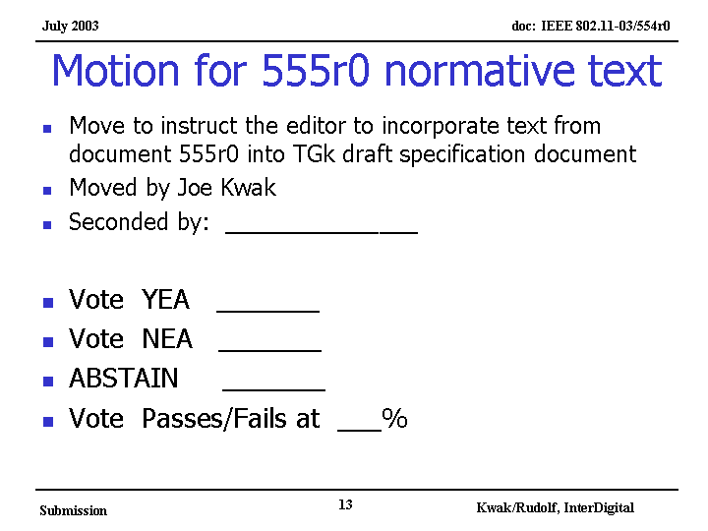

Comment: This adds text and more software to incorporate in the MAC that is not useful.
Comment: This is needed and does look like SNMP, the question is how should it be presented in the standard.
Comment: doesn’t believe this is the right this to do. It was agreed that these should be measurements and not a new SNMP and is open for abuse.
will defer decision until after Simon Black’s paper

Joe Kwak presented document 03/557 “Discussion on 11K MID extensions”

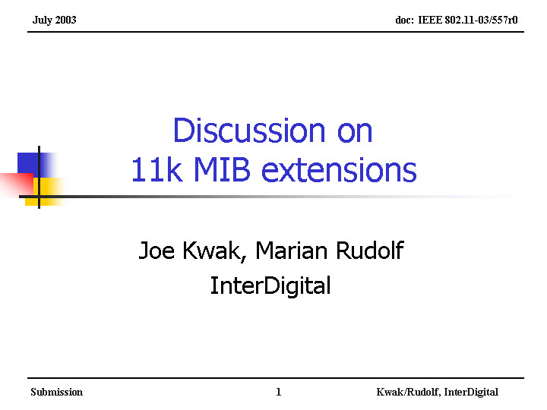

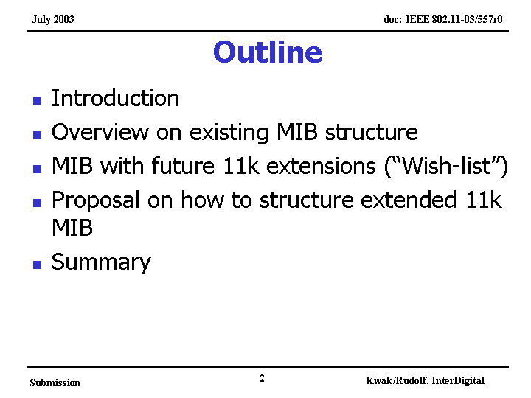

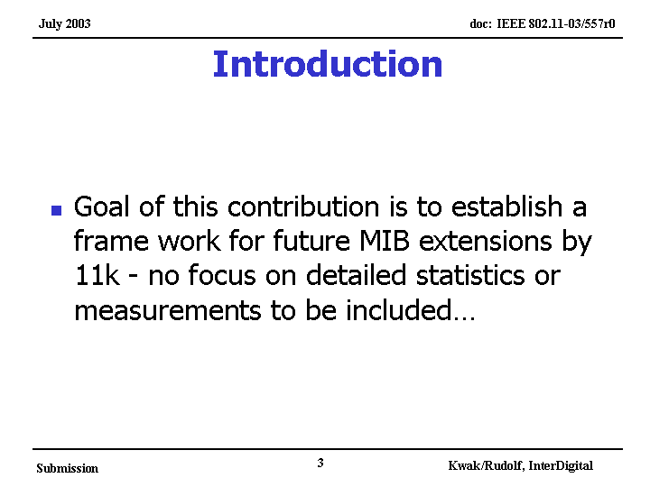

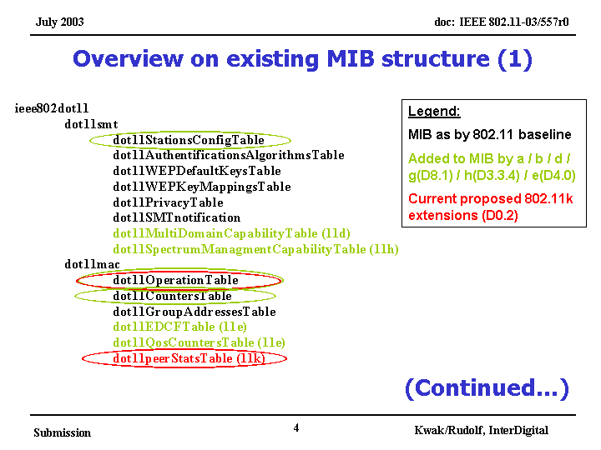

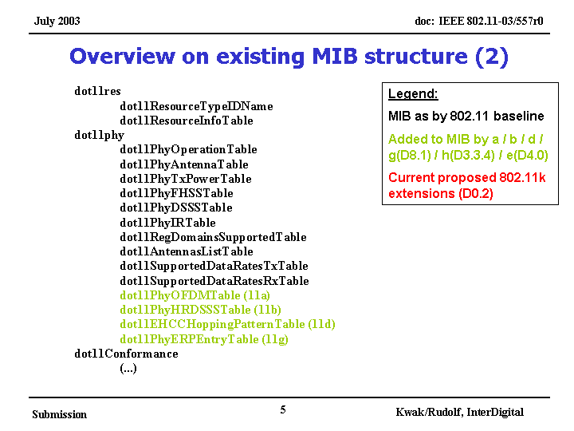

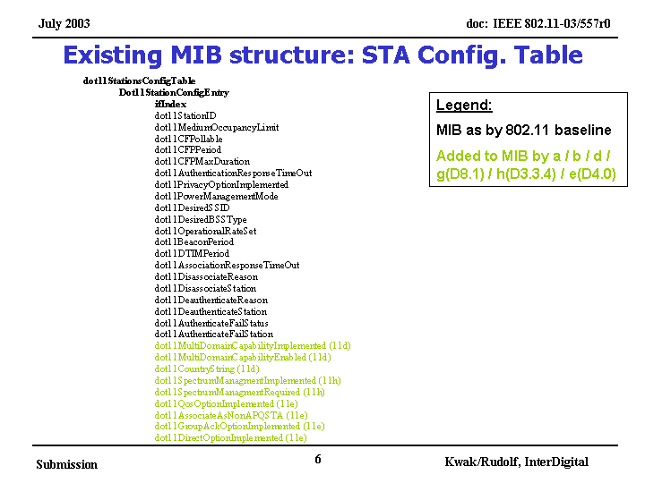

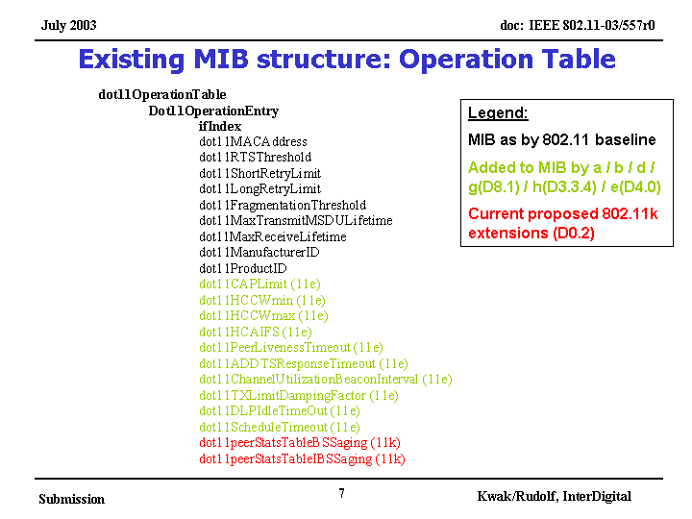

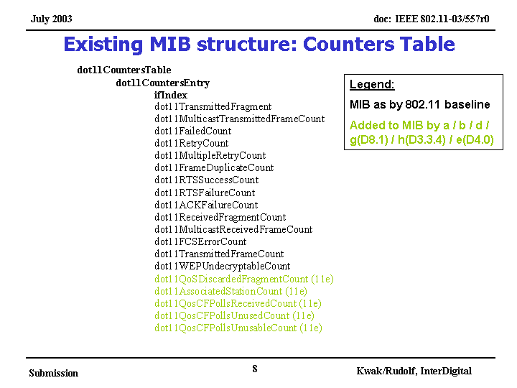

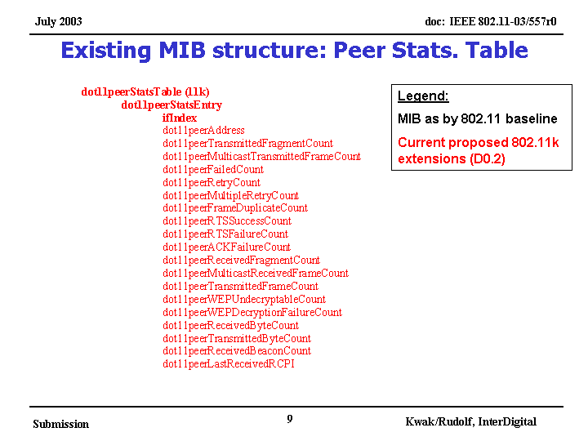

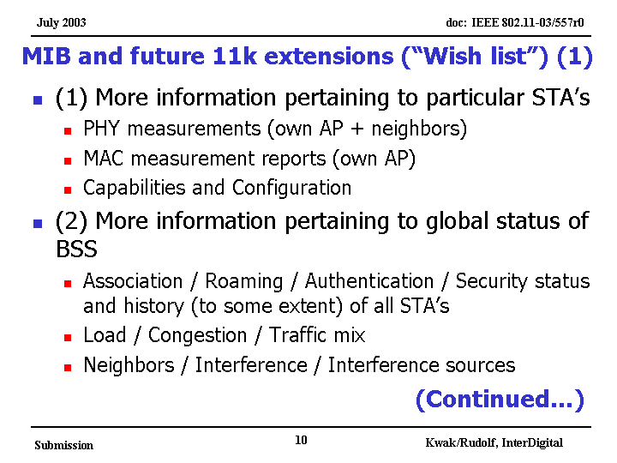

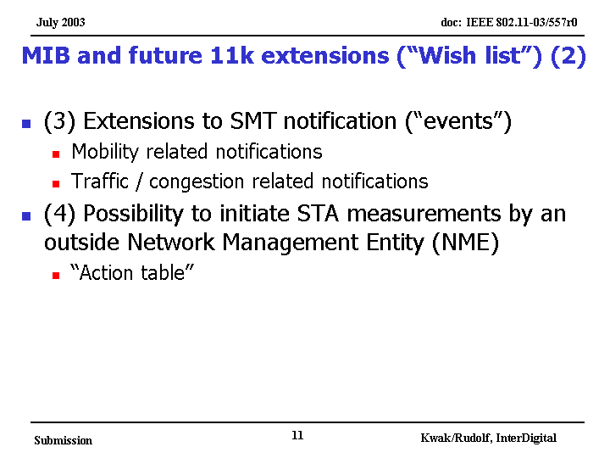

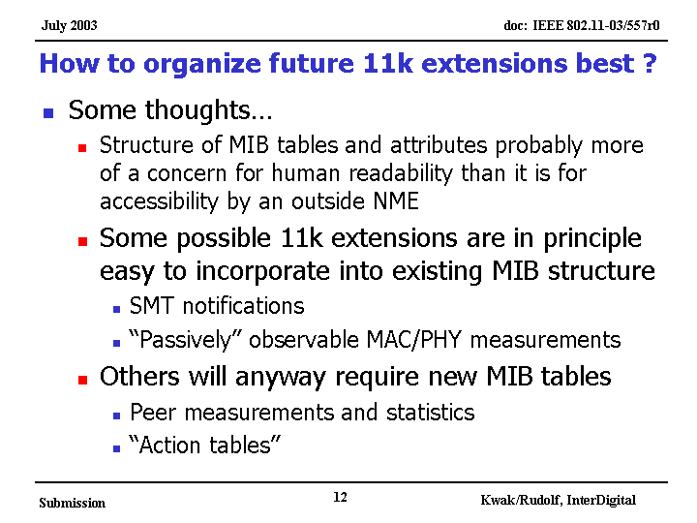

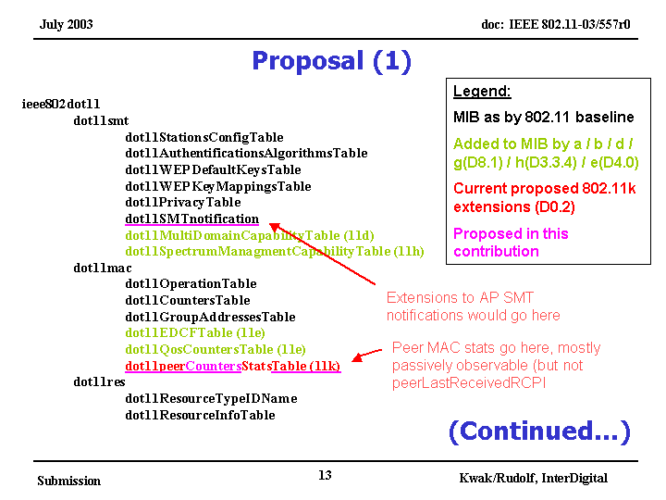

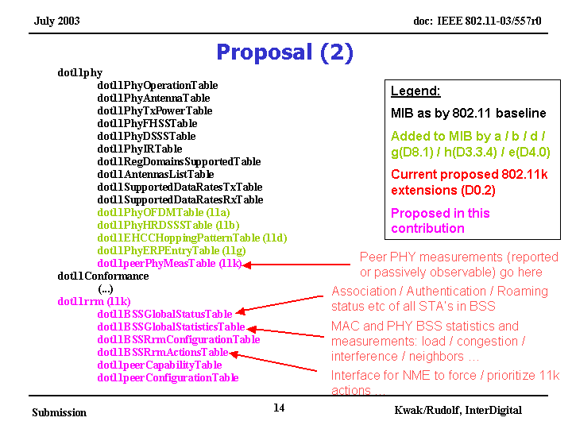

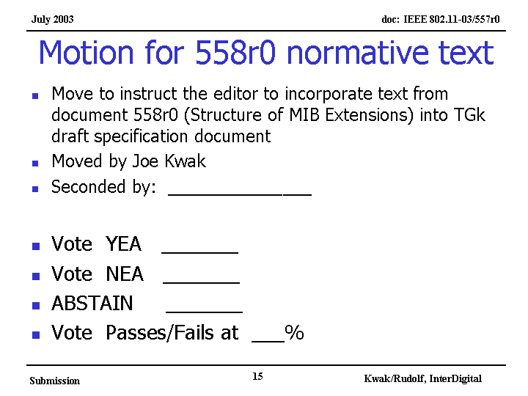

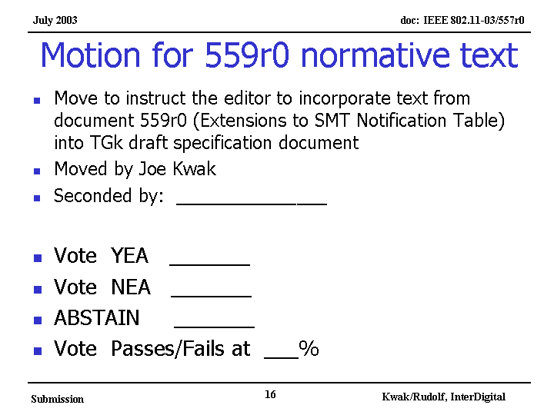

Draft normative text is located in documents 03/558 and 03/559 and lists the details of this power point document.

Comment: Peer stats table is local passive measurements only …. a table of STAs only that you are communicating with.
Author wants to merge the other MIB documents with this.

Motion:
Move to modify the agenda to add Simon Black presentations 581 and 582 to the 1-3 PM Tuesday session agenda .
Moved : Simon Blcak
Second J Kim
yes 18 no 0 abs 3
Motion passes

Simon Black presented document 03/581 “ STA MIB Statistics”

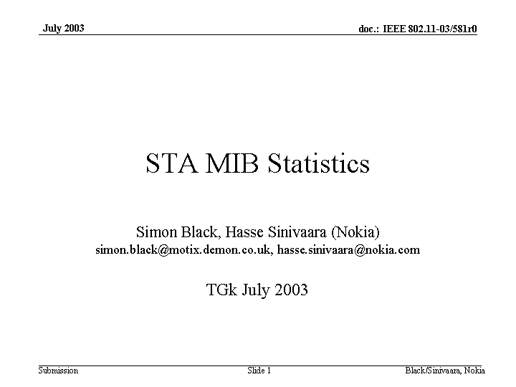

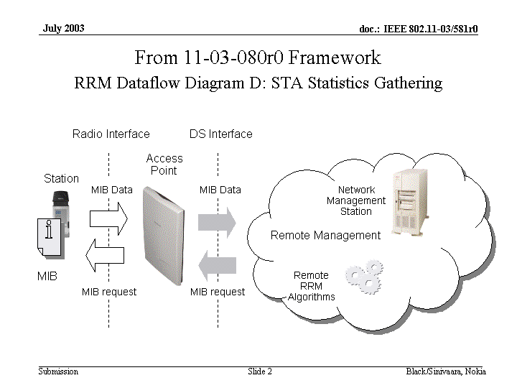

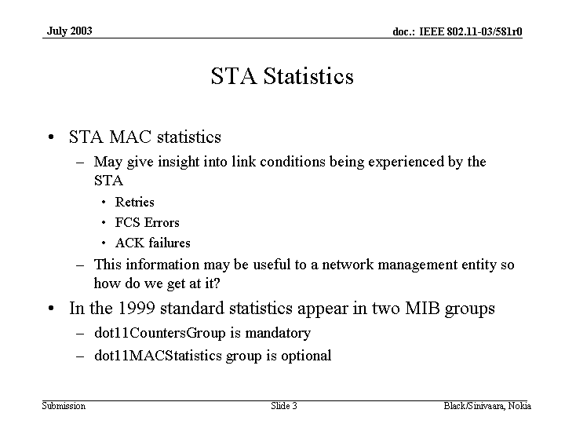

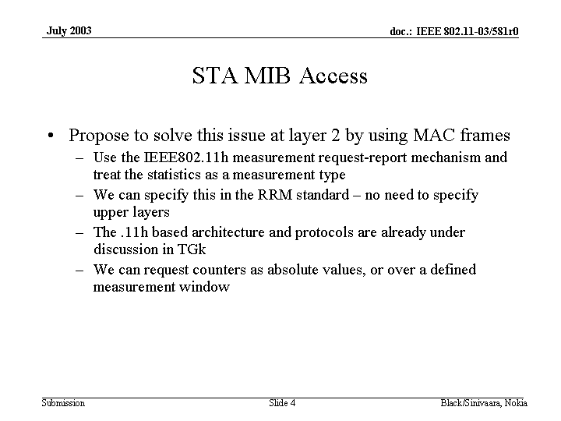

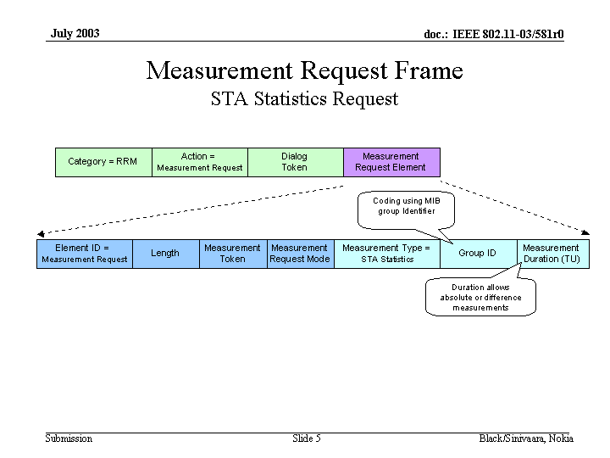

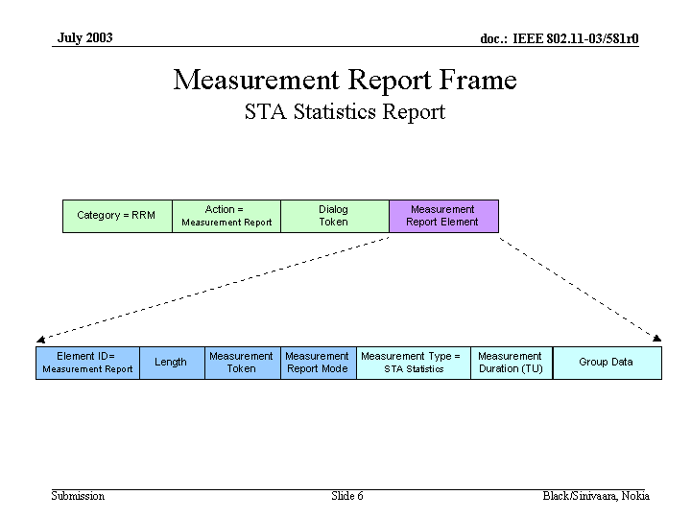

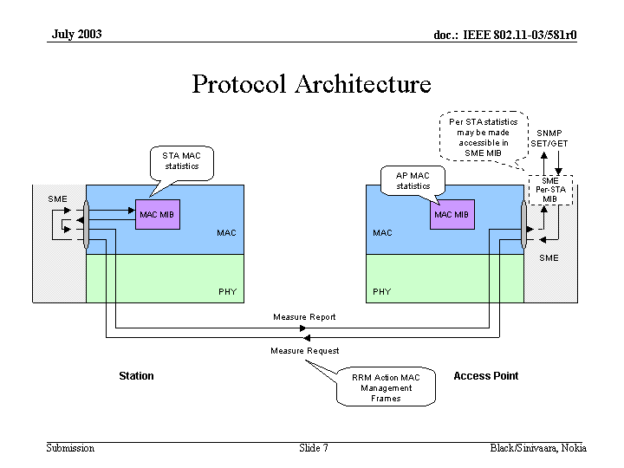

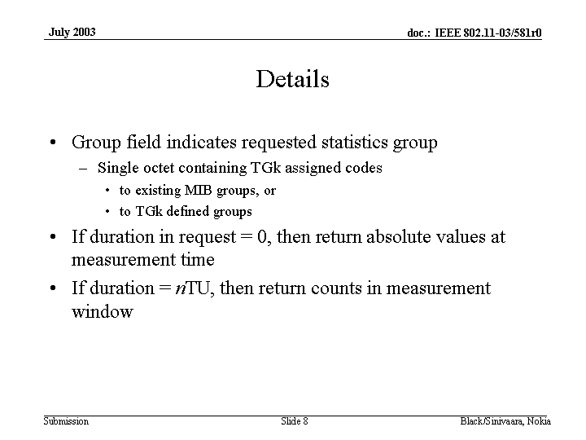

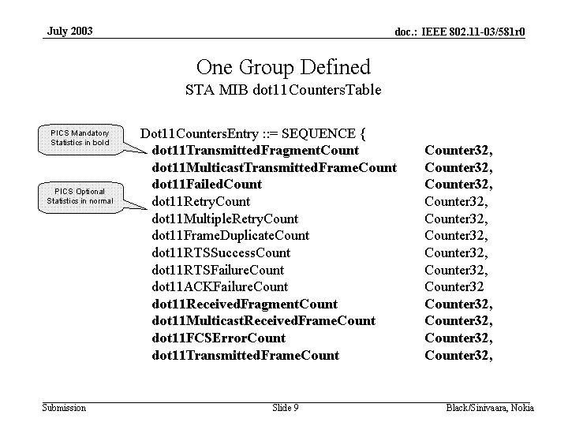

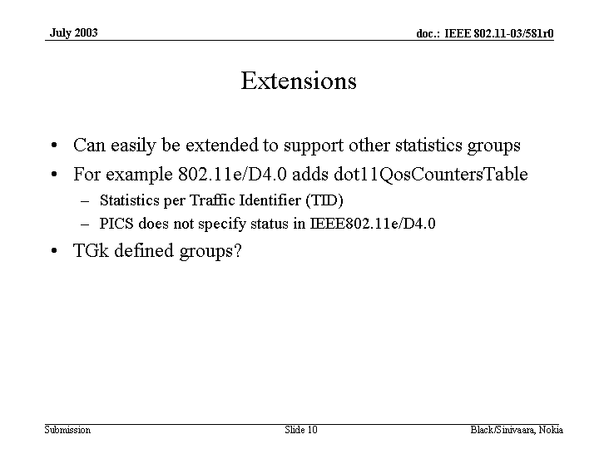

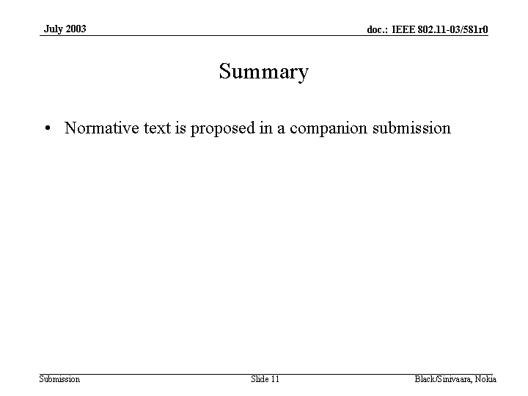

Treats STA Statistics as measurements not a new SNMP type
Draft normative text is located in documents 03/552 and lists the details of this power point document.
Discussions:
Comment: Duration measurement time must be specified better…need to flush the counters when AP association is changed
Comment: Can’t reset a counter32 in a MIB….Just continues to count
suggestion to remove any redundency in the measurements

Chair: The rules state that the document need to be on the server 4 WG hours (8:00am to 9:30PM) prier to voting on the presentation.
Recess…..Unamously

Monday, July 21, 2003
7:00 PM – 9:30 PM

Call to Order
Chairs overview of where the group is.
Not quite ready for letter ballot but close

Richard presented a document 03490r1 which is a revision to Victoria Poncini’s document 03/490r0


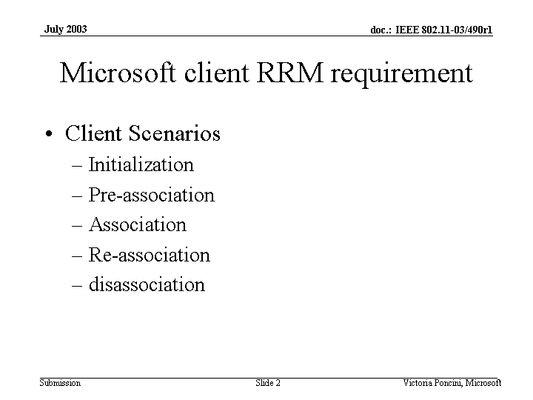
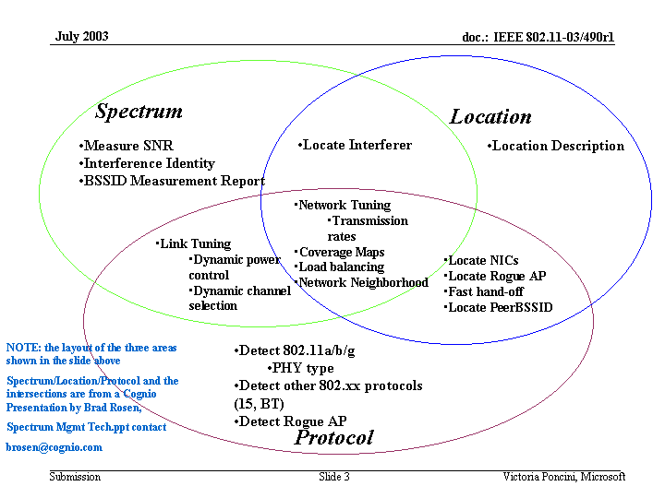
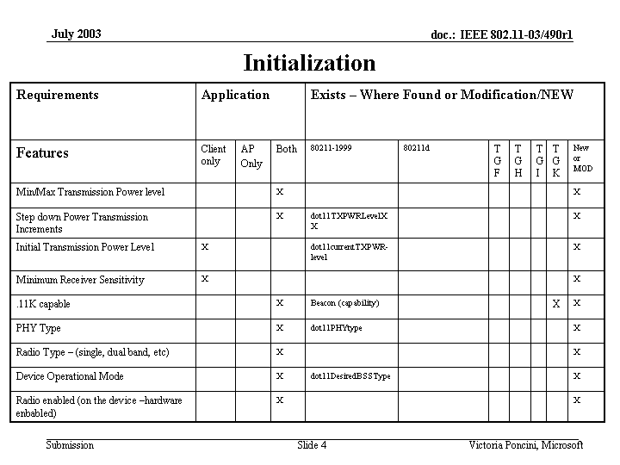
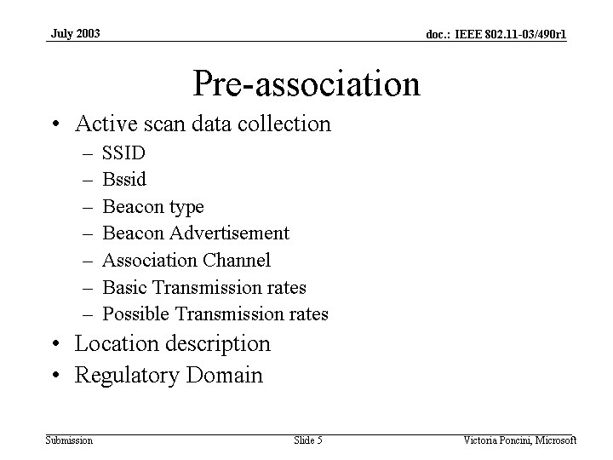
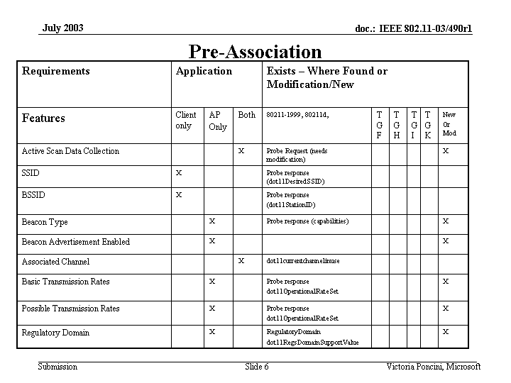
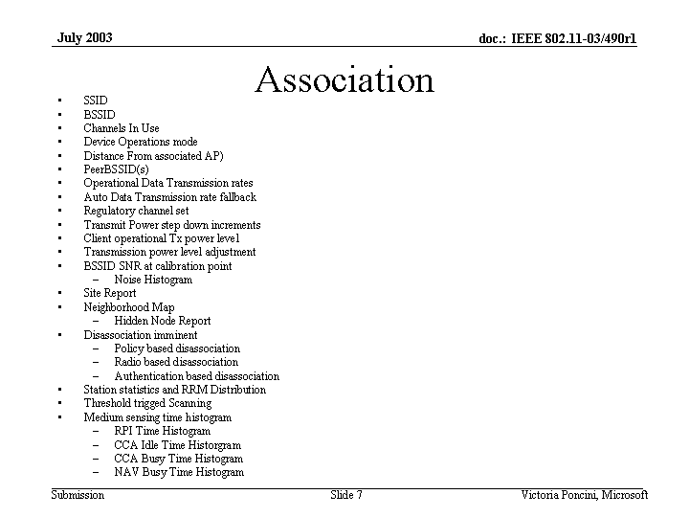
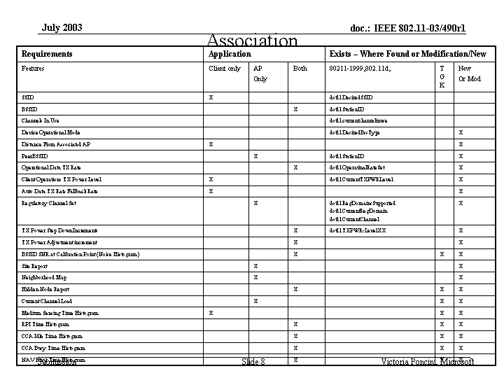
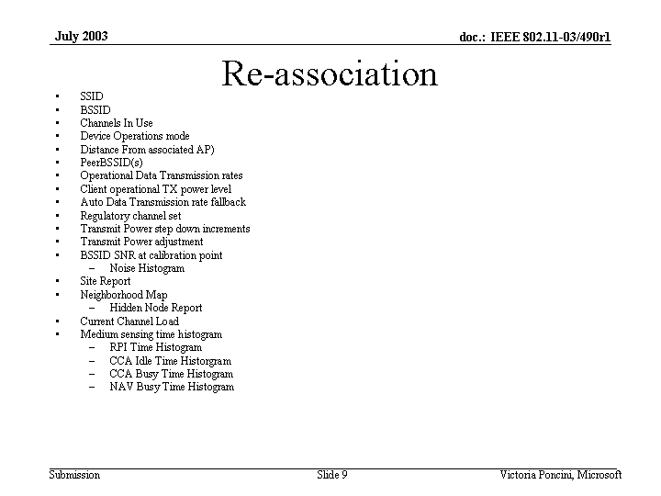
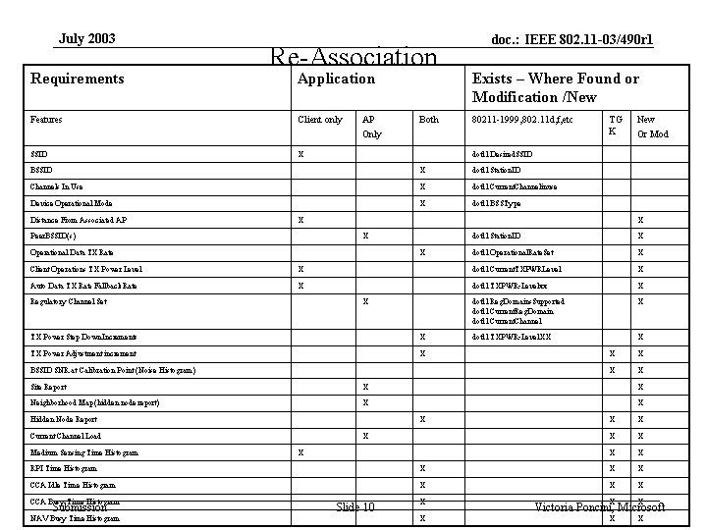
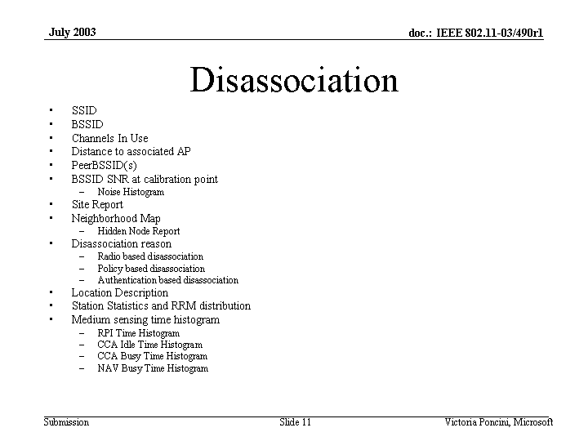
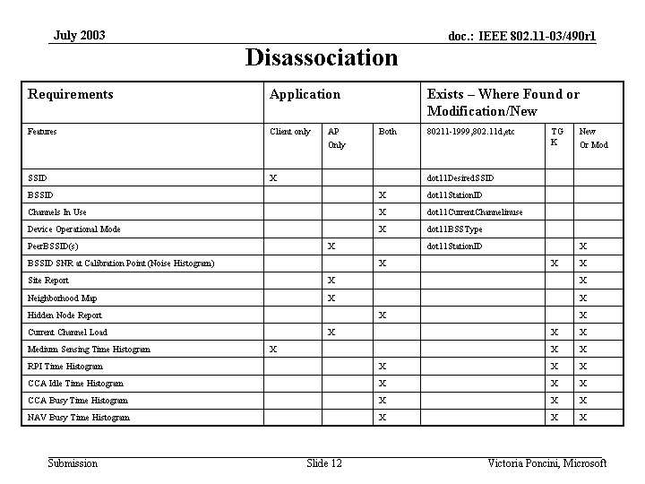

Comment: Location requirements seem to have varying opinions as to the granularity needed and capabilities required in 802.11 for finding clients.

Simon Black presented document 03/601 “Adaptive Beaconing”

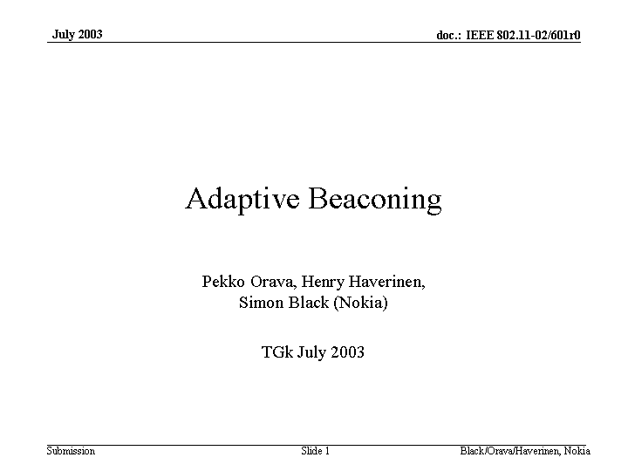
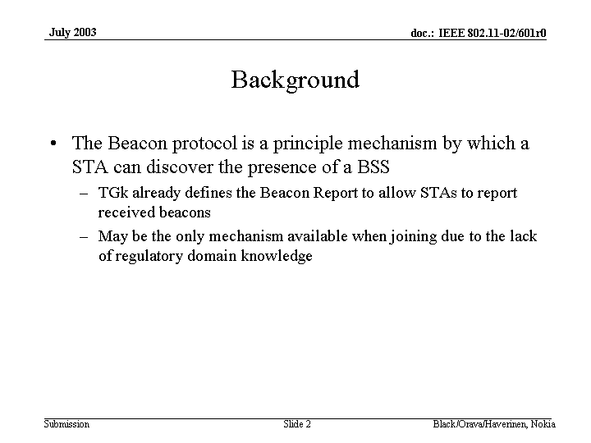
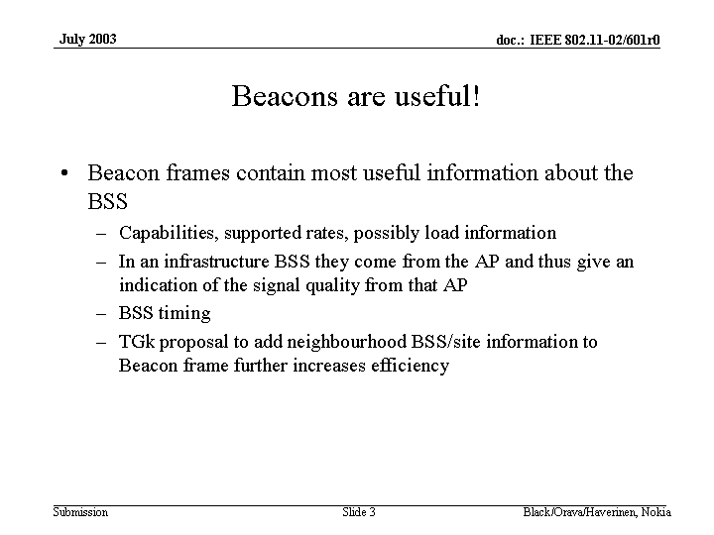
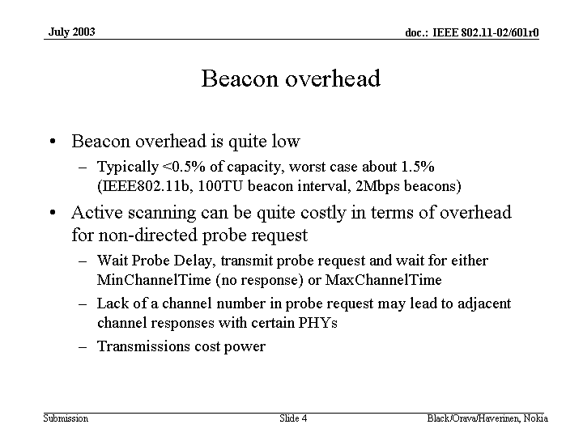
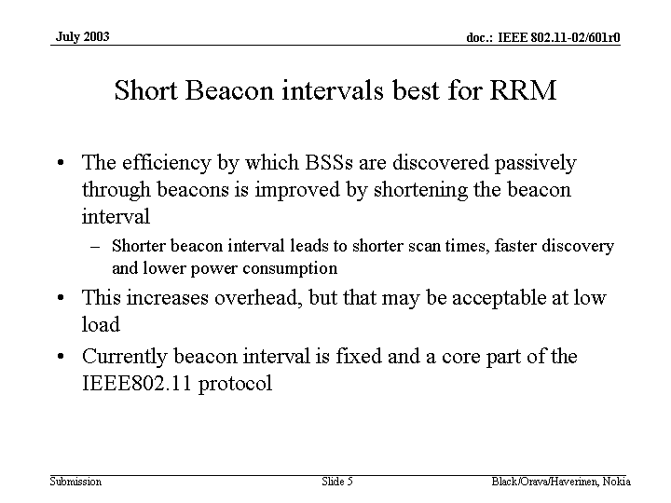
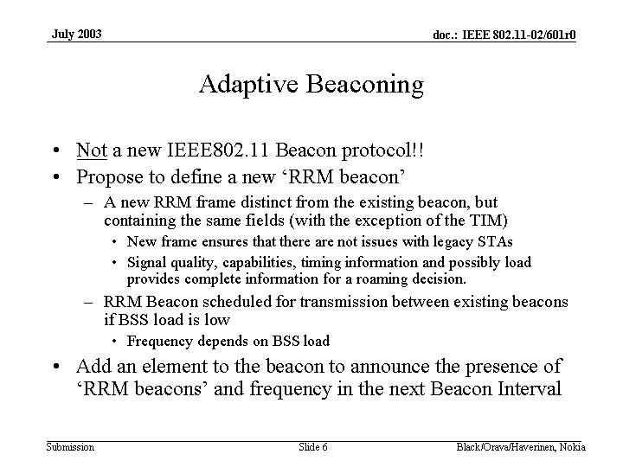
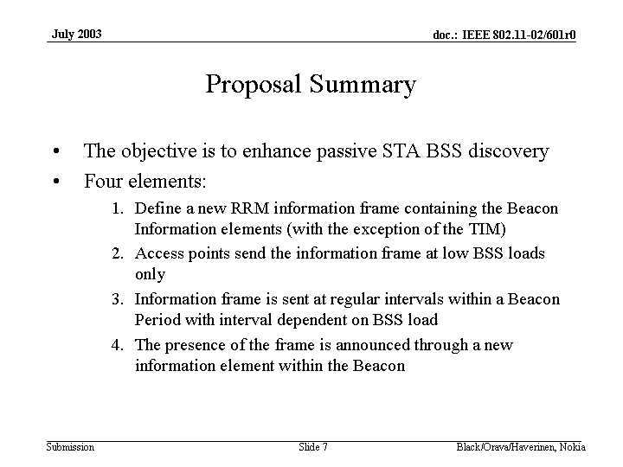

Discussion:
Comment: Attempting to optimise power consumption….active scanning can be very efficient.
Comment: There are varying opinions as to the power consumed (energy) between passive scanning and active scanning.

Chair: Want to determine how many votes there will be and when they will happen.
- J Kim presentation
- Patrick speak to action frames and the Kaiser document
- Samsung presentation on link margin limitations
- votes
  - 3 motions Simon Black wed pm
  - 1 motion Marty Thuraday pm early and presentation
  - Zhong/Jeong proposal and possible vote
  - Joe Kwak none as yet – just presentations
  - Patrick Worfolk vote

MIB subgroup
Comment: substantial work will be needed to the MIB for SNMP, measurement request and to get a response back.
Comment: How many MIB entries are missing …..not sure yet
Comment: need to know how to do measurements for external entity

Chair: covered some work he did on similar matchmaking to scenarios
Motion:
Move to Recess
Moved: Bob Neilsen
Second: Tim Olson
no objections

Wednesday, July 23, 2003
3:30 PM – 5:30 PM
Call to Order
Agenda
Paper Worfolk
Paper Lee
Paper
Jeong/Zhong

Motion:
Move to Approved the agenda
Moved: Bob Neilson
Second: Tim Olson
Approved 30 Disapprove 0 abs 1
Motion passes

Patrick Worfolk presented document 03/607 “Fixes for IBSS”

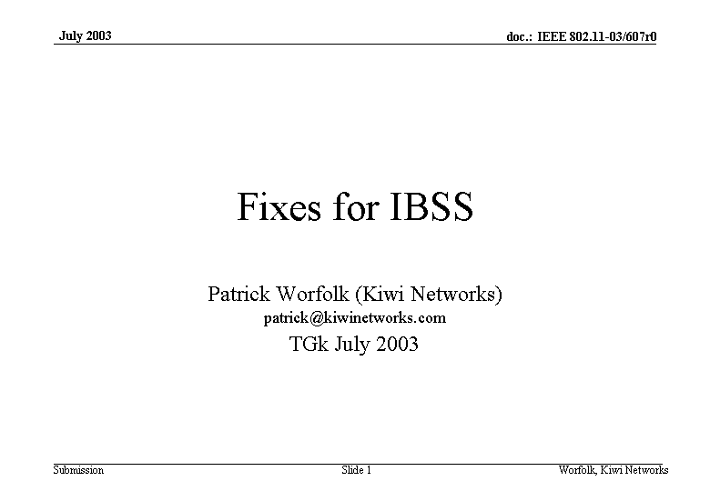
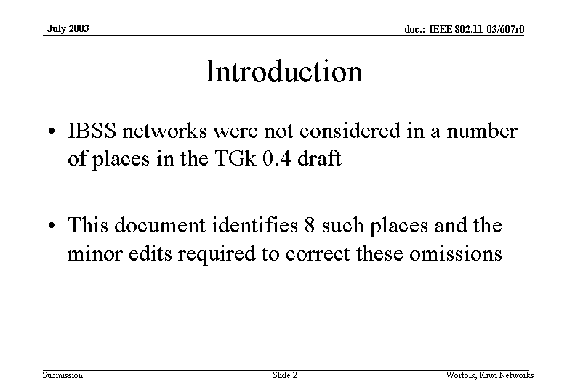
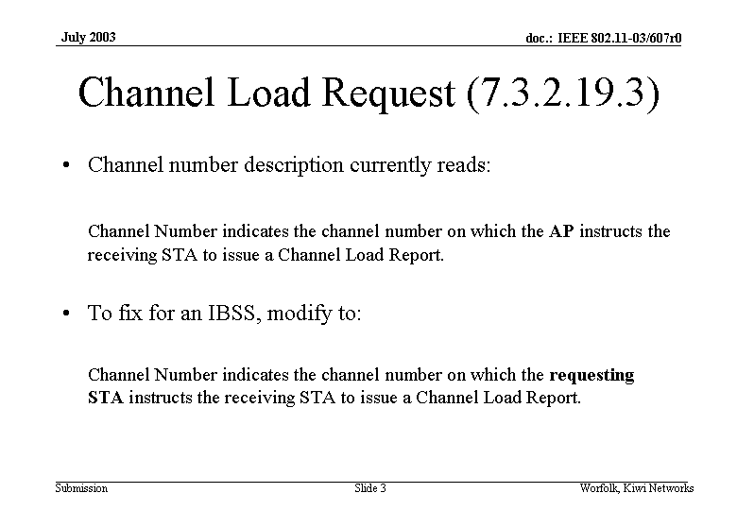
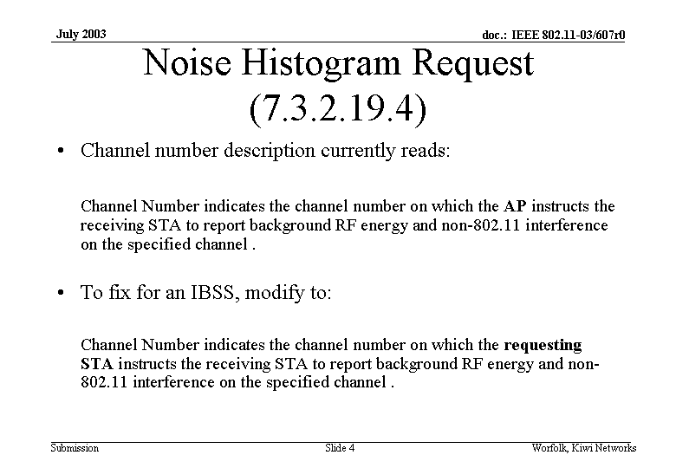
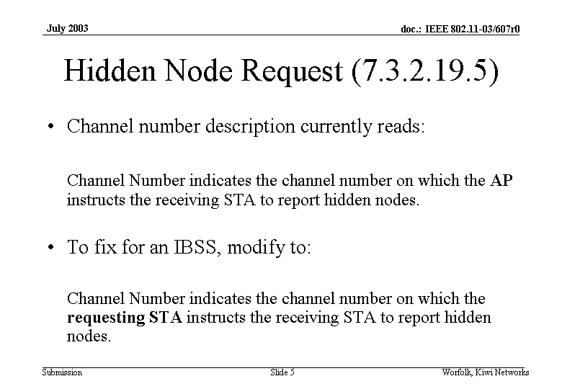
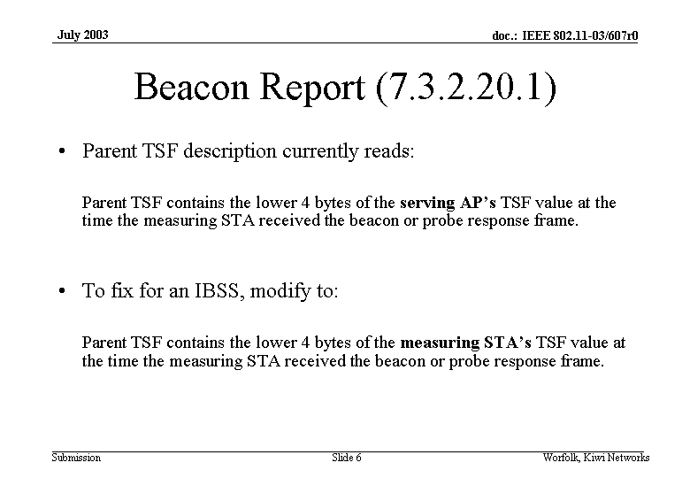
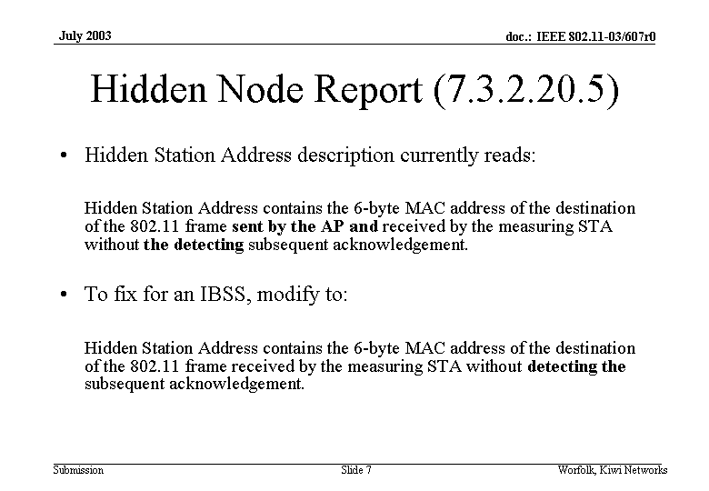
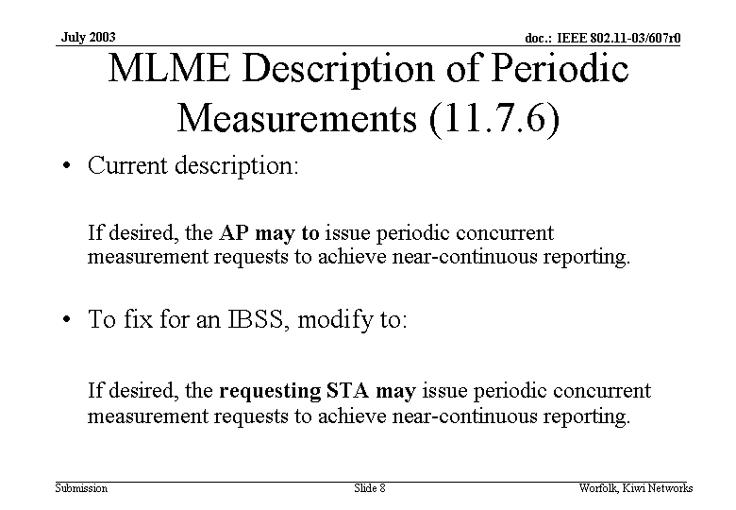
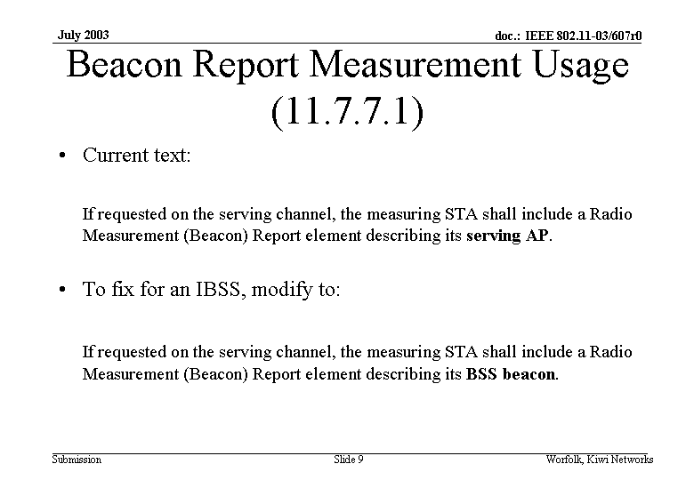
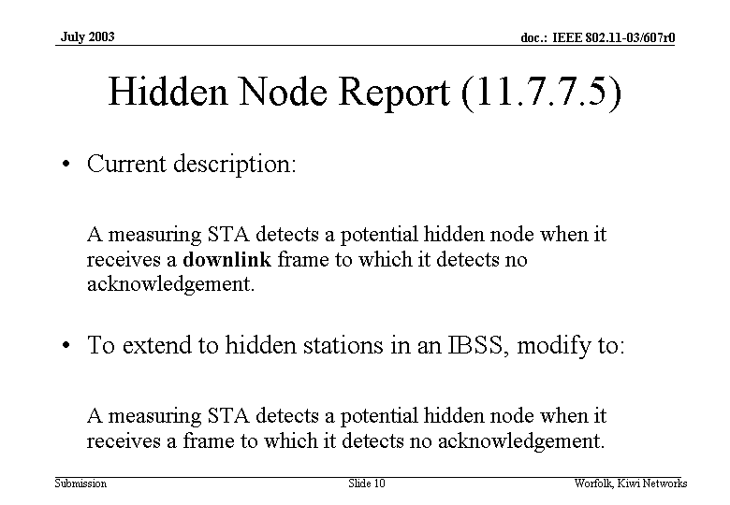
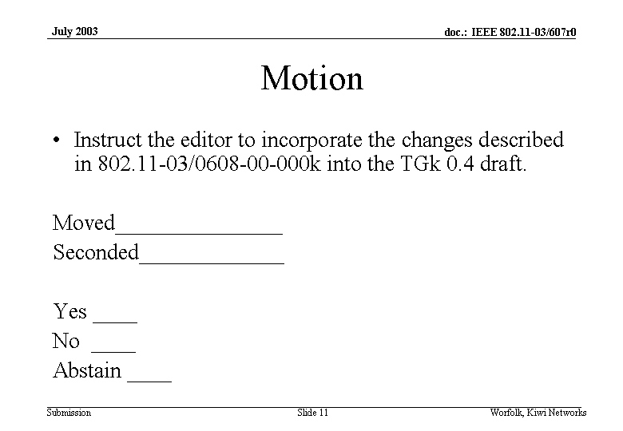

Motion:
To instruct the editor to incorporate the changes described in 03/608 into the TGk 0.4 draft.
Moved by Patrick Worfolk
Second Srini Candella
Yes 12 no 1 abs 20
Motion Passes

Tae-Jin Lee presented document 03491 “Measurement Request and Report for Link Margin Measurement”
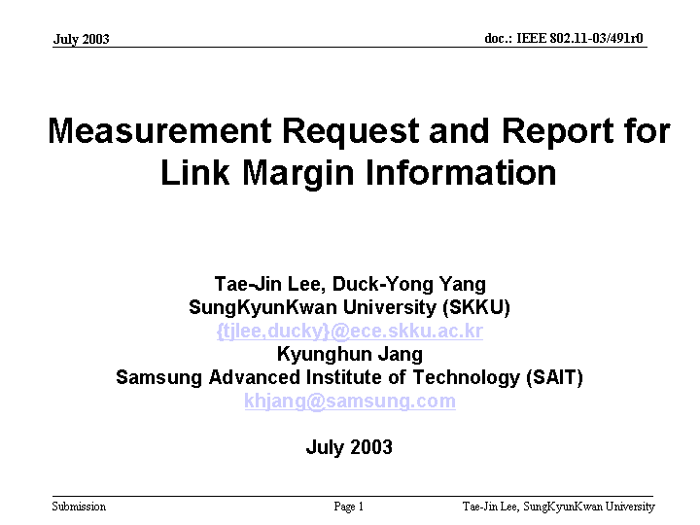
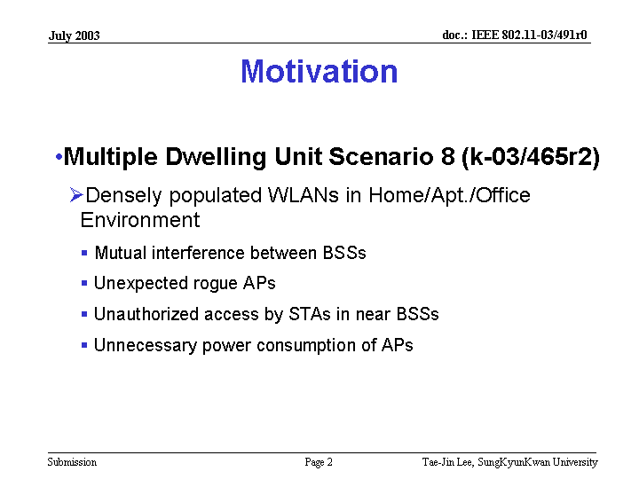
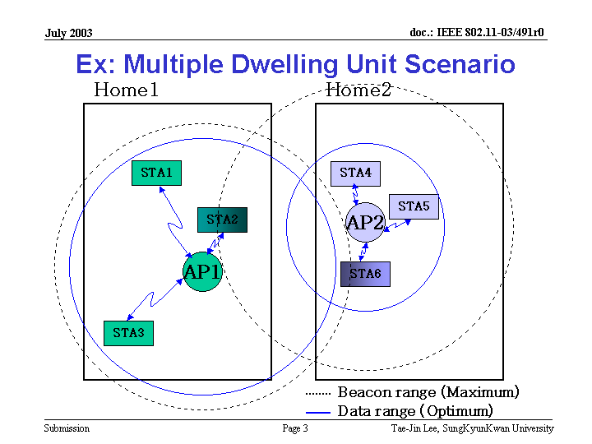
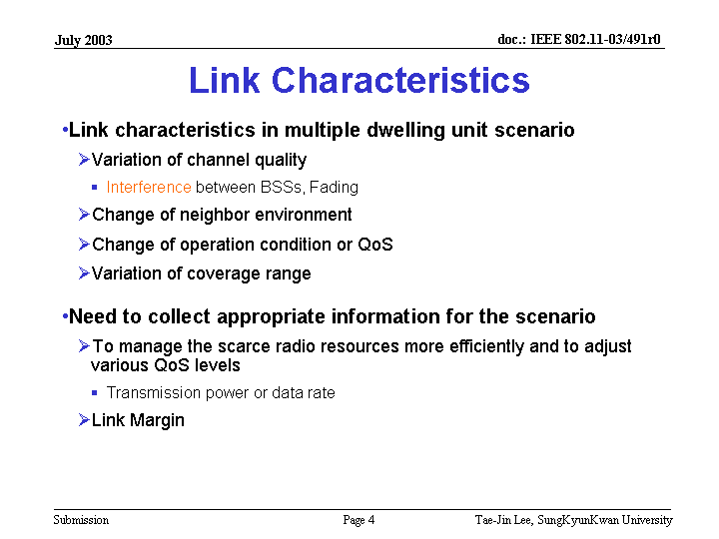
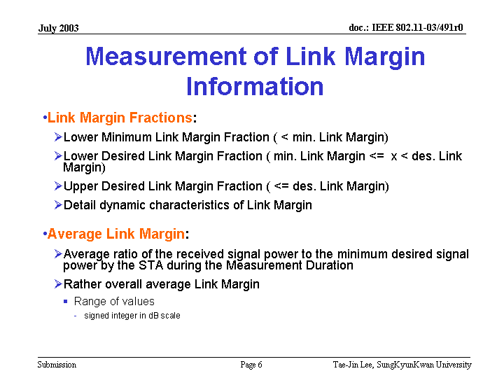
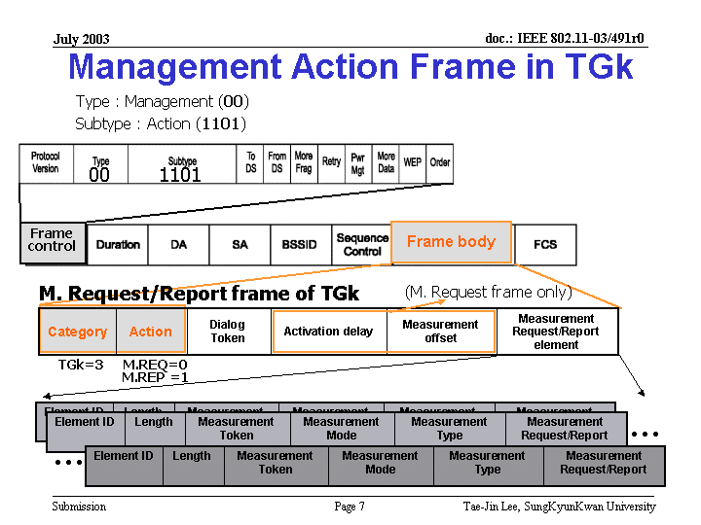
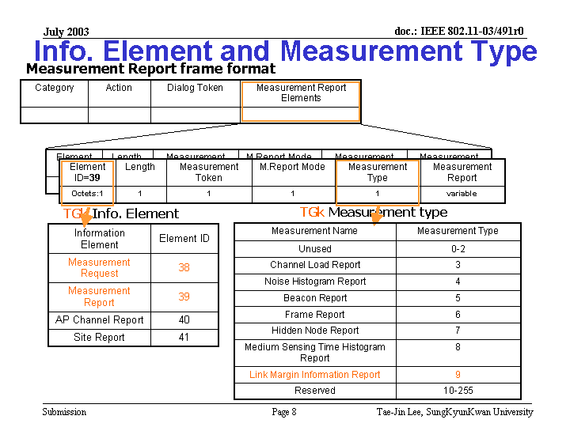
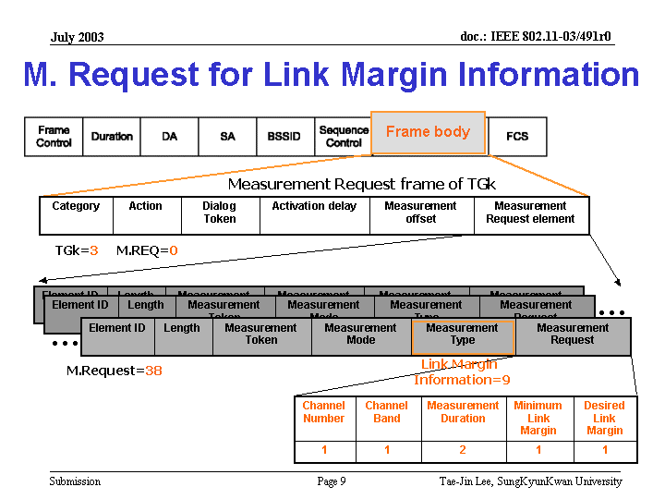
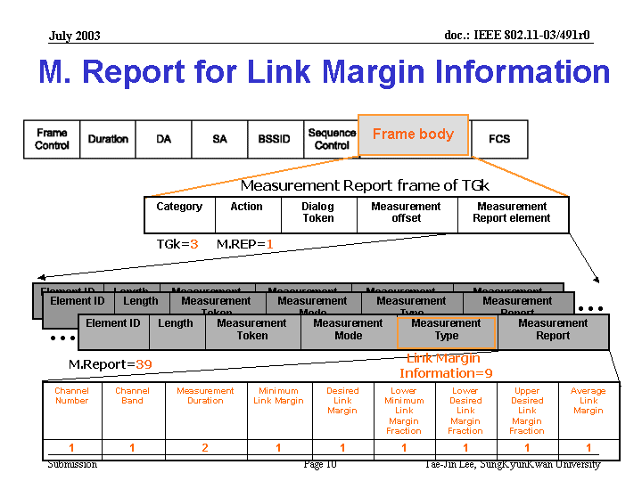
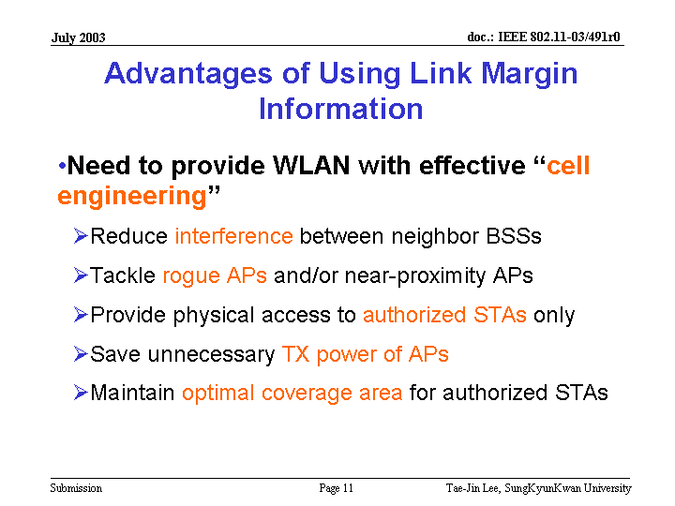
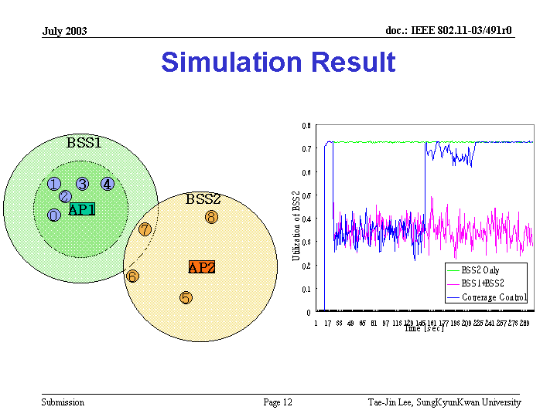
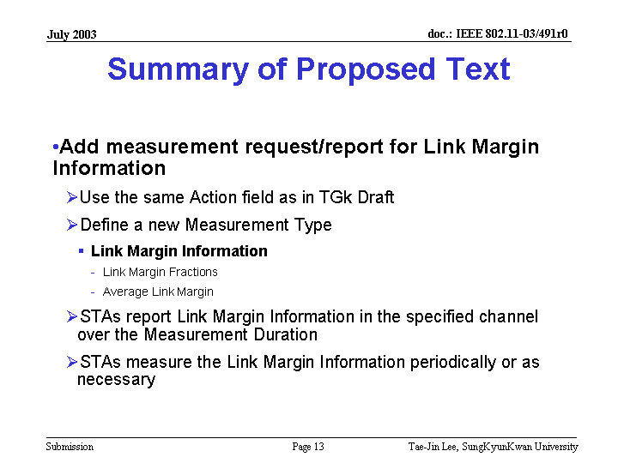

Comment: calculations should not be using the real time of the MAC…algorithm should be move to upper layers

Motion:
Move to instruct the editor to incorporate the changes described in 03/491 into the TGk 0.4 draft.
Moved Sunghyun Choi
Second Dongjun Lee
Yes 9 No 17 Abs 14
Motion Fails

Moo Ryong Jeong presented document 03/623 “Fast Active Scan Proposal”

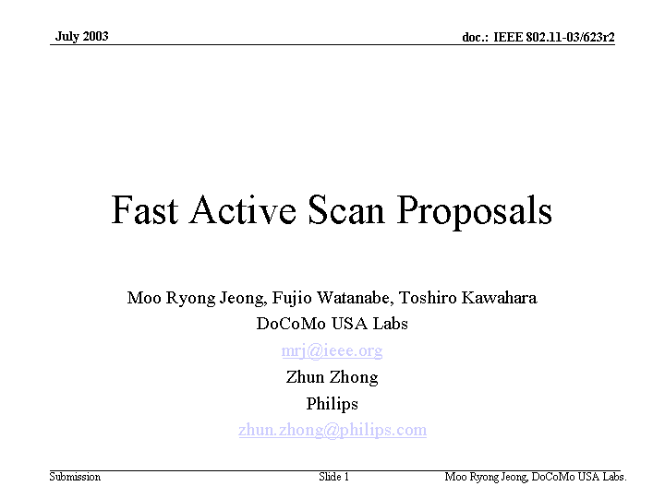
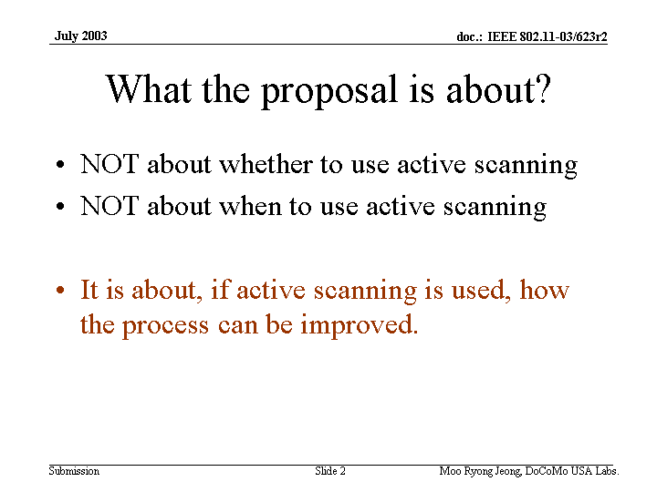
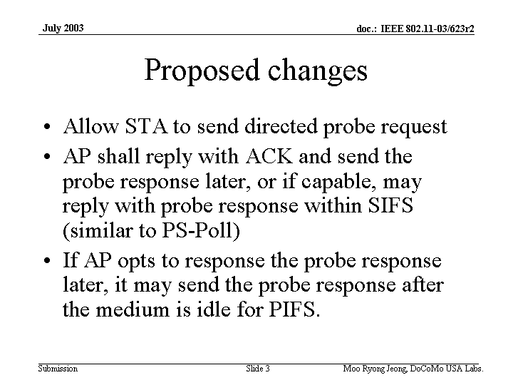
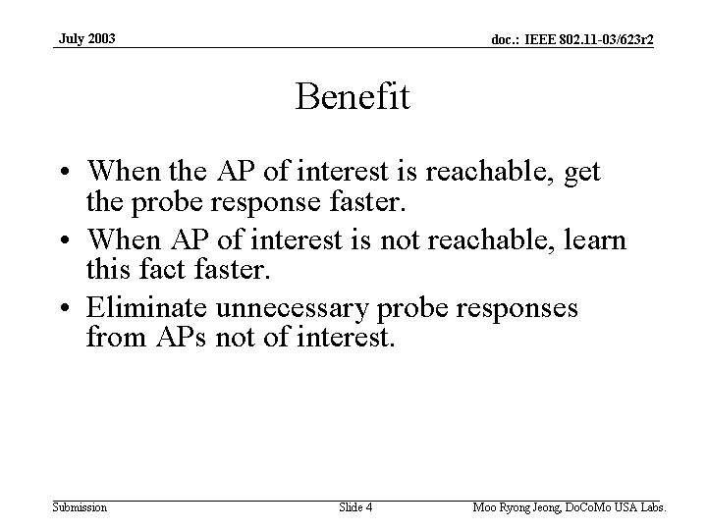
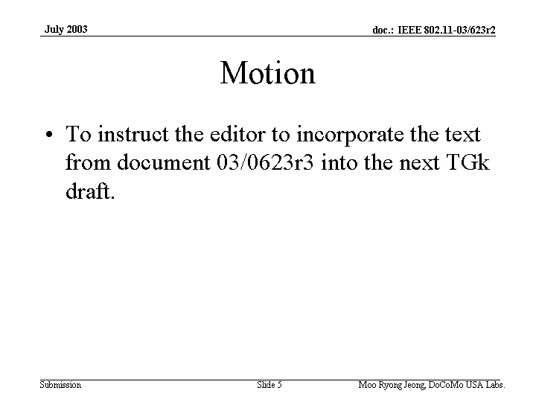
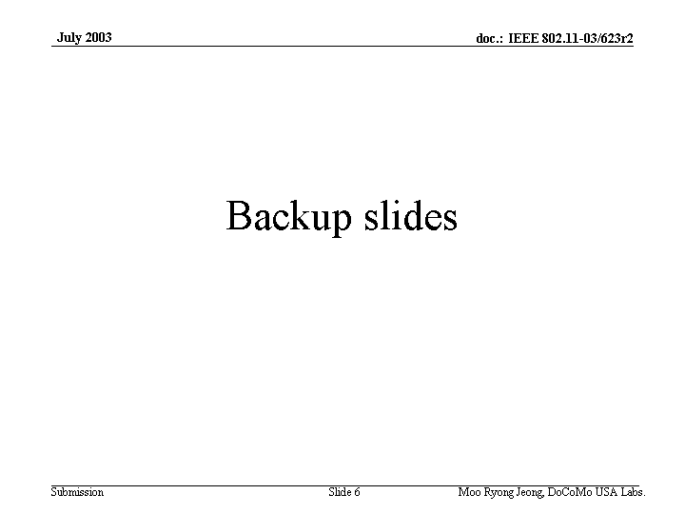
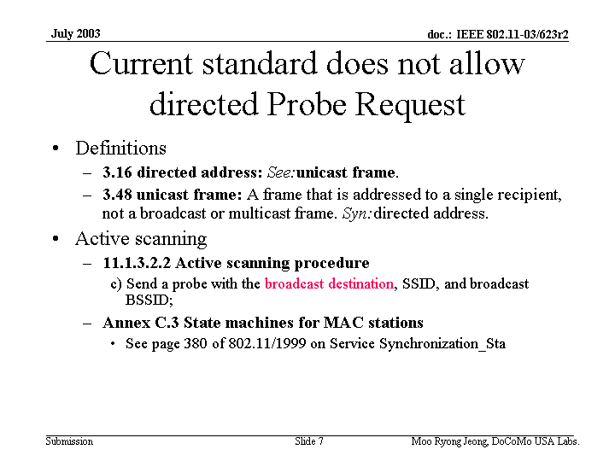
Discussion:
Comment: if no ACK what happens…..the client will think no AP is there
Will use fast active scanning to find new APs
Comment: This will be generating more traffic and is not scaleable….waist bandwidth that could be used for traffic
Comment: Increasing the number of STAs will cause the traffic to increase the non-useful traffic
This is a problem with all scanning schemes not just this one
Comment: This is not worse than the current spec so can be useful
Will be based on how good the algorithm is for site report
Will use broadcast frame or unicast frame because it has no choice
Comment: Scheme 1- if you send a broadcast probe request, the time will be shorter than sending a single AP probe.

Chairs comments:
Will be a busy day tomorrow with presentations and votes
Will meet from 1:00PM to 9:30PM
Bob O’ Hara will speak on 802.11 D and LLAP
recess - unanimous

Thursday, July 24, 2003
3:30 PM – 5:30 PM

Call to Order

Motion:
Move to approve the agenda
Moved Simon Black
Second Bob Neilson
Yes 15 No 0 abs 0
Motion passes

J Kim presented 03/624 “

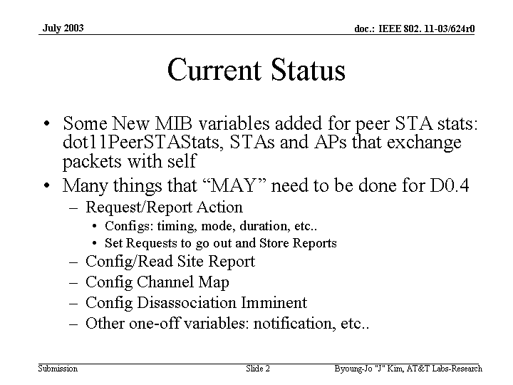
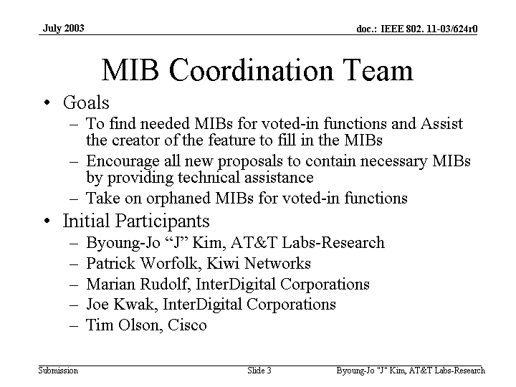
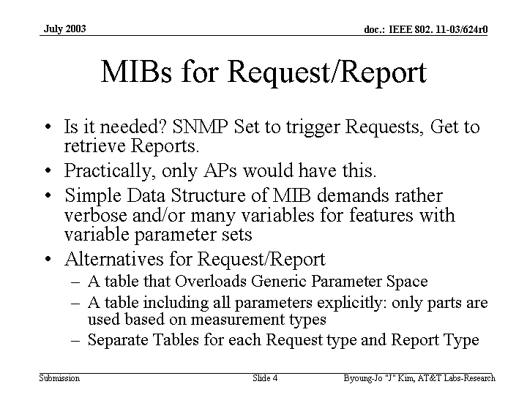
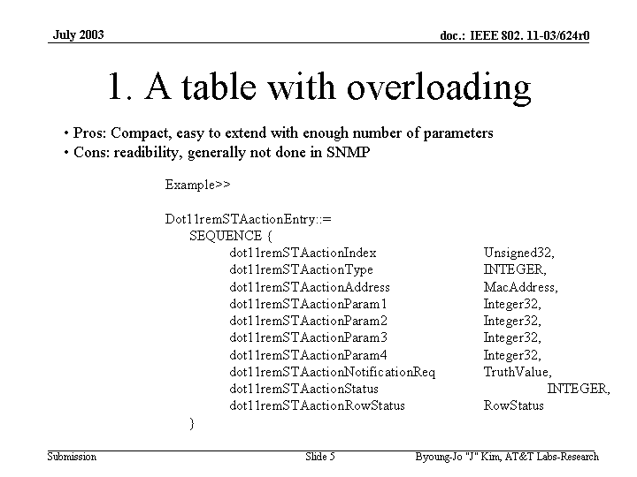

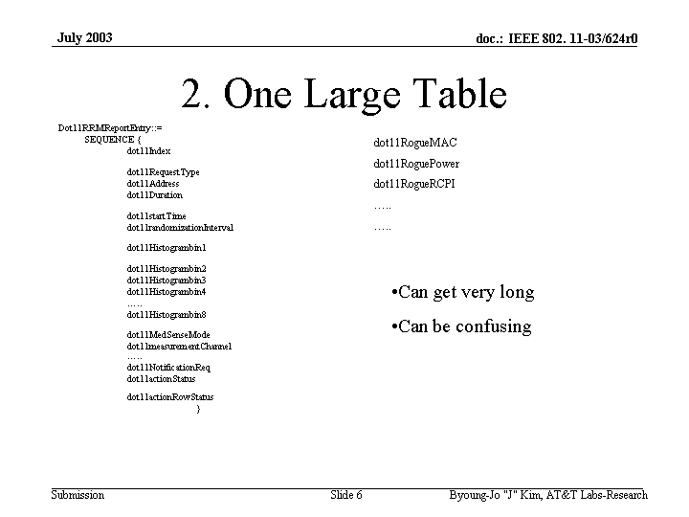
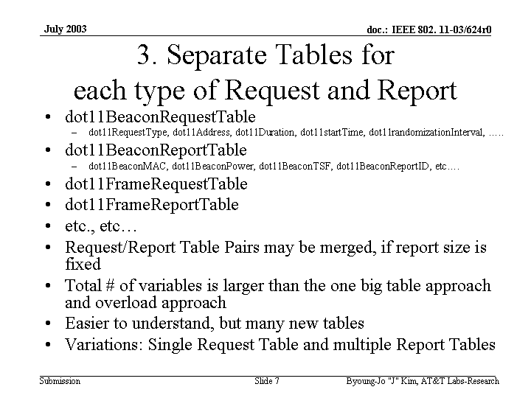
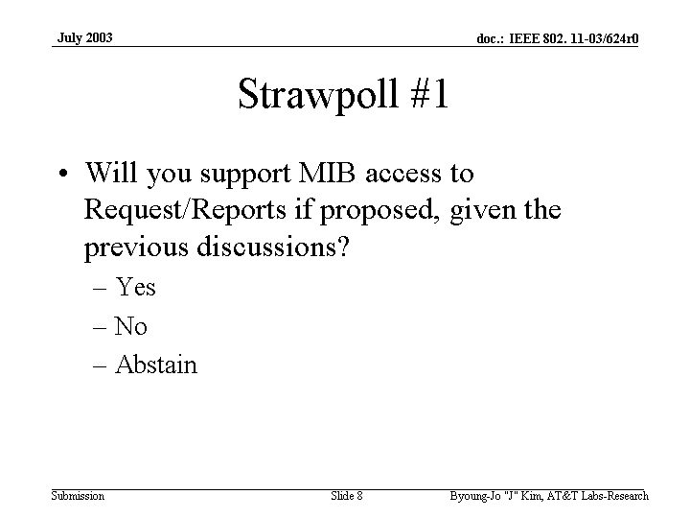
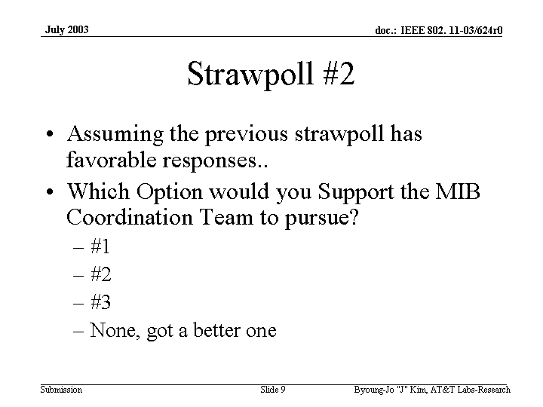

Comment: Would like to see some thought to minimize the size of the tables by having them in upper layers
Comment: This should be optional

Straw Poll:
Will you support MIB access to Request/reports if proposed, given the previous part of the presentation?

Yes 18 No 1 Abs 17

Marty Lefkowitz presented document 03/587 “Rogue AP Definition”

IEEE P802.11
Wireless LANs
Rogue AP Definition
Date: July, 22, 2003
Author: Martin Lefkowitz
Trapeze Networks
5753 W. Las Positas Blvd
Phone: 925-474-2241
Fax: 925-251-0642
e-Mail: lefko@trapezenetworks.com
Abstract

This document includes normative text that defines what a Rogue AP is and how a STA should react to one, as well as informative text that describes how to use the preferred and trusted bit.

Add to Clause 3 definitions

Rogue AP – A rogue AP is an AP that is known to be unauthorized to participate in the ESS, or for the entire site. Rogue AP’s are a security issue, and associating with it will compromise the security of the STA, and possibly the BSS, or ESS. STA’s are discouraged from associating with a rogue AP.

Append informative note after bullited list in 7.3.2.22 (describing BSSID Match Status Bits)

Informative note:
The preferred bit is a site specific bit that can indicate that there is a tight coupling between the BSSID the STA is currently on and the one showed in the site report element. That can be, but is not limited to a relationship between the current BSS and the new BSS that enable fast roaming, or that the new AP has a comparable feature, or the appropriate resources to continue the session. Whereas the trusted bit indicates that the AP is a trusted member, but may not have the capabilities, or resources, that AP’s with the preferred bit also set could provide

Comment: Bits will be useful but needs protocol to back them up…definition is not good enough
Comment: definitions don’t go far enough…much to mine vs. theirs…it is a start… must have meaning to the bits. Need to provide a complete package to be voted in the group
Comment: what is intended by rogue and preferred? What is the intention? Is a subjective classification and how can it be used to the standards advantage.
Comment: One preferred bit may not be enough.
Comment: Rogue with respect to what entity….needs more work.

Motion:
To Instruct the Editor to incorporate the normative section of document 03/587r0 with appropriate spelling and grammar changes into the TGk draft 0.4 next TGk draft.

Moved Marty Lefkowitz
Second Malik Audeh
Discussion:
Comment: Opposed, doesn’t understand how it can be used here. Should read “next revision”

Motion to amend the motion

Moved Carl Anderen
Second Patrick Worflok

To change the motion text to read “To Instruct the Editor to incorporate the normative section of document 587 into the next TGk draft.”
Yes 16 No 0 Abs 5

Motion
To Instruct the Editor to incorporate the normative section of document 587 into the next TGk draft.”
Moved Marty Lefkowitz
Second Malik Audeh

Comment: Still not accurate enough

Motion to amend:
To Instruct the Editor to incorporate the normative section of document 03/587r0 with appropriate spelling and grammar changes into the TGk draft 0.4 next TGk draft.
moved Zhun Zhong
Second Carl Andren
yes 22 No 0 Abs 10
Motion passes

Motion now reads
To Instruct the Editor to incorporate the normative section of document 03/587r0 with appropriate spelling and grammar changes into the next TGk draft.

Move to table motion
Unanimous

Straw Poll
“Does the group feel that a definition of what a rogue AP is, is needed in the draft.”
Yes 20 No 11 abs ---

Simon Black presented 03/543r0 “Site Report Elements”

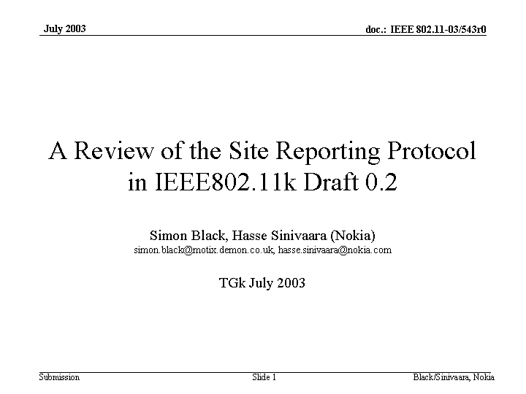
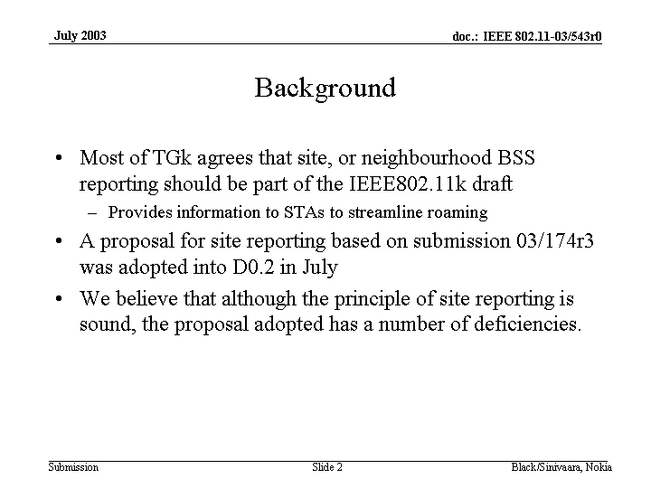
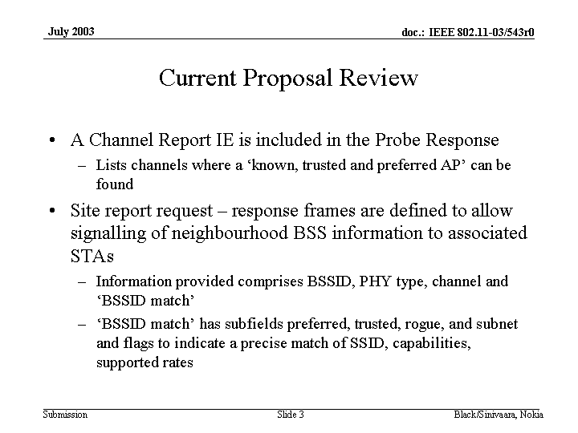
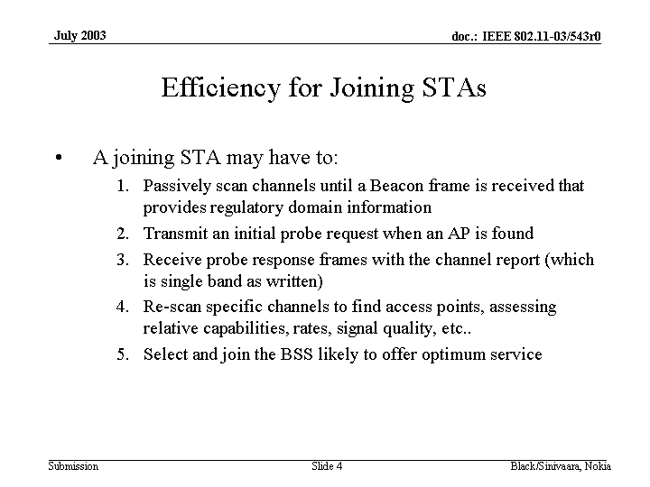
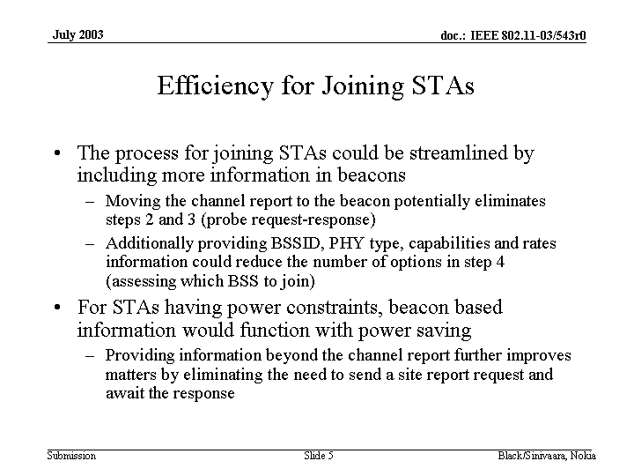
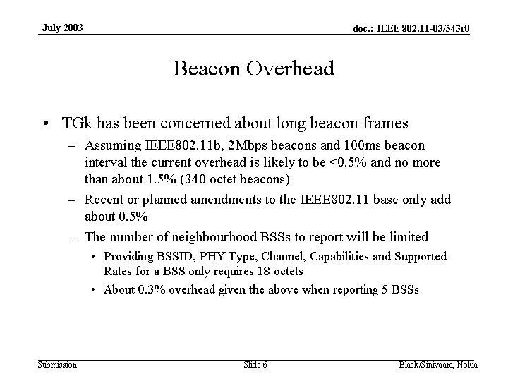
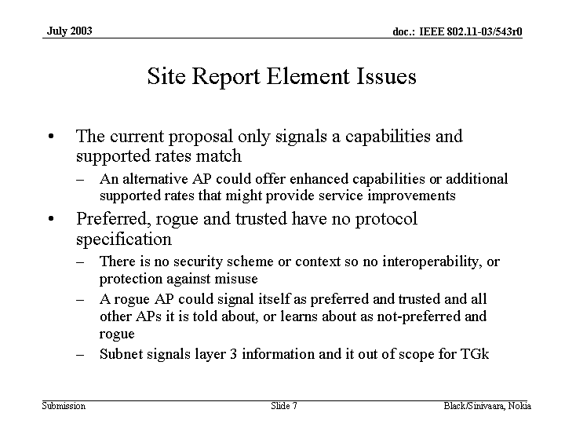
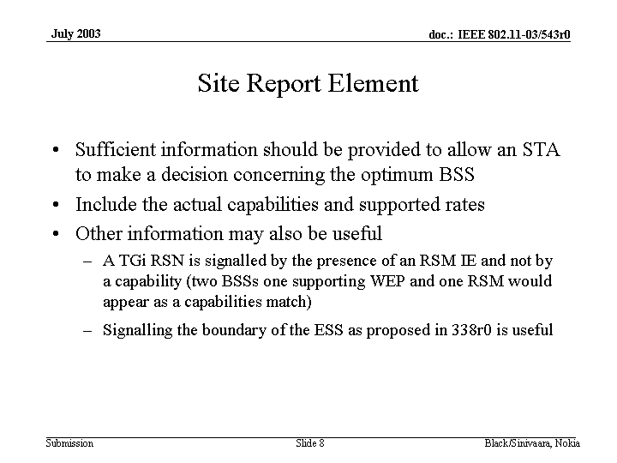
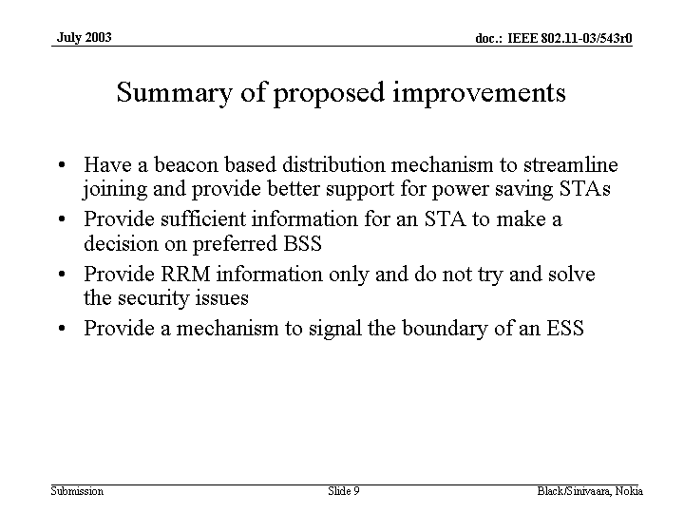

Motion:
To instruct the editor to remove clause 7.3.2.22 (Site Report Information Element) in IEEE 802.11k Draft 0.4 together with clause 11.8 and add the bss Information Element together with clause 10, clause 11, and Annex D (MIB) functionality from submission 11-03-580r1 into the next TGk draft.

Moved Simon Black
Second Carl Andren

Motion:
Move to call question Harry Worstell
Second Malik Audeh
yes 22 No 2 abs 7

Motion to call the question passes

Main motion
To instruct the editor to remove clause 7.3.2.22 (Site Report Information Element) in IEEE 802.11k Draft 0.4 together with clause 11.8 and add the bss Information Element together with clause 10, clause 11, and Annex D (MIB) functionality from submission 11-03-580r1 into the next TGk draft.

yes 15 No 10 abs 8

Motion fails with 60%

Motion:
To instruct the editor to add the contents of submission 11-03-0582r2 into the next version of the IEEE802.11k Draft.
Moved Simon Black
Second Dave Bagby
Yes 17 no 0 abs 15
Motion passes with 100%

Motion
Move to change the agenda to move the Jeong presentation
to the evening time
Moved Zhong
Second Tim Olson
Unanimous

Break

Joe Kwak presented document 03/638r0 “EVM Simulations for OFDM”
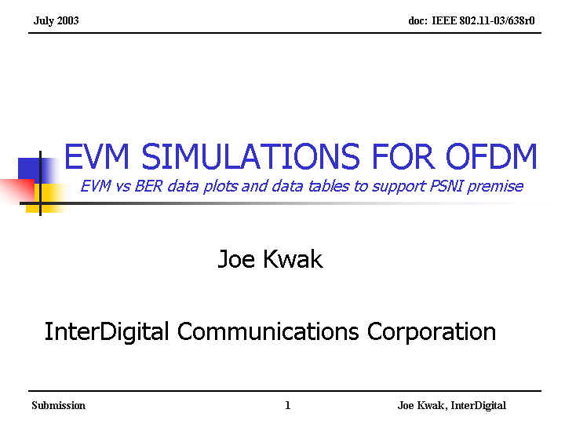
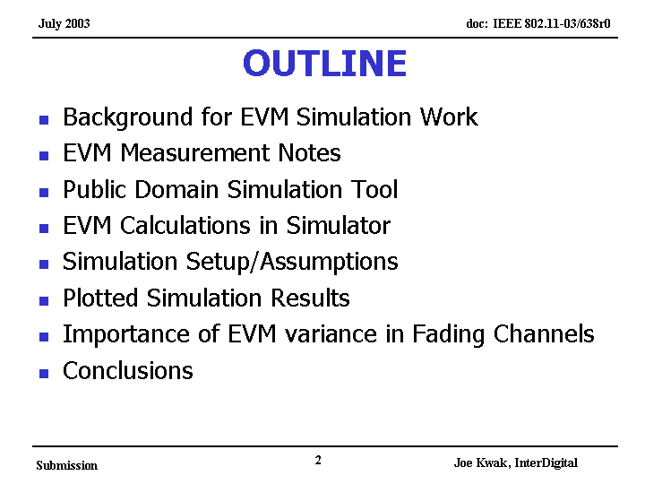
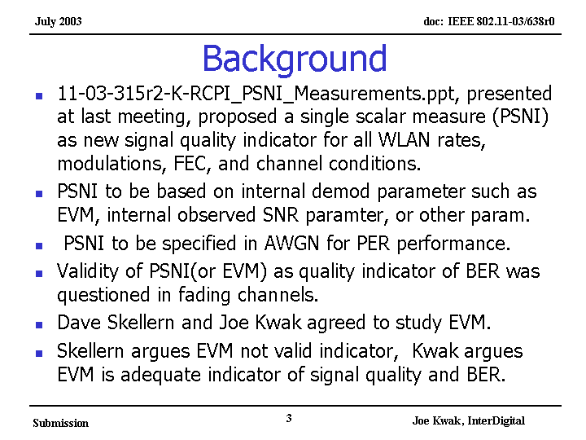

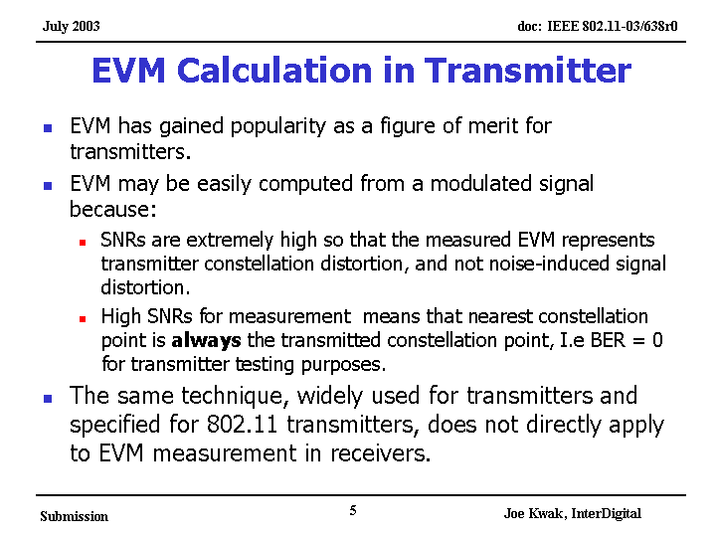
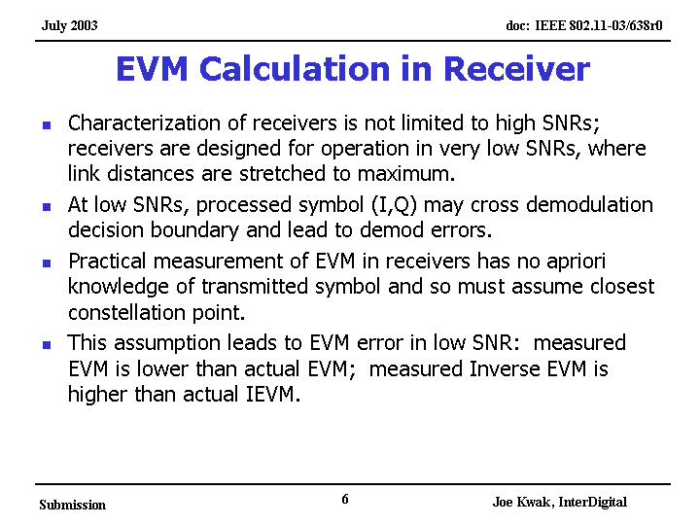
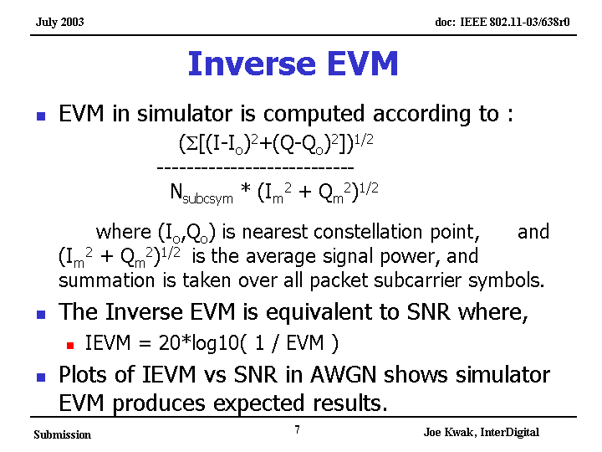
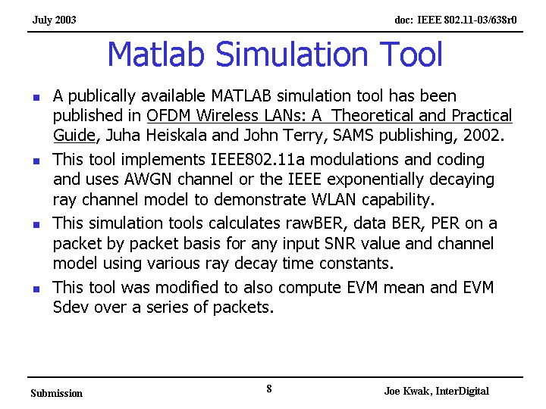
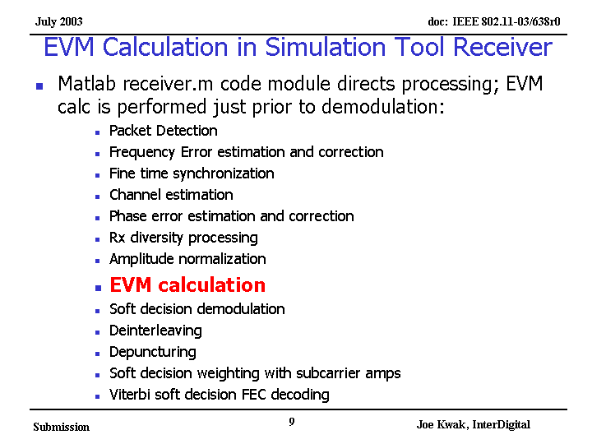
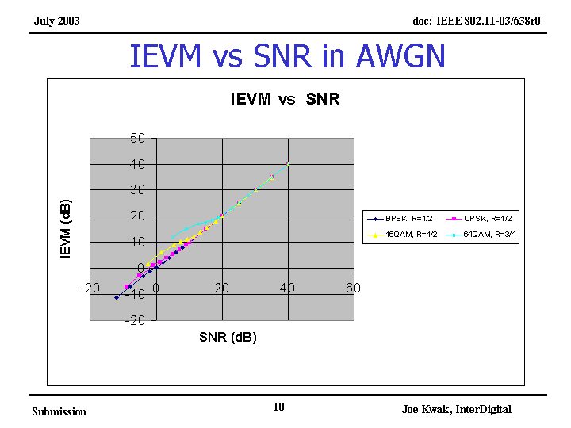
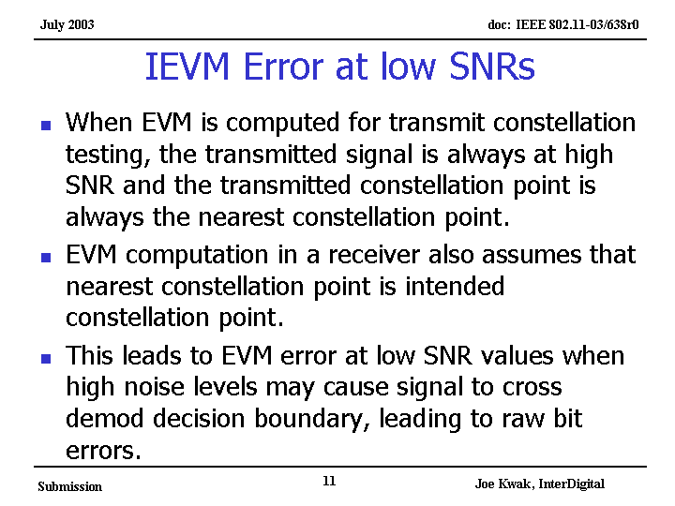
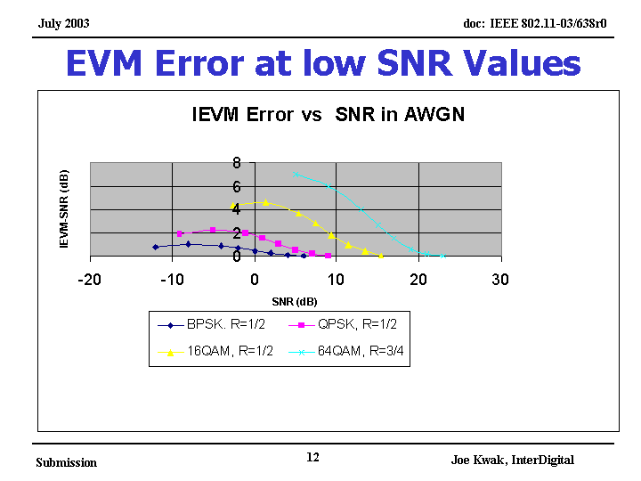
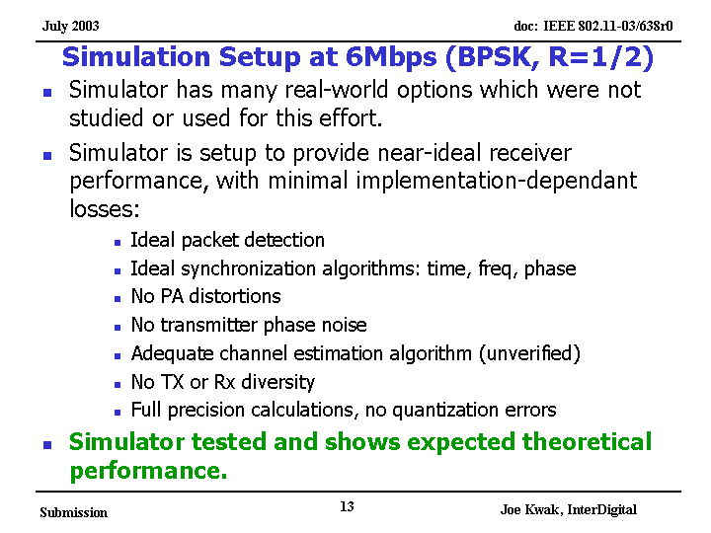
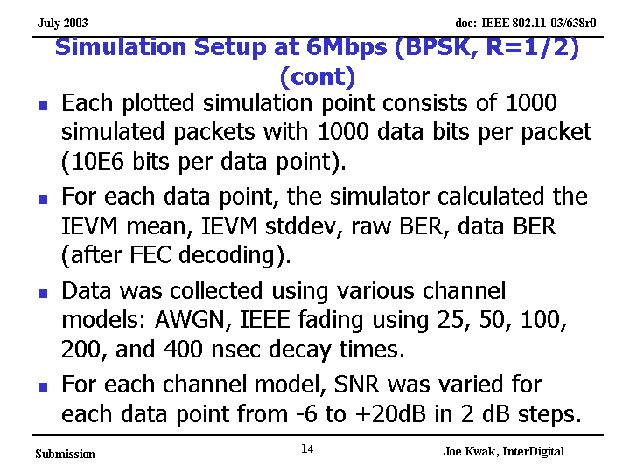
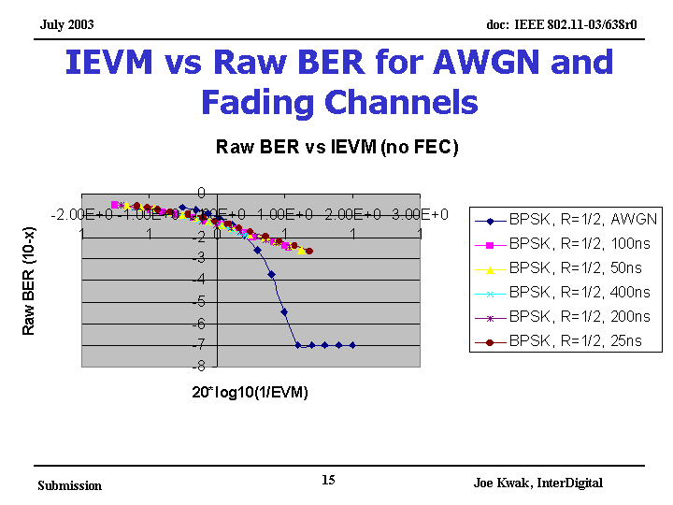
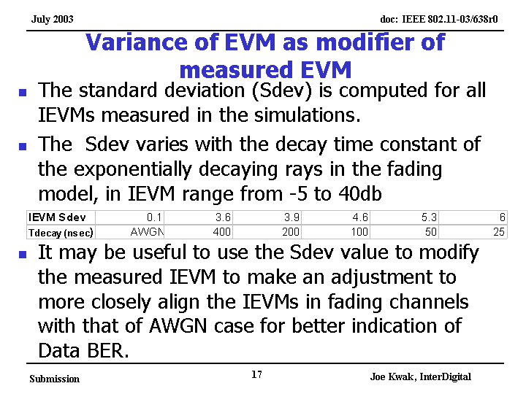
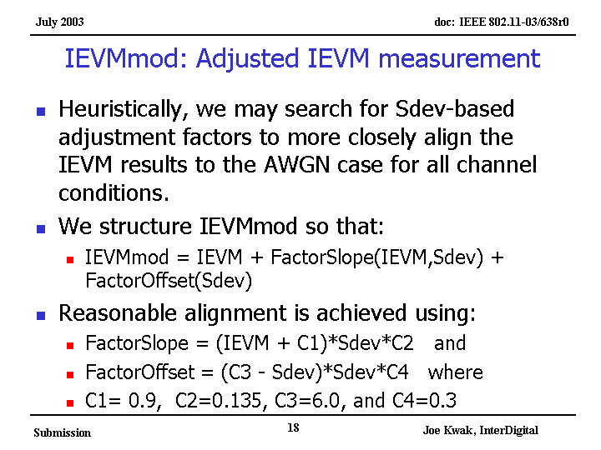
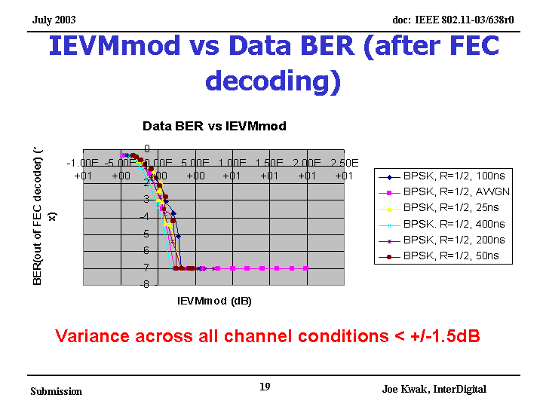
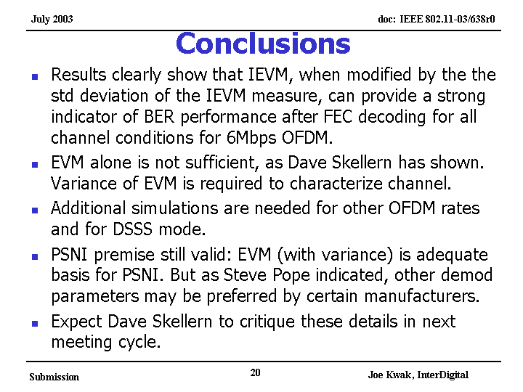
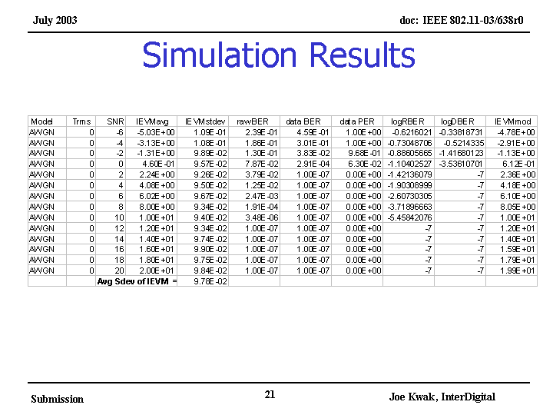
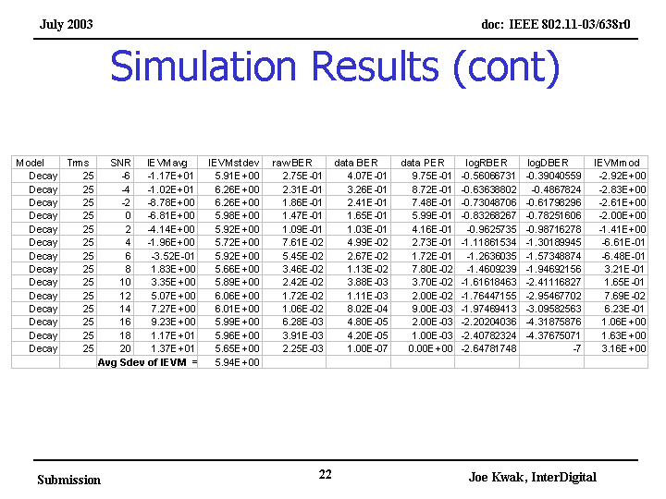
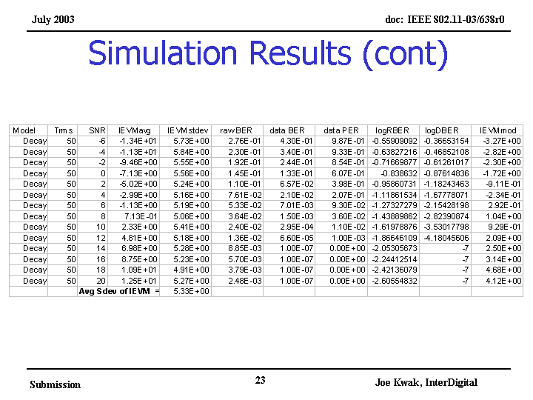
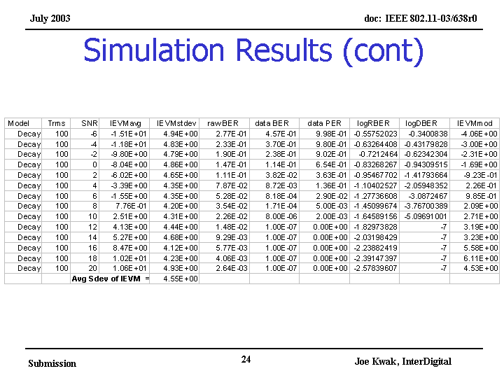
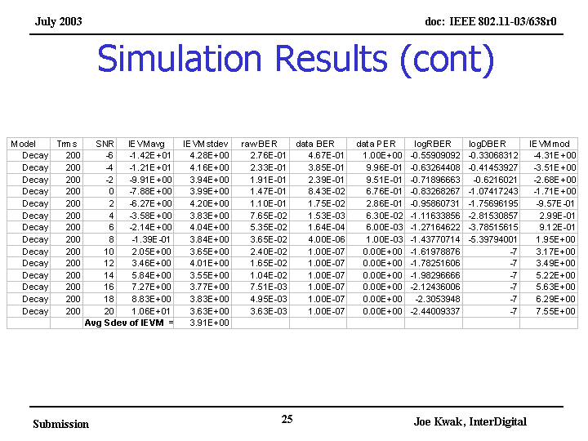
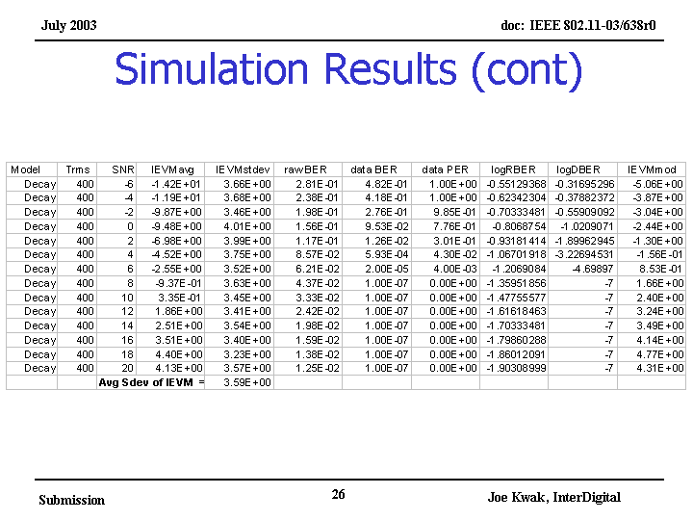
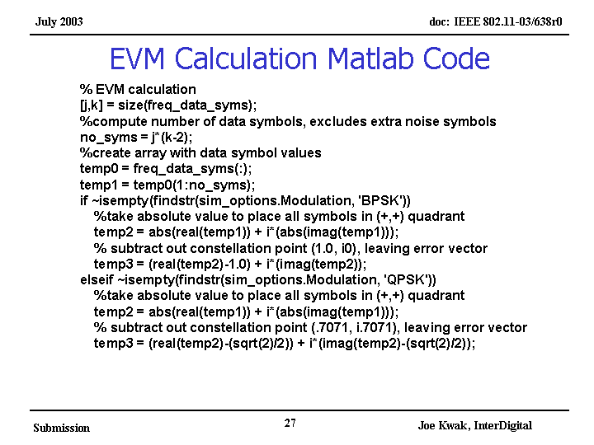
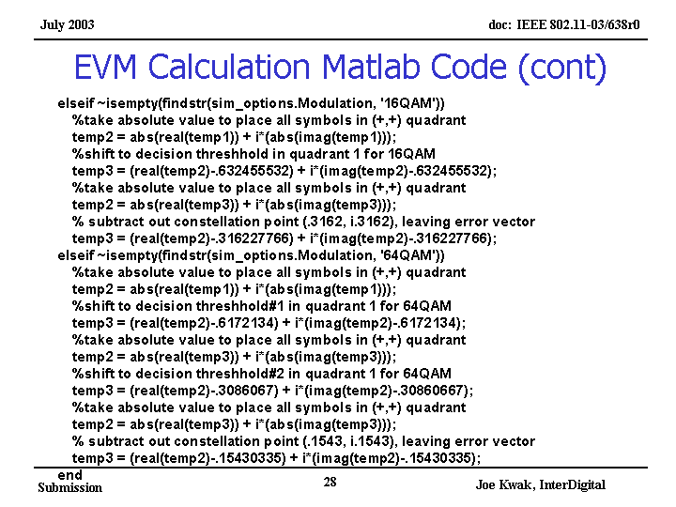
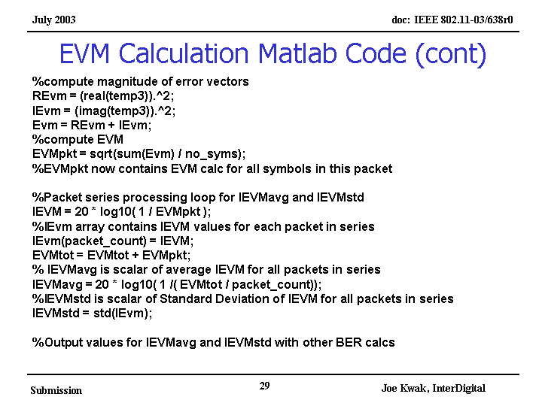

Discussion:
None

Joe Kwak presented 03/603r0 “Two New MAC Measurements”

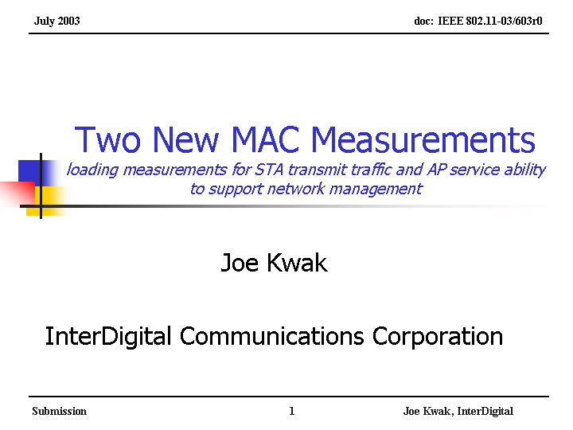
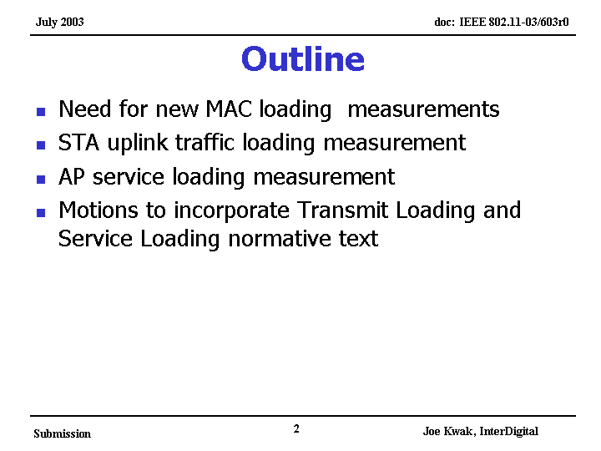
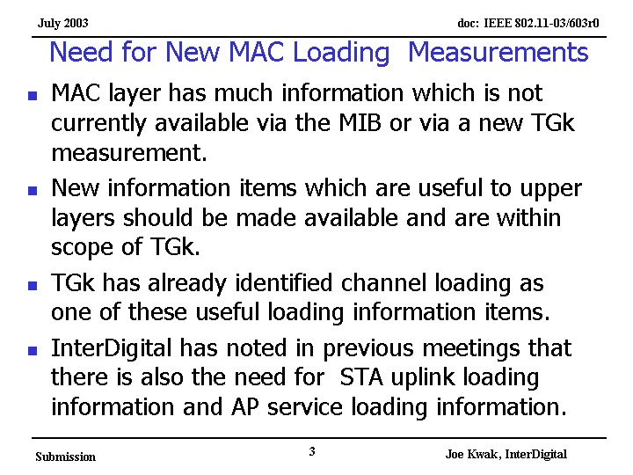
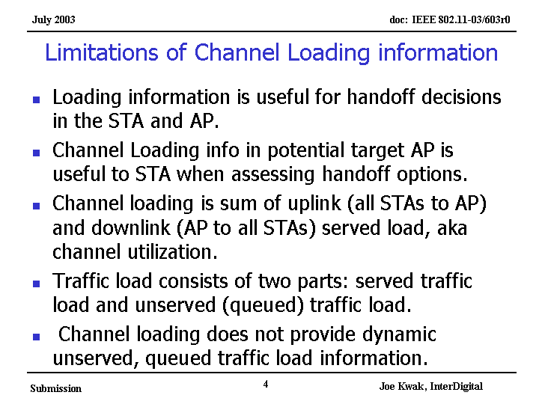
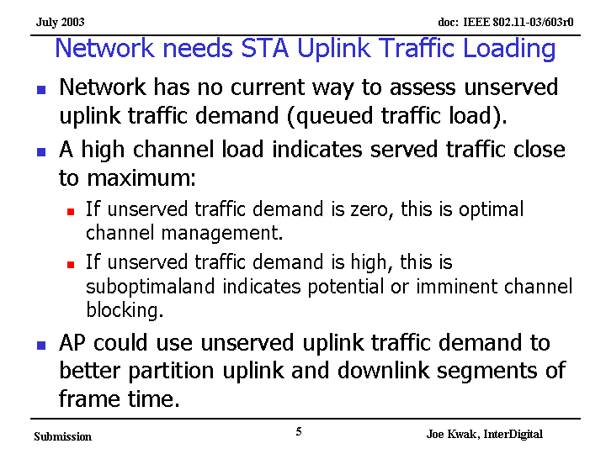
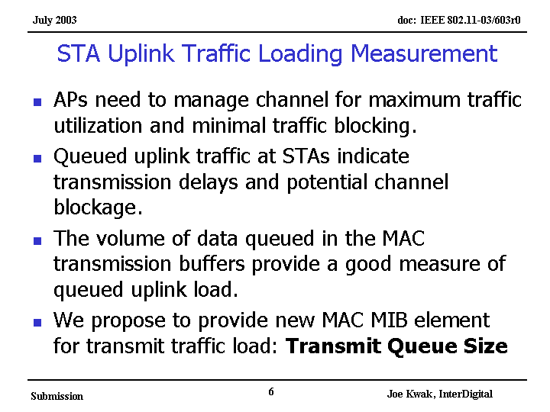
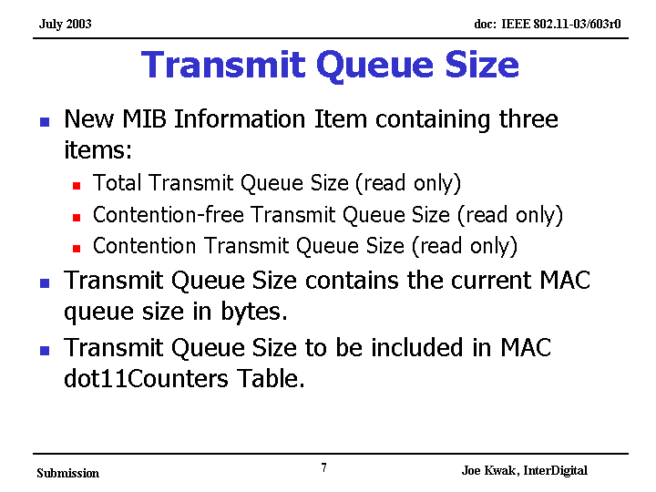
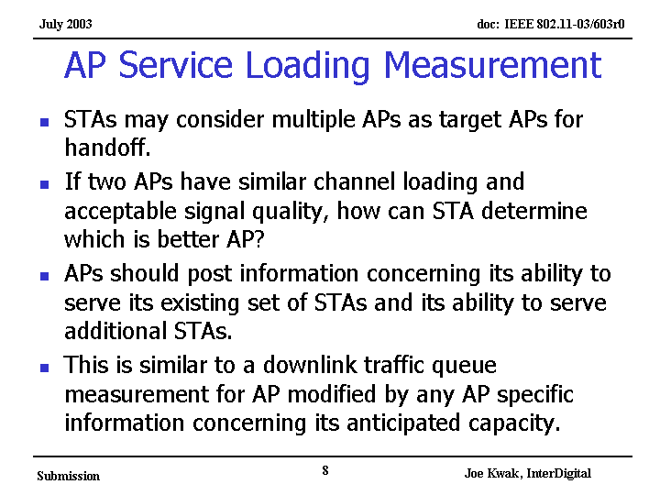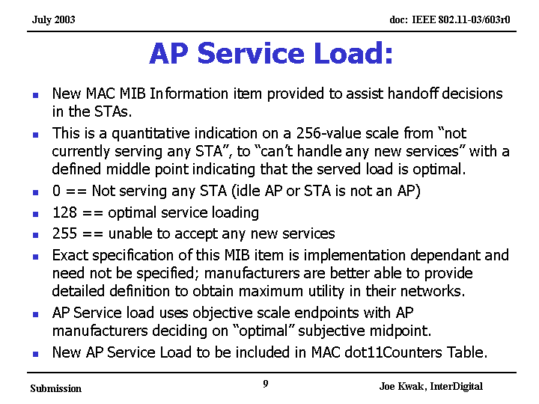

Document 03/604r0 is normative text for presentation 03/603r0

Discussion:
Would like to have some filtering on these measurements due to the load may have spikes of load.

Straw Poll
Would you instruct the editor to incorporate the text from document 03/0604r0 MIB TxQ size doc into the TGk Draft Specification?

yes 15 no 9 abs 13 (62.5%)

Straw Poll:
Would you instruct the editor to incorporate the text from document 03/0605r0 MIB AP Load doc into the TGk Draft Specification?

yes 18 no 8 abs 7 (69.2%)

Tamara Shelton presented 03/633r0

IEEE P802.11
Wireless LANs

Scenarios for Radio Resource Measurement
Date: July 24, 2003
Author:

Tamara Shelton
Athene Consulting
tamara@athenecon.com

Richard Paine
Boeing
richard.h.paine@boeing.com

Bob Neilsen
Symbol Technologies
bob@sj.symbol.com

Harry Worstell
AT&T Labs
hworstell@research.att.com

The following document presents scenarios for public, enterprise and airplane WLAN usage. The public scenarios include hotspots, hotzones and high density/multi-use (residential/office/retail) settings. The enterprise scenarios consider ubiquitous/non-ubiquitous coverage and device type (laptop or handheld).

Public Scenarios
Hotspot – Starbucks, Borders, theaters (no roaming until maybe afterwards)
- Single SSID for hotspot, could see other APs
- AP 11k Service beacon
- AP Site report
- STA site report
- Bandwidth is sometimes limited to DSL
- STA Measurements Needed
  - Beacon (passive scan)
    - SSID
    - BSSID
    - ESS Information
    - RCPI
    - Data Rate
    - BER
    - SNR
    - Neighbor Graph
  - Probe
    - RCPI
    - Data Rate
    - BER
    - SNR
    - Site Report
    - Neighbor Graph
    - Location + direction
- AP Measurements Needed
  - Beacon (passive scan)
    - SSID
    - BSSID
    - ESS Information
    - RCPI
    - Data Rate
    - BER
    - SNR
    - Neighbor Graph
  - Probe
    - RCPI
    - Data Rate
    - BER
    - SNR
    - Site Report
    - Neighbor Graph
    - STA location + direction
- Roam Capability
  - Measurement Trigger for Roam (dissociateimminent) after association

HotZone – Airports, train stations, malls
- Multiple SSIDs (virtual Aps)
- Better backhaul
- STA Measurements Needed
  - Beacon (passive scan)
    - SSID
    - BSSID
    - ESS Information
    - RCPI
    - Data Rate
    - BER
    - SNR
    - Neighbor Graph
  - Probe
    - RCPI
    - Data Rate
    - BER
    - SNR
    - Site Report
    - Neighbor Graph
    - Location + direction
- AP Measurements Needed
  - Beacon (passive scan)
    - SSID
    - BSSID
    - ESS Information
    - RCPI
    - Data Rate
    - BER
    - SNR
    - Neighbor Graph
  - Probe
    - RCPI
    - Data Rate
    - BER
    - SNR
    - Site Report
    - Neighbor Graph
    - STA location + direction
- Roam Measurement Capability
  - Measurement Trigger for Roam (dissociate imminent)
  - Context transfer to roam across APs and possibly subnets

Multifamily Housing and Mixed Use -(This scenario assumes diverse and high-density land uses including apartments, town homes, retail and office.)
- Many SSIDs
- Optimization of a dense radio environment
- Power level optimization
- Load balancing
- Context Transfer Protocol or IAPP back to the device.
- Handover if community WLAN offered by management
- Channel map
- site report
- parameters stored in the MIB (disassociate imminent)
- STA Measurements Needed
  - Beacon (passive scan)
    - SSID
    - BSSID
    - ESS Information
    - RCPI
    - Data Rate
    - BER
    - SNR
    - Neighbor Graph
  - Probe
    - RCPI
    - Data Rate
    - BER
    - SNR
    - Site Report
    - Neighbor Graph
    - Location + direction
- AP Measurements Needed
  - Beacon (passive scan)
    - SSID
    - BSSID
    - ESS Information
    - RCPI
    - Data Rate
    - BER
    - SNR
    - Neighbor Graph
  - Probe
    - RCPI
    - Data Rate
    - BER
    - SNR
    - Site Report
    - Neighbor Graph
    - STA location + direction
- No roam

Enterprise Scenarios
Rogues
- Roque APs (clients collect data and report it to the network manager. APs are too busy to collect information. Think of them as T-cells. )
- Measurements Needed
  - Beacon (passive scan)
    - SSID
    - BSSID
    - ESS Information
    - RCPI
    - Data Rate
    - BER
    - SNR
    - Neighbor Graph
    - Location
  - Probe (active scan)
    - RCPI
    - Data Rate
    - BER
    - SNR
    - Site Report
    - Neighbor Graph
    - Location
    - No Roam

Ubiquitous WLAN Scenario (laptop pre-configured to have a single SSID)
- Single or few SSIDs
- Context Transfer Protocol or IAPP back to the device.
- Handover – requires RCPI
- Channel map
- site report for pre-authentication and preauthorization
- parameters stored in the MIB (dissassociateimminent)
- STA Measurements Needed
  - Beacon (passive scan)
    - SSID
    - BSSID
    - ESS Information
    - RCPI
    - Data Rate
    - BER
    - SNR
    - Neighbor Graph
  - Probe
    - RCPI
    - Data Rate
    - BER
    - SNR
    - Site Report
    - Neighbor Graph
    - Location + direction
- AP Measurements Needed
  - Beacon (passive scan)
    - SSID
    - BSSID
    - ESS Information
    - RCPI
    - Data Rate
    - BER
    - SNR
    - Neighbor Graph
  - Probe
    - RCPI
    - Data Rate
    - BER
    - SNR
    - Site Report
    - Neighbor Graph
    - Location + direction
- Roam Capability
  - Measurement Trigger for Roam (dissociateimminent)
  - Corresponding AP action to initiate preauth, etc

Non-Ubiquitous WLAN Scenario (laptop pre-configured to have a single SSID)

- Single or few SSIDs
- Context Transfer Protocol or IAPP back to the device.
- Stateful protocol to maintain state until the device is back in coverage
- Handover – requires RCPI
- Channel map
- site report for pre-authentication and preauthorization
- parameters stored in the MIB (dissassociateimminent)
- STA Measurements Needed
  - Beacon (passive scan)
    - SSID
    - BSSID
    - ESS Information
    - RCPI
    - Data Rate
    - BER
    - SNR
    - Neighbor Graph
  - Probe
    - RCPI
    - Data Rate
    - BER
    - SNR
    - Site Report
    - Neighbor Graph
    - Location + direction
- AP Measurements Needed
  - Beacon (passive scan)
    - SSID
    - BSSID
    - ESS Information
    - RCPI
    - Data Rate
    - BER
    - SNR
    - Neighbor Graph
  - Probe
    - RCPI
    - Data Rate
    - BER
    - SNR
    - Site Report
    - Neighbor Graph
    - Location + direction
- Roam Capability
  - Measurement Trigger for Roam (dissociateimminent)
  - Corresponding AP action to initiate preauth, etc
  - Hysteresis – history + trending

Hand-held Ubiquitous WLAN Scenario

- handheld pre-configured to have a single SSID
- Power save mode impacts frequency and scope of measurements
- Needs AP's site report to create its own.
- Measurement of battery levels for radio transmission
- This site report changes in real-time as he/she roams.
- signal strength measure by initiating a request to do pre-authentication and pre-authorization with the next cell's AP.
- The site report of the STA in the iPAQ continuously reflects the signal strengths and unique characteristics of the STA and its environment.
- The setup is in the pre-authentication and pre-authorization before the handoff.
- handoff in 40ms
- STA Measurements Needed
  - Beacon (passive scan)
    - SSID
    - BSSID
    - ESS Information
    - RCPI
    - Data Rate
    - BER
    - SNR
    - Neighbor Graph
  - Probe
    - RCPI
    - Data Rate
    - BER
    - SNR
    - Site Report
    - Neighbor Graph
    - Location + direction
- AP Measurements Needed
  - Beacon (passive scan)
    - SSID
    - BSSID
    - ESS Information
    - RCPI
    - Data Rate
    - BER
    - SNR
    - Neighbor Graph
  - Probe
    - RCPI
    - Data Rate
    - BER
    - SNR
    - Site Report
    - Neighbor Graph
    - Location + direction
- Roam Capability
  - Measurement Trigger for Roam (dissociateimminent)
  - Corresponding AP action to initiate preauth, etc

Handheld Non-Ubiquitous WLAN Scenario
- Single SSID
- the site report indicates that there is no AP in that direction to handoff to.
- The AP maintains state until the next coverage area occurs using the site report information it has. Before it reaches the boundary of the next coverage area,
- the RCPI and the site report have indicated that it is moving into the range of one AP.
- The trigger is possibly the old site report indicating an associate is imminent or other parameters stored in the MIB.
- The preauthentication and preauthorization occur with the next AP that is in the site report, using hysteresis (history + trending) and site reporting.
- If a different subnet, then the DHCP request is made by the next AP for a new IP address and passed via Context Transfer Protocol or IAPP back to the device through the old AP.
- STA Measurements Needed
  - Beacon (passive scan)
    - SSID
    - BSSID
    - ESS Information
    - RCPI
    - Data Rate
    - BER
    - SNR
    - Neighbor Graph
  - Probe
    - RCPI
    - Data Rate
    - BER
    - SNR
    - Site Report
    - Neighbor Graph
    - Location + direction
- AP Measurements Needed
  - Beacon (passive scan)
    - SSID
    - BSSID
    - ESS Information
    - RCPI
    - Data Rate
    - BER
    - SNR
    - Neighbor Graph
  - Probe
    - RCPI
    - Data Rate
    - BER
    - SNR
    - Site Report
    - Neighbor Graph
    - Location + direction
- Roam Capability
  - Measurement Trigger for Roam (dissociateimminent)
  - Corresponding AP action to initiate preauth, etc
  - Hysteresis – history + trending

High Speed Mobile
High Speed Mobile Setup (may be multiple SSIDs)
- Single or few SSIDs
- Context Transfer Protocol or IAPP back to the device.
- Handover – requires RCPI
- Channel map
- site report for pre-authentication and preauthorization
- parameters stored in the MIB (dissassociateimminent)
- mechanism for rapid changes in APs
- STA Measurements Needed
  - Beacon (passive scan)
    - SSID
    - BSSID
    - ESS Information
    - RCPI
    - Data Rate
    - BER
    - SNR
    - Neighbor Graph
  - Probe
    - RCPI
    - Data Rate
    - BER
    - SNR
    - Site Report
    - Neighbor Graph
    - Location + direction
- AP Measurements Needed
  - Beacon (passive scan)
    - SSID
    - BSSID
    - ESS Information
    - RCPI
    - Data Rate
    - BER
    - SNR
    - Neighbor Graph
  - Probe
    - RCPI
    - Data Rate
    - BER
    - SNR
    - Site Report
    - Neighbor Graph
    - STA location + direction
- Very fast roaming and handoff
  - Same network easy
  - Different network difficult
Airplane
Passengers very close together (single SSIDs) and they are a captive audience.
- One SSID
- Optimization of a very dense radio environment
- Power level optimization
- Load balancing
- Context Transfer Protocol or IAPP back to the device.
- Channel map
- STA Measurements Needed
  - Beacon (passive scan)
    - SSID
    - BSSID
    - ESS Information
    - RCPI
    - Data Rate
    - BER
    - SNR
    - Neighbor Graph
  - Probe
    - RCPI
    - Data Rate
    - BER
    - SNR
    - Site Report
    - Neighbor Graph
    - Location + direction
- AP Measurements Needed
  - Beacon (passive scan)
    - SSID
    - BSSID
    - ESS Information
    - RCPI
    - Data Rate
    - BER
    - SNR
    - Neighbor Graph
  - Probe
    - RCPI
    - Data Rate
    - BER
    - SNR
    - Site Report
    - Neighbor Graph
- Roam across four or five Aps

Requirements Summary
- RCPI
- SNR
- Threshold of SNR
- Measurement of client battery levels (number of recharges; power allocation for system resource/background housekeeping).
- Signal Quality measurement
- Data Rate
- Delta between manufacturer sensitivity and measure sensitivity
- Radio type - single and multi-band
- Current channel load
- RPI time
- Channel map
- 11k capability
- Load balancing
- AP Site report
- STA site report
- Neighborhood map
- Overlapping BSS
- Hidden node
- Parameters stored in the MIB (disassociate imminent)
- Association imminent
- New IP address flag
- Active scan (when permitted)
- Medium sensing time
- CCA idle time
- CCA busy time
- NAV busy time (network allocation vector)

Discussion
None

The Chair discussed what Bob O’Hara is going to present about the work TGd did on country codes and its impact on TGk. Also, asked him to discuss Seamless Mobility (Seamoby).

recess until 7:00PM

Thursday, July 24, 2003
7:00 PM – 9:30 PM

Call to order 7:00pm

Motion:
Move to Approve the 7:00PM agenda

Moved by Simon Black
Second John Rosdahl

Motion to amend –
Move to amend the agenda to place the Simon Black vote after the vote on fast active scanning.
Moved: Malik Ahdeh
Second Rodger Durand
yes 4 no 10 abs 12 (28.5%)
Motion on the amendment fails

Original motion
yes 17 no 3 abs 5 (85%)
Motion Passes

Motion:
With reference to Clause 7.3.2.22 of IEEE802.11k Draft 0.4 and considering the Preferred, Trusted and Rouge sub-fields ill-defined and the Subnet subfield out-of scope: instruce the editor to remove the said fields, associated definitions and related descriptive text in clause 11.8 in the next IEEE 802.11k draft

Moved Simon Black
Second Stuart Kerry
Discussion:
Comment: Against: Should not rip out these bits
Mover: For: Does not want to have things in the draft that is ill defined.
Comment: discussion should not be a 2 person discussion
Comment: Against: This is not a layer violation and would rather define the bite than remove them
Comment: For: agrees that needs defined f before placing in draft
Comment: Against: over 50% believes it is needed and should be fixed and not removed.
Comment: For: what do these have to do with measurements and could be added later when better defined
Comment: Against: They need to be improved and not pulled out.
No further discussion
yes 20 no 6 abs 13 (77 %)
Motion passes

A request for a recount – Malik Audah
Chair declined a recount

Zhun Zhong presented 03/623r2 “Fast Active Scan Proposal”
Intends to show again the presentation for clarification
then show the normative text and then vote on the text.

IEEE P802.11
Wireless LANs
Proposed Text for Fast Active Scan
Date: 24 July 2003
Author: Moo Ryong Jeong, Fujio Watanabe, Toshiro Kawahara
DoCoMo USA Laboratories
181 Metro Dirve Suite 300
San Jose, CA 95110
Phone: 408 451 4761
e-Mail: jeong@docomolabs-usa.com
Zhun Zhong
Philips Research
345 Scarborough Road
Briarcliff Manor, NY 10510
Phone: 914 945 6310
e-Mail: zhun.zhong@philips.com

Abstract

This document contains instructions to the editor to edit normative text concerning a fast active scanning. The fast active scanning can be effectively used to reduce channel scanning time.
.

9.2.3.1 Short IFS (SIFS)
Change the first paragraph as follow:
The SIFS shall be used for an ACK frame, a CTS frame, the second or subsequent MPDU of a fragment burst, and by a STA responding to any polling by the PCF. It may also be used by a PC for any types of frames during the CFP (see 9.3) and by an AP for a probe response frame that is sent immediately after a probe request frame,The SIFS is the time from the end of the last symbol of the previous frame to the beginning of the first symbol of the preamble of the subsequent frame as seen at the air interface. The valid cases where the SIFS may or shall be used are listed in the frame exchange sequences in 9.7.

9.2.3.2 PCF IFS (PIFS)
Change the first paragraph as follow:
The PIFS shall be used by STAs operating under the PCF to gain priority access to the medium at the start of the CFP and may be used by APs responding to probe request with probe response. A STA using the PCF shall be allowed to transmit contention-free traffic after its carriersense mechanism (see 9.2.1) determines that the medium is idle at the TxPIFS slot boundary as defined in 9.2.10. Subclause 9.3 describes the use of the PIFS by STAs operating under the PCF.

9.2.8 ACK Procedure
Delete the last sentence in the section:
The sole exception is that recognition of a valid data frame sent by the recipient of a PS-Poll frame shall also be accepted as successful acknowledgment of the PS-Poll frame.

Insert the following sentences to replace the above deleted sentence:
The exceptions are that recognition of a valid data frame sent by the recipient of a PS-Poll frame shall also be acceptable as successful acknowledgement of the PS-Poll frame and that recongnition of a valid probe response sent by the recipient of a probe request shall also be acceptable as successful acknowledgement of the probe request frame.

9.7 Frame exchange sequences
Insert the following row into the Table 21:
Table 21 – Frame sequences
Sequence | Frames in sequence | Usage
fast probe request − fast probe response | 2 | Directed MMPDU
fast probe request -- ACK | 2 | Defered probe response
Insert the following text at the end of LEGEND:

24 – “fast probe request” represents a management frame of subtype Probe Request with an individual address in the Address 1 field.
25 – “fast probe response” represents a management frame of subtype Probe Response with an broadcast address in the Address 1 field.

10.3.2.1.2 Semantics of the service primitive
Change part of Table contents as follows:

Name | Type | Valid range | Description
BSSID | MAC address | Any valid individual or broadcast MAC address. Only individual MAC address is allowed if ScanType is Fast Active. | Specifies the desired BSSID or the broadcast BSSID.
ScanType | Enumeration | ACTIVE,  PASSIVE, FAST ACTIVE | Indicates one of three scanning types: active scanning, passive scanning, and fast active scanning
ProbeDelay | Integer | N/A | Delay (in us) to be used prior to transmitting a Probe frame during active and fast active scanning
ChannelList | Ordered set of integers | Each channel will be selected from the valid channel range for the appropriate PHY and carrier set | Specifies a list of channels that are examined when scanning for a BSS. If ScanType is Fast Active, contains only a single channel, which is the current channel of the desired BSS.

10.3.3.1.2 Semantics of the service primitive
Change a part of Table contents as follows:
Name | Type | Valid range | Description
ProbeDelay | Integer | N/A | Delay (in us) to be used prior to transmitting a Probe frame during active and fast active scanning

10.3.10.1.2 Semantics of the service primitive
Change a part of Table contents as follows:

Name | Type | Valid range | Description
ProbeDelay | Integer | N/A | Delay (in us) to be used prior to transmitting a Probe frame during active and fast active scanning

11.1.3 Acquiring synchronization, scanning
Change the first three paragraphs as follows:
A STA shall operate in one of three scanning modes: Passive Scanning mode, Active Scanning mode, and Fast Active Scanning mode depending on the current value of the ScanType parameter of the MLME-SCAN.request primitive.

Upon receipt of the MLME-SCAN.request primitive, a STA shall perform scanning. The SSID and BSSID parameters indicate the SSID and BSSID for which to scan, respectively.

To become a member of a particular ESS using passive scanning, a STA shall scan for Beacon frames containing that ESS’s SSID, returning all Beacon frames matching the desired SSID in the BSSDescriptionSet parameter of the corresponding MLME-SCAN.confirm primitive with the appropriate bits in the Capabilities Information field indicating whether the beacon came from an Infrastructure BSS or IBSS. To actively scan, the STA shall transmit Probe frames containing the desired SSID. To become a member of a particular BSS using fast active scanning, a STA shall transmit Probe frames containing the desired BSSID in Address 1 field and BSSID field. Upon completion of scanning, an MLME-SCAN.confirm is issued by the MLME indicating all of the BSS information received.

11.1.3.2.1 Sending a probe response
Change the first paragraph as follow:
STAs, subject to criteria below, receiving Probe Request frames shall respond with a probe response only if the SSID in the probe request is the broadcast SSID or matches the specific SSID of the STA. Probe Response frame shall be sent as a directed frame to the address of the STA that generated the probe request. If the Address 1 and BSSID in the probe request are same as the MAC address of the STA and the STA’s dot11RadioMeasurementEnabled is true, the STA shall respond with the corresponding probe response with broadcast destination address immediately after SIFS, or acknowledge the probe request and response with the corresponding probe response at a later time. When the STA responds with the corresponding probe response at a later time, it may transmit the probe response after the medium is idle for PIFS.If the Address 1 is broadcast address or the STA’s dot11RadioMeasurementEnabled is false, the probe response shall be sent using normal frame transmission rules. An AP shall respond to all probe requests meeting the above criteria. In an IBSS, the STA that generated the last beacon shall be the STA that responds to a probe request.

Insert the following three sections after Section 11.1.3.4 and renumber figures and tables as necessary:

11.1.3.5 Fast active scanning
Fast active scanning is a way for a STA to reduce channel-scanning time when the STA knows the BSSID and current channel of the AP to be scanned prior to the commencement of fast active scanning. The BSSID and current channel of an AP can be obtained from Site Report or scanning results of previous passive or active scanning.
The details of the fast active scanning procedures are as specified in the following subclauses.

11.1.3.5.1 Sending a probe response
STAs receiving Probe Request frames shall respond with a probe response only if the SSID in the probe request is the broadcast SSID or matches the specific SSID of the STA. A Probe Response frame shall be sent as a directed frame to the address of the STA that generated the probe request. If the Address 1 and BSSID in the probe request are same as the MAC address of the STA and the STA’s dot11RadioMeasurementEnabled is true, the STA shall respond with the corresponding probe response with broadcast destination address immediately after SIFS (See Figure 0-1), or acknowledge the probe request and response with the corresponding probe response at a later time (See Figure 0-2 and Figure 0-3). When the STA responds with the corresponding probe response at a later time, it may transmit the probe response after the medium is idle for PIFS (See Figure 0-3).If the Address 1 is broadcast address or the STA’s dot11RadioMeasurementEnabled is false, the probe response shall be sent using normal frame transmission rules. An AP shall respond to all probe requests meeting the above criteria.

11.1.3.5.2 Fast active scanning procedure
Upon receipt of the MLME-SCAN.request with ScanType indicating a fast active scan, a STA shall use the following procedure:

For the current channel of the desired BSS to be scanned,

a) Wait until the ProbeDelay time has expired or a PHYRxStart.indication has been received;
b) Perform the Basic Access procedure as defined in 9.2.5.1;
c) Send a Probe Request frame with the desired BSSID in destination and BSSID filed, and SSID;
d) Clear and start a ProbeTimer at the PHY-TXEND.confirm;
e) If a PHY-RXSTART.indication does not occur before the Probe Timer reaches MinChannelTime, then proceed to step h), else when a PHY-RXSTART.indication does occur, the STA shall wait for the corresponding PHY-RXEND.indication to determine whether the received frame is an appropriate frame. The recognition of valid Probe Response frame or ACK frame sent by the recipient of the Probe Request frame, corresponding to this PHY-RXEND.indication, shall be interpreted as appropriate.
f) If a valid ACK frame was recognized in step e), stay on the channel until a Probe Response frame is received from the recipient of the Probe Request frame or ProbeTimer reaches MaxChannelTime
g) If a valid Probe Response frame was recognized in step e) or f), process the received Probe Response frame and proceed to step h),
h) Clear NAV and issue an MLME-Scan.confirm with the BSSDescriptionSet containing the information gathered during the scan, if any.

Figure 0- Probe response that is sent immediately after probe request in fast active scanning

Figure 0- Probe response that is sent with DIFS after sending immediate ACK to probe request in fast active scanning
Figure 0- Probe response that is sent with PIFS after sending immediate ACK to probe request in fast active scanning

11.2.1 Power management in an infrastructure network
Change the fourth paragraph as follow:
In a BSS operating under the DCF, or during the contention period of a BSS using the PCF, upon determining that an MSDU is currently buffered in the AP, a STA operating in the PS mode shall transmit a short PS-Poll frame to the AP, which shall respond with the corresponding buffered MSDU immediately, or acknowledge the PS-Poll and respond with the corresponding MSDU at a later time. If the TIM indicating the buffered MSDU is sent during a contention-free period (CFP), a CF-Pollable STA operating in the PS mode does not send a PS-Poll frame, but remains active until the buffered MSDU is received (or the CFP ends). If any STA in its BSS is in PS mode, the AP shall buffer all broadcast and multicast MSDUs except those of probe response and deliver them to all STAs immediately following the next Beacon frame containing a delivery TIM (DTIM) transmission.

11.2.1.3 TIM types
Change the fourth paragraph as follow:
The third and fourth lines in Figure 67 depict the activity of two STAs operating with different power management requirements. Both STAs power-on their receivers whenever they need to listen for a TIM. This is indicated as a ramp-up of the receiver power prior to the TBTT. The first STA, for example, powers up its receiver and receives a TIM in the first beacon; that TIM indicates the presence of a buffered MSDU for the receiving STA. The receiving STA then generates a PS-Poll frame, which elicits the transmission of the buffered data MSDU from the AP. Broadcast and multicast MSDUs except those of probe response are sent by the AP subsequent to the transmission of a beacon containing a DTIM. The DTIM is indicated by the DTIM count field of the TIM element having a value of 0.

Discussion:
C: Where would this be legal because it is illegal and soon to be illegal in us soon?
A: can use active scanning if you are confirmed to use the channel. STA Must receive a beacon before you can active scan after the beacon is received active scanning is ok
When to use it and where is out of scope for this group.
Comment: 5GHz it is illegal but maybe for only 5 years but at 2.4 GHz it is not Illegal…
Comment: if the APs are the transmitter then a site report will give that information
A: not defining when and where to use active scanning and should not forbid anyone to do so.
Comment: 2GHz is OK in the 5GHz band you are listening for RADAR before you can transmit.
Comment: understanding is the FCC requires that the channel can not be scanned until you understand which regulatory domain
Comment: Likes active scanning but against the proposal because the directed probe is already in the spec and they will help in fast handoff
A: Spec does not permit a directed probe request
Comment: There is more in the spec then what is sited and the reference is incomplete
A: TGe has changes to correct an error…..
Comment: Maybe permitted to day but this won’t hurt to be in spec.
first 2 should be optional and third mandatory
Comment: needs more clarification
Comment: is this optional
A: AP needs to respond after PIFS…hard for current hardware today but can do an ACK
Comment: how long are you willing to wait for the response.
A: difficult today but why not do it for new hardware…doesn’t aggress with long timing assumptions and it is optional.
Comment: how does this apply to TGk it is not measurements
Is it measurements or fast roaming.
A: First step in fast roaming is to collect information

Draft normative text is located in documents 03/623/r3 and lists the details of this power point document.

Motion:
Move to instruct the editor to incorporate the text from document 03/0623r3 into the next TGk draft.
Move Zunng
Second Javier de Prado
yes 18 no 15 abs 12 55%
Motion fails

Motion:
Move to defer the approval of the teleconference minutes from the May 2003 interim to the July 2003 plenary session until the September session until the membership has the opportunity to see them
Moved Harry
Second Bob Neilsen
yes 34 no 0 abs 0 (100%)

Showed the motions for the plenary

Motion
- Believing that TGk will approve motions resulting in a document that satisfies WG 802.11 rules for letter ballot at a duly authorized meeting conduct in good order,
- conditionally authorize a 40 day LB to conclude no later than one week prior to the November plenary asking the question “Should the attached draft by TGk be forwarded to SB,” conditional on the existence of a document by 802.11 WG meeting rules for letter ballot.

Moved: Tamara Shelton
Second: Bob Neilsen
yes 28 no2 abs 4

STA Statistics – 13.6 of document 03/427r8
There has been nothing done on the subject as yet.
Joe Kwak
A measurement by itself is not necessarily meaningful
but a group of measurements are more meaningful. (RCPI, Signal quality measure, some counters)

Comment: Concern that doing the computations at layer 2 and using up the real time of the MAC for all of these computations may not be the best use of the MAC and the group should be very cautious with these computations that can be done at higher layers

Comment: Some new devices(Wireless switches) have the ability to place most of the MAC
in the switch and will have the ability to do this.

Comment: Standards are written for all devices and must not take into consideration proprietary instances.

Motion:
Motion to adjourn
Moved: Simon Barber
Second: Tamara Shelton
Unanimous

