IEEE P802.11
Wireless LANs
Title
Date: May 14, 2003
Author: Bob O’Hara
Airespace, Inc.
110 Nortech Pkwy
San Jose, CA 95134
Phone: +1 408 635 2025
Fax: +1 408 941 0495
e-Mail: bob@airespace.com
Interpretation Number: 4-05/03 (Country Information Element)
Topic: Country Information Element
Relevant Clauses: 7.3.2.9 (7.3.2.12 from the requester), 17.3.8.3.3
Classification: unambiguous

Interpretation Request

Abstract
The current description of the country information element is vague about the precise contents of the country information element. It remains unclear whether the country information must always contain the full set of regulatory domain information as specified by the regulatory administrations or that a subset of the regulatory domain information can be used as specified by the network operator. Furthermore, it is ambiguous how the country information element should be used in the 5GHz band.

Current definition of the country information element
The country information element contains the information required to allow a station to identify the regulatory domain in which the station is located and to configure its PHY for operation in that regulatory domain.

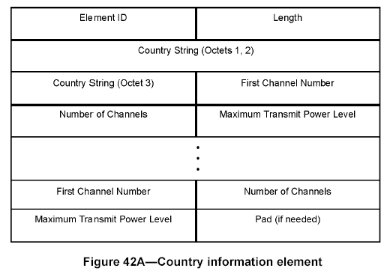

Vague rules for sub band definition in 2GHz band
The country information element allows the definition of multiple sub bands with each their own maximum transmit power levels.
The rules specified for these sub bands are:
- sub band ranges must not overlap;
- sub bands must monotonically increase.

This definition does not demand that sub bands exactly fill up the regulatory channels.

For example, this definition allows network operators to create a country element as follows:
The country element contains three sub bands.
1) The First Channel Number element of the first sub band is set to channel 1 and the Number of Channels element is set to one.
2) The First Channel Number element of the second sub band is set to channel 5 and the Number of Channels element is set to one.
3) The First Channel Number element of the third sub band is set tot channel 9 and the Number of Channels element is set to one.

The resulting country information element is valid within the FCC regulatory domain and might be valid to the definition of the country information element in the IEEE 802.11d standard.

STAs that use the above country information to determine the regulatory domain, will only mark channels 1, 5 and 9 as regulatory permitted and will not look for networks at the other channels. Although this may improve the scanning behavior of STAs, we believe this is not what the country information element is intended for according to the definition in the first paragraph of section 7.3.2.12 (lines 30-32 of page 1 of this document).

Proposal
Change text to clearly state that the country information element must be used to inform STAs about the full regulatory domain of operation. Sub bands may only be used if the regulatory domain consists of sub bands.

Proposed text change
(802.11d, page 4, paragraph 4): Change “The group of channels described .. increasing in channel numbers.” into “The group of channels described by each pair of the First Channel Number and Number of Channels fields shall not overlap, shall be monotonically increasing in channel numbers and shall describe all channels allowed in the regulatory domain.”

Interpretation for IEEE std 802.11-1999 (reaffirmed 2003)
The definition of the use of the Country information element in either of the cases described by the requester is allowed in the standard. The Country information element provides a mechanism to communicate information relevant to the configuration of a radio necessary for proper operation in a regulatory domain. The standard does not limit the use of this mechanism to transfer only information identical to that required for the full use of bands (or sub-bands) defined for the regulatory domain.

It is possible that some clarifying text might be helpful to guide the implementer to the expect either of these uses of the mechanism. This is being brought to the attention of the 802.11 working group with the possibility of action in a future revision or maintenance change.

Interpretation Request

Ambiguous definition in 5GHz band
It is not defined how to use the country information element in the 5GHz band. Unlike the 2GHz band, in the 5GHz band channels numbers specify the center frequencies of 20MHz wide channels. Channel numbers below 240 are encoded as steps of 5MHz from the 5GHz base (e.g. channel 36 => 5GHz + (36*0.005) = 5.18GHz). Channel numbers from 240 and up are defined as negative channel numbers with steps of 5MHz from base 5GHz (e.g. channel 240 = 5GHz – (16*0.005) = 4.92GHz).

Channels in the 5GHz band are always spaced 20MHz apart. If the channel number of a channel is 40, its neighboring channels will have channel numbers 36 and 44 respectively.

The ambiguity in the country information element is the definition of a sub band in the 5GHz. If the channel number is set to 36 and the number of channels is set to 4, does this imply that this sub band consists of channels 36, 40, 44 and 48 or consists of channels 36, 37, 38 and 39? The latter definition would not make any sense with respect to the 20MHz wide channels.

Proposal
Add text to describe that the channel number specifies the first channel of the sub band and that in the 5GHz band the number of channels specifies the number of 20MHz wide channels in the sub band.

Proposed text addition
(802.11d, page 4, paragraph 5): Add following text after: “The Number of Channels field .. in length.”
“In the 5GHz band, it shall contain a positive integer value that indicates the number of 20MHz wide channels in the sub band adjacent to the first channel. Expressed in channel numbers this implies that the last channel in the sub band will have channel number First Channel Number + ((Number of Channels –1) * 4).”

Interpretation for IEEE std 802.11-1999 (reaffirmed 2003)
Because the channel numbers are specific to a particular PHY, it is critical to understanding how the channel number and number of channels is used in the Country information element to refer to the definition of valid, or legal, channels defined in the PHY. For the instance cited by the requester, the 5 GHz PHY defines those valid channels in clause 17.3.8.3.3. For a First Channel Number of 36 and a Number of Channels of 4 in a Country information element the individual channel numbers defined for the 5 GHz PHY by these parameters are 36, 40, 44, and 48.

It is possible that some clarifying text might be helpful to guide the implementer to the information already in the standard. This is being brought to the attention of the 802.11 working group with the possibility of action in a future revision or maintenance change.

