IEEE P802.11
Wireless LANs
A Framework for Radio Resource Measurement (RRM)
Date: January 14th, 2003
Author: Simon Black, Mika Kasslin, Hasse Sinivaara
Nokia
e-Mail: simon.black@qosine.co.uk, mika.kasslin@nokia.com,
hasse.sinivaara@nokia.com
Abstract

This is a framework for IEEE802.11 WLAN Radio Resource Measurement (RRM). An attempt has been made to propose a reasonably complete and self-consistent submission that addresses objectives, requirements, architecture and at least an initial level of technical content. A primary objective of this submission is to prompt discussion, so naturally the authors invite constructive comment and feedback.

1 RRM Objectives
Radio Resource Measurement is about obtaining information and delivering it to the appropriate place. To guide the development of this framework, a number of specific application objectives have been considered:
- Improved observation of AP and client performance and environment to facilitate
    - Improved WLAN client performance though better network management
    - Optimization of the overall system capacity – particularly in dense BSS environments
    - Refinement of system installation/deployment – are new APs required? Are existing APs badly sited?
    - Improved diagnosis of network management problems – audit trails, system alerts
    - Managed link quality for QoS provision
    - Provision of a flexible framework that can be adapted for new services
- Enhancing information provided to WLAN clients to:
    - Improve the AP selection process both when joining and when roaming
    - Provide assisted handover support
- Assisted, or possibly autonomous network configuration during installation and expansion
This is not intended to be a definitive list, but a useful foundation for the remainder of the submission. It is our view that any RRM protocol should do more than provide a long list of statistics. Our proposal therefore provides both observation (measurement) and at least limited control aspects, for instance the ability to request that an RRM capable STA make a channel measurement.

2 RRM Requirements
Consideration of the objectives leads us to propose a set of functional requirements.
- It should be possible to identify an RRM capable AP, or STA.
- It should be possible to request that an Access Point make radio channel measurements both prior to MLME-START.request being issued, and while operating. The originator of the measurement request may be some management entity that is within the APME, or located in some remote network management station. The facility for a BSS ‘quiet period’ similar to that defined in the IEEE802.11h draft [3] may be useful for measurements during BSS operation. A minimum set of measurements might be:
    - The fraction of the measurement time that the channel was busy according to the CCA algorithm for the PHY in use – similar to the IEEE802.11h CCA measurement.
    - The presence of other infrastructure or independent BSSs indicated by the reception of a frame from that BSS.
    - The presence of a signal that is not a IEEE802.11 PHY transmission for the relevant PHY – e.g. a cordless phone for an IEEE802.11b/g system at 2.4GHz.
    - The average RSSI – or optionally a received power histogram similar to that defined for the IEEE802.11h RPI measurement.
- STAs should have the ability to make and report the above channel measurements when requested via the AP. The origin of the measurement request could come from RRM algorithms within the APME, or from some remote management entity. There should also be a capability for an RRM capable STA to make and report channel measurements autonomously, though it should be possible for an AP to suppress these. Due regard should be given to power consumption of STAs in performing measurements.
- It should be possible for a Network Management Entity to obtain configuration and statistics information. IEEE802.11 specifies a fairly complete STA MIB that includes capability and statistics information and this should form the basis of the solution. A shortcoming that has already been identified by Task Group K is the need for information at the AP regarding the list of associated STAs and their related statistics on a per client basis. This is in contrast to the current IEEE802.11 AP MIB approach, which presents a global summary for the AP MAC.
- It should be possible to generate management alerts for certain conditions – an example might be on association failure. This might also be achieved through an enhanced AP MIB.
- It should be possible to set the transmit power used within a BSS. It is proposed that this be done in the simplistic manner of IEEE802.11h due to characteristics of the DCF mechanism and the potential for hidden nodes.
- Information should be available to STAs to assist in making association decisions that result in (a) good service characteristics for the individual STA without affecting those experienced by other STAs in the ESS and (b) efficient usage of the available resources. This is likely to be particularly important if applications with Quality-of-Service (QoS) requirements are being supported. An example is the provision of BSS load information.
- Information should be available to STAs that assists in streamlining the roaming process. This would be transmitted by the AP and could include information regarding other APs in the ESS (neighbourhood BSSs) and co-located, or overlapping BSSs available using alternative PHYs. The information might also indicate the boundary of an ESS. The overall objective would be to improve the user experience at handover through the provision of additional radio resource and system information. The use of this information by SME management algorithms would be outside the scope of the RRM standard. This would mean, for example, that the decision of when to scan for and join to a given BSS would still be an STA decision – though as allowed today the AP might drop a strong hint by disassociating the STA!

3 RRM Architecture

4 RRM Scenarios
The purpose of this section is to explore some RRM scenarios and consider the information flows within the system.
The first scenario considered is that of RRM via the AP MIB (figure 1). Within the provisions of ISO/IEC 8802-11/1999, it is possible to control many AP configuration parameters by setting MIB attributes appropriately – usually prior to issuing an MLME-START.request primitive at the AP MLME service interface – examples are SSID and operating channel. These controls may be added to through RRM extensions to the MIB – an example would be the provision of some basic transmit power control (TPC) possibly adapted from the IEEE802.11h draft.
Statistics may also be gathered, though as previous RRM contributions [2] have pointed out, this is limited to global AP MAC counters. The extension of the AP MIB to provide information per associated STA is therefore a useful addition for RRM.
The AP MIB might be accessed locally by some AP management entity (APME), or remotely by some management entity in the DS, or beyond. An obvious example is the use of SNMP, which would involve an SNMP agent in the APME and some remote Network Management Station (NMS). Any higher layer management protocols such as those depicted at the DS interface in the figure will be outside the scope of the RRM standard, though recommended practices could be developed.
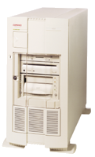
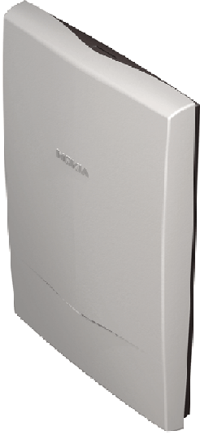
Configuration{data}
Control {data}
MIB request
MIB Data
Access
Point
Network Management Station
Remote RRM Algorithms
AP MIB
DS Interface
Remote Management
APME RRM
Algorithms
Figure 1 ~ RRM Scenario A: AP MIB Related Configuration, Control, and Statistics

Scenario B, illustrated in figure 2, concerns AP measurements. The AP may be commanded either by a local RRM algorithm, or a remote management entity to perform one or more measurements of the radio environment. It is envisaged that the RRM standards will specify a range of measurements designed to report IEEE802.11 and foreign signals. These measurements may be performed prior to the MLME-START.request being issued at the AP, or perhaps during AP operation. In the latter case due care must be given to the potential disruption of BSS traffic.
Measure request
Measurement{data}
Access
Point
Network Management Station
Remote RRM Algorithms
AP MIB
DS Interface
Remote Management
APME RRM
Algorithms
Measurements
Radio Interface
Figure 2 ~ RRM Scenario B: AP Measurements

The requirement to distribute RRM information from an AP to listening STAs (which might be associated, or not) is dealt with by scenario C, illustrated in figure 3. It is assumed here that the information distributed is from the AP MIB and sent to STAs in MAC management frames. The RRM information could be broadcast in a Beacon frame, or in response to a request from a specific STA. This could be via the existing probe-probe request mechanism, or through new MAC management frames.
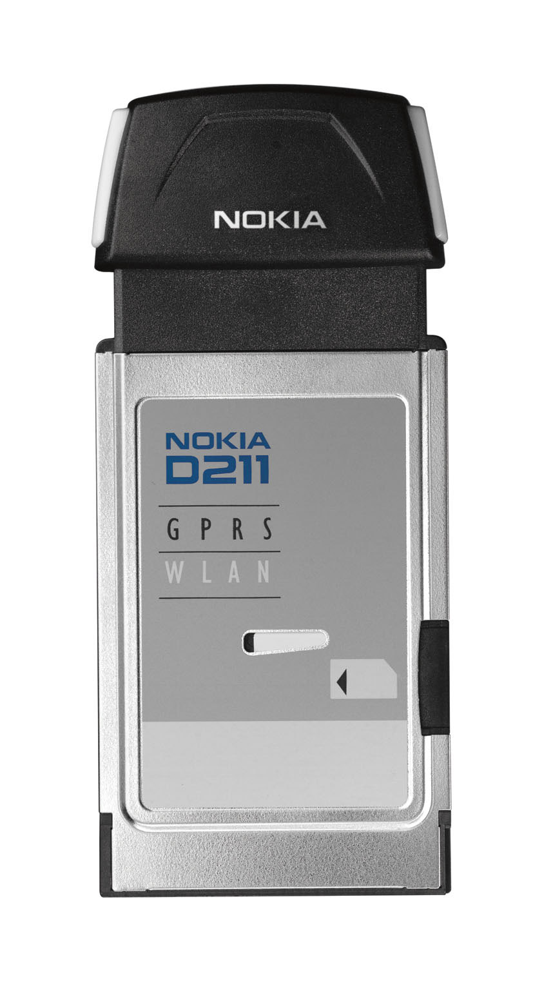
AP MIB
Access
Point
Radio Interface
RRM Information{data}
Station
Station
Station
Info Request
Figure 3 ~ RRM Scenario C: Distribution of RRM Information to STAs

The previous three scenarios have dealt primarily with AP related RRM information. The following three scenarios are STA related. The first, scenario D, is access to the STA MIB (figure 4), for example for statistics gathering. There are architectural issues with this scenario concerning whether the transport of MIB data across the radio interface falls within the scope of the RRM standard. This will be discussed further in a later section of this submission.
Station
MIB
Network Management Station
Remote RRM Algorithms
Remote Management
Access
Point
MIB Data
MIB request
DS Interface
Radio Interface
MIB Data
MIB request
Figure 4 ~ RRM Scenario D: STA Statistics Gathering

Scenario E is the use of RRM to command the STA to perform some action. For RRM the permitted actions are likely to be restricted to a very limited scope, though the ability to command the STA to make and report a measurement on its radio environment is one such action which is considered useful.
SME RRM
Algorithms
[Action]
Access
Point
Network Management Station
Remote RRM Algorithms
AP MIB
DS Interface
Remote Management
APME RRM
Algorithms
Action
request
Action Response
Radio Interface
Action
request
Action Response
Figure 5 ~ RRM Scenario E: RRM Commanded STA Actions

The final scenario, E, is that of the STA making and reporting RRM data to the AP autonomously. A typical application would again be the reporting of radio environment information.
Information
Access
Point
Network Management Station
Remote RRM Algorithms
AP MIB
DS Interface
Remote Management
APME RRM
Algorithms
Information
Radio Interface
SME RRM
Algorithms
[Action]
Figure 6 ~ RRM Scenario F: STA Autonomous Action

5 RRM Architecture
The scope of the RRM standardization effort is limited and in practice the protocol elements that are specified will be MAC and PHY extensions – most likely MLME and PLME services. In addition to protocol layer scope, a distinction must be made between protocol and policy. The standard should deal with protocol and not policy – for example a set of measurements may be defined but not any specific rule as to when these measurements should be made. Effectively the standard should provide a tool-kit for RRM.
This has much similarity with the functionality in the IEEE802.11h draft standard – perhaps unsurprising since IEEE802.11h is effectively RRM for DFS and TPC at 5GHz. The management model developed for the IEEE802.11 draft standard is reproduced in figure 7. Here measurement request/report frames, measurement, PLME control and timing and channel switch timing are all contained within the MLME protocol and are specified in the IEEE802.11h draft. Measurement policy and channel switch decision making are considered to be in the SME and are not specified. The interface to the management protocol is via a set of MLME primitives and an IEEE802.11h MIB.

MAC Timing
Measurement
Protocol
Measurement
Policy
Channel Switch
Decision
Measurement
Frames
SME
MLME
Channel Switch
Timing
PLME
MEASURE
CHANNEL
SWITCH
MREQUEST& MREPORT
Policy
Protocol
MLME Frames
Figure 7 ~ TGh Layer Management Model

The same protocol architecture could be applied to RRM together with at least some of the MLME protocols. A possible RRM layer management model is given in figure 8. Considering the RRM scenarios, four protocol elements seem be required:
- Use of the existing MIB mechanisms with appropriate extensions to the MIBs, for example for per-STA statistics at the AP.
- The definition of appropriate measurements and the specification of a mechanism to initiate the measurements and report the results.
- The definition of appropriate action and response action management frames to signal an STA to take appropriate actions – such as making measurements.
- The definition of a new set of management frame elements to communicate RRM information – either broadcast in Beacon frames, or in directed response frames.
The interface to these mechanisms will mostly lie at the MLME service interface and be accessed via new MLME primitives. As previously noted, higher layer protocols may be involved in the overall RRM system. We do not plan to address these here – they would be limited to recommended practices if included in the RRM standardisation effort at all.
Access to the STA MIB could either be achieved using higher layer protocols (simply carried as data frames over the radio interface), or using MAC management frames with protocol conversion at the AP. While we consider STA MIB access important within this framework, the definition of a MAC protocol for conveying MIB attributes across the air seems an unnecessary complexity.

MAC
Timing
Measurement
Protocol
Measurement
Policy
Measurement
Frames
APME
MLME
MIB
MEASURE
MREQUEST& MREPORT
Policy
PLME
MIB
MLME
Frames
Beacon
Process
Measure
MIB
GET/SET
Beacon
Frames
Higher Layer Protocols
TPC
TPC
TPC
Protocol
Figure 8 ~ Possible RRM Layer Management Model

Use of this management model may be illustrated by considering one of the Message Sequence Charts from the IEEE802.11h draft – for a successful measurement request in this instance. See figure 9.
Decision to request measurement from peer STA
SME
MLME
MLME
SME
IEEE802.11h STA
IEEE802.11h STA
MLME-MREQUEST.req
MLME-
MREQUEST.ind
Decision to accept measurement request from peer STA
MLME-
MEASURE.req
Measurement Process
MLME-
MEASURE.cfm
Compile Measurement Report
MLME-
MREPORT.req
MEASUREMENT REQUEST FRAME
MEASUREMENT REPORT FRAME
MLME-MREQUEST.cfm
MLME-
MREPORT.ind
MLME-
MREPORT.cfm
Measurement Request Completed
Figure 9 ~ IEEE802.11h MLME MSC to illustrate protocol model

6 RRM Protocol Elements
This framework will not attempt to present a complete RRM protocol. However, we do propose the following:
- The addition of a bit in the Capability Information fixed field to indicate RRM capability
- Extension of the AP MAC MIB to allow access to a table of associated STAs and per-STA link statistics.
- The use of the Action management frame type as defined in the IEEE802.11h draft, with new Action category values defined for RRM and RRM error.
- Use of the measurement request and measurement report formats and protocol as defined in the IEEE802.11h draft. The precise list of measurements required to meet the objectives is for further study – though an initial list is given in the above RRM requirements section. If measurements in a different band to that in which the request frame is being sent are required, the channel number field will need to be extended. One possible scheme would be to add an additional octet to indicate the band and channel plan – 0 indicating 2.4GHz with a channel plan as per IEEE802.11b/g (clause 18.4.6.2 Table 105), 1 indicating 5GHz with a channel plan as per IEEE802.11a (clause 17.3.8.3.3), 2…255 reserved.
- The definition of a BSS load information element that includes an associated STA count and a channel utilization figure. The QBSS Load Element should be reviewed for its potential applicability to this function.
- The definition of an ESS Information element that indicates information on potential neighbour BSSs and defines the boundary of the BSS.

7 Notes
The use of terms in this submission is consistent with the ISO/IEC 8802-11/1999 standard [1], with the exception that STA is used to indicate a station that is not an AP – even though in ISO/IEC 8802-11/1999 an AP technically contains an STA.
The following additional acronyms are defined:
APME – Access Point Management Entity
DFS – Dynamic Frequency Selection
RRM – Radio Resource Measurement
TPC – Transmit Power Control

8 References
[1] ISO-IEC 8802-11 ANSI-IEEE Std 802.11-1999 edn
[2] 11-02-630r0-RRM Overview of Cisco Per Client Extensions to 802.11 MIB
[3] IEEE802.11h Draft 3.0 Spectrum and Transmit Power Management extensions in the 5GHz band in Europe

