IEEE P802.11
Wireless LANs
WFA Submission to ExCom
Date: January 14, 2003
Author: Matthew B. Shoemake
IEEE 802.11 Task Group G Chairperson
shoemake@ti.com
Abstract

The following pages contain a letter that was submitted to the IEEE 802 Executive Committee (ExCom) and copied to the IEEE 802.11 Chairperson and the IEEE 802.11 Task Group G Chairperson. The letter is from the Wi-Fi Alliance Board of Directors and was submitted by Dennis Eaton, Chairperson of the Wi-Fi Alliance
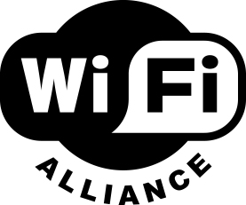

January 11, 2003

IEEE 802 Executive Committee
C/o Paul Nikolich
IEEE 802 Chairperson

RE: IEEE 802.11g Standard Approval Process

Dear IEEE 802 Executive Committee members:

This correspondence is sent on behalf of the Wi-Fi Alliance, a non-profit, mutual benefit corporation chartered to (i) promote Wi-Fi technology (based on the IEEE 802.11 family of standards) as the global WLAN standard, and, (ii) certify interoperability of Wi-Fi devices. As background, the Alliance is an industry association with over 200 member companies and has certified over 500 different Wi-Fi products. As the acknowledged complementary promotional and compliance function to the standard-development activities of the IEEE 802.11 Working Group, The Wi-Fi Alliance represents common commercial interests regarding the successful deployment of all 802.11 standards.

The subject of our letter is to inform you that many member companies of the Wi-Fi Alliance have indicated their desire to offer IEEE 802.11g-based products to the market immediately upon final approval of the standard by the IEEE. Due to the expected interest in products based on this specification, we encourage whatever assistance can be provided by the IEEE 802 Executive Committee to allow a timely approval of 802.11g. The Wi-Fi Alliance believes that a predictable schedule for the formal approval of the 802.11g amendment, will facilitate successful adoption of this new technology.

As you may know, the IEEE 802.11g task group spent the year 2002 resolving thousands of technical comments relating to sequential revisions of the draft standard. This large number of comments itself, and the subsequent successful closure process, both attest to the importance and demand for the availability of the final IEEE 802.11g amendment and the valuable work of your members. The draft now appears to be entering the final stages of completion. An excerpt form the estimated schedule listed on the IEEE 802.11g site (http://grouper.ieee.org/groups/802/11/Reports/tgg_update.htm) is as follows:

- November 2002 – Resolve Comments from Recirculation Ballot and Issue Working Group Letter Ballot
- January 2002 – Forward Draft 5.0 to Sponsor Ballot
- March 2003 – Resolve Comments from Sponsor Ballot and Recirculate to Sponsor Ballot Pool
- May 2003 – Submission to RevCom
- June/July 2003 – Estimated Final Approval of IEEE 802.11g

The Wi-Fi Alliance is presently developing the expected interoperability test suite, which will cover devices complying with the IEEE 802.11g amendment. It is our intent to coordinate the formal announcement and availability of these test plans with the IEEE’s estimated schedule for IEEE 802.11g approval. Thus, it is our desire that final approval of the IEEE 802.11g amendment is achieved on or before August 2003, thereby allowing the Wi-Fi Alliance member companies to help attain a successful and wide market adoption of this eagerly anticipated new IEEE 802 standard.

Thank you in advance for your consideration and assistance.

Sincerely,
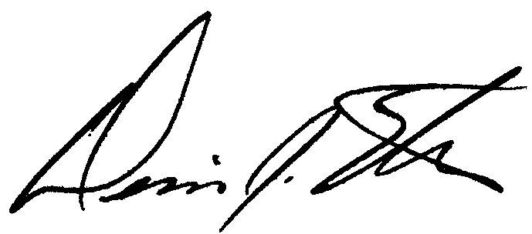

Dennis Eaton
Chairperson – Wi-Fi Alliance, on behalf of Wi-Fi Alliance Board of Directors

Cc:
Stuart Kerry, IEEE 802.11 Working Group Chairperson
Matthew B. Shoemake, IEEE 802.11 Task Group G Chairperson

