IEEE 802.11 Wireless LANs, IEEE 802.15 Wireless PANs,
IEEE 802.18 RR-TAG, IEEE 802.19 CoEXISTENCE
and MBWA Study Group

Venue and Hotel Information for the January 2003
IEEE 802-Motorola Interim Meetings in
Fort Lauderdale, FLORIDA, USA
Date: November 11, 2002
Host Contact: Ed Callaway
Motorola, Inc.
Plantation, FL
Phone: +1 954-723-8341
Fax: +1 954-723-3712
Email: Ed.Callaway@motorola.com

Joint IEEE Interim 802.11, 802.15, 802.18 and 802.19

Standards Meetings, along with MBWA Study Group

January 13-17, 2003
Hosted by:

Hotel Information:
Fort Lauderdale Marina Marriott Web Site: www.marriottmarina.com
1881 Southeast 17th Street
Fort Lauderdale, FL. 33316
Marriott Room Reservations Phone: + 1 800-433-2254 (prior to cut-off date)
Marriott-Ft. Lauderdale: Phone: +1 954-463-4000 Reservation Fax: +1 954-527-6737

Room Reservations:

Option #1:
To make a room reservation on the WEB, please go to: http://www.marinamarriott.com
- click on “make reservation”,
- enter dates of stay and the following 7 letter Group Code: IEEIEEA.

Option #2:
Attached is a registration form for hotel reservations. Please fill out the information on the form and fax it to the Fort Lauderdale Marina Marriott, Fort Lauderdale, Florida. Be sure to indicate on the fax that you are with the “IEEE 802-Motorola Interim Meeting ” - Group Code:IEEE

Option #3:
To make a room reservation at Marriott Hotels – 800#
- call 1-800-433-2254
- ask for the Fort Lauderdale Marriott Marina
- Group Code: IEEE 802
.
We have reserved a block of rooms with an 802 special rate of $129.00 single/double occupancy + taxes. There is no resort fee at this hotel. These special rates will apply from 3 days prior to and 3 days after based on availability.

Hotel Reservation Deadline: Monday, December 16, 2002

Please note: Fort Lauderdale is a very popular travel destination, and the hotel may fill up quickly. If you want to be guaranteed a room, please make your reservation by the above date. The conference rate will still be honored after this date, but on a space availability basis only.

Hotel Reservation:
A one-night (room + tax) cash deposit or major credit card will be required to guarantee your reservation. All reservations must be guaranteed for arrival. Cancellation of reservations must be made 48 hours prior to scheduled arrival date. If reservations are NOT cancelled, a “no-show” fee equivalent to one night’s room and tax charges will be assessed. Please note that check-in time is 4:00PM and check-out time is 11:00AM.

Meeting Registration:
The pre-web registration cost per attendee will be $350US and the on-site registration fee will be $400US. The registration fee will cover meeting rooms, AV equipment, power hook-ups for laptop computers, Internet access, Lunches, Morning and Afternoon Refreshments, and meeting services/supplies. The Wednesday Social Reception will be hosted by Motorola Inc.

Meeting Information:
Please contact our meeting planners, should you require further assistance with registration and/or
meeting information at:

Face To Face Events, Inc.
2699 Iversen Court
Santa Clara, CA. 95051
Tel: +1 408-241-8906
Fax: +1 408-241-8918
Email: 802info@ieee.org

Transportation Information:
Location:
The Fort Lauderdale Marina Marriott is located on the Intercoastal Waterway. Just five minutes from the Fort Lauderdale/Hollywood International Airport, one mile from downtown and one mile from the beach.
Directions to hotel: http://www.marriott.com/epp/map.asp?MarshaCode=FLLFL

Airports: (times below may vary based on traffic conditions)
- 5 minutes from Fort Lauderdale/Hollywood International Airport
- taxi is approximately $10.00-$15.00 one way
- 45-60 minutes from Miami International Airport

Shuttle Service:
Miami to Fort Lauderdale, please contact Super Shuttle at: 800-874-8885 or on the web at:
http://www.supershuttle.com/htm/cities/mia.htm
- approximately $23.00 each way per person
Fort Lauderdale to Hotel, please contact Tri-County Airport Express at: 800-244-8252 or on the web at: http://www.floridalimo.com/

Vistors Information:
Please visit- http://www.sunny.org/ for vistors info.

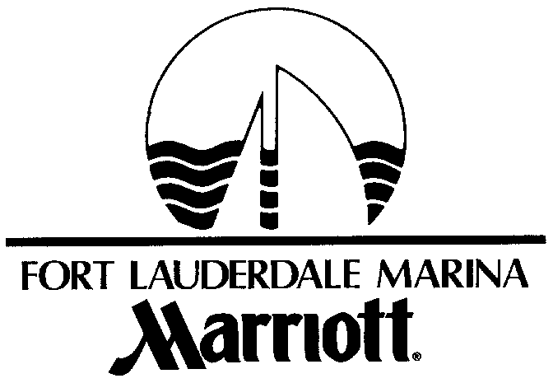

1881 Southeast 17th Street • Fort Lauderdale, Florida 33316 • 954-463-4000

IEEE 802 – Motorola Interim Meeting --- January 7 – 20, 2003
Group Code: IEEE Rate: $129.00 single or double occupancy

PLEASE FAX TO 954-527-6737 OR CALL 1-800-433-2254 TO MAKE RESERVATIONS

The staff of the Fort Lauderdale Marina Marriott looks forward to accommodating you during your upcoming visit. With every reservation request for late arrival (arrival after 6:00 P.M.) we require that you either:
- Enclose a check or money order in the amount of your first night’s room rate…
- OR -
- Provide the entire number from your credit card. Don’t forget the expiration date and your signature please.

The Marina Marriott regrets that it cannot confirm your reservation request after 6:00 P.M. on the day of arrival without your guarantee of the reservation by one of the two methods listed above. Should you be unable to arrive on the date planned, your deposit will be refunded only if cancellation confirmation is obtained no later than 48 hours prior to your scheduled date of arrival.

Name (print)
Address
City |  |  |  |  |  | State |  |  |  | Zip |  |  |  | Phone
For Arrival on |  |  |  |  |  |  |  |  |  | Depart on
 |  |  | (day) (date) (time) |  |  |  |  |  |  |  |  |  | (day) (date) (time)
Time of Arrival |  |  |  |  |  |  |  |  | PM AM (circle one)
Please reserve |  |  |  |  |  |  |  | No. of Rooms, for |  |  |  |  |  |  |  | People
Name(s) of person(s) sharing accommodations

Accommodation preferences: ◻ King ◻ Double Beds ◻ No Preference
◻ Smoking ◻ Non-Smoking ◻ No Preference

◻ Carte Blanche ◻ Diners Club ◻ Master Card ◻ Discover
◻ American Express ◻ Visa ◻ Check or money order enclosed: Amount ______________

Credit Card Number: |  | Expiration Date:

Is this the same credit card that will be used to settle your account? ◻ YES ◻ NO
Signature for guarantee
All reservations requests must be received by the following cut-off date: |  | December 16, 2002

RESERVATION REQUESTS RECEIVED AFTER THE CUT-OFF DATE ARE SUBJECT TO DATE AND RATE AVAILABILITY. OUR CHECK-IN TIME IS 4:00 P.M. AND OUR CHECK-OUT IS 11:00 A.M. REQUESTS FOR DATES OTHER THAN THE CONFERENCE DATES LISTED ABOVE ARE SUBJECT TO AVAILABILITY. ROOM RATES ARE SUBJECT TO STATE, CITY, AND LOCAL TAXES (CURRENTLY 11%).

