IEEE P802.11
Wireless LANs
Extended Data Rate 802.11a
Date: March 11, 2002
Author: Todor Cooklev
Marcos Tzannes
Dongjun Lee
Colin Lanzl
Aware, Inc.
3685 Mt Diablo Blvd, suite 395
Lafayette, CA 94549
Phone: 1-781-687-0682
Fax: 1-925-962-1301
e-Mail: tcooklev@aware.com
Abstract

The Wireless Next Generation Study Group is currently investigating high-data rate extensions of 802.11a. We discuss an extension to 802.11a that would allow for higher data rates than the current standard. The main features of our technology are: (1) it achieves data rates over two times higher than 802.11a; (2) it does not set a limit on the maximum data rate that can be achieved; (3) it is based on mature and widely understood technology.

- Background

The Wireless Next Generation Study Group is currently considering the issue of higher data rates in the UNI-I bands. As there is a constant demand for higher data rates this discussion has generated a lot of interest. In general, there are a number of ways to extend the 802.11a standard. In this submission we describe one method that has the following advantages. First, it can be readily incorporated in the standard, and the standardization effort that is required is small. Thus it can be incorporated in various products much quicker than other technologies, which require a long standardization effort. Second, the described technology is mature and widely understood. It has been incorporated in other standards such as ITU Standards G.992.1 and G.992.2 for ADSL equipment.
- Bit allocation and trellis coding
Multicarrier communications systems use a Bit allocation table to specify the number of bits modulated on each carrier. Standard 802.11a transceivers use the same number of bits on all subchannels, which is the simplest type of a bit allocation table. Since wireless communications experience multipath, the communications channel is not flat in frequency, which means that different subcarriers will have different Signal to Noise Ratios (SNRs). Therefore a bit allocation table can be used so that carriers with higher SNR modulate more bits then carriers with lower SNR. In a multicarrier system, the process of modulating a different number of bits on each carrier based on the SNR of the carriers is often called Bit Loading. In general, as a result of bitloading all carriers will have an equal Symbol Error Rate (SER) or Bit Error Rate (BER). Bit loading also enables constellations sizes much higher than 64QAM to be used. One design requirement in a system that uses bit loading is that it requires a feedback mechanism to communicate the Bit-allocation table from the receiver to the transmitter. This communication from the receiver to the transmitter must happen faster than substantial changes in the channel profile.
Further improvement in data rate can be obtained using coded modulation techniques (such as trellis coded modulation (TCM)). TCM maps the coded bits to points in the signal space such that the Eucledean distance between transmitted sequences is maximized. Typically the method of set partitioning is used to maximize the Eucledean distance. Since coded modulation schemes do not encode all information bits, coded modulation must be combined with bit loading in multipath channels to achieve the coding gain benefits.

- Simulation results

To illustrate the performance of the high data-rate system obtained using 802.11a with
bit-loading and trellis coding we have performed a number of simulations. As a wireless channel, we have selected a channel without a direct line of sight, corresponding to a large space, with a 100 ns rms delay spread. The impulse and frequency responses of the channel are shown in Figs. 1 and 2.
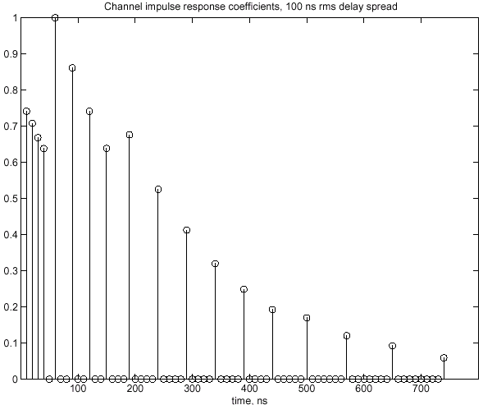
Fig. 1 Wireless channel impulse response

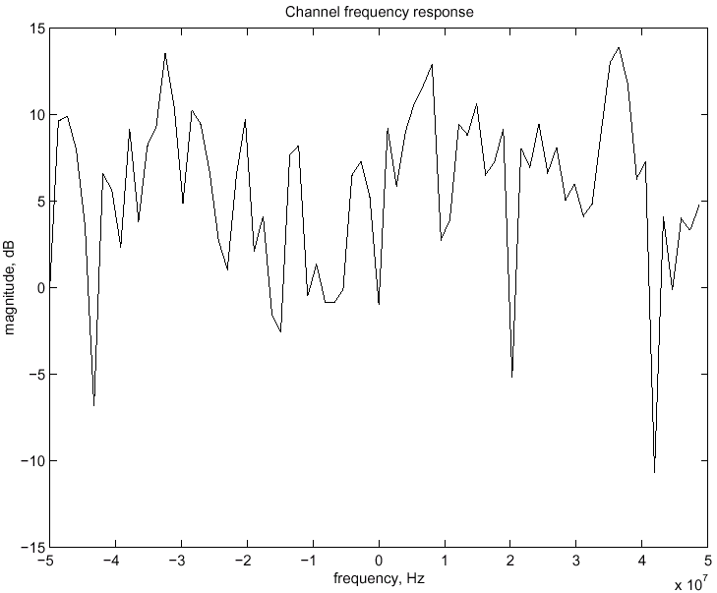

Fig. 2 Wireless channel frequency response

Fig. 3 shows the higher data rate that can be obtained with the new approach for the lower UNI-I band. In the simulation the transmit power level is set at –56.9 dBm/Hz. The receiver noise figure is assumed to be 10 dB, and an additional implementation loss of 5 dB is assumed. The thermal noise level is assumed to be –174 dBm/Hz. The gain of the receive and transmit antennas is assumed to be zero. With these parameter values an 802.11a system is simulated and the results are shown in Fig. 3. The 802.11a system uses equal number of bits per carrier. Using the same parameter values we have simulated a system, in which bit-loading and trellis-coded modulation are added to 802.11a. The maximum data rate for the two systems is determined as the maximum data rate in which the packet error-rate is 10 %. Note that the statistics of the bit errors can be substantially different. Bit loading and trellis coding are performed according to the ITU G.992.1 ADSL standard. In the new system, the number of bits per carrier is assigned depending on the snr per carrier. If the average number of bits per carrier remains the same, this technique will not lead to a higher data rate. Bit loading together with trellis coding allows for a higher average number of bits per carrier. In trellis-coding schemes, in which the Eucledean distance is maximized, not all bits are coded. This allows the code to be much better suited to the characteristics of the wireless channel. Furthermore, various codes can be used in trellis-coding schemes, such as capacity-approaching codes as turbo codes or low-density parity-check (LDPC) codes. The use of a capacity-approaching code will yield further data rate improvements.
It is obvious that the performance improvement is not the maximum that can be achieved. The TX power level that is allowed in the middle and upper UNI-I bands is –49 dBm/Hz and –43 dBm/Hz. Operating at these increased power levels will directly result in a higher signal-to-noise ratios and considerably higher data rate. The described technology in this presentation does not have a maximum data rate. Therefore improvements in technology can immediately lead to higher data rates, without having to go through the standardization process every time. Furthermore maximum supported data rate is likely to be among the criteria according to which vendors compare their products and compete in the marketplace.
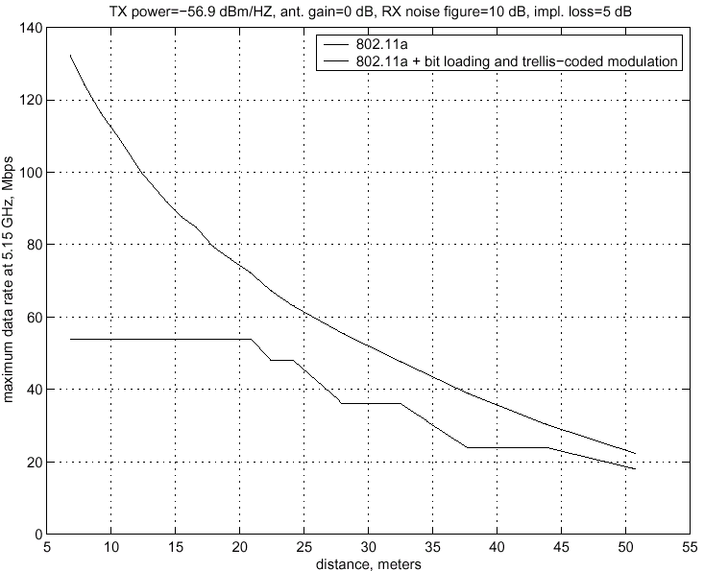
Fig. 3 Comparison of the maximum data rates that can be achieved with the specified simulation parameters for a plain 802.11a system and 802.11a system with bit loading and trellis coding.

