IEEE P802.11
Wireless LANs
A Simulation Model for the 802.11 PCF
Date: September 18, 2000
Author: Matthew Sherman
AT&T Labs - Research
180 Park Avenue
Florham Park, NJ 07932
973-236-6791
mjsherman@att.com
Abstract
This document presents details of a simulation model for the 802.11 PCF. The model has been developed to assist the 802.11 committee in the evaluation of MAC enhancement proposals. OPNET is the software package that the model has been developed in. The model includes key aspects of the PCF protocol, and additional capabilities required to simulate the protocol. It also includes improvements on the 802.11 DCF model currently available in the OPNET standard models library. The model is being made available to 802.11 participants from AT&T. It is being enhanced to include a channel model described in Document # IEEE 802.11-00/277, and the PHY model described in Document # IEEE 802.11-00/252. It will then be enhanced to model advanced QoS features as described in Document # IEEE 802.11-00/120. Once the enhancements are complete, the model (supporting DCF, PCF, and Enhanced QoS modes) will be made generally available, either through OPNET’s contributed model web site, or as a permanent part of OPNET’s standard model library.

Introduction / Background
The 802.11 PCF is a centralized polling based protocol intended to support time critical services within 802.11 wireless LANs. AT&T chose this function as a starting point to develop their proposal for 802.11 QoS MAC enhancements. These proposed enhancements have since been incorporated within a joint proposal presented in [00/120]. To do performance simulations of the proposed enhancements, it is necessary to first model the 802.11 PCF. No model of the PCF was known to exist, so AT&T developed the model described in this paper. It is a jumping off point for modeling of enhancements.
The model developed is currently available to participants of 802.11 from AT&T under NDA for use in baseline simulations, and for further development to assist in evaluating 802.11 MAC enhancement proposals. AT&T is in discussions with OPNET to make the model a part of the OPNET standard library, at which point it would become widely available without an NDA. AT&T is continuing development of the model first to incorporate OPNET based PHY and channel models (presented in [00/252] and [00/277] respectively) and then to include elements of the MAC enhancements proposed in [00/120]. The completed model would have DCF, PCF, and enhanced modes independently selectable. Once completed it will be made available as a contributed model (open source) on OPNET’s contributed model website and will no longer require an NDA. OPNET’s contributed model web site is not passworded and is available to anyone.
AT&T is not planning to do any further work on the PCF function right now, although validation testing and required fixes will be supported. AT&T will also support integration of the PCF model with the PHY and Channel modes. However AT&T’s main focus will be on modeling MAC enhancements. In implementing those enhancements some further improvements may be made to the PCF if convenient. As stated, the PCF code is available under NDA to anyone who wishes to make additional improvements.

Existing 802.11 models
A number of simulations models have been developed for 802.11, although many are proprietary. The three open source models most widely available are the model developed in OPNET by Virginia Polytechnic Institute (VPI) and State University - Blacksburg, VA, a separate OPNET model created by OPNET technologies themselves, and a C based model created by Carnegie Mellon University’s Monarch activities that runs over Berkley’s Network Simulator (NS) software. Key web pointers for more information on these models are:
Description VPI OPNET model: ftp://opguest2:opguest2@corporate7.opnet.com/24/
Code for VPI OPNET model: ftp://opguest:opguest@corporate7.opnet.com/134/
Model Guide for OPNET Tech. OPNET model: http://www.opnet.com/products/library/WLAN_Model_Guide.pdf
Description of CMU Monarch work: http://www.monarch.cs.cmu.edu/
Description of NS work: http://www.isi.edu/nsnam/ns/
Of course, another open source model of 802.11 is in fact the SDL code, which comes with the standard. However, this code has never been fully simulated, and the SDL tool set did not seem appropriate for QoS performance simulations, which is the main purpose of the model developed by AT&T. None of the other open source models included the PCF, or even a full implementation of the DCF. However, they all provided an appropriate starting point for further development.
A number of factors came into play when trading off which model to use as a starting point. The VPI model closely followed the SDL code in the 802.11 standard, where as the OPNET Technologies code did not. So, in some sense the VPI code is a more rigorous implementation. However, the OPNET technologies model has on going support for bug fixes, maintenance, and enhancements, where as the VPI model does not. The architecture of the OPNET technologies code was also more optimized for speed. At the time the Monarch code was examined (12/99), it seemed quite disjoint and complex because of all the piece parts of code that had to be downloaded and integrated. Also, the support environment (that is the ability to produce graphics, availability of source models, and other network models) seemed somewhat lacking. However it had an advantage in that it was all open source C, and did not require any proprietary software tools to use. Given these tradeoffs, AT&T ultimately decided to use the OPNET Technologies (hence forth Standard) model as a starting point.
Note that recently, the Monarch software has been directly integrated into the NS package. Some members of the 802.11e Ad Hoc Simulation Group (AHSG) are now working with NS and are working to integrate a PCF model into that package. It may soon be available as another modeling option for the 802.11group.

Model requirements
As stated, this model is a jumping off point for simulation of 802.11 MAC enhancements proposed by AT&T. However, it was recognized that other companies may be proposing enhancements based on the 802.11 PCF. Also, it is important to have a baseline of comparison so that relative merits can be decided. Therefore the PCF model has been developed initially as a standalone baseline that can be used by members of the 802.11 community as part of a “Simulation Framework” being developed by the 802.11e Ad Hoc Simulation Group (AHSG) for evaluating MAC enhancement proposals. The baseline can be used as a reference point for evaluating the performance of proposed MAC enhancements. As a minimum the baseline model needs to incorporate:
- Accurate timing implementation of DCF protocols
- At least partial implementation of the Beacon message
- Implementation of PCF Message types
- Accurate timing implementation of PCF protocols
- Implementation of a polling scheme
- Ability for of DCF and PCF terminal to operate within a single BSS during a simulation
- Probe points allowing capture of relevant performance data
Aside from the last point, it is believed the model addresses all these point. Probe points do exist in the current model, but they are the same as those available with the OPNET standard model. Thought is still required as to whether these probe point are sufficient for the needs of the 802.11 community in evaluating MAC enhancements. In addition, a true baseline needs to include PHY and Channel effects. As mentioned above, models have been developed for these in OPNET. However, these other models still need to be integrated with the PCF model into a single model. This work is not finished, but is expected to be completed by October 2000.

PCF Process model

Development Approach and Capabilities
This section will partially detail the capabilities of the OPNET Standard model code, and how they have been enhance in the PCF code. As said, the capabilities of the Standard model are given in the WLAN Model Guide (hence forth Model Guide). It should be assumed if a capability is not mentioned in this contribution, that it is the same for the PCF code as given for the Standard code in the model guide. Note that there were a number of releases of OPNET’s Standard model. Unless otherwise specified, all references to the Standard model will be to the July 2000 release. Also, all references to the 802.11 standard are based on [802.11]. This is the most recent electronic version of the standard available to the author while writing this contribution. All acronyms not explicitly defined in this contribution can be found in [802.11].

DCF and General Capabilities
As stated, OPNET technologies’ Standard model was used as a starting point. The model first became publicly available in May 2000. However, AT&T procured a beta release of the model to start with in April. The original OPNET code supports RTS / CTS as well as fragmentation. It does not support functions such as PS Poll, TIMS, ATIMS, Association, Authentication, WEP, and has other limitations as described in the Model Guide. A number of AHSG participants have examined the OPNET code and reported bugs to OPNET. In particular Philips Research has reported bugs to OPNET and the 802.11 committee [00/141, 00/144]. OPNET did respond to the Phillips inputs and put out a new version of the Standard model in July 2000. This model was examined and again found to have a number of bugs, which have again been reported to OPNET. Most of these bugs have to do with the proper implementation of deference and backoff. In addition there were a number of DCF capabilities that need to be added / modified to support the PCF. Specifically, Beacon frames had to be created, and certain overloading of the Type field in packets used to represent MAC frames modified. The following sections detail some of the DCF related and general capabilities that have been modified. A new version of the Standard code is due out in September 2000 that may address some of the issues and shortcomings identified here.

Field Irregularities
The original code only supported 4 frame types, DATA, Ack, RTS, and CTS. There were two OPNET packet formats created to support these frame, a control packet format, and a data packet format. These are shown in Figures 2.1.1 and 2.1.2. The key difference between them is that the data packet could have another packet (the actual MSDU) embedded within it. The packets created to support these frames did not strictly follow the formats in the standard. For one, the only header field explicitly called out is the Type field. All the other fields are lumped into a single field called Wlan Header. In the packet definition, the Type field accounts for two bits of the packet size (used to calculate transmission times, etc.). However, the data structure containing the value of that field is an integer. This allows the Type field to be “overloaded”. The July 2000 OPNET model used a “6 bit” encoding of the 802.11 Type / Subtype fields placed in the integer associated with the OPNET Type field. The encoding did not obviously map to the standard and had other problems. In the “PCF” code this was replaced with an 8 bit mapping which codes the Protocol Version field as well as the Type / Subtype fields in the standard. The type field in the OPNET packet format in the PCF code remains overloaded in that it is still only counted as two bits. However, the extra bits coded in the type field are accounted in the overall header size of the packet. Adjustments may be made at a later date to clean the code up on this point.
Aside from the limitations mentioned in the Model Guide, there are a couple of other irregularities that are not yet corrected in the PCF model. One is that the moredata bit is not implemented. The second is that transmitted data packets always use 3 addresses. The data structure associated with Wlan Header in the packet format contains an integer variable for Address 4, but it is never used. The size of the Wlan Header field in data packets corresponds to 3 addresses being present, not 4. Also while the frame sizes and duration fields are believed to be coded right, limited checking has been done to ensure this. Note that while the picture shows a fixed header size for the control packets, the overall size of the packet is set a transmission time based on the type of packet being transmitted. It does not necessarily reflect the bit count shown in Figure 2.1.1. The moredata bit is somewhat important in the PCF and will probably be implemented in the next release of the code.

Beacon Frame coding
Ultimately, the PCF capability was the focus of the coding efforts. But it was necessary to add some DCF capabilities to support the PCF efforts. The Standard model does not generate any management frames, in particular the Beacon frame, which is needed to indicate the beginning of the CFP. A full coding of the Beacon frame capabilities would be a large job, and is not required for the PCF. Instead, only the Beacon frame capabilities required to implement the CFP were coded. Rather than create a new OPNET frame type for 802.11 management frames, the existing packet format for data frames was used, and the beacon body embedded as a “data packet” within it. A new packet type for the beacon body was created shown in Figure 2.1.3. Whenever the Beacon frame is sent, a Data packet is created, the header fields are set to their proper values, and a Beacon Body packet is created and stuffed in the Frame Body field of the Data packet. The fields represented in sizing the Beacon body are:
Field Title Size (Bytes)
Timestamp 8
Beacon interval 2
Capability information 2
SSID 8
Supported rates 6
DS Parameter Set 3
CF Parameter Set 6
TIM Omitted
Total 35
Of these, the only fields with associated data structures are the Timestamp, Beacon Interval, and the CF Parameters set. The other fields were only used to determine the overall size of the Beacon Body packet.
If there is an AP in the system, it will attempt to transmit a Beacon at every Target Beacon Transmission Time (TBTT). The Beacon frame transmitted will always be the same size, and contain the fields identified above in the Beacon Body. If the TBTT starts a CFP, the AP will defer to a busy medium, and then transmit the Beacon frame after a PCF Inter-Frame Space (PIFS). If the Beacon is not starting a CFP, it follows normal DCF rules for deference and backoff. As with the Ack, RTS, and CTS control frames in the original model, this frame type can only be transmitted at 1 Mbps.

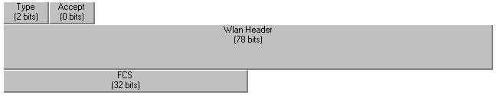

Figure 2.1.1) Format for Wlan Control Packets

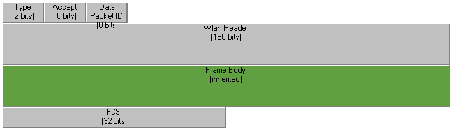

Figure 2.1.2) Format for Wlan Mac (Data) Packets



Figure 2.1.3) Format for Wlan Beacon Body Packets

As a final note on the Beacon coding, when originally coded (based on OPNET’s April 2000 Standard model) Data frames used a fixed size which corresponded to four addresses being present rather than three. The Beacon frame reduced the size of the header to correspond to three addresses being present. In OPNET’s July Standard model, the size of the Data frame was modified to correspond with three addresses being present. However, the Beacon code is still compensating, so the current frame size being transmitted by the Beacon is off 6 bytes (48 bits). This will be corrected in the next release of the code.

Deference and Backoff
There were a number of deference and backoff irregularities in the standard code. For example, the NAV was set during transmission, and reset in numerous cases due to various events. And Extended Inter-Frame Spaces (EIFS) were implemented by setting the NAV for an EIFS time from the current time and did not defer to the medium. Also, in the first release of the Standard model (May 2000) Backoff only occurred if there was something in the queue to transmit. This irregularity was identified to OPNET, and they attempted to correct it in the July 2000 release of the Standard code. Unfortunately, their correction was improper in that the code would now backoff after appropriate transmissions (regardless of the status of the queue) but those backoffs would not defer to the medium once they started.
A lot of time was spent reviewing the 802.11 standard and the original OPNET code for deference and backoff. All the irregularities identified above are believed to have been corrected in the PCF code. The EIFS is now implemented as a normal part of the deference routine, the NAV is no longer set during transmits, and many related resets of the NAV have been removed. The state diagram for the PCF MAC process was restructured to ensure proper use of backoff after appropriate transmissions. The Process state diagram was reorganized somewhat (hopefully improving readability). A picture of the state diagram is provided in Figure 2.1.4. The deference and backoff procedures were streamlined. Finally an attempt was made to deal with some of the more subtle issues such as Ack frames not deferring to a busy medium, and EIFS not deferring to the NAV.
One know issue is whether a Short Inter-Frame Space (SIFS) defers to physical carrier sense. In OPNET’s standard model (all versions) a SIFS always defers to receiver busy, which is the OPNET equivalent of Clear Channel Assessment (CCA). The PCF code has maintained this convention. While this may seem like common sense, it really is not in keeping with the spirit of the 802.11 standard. A slot time is the minimum time required to evaluate CCA. A SIFS time is shorter than a slot time; therefore CCA cannot be valid within a SIFS time of receiving a transmission. As such, all transmissions that use a SIFS should not defer to CCA (receiver busy).
It is not believed that SIFS deferring to CCA is a critical issue. In the OPNET code, overlapping transmissions are all marked bad by the channel model, and cannot cause a response. Thus except for the very unlikely circumstance of a transmission from one STA starting within a SIFS time of a transmission by another STA ending, the point is moot. Ultimately, the code will probably be corrected on this matter, but it is believed the effects on operation are so small as to be negligible anyway.
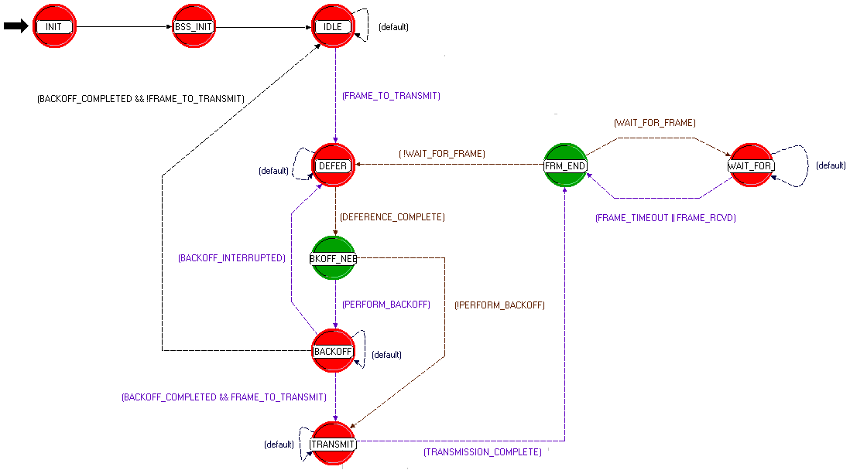
Figure 2.1.4) Process Diagram (State Machine) for PCF MAC

Finally, while the codes timing has been checked in the past, due to schedule constraints, the code’s timing has not been thoroughly checked recently. Also, the validation procedure has not started yet. For now the code runs and is probably working correctly. But further checks of the timing and validation are planned in the near future. Any errors in the timing will be promptly corrected.

PCF capabilities
This section provides a summary of the work done to implement a model of the 802.11 PCF in OPNET. As a rough order of scale, the July version of the standard model has about 4000 lines of code when compiled to C versus 5500 for the PCF model. And of course, many of the original lines have been changed. A rough estimate is that 50% of the lines in the PCF code are new, or are different as compared to the Standard model. However, all of the original routine names and rough functionality have been preserved. Also while the process diagram and top-level code architecture have changed, this was more to address DCF issues than PCF issues. A couple of new routines have been added, but they are all small in size. Most of the changes are scattered throughout the previously existing routines. The following subsections detail the more important changes from a functional sense.

New Frame Formats
Once Beacon processing was established, it was then necessary to implement the message formats and receive / transmit processing for PCF specific messages. These include:
CF-End, CF-End + CF-Ack, Null function
Data + CF-Ack, Data + CF-Poll, Data + CF-Ack + CF-Poll
CF-Ack CF-Poll CF-Ack + CF-Poll
To avoid a proliferation of frame formats, the exist DCF frame formats were used. The CF-End and CF-End + CF-Ack used the control packet format, since they are of Type control. All the rest of the frame types are of Type data, and use the same packet format as for Data frames. In cases where the frame type does not include a data packet (for example CF-Ack), a null packet is stuffed in the Frame body field. All these frame types and there processing have been added.
Rather than use large case statements with separate processing for each frame type, some of the processing was grouped across multiple types. This saves on line count, and centralizes some of the processing so it only needs to be changed once (rather than at multiple times throughout the code) to be updated. This necessitated changing some of the existing code structures from case statements to if else ladders. Otherwise there was little change in the overall architecture of the code.

Implementing the CFP
Once the required frame formats existed, the required logic was added to implement the CFP. The CFP parameters can be set in each station node (STA) via the MAC’s interface attributes. However, STAs also listen for beacons, and process the CFP parameters in all received Beacons. The parameters in the Beacon messages from an STA’s own BSS (not other BSS’s) overwrite those given at initialization. When a STA receives a Beacon starting a CFP, it set’s it’s Network Allocation Vector (NAV) based on the duration remaining field regardless of what BSS the Beacon originated from. However, after hearing the Beacon once from its own BSS, at every appropriate Target Beacon Transmit Time (TBTT) the STA will set it’s (NAV) for the CFP regardless of whether or not it hears the Beacon. This guarantees that STAs in the same BSS don’t transmit inappropriately during the CFP. If an STA is polled, it responds regardless of whether or not its NAV is set. The AP will only poll terminals that have registered for the PCF, and there are no potential error sources that would allow a terminal to think it heard a poll that was not there. Thus, only PCF enable terminals will be polled and respond. When the AP has completed it’s polling for the current CFP, or if the CFP interval expires, the AP will send a CF-End (or CF-End +CF-Ack if appropriate) and end the CFP. All STAs receiving a CF-End from an AP in there own BSS will then reset their NAV and start the Contention Period (CP) under control of the DCF. CF-End received from other BSS will be ignored.
Note that section 9.3.2.2 of the 802.11 standard states that CF-End should reset the NAV regardless of what BSS it comes from. However, this seems unwise so it is not currently implemented as such. Further direction regarding this will be sought of other 802.11 participants. Also, there has been some discussions amongst participants of 802.11 that the text in 9.3.2.2 actually indicates that each STA must track the start of the CFP for each BSS for which it hears beacons, and set it’s NAV to cover all the CFPs for those BSS regardless of whether or not it hears the Beacon starting it. This would be a fairly complex requirement and is not supported by the current PCF model. However, the difference in performance between just setting the NAV for Beacons heard, or actually setting the NAV from the start of the CFP regardless of whether a Beacon is heard is believed to be small. For now, the OPNET radio pipeline for 802.11 screens frames from outside a STA’s BSS anyway, so these points are currently moot.

PCF Deference
The Standard model’s deference routine has been updated to include PCF deference. Basically, if a STA is polled, a polled flag is set. When the STA executes the deference routine, this flag forces it to use a SIFS. Similarly, when the AP is polling terminals, flags are set such that it too only uses a SIFS (except for the initial Beacon which uses a PIFS). As noted in 2.1.1.3 of this contribution, SIFS currently defers to receiver busy (CCA). This is not considered to be an issue, but the code will probably be corrected on this matter.

The Polling Routine
A supporting function within the MAC that is mentioned in the 802.11 standard, but not fully specified is the Polling list, it’s use and maintenance. A very simple polling routine has been added to support PCF testing. Stations are set up at initialization to either use PCF or DCF, but not both. If they are using the PCF, they register as such at the beginning of the simulation. This registration is through special OPNET constructs, and the admission of terminal to a BSS by the AP, etc is not modeled currently. The AP then adds the PCF terminals to the polling list. Each CFP, the Polling routine starts with the lowest station address (Equivalent to Association ID in the simulations), polls the station, and sends data. It keeps sending Data+Poll frames to the first station as long as data for that station exists in the queue. It then moves to the next station. When it runs out of stations (or time in the CFP) it sends a CF-End. More sophisticated algorithms are possible, but this is what exists right now. Ideally, the polling routine should be defined as a separate function. But, at the moment it is embedded at the front of the wlan_frame_transmit routine. Consideration to moving it will be given at a later date.

PCF Queue
OPNET’s Standard model has a single queue. As packets arrive from the upper layers, they are loaded into the queue. Under the DCF, they are transmitted on the basis of time of arrival (first in, first out). The 802.11 standard requires that members of the polling list be serviced on the basis of Association ID (AID). Lower AIDs get served before higher AIDs. For the AP, if the PCF packets were mixed with the DCF packets, a lengthy complex search routine would be required to pull PCF packets from the DCF queue out of time order. Instead, PCF enabled AP’s are provided a separate queue for PCF traffic. Packets from the upper layers destined for transmission under the PCF are inserted into the dedicated PCF queue in order of increasing MAC address (equivalent to AID). The PCF starts transmitting packets from the top of the Queue (lowest AID) at the beginning of every CFP. Note that all STA which are not AP’s use the DCF queue regardless of whether or not they are registered for DCF or PCF, and transmit packets on a first in first out basis.

Side-Traffic Capabilities
The 802.11 standard as currently written is somewhat contradictory about whether a STA can send traffic to another STA directly in the presence of an AP. Regarding Contention-Free usage rules, section 9.3.3.4 of the standard reads:
“When polled by the PCF (Data+CF-Poll, Data+CF-ACK+CF-Poll, CF-Poll, or CF-ACK+CF-Poll) a CF-Pollable STA may send one data frame to any destination. Such a frame directed to or through the PC STA shall be acknowledged by the PC, using the CF-ACK indication (Data+CF-ACK, Data+CF-ACK+CF-Poll, CF-ACK, CF-ACK+CF-Poll, or CF-End+ACK) sent after a SIFS. Such a frame directed to a non-CF-Pollable STA shall be acknowledged using an ACK Control frame sent after a SIFS period.”
However, such a transmission would require that both the ToDS and FromDS bits be set to zero, and Table 2 of section 7.1.3.1.4 makes it clear that this setting is only valid for Data frames in an IBSS (which would exclude PCF use). Conversations with several 802.11 participants confirm that the ability to send side traffic directly between two STAs (without forwarding by an AP) outside of an IBSS was voted out of the standard. Unfortunately, the editing has not yet caught up with the intent of the standard, which requires further edits to clarify this point.
The ability to send side traffic was not included in OPNET’s standard model. But it was added to the PCF code before the realization that it was prohibited by the standard. Rather than remove the capability, it was made an option, so that it’s advantages / disadvantages can be explored. That option can be enabled for both DCF and PCF operation. In the case of DCF, “normal” DCF rules apply. In the case of the PCF, if the AP detects a Poll response not destined for itself, it will defer for sufficient time to allow an Ack to be transmitted by the sending STA. It then will again take control of the medium after a SIFS time.

New MAC Process Attributes
A number of new attributes have been added to the MAC process model attributes to support the PCF. On the top level under the Wireless LAN parameters attribute, there are three new attributes, shown in Figure 2.2.1. They are described as follows:
Beacon Interval: The time in seconds between Target Transmit Beacon Times (TBTT). The default value is 0.01 seconds.
PCF Parameters: A compound attribute who’s individual attributes are described below.
AP BSS Relay: If enabled, this attribute forces all STA to send any side traffic through the AP rather than directly to another STA. If disabled, terminals in both the PCF and DCF will transmit traffic destined for other stations in the BSS directly to those stations, rather than forwarding them through the AP. The default value for this parameter is enabled (compliant with the 802.11 standard).
The compound attributes under the PCF parameters are shown in Figure 2.2.2. They are somewhat confusing, so an example of how they effect the CFP is shown in Figure 2.2.3. Improved nomenclature that is more consistent with the standard may be considered at a later date. In the example, the Beacon Interval is set to 0.02, and the PCF Parameters have the following descriptions and explanations.
PCF Functionality: If enabled, a non-AP STA will register for the polling list at the beginning of a simulation, and only use the CFP for data transmission. It will not transmit during the Contention Period (CP) under the DCF even if it has data to transmit. It will reply with Acks to data it receives during the CP. An AP will not attempt to deliver data to a STA that has this function enabled during the CP, but will poll it regularly and deliver data during the CFP as system loading permits. If this attribute is enable for an AP, the AP will act as a Point Coordinator (PC) for the BSS. An AP will not act as an AP for a BSS (or implement a polling list or CFP) if this function is not enabled. If this attribute is disabled the terminal will operate under the DCF and set it’s NAV so as not to transmit during the CFP. The default value for this attribute is disabled.
CFP Beacon Multiple: This parameter determines the number of TBTT’s between CFPs. For the example in Figure 2.2.3 it is set to 2, meaning that a CFP will occur every other TBTT. The default value for this parameter is 0. If PCF functionality were enabled, it is not clear what behavior would result if this parameter were 0. At a later point, the default for this parameter will probably be changed.
CFP Offset: This is perhaps the most confusing of the PCF parameters. This parameter determines the number of TBTT that the CFP is offset from its nominal position. It can be thought of as setting the phasing of the CFP modulo the Beacon Multiple. For the example in Figure 2.2.3, if this parameter were set to 0, the CFPs in the figure would start at 0 and 40 milliseconds (msec) respectively. If the CFP Offset were set to 1, the beginning of each CFP would be delayed by 1 TBTT (in this case 20 msec) so as to start at 20 and 60 msec. Since the arithmetic determining the start of the CFP is modulo the Beacon Multiple, setting the Offset to 2 would result in the same CFP start times as setting the offset to zero – namely 0 and 40 msec. In the future consideration may be given to making this offset relative to the first TBTT (rather than being modulo the Beacon Multiple). Doing so would accomplish the same function (setting the phasing relative to the Beacon Multiple) but would be more general in that the start of the PCF relative to the start of the simulation and DCF could be set to an arbitrary time. The default value for this attribute is 0.
CFP Interval: This is equivalent to CFPMaxDuration in the standard. It is the maximum time in seconds allowed for the CFP. In Figure 2.2.3, it is shown set to 10 msec. Of course, if the PC has polled all terminal required, and sent all the data in its queue a CF-End will be sent before the CFP Interval elapses allowing the DCF to make use of the additional time that had been allocated to the CFP. The default value for this parameter is 0.0 seconds. The behavior of the AP for this setting is not currently known. Steps may be taken at a later date to guarantee the behavior of the MAC for the default of this attribute.
Max Failed Polls: This is the maximum number of consecutive polls to an STA that are allowed without a valid response for which the station will still poll. The AP will continue to poll till Max Failed Polls is exceeded. For example, if this attribute were set to 2, The AP would allow two polls to fail, and would still poll the STA a third time. Thus it is possible for three failed polls to occur before the AP moves on to the next address on the polling list. This may be changed at a later date, as it would be more intuitive for the AP to quit after 2 failed polls in this situation.
Note that the PCF model is not “fool proof” in that if these new parameters are set to unreasonable values, unreasonable behavior will result – without warning to the user.

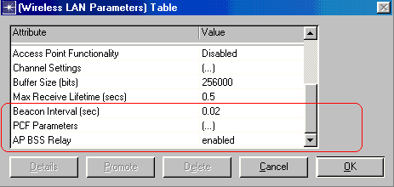

Figure 2.2.1) Attributes added to Wireless LAN Parameters Table

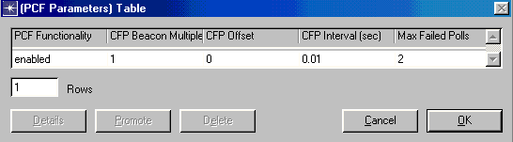

Figure 2.2.2) PCF Parameters Table

Figure 2.2.3) Example of CFP Parameters Use

Simple PCF Scenario
A sample scenario is provided with the PCF code that demonstrates it’s use. The scenario is titled “wlan_simple_pcf” and is shown in Figure 3.1. The main purpose of the scenario is to show simultaneous operation of DCF and PCF nodes in a single BSS. There are 5 Nodes. The nodes are of type wireless_lan_adv_pcf. This node model is depicted in figure 3.2. It is identical to the node model wireless_lan_adv available with the Standard model, except that it uses the PCF MAC model rather than the Standard MAC model. The names of the nodes indicate which STA is the AP, and which terminals are using the PCF and DCF. The MAC address of the STA is also included in the name.
There is a minor irregularity in the scenario. To truly be an AP with an active PC, there must be a Distribution System (DS) available. There is no DS in this scenario. However, the sink and source in the AP node acts as a DS for the purpose of providing a simple example of PCF operation.
The nodes are set up such that they are all using the 11 mbps Direct Sequence PHY. All other attributes are set to there default values except as noted. The AP has the AP enabled. The AP and two PCF STAs have the following PCF Parameters:
PCF Functionality: enabled
CFP Beacon Multiple: 1
CFP Offset: 0
CFP Interval: 0.01
Max Failed Polls: 2
The traffic sources are all set up to start generating constant rate, constant size traffic starting approximately 1 second into the simulations. The actual start time values are:
STA10_DCF: 1.00001
STA11_DCF: 1.00002
STA20_PCF: 1.00000
STA21_PCF: 1.00000
STA30_AP: 1.00003
These delays were initially created to reduce the potential for collisions under the DCF. If the MACs received packets from the upper layers at exactly the same time, (depending on the state of backoff) they may try to transmit at exactly the same time. This would potentially result in a large number of collisions. It probably is not critical that these timing offsets are used for this scenario to work.
As for the packet traffic sent, the PCF nodes are sending 168 byte packets once every 0.02 seconds, and the DCF terminals are sending 1024 byte packets every 0.025 seconds. These traffic loading are essentially arbitrary. As for the AP, the node model does not include an IP stack (which adds a lot of overhead to the simulations). This means it is not possible to identify specific traffic for individual STA, except to send all traffic from the AP to a single STA. Sending all traffic to a single STA is not desired. The node model does have the capability to select a destination address randomly. So, the AP is currently configured to send a 168 byte packet every 0.005 seconds to a random address.
Some sample collected data is shown in Figures 3.3 (for a DCF STA) and 3.4 (for a PCF STA). It can see from the simulations that retransmissions (collisions) occur for the DCF terminal, while none occur for the PCF terminal. Both the DCF and PCF terminal have back off. All terminals are required to backoff after transmissions. However, since the PCF terminals never transmit unless polled, and ignore backoff whenever they are polled, the backoff statistic is not relevant. The channel reservation statistic is a measure of how much the NAV is set during a simulation. Again, the NAV does not affect PCF terminals since they ignore the NAV when responding to a poll and never transmit otherwise. The data traffic received / sent statistics are self-explanatory. But, it should be noted that the received statistics includes all traffic received from the media, not just the traffic addressed to a particular terminal. Finally the Media access delay is somewhat misleading. OPNET coded it to represent the time spent in the transmit queue. It does not include retransmission time if any. Also the PCF terminal seems to do much better. But this is largely a result of when data becomes available relative to the TBTT. The PCF always gets to go first, and so always has shorter transmit times. In a real system this is desired behavior, but probably not guaranteed. If the data were coming in closer to the CP, the DCF would suddenly have an advantage. Consideration should be given to the appropriate timing of data arrivals when performance simulations of MAC proposals begin.

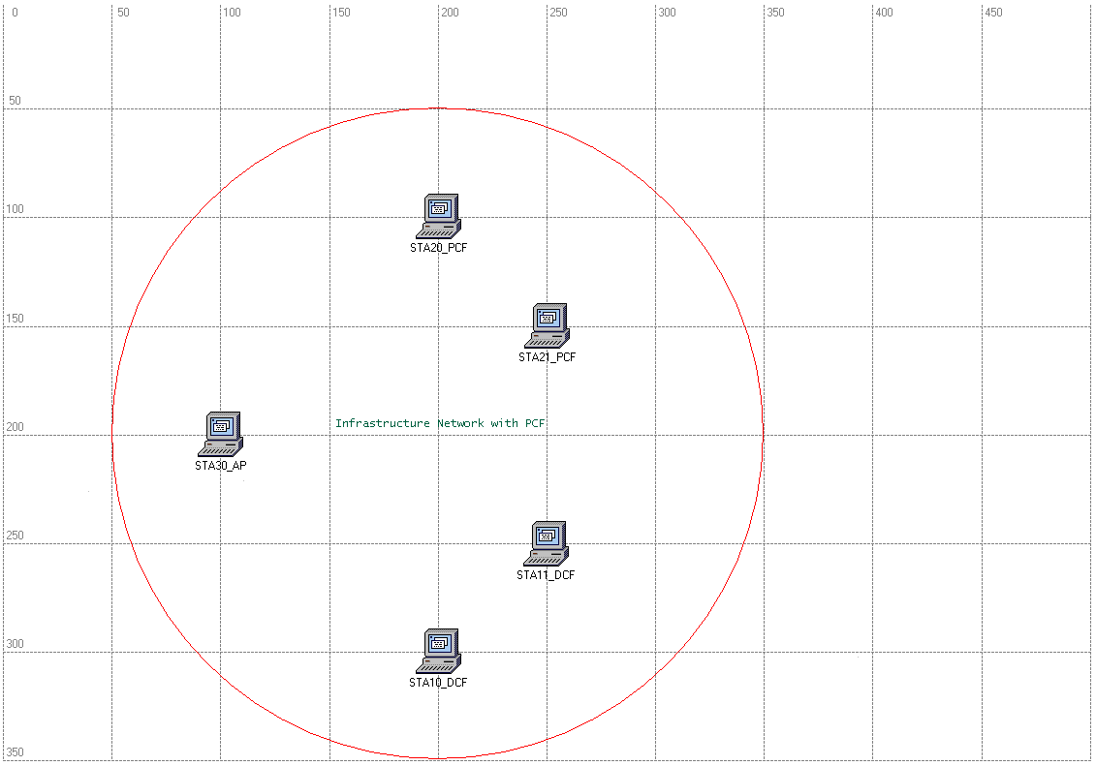

Figure 3.1) Simple PCF Scenario

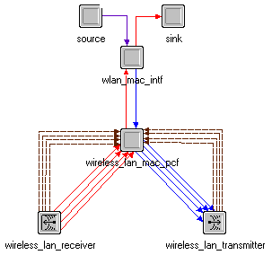

Figure 3.2) wireless_lan_adv_pcf Node Model
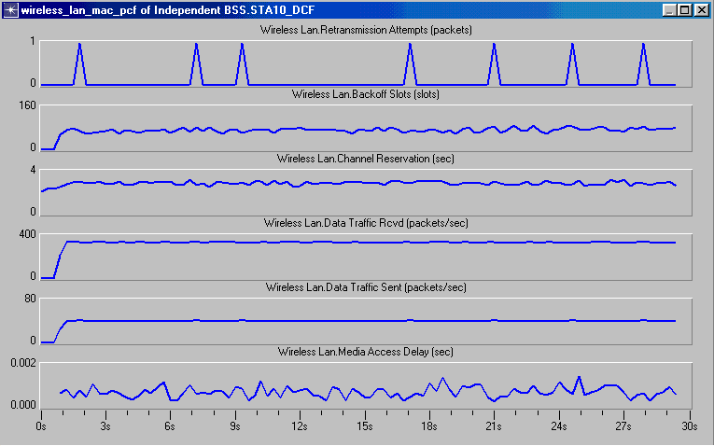
Figure 3.3) Sample Data Collected for DCF STA

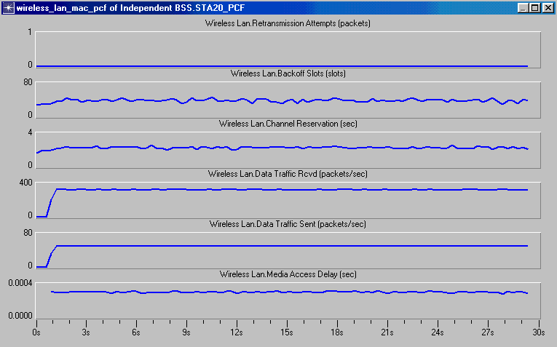
Figure 3.3) Sample Data Collected for DCF STA

Conclusions and Future Work
An open source model of the 802.11 PCF has been developed based on the 802.11 model available in OPNET Technologies standard models library for OPNET. This model has yet to be validated, but is believed to be a fairly accurate representation of true PCF operation. There are still minor issues with the model, but most of these will be resolved within a few weeks. Work is starting on integrating this model with an 802.11 Channel model from Intel, and an 802.11 PHY model from Phillips, both of which are available in OPNET. After that, work will begin on modeling MAC enhancements being proposed by AT&T built over the PCF model developed.

References
[802.11] IEEE, “Reference number ISO/IEC 8802-11:1999(E) IEEE Std 802.11, 1999 edition. International Standard [for] Information Technology-Telecommunications and information exchange between systems-Local and metropolitan area networks-Specific Requirements- Part 11: Wireless LAN Medium Access Control (MAC) and Physical Layer (PHY) specifications”, 1999.
[00/120] Jin-Meng Ho, Wim Diepstraten, and Rajugopal Gubbi “Joint Proposal for 802.11E QoS Enhancements,” submission to IEEE 802.11 WG, 802.11-00/120, May 2000.
[00/141] Gerard Cervelló and Sunghyun Choi, “Comparison of Two 802.11 Models in OPNET Simulator,” submission to IEEE 802.11 WG, 802.11-00/141, May 2000.
[00/144] Gerard Cervelló and Sunghyun Choi, “Answers/Arguments to the Comments of OPNET on the Paper “Comparison of Two 802.11 Models in OPNET Simulator”,” submission to IEEE 802.11 WG, 802.11-00/144, May 2000.
[00/252] Daji Qiao and Sunghyun Choi, "Philips’ Implementation for Enhancement of IEEE 802.11 OPNET Simulation Model," submission to IEEE 802.11 WG, 802.11-00/252, August 2000.
[00/277] Shantanu Kangude, Evan Green, and V. Srinivasa Somayazulu, “A Channel model implementation in OPNET for simulation of the IEEE 802.11 MAC”, submission to IEEE 802.11 WG, 802.11-00/277, September 2000.

