Project | IEEE 802 Executive Committee Study Group on TV White Spaces
Title | 802.22 systems use
Date Submitted | 2008-12-04
Source(s) | Gerald Chouinard  CRC | Voice: 613-998-2500  mailto: gerald.chouinard@crc.ca
Abstract | Summary description of the typical use foreseen for 802.22 Wireless Regional Area Networks (WRAN). This was extracted form clause 1.3 of the Draft 802.22 Standard.
Purpose | To establish the use of 802.22 system in the context of the discussions for the use of TV white space.
Release | The contributor grants a free, irrevocable license to the IEEE to incorporate material contained in this contribution, and any modifications thereof, in the creation of an IEEE Standards publication; to copyright in the IEEE’s name any IEEE Standards publication even though it may include portions of this contribution; and at the IEEE’s sole discretion to permit others to reproduce in whole or in part the resulting IEEE Standards publication. The contributor also acknowledges and accepts that this contribution may be made public by IEEE 802.
Patent Policy and Procedures | The contributor is familiar with the IEEE-SA Patent Policy and Procedures:  <http://standards.ieee.org/guides/bylaws/sect6-7.html#6> and <http://standards.ieee.org/guides/opman/sect6.html#6.3>.  Further information is located at <http://standards.ieee.org/board/pat/pat-material.html> and <http://standards.ieee.org/board/pat>.

Typical use of the 802.22 Wireless Regional Area Networks (WRAN)

The Wireless Regional Networks for which the IEEE 802.22 standard is developed are expected to operate in low population density areas and provide broadband access to data networks using vacant TV channels in the VHF and UHF bands allocated to the Television Broadcasting Service in the frequency range between 54 MHz and 862 MHz while avoiding interference to the broadcast incumbents in these bands. A typical application can be the coverage of the rural area around a village as illustrated in Figure 1 within a radius of 17 km to 30 km depending on the EIRP of the base station using adaptive modulation although the MAC should be able to accommodate user terminals located as far as 100 km when exceptional RF signal propagation conditions prevail.

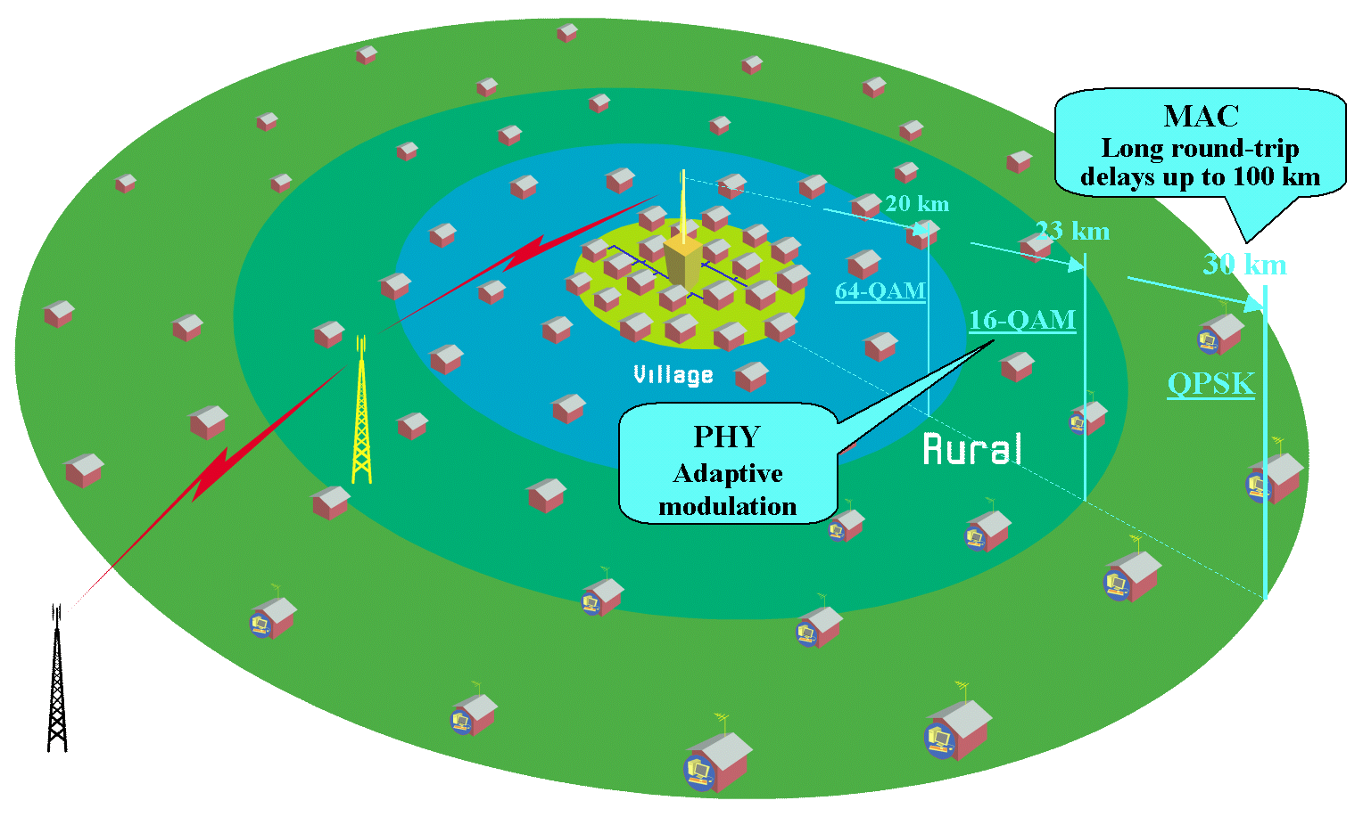
- Typical application of the 802.22 WRAN standard

As indicated in the 802.22 Functional Requirement document (22-05-0007-47-0000_RAN_Requirements.doc), the capacity at the user terminal is expected to be of 1.5 Mbit/s in the downstream and 384 kbit/s in the upstream. The service availability due to RF propagation is assumed to be at 50% of locations to allow the service provider to reach subscribers in fringe areas and 99.9% of the time to provide a reliable connection where it is possible. The average spectrum efficiency over the coverage area is expected to be around 2 bps/Hz given the adaptive modulation parameters and the operating constraints described below, and assuming a 6 MHz TV channel bandwidth and a 40:1 oversubscription ratio resulting from the stochastic nature of the data network usage, this translates into a total of 255 user terminals that can be served by the base station per TV channel.

Figure 2 illustrates the main characteristics of the 802.22 WRAN standard relative to the other existing wireless network standards.

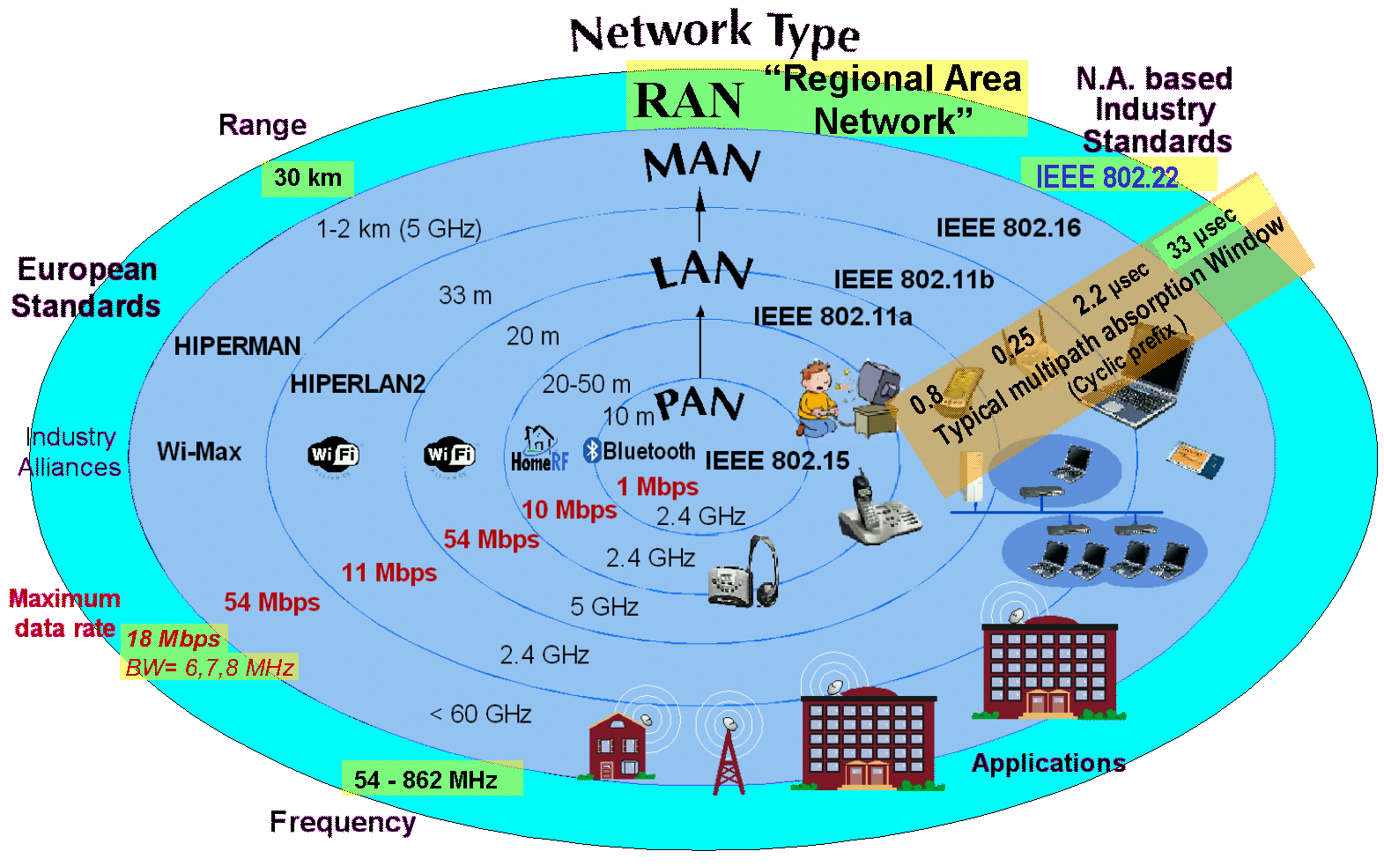
- Characteristics of the WRAN standard relative to other wireless network standards

References:

- IEEE P802.22™/ DRAFTv1.40, Draft Standard for Wireless Regional Area Networks Part 22: Cognitive Wireless RAN Medium Access Control (MAC) and Physical Layer (PHY) specifications: Policies and procedures for operation in the TV Bands

- Functional Requirements for the 802.22 WRAN Standard (22-05-0007-47-0000_RAN_Requirements.doc)

- WRAN Reference Model (22-04-0002-16-0000_WRAN_Reference_Model.xls)

