IEEE P3079 Working Group

Meeting Minutes April 23th~ 26th 2018
Session #5 Meeting, Tokyo, Japan

Chair: Dongil Dillon Seo
Secretary: Sangkwon Peter Jeong

First Day AM2 (10:30am-12:30pm), April 23, 2018: E-1904 Aoyama-Twin Tower Bldg., 1-1-1 Minami-aoyama, Minato-ku, Tokyo 107-0062, Japan

IEEE P3079 WG Opening Plenary: Meeting is called to order at 10:30am by Dongil Dillon Seo, Chair of IEEE P3079 WG with opening notes

Meeting is called to order at 10:30am by Dongil Dillon Seo, Chair of IEEE P3079 WG

Roll Call

Establish Quorum

06/06, quorum achieved

IEEE 3079 Session #5 Opening Plenary Notes (3079-18-0028-00-0000-Session-5-WG-Closing-Plenary)

All submitted documents can be found on https://mentor.ieee.org/3079/documents

Attendance procedures, logistics, breaks

Duty to inform slides 1-4, etc.

Request to make Intellectual Property declaration

No one declared any patent claims in this session

LMSC Chair’s Guidelines on Commercialism at meetings

Introducing each attendant

Review meeting minutes of January, 2018 (DCN: 3-18-0011-00-0000-Session-4-WG-Meetingminutes)

April, 2018 Meeting Agenda (3079-18-0018-01-0000-Session-05-Agenda)

Agenda bashing:

Agenda confirmed to ‘3-18-0018-02-0000-Session-05-Agenda’.

First Day PM1 (1:30pm-3:30pm), April 23, 2018: E-1904 Aoyama-Twin Tower Bldg., 1-1-1 Minami-aoyama, Minato-ku, Tokyo 107-0062, Japan

Presentation on Terms and Definition

Jeong, Sangkwon presented “Terms and Definition on Excel” (3079-18-0021-00-0000-Terms and Definition on Excel).

Motion #1: To approve the ‘3079-18-0021-00-0000-Terms and Definition on Excel’ to the standard document after modifying this document.

Motioned by: Jeong, Sangkwon

Seconded by: Lee, Beom-Ryeol

Motion Vote:

For agree: 6

Against: N/A

Abstentions: N/A

Outcome: Approved

Presentation on Terms and Definition

Kang, Suk-Ju presented “terms-and-definition-on-excel” (DCN 3079-18-0022-00-0004).

Motion #2: To approve the ‘3079-18-0022-00-0000-Terms and Definition on Excel’ to the standard document after modifying this document.

Motioned by: Kang, Suk-Ju

Seconded by: Lee, Gook-Hwan

Motion Vote:

For agree: 6

Against: N/A

Abstentions: N/A

Outcome: Approved

First Day PM2 (3:30pm-5:00pm), January 29, 2018: E-1904 Aoyama-Twin Tower Bldg., 1-1-1 Minami-aoyama, Minato-ku, Tokyo 107-0062, Japan

Presentation on Terms and Definition

Lee, Beom-Ryeol presented “terms-and-definition-on-excel_UPDATE” (DCN 3-18-0019-00-0002).

Motion #3: To approve the ‘3079-18-0019-00-0002- terms-and-definition-on-excel_UPDATE’ to the standard document after modifying this document.

Motioned by: Lee, Beom-Ryeol

Seconded by: Jeong, Sangkwon

Motion Vote:

For agree: 6

Against: N/A

Abstentions: N/A

Outcome: Approved

Day2 AM1 (08:00am-10:00am), April 24, 2018: E-1904 Aoyama-Twin Tower Bldg., 1-1-1 Minami-aoyama, Minato-ku, Tokyo 107-0062, Japan

Discuss on Terms and Definition

Dillon presented “Second Draft of Terms and Definition” (DCN 3079-18-0027-00-0000).

Day2 AM2 (10:30am-12:30pm), January 30, 2018: E-1904 Aoyama-Twin Tower Bldg., 1-1-1 Minami-aoyama, Minato-ku, Tokyo 107-0062, Japan

Presentation on Terms and Definition

Oh, Minseok presented “terms-and-definitions-network” (DCN 3079-18-0025-00-0000).

Motion #4: To approve the ‘DCN 3079-18-0025-00-0000-terms-and-definitions-network’ to the standard document after modifying this document.

Motioned by: Oh, Minseok

Seconded by: Jeong, Sangkwon

Motion Vote:

For agree: 6

Against: N/A

Abstentions: N/A

Outcome: Approved

Day2 PM1 (1:30pm-3:30pm), April 24, 2018: E-1904 Aoyama-Twin Tower Bldg., 1-1-1 Minami-aoyama, Minato-ku, Tokyo 107-0062, Japan

Presentation on Technical issues on 360o VR Scene on Web environment

Yoo, Kwan-Hee presented “Technical issues on 360o VR Scene on Web environment” (DCN 3079-18-0026-00-0000).

Motion #5: To approve the ‘DCN 3079-18-0026-00-0000-Technical issues on 360o VR Scene on Web environment’ to the standard document after modifying this document.

Motioned by: Yoo, Kwan-Hee

Seconded by: Lee, Beom-Ryeol

Motion Vote:

For agree: 6

Against: N/A

Abstentions: N/A

Outcome: Approved

Reviewing on Usecases

Kang, Suk-Ju presented “use-cases-for-measuring-the-motion-to-photon-latency-in-the-display” (DCN 3079-18-0023-00-0004).

Motion #6: To approve the ‘DCN 3079-18-0023-00-0004-use-cases-for-measuring-the-motion-to-photon-latency-in-the-display’ to the standard document after modifying this document.

Motioned by: Kang, Suk-Ju

Seconded by: Lee, Beom-Ryeol

Motion Vote:

For agree: 6

Against: N/A

Abstentions: N/A

Outcome: Approved

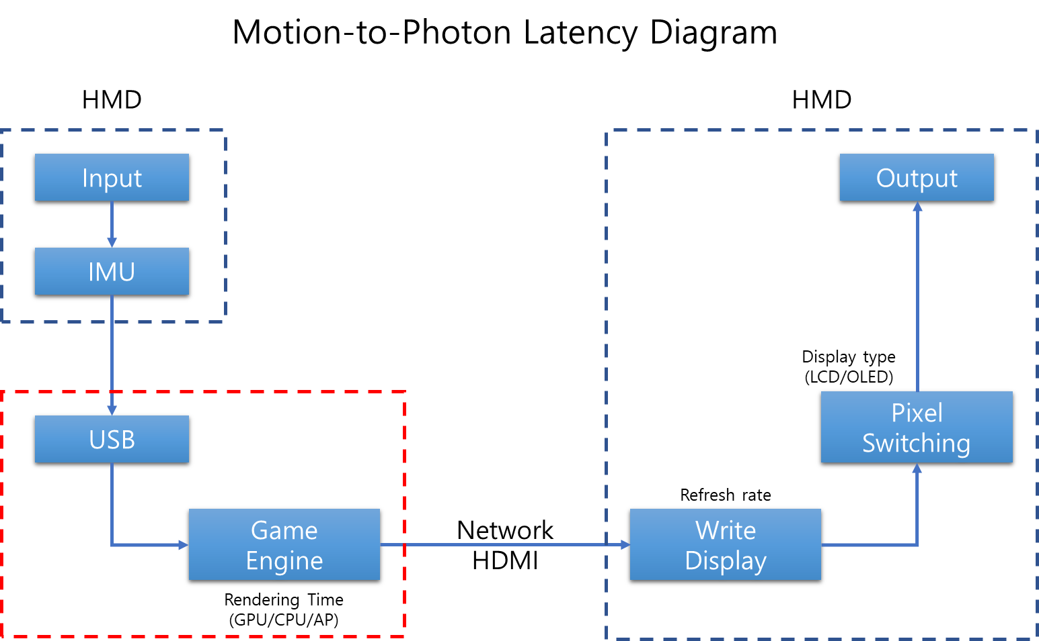

Day2 PM2 (4:00pm-6:00pm), April 24, 2018: E-1904 Aoyama-Twin Tower Bldg., 1-1-1 Minami-aoyama, Minato-ku, Tokyo 107-0062, Japan

Reviewing on Usecases

“Second Draft of Terms and Definition” (DCN 3079-18-0027-00-1000).

Motion #7: To approve the ‘DCN 3079-18-0027-00-0000- Second Draft of Terms and Definition’ to the standard document after modifying this document.

Motioned by: Dillon Seo

Seconded by: Jeong, Sangkwon

Motion Vote:

For agree: 6

Against: N/A

Abstentions: N/A

Outcome: Approved

Reviewing on Usecases

Lee, Beom-Ryeol presented “use-cases-of-Content-&-SW-for-evaluation-of-CSL” (DCN 3079-18-0020-00-0002).

Motion #8: To approve the ‘DCN 3079-18-0020-00-0002-use-cases-of-Content-&-SW-for-evaluation-of-CSL’ to the standard document after modifying this document.

Motioned by: Lee, Beom-Ryeol

Seconded by: Jeong, Sangkwon

Motion Vote:

For agree: 6

Against: N/A

Abstentions: N/A

Outcome: Approved

Day3 AM1 (08:00am-10:00am), April 25, 2018: E-1904 Aoyama-Twin Tower Bldg., 1-1-1 Minami-aoyama, Minato-ku, Tokyo 107-0062, Japan

Reviewing on Usecases

Jeong, SangKwon presented “Use cases and Network Requirements” (DCN 3079-18-0024-00-0003).

Motion #9: To approve the ‘DCN 3079-18-0024-00-0003-Use cases and Network Requirements’ to the standard document after modifying this document.

Motioned by: Jeong, Sangkwon

Seconded by: Lee, GookHwan

Motion Vote:

For agree: 6

Against: N/A

Abstentions: N/A

Outcome: Approved

Day3 AM2 (11:30am-1:00pm), April 25, 2018: E-1904 Aoyama-Twin Tower Bldg., 1-1-1 Minami-aoyama, Minato-ku, Tokyo 107-0062, Japan

Discuss on Usecases

All member of WG

Day3 PM1 (2:00pm-3:30pm), April 25, 2018: E-1904 Aoyama-Twin Tower Bldg., 1-1-1 Minami-aoyama, Minato-ku, Tokyo 107-0062, Japan

Discuss on Usecases

All member of WG

Day3 PM2 (4:00pm-6:00pm), April 25, 2018: E-1904 Aoyama-Twin Tower Bldg., 1-1-1 Minami-aoyama, Minato-ku, Tokyo 107-0062, Japan

Discuss for structure of standard document

All member of WG

Day4 AM1 (08:00am-10:00am), April 26, 2018: E-1904 Aoyama-Twin Tower Bldg., 1-1-1 Minami-aoyama, Minato-ku, Tokyo 107-0062, Japan

Reviewing for structure of standard document

All member of WG

Day4 AM2 (10:30am-12:30am), April 26, 2018: E-1904 Aoyama-Twin Tower Bldg., 1-1-1 Minami-aoyama, Minato-ku, Tokyo 107-0062, Japan

Closing Plenary

3079-18-0028-00-0000-Session-5-WG-Closing-Plenary

Attendees

Seo, Dongil Dillon | VoleRCreative
Jeong, Sangkwon Peter | JoyFun Inc.,
Lee, Beom Ryeol | ETRI
Kang, Suk-Ju | Sogang University
Lee, GookHwan | JoyFun Inc.,
Yoo, Kwan-Hee | Chungbuk National University

