Project | Head Mounted Display (HMD) Based 3D Content Motion Sickness Reducing Technology  <http://sites.ieee.org/sagroups-3079/>
Title | Terms and Definition in the Display Technology
DCN | 3-18-0010-00-0000-
Date Submitted | January 29, 2018.
Source(s) | Sangkwon Peter Jeong ceo@joyfun.kr (JoyFun Inc.,)  Dongil Dillon Seo dillon@volercreative.com (VoleRCreative)  GookHwan Lee ghlee@joyfun.kr (JoyFun Inc.,)
 | IEEE P3079 Session #4 in Gyeonggi, Korea
Abstract
Purpose
Notice | This document has been prepared to assist the IEEE P3079 Working Group. It is offered as a basis for discussion and is not binding on the contributing individual(s) or organization(s). The material in this document is subject to change in form and content after further study. The contributor(s) reserve(s) the right to add, amend or withdraw material contained herein.
Release | The contributor grants a free, irrevocable license to the IEEE to incorporate material contained in this contribution, and any modifications thereof, in the creation of an IEEE Standards publication; to copyright in the IEEE’s name any IEEE Standards publication even though it may include portions of this contribution; and at the IEEE’s sole discretion to permit others to reproduce in whole or in part the resulting IEEE Standards publication. The contributor also acknowledges and accepts that IEEE P3079 may make this contribution public.
Patent Policy | The contributor is familiar with IEEE patent policy, as stated in Section 6 of the IEEE-SA Standards Board bylaws <http://standards.ieee.org/guides/bylaws/sect6-7.html#6> and in Understanding Patent Issues During IEEE Standards Development http://standards.ieee.org/board/pat/faq.pdf
- Terms & Definitions

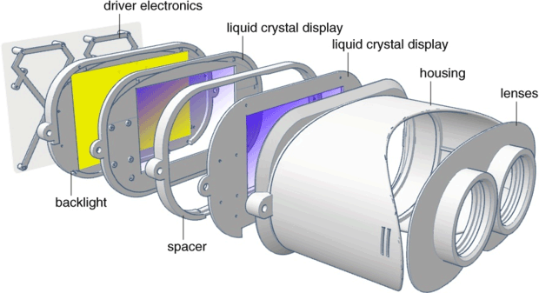

  - Types of Head Mounted Display based Virtual Reality Devices

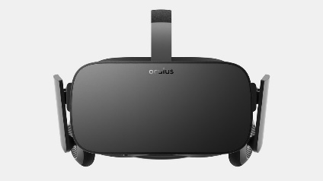 | 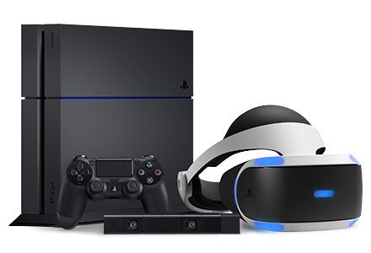 | 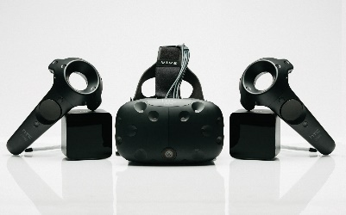
(Oculus Rift) | (PS VR) | (Vive)

    - HMD, Head Mounted Display
- A generic term for display devices that are attached to the head
- A device that is worn like a goggle or a helmet on a person's head and through which the image displayed to the front panel can be seen by the wearer. Normally sensors such as a gyro, an accelerometer, and a magnetometer are attached to respond to user's head movement.

    - HMD Connected to PC or Console
The HMD is tethered to a PC or a console and receives video and sound information from an external device such as PC or console for the purpose of displaying virtual reality
- Various sensors are built in and/or external sensors are used to track various HMD movement.

    - HMD Connected to Smart Phone
The HMD is physically attached to a smart phone and receives video and sound information from the attached smart phone.
- Most of the HMD performance depends on the smart phone performance.

  - Terms and Definitions for HMD Components

This section defines the components that make the HMD and the external input/output and control interfaces.

    - Foam Padding
A padding attached to the HMD to make the user feels more comfortable and to absorb any shock caused by any external impact.

    - Fisheye Lens
An ultra-wide angle lens with viewing angle over 180°
- VR HMDs are using a pair of fisheye lenses to obtain a wide field of view and this makes the viewing image distorted. To correct this image distortion, the video output from the display panel is distorted opposite way to the fisheye lens distortion.

    - Lens Holder
A holder to fix the lens position and to prevent it from moving.

    - Body (or Barrel)
A body frame that forms the overall shape of the HMD.

    - Display Panel
A display component that outputs the video and/or image
- OLED(Organic Light Emitting Diode) or LCD(Liquid Crystal Display) are often used. To reduce the motion-to-photon latency, OLED is preferred.

    - Driver Electronics
An electric device for outputting the video and/or image

    - USB, Universal Serial Bus
One of the input and output standards used to connect computers and peripherals
- It was made to replace various conventional serial and parallel connections. It is used to connect various devices such as keyboards, mice, game pads, joysticks, scanners, digital cameras, printers, PDAs and storages. Most of these devices are using standard connection methods. USB has been developed for PC, but now it is being used in PDA and game console. Also, it is being used for charging devices as the USB has a power supply function. There are more than 2 billion USB devices around the world. ‘USB Implementers Forum’ determines the USB standards.

    - HDMI, High Definition Multimedia Interface
High-speed multimedia interface that transfers both uncompressed full digital audio and video signals
- Mainly used in PCs, game consoles, Blu-ray players, TVs, and some smart phones. Most video players have HDMI and component video/audio jacks, so you can use the HDMI connection for the video only and use the component audio jacks for the sound.
- HDMI 1.3 has expanded the bandwidth from 5 Gbps (165 MHz) to 10 Gbps (340 MHz), enabling transmission and reception of large amounts of data about twice as much. It can also display 30 to 48 bit colors compared its old 24 bit colors based on the existing RGB standard. In addition, it supports xvYCC, which expands 1.8 times the color space, and supports 2,560 × 1,600 resolution or 1,440p beyond 1,920 × 1,080, which is the full HD standard. It implements 120 frames per second and improves image reproduction ability and response speed. It also supports audio formats such as DVD audio and Super Audio CD (SACD) as well as next-generation HD audio standards such as Dolby True HD and DTS HD in Digital Theater System (DTS).

    - DP, Display Port
Digital video transmission interface standard, which is mainly used for transmitting video to display devices such as computer monitors
- VESA standards are royalty free. VESA has designed the display port to create high-performance standards that would replace VGA. DVI, and LVDS. Dongles are used to support the backward compatibility with VGA and DVI. It serves almost the same functions as HDMI, but it is a complementary feature rather than a replacement to HDMI.
- As it integrates the DVI (Digital Video Interface), the external interface standard, and the LVDS (Low Voltage Differential Signaling), the internal interface standard, it displays the high resolution graphics much faster.

    - Head Band
A band used to fix the HMD position on head so that the user can attach the HMD on the face.
- This is only useful for heavy and bulky HMDs, and it is a cumbersome and unnecessary component when the weight of HMD is light and the size is small.

    - Face Cover
A front cover attached to the outside of the HMD body to protect the electric circuit board for displaying video and the backlight.
- It also plays a role for the beauty of the product, but it blocks the inflow of light from the outside to enhance the immersion feeling and the sense of presence of the user. It also has the function to detect the change to the user or outside situation by attaching the sensor.

    - Tracking Sensor
A device for enhancing the user's immersion feeling by tracking the movement of the user and synchronizing with the content

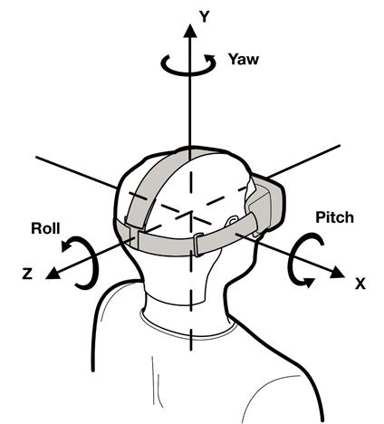
      - Head Tracking
- A technique in which tracks the yaw, pitch and roll movement of the HMD and displays the video accordingly.
- The sensor used for head tracking calculates the position value of head rotation through accelerometer, gyro and magnetometer. The direction of the headset depends mainly on the gyro sensor, and the accelerometer plays an auxiliary role in many cases. In some cases, the direction reference is determined through the help of the magnetometer, but its role is limited because it can be easily disturbed by external the magnetic field. The position tracking is also done using a separate infrared camera as an alternative.

      - Positional Tracking
A technique to track user body position. Currently, It is done through either infrared laser system or LED marker system.

        - LED Marker Tracking
Positional tracking technology that detects position by tracking the LED markers on HMD with an external camera
- Oculus Rift uses a method of detecting the position of the infrared LED markers on the HMD with an infrared camera.
- PS VR uses a method of detecting the position of the visible light LED markers on the HMD with a camera and processing the captured video.

        - Laser Tracking
Positional tracking technology that detects position by tracking the infrared sensors on the HMD using the infrared laser from a base station. The base station shoots the infrared laser periodically in vertical and horizontal and detects the infrared sensors on the HMD to calculate the HMD position. It calculates how long the HMD infrared sensors to react to the laser scan and the sensor position. The position calculation of the HMD is possible only by geometric calculation.
- HTC Vive uses two base stations to shoot infrared laser and the HMD receives the laser.

      - Accelerometer
A sensor for measuring linear acceleration or angular acceleration by measuring inertia-induced reaction.
- Unit is indicated by G value, and it has various range according to sensor.

      - Magnetometer
A sensor for measuring magnetism – the direction, strength and relative change of a magnetic field at a particular location.

      - Gyroscope
A sensor for measuring orientation and angular velocity. It is also the term collectively refers to a device for measuring gravity using elastic deformation by gravity.
- In HMD, it refers to a gravity meter that works perpendicular to the center of the earth.

  - Terms and Definitions for the Element Technology
This section defines the terms used to describe the technology behind the HMD, not the physical components.

    - Image Distance, Focus Distance
In HMD, it is the distance that an image is focused on the user’s eyes by an optical system.
- It generally refers to the focused distance as the parallel light passes through the optical system.

    - Eye Relief
The distance between the eyepiece and the user’s eyes.
- For people who wear eye glasses, the distance must be at least 25 mm in order to wear the HMD with the glasses.

    - Diagonal, Horizontal, Vertical FOV
The viewing angle in diagonal, horizontal and vertical direction.

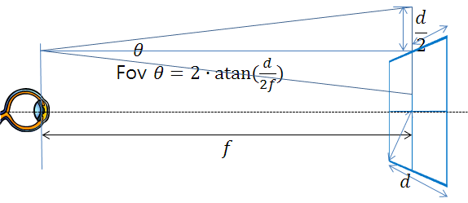

    - Pupil, Pupil size, Exit pupil
The entrance of the eye where the light from the optical equipment passes through to make an image on the retina.
- The size of the pupil changes from 2 to 7 mm depending on the ambient brightness

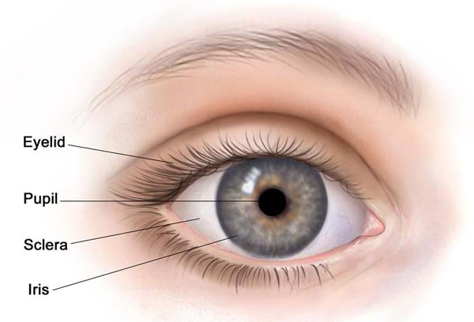

    - FOV, Field of View or Field of Vision
The range of images that can be displayed in the HMD.
- It is measured in angle. Unless specified, it represents diagonal view angle.

    - Transmittance, See-through ratio
The intensity or number of particles that penetrate the material or boundary layer
- Percentage of transmittance is referred to as see-through ratio or transmission coefficient. When parallel rays are incident perpendicularly to the interface, the incident intensity(IO) and the intensity after transmission (IT) are used to determine the transmission coefficient. Transmission Coefficient = (IT/IO)×100.
- In the case of See-through HMD, it is the ratio of the incident intensity that the light incident from the outside is transmitted to the user. It is a value showing the degree that the user can wear the HMD and view the object.

    - Optical distortion
Distortion occurred by the optical system – often the distorted image is in a barrel or pincushion shape depending on the system.
- In some complex situation, S type (also known as mustache type) distortion may appear. The degree of distortion is expressed by the difference between the ideal optical design value and the actually measured value. Since the value has different values depending on the distance, a graph expressing the degree of distortion in percentage from the center to the edge is used.

    - Brightness, Luminance
The level of brightness or darkness the eyes sense when the light is reflected.
- There are two types of brightness, the amount of radiation which is the radiant energy of the electromagnetic wave, and the amount of light which is the light detected by the human eye.

    - Contrast
Ratio of the brightest and the darkest light.

    - Ocularity, Monocular, Binocular, Biocular
Type of optical systems used in the HMD determined by the number of video signals.
- When the video signal is delivered to one eye, it is called monocular. When two different video signals are delivered to both eyes, it is called binocular. When a single video signal is delivered to both eyes, it is called biocular.

    - Exit Pupils
The range of pupil size in the HMD.
- In a general optical system, it refers to a hole through which the light exits, an exit hole seen from the direction in which the optical system is seen from the eye, or a hole through which the image can be formed by the lens behind the optical system.

    - Spatial 3D Sound
A technology that allows the user to identify the location of a sound source where sound is generated.
- In conjunction with Head Tracking of HMD, the sound is generated relative to the head direction.

    - Refresh Rate
The number of pictures that can be processed by the imaging device at one time. The measurement unit is Hz (Herz).

  - Terms and Definitions for Content
This section defines the terms used for virtual reality content creation and content service using a HMD.

    - VR, Virtual Reality
It refers to any specific environment, situation or technology itself where the actual reality is being simulated by artificial technology using computers.
- Factors necessary to explain virtual reality are three-dimensional spatiality, real-time interactivity, and immersion. Three-dimensional spatiality means that the user is inputting the physical activities and commands needed to create the virtual space that mimics the real physical world into the computer and is outputting to a similar three-dimensional space.

    - Image Resolution
Video content resolution displayed in the HMD. Generally, it is expressed in number of pixels in horizontal and vertical.

    - Angular resolution
A value representing an interval between pixels of an image displayed by a HMD on the basis of an angle
- It is expressed by the number of pixels (PPD, Pixel Per Degree) in 1 degree (°). In general, the angular resolution can be approximated by dividing the resolution by the viewing angle. The angular resolution of the HMD device is affected by the optical structure and generally, it is determined by the center of optical axis. When the difference between the center and the periphery angular resolution is significant, it is displayed separately.
- For a HMD with HD (1920x1080) resolution and a diagonal FOV of 60 °, it has the horizontal FOV of 53.4 ° and the vertical FOV of 31.6 ° The horizontal angular resolution is about 36 PPD and the vertical angular resolution is about 34 PPD.
- The angular resolution for the person with 1.0 visual acuity is approximately 30 cycles per degree. One cycle requires two pixels to display black and white, so it requires angular resolution of 60 PPD. Curcio et al. (1990) Human Photoreceptor Topography, The Journal of Comparative Neurology.
- Apple defines its Retina Display to have angular resolution of 53 to 57 PPD.

    - FPS (Frame per Second)
The number of images that can be processed per second.
- It displays the lower value between the refresh rate processed by the display device and the refresh rate processed by the image processor. Most of the display devices released in 2016 support more than 144 Hz so it affected by the performace of image process

    - PPS (Polygon per Second)
The number of polygons that can be processed per second.
- Polygon is a basuc unit used to express objects in 3D graphics. Severval polygons come together to represent a single shape.
- Unlike CG movies, the game is very sensitive to the number of polygons as the amount of computational burden increases as the number of polygons increases.

    - 360 degree Camera
Cameras designed to capture 360 degree spherical surfaces at the same time.

    - Stitch
Technique to combine two or more videos to create 360 degree video and minimize the image distortion.

  - Terms and Definitions for Content Service
This section defines the terms used to describe the technology for HMD based virtual reality content service.

    - Blue Light
Blue-based light at wavelengths between 380 and 500 nanometers
- Much of it is released in display devices such as TVs and computer monitors and LED lighting equipments. When it is exposed for a long time, it causes eye fatigue as well as dried eyes. In severe cases, it may cause damage to the retina or lens in the eye. The medical communities report that it may reduce sleep induction hormone secretion and disturb sleeping.

    - 5th Generation Telecommunication Network
Telecommunication technology using ultra high frequency of 28 GHz
- Unlike 4G LTE (Long Term Evolution) which is using under 2 GHz frequency, it uses 28 GHz ultra high frequency. This makes it possible to deliver ultra-high-definition movies faster than LTE and just in one second. The low-band frequency has a long reach and a low speed while the high-band frequency has a strong directivity and a short reach but a high speed.
- In order to provide high quality HMD based virtual reality service equal to the full HD level resolution, 5th generation telecommunication service is required.

    - HD, High-definition video
A general term for video quality with higher resolution than standard defition (SD) resolution
- There are no standards but generally, it is called high defition if there are more than 480 horizontal lines (North American standard) or more than 576 horizontal lines (European standar)

    - Full HD
Term created for a marketing purpose and has 1920x1080 resolution (2,073,600 pixels)

    - UHD (Ultra High Definition)
Ultra-high-resolution image and video

    - 4K UHD (4K Ultra High Definition)
A term referring to next-generation high-definition resolution with a horizontal resolution of 4 kilo pixels (4 kP)
- The Consumer Electronics Association defines the 4K as 3840×2160 pixels, which is four times the full HD for TV broadcasting, and the Digital Cinema Initiatives (DCI) defines the 4K as 44096 × 2,160 pixels.

    - 8K UHD (8K Ultra High Definition)
It refers to a display resolution of 7680x4320 pixels and it has approximately 33 million pixels
- It is 16 times more than full HD TV and 4 times clearer than 4K UHD TV. 8K is a next-generation broadcasting technology after 4K, and the Japanese government is preparing to broadcast 8K test from 2018, and Korea will also broadcast an experiment with 8K of PyeongChang Winter Olympic Games in 2018.

