Project | Head Mounted Display (HMD) Based 3D Content Motion Sickness Reducing Technology  <http://sites.ieee.org/sagroups-3079/>
Title | Terms and Definition in the Display Technology
DCN | 3-17-0000-00-0000-
Date Submitted | January 20, 2018.
Source(s) | Kang, Suk-Ju (Sogang University) email: sjkang@sogang.ac.kr
 | IEEE P3079 Session #4 in Gyeonggi, Korea
Abstract
Purpose
Notice | This document has been prepared to assist the IEEE P3079 Working Group. It is offered as a basis for discussion and is not binding on the contributing individual(s) or organization(s). The material in this document is subject to change in form and content after further study. The contributor(s) reserve(s) the right to add, amend or withdraw material contained herein.
Release | The contributor grants a free, irrevocable license to the IEEE to incorporate material contained in this contribution, and any modifications thereof, in the creation of an IEEE Standards publication; to copyright in the IEEE’s name any IEEE Standards publication even though it may include portions of this contribution; and at the IEEE’s sole discretion to permit others to reproduce in whole or in part the resulting IEEE Standards publication. The contributor also acknowledges and accepts that IEEE P3079 may make this contribution public.
Patent Policy | The contributor is familiar with IEEE patent policy, as stated in Section 6 of the IEEE-SA Standards Board bylaws <http://standards.ieee.org/guides/bylaws/sect6-7.html#6> and in Understanding Patent Issues During IEEE Standards Development http://standards.ieee.org/board/pat/faq.pdf

Definition

- Display Resolution – The resolution of a digital television, computer monitor or display device is the number of distinct pixels in each dimension that can be displayed.

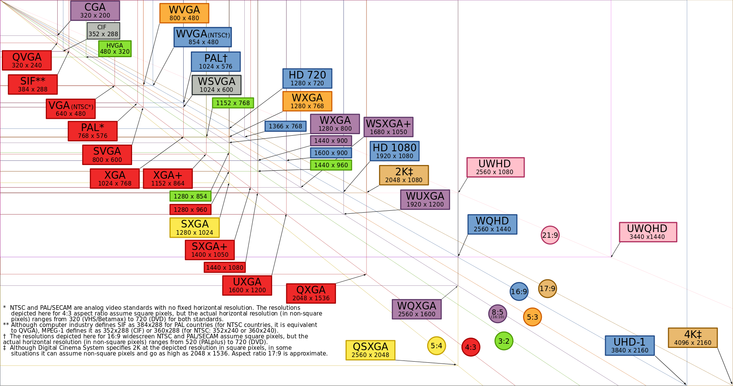
*From Wikipedia

- Ultra High Definition (UHD) – It is a display resolution standard of at least 3840 by 2160 pixels.
  - 3840 by 2160 is only the floor value, and resolutions being put on various screens range from this size up to 4096 by 3112 for 4K and up to 7680 by 4320 for 8K.
  - The Consumer Electronics Association (CEA) clarified in October of 2012 that UHD would refer to any display with a 16:9 aspect ratio and a minimum of 3840-by-2160 pixels resolution.

- Full High Definition (FHD) – It is a set of HDTV high-definition video modes characterized by 1080 horizontal lines of vertical resolution.
  - The term usually assumes a widescreen aspect ratio of 16:9, implying a resolution of 2.1 megapixels.

- Response Time – It is the amount of time a pixel in a display takes to change (It is measured in milliseconds (ms)).
  - Lower numbers mean faster transitions and therefore fewer visible image artifacts
  - Older monitors with long response times would create display motion blur around moving objects, making them unacceptable for rapidly moving images

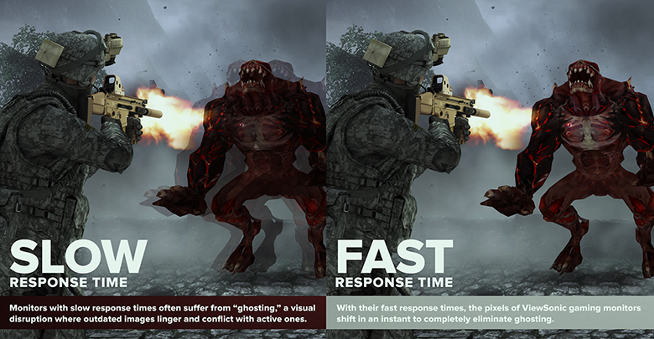

- Contrast Ratio (CR) – It is a property of a display system, defined as the ratio of the luminance of the brightest color (white) to that of the darkest color (black) that the system is capable of producing.
  - Static contrast ratio is the luminosity ratio comparing the brightest and darkest color the system is capable of producing simultaneously at any instant of time.
    - ANSI contrast, in which the measurement is done with a checker board patterned test image where the black and white luminosity values are measured simultaneously.
  - Dynamic contrast ratio is the luminosity ratio comparing the brightest and darkest color the system is capable of producing over time (while the picture is moving).
    - Full on/Full off method effectively measures the dynamic contrast ratio of a display.

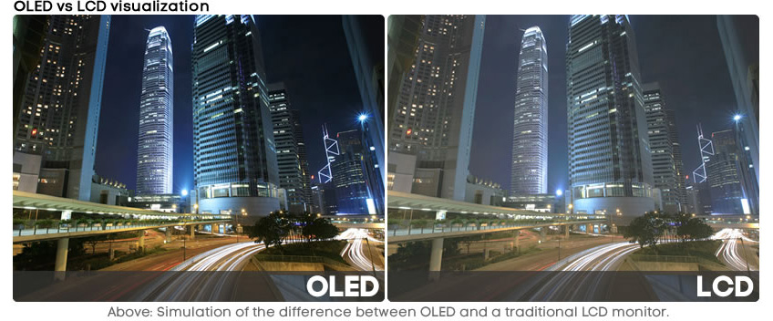

- Pixel Per Inch (PPI) – It is the measurement of the pixel density of an electronic image device such as a computer monitor or television display. Horizontal and vertical density are usually the same, as most devices have square pixels.
  - A 100×100 pixel image printed in a 1 inch square has a resolution of 100 pixels per inch.
  - Theoretically, PPI can be calculated from knowing the diagonal size of the screen in inches and the resolution in pixels (width and height). This can be done in two steps:

- Motion-to-Photon Latency – It is the time needed for a user movement to be fully reflected on a display screen.
  - To make virtual reality world realistic, virtual reality systems want low motion-to-photon latency(<20ms).
  - A high motion-to-photon latency makes a poor virtual reality experience (motion sickness and nausea).

- Motion Blur – It is the apparent streaking of rapidly moving objects in a still image or a sequence of images such as a movie or animation.
  - Motion blur occurs when the image being recorded changes during the recording of a single exposure, either due to movement or long exposure.

- Liquid Crystal Display (LCD) – It is a flat-panel display or other electronically modulated optical device that uses the light-modulating properties of liquid crystals.
  - LCDs are available to display arbitrary images or fixed images with low information content, which can be displayed or hidden

- Organic Light Emitting Diode (OLED) Display – It is a light-emitting diode (LED) in which the emissive electroluminescent layer is a film of organic compound that emits light in response to an electric current.

- Chromatic Aberration (Color Distortion) – It is an effect resulting from dispersion in which there is a failure of a lens to focus all colors to the same convergence point. It occurs because lenses have different refractive indices for different wavelengths of light.



- Stereoscopic Vision – When we look at a stereoscopic picture, our brain extracts and computes the size of the disparities to access the distance of the objects.
  - Distance between the left and right eye projections is called the horizontal parallax

