IEEE P3333.3 Working Group

Meeting Minutes May 12th, 2017 – 10am to 12pm Seoul Time
Recorded by Sangkwon Peter Jeong

- Call to Order

  - Roll Call
  - Establish Quorum
    - 4/5, quorum achieved

- Announce: July F2F meeting, 2017
  - Where: IEEE Office in NY (3 Park Ave, New York, NY 10016)
  - When: 24th ~27 th, July

- Discussion #1: To approve the of Agenda for July F2F meeting, 2017
  - Tentative meeting Agenda

 | Monday  (July 24, 2017) | Tuesday  (July 25, 2017) | Wednesday  (July 26, 2017) | Thursday  (July 27, 2017)
AM-1  8:00-10:00a | Registration | Open Discussion  (HF & Med) | Open Discussion  (Sensors) | Discussing  Future Roadmap
AM-2  10:30-12:30 | Open Plenary  Roll Call  Reviewing last meeting minutes  (Introducing participants) | Open Discussion  (Tools & Content) | Open Discussion  (Lens) | Closing Plenary
PM-1  1:30 – 3:30p | Introducing P3333.3  Introducing TG  (3 TGs first) | Open Discussion  (Display) | Summarizing standard requirements
PM-2  4:00 – 6:00p | Discussing rest of TGs | Open Discussion  (Network) | Electing TG Chairs  (3 Remaining)

* R&R: Roles & Responsibilities

  - Main issues
    - Explained why the WG has been structured into six smaller TGs
      - TG 1, 2 and 3 deal with Software aspect of motion sickness problem
      - TG 4, 5 and 6 deal with Hardware aspect of motion sickness problem.
    - Discussed TG’s Roles & Responsibilities (Presented by TG Chair)
    - Currently elected positions and yet to be elected positions
      - Already elected: HF, Display, Content
      - Yet to be elected: Lens, Sensor, Network
    - Future Roadmap

- Discussion #2: Order to number of TG

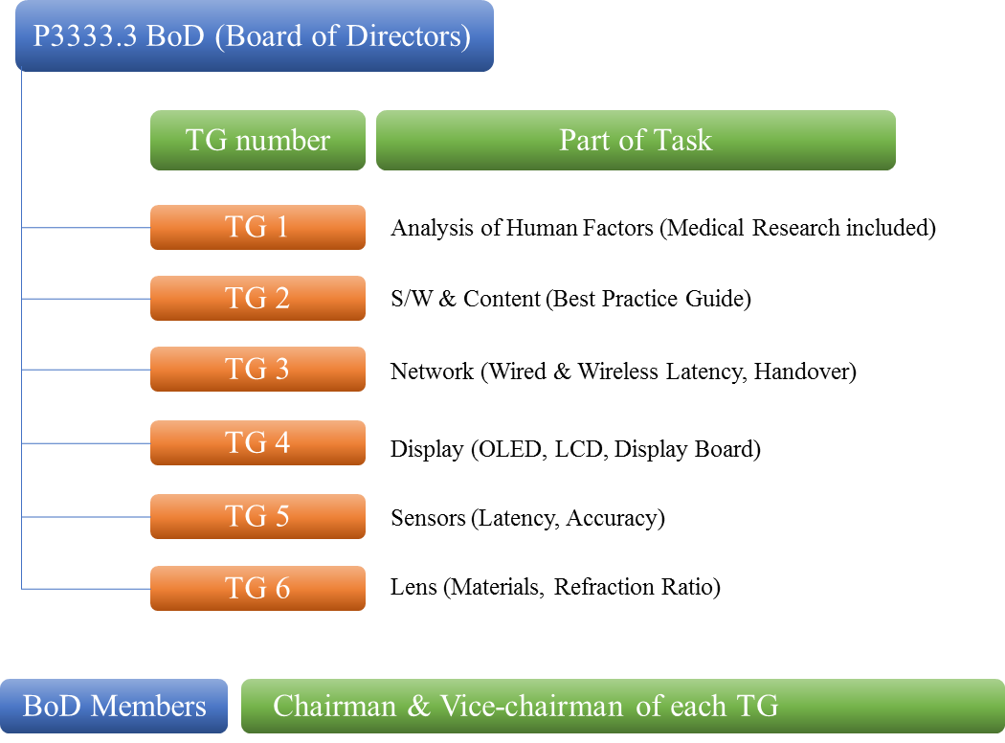
  - Renumbering the TGs by
    - Similarities – Software (TG 1, 2 and 3) and Hardware (TG 4, 5 and 6)
    - Relevance – considered the level of collaboration.
  - Vote Result for the renumbering:
    - Agree: 4
    - Disagree: N/A
    - Abstention: N/A
    - Outcome: Approved

- Next meeting: Fixed by Doodling

