Section 2: Fundementals of Power Systems
  - Electric Power Circuits
    - Electric Power Circuits
    - Single Phase Circuits
  - Power System Generation and Delivery
Bronze 8.2, 8.3, Red 14.9, White 5.8
    - Forms of cogeneration (Bronze 8.2)
Cogeneration systems may be grouped broadly into two types: topping cycles and bottoming cycles. Virtually all cogenerators use the topping cycle that generates electricity from high-pressure steam and that uses the exhausted steam or other hot gas for process heat.
The bottoming cycle utilizes lower working temperatures in various arrangements to produce process steam or electricity. Thermal energy is first used for the process, then the exhaust energy is used to produce electricity at the bottom of the cycle. The applications for electrical generation may be limited. This cycle is most beneficial where large amounts of heat are utilized in processing, such as in rotary kilns, furnaces, or incinerators. Table 8-1 gives a summary of cogeneration technologies.
- —Summary of cogeneration technologies
Technology | Unit size | Fuels used  (present/possible in future) | Average  annual  availability  (%) | Full-load  electric  efficiency  (%) | Part-load  (at 50% load)  electric efficiency  (%) | Total heat rate  ^{(Btu/kWh)} | Net heat  rate  (Btu/kWh) | Electricity-  to-steam  ratio  (kWh  MMBtu)
Steam turbine topping | 500 kW to  100 MW | Natural gas, distillate, residual, coal, wood solid waste/coal- or biomass-derived gases and liquids | 90–95 | 14–28 | 12–25 | 12 000 to 24 000 | 4500–6000 | 30–75
Open-cycle gas  turbine topping | 100 kW to  100 MW | Natural gas, distillate, treated residual/coal- or biomass- derived, gases and liquids | 90–95 | 24–35 | 19–29 | 9750 to 14 200 | 5500–6500 | 140–225
Closed-cycle gas turbine topping | 500 kW to  100 MW | Externally fired—can use most fuels | 90–95 | 30–35 | 30–35 | 9750 to 11 400 | 5400–6500 | 150–230
Combined gas turbine/steam turbine topping | 4 MW to 100 MW | Natural gas, distillate, residual/ coal- or biomass-derived gases and liquids | 77–85 | 34–40 | 25–3 0 | 8000 to 10 000 | 5000–6000 | 175–320
Diesel topping | 75 kW to 30  MW | Natural gas, distillate, treated residual/coal- or biomass- derived gases and liquids, slurry or powdered coals | 80–90 | 33–40 | 32–39 | 8300 to 10 300 | 6000–7500 | 350–700
Rankine cycle bottoming;  Steam Organic | 500 kW to  10 MW  2 kW to 2  MW | Waste heat  Waste heat | 90  80–90 | 10–20  10–20 | Comparable to full  load  Comparable to full | 17 000 to 34 100  17000 to 34 100 | NA  NA | NA  NA
Fuel cell topping | 40 kW to 25  MW | Hydrogen, distillate/coal | 90–92 | 37–45 | 37–45 | 7500 to 9300 | 4300–5500 | 240–300
Stirling engine topping | 3 to 100  MW  (expect) 1.5  MW by  1990) | Externally fired— can use most fuels | Not known— expected to be similar to gas turbines and diesels | 35–41 | 34–40 | 8300 to 9750 | 5500–6500
Source: Industrial and Commercial Cogeneration, Office of Technology Assessment, Washington, DC, 1983.

Figure 1 illustrates, in a simplified manner, a widely used topping cycle consisting of high-pressure boilers, typically 600–1500 lbf/in2, generating steam for admission to back pressure steam turbines. The steam turbine drives an electrical generator, or serves as a mechanical driver, for such equipment as fans, pumps, compressors, etc. The advantage of this system is that only the energy content of the steam required for mechanical power and losses is utilized in the turbine. The majority of the energy content remains in the back pressure steam that will be utilized in the process system. Electrical generation in the 4500–6500 Btu/kWh range is typical as compared to the usual 10 000–12 000 Btu/ kWh heat rate of the electric utility. At 100% efficiency, the conversion rate is 3412 Btu/kWh. The use of this system implies a balance between kilowatt requirements and process steam requirements. If a balance does not exist, other means shall be provided to effect a balance or the difference shall be handled by outside means, such as exchanging power with the electric utility. The system illustrated in figure 1 typically has an output of 30–35 kW/(1000 lb/h) of steam flow and has a thermal efficiency of approximately 80%.
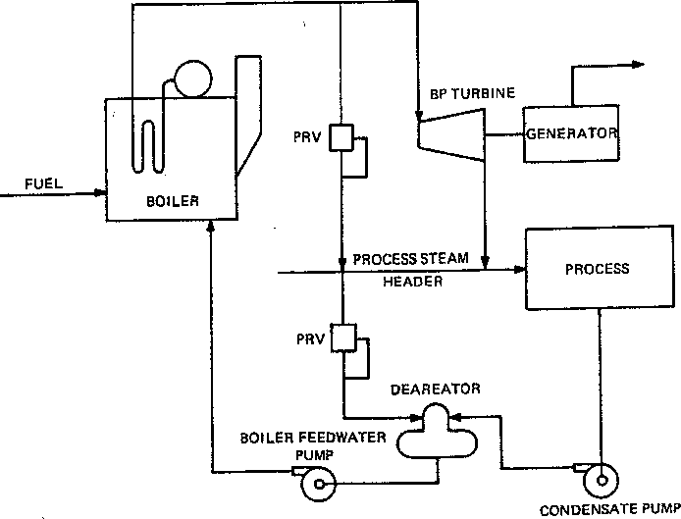
- —Plant topping cycle cogeneration steam system
Another highly efficient topping cycle employs the gas turbine-heat recovery boiler combination that utilizes a steam turbine in the cycle. Occasionally, the exhaust from the gas turbine can be used directly in the process, as for certain lumber drying kilns.
The combined cycle steam, as shown in figure 2, has a much higher kilowatt producing capability per unit of steam produced than the back pressure system in figure 1. Typically, the system illustrated in figure 2 has an output of 300–350 kW/(1000 lb/h) of steam produced at a thermal efficiency of approximately 70%.
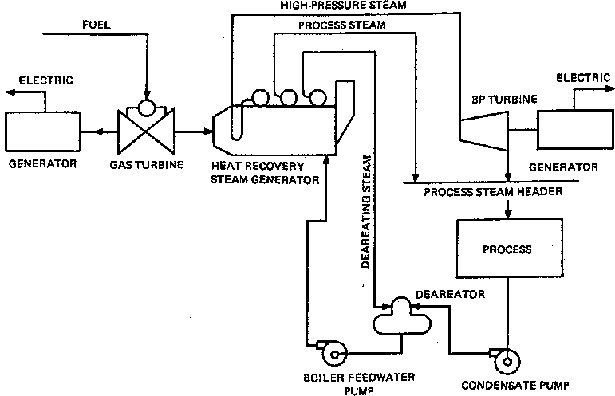
- —Plant combined cycle cogeneration steam system
Advanced gas turbines available for base load service have exhaust temperatures in the 900–1000 °F range with exhaust gas mass flows of typically 25–35 lb/kWh, resulting in some 5250 Btu/kWh of available exhaust energy. This high energy content can convert condensate to steam in a heat recovery boiler for use in a steam turbine or for direct use in process requirements. Generally, no additional fuel is required in the heat recovery steam generator.
The use of a steam turbine-generator results in additional incremental electrical power being generated at basically the cost of capital. There is some incremental reduction in the total quantity of waste heat steam produced because of the higher pressure level required. There is also an increase in the energy input to some small extent.
The objective in cogeneration is accomplished by utilizing the heat rejection inherent in the cycles commonly used for the production of electricity or process steam. Figure 8-3 illustrates the temperature-entropy diagram that will be used to describe the basic cycle.
In both diagrams of figure 8-3, point A represents water conditions after the boiler feed pump, and points A to B represent the energy addition in the boiler system. Point C represents the steam after going through the turbine or process and before being condensed. The area enclosed by ABCD represents the work portion of the cycle. The crosshatched area under CD represents the rejected heat loss of the system.
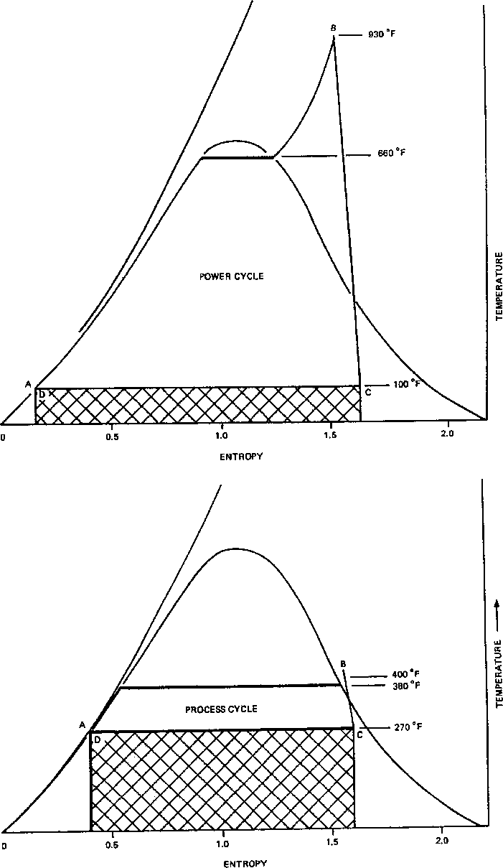
- —Entropy diagrams for generation: (a) electric output, (b) steam output
The typical power cycle usually has a thermal efficiency in the 35% range. The condenser losses (heat rejection) are approximately 48%, and stack and miscellaneous boiler losses are approximately 17%.
The typical process steam generating cycle may operate at efficiencies in the 85% range with stack and miscellaneous boiler losses of approximately 15%.
The cogeneration approach attempts to minimize these heat rejection losses by combining the production of electricity and steam into a common facility. In a sense, the process load replaced the condenser so that useful energy is extracted from the exhaust steam. The overall efficiency is approximately 70%. However, it must be noted that each potential cogeneration facility will have unique requirements in the amount of electricity and steam required. Each facility will have varying degrees of energy savings.
      - Noncogeneration interconnections (Bronze 8.2)
Industrial and commercial generators may operate in parallel with a utility without recovering heat for use in a process. The Public Utilities Regulatory Policies Act of 1978, Section 210 (PURPA 210)33 recognizes generating systems that use renewable fuels such as wind, solar, and water as their primary energy source. Conventional steam generators using trash as a fuel, without heat recovery, qualify under PURPA 210, mandating utility interconnection.
Normal fossil fuel generating systems that do not recover heat and operate in parallel with a utility for peak shaving, or to provide energy during contracted interruptible load curtailment periods, are not recognized by PURPA 210 as “qualified.” Utility participation to interconnect is not mandatory. The financial success of such undertakings should be evaluated carefully. Since energy efficiencies are much less than those in cogeneration systems, the savings realized are solely dependent on the generators' effect on the billing demand registered by the facility's serving utility. Redundancy requirements for the generation should be studied. Electrical requirements for interconnection would be identical to a cogeneration facility operating in parallel.
      - Types of prime movers (Bronze 8.2)
Selection of a prime mover must be based on the advantages and disadvantages of a particular prime mover type in a specific application. The primary considerations for the selection of a prime mover for a cogeneration application are the electrical and thermal capacity profiles of an engine generator type and how the profiles meet the load needs of the host facility. Selection is usually based upon an evaluation of the thermal and electrical load requirements, prime mover characteristics (i.e., electrical power output, recoverable thermal energy, available fuel types, etc.), and on an overall system life cycle economic analysis. Table 8-2 compares the advantages of both reciprocating and combustion turbine prime movers. Steam turbine prime movers are usually selected under a separate evaluation that is primarily contingent on the available steam power supply and facility steam needs. A brief description of each type of prime mover follows in 8.2.2.1 through 8.2.2.3.
\

- — Reciprocating engine and combustion turbine comparison
Reciprocating engine advantages | Combustion turbine advantages
High-speed engines have lower equipment costs. Many low-speed engines exceed combustion turbine costs. | Lower maintenance costs
Higher thermal efficiency | More efficient for high thermal loads
Greater variety of sizes and manufacturers | Lower installation costs: Lighter weight Smaller size  Less vibration  Engine air-cooled
Gas pressure requirements are satisfied by available utility gas distribution systems. | Superior in full-load transient frequency response
Full loading capabilities in 10 s

        - Reciprocating engines (Bronze 8.2)
Reciprocating engines typically operate in the 720–1800 r/min range and are of either two- or four-cycle design. Ignition can be either spark or diesel, depending on the fuel selection and engine type. Electrical power output capability ranges up to 8 MW with custom designed engine generators capable of gaseous fuels. Gaseous fuel engines can be equipped with multiple carburetors, thus allowing them to operate with different gas fuels. Gaseous fuel engines may either require diesel oil primer or permit greater leakage of lube oil into the cylinders to assist combustion. Liquid-fueled engines may be spark ignited, may burn gasoline, or a diesel engine may burn light or heavy oils. For cogeneration, heat is recovered from the jacket water cooling and engine exhaust.
        - Combustion turbines (Bronze 8.2)
Combustion turbines typically operate at 3600 r/min or at higher base load speeds. Units operating above 3600 r/min use gear reducers or other types of speed reducers to drive generators at 3600 r/min or 1800 r/min. Combustion turbine generator output capacities are approaching 200 MW, with small units available below 5 MW. Combustion turbines generally require less maintenance than high- or medium-speed reciprocating engines and will generally have a lower installation cost, since they are smaller, lighter, and do not require vibration-absorbing foundations. In addition, the combustion turbine is air-cooled and does not require an elaborate cooling system. Combustion turbines use both liquid and gaseous fuels. These fuels included light and heavy oils, natural gas, and other gaseous fuels. For cogeneration, heat is recovered from the engine exhaust system.
        - Steam turbines (Bronze 8.2)
Steam turbines usually operate at either 1800 r/min or 3600 r/min with a wide variety of power output capabilities. They range in size from single-stage to heavy duty multistage machines. They may be condensing or noncondensing, with or without steam extraction, and may be of the direct drive or reduction gear drive type. In typical cogeneration applications, they are used in combined cycle facilities with combustion turbines where combustion turbine exhaust heat is recovered for steam generation.
    - Determining the feasibility of cogeneration (Bronze 8.3)
Decisions made to install a cogeneration facility are based on economic and process requirements that will vary depending on the system's operating parameters, availability of fuels, and electrical energy costs of the serving utility. It is important to compare the cost of the cogeneration system to the cost of purchasing electrical power from the utility and installing a separate boiler to satisfy the process heat requirements. This study should extend over the expected life of the plant, and be evaluated at the present worth values of the total costs. Major items for consideration are as follows:
- Amount of process heat required (lb/h for steam)
- Operating parameters of the heat system (steam pressure, lb/in²)
- Electrical plant size (kW)
- Cost of generation equipment
  - Heat plant
  - Prime mover
  - Generator and associated electrical equipment
- Cost of capital financing—business plan
- Hours of operation
- Operation and maintenance costs
- Fuel cost
- Purchased electrical energy cost
  - Firm contract
  - Backup and/or maintenance electrical power
- Expected revenues from excess electrical energy sold
      - Sizing the system (Bronze 8.3)
The first step in determining costs is to size the cogeneration system. The amount of heat that must be delivered to the process must be determined, and assumptions must be made on the losses in the system and the expected heat rate of the generator. With this information, the total energy requirement for the system can be determined.
Comparing the heat and electrical generation inputs and outputs of a cogeneration facility can be simplified if all energy is converted into an equivalent thermal unit. Kilowatts, barrels of oil, or British thermal units are commonly used. Figures 8-4 and 8-5 compare a typical cogeneration system supplying heat and electrical energy versus the traditional arrangement of generating heat with a boiler and purchasing electrical power generated by a utility. The cogeneration facility can produce the heat and electrical requirements of the facility with a 30% reduction in the total energy input to the system. The energy savings are attributed to the cogenerator's reduced system losses. Utilities condense the exhaust steam of a turbine and reject this heat to the atmosphere.
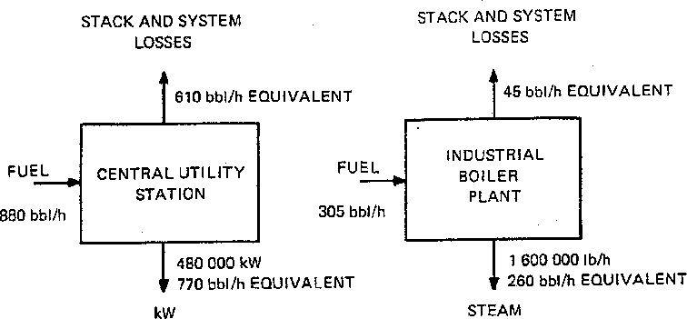
Figure 8-4 —Cogeneration fuel saving potential
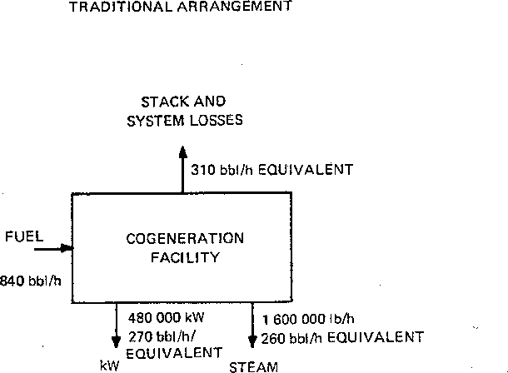
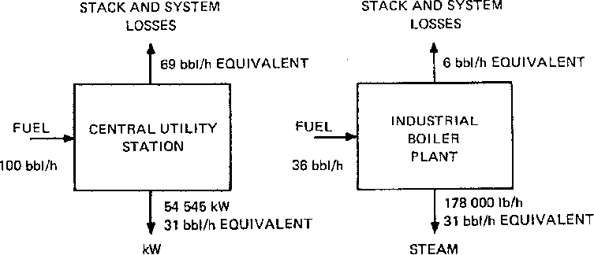


- —Cogeneration fuel-saving potential
(unit comparison)
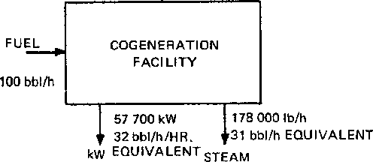
Although the total energy consumed by the system is less, the facility's boiler capacity and fuel consumed is almost three times greater than would be necessary to supply heat for the process with a separate boiler. The cost for the increased capacity, fuel consumed, and maintenance should be offset by the savings realized in the facility's reduced electrical consumption from the utility.
      - Utility energy costs (Bronze 8.3)
The impact of the electrical energy supplied by the cogeneration facility should be evaluated. The facility's electrical energy output and hours of operation should be estimated for a full year, including shutdown periods for scheduled maintenance, and forced outages.
The serving utility is an excellent resource in determining the estimated annual savings that the cogeneration facility
can realize. Most industrial rate structures are complex. They are sensitive to demand and time of use, which will vary

during the time of day as well as from season to season. The cogeneration operation profile should be studied hour by hour, month by month on a yearly basis to ensure that the study accounts for all of the utility's rate clauses. Using a facility's yearly average cost per kilowatthour in the analysis of the generator's impact will not predict an accurate analysis of the savings involved.
The cost of maintenance and backup energy should be considered in the utility cost impact study. Most utilities offer cogenerators a special rate for either or both of these items. Maintenance energy purchases usually require notification of the shutdown in advance. The utility usually has the right to force the cogeneration shutdown to a time of day or month of year when it will have the least impact on the utility system. Backup energy, on the other hand, supplies electrical energy to the facility when the cogeneration unit experiences a forced out-age from electrical or mechanical failure. The utility may have limitations on the number of hours that this service can be used during a given month or year, and will generally charge more for this energy than maintenance energy, If these tariffs are not offered or attached to the agreement between the utility and the cogenerator, costs of electrical energy during shutdowns will be charged according to the normal rates applied to the type of service supplied by the utility.
Another major item for consideration is the value of electricity sold to the utility, or wheeled to another utility over the serving utility's transmission system. This value is generally negotiable and may include credits for generation capacity. Each utility will have its own tariffs concerning energy purchases and wheeling rates on its transmission system. These energy purchase agreements are usually approved by the state public utility or service commission that regulates the serving utility.

2.2.0.3.3 Business plan (Bronze 8.3)
One of the early requirements in developing a cogeneration system, especially when more than one party is involved, is the development of a business plan. This plan is essential for the generation of equitable and workable systems in the design, construction, operation, and management of a multi-owned cogeneration facility, A business plan provides for the initial management of the project, provides the vehicle for financial requirements, and provides a forum for the joint development of the project by all participants. One major consideration is the state or local public utility regulations. The joint venture will probably come under the scrutiny of various federal and state agencies. Should the economics appear favorable, legal analysis of regulation is then performed.
Proper ownership shall be established. In many single-party projects, the ownership alternatives are limited. In a multiparty project, the ownership shall be decided on the basis of an equitable return to all, with consideration for the favorable tax and credit incentives available. The final decision will vary for each case and will seldom be the same for any two cases.
The economic analysis of the project should consider the ever-changing legislative environment that includes some of the following factors:
- Environmental regulations
- Fuel use taxes or credits
- Tax life and depreciation schedules

    - Voltage Considerations
Red 3.1-3.10, Grey 3.1 – 3.13, White 3.4
      - General (Red 3.1)
An understanding of system voltage nomenclature and the preferred voltage ratings of distribution apparatus and utilization equipment is essential to ensure proper voltage identification throughout a power distribution system. The dynamic characteristics of the system need to be recognized and the proper principles of voltage control applied so that satisfactory voltages will be supplied to all utilization equipment under all normal conditions of operation. Consideration should be given for transient and momentary voltage variations to ensure appropriate performance of utilization equipment.
        - Definitions (Red 3.1)
The following terms and definitions, quoted from ANSI C84.1- 1989,1 are used to identify the voltages and voltage classes used in electric power distribution.
          - System voltage terms (Red 3.1)
Note that the nominal system voltage is near the voltage level at which the system normally
operates. To allow for operating contingencies, systems generally operate at voltage levels
about 5-10% below the maximum system voltage for which system components are designed.
system voltage: The root-mean-square phase-to-phase voltage of a portion of an ac electric system. Each system voltage pertains to a portion of the system that is bounded by transformers or utilization equipment. (All voltages hereafter are root-mean-square phase-tophase or phase-to-neutral voltages.)
nominal system voltage: The voltage by which a portion of the system is designated and to which certain operating characteristics of the system are related. Each nominal system voltage pertains to a portion of the system that is bounded by transformers or utilization equipment.
maximum system voltage: The highest system voltage that occurs under normal operating conditions, and the highest system voltage for which equipment and other components are designed for satisfactory continuous operation without derating of any kind. In defining maximum system voltage, voltage transients and temporary overvoltages caused by abnormal system conditions, such as faults, load rejection, and the like, are excluded. However, voltage transients and temporary overvoltages may affect equipment operating performance and are considered in equipment application.
service voltage: The voltage at the point where the electric system of the supplier and the electric system of the user are connected.
utilization voltage: The voltage at the line terminals of utilization equipment.
nominal utilization voltage: The voltage rating of certain utilization equipment used on the system.
        - System voltage classes (Red 3.1)
Low Voltage: A class of nominal system voltages less than 1000 V.
Medium Voltage: A class of nominal system voltages equal to or greater than 1000 V and less than 100 000 V.
High Voltage: A class of nominal system voltages equal from 100 000 V to 230 000 V.
        - Standard nominal system voltages for the United States (Red 3.1)
These voltages and their associated tolerance limits are listed in ANSI C84.1-1989 for voltages from 120Ð230 000 V and in ANSI C92.2-1987 for voltages above 230 kV nominal. Table 3-1, reprinted from ANSI C84.1-1989 and containing information from ANSI C92.9- 1987, provides all the standard nominal system voltages and their associated tolerance limits for the United States. Preferred nominal system voltages and voltage ranges are shown in boldface type while other systems in substantial use that are recognized as standard voltages are shown in regular type. Other voltages may be encountered on older systems but they are not recognized as standard voltages. The transformer connections from which these voltages are derived are shown in figure 3-1.
Two sets of tolerance limits are defined: range A, which specifies the limits under most operating conditions, and range B, which allows minor excursions outside the range A limits.
        - Application of voltage classes (Red 3.1)
- Low-voltage class voltages are used to supply utilization equipment.
- Medium-voltage class voltages are used for subtransmission and primary distribution. Medium voltages often supply distribution transformers which step the medium voltage down to low voltage to supply utilization equipment. Medium voltages may also supply distribution substations that transform the voltage from a higher to a lower voltage in the medium-voltage class. Medium voltages of 13 800 V and below are also used to supply utilization equipment such as large motors (see 3.5.2, table 3-8).
- High-voltage class voltages are used to transmit large amounts of electric power between transmission substations. Transmission substations located adjacent to generating stations step the generator voltage up to the transmission voltage. Other transmission substations transform the high voltage down to medium voltage for sub-transmission and primary distribution. Transmission lines also interconnect transmission substations to provide alternate paths for power transmission for higher reliability.
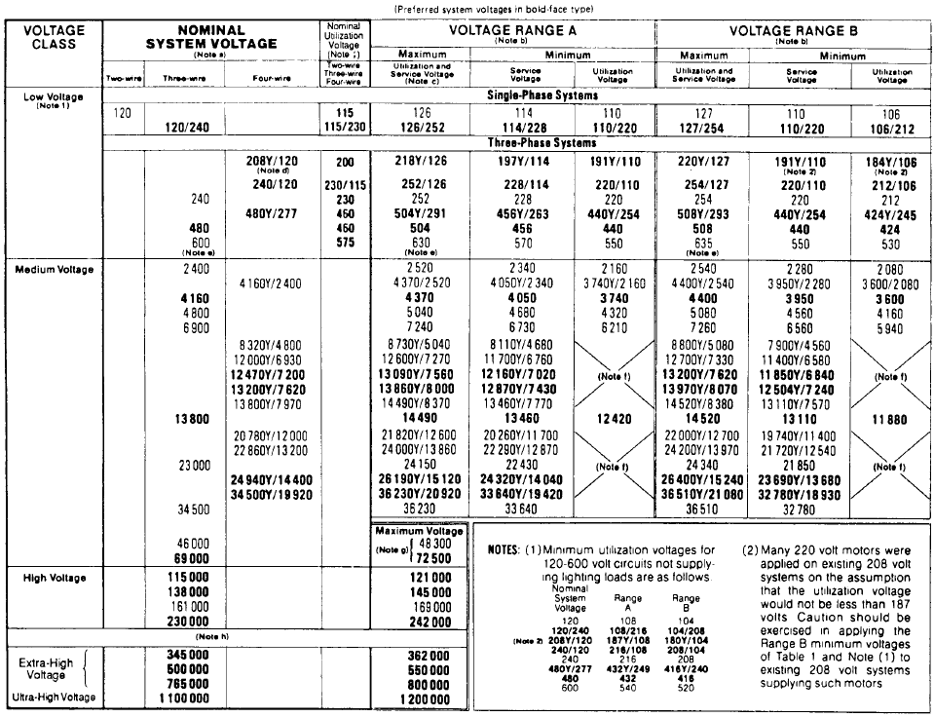
Table 3-1 (Continued)
NOTES FOR TABLE 3-1
a—Three-phase, three-wire systems are systems in which only the three-phase conductors are carried out from the source for connection of loads. The source may be derived from any type of three-phase transformer connection, grounded or ungrounded. Three-phase, four-wire systems are systems in which a grounded neutral conductor is also carried out from the source for connection of loads. Four-wire systems in this table are designated by the phase-to-phase voltage, followed by the letter Y (except for the 240/120 V delta system), a slant line, and the phase-to-neutral voltage. Single-phase services and loads may be supplied from either single-phase or three-phase systems. The principal transformer connections that are used to supply single-phase and three-phase systems are illustrated in figure 3-1.
b—The voltage ranges in this table are illustrated in ANSI C84.1-1989, Appendix B.
c—For 120Ð600 V nominal systems, voltages in this column are maximum service voltages. Maximum utilization voltages would not be expected to exceed 125 V for the nominal system voltage of 120, nor appropriate multiples thereof for other nominal system voltages through 600 V.
d—A modification of this three-phase, four-wire system is available as a 120/208Y-volt service for single-phase, three-wire, open-wye applications.
e—Certain kinds of control and protective equipment presently available have a maximum voltage limit of 600 V; the manufacturer or power supplier, or both, should be consulted to ensure proper application. f—Utilization equipment does not generally operate directly at these voltages. For equipment supplied through transformers, refer to limits for nominal system voltage of transformer output.
g—For these systems, Range A and Range B limits are not shown because, where they are used as service voltages, the operating voltage level on the user's system is normally adjusted by means of voltage regulation to suit their requirements.
h—Standard voltages are reprinted from ANSI C92.2-1987 for convenience only.
i—Nominal utilization voltages are for low-voltage motors and control. See ANSI C84.1-1989, Appendix C, for other equipment nominal utilization voltages (or equipment nameplate voltage ratings).

        - Voltage systems outside of the United States (Red 3.1)
Voltage systems in other countries generally differ from those in the United States. For example, 415Y/240 V and 380Y/220 V are widely used as utilization voltages even for residential service. Also, the frequency in many countries is 50 Hz instead of 60 Hz, which affects the operation of some equipment such as motors. Motors on 50 Hz systems run approximately 17% slower than in the United States. Plugs and receptacles are generally different, and this helps to prevent utilization equipment from the United States from being connected to the wrong voltage.
Users should check with the equipment manufacturer before attempting to operate equipment on a voltage or frequency for which the equipment is not specifically rated. Equipment rated for use with one voltage and frequency often cannot be used or may not give adequate performance on another voltage or frequency. Some equipment has multiple voltage and/or frequency ratings for application on a variety of systems. If electric equipment made for use on one system must be used on a different system, information on the voltage, frequency, and type of plug required should be obtained. If the difference is only in the voltage, transformers are generally available to convert the available supply voltage to match the equipment voltage.

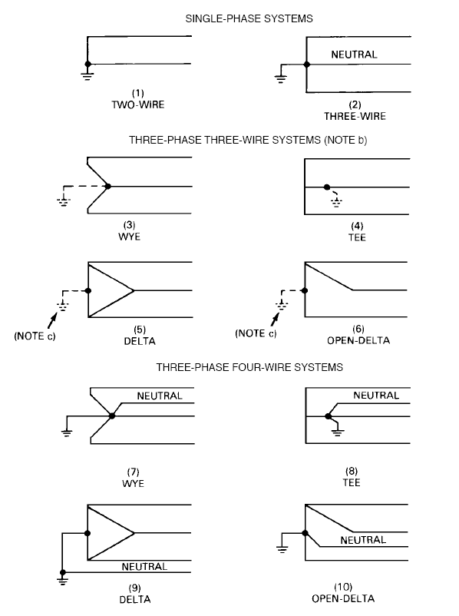
NOTES
a—The above diagrams show connections of transformer secondary windings to supply the nominal system voltages of table 3-1. Systems of more than 600 V are normally three phase and supplied by connections (3), (5) ungrounded, or (7). Systems of 120Ð600 V may be either single phase or three phase and all of the connections shown are used to some extent for some systems in this voltage range.
b—Three-phase, three-wire systems may be solidly grounded, impedance grounded, or ungrounded, but are not intended to supply loads connected phase-to-neutral (as the four-wire systems are).
c—In connections (5) and (6), the ground may be connected to the midpoint of one winding as shown (if available), to one phase conductor (corner grounded), or omitted entirely (ungrounded). d—Single-phase services and single-phase loads may be supplied from single-phase systems or from three-phase systems. They are connected phase-to-phase when supplied from three-phase, three-wire systems and either phase-to-phase or phase-to-neutral from three-phase, four-wire systems.
- —Principal transformer connections
to supply the system voltages of table 3-1

        - Voltage standard for Canada (Red 3.1)
The voltage standard for Canada is CAN3-C235-83. This standard differs from the United States standard in both the list of standard nominal voltages and the tolerance limits.
      - Voltage control in electric power systems (Red 3.2)
Power supply systems and utilization equipment should be designed to be compatible. This requires coordinated efforts and standards that place requirements on voltage ranges supplied by utilities, allowable voltage drops in plant distribution systems, and voltage ranges for utilization equipment. This section outlines these coordinated efforts and standards associated with assuring good operation of the utilization equipment.
        - Principles of power transmission and distribution in utility systems (Red 3.2)
A general understanding of the principles of power transmission and distribution in utility systems is necessary since most industrial plants obtain most of their electric power from the local electric utility. Figure 3-2 shows a simplified one-line diagram of a typical utility power generation, transmission, and distribution system.
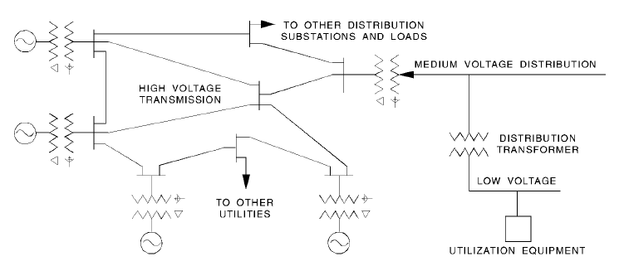
- —Typical utility generation,
transmission and distribution system
Most utility generating stations are located near sources of water, often a considerable distance from major load areas. Generated power, except for station requirements, is transformed in a transmission substation located at the generating station to voltage generally 69 000 V or higher for transmission to major load areas. These transmission lines are usually interconnected in large free flowing networks. For example, most transmission lines in the eastern half of the United States are interconnected to form one network. Utilities are constantly adjusting generation to match the load. They adjust generation to regulate the 60 Hz frequency, keeping clocks on time within a few seconds. Transmission lines are generally for bulk energy transfers and are controlled only to keep the lines operating within normal voltage limits and to facilitate power flow. ANSI C84.1-1989 and ANSI C92.2-1987 specify nominal and maximum but no minimum values for systems over 34 500 V.
Transmission line networks supply distribution substations equipped with transformers that step the transmission voltage down to a primary distribution voltage generally in the range from 4160 to 34 500 V with 12 470, 13 200, and 13 800 V in widest use. There is an increasing trend in the electric utility industry to use 23 kV and 34.5 kV for distribution. If the supplying utility offers one of these voltages for primary distribution within a building, competent electricians experienced in making splices and terminations must be secured to obtain a good installation.
Voltage control is applied when necessary for the purpose of supplying satisfactory voltage to the terminals of utilization equipment. Transformers stepping the transmission voltage down to the primary distribution voltage are generally equipped with automatic tap-changing under-load equipment, which changes the turns ratio of the transformer under load. This regulates the primary distribution voltage within a specific range of values regardless of fluctuations in the transmission voltage or load. Separate step or induction regulators may also be used.
If the load is remote from the substation, the regulator controls are equipped with compensators that raise the voltage as the load increases and lower the voltage as the load decreases to compensate for the voltage drop in the primary distribution system that extends radially from the substation. This effectively regulates the voltage at a point of the primary distribution system some distance from the substation. This is illustrated in figure 3-3. Note that plants close to the substation will receive voltages which, on the average, will be higher than those received by plants at a distance from the distribution substation. See 3.2.8 on the use of distribution transformer taps. Switched or fixed capacitors are also used to improve the voltage on primary feeders.
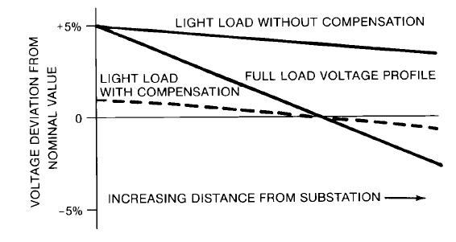
- —Effect of regulator compensation
on primary distribution system voltage
The primary distribution system supplies distribution transformers that step the primary distribution voltage down to utilization voltages generally in the range of 120 to 600 V to supply a secondary distribution system to which the utilization equipment is connected. Distribution transformers generally do not have any automatic means for regulating the utilization voltage. Small transformers used to step a higher utilization voltage down to a lower utilization voltage, such as 480 V to 208Y/120 V, are considered part of the secondary distribution system.
The supply voltages available to an industrial plant depend upon whether the plant is connected to the distribution transformer, the primary distribution system, or the transmission system, which in turn depends on the size of the plant load.
Small plants with loads up to several hundred kilovoltamperes and all plants supplied from low-voltage secondary networks are connected to the distribution transformer, and the secondary distribution system consists of the connections from the distribution transformer to the plant service and the plant wiring.
Medium-sized plants with loads of a few thousand kilovoltamperes are connected to the primary distribution system, and the plant provides the portion of the primary distribution system within the plant, the distribution transformers, and the secondary distribution system.
Large plants with loads of more than a few thousand kilovoltamperes are connected to the
transmission system, and the plant provides the primary distribution system, the distribution
transformers, the secondary distribution system, and it may provide the distribution substation.
Details of the connection between the utility system and the plant system will depend on the policy of the supplying utility. Refer to Chapter 15 for more detailed information about utility interface considerations.
        - System voltage tolerance limits (Red 3.2)
ANSI C84.1-1989 specifies the preferred nominal voltages and operating voltage ranges for utilization and distribution equipment operating from 120Ð34 500 V in the United States. It specifies voltages for two critical points on the distribution system: the point of delivery by the supplying utility and the point of connection to utilization equipment. For transmission voltages over 34 500 V, ANSI C84.1-1989 only specifies the nominal and maximum voltage because these voltages are normally unregulated and only a maximum voltage is required to establish the design insulation level for the line and associated apparatus.
The actual voltage measured at any point on the system will vary depending on the location of the point of measurement and the system load at the time the measurement is made. Fixed voltage changes take place in transformers in accordance with the transformer ratio. Voltage variations occur from the operation of voltage control equipment, changes in voltage drop due to changes in load current, and other reasons. It should be recognized that because of conditions beyond the control of the supplier or user, or both, there will be infrequent and limited periods when sustained voltages outside range B limits will occur.
The tolerance limits for the service voltage provide guidance to the supplying utility for the design and operation of its distribution system. The service voltage is the voltage at the point where the utility conductors connect to the user conductors. It is generally measured at the service switch for services of 600 V and below and at the billing meter voltage (potential) transformers for services over 600 V. The tolerance limits for the voltage at the point of connection of utilization equipment provide guidance to the user for the design and operation of the user distribution system, and to utilization equipment manufacturers for the design of utilization equipment. Electric supply systems are to be designed and operated so that most service voltages fall within the range A limits. User systems are to be designed and operated so that, when the service voltages are within range A, the utilization voltages are within range A. Utilization equipment is to be designed and rated to give fully satisfactory performance within the range A limits for utilization voltages.
Range B allows limited excursions of voltage outside the range A limits that necessarily result from practical design and operating conditions. When voltages are outside range A and inside range B, the corrective action should be taken within a reasonable time to restore service voltages to range A limits. Insofar as practicable, utilization equipment may be expected to give acceptable performance at voltages outside range A but within range B. When voltages occur outside the limits of range B, prompt corrective action should be taken. Responsibility for corrective action depends upon where the voltage is out of range A compared to the limits specified for each location identified in ANSI C84.1-1989.
        - Development of the voltage tolerance limits for ANSI C84.1-1 989 (Red 3.2)
The voltage tolerance limits in ANSI C84.1- 1989 are based on NEMA MG 1-1993, which established the voltage tolerance limits of the standard induction motor at ±10% of nameplate ratings of 230 V and 460 V. Since motors represent the major component of utilization equipment, they were given primary consideration in the establishment of the voltage standard.
The best way to show the voltages in an electric power distribution system is in terms of a 120 V base. This cancels the transformation ratios between systems so that the actual voltages vary solely on the basis of the voltage drops in the system. Any voltage may be converted to a 120 V base by dividing the actual voltage by the ratio of transformation to the 120 V base. For example, the ratio of transformation for the 480 V system is 480/120 or 4, so 460 V in a 480 V system would be 460/4 or 115 V on a 120 V base.
The tolerance limits of the 460 V motor in terms of the 120 V base become 115 V plus 10%, or 126.5 V, and 115 V minus 10%, or 103.5 V. The problem is to decide how this tolerance range of 23 V should be divided between the primary distribution system, the distribution transformer, and the secondary distribution system, which make up the regulated distribution system. The solution adopted by ANSI Accredited Committee C84 is shown in table 3-2.
The Range B tolerance limits raised the standard motor tolerance on the 120 V base 0.5 V to 127 V maximum and 104 V minimum to eliminate the fractional volt. These values became the tolerance limits for range B in the standard. An allowance of 13 V was allotted for the voltage drop in the primary distribution system. Deducting this voltage drop from 127 V establishes a minimum of 114 V for utility services supplied from the primary distribution system. An allowance of 4 V was provided for the voltage drop in the distribution transformer and the connections to the plant wiring. Deducting this voltage drop from the minimum primary distribution voltage of 114 V provides a minimum of 110 V for utility secondary services from 120Ð600 V. An allowance of 6 V, or 5%, for the voltage drop in the plant wiring, as provided in ANSI/NFPA 70-1993 (the National Electrical Code [NEC]) Articles 210-19(a) (FPN No. 4) and 215-2(b) (FPN No. 2), provides the minimum utilization voltage of 104 V.
Table 3-2—Standard voltage profile for
low-voltage regulated power distribution system, 120 V base
 | Range A  (V) |  | Range B  (V)
Maximum allowable voltage | 126 | (125*) | 127
Voltage drop allowance for primary distribution line | 9 |  | 13
Minimum primary service voltage | 117 |  | 114
Voltage drop allowance for distribution transformer | 3 |  | 4
Minimum secondary service voltage | 114 |  | 110
Voltage drop allowance for plant wiring | 6 | (4t) | 6 | (4t)
Minimum utilization voltage | 108 | (1 10t) | 104 | (106t)

*For utilization voltage of 120Ð600 V.
tFor building wiring circuits supplying lighting equipment.

The range A limits for the standard were established by reducing the maximum tolerance limits from 127 V to 126 V and increasing the minimum tolerance limits from 104 V to 108 V. The spread band of 18 V was then allotted as follows: 9 V for the voltage drop in the primary distribution system to provide a minimum primary service voltage of 117 V; 3 V for the voltage drop in the distribution transformer and secondary connections to provide a minimum secondary service voltage of 114 V; and 6 V for the voltage drop in the plant low-voltage wiring to provide a minimum utilization voltage of 108 V.
Four additional modifications were made in this basic plan to establish ANSI C84.1-1989. The maximum utilization voltage in range A was reduced from 126 V to 125 V for low-voltage systems in the range from 120 to 600 V because there should be sufficient load on the distribution system to provide at least 1 V drop on the 120 V base under most operating conditions. This maximum voltage of 125 V is also a practical limit for lighting equipment because the life of the 120 V incandescent lamp is reduced by 42% when operated at 125 V (see 3.5.4, table 3-9). The voltage drop allowance of 6 V on the 120 V base for the drop in the plant wiring was reduced to 4 V for circuits supplying lighting equipment. This raised the minimum voltage limit for utilization equipment to 106 V in range B and 110 V in range A because the minimum limits for motors of 104 V in range B and 108 V in range A were considered too low for satisfactory operation of lighting equipment. The utilization voltages for the 6900 V and 13 800 V systems in range B were adjusted to coincide with the tolerance limits of ±10% of the nameplate rating of the 6600 V and 13 200 V motors used on these respective systems.
To convert the 120 V base voltage to equivalent voltages in other systems, the voltage on the 120 V base is multiplied by the ratio of the transformer that would be used to connect the other system to a 120 V system. In general, distribution transformers for systems below 15 000 V have nameplate ratings that are the same as the standard system nominal voltages; so the ratio of the standard nominal voltages may be used to make the conversion. However, for primary distribution voltages over 15 000 V, the primary nameplate rating of distribution transformers is not the same as the standard system nominal voltages. Also, most distribution transformers are equipped with taps that can be used to change the ratio of transformation. So if the primary distribution voltage is over 15 000 V, or taps have been used to change the transformer ratio, then the actual transformer ratio must be used to convert the base voltage to another system.
For example, the maximum tolerance limit of 127 V on the 120 V base for the service voltage in range B is equivalent, on the 4160 V system, to 4160 Ö 120 á 127 = 4400 V to the nearest 10 V. However, if the 4160-120 V transformer is set on the +21/2% tap, the voltage ratio would be 4160 + (4160 á 0.025) = 4160 + 104 = 4264 to 120. The voltage on the primary system equivalent to 127 V on the secondary system would be 4264 Ö 120 á 127 = 35.53 á 127 = 4510 V to the nearest 10 V. If the maximum primary distribution voltage of 4400 V is applied to the 4264-120 V transformer, the secondary voltage would be 4400 Ö 4260 á 120 = 124 V.
        - Voltage profile limits for a regulated distribution system (Red 3.2)
Figure 3-4 shows the voltage profile of a regulated power distribution system using the limits of range A in table 3-1. Assuming a nominal primary distribution voltage of 13 800 V, range A in table 3-1 shows that this voltage should be maintained by the supplying utility between a maximum of 126 V and a minimum of 117 V on a 120 V base. Since the base multiplier for converting from the 120 V system to the 13 800 V system is 13 800/120 or 115, the actual voltage limits for the 13 800 V system are 115 á 126 or 14 490 V maximum and 115 á 117 or 13 460 V minimum.
If a distribution transformer with a ratio of 13 800 to 480 V is connected to the 13 800 V distribution feeder, range A of table 3-1 requires that the nominal 480 V secondary service be maintained by the supplying utility between a maximum of 126 V and a minimum of 114 V on the 120 V base. Since the base multiplier for the 480 V system is 480/120 or 4, the actual values are 4 á 126 or 504 V maximum and 4 á 114 or 456 V minimum.
Range A of table 3-1 as modified for utilization equipment of 120Ð600 V provides for a maximum utilization voltage of 125 V and a minimum of 110 V for lighting equipment and 108 V for other than lighting equipment on the 120 V base. Using the base multiplier of 4 for the 480 V system, the maximum utilization voltage would be 4 á 125 V or 500 V and the minimum for other than lighting equipment would be 4 á 108 V or 432 V. For lighting equipment
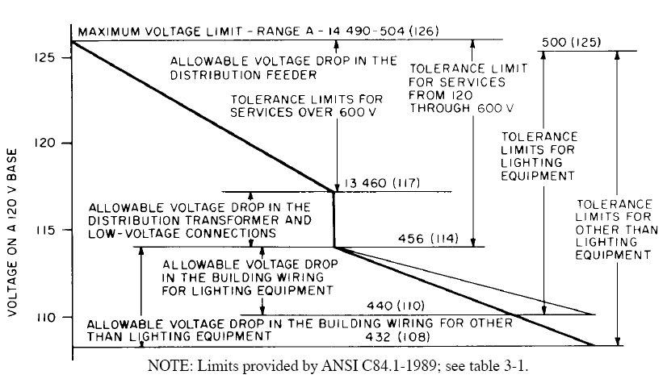
- —Range A voltage profile limits
connected phase to neutral, the maximum voltage would be 500 V divided by the square root of 3 or 288 V and the minimum voltage would be 4 á 110 V or 440 V divided by the square root of 3 or 254 V.
        - System voltage nomenclature (Red 3.2)
The nominal system voltages in table 3-1 are designated in the same way as on the nameplate of the transformer for the winding or windings supplying the system.
- Single-Phase Systems
120 Indicates a single-phase, two-wire system in which the nominal voltage between the two wires is 120 V.
120/240 Indicates a single-phase, three-wire system in which the nominal voltage between the two phase conductors is 240 V, and from each phase conductor to the neutral it is 120 V.
- Three-Phase Systems
240/120 Indicates a three-phase, four-wire system supplied from a delta connected transformer. The midtap of one winding is connected to a neutral. The three-phase conductors provide a nominal 240 V three-phase system, and the neutral and the two adjacent phase conductors provide a nominal 120/ 240 V single-phase system.
480 Indicates a three-phase, three-wire system in which the number designates the nominal voltage between phases.
480Y/277 Indicates a three-phase, four-wire system from a wye-connected transformer in which the first number indicates the nominal phase-to-phase voltage and the second number indicates the nominal phase-to-neutral voltage.
NOTES
1 —All single-phase systems and all three-phase, four-wire systems are suitable for the connection of phase-to-neutral load.
2—See Chapter 7 for methods of system grounding.
3—Figure 3-5 gives an overview of voltage relationships for 480 V three-phase systems and 120/240 V single- and three-phase systems.
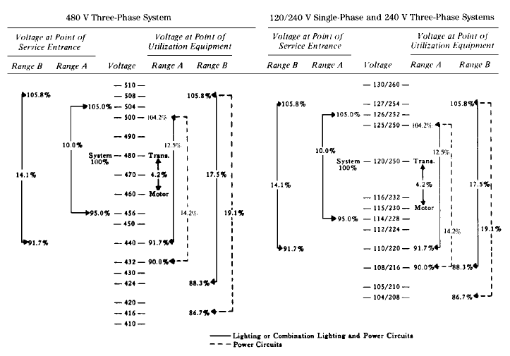
- —Voltage relationships based on
voltage ranges in ANSI C84.1-1989
        - Nonstandard nominal system voltages (Red 3.2)
Since ANSI C84.1-1989 lists only the standard nominal system voltages in common use in the United States, system voltages will frequently be encountered that differ from the standard list. A few of these may be so widely different as to constitute separate systems in too limited use to be considered standard. However, in most cases the nominal system voltages will differ by only a few percent as shown in table 3-3. A closer examination of the table shows that these differences are due mainly to the fact that some voltages are multiples of 110 V, others are multiples of 115 V, some are multiples of 120 V, and a few are multiples of 125 V.
The reasons for these differences go back to the original development of electric power distribution systems. The first utilization voltage was 100 V. However, the supply voltage had to be raised to 110 V in order to compensate for the voltage drop in the distribution system. This led to overvoltage on equipment connected close to the supply, so the utilization equipment
Table 3-3—Nominal system voltages
Standard nominal system ^{volta}g^{es} | Associated nonstandard  nominal system voltages
Low voltages
120 | 110, 115, 125
120/240 | 110/220, 115/230, | 125/250
208Y/120 | 216Y/125
240/120
240 | 230, 250
480Y/277 | 460Y/265
480 | 440
600 | 550, 575
Medium voltages
2400 | 2200, 2300
4160Y/2400
4160 | 4000
4800 | 4600
6900 | 6600, 7200
8320Y/4800 | 11 000, 11 500
12 000Y/6930
12 470Y/7200
13 200Y/7620
13 200
13 800Y/7970 | 14 400
13 800
20 780Y/12 000
22 860Y/13 200
23 000
24 940Y/14 400
34 500Y/19 920
34 500 | 33 000
46 000 | 44 000
69 000 | 66 000
High voltages
115 000 | 110 000, 120 000
138 000 | 132 000
161 000 | 154 000
230 000 | 220 000
Extra-high voltages
345 000
500 000
765 000

rating was also raised to 110 V. As generator sizes increased and distribution and transmission systems developed, an effort to keep transformer ratios in round numbers led to a series of utilization voltages of 110, 220, 440, and 550 V, a series of primary distribution voltages of 2200, 4400, 6600, and 13 200 V, and a series of transmission voltages of 22 000, 33 000, 44 000, 66 000, 110 000, 132 000, and 220 000 V.
As a result of the effort to maintain the supply voltage slightly above the utilization voltage, the supply voltages were raised again to multiples of 115 V, which resulted in a new series of utilization voltages of 115, 230, 460, and 575 V, a new series of primary distribution voltages of 2300, 4600, 6900, and 13 800 V, and a new series of transmission voltages of 23 000, 34 500, 46 000, 69 000, 115 000, 138 000, and 230 000 V.
As a result of continued problems with the operation of voltage-sensitive lighting equipment and voltage-insensitive motors on the same system, and the development of the 208Y/120 V network system, the supply voltages were raised again to multiples of 120 V. This resulted in a new series of utilization voltages of 120, 208Y/120, 240, 480, and 600 V, and a new series of primary distribution voltages of 2400, 4160Y/2400, 4800, 12 000, and 12 470Y/7200 V. However, most of the existing primary distribution voltages continued in use and no 120 V multiple voltages developed at the transmission level.
        - Standard nominal system voltages in the United States (Red 3.2)
The nominal system voltages listed in the left-hand column of table 3-3 are designated as standard nominal system voltages in the United States by ANSI C84.1-1989. In addition, those shown in boldface type in table 3-1 are designated as preferred standards to provide a long-range plan for reducing the multiplicity of voltages.
In the case of utilization voltages of 600 V and below, the associated nominal system voltages in the right-hand column are obsolete and should not be used. Where possible, manufacturers are encouraged to design utilization equipment to provide acceptable performance within the utilization voltage tolerance limits specified in the standard. Some numbers listed in the right- hand column are used in equipment ratings, but these should not be confused with the numbers designating the nominal system voltage on which the equipment is designed to operate.
In the case of primary distribution voltages, the numbers in the right-hand column may designate an older system in which the voltage tolerance limits are maintained at a different level than the standard nominal system voltage, and special consideration should be given to the distribution transformer ratios, taps, and tap settings.
        - Use of distribution transformer taps to shift utilization voltage spread band
(Red 3.2)
Power and distribution transformers often have four taps on the primary winding in 21/2% steps. These taps are generally +5%, +2 1/2 %, nominal, -2 1/2 %, and -5%. These taps allow users to change the transformer ratio and raise or lower the secondary voltage to provide a closer fit to the tolerance limits of the utilization equipment. There are three situations requiring the use of taps:
- Taps are required when the primary voltage has a nominal value that is slightly different from the transformer primary nameplate rating. For example, if a 13 200Ð480 V transformer is connected to a nominal 13 800 V system, the nominal secondary voltage would be (13 800/13 200) × 480 = 502 V. However, if the 13 800 V system were connected to the +5% tap of the 13 200Ð480 V transformer at 13 860 V, the nominal secondary voltage would be (13 800/13 860) á 480 = 478, which is practically the same as would be obtained from a transformer having the proper ratio of 13 800Ð 480 V.
- Taps are required when the primary voltage spread is in the upper or lower portion of the tolerance limits provided in ANSI C84.1-1989. For example, a 13 200Ð480 V transformer is connected to a 13 200 V primary distribution system close to the substation where the primary voltage spread band stays in the upper half of the tolerance zone for range A, or 13 200Ð13 860 V. This would result in a nominal secondary voltage under no-load conditions of 480 to 504 V. By setting the transformer on the
- 1
- +2 1 / 2 % tap at 13 530 V, the no-load secondary voltage would be lowered 2 / 2 % to a range of 468Ð491 V.
- Taps are required to adjust the utilization voltage spread band to provide a closer Þt to the tolerance limits of the utilization equipment. For example, table 3-4 shows the shift in the utilization voltage spread band for the +2¹/2% and 5% taps as compared to the utilization voltage tolerance limits for range A of ANSI C84.1-1989 for the 480 V system. Table 3-5 shows the voltage tolerance limits of standard 460 V and 440 V three-phase induction motors. Table 3-6 shows the tolerance limits for standard 277 V and 265 V fluorescent lamp ballasts. A study of these three tables shows that a tap setting of nominal will provide the best Þt with the tolerance limits of the 460 V motor and the 277 V ballast, but a setting on the +5% tap will provide the best Þt for the 440 V motor and the 265 V ballast. For buildings having appreciable numbers of both ratings of motors and ballasts, a setting on the +2¹/2% tap may provide the best compromise.
Table 3-4—Tolerance limits for lighting circuits from table 3-1, range A, in volts
Nominal system  voltage (volts) | Transformer tap | Minimum utilization  voltage (volts) | Maximum  utilization voltage  (volts)
480Y/277 | Nominal | 440Y/254 | 500Y/288
468Y/270 | + 2¹/2% | 429Y/248 | 488Y/281
456Y/263 | + 5% | 418Y/241 | 475Y/274

Table 3-5—Tolerance limits for low-voltage three-phase motors, in volts
Motor rating (volts) | -10% | +10%
460 | 414 | 506
440 | 396 | 484

Table 3-6—Tolerance limits for low-voltage standard
fluorescent lamp ballasts, in volts
Ballast rating (volts) | Minimum  -10% | Maximum  +10%
277 | 254 | 289
120 | 110 | 125

Note that these examples assume that the tolerance limits of the supply and utilization voltages are within the tolerance limits specified in ANSI C84.1-1989. This may not be true, so the actual voltages should be recorded over a time period that provides voltage readings during the night and over weekends when maximum voltages often occur. These actual voltages can then be used to calculate voltage profiles similar to figure 3-4 to check the proposed transformer ratios and tap settings. If transformer taps are used to compensate for voltage drop, the voltage profile should be calculated for light-load periods to check for possible overvoltage situations.
Where a plant has not yet been built, the supplying utility should be requested to provide the expected spread band for the supply voltage, preferably supported by a seven-day graphic chart from the nearest available location. If the plant furnishes the distribution transformers, recommendations should also be obtained from the supplying utility on the transformer ratios, taps, and tap settings. With this information, a voltage profile can be prepared to check the expected voltage spread at the utilization equipment.
Where the supplying utility offers a voltage over 600 V that differs from the standard nominal voltages listed in ANSI C84.1-1989, the supplying utility should be asked to furnish the expected tolerance limits of the supply voltage, preferably supported by seven or more days of voltage recordings from a nearby location. The supplying utility should also be asked for the recommended distribution transformer ratio and tap settings to obtain a satisfactory utilization voltage range. With this information, a voltage profile for the supply voltage and utilization voltage limits can be constructed for comparison with the tolerance limits of utilization equipment. If the supply voltage offered by the utility is one of the associated nominal system voltages listed in table 1-1, the taps on a standard distribution transformer will generally be sufficient to adjust the distribution transformer ratio to provide a satisfactory utilization voltage range.
Taps are on the primary side of transformers. Therefore, raising the tap setting to +21/2% increases the transformer ratio by 21/2% and lowers the secondary voltage spread band by 21/2% minus the voltage drop in the transformer. Taps only serve to move the secondary voltage spread band up or down in the steps of the taps. They cannot correct for excessive spread from the supply voltage or from excessive drop in the plant wiring system. If the voltage spread band at the utilization equipment falls outside the satisfactory operating range of the equipment, then action must be taken to improve voltage conditions by other means (see 3.7).
In general, transformers should be selected with the same primary nameplate voltage rating as the nominal voltage of the primary supply system, and the same secondary voltage rating as the nominal voltage of the secondary system. Taps should be provided at +21/2% and +5% and at _21/2% and —5% to allow for adjustment in either direction.
      - Voltage selection (Red 3.3)
        - Selection of low-voltage utilization voltages (Red 3.3)
The preferred utilization voltage for industrial plants is 480Y/277 V. Three-phase power and other 480 V loads are connected directly to the system at 480 V, and gaseous discharge lighting is connected phase-to-neutral at 277 V. Small dry-type transformers rated 480-208Y/ 120 V are used to provide 120 V, single-phase, for convenience outlets, and 208 V, single- phase and three-phase, for small tools and other machinery. Where requirements are limited to 120 or 240 V, single-phase, 480-120/240 V single-phase transformers may be used. However, single-phase transformers should be connected in sequence to the individual phases in order to keep the load on each phase balanced (see 3.8).
For small industrial plants supplied at utilization voltage by a single distribution transformer, the choice of voltages is limited to those the utility will supply. However, most utilities will supply most of the standard nominal voltages listed in ANSI C84.1-1989 with the exception of 600 V, although all voltages supplied may not be available at every location. The built-up downtown areas of most large cities are supplied from secondary networks. Originally only 208Y/120 V was available, but most utilities now provide spot networks at 480Y/277 V for large installations.
        - Utility service supplied from a medium-voltage primary distribution line (Red 3.3)
Industrial plants too large for utilization voltage supply from one distribution transformer, normally furnished by the utility and located outdoors, generally require a tap from the primary distribution line. The plant constructs a primary distribution system from this tap to supply distribution transformers, which are generally dry-type with solid cast or resin-encapsulated windings, less flammable liquid, or nonflammable fluid suitable for indoor installation. Generally these distribution transformers are combined with primary and secondary switching and protective equipment to become unit substations. They are designated as primary unit substations when the secondary voltage is over 1000 V and secondary unit substations when the secondary voltage is 1000 V and below. Primary distribution may also be used to supply large industrial plants or plants involving more than one building. In this case, the primary distribution line may be run overhead or underground and may supply distribution transformers located outside the building or unit substations inside the building.
Original primary distribution voltages were limited to the range from 2400 to 14 400 V, but the increase in load densities in recent years has forced many utilities to limit expansion of primary distribution voltages below 15 000 V and to begin converting transmission voltages in the range from 15 000 to 50 000 V (sometimes called subtransmission voltages) to primary distribution. ANSI C84.1-1989 provides tolerance limits for primary supply voltages up through 34 500 V. IEEE Std C57.12.20-1988 lists overhead distribution transformers for primary voltages up through 69 000 V.
In case an industrial plant, supplied at utilization voltage from a single primary distribution transformer, contemplates an expansion that cannot be supplied from the existing transformer, a changeover to primary distribution will be required, unless a separate supply to the new addition is permitted by the local electrical code enforcing authority and the higher cost resulting from separate bills from the utility is acceptable. In any case, the proposed expansion needs to be discussed with the supplying utility to determine whether the expansion can be supplied from the existing primary distribution system or whether the entire load can be transferred to another system. Any utility charges and the plant costs associated with the changes need to be clearly established.
In general, primary distribution voltages between 15 000 and 25 000 V can be brought into a plant and handled like the lower voltages. Primary distribution voltages from 25 000Ð 35 000 V will require at least a preliminary economic study to determine whether they can be brought into the plant or transformed to a lower primary distribution voltage. Voltages above 35 000 V will require transformation to a lower voltage.
In most cases, plants with loads of less than 10 000 kVA will find that 4160 V is the most economical plant primary distribution voltage, and plants with loads over 20 000 kVA will find 13 800 V the most economical considering only the cost of the plant wiring and transformers. If the utility supplies a voltage in the range from 12 000Ð15 000 V, a transformation down to 4160 V at plant expense cannot normally be justified. For loads of 10 000Ð20 000 kVA, an economic study including consideration of the costs of future expansion needs to be made to determine the most economical primary distribution voltage.
Where overhead lines are permissible on plant property, an overhead primary distribution system may be built around the outside of the building or to separate buildings to supply utility-type outdoor equipment and transformers. This system is especially economical at voltages over 15 000 V.
Care must be taken to be sure the transformer types and installation methods are compatible with National Electrical Code (NEC) (ANSI/NFPA 70-1993) requirements, fire insurance rules, and environmental considerations. A number of transformer types are available up to 40 000 V. Appropriate installation methods can be made to satisfy insurers and code-enforcing authorities.
Utility primary distribution systems are almost always solidly grounded wye systems, and the neutral is often carried throughout. This grounding method and other factors must be adapted to the plant distribution system if the utility distribution voltage supplies the plant without transformers and without grounding methods specifically dedicated to that plant.
        - Utility service supplied from medium-voltage or high-voltage transmission lines (Red 3.3)
Voltages on transmission lines used to supply large industrial plants range from 23 000 to 230 000 V. There is an overlap with primary distribution system voltages in the range from 23 000 to 69 000 V, with voltages of 34 500 V and below tending to fall into the category of regulated primary distribution voltages and voltages above 34 500 V tending to fall into the category of unregulated transmission lines. The transmission voltage will be limited to those voltages the utility has available in the area. A substation is required to step the transmission voltage down to a primary distribution voltage to supply the distribution transformers in the plant.
          - Substation is supplied by the industrial plant (Red 3.3)
Most utilities have a low rate for service from unregulated transmission lines which requires the plant to provide the substation. This permits the plant designer to select the primary distribution voltage but requires the plant personnel to assume the operation and maintenance of the substation. The substation designer should obtain from the supplying utility the voltage spread on the transmission line, and recommendations on the substation transformer ratio, tap provisions, and tap setting, and whether regulation should be provided.
With this information, a voltage profile similar to figure 3-4 is obtained using the actual values for the spread band of the transmission line and the estimated maximum values for the voltage drops in the substation transformer, primary distribution system, distribution transformers, and secondary distribution system to obtain the voltage spread at the utilization equipment. If this voltage spread is not within satisfactory limits, then regulators are required in the substation, preferably by equipping the substation transformer or transformers with tap changing under load.
For plants supplied at 13 800 V, the distribution transformers or secondary unit substations should have a ratio of 13 800-480Y/277 V with two ±21/2% taps. Where medium-sized motors in the 200 hp or larger range are used, a distribution transformer stepping down to 4160 V or 2400 V may be more economical than supplying these motors from the 480 V system.
For plants supplied at 4160 V, the distribution transformers or secondary unit substations should have a ratio of 4160-480Y/277 V with two ± 21/2% taps. Medium-sized motors of a few hundred horsepower may economically be connected directly to the 4160 V system, preferably from a separate primary distribution circuit.
          - Distribution substation is supplied by the utility (Red 3.3)
Most utilities have a rate for power purchased at the primary distribution voltage that is higher than the rate for service at transmission voltage because the utility provides the substation. The choice of the primary distribution voltage is limited to those supplied by the particular utility, but the utility will be responsible for keeping the limits specified for service voltages in ANSI C84.1-1989. The utility should be requested to provide recommendations for the ratio of the distribution transformers or secondary unit substations, provisions for taps, and the tap settings. With this information, a voltage profile similar to figure 3-4 can be constructed using the estimated maximum values for the voltage drops in the primary distribution system, the transformers, and the secondary distribution system to make sure that the utilization voltages fall within satisfactory limits.
      - Voltage ratings for low-voltage utilization equipment (Red 3.4)
Utilization equipment is defined as electric equipment that uses electric power by converting it into some other form of energy such as light, heat, or mechanical motion. Every item of utilization equipment is required to have, among other things, a nameplate listing the nominal supply voltage for which the equipment is designed. With one major exception, most utilization equipment carries a nameplate rating that is the same as the voltage system on which it is to be used; that is, equipment to be used on 120 V systems is rated 120 V (except for a few small appliances rated 117 or 118 V), for 208 V systems, 208 V, and so on. The major exception is motors and equipment containing motors. These are also about the only utilization equipment used on systems over 600 V. Single-phase motors for use on 120 V systems have been rated 115 V for many years. Single-phase motors for use on 208 V single-phase systems are rated 200 V and for use on 240 V single-phase systems are rated 230 V.
Prior to the late 1960s, low-voltage three-phase motors were rated 220 V for use on both 208 and 240 V systems, 440 V for use on 480 V systems, and 550 V for use on 600 V systems. The reason was that most three-phase motors were used in large industrial plants where relatively long circuits resulted in voltages considerably below nominal at the ends of the circuits. Also, utility supply systems had limited capacity and low voltages were common during heavy-load periods. As a result, the average voltage applied to three-phase motors approximated the 220, 440, and 550 V nameplate ratings.
In recent years, supplying electric utilities have made extensive changes to higher distribution voltages. Increased load density has resulted in shorter primary distribution systems. Distribution transformers have been moved inside buildings to be closer to the load. Lower impedance wiring systems have been used in the secondary distribution system. Capacitors have been used to improve power factors. All of these changes have contributed to reducing the voltage drop in the distribution system which raised the voltage applied to utilization equipment. By the mid-1960s, surveys indicated that the average voltage supplied to 440 V motors on 480 V systems was 460 V, and there were increasing numbers of complaints of overvoltages as high as 500 V during light-load periods.
At about the same time, the Motor and Generator Committee of the National Electrical Manufacturers Association (NEMA) decided that the improvements in motor design and insulation systems would allow a reduction of two frame sizes for standard induction motors rated 600 V and below. However, the motor voltage tolerance would be limited to ±10% of the nameplate rating. As a result, the nameplate voltage rating of the new motor designated as the T-frame motor was raised from the 220/440 V rating of the U-frame motor to 230/460 V. Subsequently, a motor rated 200 V for use on 208 V systems was added to the program. Table 3-7 shows the nameplate voltage ratings of standard induction motors, as specified in NEMA MG 1-1978.
Table 3-7—Nameplate voltage ratings of standard induction motors
Nominal system voltage | Nameplate voltage
Single-phase motors
120 | 115
240 | 230
Three-phase motors
208 | 200
240 | 230
480 | 460
600 | 575
2400 | 2300
4160 | 4000
4800 | 4600
6900 | 6600
13 800 | 13 200

The question has been raised why the confusion between equipment ratings and system nominal voltage cannot be eliminated by making the nameplate rating of utilization equipment the same as the nominal voltage of the system on which the equipment is to be used. However, manufacturers say that the performance guarantee for utilization equipment is based on the nameplate rating and not the system nominal voltage. For utilization equipment such as motors where the performance peaks in the middle of the tolerance range of the equipment, better performance can be obtained over the tolerance range specified in ANSI C84.1-1989 by selecting a nameplate rating closer to the middle of this tolerance range.
      - Effect of voltage variations on low-voltage and medium-voltage utilization equipment (Red 3.5)
        - General effects
When the voltage at the terminals of utilization equipment deviates from the value on the nameplate of the equipment, the performance and the operating life of the equipment are affected. The effect may be minor or serious depending on the characteristics of the equipment and the amount of the voltage deviation from the nameplate rating. Generally, performance conforms to the utilization voltage limits specified in ANSI C84.1-1989, but it may vary for specific items of voltage-sensitive equipment. In addition, closer voltage control may be required for precise operations.
        - Induction motors
The variation in characteristics as a function of the applied voltage is given in table 3-8.
Motor voltages below nameplate rating result in reduced starting torque and increased full-
load temperature rise. Motor voltages above nameplate rating result in increased torque, increased starting current, and decreased power factor. The increased starting torque will increase the accelerating forces on couplings and driven equipment. Increased starting current causes greater voltage drop in the supply circuit and increases the voltage dip on lamps and other equipment. In general, voltages slightly above nameplate rating have less detrimental effect on motor performance than voltages slightly below nameplate rating.
Table 3-8—General effect of voltage variations
on induction-motor characteristics
Characteristic | Proportional to | Voltage variation
Characteristic | Proportional to | 90% of nameplate | 110% of nameplate
Starting and maximum running torque | Voltage squared | -19% | +21%
Percent slip | (1/voltage)² | +23% | -19%
Full load speed | Synchronous speed—slip | -0.2 to -1.0% | +0.2 to 1.0%
Starting current | Voltage | -10% | +10%
Full load current | Varies with design | +5 to +10% | -5 to -10%
No load current | Varies with design | Ð10 to -30% | +10 to +30%
Temperature rise | Varies with design | +10 to +15% | Ð10 to -15%
Full load efficiency | Varies with design | -1 to -3% | +1 to +3%
Full load power factor | Varies with design | +3 to +7% | -2 to -7%
Magnetic noise | Varies with design | Slight decrease | Slight increase

        - Synchronous motors
Synchronous motors are affected in the same manner as induction motors, except that the speed remains constant (unless the frequency changes) and the maximum or pull-out torque varies directly with the voltage if the field voltage remains constant, as in the case where the field is supplied by a generator on the same shaft with the motor. If the field voltage varies with the line voltage as in the case of a static rectifier source, then the maximum or pull-out torque varies as the square of the voltage.
        - Incandescent lamps
The light output and life of incandescent filament lamps are critically affected by the impressed voltage. The variation of life and light output with voltage is given in table 3-9. The figures for 125 V and 130 V lamps are also included because these ratings are useful in signs and other locations where long life is more important than light output.

Table 3-9—Effect of voltage variations on incandescent lamps
Applied  voltage  (volts) | Lamp Rating
Applied  voltage  (volts) | 120 V |  | 125 V |  | 130 V
Applied  voltage  (volts) | % life | % light | % life | % light | % life | % light
105 | 575 | 64 | 880 | 55 | Ñ | Ñ
110 | 310 | 74 | 525 | 65 | 880 | 57
115 | 175 | 87 | 295 | 76 | 500 | 66
120 | 100 | 100 | 170 | 88 | 280 | 76
125 | 58 | 118 | 100 | 100 | 165 | 88
130 | 34 | 132 | 59 | 113 | 100 | 100

        - Fluorescent lamps
Light output for magnetic ballasts varies approximately in direct proportion to the applied voltage. Thus a 1% increase in applied voltage will increase the light output by 1% and, conversely, a decrease of 1% in the applied voltage will reduce the light output by 1%. Light output for electronic ballasts may be more or less dependent on input voltage. Consult with the manufacturer for the information specific to a particular ballast. The life of fluorescent lamps is affected less by voltage variation than that of incandescent lamps.
The voltage-sensitive component of the fluorescent fixture is the ballast. It is a small reactor, transformer, electronic circuit, or combination that supplies the starting and operating voltages to the lamp and limits the lamp current to design values. These ballasts may overheat when subjected to above-normal voltage and operating temperature, and ballasts with integral thermal protection may be required. See NEC, Article 410.
        - High-intensity discharge (HID) lamps (mercury, sodium, and metal halide)
Mercury lamps using a typical reactor ballast will have a 12% change in light output for a 5%
change in terminal voltage. HID lamps may extinguish when the terminal voltage drops
below 75% of rated voltage. A constant wattage autotransformer ballast will produce a ±5% change in lamp wattage for mercury or a ±10% change in wattage for metal halide, when the line voltage varies ±10%.
Approximate warm-up and restrike times for HID lamps are as follows:
Light source Warm-up Re-strike
Mercury vapor 5 to 7 min 3 to 6 min
Metal halide 2 to 5 min 10 to 20 min
High-pressure sodium 3 to 4 min 0.5 to 1 min
Low-pressure sodium 7 to 10 min 1.2 s to 5 min
The lamp life is related inversely to the number of starts so that, if low-voltage conditions require repeated starting, lamp life will be reduced. Excessively high voltage raises the arc temperature, which could damage the glass enclosure if the temperature approaches the glass softening point. See the manufacturers' catalogs for detailed information.
        - Infrared heating processes (Red 3.5)
Although the filaments in the lamps used in these installations are of the resistance type, the energy output does not vary with the square of the voltage because the resistance varies at the same time. The energy output varies slightly less than the square of the voltage. Voltage variations can produce unwanted changes in the process heat available unless thermostatic control or other regulating means is used.
        - Resistance heating devices (Red 3.5)
The energy input and, therefore, the heat output of resistance heaters varies approximately as the square of the impressed voltage. Thus a 10% drop in voltage will cause a drop of approximately 19% in heat output. This, however, holds true only for an operating range over which the resistance remains essentially constant.
        - Electron tubes (Red 3.5)
Electron tubes are rarely specified in new equipment except for special applications. The current-carrying ability or emission of all electron tubes is affected seriously by voltage deviation from nameplate rating. The cathode life curve indicates that the life is reduced by half for each 5% increase in cathode voltage. This is due to the reduced life of the heater element and to the higher rate of evaporation of the active material from the surface of the cathode. It is extremely important that the cathode voltage be kept near rating on electron tubes for satisfactory service. In many cases this will necessitate a regulated power source. This may be located at or within the equipment, and often consists of a regulating transformer having constant output voltage or current.
        - Capacitors (Red 3.5)
The reactive power output of capacitors varies with the square of the impressed voltage. A drop of 10% in the supply voltage, therefore, reduces the reactive power output by 19%, and where the user has made a sizable investment in capacitors for power factor improvement, the user loses the benefit of almost 20% of this investment.
        - Solenoid-operated devices (Red 3.5)
The pull of ac solenoids varies approximately as the square of the voltage. In general, solenoids are designed to operate satisfactorily on 10% overvoltage and 15% undervoltage.
        - Solid-state equipment (Red 3.5)
Thyristors, transistors, and other solid-state devices have no thermionic heaters. Thus they are not nearly as sensitive to long-time voltage variations as the electron tube components they are largely replacing. Internal voltage regulators are frequently provided for sensitive equipment such that it is independent of supply system regulation. This equipment as well as power solid-state equipment is, however, generally limited regarding peak reverse voltage, since it can be adversely affected by abnormal voltages of even microsecond duration. An individual study of the maximum voltage of the equipment, including surge characteristics, is necessary to determine the effect of maximum system voltage or whether abnormally low voltage will result in malfunction.
      - Voltage drop considerations in locating the low-voltage secondary distribution system power source (Red 3.6)
One of the major factors in the design of the secondary distribution system is the location of the power source as close as possible to the center of the load. This applies in every case, from a service drop from a distribution transformer on the street to a distribution transformer located outside the building or a secondary unit substation located inside the building. Frequently building esthetics or available space require the secondary distribution system power supply to be installed in a corner of a building without regard to what this adds to the cost of the building wiring to keep the voltage drop within satisfactory limits.
Figure 3-6 shows that if a power supply is located in the center of a horizontal floor area at point 0, the area that can be supplied from circuits run radially from point 0 with specified circuit constants, and voltage drop would be the area enclosed by the circle of radius 0-X. However, conduit systems are run in rectangular coordinates so, with this restriction, the area that can be supplied is reduced to the square X-Y-X'-Y' when the conduit system is run parallel to the axes X-X' and Y-Y'. But the limits of the square are not parallel to the conduit system. Thus, to fit the conduit system into a square building with walls parallel to the conduit system, the area must be reduced to F-H-B-D.
If the supply point is moved to the center of one side of the building, which is a frequent situation when the transformer is placed outside the building, the area that can be served with the specified voltage drop and specified circuit constants is E-A-B-D. If the supply station is moved to a corner of the building—a frequent location for buildings supplied from the rear or from the street—the area is reduced to O-A-B-C.
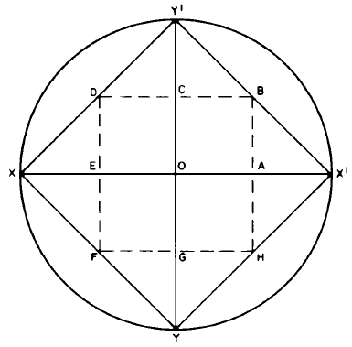
Source: [B11]
- —Effect of secondary distribution system power source location
on area that can be supplied under specified voltage drop limits
Every effort should be made to place the secondary distribution system supply point as close as possible to the center of the load area. Note that this study is based on a horizontal wiring system and any vertical components must be deducted to establish the limits of the horizontal area that can be supplied.
Using an average value of 30 ft/V drop for a fully loaded conductor, which is a good average figure for the conductor sizes normally used for feeders, the distances in figure 3-6 for 5% and 21/2% voltage drops are shown in table 3-10. For a distributed load, the distances will be approximately twice the values shown.
      - Improvement of voltage conditions (Red 3.7)
Poor equipment performance, overheating, nuisance tripping of overcurrent protective devices, and excessive burnouts are signs of unsatisfactory voltage. Abnormally low voltage occurs at the end of long circuits. Abnormally high voltage occurs at the beginning of circuits close to the source of supply, especially under lightly loaded conditions such as at night and over weekends.
Table 3-10—Areas that can be supplied for specific voltage drops and
voltages at various secondary distribution system power source locations
Nominal system  voltage (volts) | Distance (feet)
Nominal system  voltage (volts) | 5% voltage drop |  | 2¹/2% voltage drop
Nominal system  voltage (volts) | 0-X | 0-A | 0-X | 0-A
120/240 | 360 | 180 | 180 | 90
208 | 312 | 156 | 156 | 78
240 | 360 | 180 | 180 | 90
480 | 720 | 360 | 360 | 180

In cases of abnormally low voltage, the first step is to make a load survey to measure the current taken by the affected equipment, the current in the circuit supplying the equipment, and the current being supplied by the supply source under peak-load conditions to make sure that the abnormally low voltage is not due to overloaded equipment. If the abnormally low voltage is due to overload, then corrective action is required to relieve the overloaded equipment.
If overload is ruled out or if the utilization voltage is excessively high, a voltage survey should be made, preferably by using graphic voltmeters, to determine the voltage spread at the utilization equipment under all load conditions and the voltage spread at the utility supply. This survey can be compared with ANSI C84.1-1989 to determine if the unsatisfactory voltage is caused by the plant distribution system or the utility supply. If the utility supply exceeds the tolerance limits specified in ANSI C84.1-1989, the utility should be notified. If the industrial plant is supplied at a transmission voltage and furnishes the distribution substation, the operation of the voltage regulators should be checked.
If excessively low voltage is caused by excessive voltage drop in the plant wiring (over 5%), then plant wiring changes are required to reduce the voltage drop. If the load power factor is low, capacitors may be installed to improve the power factor and reduce the voltage drop. Where the excessively low voltage affects a large area, the best solution may be conversion to primary distribution if the building is supplied from a single distribution transformer, or to install an additional distribution transformer in the center of the affected area if the plant has primary distribution. Plants wired at 208Y/120 or 240 V may be changed over economically to 480Y/277 V if an appreciable portion of the wiring system is rated 600 V and motors are dual rated 220:440 V or 230:460 V.
      - Phase-voltage unbalance in three-phase systems (Red 3.8)
        - Causes of phase-voltage unbalance (Red 3.8)
Most utilities use four-wire grounded-wye primary distribution systems so that single-phase distribution transformers can be connected phase-to-neutral to supply single-phase loads, such as residences and street lights. Variations in single-phase loading cause the currents in the three-phase conductors to be different, producing different voltage drops and causing the phase voltages to become unbalanced. Normally the maximum phase-voltage unbalance will occur at the end of the primary distribution system, but the actual amount will depend on how well the single-phase loads are balanced between the phases on the system.
Perfect balance can never be maintained because the loads are continually changing, causing the phase-voltage unbalance to vary continually. Blown fuses on three-phase capacitor banks will also unbalance the load and cause phase-voltage unbalance.
Industrial plants make extensive use of 480Y/277 V utilization voltage to supply lighting loads connected phase-to-neutral. Proper balancing of single-phase loads among the three phases on both branch circuits and feeders is necessary to keep the load unbalance and the corresponding phase-voltage unbalance within reasonable limits.
        - Measurement of phase-voltage unbalance (Red 3.8)
The simplest method of expressing the phase-voltage unbalance is to measure the voltages in each of the three phases:
The amount of voltage unbalance is better expressed in symmetrical components as the negative sequence component of the voltage:
percent unbalance maximum deviation from average
= ⋅ 100
average
voltage unbalance factor negative-sequence voltage
=
positive-sequence voltage
        - Effect of phase-voltage unbalance (Red 3.8)
When unbalanced phase voltages are applied to three-phase motors, the phase-voltage unbalance causes additional negative-sequence currents to circulate in the motor, increasing the heat losses primarily in the rotor. The most severe condition occurs when one phase is opened and the motor runs on single-phase power. Figure 3-7 shows the recommended derating for motors as a function of percent phase-voltage unbalance. Linders, 1971 [B7] ,2 provides a more comprehensive review of the effects of unbalance on motors.
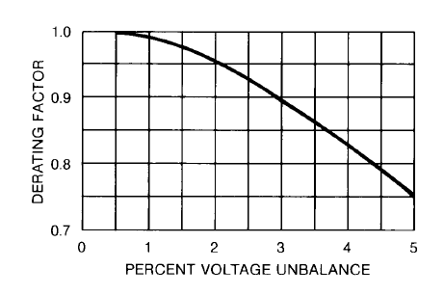
Source: NEMA MG 1-1993.
- —Derating factor for motors operating with
phase voltage unbalance
Although there will generally be an increase in the motor load current when the phase voltages are unbalanced, the increase is insufficient to indicate the actual temperature rise that occurs because NEMA current-responsive thermal or magnetic overload devices only provide a trip characteristic that correlates with the motor thermal damage due to normal overload current (positive-sequence) and not negative-sequence current.
All motors are sensitive to phase-voltage unbalance, but hermetic compressor motors used in air conditioners are most susceptible to this condition. These motors operate with higher current densities in the windings because of the added cooling effect of the refrigerant. Thus the same percent increase in the heat loss due to circulating currents, caused by phase-voltage unbalance, will have a greater effect on the hermetic compressor motor than it will on a standard air-cooled motor.
Since the windings in hermetic compressor motors are inaccessible, they are normally protected by thermally operated switches embedded in the windings, set to open and disconnect the motor when the winding temperature exceeds the set value. The motor cannot be restarted until the winding has cooled down to the point at which the thermal switch will reclose.
When a motor trips out, the first step in determining the cause is to check the running current after it has been restarted to make sure that the motor is not overloaded. The next step is to measure the three-phase voltages to determine the amount of phase-voltage unbalance. Figure 3-7 indicates that where the phase-voltage unbalance exceeds 2%, the motor is likely to become overheated if it is operating close to full load.
Some electronic equipment, such as computers, may also be affected by phase-voltage unbalance of more than 2 or 21/2%. The equipment manufacturer can supply the necessary information.
In general, single-phase loads should not be connected to three-phase circuits supplying equipment sensitive to phase-voltage unbalance. A separate circuit should be used to supply this equipment.
      - Voltage sags and flicker (Red 3.9)
The previous discussion has covered the relatively slow changes in voltage associated with steady-state voltage spreads and tolerance limits. However, sudden voltage changes should be given special consideration.
Lighting equipment output is sensitive to applied voltage, and people are sensitive to sudden illumination changes. A voltage change of 0.25 to 0.5% will cause a noticeable reduction in the light output of an incandescent lamp and a less noticeable reduction in the light output of HID lighting equipment. Intermittent equipment operation such as welders, motor starting, and arc furnaces can affect the voltage supplied to lighting equipment so much that people complain about flickering lights.
Motor starting and short circuits on nearby lines can cause lamp flicker and even large momentary voltage sags that disrupt sensitive utilization equipment. Arc furnaces and welders can cause voltage flicker that occurs several times a second. This produces a stroboscopic effect and can be particularly irritating to people.
Care should be taken to design systems that will not irritate people with flickering lights and that will not disrupt important industrial and commercial processes.
        - Motor starting voltage sags (Red 3.9)
Motors have a high initial inrush current when turned on and impose a heavy load at a low power factor for a very short time. This sudden increase in the current flowing to the load causes a momentary increase in the voltage drop along the distribution system, and a corresponding reduction in the voltage at the utilization equipment.
In general, the starting current of a standard motor averages about 5 times the full-load running current. The approximate values for all ac motors over / 2 hp are indicated by a code letter on the nameplate of the motor. The values indicated by these code letters are given in NEMA MG 1-1978 and also in Article 430 of the NEC.
A motor requires about 1 kVA for each motor horsepower in normal operation, so the starting current of the average motor will be about 5 kVA for each motor horsepower. When the motor rating in horsepower approaches 5% of the secondary unit substation transformer capacity in kilovoltamperes, the motor starting apparent power approaches 25% of the transformer capacity which, with a transformer impedance voltage of 6-7%, will result in a noticeable voltage sag on the order of 1%.
In addition, a similar voltage sag will occur in the wiring between the secondary unit substation and the motor when starting a motor with a full-load current which is on the order of 5% of the rated current of the circuit. This will result in a full-load voltage drop on the order of 4 or 5%. However, the voltage drop is distributed along the circuit so that maximum sag occurs only when the motor and the affected equipment are located at the far end of the circuit. As the motor is moved from the far end to the beginning of the circuit, the voltage drop in the circuit approaches zero. As the affected equipment is moved from the far end to the beginning of the circuit, the voltage dip remains constant up to the point of connection of the motor and then decreases to zero as the equipment connection approaches the beginning of the circuit.
The total voltage sag is the sum of the sag in the secondary unit substation transformer and the secondary circuit. In the case of very large motors of several hundred to a few thousand horsepower, the impedance of the supply system should be considered.
Special consideration should always be given when starting larger motors to minimize the voltage sag so as not to affect the operation of other utilization equipment on the system supplying the motor. Large motors (see table 3-11) may be supplied at medium voltage such as 2400, 4160, 6900, or 13 200 V from a separate transformer to eliminate the voltage dip on the low-voltage system. However, consideration should be given to the fact that the maintenance electricians may not be qualified to maintain medium-voltage equipment. A contract with a qualified electrical firm may be required for maintenance. Standard voltages and preferred horsepower limits for polyphase induction motors are shown in table 3-11.
Table 3-11 —Standard voltages and preferred horsepower limits
for polyphase induction motors
Motor nameplate voltage |  | Preferred horsepower limits
 |  | Low-voltage motors
115 |  | No minimum—15 hp maximum
230 |  | No minimum—200 hp maximum
460 and 575 |  | 1 hp minimum—1000 hp maximum
 |  | Medium-voltage motors
2300 |  | 50 hp minimum—6000 hp maximum
4000 |  | 100 hp minimum—7500 hp maximum
4500 |  | 250 hp minimum—no maximum
6000 |  | 400 hp minimum—no maximum
13 200 |  | 1500 hp minimum—no maximum

Source: Based on [B91, table 18-5.
        - Flicker limits (Red 3.9)
Where loads are turned on and off rapidly as in the case of resistance welders, or fluctuate rapidly as in the case of arc furnaces, the rapid fluctuations in the light output of incandescent lamps, and to a lesser extent, gaseous discharge lamps, is called flicker. If utilization equipment involving rapidly fluctuating loads is on the order of 10% of the capacity of the secondary unit substation transformer and the secondary circuit, accurate calculations should be made using the actual load currents and system impedances to determine the effect on lighting equipment.
Individuals vary widely in their susceptibility to light flicker. Tests indicate that some individuals are irritated by a flicker that is barely noticeable to others. Studies show that sensitivity depends on how much the illumination changes (magnitude), how often it occurs (frequency), and the type of work activity undertaken. The problem is further compounded by the fact that fluorescent and other lighting systems have different response characteristics to voltage changes. For example, incandescent illumination changes more than fluorescent, but fluorescent illumination changes faster than incandescent. Sudden voltage changes from one cycle to the next are more noticeable than gradual changes over several cycles. Illumination flicker can be especially objectionable if it occurs often and is cyclical.
Figure 3-8 [B6] shows acceptable voltage flicker limits for incandescent lights used by a large number of utilities. Two curves show how the acceptable voltage flicker magnitude depends on the frequency of occurrence. The lower curve shows a borderline where people begin to detect flicker. The upper curve is the borderline where some people will find the flicker objectionable. At 10 per hour, people begin to detect incandescent lamp flicker for voltage fluctuations larger than 1% and begin to object when the magnitude exceeds 3%.
In using this curve, the purpose for which the lighting is provided needs to be considered. For example, lighting used for close work such as drafting requires flicker limits approaching the borderline of visibility curve. For general area lighting such as storage areas, the flicker limits may approach the borderline of the irritation curve. Note that the effect of voltage flicker depends on the frequency of occurrence. An occasional dip, even though quite large, is rarely objectionable.
When objectionable flicker occurs, either the load causing the flicker should be reduced or eliminated, or the capacity of the supply system increased to reduce the voltage drop caused by the fluctuating load. In large plants, flicker-producing equipment should be segregated on separate transformers and feeders so as not to disturb flicker-sensitive equipment.
Objectionable flicker in the supply voltage from the utility should be reported to the utility for correction. Flexibility in approach and effective communications between the customer and the utility can be invaluable in resolving potential flicker problems.
        - Fault clearing voltage sags (Red 3.9)
Solid-state controllers such as adjustable speed drives, microprocessor controllers, sensors,
and other equipment are often sensitive to momentary voltage sags associated with remote electrical short circuits. A short circuit on adjacent plant feeders, a nearby utility distribution line, or even a transmission line many miles from the sensitive load can cause a noticeable sag in voltage while short-circuit current is flowing. The voltage sag continues until the circuit breaker or other fault clearing equipment interrupts the short-circuit current. Consideration should be given to include capabilities to ride through these voltage sags for processes where sudden, unplanned shutdowns have a significant cost.
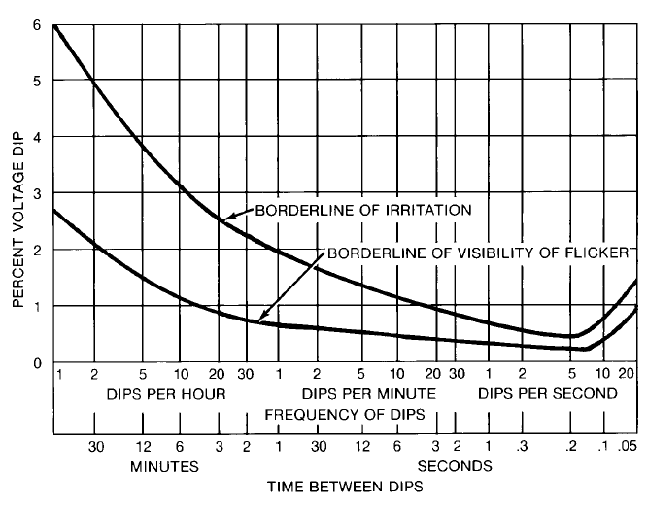
- —Range of observable and objectionable
voltage flicker versus time
The magnitude of the voltage sag depends on the electrical location of the short circuit relative to the load. Single- and two-phase short circuits are more likely and cause different sag voltages on each phase. Generally, short circuits on only a few miles of line can cause deep voltage sags for any one site. However, there are often many miles where short circuits can cause shallow sags at the same site. This phenomena makes shallow sags many times more likely than deep sags. Figure 3-9 shows relative probabilities of occurrence compared to the lowest phase voltage when sags occur. For example, equipment that turns off at 90% of nominal voltage may experience 3.1 times more voltage sag problems than equipment that tolerates sags to 80% of nominal.
The duration of voltage sags depends upon the time required to detect and interrupt the short-
circuit current. Typical minimum interruption time for medium- and high-voltage circuit
breakers are 3Ð5 cycles at 60 Hz while older breakers may be rated for 8 cycles. Some sags because of required time delay for overcurrent coordination. Figure 3-10 shows the probability density of voltage sag duration. The three curves show that half to three quarters of the measured voltage sags had a duration less than 0.2 s.
Equipment sensitivity to voltage sags generally involves a combination of voltage magnitude and duration. Both should be considered when specifying equipment performance capabilities during voltage sags.
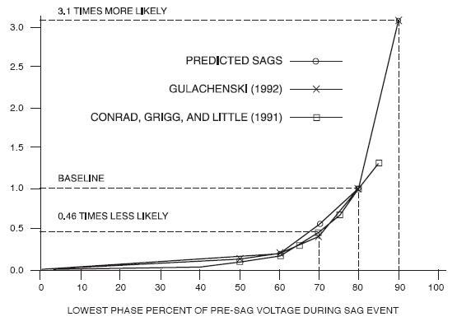
- —Voltage sag probabilities
last even longer longer because of required time delay for overcurrent coordination. Figure 3-10 shows the probability density of voltage sag duration. The three curves show that half to three quarters of the measured voltage sags had a duration less than 0.2 s.
Equipment sensitivity to voltage sags generally involves a combination of voltage magnitude and duration. Both should be considered when specifying equipment performance capabilities during voltage sags.
      - Harmonics (Red 3.10)
Voltage and current on the ideal ac power system have pure single frequency sine wave shapes. Real power systems have some distortion because an increasing number of loads require current that is not a pure sine wave. Single- and three-phase rectifiers, adjustable speed drives, arc furnaces, computers, and fluorescent lights are good examples.
Fourier analysis shows the waveform distortion contains higher frequency components that are integer multiples of the fundamental frequency. For a 60 Hz power system, the second harmonic would be 2 × 60 or 120 Hz and the third harmonic would be 3 × 60 or 180 Hz. These higher frequency components distort the voltage by interacting with the system impedance. Capacitor failure, premature transformer failure, neutral overloads, excessive motor heating, relay misoperation, and other problems are possible when harmonics are not properly controlled.
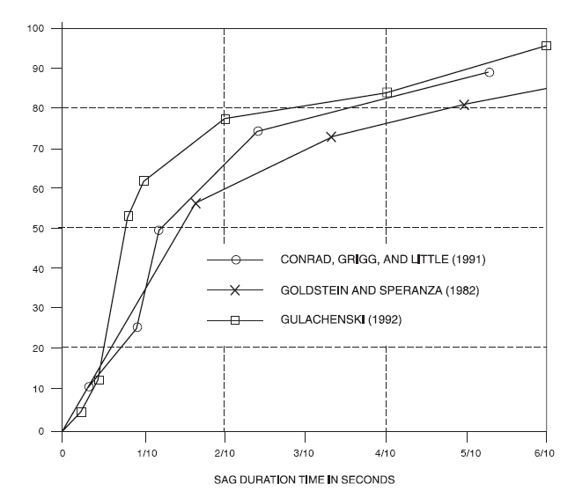
- —
IEEE Std 519-1992 is a recommended practice for control of harmonics in power systems. It recommends limits for supply voltage distortion and limits for allowable harmonic current demands. Chapter 9 of this book also contains more detailed information on harmonics.
    - Grounding Considerations
Green 1.1 – 1.6, Red 7.1 – 7.6
      - Introduction (Red 7.1)
All phases of the subject of grounding applicable to the scope of the IEEE Industrial and Commercial Power Systems Department (I&CPSD) have been studied and documented in IEEE Std 142-1991 [B23]. That standard is the basic source of technical guidance for this chapter.1
Chapter 7 will identify and discuss those facets of grounding technology that relate to industrial plants. The topics to be discussed are as follows:
- Introduction
- System grounding
- Equipment grounding
- Static and lightning protection grounding
- Connection to earth
- Grounding resistance measurement
Unless otherwise noted, the discussions in this chapter address low-voltage systems. (For voltage system classifications, see Chapter 1, table 1-1.) When emergency and standby systems are involved, IEEE Std 446-1987 [B24], should be consulted.
      - System grounding (Red 7.2)
Alternating-current electric power distribution system grounding is concerned with the nature and location of an intentional electric connection between the electric system phase conductors and ground (earth). The common classifications of grounding found in industrial plant ac power distribution systems are as follows:
- Ungrounded
- Resistance grounded
- Reactance grounded
- Solidly grounded
There are several other methods for grounding electrical systems that are not covered in as much detail as the above methods. The following methods are deviations or variations of the above:
- Corner-of-the-delta solidly grounded
- Low-reactance
- Mid-phase (solidly grounded) of a three-phase delta (commonly called center-tap)
The method of electric system grounding may have a significant effect on the magnitude of phase-to-ground voltages that must be endured under both steady-state and transient conditions. In ungrounded electric systems that are characteristically subject to severe overvoltage, reduced useful life of insulation and associated equipment can be expected. Insulation failures usually cause system faults. In rotating electric machines and transformers where insulation space is limited, this conflict between voltage stress and useful life is particularly acute.
In addition to the control of system overvoltages, intentional electric system neutral grounding makes possible sensitive and high-speed ground-fault protection based on detection of ground-current flow. Solidly grounded systems, in most cases, are arranged so circuit protective devices will remove a faulted circuit from the system regardless of the type of fault. Any contact from phase to ground in the solidly grounded system thus results in instantaneous isolation of the faulted circuit and the associated loads. The experience of many engineers has been that greater service life of equipment can be obtained with grounded-neutral than with ungrounded-neutral systems. Furthermore, a very high order of ground-fault protection for rotating machinery may be acquired by a simple, inexpensive ground overcurrent relay. The protective qualities of rotating machine differential protection can be enhanced by grounding the power supply system.
Where service continuity is required, such as for a continuous operating process, the high- resistance grounded system can be used. With this type of grounded system, the intention is that any contact between one phase conductor and a grounded (earthed) surface will not cause the phase overcurrent protective device to operate (trip).
Overvoltages are minimized with any type of grounded electrical system. With high-resistance grounded systems, like the solidly grounded system, greater service life of equipment can be obtained, along with continuity of service.
For a detailed discussion and charts of the advantages and disadvantages, fault current, costs comparisons, system voltages, and areas of applications of the different methods of system grounding, see Catalog GET-3548 [B35].
The following practice is recommended for establishing the system grounding connection:
- Systems used to supply phase-to-neutral loads must be solidly grounded as required by the National Electrical Code (NEC) (ANSI/NFPA 70-1993).² They are
  - 120/240 V, single-phase, three-wire
  - 208Y/120 V, three-phase, four-wire
  - 480Y/277 V, three-phase, four-wire
- Systems that may/could be resistance grounded are
  - 480 V, three-phase, three-wire
  - 480Y/277 V, three-phase, four-wire without phase-to-neutral loads
  - 600 V, three-phase, three-wire
  - 5000 volt class
  - 2400 V, three-phase, three-wire
  - 4160 V, three-phase, three-wire
  - 8000 volt class
  - 6900 V, three-phase, three-wire
  - 15 000 volt class
  - 12 000 V, three-phase, three-wire wye
  - 12 470 V, three-phase, three-wire wye
  - 13 200 V, three-phase, three-wire wye
  - 13 800 V, three-phase, three-wire wye
        - Ungrounded systems (Red 7.2)
The ungrounded system is actually high-reactance capacitance grounded as a result of the coupling to ground of every energized conductor. The operating advantage, sometimes claimed for the ungrounded system stems from the ability to continue operations during a single phase-to-ground fault, if sustained, will not result in an automatic trip of the circuit. There will be merely the flow of a small charging current to ground. It is generally conceded that this practice introduces potential hazards to insulation in apparatus supplied from the ungrounded system (Beeman 1955 [B4]).
There is divided opinion among engineers about the degree of the overvoltage problem on ungrounded systems (600 V and less) and the probability of its affecting the electrical service continuity. Many engineers believe that fault locating is improved and insulation failures are reduced by using some type of grounded power system. Others feel that under proper operating conditions the ungrounded system offers an added degree of service continuity not jeopardized by insulation failures resulting from steady state and the probability of transient overvoltages. Additional discussion of the factors influencing a choice of the grounded or ungrounded system is given in Chapter 1 of IEEE Std 142-1991 [B23] and GET-3548 [B35].
As long as no disturbing influences occur on the system, the phase-to-ground potentials (even on an ungrounded system) remain steady at about 58% of the phase-to-phase voltage value. For the duration of the single phase to ground fault, the other two phase conductors throughout the entire raceway system are subjected to 73% overvoltage. It is, therefore, extremely important to locate the ground fault promptly and repair or remove it before the abnormal voltage stresses produce insulation breakdown on machine windings, other equipment, and circuits. Because of the capacitance coupling to ground, the ungrounded system is subject to dangerous overvoltages (five times normal or more) as a result of an intermittent contact ground fault (arcing ground) or a high inductive reactance connected from one phase to ground or phase to phase.
Accumulated operating experience indicates that, in general purpose industrial power distribution systems, the overvoltage incidents associated with ungrounded operation reduce the useful life of insulation so that electric circuit and machine failures occur more frequently than they do on grounded power systems. The advantage of an ungrounded system not immediately dropping load upon the occurrence of a phase to ground fault may be largely eliminated by the practice of ignoring a ground fault and allowing it to remain on the system until a second fault occurs causing a power interruption. An adequate detection system with an organized program for removing ground faults is considered essential for operation of the ungrounded system. These observations are limited to ac systems. Direct-current system operation is not subject to many of the overvoltage hazards present in ac systems. One final consideration for ungrounded systems is the necessity to apply overcurrent devices based upon their "single-pole" short-circuit interrupting rating, which can be equal to or in some cases is less than their "normal rating.”
        - Resistance-grounded systems (Red 7.2)
Resistance-grounded systems employ an intentional resistance connection between the electric system neutral and ground. This resistance appears in parallel with the system-to-ground capacitive reactance, and this parallel circuit behaves more like a resistor than a capacitor. Resistance-grounded systems can take the forms of
- High-resistance grounded systems
- Low-resistance grounded systems
Investigations recommend that high-resistance grounding should be restricted to 5 kV class or lower systems with charging currents of about 5.5 A or less and should not be attempted on 15 kV systems (Walsh 1973 [B37]), unless proper ground relaying is employed. The reason for not recommending high-resistance grounding of 15 kV systems is the assumption that the fault will be left on the system for a period of time. Damage to equipment from continued arcing at the higher voltage can occur. If the circuit is opened immediately, there is no problem.
In a high-resistance connection (R ≤ Xco/3, where R is the intentional resistance between the electric system neutral and ground, and X co /3 is the total system-to-ground capacitive reactance), the overvoltage-producing tendencies of a pure capacitively grounded system will be sufficiently reduced. In a low-resistance grounded system, phase-to-ground potentials are rigidly controlled, and sufficient phase-to-ground fault current is also available to operate ground-fault relays selectively. X co is difficult to determine in a high resistance grounded system without testing (Bridger 1983 [B7]), thus 5 A to 10 A is recommended for the phase-toground fault current limitation.
The ohmic value of the resistance should be not greater than the total system-to-ground capacitive reactance (X co/3). The neutral resistor current should be at least equal to or greater than the system total charging current. For details on obtaining and testing the value of the total system charging current. (See Bridger 1983 [B7].)
High-resistance grounding provides the same advantages as ungrounded systems yet limits the steady state and severe transient overvoltages associated with ungrounded systems. Continuous operation can be maintained. Essentially, there is minimal phase-to-ground shock hazard during a phase-to-ground fault since the neutral is not run with the phase conductors and the neutral is shifted to a voltage approximately equal to the phase conductors. There is no arc flash hazard, as there is with a solidly grounded system, since the fault current is limited to approximately 5 A.
Another benefit of high-resistance grounded systems is the limitation of ground fault current to prevent damage to equipment. High value of ground faults on solidly grounded systems can destroy the magnetic iron of the rotating machinery. Small winding faults on solidly grounded systems may be readily repaired without replacing the magnetic iron. However, not having to replace the lamination with equipment installed on high-resistance grounded systems, when a phase-to-ground fault occurs, is a benefit.
High-resistance grounded systems should require immediate investigation and clearing of a ground fault even though the ground-fault current is of a very low magnitude (usually less than 10 A). This low magnitude of continuous fault current can deteriorate adjacent insulation or other equipment. As long as a phase-to-ground fault does not escalate into an additional phase-to-ground fault on a different phase, resulting in a phase-to-phase fault and operating the protective device, the continuous operation can continue. It is essential to monitor and alarm on the first phase-to-ground fault. If the fault impedance is zero, solidly connected to ground, the high-resistance system takes on the characteristics of a solidly grounded system until the fault is located and repaired.
The key to locating a ground fault on a high-resistance grounded system is the ability to injection a traceable ground signal to the faulted system. This fault-indicating system permits fault location with the power system energized. An oversized, large opening, special clamp on type ammeter is used. Some skill is required in finding the location of the fault. (See GET- 35548 [B35] for additional information.)
High-resistance grounding will limit to a moderate value the transient overvoltages created by an inductive reactance connection from one phase to ground or from an intermittent- contact phase-to-ground short circuit. It will not avoid the sustained 73% overvoltage on two phases during the presence of a ground fault on the third phase. Nor will it have much effect on a low-impedance overvoltage source, such as an interconnection with conductors of a higher voltage system, a ground fault on the outer end of an extended winding transformer or step-up autotransformer, or a ground fault at the transformer-capacitor junction connection of a series capacitor welder.
Low-resistance grounding requires a grounding connection of a much lower resistance. It is common to have 5 kV and 15 kV systems low-resistance grounded. The resistance value is selected to provide a ground-fault current acceptable for relaying purposes. The generator neutral resistor is usually limited for large generators to a minimum of 100 A and to a maximum of 1.5 times the normal rated generator current (Johnson 1945 [B28]). Typical current values used range from 400 A (to as low as 100 A) on modern systems using sensitive toroid or core balance current transformer ground-sensor relaying and up to perhaps 2000 A in the larger systems using residually connected ground overcurrent relays. In mobile electric shovel application, much lower levels of ground-fault current (50 to 25 A) are dictated by the acute shock-hazard considerations. One final consideration for resistance-grounded systems is the necessity to apply overcurrent devices based upon their "single-pole" short-circuit interrupting rating, which can be equal to or in some cases less than their "normal rating."
        - Reactance-grounded system (Red 7.2)
Reactance-grounded systems are not ordinarily employed in industrial power systems. The permissible reduction in available ground-fault current without risk of transitory overvoltages is limited. The criterion for curbing the overvoltages is that the available ground-fault current be at least 25% of the three-phase fault current ( X ≤
0 / X 10, where X is the zero-sequence
1 0
inductive reactance, and X is the positive-sequence inductive reactance of the system). The
1
resulting fault current can be high and present an objectionable degree of arcing damage at the fault, leading to a preference for resistance grounding. Much greater reduction in fault- current value is permissible with resistance grounding without risk of overvoltage. One final consideration for reactance grounded systems is the necessity to apply overcurrent devices based upon their "single-pole" short-circuit interrupting rating, which can be equal to or in some cases less than their "normal rating."
        - Solidly grounded system (Red 7.2)
Solidly grounded systems exercise the greatest control of overvoltages but result in the highest magnitudes of ground-fault current. These high-magnitude fault currents may introduce problems and generate other design problems in the equipment grounding system. Solidly grounded systems are used extensively at all operating voltages. At high voltages, impedance grounding sensing equipment costs needs to be considered. Large magnitude ground-fault currents generally do not affect electrical equipment braced for that stress. Note that the pressure relief duty of surge arresters will be affected by solidly grounded systems. Also, the amount of insulation for medium voltage cable may be affected. Also, a large magnitude of available ground-fault current is desirable to secure optimum performance of phase-overcurrent trips or interrupting devices. The low phase-to-neutral driving voltage of the supply system (346 V in the 600 V system and 277 V in the 480 V system) lessens the likelihood of dangerous voltage gradients in the ground-return circuits even when higher than normal ground-return impedances are present.
The solidly grounded system has the highest probability of escalating into a phase-to-phase or three-phase arcing fault, particularly for the 480 and 600 V systems. The danger of sustained arcing for phase-to-ground fault probability is also high for the 480 and 600 V systems, and low or near zero for the 208 V system. For this reason ground fault protection shall be required for systems over 1000 A (ANSIINFPA 70-1993). A safety hazard exists for solidly grounded systems from the severe flash, arc burning, and blast hazard from any phaseto-ground fault.
        - Resonant Grounding (Ground-Fault Neutralizer) (Red 7.2)
A ground-fault neutralizer is a reactor connected between the neutral of a system and ground. The reactor, XL, is specially selected, or tuned, to resonate with the distributed capacitance, Xco of the system so that a resulting ground fault current is resistive and low in magnitude. A resistance, r, is shown depicting reactor losses. The resulting ground fault current is in phase with the line to neutral voltage so that current zero and voltage zero occur simultaneously. If the ground fault is in air, such as an insulator flashover, it may be self-extinguishing.
Operation of a ground fault neutralizer is explained with reference to Figure 1-12. The distributed capacitance per phase is assumed to be balanced. When one phase of the system is grounded (assume phase C) a line-to-neutral voltage, VCN, is impressed across the reactor. This produces a lagging inductive current, IL, that flows from the neutralizer through the transformer, to the fault, then to the ground. At the same time a leading capacitive current, 3 Ico, flows from the two unfaulted lines through the capacitance to ground and to the fault. The lagging current from the inductor and the leading current from the distributed capacitance are practically 180° out of phase. By properly tuning the reactor (selecting the right tap), the inductive and capacitive components of current can be made to neutralize each other, leaving only a relatively small component of resistive current, Ir, to flow in the fault.
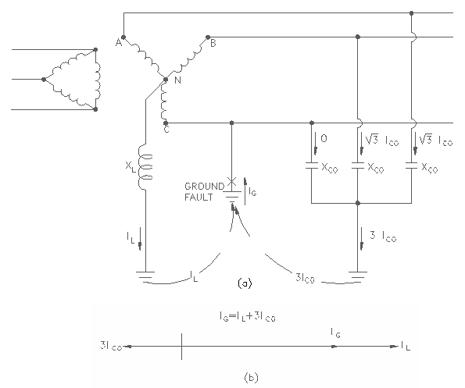
- —Single line-to-ground Fault on a Low Reactance Grounded System
(a) Circuit Configuration (b) Vector Diagram
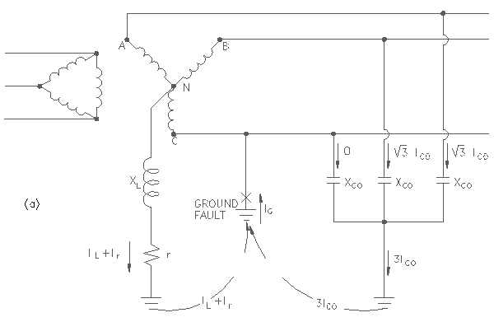
- —Single line-to-ground Fault on a Resonant Grounded System:
(a) Circuit Configuration, (b) Vector Diagram

This method of grounding formerly was occasionally seen in high-voltage transmission practice. Today, it is rarely encountered in North America. There are a few instances in which it has been applied for generator grounding in large central stations, especially in the New England area. However, it is relatively common in electric utility distribution practice in the UK and Europe. A key requirement is that because the resonant circuit must be retuned if the distributed parameters of the associated circuit are changed, the ideal application is one that does not involve frequent circuit switching or reconfiguration.
        - System-grounding design considerations (Red 7.2)
There are three levels of conductor insulation for medium-voltage cables: 100, 133, and 173% levels. The solidly grounded system permits the use of 100% insulation level. When the fault on the other system will raise the system voltage above normal during the time of the fault, 133% insulation level should be specified if the fault is cleared within one hour. When the fault will remain on the system for an indefinite time, 173% voltage level insulation should be used (Bridger 1983 [B7]; NEMA WC5-1992 [B33]; GET-3548 [B35]).
The intent of the preceding advisory recommendations is to promote broad application of the fewest variety of system-grounding patterns that will satisfy the operational requirements of industrial plant electric power systems in general. Even minor deviations in design practice within a particular variety are to be avoided as much as possible. Nonetheless, it is admitted that the list of recommended patterns is not all inclusive and hence is not to be regarded as mandatory (IEEE Std 446-1987 [B24]).
Utility practices may justify a deviation from the patterns listed in previous paragraphs. Circumstances can arise that may well justify solid grounding with circuit patterns other than those named in these recommendations. For example, when the power supply is obtained from the utility company via feeders from a 4.16Y/2.4 kV solidly grounded substation bus, the user will be justified in adopting that pattern. In such inevitable situations it is imperative that adequate ground-return conductors be provided to minimize the inherent step-and-touch potentials of high ground-fault currents associated with solidly grounded systems and to provide instantaneous ground fault relaying or equivalent to minimize the fault duration. See the National Electrical Safety Code (NESC) (Accredited Standards Committee C2-1993), and IEEE Std 80-1986.
Step voltage or step potential is the potential difference between two points on the earth's surface separated by a distance of one pace of a human (assumed to be 1 m [one meter]) in the direction of the maximum potential gradient (IEEE Std 100-1992 [B22]). Within a substation during a fault condition with a large current flow over and through the ground, a potential is developed across the soil surface as a result of the soil's resistance. Current flow through earth from a lightning discharge will develop a potential also. Touch potential or touch voltage is the potential difference between a grounded metallic structure and a point on the earth's surface separated by a distance equal to the normal maximum reach, approximately 1 m. These potential differences, step or touch, could be dangerous and could result from induction or fault conditions, or both.
Furthermore, should the user desire to serve 120 V single-phase, one-side-grounded, load circuits, there could be firm justification for solidly grounding the midpoint of one phase of a 240 V delta system to obtain a 240 V three-phase four-wire delta pattern. This is a utility practice where a large single phase 120/240 V load exists and a small three-phase load is required.
Ungrounded systems can be converted to solid, corner-grounded delta, thus gaining the advantage of control of overvoltages and longer life of electrical equipment insulation. The use of a 120 V three-phase delta system for general-purpose power could well justify solid corner-of-the-delta grounding, although such systems are not designed today.
In designing the electric power supply system to serve electrically operated excavating machinery, the existence of a greatly accentuated degree of electric-shock-voltage exposure may justify the use of a system-grounding pattern employing a 25 A resistive grounding connection (to establish a 25 A level of available ground-fault current). The achievement of keeping personnel secure from dangerous electric-shock injury, both operators and bystanders, may require the reduction in rotating-machine fault-detection sensitivity, which is therefore sacrificed.
There may be sound justification for the insertion of a reactor in the neutral connection of a generator that is to be connected to a solidly grounded three-phase distribution system in order to avoid excessive generator-winding current in response to phase-to-ground fault on the system. The reactance of the neutral grounding reactor for generator grounding is calculated such that current in any winding does not exceed three-phase short-circuit current and is not less than 25% of three-phase short-circuit current. A minimum short-circuit current of not less than 25% of the three-phase short-circuit current is required to minimize transient overvoltages.
The foregoing examples clearly illustrate the need for design flexibility to tailor engineer the system grounding pattern to cope with the unique and unusual situations. However, the decision to deviate from the advisory recommendations should be based on a specific engineering evaluation of a need for that deviation.
      - Obtaining the System Neutral (Green 1.5)
The best way to obtain the system neutral for grounding purposes in three-phase systems is to use source transformers or generators with wye-connected windings. The neutral is then readily available. Such transformers are available for practically all voltages except 240 V. On new systems, 208Y/120 V or 480Y/277 V, wye-connected transformers may be used to good advantage instead of 240 V. Wye-connected source transformers for 2400 V, 4160 V, and 13 800 V systems are available as a standard option, whereas 4800 V and 6900 V, wye-connected source transformers may be priced at a premium rate. The alternative is to apply grounding transformers.
      - Grounding Transformers (Green 1.6)
System neutrals may not be available, particularly in many older systems rated 600 V or less and in many existing 2400 V, 4800 V, and 6900 V systems. When existing delta connected or ungrounded systems are to be grounded, grounding transformers can be used to obtain a neutral. The most commonly used grounding transformers are the zigzag and wye-delta type.

        - Zigzag Grounding Transformers.
One type of grounding transformer commonly used is a three-phase zigzag transformer with no secondary winding. The internal connection of the transformer is illustrated in Figure 1-14. The impedance of the transformer to balanced three-phase voltages is high so that when there is no fault on the system, only a small magnetizing current flows in the transformer winding. The transformer impedance to zero-sequence voltages, however, is low so that it allows high ground-fault currents to flow. The transformer divides the ground-fault current into three equal components; these currents are in phase with each other and flow in the three windings of the grounding transformer. The method of winding is seen from Figure 1-14(1) to be such that when these three equal currents flow, the current in one section of the winding of each leg of the core is in a direction opposite to that in the other section of the winding on that leg. This tends to force the ground-fault current to have equal division in the three lines and accounts for the low impedance of the transformer-to-ground currents.
A zigzag transformer may be used for effective grounding, or an impedance can be inserted between the derived neutral of the zigzag transformer and ground to obtain the desired method of grounding. This transformer is seldom employed for medium-voltage, high-resistance grounding. An example of low-resistance grounding is shown in Figure 1-14(2). The overcurrent relay, 51G, is used to sense neutral current that only flows during a line-to-ground fault.
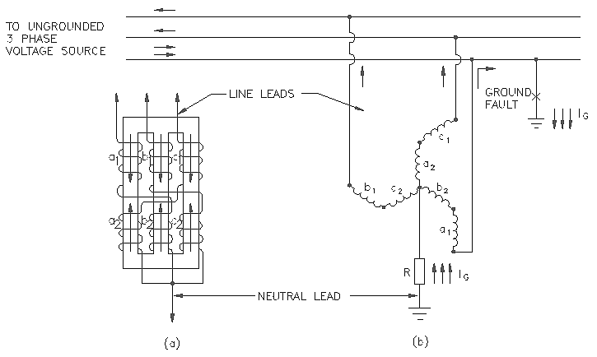
Figure 1-14(1)--Zigzag Grounding Transformer-
(a) Core Windings, (b) System Connection with Neutral Sensing Current Relay
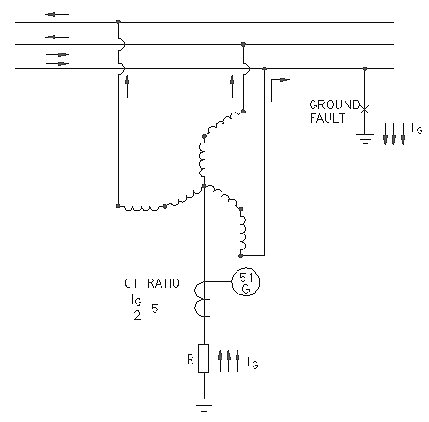
Figure 1-14(2)-- Low Resistance Grounding of System through a Zigzag Grounding Transformer with Neutral sensing Current Relay

        - Wye-Delta Grounding Transformers
A wye-delta connected three-phase transformer or transformer bank can also be utilized for system grounding, as shown in Figure 1-15. As in the case of the zigzag transformer, it can be used for effective grounding or to accomplish resistance-type grounding of an existing ungrounded system. The delta connection must be closed to provide a path for the zero-sequence current, and the delta voltage rating is selected for any standard value. A resistor inserted between the primary neutral and ground, as shown in Figure 1-15, provides a means for limiting ground-fault current to a level satisfying the criteria for resistance-grounded systems. For this arrangement, the voltage rating of the wye winding need not be greater than the normal line-to-neutral system voltage. A neutral sensing current relay, 51G, is shown for detection of a single line-to-ground fault. For high-resistance grounding it is sometimes more practical or economical, as illustrated in Figure 1-16, to apply the limiting resistor in the secondary delta connection. For this configuration the grounding bank must consist of three single-phase transformers with the primary wye neutral connected directly to ground. The secondary delta is closed through a resistor that effectively limits the primary ground-fault current to the desired low level. For this alternative application, the voltage rating of each of the transformer windings forming the wye primary should not be less than the system line-to-line voltage.
The rating of a three-phase grounding transformer or bank, in kilovoltampere (kVA), is equal to the rated line-to-neutral voltage in kilovolts times the rated neutral current (Electrical Transmission and Distribution Reference Book). Most grounding transformers are designed to carry their rated current for a limited time only, such as 10 s or 1 min. Consequently, they are much smaller in size than an ordinary three-phase continuously rated transformer with the same rating.
It is generally desirable to connect a grounding transformer directly to the main bus of a power system, without intervening circuit breakers or fuses, to prevent the transformer from being inadvertently taken out of service by the operation of the intervening devices. (In this case the transformer is considered part of the bus and is protected by the relaying applied for bus protection.) Alternatively, the grounding transformer should be served by a dedicated feeder circuit breaker, as shown in part a) of Figure 1-17, or connected between the main transformer and the main switchgear, as illustrated in part b) of Figure 1-17. If the grounding transformer is connected as shown in part b) of Figure 1-17, there should be one grounding transformer for each delta-connected bank supplying power to the system, or enough grounding transformers to assure at least one grounding transformer on the system at all times. When the grounding transformer is so connected, it is included in the protective system of the main transformer.
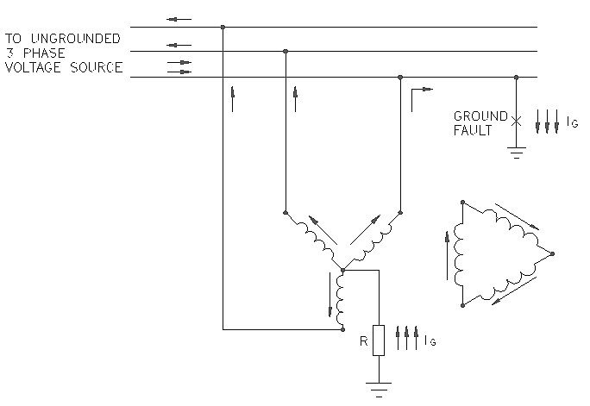
Figure 1-15(1)-- Wye-Delta Grounding Transformer Showing Current Flow
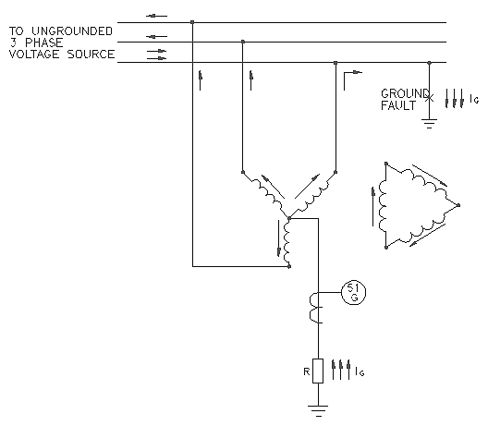
Figure 1-15(2)-- Low Resistance Grounding of System Through a Wye-Delta Grounding Transformer with Neutral Sensing Current Relay
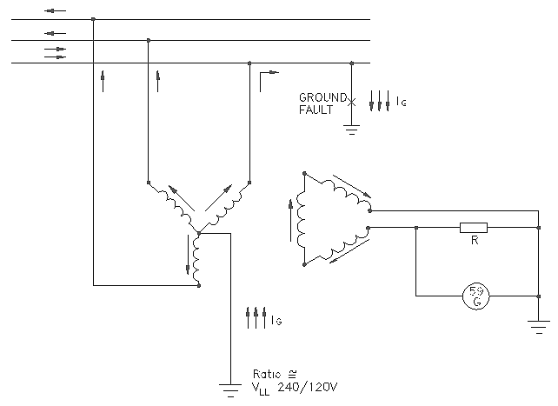
Figure 1-16--High Resistance Grounding of System through a Wye-Broken Delta Grounding Transformer with Neutral Sensing Voltage Relay
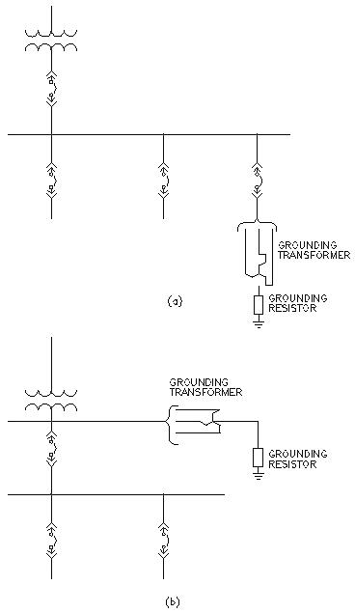
Figure 1-17--Connection of Grounding Transformers In Delta Connected or Ungrounded Power System to Obtain Neutral for System Grounding
(a) Circuit Feeder Breaker (b) Connected between Main Transformer and Main Switch Gear
      - Grounding at Points Other than System Neutral (Green 1.5)
In some cases, low-voltage systems (600 V and below) are grounded at some point other than the system neutral to obtain a grounded electrical system. This is done because delta transformer connections do not provide access to the three-phase system neutral. Two systems are in general use.

        - Corner-of-the-Delta Grounded Systems (Green 1.5)
Some low-voltage, ungrounded systems, have been conceived, as shown in part b) of Figure 1-13, using delta connected supply transformers with no readily available neutral grounding. Because of its limitations, this type of grounding is no longer popular and is not widely used in industrial systems.
        - One Phase of a Delta System Grounded at Midpoint (Green 1.5)
In some areas where the utility has both a single-phase 120/240 V load and three-phase 240 V loads, they have supplied a larger single-phase 120/240 V transformer and one or two smaller 240 V transformers, all connected in delta with the midpoint of the 120/240 V grounded for a 240/120 V three-phase four wire system. This provides neutral grounding for the single-phase 120/240 V and also grounding for the 240 V three-phase system. It is not recommended for voltages over 240 V.
The advantages of this type of grounding scheme are:
- First cost for transformers and fuses can be less than for separate single transformer and three-phase systems.
- Mid-phase grounding effectively controls, to safe levels, the transient overvoltages to ground.
- These diverse loads can be served from a single service.
The disadvantages are:
  - The shock hazard of the high phase leg to ground is 208 V, which is 1.73 times the voltage of a neutral grounded 240 V system. Since this voltage can appear across a single pole of a breaker, 277 V rated breakers may be required.
  - There must be positive identification of the conductor with the highest voltage to ground to avoid connecting 120 V loads to that conductor.
  - The fault currents on the single-phase system may be higher than normally expected for the size of the system, possibly requiring higher rated panelboards.
    - Location of System Grounding Points (Green 1.6)
      - Selection (Green 1.6)
Each system as described in this chapter is characterized by its isolation from adjacent grounding systems. The isolation is provided by transformer primary and secondary windings. The NEC defines such a system as "separately derived." A separately derived system is one "whose power is derived from a generator, transformer, or converter windings and that has no direct electrical connection, including a solidly connected grounded circuit conductor, to supply conductors originating in another system." Therefore, the new system created by a transformer or generator requires the establishment of a new system ground if it is required or desired that this system be grounded. See Figure 1-4 for an example of grounding each separately derived system. The system ground point should always be at the power source as required or permitted by the NEC, including exceptions for multi-source systems.
      - Transformer Configurations. (Green 1.6)
There are two requirements that must be met for a transformer to provide a system ground. The first requirement is fairly intuitive; the transformer winding at the voltage where a ground is desired must be connected in wye (sometimes referred to as star in European practice). The wye is essential to provide a neutral point that can be connected to earth; a delta winding does not present a neutral point and therefore there is no electrical connection that could be connected to earth for the purpose of establishing a ground reference for the system. Alternatively, transformers with windings connected in the interconnected star or zigzag configuration also provide a neutral point that can be grounded.
The second requirement is a bit more involved. Table I-1 lists a number of options for the mode of system grounding; in order for these options to exist, the impedance of the transformer to ground fault current must be significantly lower than the impedance of the connection between the neutral and earth such that this neutral impedance governs the selection of grounding mode. Electrical Transmission and Distribution Reference Book provides a good theoretical background for this statement. Essentially, however, this requirement translates into a requirement that the transformer contain a second winding that is connected in delta. Thus, a transformer that is intended to provide a system ground must provide a wye-connected winding at the voltage of the system to be grounded, and must also contain a delta winding. The most common configuration that meets this requirement in industrial and commercial applications is a transformer that has a delta-connected primary winding and a wye-connected secondary winding.
Wye-wye transformers alone cannot be used to ground industrial and commercial power systems. In special cases it is possible to use wye-wye transformers that are equipped with delta-connected tertiary windings to provide system grounding. This arrangement can be designed for low-resistance grounding as well as effective grounding. It is also possible to use wye-connected autotransformers provided they also have a delta-connected tertiary winding, although this is a relatively uncommon practice and should only be used to provide effective (solid) grounding—applying a neutral grounding resistor between ground and the neutral of an autotransformer can lead to undesirable neutral voltage excursions.
It is also a relatively common practice to use wye-wye transformers with special five-leg magnetic cores to serve commercial applications on effectively grounded (utility) distribution systems. This connection is chosen to address concerns with ferroresonance that come about because of single-phase switching (it is a common practice that utility distribution systems use single point load-break switching devices, typically hook-stick operated), and this connection minimizes concerns with ferroresonance that would otherwise be present in that situation. But rather than provide system grounding itself, what the five-leg core wye-wye transformer does is to provide a continuous path for ground fault currents from the primary distribution system into the commercial load on the secondary. Therefore, the system ground is actually established by the transformer that supplies the host distribution system. This practice therefore results in the commercial system also being effectively grounded.
      - Delta-WyeTransformer.
In a delta-wye connected transformer, with the load side neutral grounded, zero-sequence components of current can flow in the secondary wye-connected windings due to a ground fault. Zero-sequence current is then induced into the primary windings of the transformer and circulates in the delta connection. Positive and negative-sequence currents pass through the transformer combining to produce high current in two of the primary phase conductors. A ground fault on the secondary of the delta-wye connected transformer appears as a line-to-line fault on the primary.
If the neutral of the wye-connected windings is not grounded, then zero-sequence current cannot flow and the system becomes ungrounded.
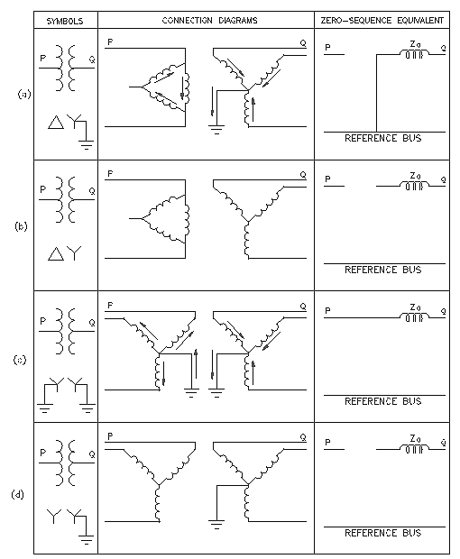
Figure 1-18—Zero-Sequence Impedance of Different Transformer Configurations
NOTE— In Figure 1-18, configurations a) and c) permit the flow of zero-sequence current; b) and d) do not.

Zero-sequence components of current can flow through a wye-wye connected transformer if a neutral path exists on both sides of the transformer. An example is shown in Figure 1-20, where a delta-wye connected transformer, T1, supplies power to a wye-wye connected transformer, T2. A fault on the load side of T2 produces zero-sequence current, which flows in the primary and secondary windings of that transformer. Zero-sequence current is permitted to flow in the primary of T2 because a path exists in the delta-wye connected transformer T1. Disconnecting any of transformer neutrals, on either T1 or T2, would prevent the flow of zero-sequence current in both transformers, except as allowed by magnetizing reactance.
Depending upon the connections to the transformer, the use of a wye-wye transformer can result in a single system, or its load side may be a separately derived system. Figure 1-19 and Figure 1-20 show a single system, whereas Figure 1-21 shows a separately derived system.
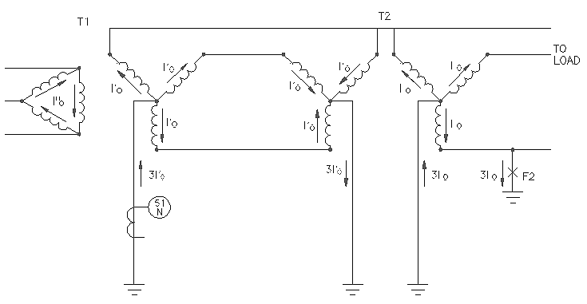
Figure 1-19--Transformer Connections Illustrating the Flow of Zero-Sequence Current Resulting from a Line to Ground Fault
      - Wye-Wye Transformers.
A wye-wye transformer, T2, is shown in Figure 1-20 with the primary and secondary neutrals interconnected and grounded. This transformer configuration is used on solidly grounded utility distribution systems, particularly underground systems, to prevent ferroresonance when the supply switches can be operated one pole at a time. The utilities ground the primary neutral point to minimize the neutral-to-earth voltage throughout the length of the distribution line and by default on underground systems using bare concentric neutral cables. They ground the secondary neutral to provide an effectively grounded low-voltage service. Note that this multiple grounding of the primary at each transformer is not essential to prevent ferroresonance or provide secondary grounding as long as the fourth conductor is brought to the primary neutral of the transformer. The-neutral-to-transformer case and ground connection minimizes secondary neutral-to-ground voltage during a fault between primary and transformer case.
In an industrial distribution system, the physical length of the circuit will usually be short enough so that excessive neutral-to-ground voltages will not be present even if there is no ground at the wye-wye transformer common neutral terminals, as shown in Figure 1-19. The NEC normally prohibits grounding of the neutral on the load side of the service disconnect, but allows multigrounding of the neutral of an outdoor overhead line or direct burial cable with bare neutral if the circuit voltage is over 1000 V.
As shown in Figure 1-19, with a continuous connection from the source neutral to the primary and secondary neutrals of the wye-wye transformer, the output of the transformer would not constitute a separately derived system as defined in the NEC. If the neutral is grounded at the source, T1, the output of the wye-wye transformer will be a continuation of the grounded system, though at the secondary voltage of the transformer. A fault, F2, on the load side of the wye-wye connected transformer, T2, will produce zero-sequence components of current in its primary windings. This zero-sequence current will flow back to the secondary neutral terminal of source transformer, T1. However, this current flowing through 51G cannot determine whether the fault is located before or after the wye-wye transformer, nor can residual or zero-sequence ground detection schemes on the output of T1. The main benefit of this transformer connection is to utilize the standard wye-wye transformer that contains an internal primary-to-secondary neutral connection suitable for utility practice as shown in Figure 1-20.
The circuit supplied by the wye-wye connected transformer shown in Figure 1-21 can be considered a separately derived system, since there are no direct metallic connections between the primary and secondary of the transformer. Primary and secondary ground faults are separately measured and relayed. The secondary of the transformer will not be grounded unless a connection to earth is made. The secondary could be impedance grounded. Secondary neutral grounding will also require a connection from the neutral of the primary source to the primary neutral of the wye-wye transformer to supply zero-sequence current. Unlike the delta-wye transformer, the wye-wye transformer itself is not a source of zero-sequence current. Grounding can be achieved without a primary neutral connection if a phase of the secondary rather than the neutral is grounded, since no zero-sequence current is involved. The effect is then identical to corner grounding of a delta-delta transformer.
If a delta tertiary is added to a wye-wye transformer it will not be necessary to supply zero-sequence current from the primary source, since the tertiary will act as a source of zero-sequence current.
Thus, the wye-wye transformer can be considered a part of a single multi-voltage system if the neutrals are interconnected or can be considered to create a separate system if they are not. The symmetry of the wye-wye allows it to provide grounding for its load-side system even though the source and load side may be interchanged at any time.
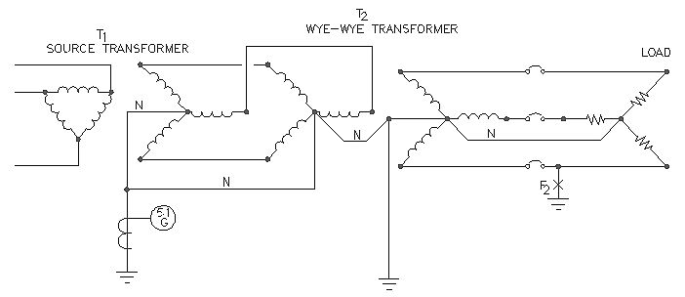
Figure 1-20. Grounded Wye-Grounded Wye Transformer with Multigrounded Common Neutral
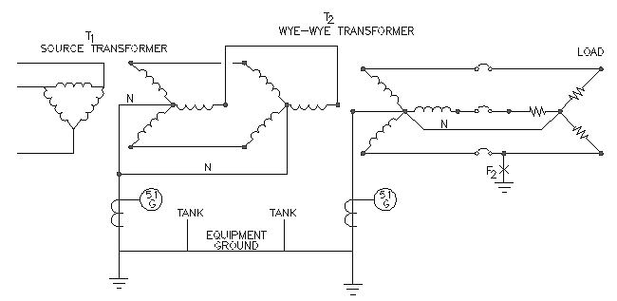
Figure 1-21. Grounded Wye-Grounded Wye Transformer with Separately Grounded Neutrals
      - Single Power Source
When a system has only one source of power (generator or transformer), grounding may be accomplished by connecting the source neutral to earth either directly or through a neutral impedance (Figure 1-22). Provision of a switch or circuit breaker to open the neutral circuit is not recommended. It is not desirable to operate the system ungrounded by having the ground connection open while the generator or transformer is in service.
In the event that some means of disconnecting the ground connection is required for measurement, testing, or repair, a disconnecting link should be used and only opened when the system is de-energized.
      - Multiple Power Sources.
For installation of interconnected multiple power sources (i.e., generators or power transformers), operated in parallel, system grounding can be accomplished using one of the two following methods:
  - Each source grounded, with or without impedance (Figure 1-23).
  - Each source neutral connected to a common neutral bus, which is then grounded, with or without impedance (Figure 1-24).
For solidly grounded systems, with multiple sources, where all sources must be solidly grounded, it is acceptable to separately ground each power source as shown in part a) of Figure 1-23 unless third harmonics are present or if it results in exceeding the fault capability of the generators. Levels of fault current in systems where generators are paralleled with transformer sources on a four-wire basis must be calculated using symmetrical component sequence values for the sources appropriately combined in the system (Nichols). Commercial computer programs are now available that will calculate branch currents for unbalanced faults in systems with both utility and generator sources. There can be a significant increase in the total system ground fault current as compared to the sum of the fault current available from sources when not in a combined system, while the increase in generator currents can be proportionally even greater. Refer to 1.8.3.2. Where sources are in close proximity, or where the system is four wire, the common neutral or ground bus as shown in part a) of Figure 1-24 should be used. In a four-wire system the sources would not be considered as separately derived.
If the power sources are not in close proximity, common ground point is not recommended. The impedance in the neutral bus connection may become large enough to prevent effectively grounding the neutral of the source at the remote location. The interconnection may inadvertently become open, allowing the transformer to operate ungrounded.
For impedance grounded systems it is acceptable to separately connect each neutral to ground through an individual impedance [part b) of Figure 1-23]. Each impedance rating should allow sufficient current to satisfy the criteria for the grounding system being used.
Individual neutral switching devices (automatic or manual) are not recommended, since incorrect operation may allow a power source to operate ungrounded.
System relaying is more complex when there are multiple ground fault sources. The fault current sensed by the feeder is variable, depending on the number of ground fault current sources that are connected at the time of the fault.
When individual source impedances are used for low- or high-resistance grounding, circulation of third harmonic currents between paralleled generators is usually not a problem since the impedance limits the circulating current to tolerable values. When the total ground-fault current from several individual impedances exceeds about 1000 A, a common ground point and single impedance should be considered to provide a single acceptable value of ground fault current [part b) of Figure 1-24]. The advantage of this connection is that the maximum fault current is known, and selective relaying can be used to open tie breakers and selectively isolate the faulted bus.
The primary purpose of neutral disconnecting devices in impedance grounded systems, as shown in part b) of Figure 1-24, is to isolate the generator or transformer neutral from the neutral bus when the source is taken out of service, because the neutral bus is energized during ground faults. A generator or transformer disconnected from the power bus, but with an unbroken connection of its neutral to the neutral bus, would have all of its terminals elevated with respect to ground during a ground fault. Disconnecting devices should be metal enclosed and interlocked in such a manner as to prevent their operation except when the transformer primary and secondary switches or generator main and field circuit breakers are open. On low-voltage systems the use of four-pole breakers may provide adequate interlocking. In this case line-to-neutral voltage should not be used for synchronizing.
In the case of multiple transformers, all neutral isolating devices may be normally closed because the presence of delta-connected windings (which are nearly always present on at least one side of each transformer) minimizes the circulation of harmonic current between transformers. Generators that are designed to suppress zero-sequence harmonics, usually by the use of a two-thirds pitch winding, will have negligible circulating currents when operated in parallel; therefore, it is often found practical to operate these types of generators with the neutral disconnect device closed. This simplifies the operating procedure and increases assurance that the system will be grounded at all times, because interlocking methods can be used.
It is sometimes desirable to operate with only one generator neutral disconnecting device closed at a time to eliminate any circulating harmonic or zero-sequence currents. In addition, this method provides control over the maximum ground fault current and simplifies ground relaying. When the generator whose neutral is grounded is to be shut down, another generator is grounded by means of its neutral disconnecting device before the main and neutral disconnecting device of the first one are opened. This method has some inherent safety considerations that must be recognized and addressed in order to ensure continual safe operation. The procedures required to permit only one disconnecting device to be closed with multiple sources generally do not permit the use of conventional interlocking methods to ensure that at least one neutral disconnecting device will be closed. Therefore, this method should only be used where strict supervision of operating procedures is assured.
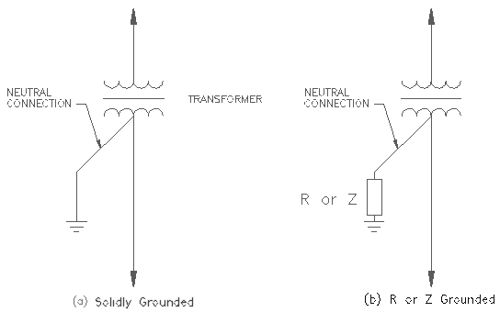
Figure 1-22. Grounding for Systems with One Source of Power:
(a) Solidly Grounded, (b) R or Z Grounded.
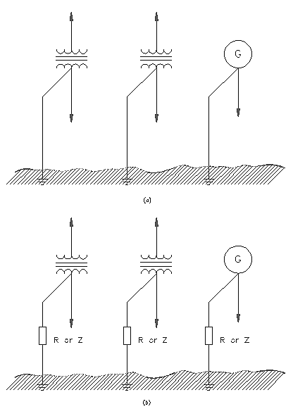
Figure 1-23. Grounding for Systems with Multiple Power Sources (Method 1):
(a) Solidly Grounded, (b) R or Z Grounded.
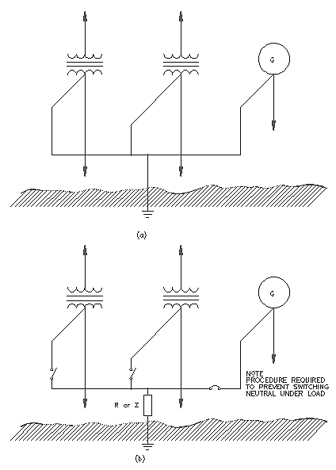
Figure 1-24. Grounding for Systems with Multiple Power Sources (Method 2):
(a) Solidly Grounded, (b) R or Z Grounded.

      - Grounding Locations Specified by the NEC
The following locations for ground connections are required, or permitted, by the NEC for the most common types of power system grounding. This is not intended to be a complete listing of code requirements, and the current edition of the NEC should be consulted for details or recent changes as well as to determine whether grounding is required or prohibited. The purpose of this subclause is to call attention to location requirements and not to interpret the requirements, since that is the province of the cognizant enforcing authorities.
On service-supplied systems of 50 V to 1000 V, system grounding, when required or elected, should be made at the service entrance, between the load end of the service drop or lateral and the neutral landing point. If the service is supplied from a transformer external to the building one additional grounding point is required external to the building. If a grounded conductor extends past the service entrance switch, it should have no further grounds on this extension except as noted by the various exceptions in the NEC to this requirement, as follows.
Where dual services feed a double-ended bus, a single ground at the center point of the neutral bus is allowed to replace those previously listed.
If more than one building is fed from a single service there should be a system grounding connection made at the entrance to each building. However, if an EGC is run with the load conductors, this ground connection can be eliminated so as to avoid elevating non current-carrying enclosures above ground potential due to load drop in the neutral conductor.
Grounding connections should not be located or connected so as to cause objectionable currents in grounding conductors or grounding paths.
Separately derived circuits, if required or elected to have a system ground, should be grounded between the source and the first disconnecting device. System grounding connections downstream of the disconnecting device have the same rules as for service-supplied circuits.
The point of grounding for systems shall be the neutral or common conductor where one exists; otherwise the point shall be a phase conductor.
On systems over 1000 V, a transformer-derived neutral may also be used as the attachment point for a system ground. This method is not mentioned for effective grounding of low-voltage systems.
High-voltage and medium voltage systems may also have multiple neutral grounds where the conductors are overhead outdoors or where they are directly buried with a bare neutral conductor.
      - Equipment grounding (Red 7.3)
Equipment grounding pertains to the system of electric conductors (grounding conductor and
ground buses) by which all non-current-carrying metallic structures within an industrial plant
are interconnected and grounded. The main purposes of equipment grounding are as follows:
- To maintain low potential difference between metallic members, minimizing the possibility of electric shocks to personnel in the area (bonding);
- To contribute to superior protective device performance of the electric system, safety of personnel and equipment; and
- To avoid fires from volatile materials and the ignition of gases in combustible atmospheres by providing an effective electric conductor system for the flow of ground- fault currents and lightning and static discharges to essentially eliminate arcing and other thermal distress in electrical equipment.
All metallic conduits, cable trays, junction boxes, equipment enclosures, motor and generator frames, etc., should be interconnected by an equipment grounding conductor system that will satisfy the foregoing requirements. The rules for achieving these objectives are given in the NEC and the NESC. These rules should be considered as minimum, and in some cases other grounding and bonding means should supplement those requirements.
Previous practice for effecting equipment grounding within an industrial facility was to first establish an external grounded loop, or a series of interconnected grounded loops, about the building and then connect or bond every electrical device to that loop. While such practice meets bonding rules, it does not always provide a path of least impedance. This happens because the path for the ground fault is usually not adjacent to the phase conductor, and that introduces additional reactance in the ground path.
In order to assure a low impedance for the grounding conductor, it is important that the grounding conductor be run adjacent to the power cables with which it is associated; i.e., in the same conduit or the same multi-conductor cable as the power conductors.
An equipment grounding conductor should be routed with the circuit phase conductors supplying a circuit. This will achieve the desired low-impedance path necessary for safe operation. Since the earth has an unknown resistance value, it should not be used for a return path.
When an insulation failure occurs along an electric power circuit, causing an electrical connection between the energized conductor and a metal enclosure, there exists a tendency to raise the enclosure to the same electrical potential that exists on the power conductor. Unless all such enclosures have been grounded, in an effective manner, an insulation breakdown will cause dangerous electric potential to appear on the enclosure creating an electric shock hazard to anyone touching it. The energy released during an arcing ground fault may be sufficient to cause a fire or explosion or serious flash burns to personnel. Proper setting of ground relays and intentional grounding of the metallic enclosures in a manner that assures the presence of both adequate ground-fault current capacity and a low value of ground-fault circuit impedance will interrupt the flow of ground-fault current and will thus minimize electric shock and fire hazards (Kaufmann 1954 [B3 1]).
Figures 7-1 and 7-2 show typical system and equipment grounding for a three-phase electric system. Solidly grounded, resistance-grounded, and ungrounded systems all have the same equipment grounding requirements. The equipment grounding conductors are connected to provide a low-impedance path for ground-fault current from each metallic enclosure or from equipment to the grounded terminal at the transformer (figures 7-1 and 7-2). The impedance of the complete ground-fault circuit should be low enough to ensure sufficient flow of ground-fault current for fast operation of the proper circuit protective devices, and to minimize the potential for stray ground currents on solidly grounded systems. To provide a ground-fault current path of low impedance and adequate capacity, either the cross-sectional area of the raceway must be large or a parallel grounding conductor must be run inside the raceway (see figure 7-2). As shown in figures 7-3 and 7-4, equipment grounding conductors are also required in resistance-grounded and ungrounded systems for personnel shock protection. The grounding conductors must provide paths of sufficient capacity to operate protective devices when phase-to-phase or phase-to-ground faults occur at different locations on a power system.
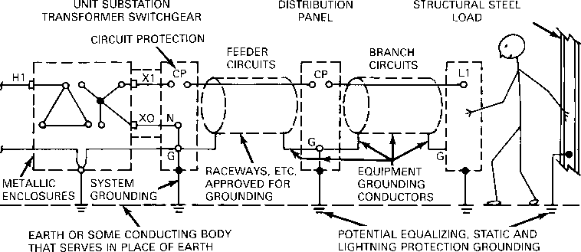
Figure 7-1 —Grounding arrangement for ground-fault protection in
solidly grounded system, three-phase, three-wire circuits
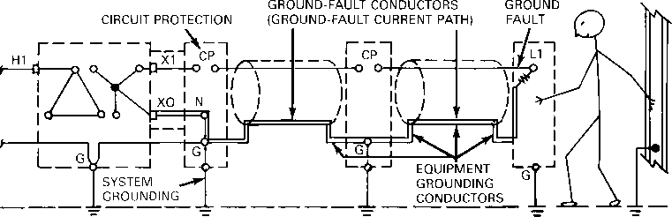
Figure 7-2—Fault-current path through ground-fault conductors in
solidly grounded system, three-phase, three-wire circuits
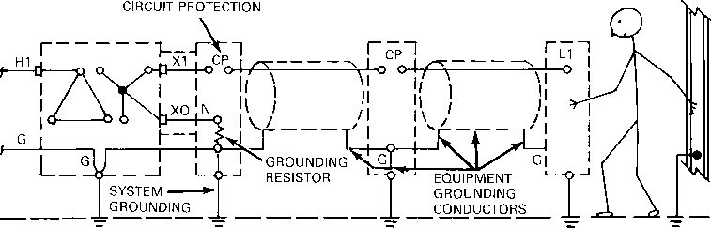
Figure 7-3—Grounding arrangement for ground-fault protection in
resistance-grounded system, three-phase, three-wire circuits
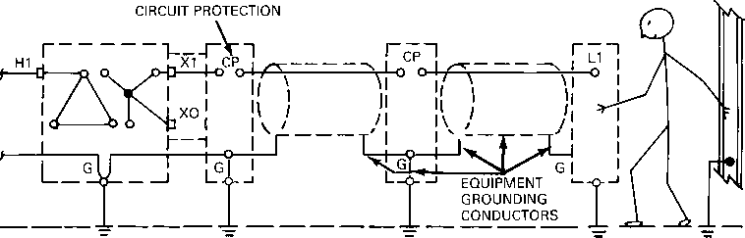
Figure 7-4—Grounding arrangement for ground-fault protection in
ungrounded system, three-phase, three-wire circuits
Economics and operating requirements have resulted in an increasing number of industrial plants owning and operating the transformer substation connecting the industrial plant with the electric utility. In addition to providing the proper equipment grounding in such a substation, step and touch potentials also must be maintained at a safe level. An appropriately designed grounding mat has traditionally served the purposes of providing for both the safety of personnel in and near the substation and proper grounding of the substation equipment. Empirical methods have been used extensively in the past for ground mat design due to the great number of calculations required for a perfectly rigorous ground mat analysis. Computer programs have added to the accuracy and ease of ground mat design. Persons involved in substation grounding are advised to refer to IEEE Std 80-1986 [B20] for substation grounding design requirements and detailed calculation procedures. See Meliopous 1988 [B 32].
The ground grid of the utility substation is often interconnected with the industrial plant grounding system, either intentionally by overhead service, or a buried ground wire or unintentionally through cable tray, conduit systems, or bus duct enclosures. As a result of this interconnection, the plant grounding system is elevated to the same potential above remote earth as the substation grid during a high-voltage fault in the substation. Dangerous surface potentials within an industrial plant as well as within the substation also must be prevented. In certain cases, hazardous surface potentials may be eliminated by effectively isolating the substation ground system from the plant ground system. In most cases, integrating the two grids together and suitably analyzing both systems for step and touch potentials have reduced these potentials to acceptable levels.
        - 7.3.1 Computer grounding (Red 7.3)
A new IEEE Color Book, IEEE Std 1100-1992 (the Emerald Book) [B26], which deals with powering and grounding sensitive electronic equipment, has recently been published.
Computers are used in industry process control, accounting, data transmission, etc. Computer system grounding is very important for optimum performance. It requires coordination with power-conditioning equipment, communication circuits, special grounding requirements of computer logic circuits, and surge arresters.
Computer manufacturers specify grounding techniques for their equipment but some are inconsistent, do not follow known grounding practices, or violate the requirements of the NEC and OSHA. Mutually acceptable solutions can be achieved by returning to fundamental principles of grounding. See IEEE Std 1100-1992 [B26] and IEEE Std 142-1991 [B23].
Computer system grounding accomplishes multiple functions, such as safety to operating personnel, a low-impedance fault-return path, and maintenance of the equipotential ground of all units of a computer system.
Connecting the frames of all units of a computer system to a common point should ensure that they stay at the same potential. Connecting that point to the ground should ensure that the equipotential is also ground potential. These objectives are achieved when the units are connected to an ac power source and include a safety equipment ground conductor in each cable or conduit that carries power that comes from a common source (IEEE Std 142-1991 [B23]; IEEE Std 1100-1992 [B26]; Kalbach 1981 [B29]).
However, when there is more than one power source, each with its separate ground, this system will create "noise" currents in the grounding systems that are connected to the units of the computer system. In such cases, a signal reference grid may be used. This grid may be a large sheet of copper foil installed under the computer or a 2 ft by 2 ft mesh of copper conductors laid out on the subfloor (see figure 7-5) to equalize the voltage over a broader frequency range. All computer units should be bonded to this grid in addition to the equipment ground conductor. The signal reference grid is grounded to the same central grounding point as the frames of the system components.
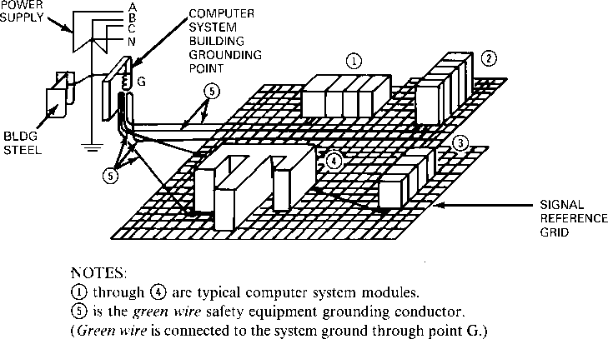
Figure 7-5—Computer units connected to
signal reference grid and to ac ground
An alternative signal reference grid could be a raised floor metal supporting structure, which is electrically conducting and suitably bonded at all joints. All precautions outlined in IEEE Std 142-1991 [B23] and Kalbach 1981 [B29] should be followed for the application of a signal reference grid.
Preferred methods of grounding the following types of equipment are given in detail in Chapter 2 of IEEE Std 142-1992 [B23]:
- Structures
- Outdoor stations
- Large generators and motor rooms
- Conductor enclosures
- Motors
- Portable equipment
- Surge/lightning protective devices
In many specific types of installations, the applicable national, state, or local electrical codes prescribe such grounding practices as a mandatory requirement.
      - Static and lightning protection grounding (Red 7.4)
        - Static grounding (Red 7.4)
Industrial plants handling solvents, dusty materials, or other flammable products often have a potentially hazardous operating condition because of static charge accumulating on equipment, on materials being handled, or even on operating personnel.
The discharge of a static charge to ground or to other equipment in the presence of flammable or explosive materials is often the cause of fires and explosions, which result in substantial loss of life and property each year.
The simple solution of grounding individual equipment is not always the solution to the problem and is not always possible in many processes. Each installation should be studied so an adequate method of control may be selected.
The protection of human life is the prime objective in the control of electrostatic charges. In addition to the direct danger to life from explosion or fire created by an electrostatic discharge, there is the possibility of personal injury from being startled by an electric shock. This may in turn, induce an accident such as a fall from a ladder or platform.
Another objective in controlling static electricity is the avoidance of
- Investment losses, buildings, contained equipment, or stored materials
- Lost production, idle workers, delivery penalties (real or intangible)
The avoidance of losses by providing electrostatic control in this manner represents good insurance. EMI (electric magnetic interference) emanating from static electric discharges can cause interference with sensitive electronic equipment, including critical control and communications equipment.
An additional reason to implement effective electrostatic control may be to assure product quality. For example, static charges in grinding operations can prevent grinding to the degree of fineness desired in the finished product. In certain textile operations static charges may cause fibers to stand on end instead of lying flat, resulting in an inferior product.
Material handled by chutes, conveyors, or ducts has been known to develop and accumulate static charges, causing the material to cling to the surfaces of the chutes or ducts and thereby clog openings or create increased friction to wear surfaces. Static charges on persons can result in damage to sensitive electronic components or corruption of valuable data. Static problems in printed circuit board manufacturing or assembly is controlled by having the personnel grounded through 1Ð5 M Ù resistor by the wearing of wrist straps.
Chapter 3 of IEEE Std 142-1982 contains a detailed treatment of the following topics:
- Purpose of static grounding
- Fundamental causes of static, magnitudes, and conditions required for a static charge to cause ignition
- Measurement and detection of static potentials
- Hazards in various facilities and mechanisms
- Recommended control methods
Also see ANSI/NFPA 77-1988.
        - Lightning-protection grounding (Red 7.4)
Lightning-protection grounding is concerned with the control of current discharges, in the atmosphere, originating in cloud formations, to earth. The function of the lightning grounding system is to convey these lightning discharge currents safely to earth without incurring damaging potential differences across electrical insulation in the industrial power system, without overheating lightning grounding conductors, and without the disruptive breakdown of air between the lightning ground conductors and other metallic members of the structure (ANSI/ NFPA 780-1992 [B3]; AIEE Committee Report 1958 [B1]; Fagan and Lee 1970 [B14]).
A lightning risk evaluation should be made to determine if lightning protection should or should not be installed. The risk evaluation considers
- Human occupancy
- Exposure/structural factors affecting safety
- Type of construction
- Use and value of contents
- Degree of exposure and isolation
- Feasibility/practical factors
- Thunderstorm frequency
- Ground area covered
Lightning represents a vicious source of overvoltage. It is capable of discharging a potential of one half million volts or more to an object. The current in the direct discharge may be as high as 200 000 A. The rate at which this current builds up may be as much as 10 000 A/jis.
The presence of such high-magnitude fast-rising surge current emphasizes the need for high- discharge capability in surge arresters and low impedance in the connecting leads. For example, should a direct lightning stroke contact a lightning rod or a mast on an industrial building and encounter an inductance of as little as 1 iH with a current buildup rate of 10 000 A/jis, could result in a 10 000 V potential drop across this inductance. Lightning protection consists of placing suitable air terminals or diverter elements at the top of or around the structure to be protected, and connecting them by an adequate down conductor to the earth itself. (In lightning terminology a "down conductor" is the conductor serving as a lead going down to earth. It is not, as in utility terms, a broken power line.)
The down conductor (1) must have adequate current-carrying capacity and (2) must not include any high-resistance or high-reactance portions or connections and (3) should present the least possible impedance to earth. There should be no sharp bends or loops in surge-protective grounding circuits. Bend radii should be as large as possible, since sharp bends increase the reactance of the conductor. Reactance is much more critical than resistance, because of the very high frequency of the surge front.
Remote lightning strikes can induce dangerous surges in nearby cable, can cause malfunction of control circuits, and can cause electronic interference. Surge arresters and surge capacitors, properly applied, can reduce the effects of these induced surges. Ground currents caused by lightning strikes can cause large differentials of potential between different earth points, causing high currents in cable sheaths and high voltages between cable phase conductors and ground.
          - Zone of protection (Red 7.4)
In past standards the cone of protection was believed to be an angle of either 45¡ or 60¡ from the vertical air terminal depending on the probability of protection desired. Any area under the imaginary line drawn from the top of the air terminal, at the angle of the degree of protection sought, was considered protected from a lightning strike. The current standard (ANSI/ NFPA 780-1992) uses an imaginary rolling ball (sphere). The radius of this rolling sphere, is 45 m (150 ft). With the sphere resting on two points, any area under the sphere is considered to be in the zone of protection. To improve the degree of probability of protection, the radius is decreased.
There are several methods of lightning protection, such as
- Franklin air terminal
- Faraday cage
- Early emission (ionizing) streamer
- Eliminator, deterrent, sphere, ball
          - Air terminals (Red 7.4)
The Franklin air terminals are connected to cross conductors and down conductors. The cross conductors and down conductors constitute a Faraday cage. The Franklin air terminal and the Faraday cage are combined to form a complete system and referred to by several terms, air terminal system, Faraday cage and/or the Franklin method or the Fortress concept. Steel- framed structures, adequately grounded, meet the above requirements with the addition of air terminals. Typically the air terminals are spaced 6 m (20 ft) to 7.6 m (25 ft) apart on the edge of the structure and 15 m (50 ft) on the interior of the roof. Cross connections are made at 45 m (150 ft). Without a steel framework, down conductors must provide at least two paths to earth for a lightning stroke to any air terminal (ANSI/NFPA 780-1992).
          - Early emission ionizing streamer (Red 7.4)
Ionization lightning conductor technology dates back to 1914. A patent was issued in 1931. In 1953 Alphonse Capart, the son of the inventor, improved this device. Early-emission ionizing-streamer lightning-protection devices are considered dynamic devices compared to the Franklin cone or the Faraday cage. Radioactive sources are used to obtain ionization of the air around the tip of the air terminal. The theory states that the radioactive ionization terminal produces a rising air stream. This column acts as an extended air terminal reducing the tension or, if the potential is sufficient, a conductive streamer is provided (Heary 1988 [B 18]). The effect is a tall Franklin air terminal with a large zone of protection. Two down conductors are required for each ionizing "mast."
          - Eliminator, deterrent, system (Red 7.4)
This controversial method has been in existence for 20 years. The National Fire Protection Association (NFPA) Standards Council at their meeting in June/July 1988 [Action 88-39], denied acceptance of this method based on lack of technical justification and the lack of specific code language. NFPA also called this method "scientifically unconfirmed technology.' Mounted on each air terminal is an array of spikes emanating from the center of the air terminal. The theory is to dissipate the charge. Its success relies on a very effective use of the Faraday cage concept and excellent grounding practices.
          - Down conductors (Red 7.4)
Locations of down conductors will depend on the location of air terminals, size of structure being protected, most direct coursing, security against damage or displacement, and location of metallic structures, water pipes, grounding electrode, and ground conditions. If the structure has metallic columns, these columns will act as down conductors. The air terminals must be interconnected by conductors to make connection with the columns. The average distance between down conductors should not exceed 30 m (100 ft).
Every down conductor must be connected, at its base, to an earthing or grounding electrode. This electrode needs to be not more than 0.6 m (2 ft) away from the base of the building. The electrode should extend below the building foundation if possible. The length of the grounding conductor is highly important. A horizontal run of, say, 15.2 m (50 ft) to a better electrode (such as a water pipe) is much less effective than a connection to a driven rod alongside the structure itself. Electrodes should contact the earth from the surface downward to avoid flashing at the surface. Earth connections should be made at uniform intervals about the structure, avoiding as much as possible the grouping of connections on one side. Properly made connections to earth are an essential feature of a lightning rod system for protection of buildings.
The larger the number of down conductors and grounding electrodes, the lower will be the voltage developed within the protection system, and the better it will perform. This is one of the great advantages of the steel-framed building. Also, at the bottom of each column is a footing, a very effective electrode. However, internal column footings of large buildings dry up and can become ineffective since they seldom are exposed to ground water.
Interior metal parts of a nonmetal-framed building that are within 6 ft (1.8 m) of a down conductor need to be connected to that down conductor. Otherwise, they may sustain side-flashes from it, incurred because of voltage drop in the lower portion of that down conductor and electrode. It is important to tie together all ground rods and other metallic structures entering the earth; otherwise lightning strikes (even remote ones) can cause serious differences of potential representing a danger to personnel and equipment.
It is highly desirable to keep the stroke (lightning) current away from buildings and structures involving hazardous liquids, gases, or explosives. Separate diverter protection systems should be used for tanks, tank farms, and explosive manufacture and storage. The diverter element is one or more masts, or one or more effectively grounded elevated wires between masts that are effectively grounded.
Tanks not protected by a diverter system should be well grounded to conduct the current of direct strokes to earth.
Lightning protection of power stations and substations includes the protection of station equipment by surge arresters. (Refer to Chapter 3 of IEEE Std 142-1991 [B23].) These arresters should be mounted on, or closely connected to, the frames of the principal equipment that they are protecting. They also may be mounted on the steel framework of the station or substation where all components are closely interconnected by the grounding grid. The surge arrester grounding conductor should be as short and straight as possible and connected to the common station ground bus. The NEC requires that an AWG No. 6 (4.11 mm diameter for solid or 4.67 mm diameter for stranded) or larger conductor be used. Larger sizes may be desirable with larger systems, based on the magnitude of power follow current.
      - Connection to earth (Red 7.5)
        - General discussion (Red 7.5)
To improve the connection to earth and to reduce the resistance to earth, two or more ground rods are suggested. As described in IEEE Std 142-1991 [B23], the distance between the two rods must be the depth of the first rod plus the depth of the second rod. Numerous books and articles show the distance between two standard length 8 or 10 ft rods to be 3 m (10 ft), which is incorrect.
Connections to earth having acceptably low values of impedance are needed to discharge lightning stroke currents, dissipate the released bound charge resulting from nearby strokes, and drain off static voltage accumulations (Chapter 4 of IEEE Std 142-1991 [B23]).
The presence of overhead high-voltage transmission circuits may introduce a requirement for a connection to earth to safely pass the ground-fault current that would result from a broken phase conductor falling on some part of the building structure.
To a great extent the internal electric distribution system installed within commercial build-
ings and industrial plants is entirely enclosed in grounded metal. Except for cable tray systems, conductors are enclosed in metallic conduit, metallic armor, or metal raceway. The other electric elements of equipment and machines can be expected to be encased in metal cabinets or metallic machine frames. All of these metallic enclosures and cable trays will be interconnected. The metallic enclosures will be bonded to other metallic components within the area, such as building structural members, piping systems, messenger cables, etc. Thus the local electric system will be self-contained within its own shell of conducting metal.
An electrical system can be designed to operate adequately and safely without any direct connection to earth itself. This can be likened to the electric distribution system as installed on an airplane. The airplane structure constitutes an adequate grounding system. No connection to earth is needed to achieve an adequate, safe electric system. Space vehicles and airplanes operate electrical systems and usually several computer systems without any connection to earth.
        - Recommended acceptable values (Red 7.5)
The most elaborate grounding system that can be designed may prove to be inadequate unless the connection of the system to the earth is adequate and has a low resistance (AIEE Committee Report 1958). The earth connection is one of the most important parts of the grounding system. It is also the most difficult part to design and to obtain.
The perfect connection to earth would have zero resistance, but this is impossible to obtain. Ground resistances of less than 1 Ù can be obtained, although such a low resistance may not be necessary. The resistance required varies inversely with the fault current to ground. The larger the fault current, the lower the resistance must be.
For larger substations and generating stations, the earth resistance should not exceed 1 Ù . For smaller substations and for industrial plants, in general, a resistance of less than 5 Ù should be obtained, if practical. The NEC, Article 250, approves the use of a single made-electrode for the system-grounding electrode, if its resistance does not exceed 25 Ù .
        - Resistivity of soils (Red 7.5)
The resistivity of the earth is a prime factor in establishing the resistance of a grounding electrode. The resistivity of soil varies with the depth from the surface, with the moisture and chemical content, and with the soil temperature. For representative values of resistivity for general types of soils and the effects of moisture and temperature, see Chapter 4 of IEEE Std 142-1991 [B23] and appendix B of the NEC.
        - Soil treatment (Red 7.5)
Soil resistivity may be reduced anywhere from 15Ð90% by chemical treatment, depending upon the kind and texture of the soil. There are several chemicals suitable for this purpose, including sodium chloride, magnesium sulfate, copper sulfate, and calcium chloride. Common salt and magnesium sulfate are most commonly used.
Chemicals are generally applied by placing them in the circular trench around the electrode in such a manner as to prevent direct contact with the electrode. While the effects of treatment will not become apparent for a considerable period, they may be accelerated by saturating the area with water. Also, such treatment is not permanent and must be renewed periodically, depending on the nature of chemical treatment and the characteristics of the soil.
        - Existing electrodes (Red 7.5)
All grounding electrodes fall into one of two categories: those that are an inherent part of the structure or its foundation, and those that have been specifically installed for electrical grounding purposes.
The NEC, Article 250, designates underground metal water piping, available on the premises, as part of the required grounding electrode system. This requirement prevails regardless of length, except that when the effective length of buried pipe is less than Ò10 ft (3.05 m) ," it shall be supplemented with an electrode of the type named in Article 250, Section 250-81.
For safety grounding and for small distribution systems where the ground currents are of relatively low magnitude, such buried metal water pipe electrodes are used because they exist and are economical in first cost. However, before reliance can be placed on any electrodes of this group, it is essential that their resistance to earth be measured to ensure that some unforeseen discontinuity has not seriously affected their suitability. The use of plastic pipe in new water systems and of wooden ones in older systems will eliminate the grounding value of the electrode. Even iron or steel piping may include gaskets that act as insulators. Sometimes small metal (brass) wedges are used to ensure electrical continuity. These wedges should be replaced when repairs are made. Interior piping systems that are likely to become energized must be bonded to the electric system grounding conductor. If the piping system contains a member designed to permit easy removal, such as a water meter, a bonding jumper must be installed to bridge the removable member.
The recent increase in the use of plastic pipes for water supply to buildings removes one of
the most common sources of complaint by the water utilities. The absence of buried metal
piping, however, demands that some other suitable grounding electrode be located or created.
        - Concrete-encased grounding electrodes (Red 7.5)
Concrete below ground level is a good electrical conductor, as good as moderately low-resistivity earth. Consequently, metal electrodes encased in such concrete will function as excellent grounding electrodes (Fagan and Lee 1970 [B 14]; Wiener 1970 [B38]). (See also the NEC, Article 250, Section 250-81 (c).) In areas of poor soil conductivity, the beneficial effects of the concrete encasement are most pronounced.
To create a made electrode by encasement of a metal electrode in concrete would probably
not be economical, but most industrial establishments employ much concrete-encased metal
below grade for other purposes. The reinforcing steel in concrete foundations and footings
are good examples. The concrete encasement of steel, in addition to contributing to low- grounding resistance, serves to immunize the steel against corrosive disintegration, such as would take place if the steel was in direct contact with the earth (NEC). Though copper and steel are in contact with each other within the bed of moist concrete, destructive disintegration of the steel member does not take place.
Steel reinforcing bars (re-bars) in foundation piers usually consist of groups of four or more vertical members held by horizontal spacer square rings at regular intervals. The vertical members are wired to heavy horizontal members in the spread footing at the base of the pier. Measurements show that such a pier has an electrode resistance of about half the resistance of a simple ground rod driven to the same depth in earth. Electrical connection to the re-bar system is conveniently made by a bar welded to one vertical re-bar and a J-bolt for the column base plate. The J-bolt then becomes the electrode connection. A weld to a re-bar at a point where the bar is in appreciable tension is to be avoided.
Usually such footings appear every 4.6 m (15 ft) by 6 m (20 ft) in all directions in industrial buildings. A good rule of thumb for determining the effective overall resistance of the grounding mat is to divide the resistance of one typical footing by half the number of footings around the outside wall of the building. (Inner footings aid little in lowering the overall resistance.)
Copper cable embedded in concrete is similarly beneficial, a fact that may be of particular value under circumstances of high earth resistivity.
        - Made electrodes (Red 7.5)
Made electrodes may be subdivided into driven electrodes, buried strips or cables, grids, buried plates, and counterpoises. The type selected will depend upon the type of soil encountered and the available depth. Driven electrodes are generally more satisfactory and economical where bedrock is 3 m (10 ft) or more below the surface, while grids, buried strips, or cables are preferred for lesser depths. Increasing the diameter of a ground rod has little effect, while increasing the length of the rod has a significant effect on reducing the resistance to earth. Grids are frequently used for substations or generating stations to provide equipotential areas throughout the entire station where hazards to life and property would justify the higher cost. They also require the least amount of buried material per ohm of ground conductance. Buried plates have not been used extensively in recent years because of the higher cost compared to rods or strips. Also, when used in small numbers, they are the least reliable type of made electrode. The counterpoise is a form of the buried cable electrode, and its use is generally confined to locations having high-resistance soils, such as sand or rock, where other methods are not satisfactory.
Discussions on methods of calculating resistance to earth, current-loading capacity of soils, recommended methods and techniques of constructing connections to earth, and the testing of the resistance of electrodes may be found in Chapter 4 of IEEE Std 142-1991 [B23].
        - Galvanic corrosion (Red 7.5)
There has developed an increased awareness of possible aggravated galvanic corrosion of buried steel members if cross-bonded to buried dissimilar metal, such as copper (Colman and Frostick 1955 [B9]; Hertzberg 1970 [B19]; Zastrow 1967 [B39]).
The result has been a trend to seek a design of electrical grounding electrode that is, galvanically, neutral with respect to the steel structure. In some cases, the grounding electrode design employs steel-exposed metal electrodes with insulated copper cable interconnections (Colman and Frostick 1955).
The corrosion of buried steel takes place even without a cross connection to buried dissimilar metal. The exposed surface of the buried steel inherently contains bits of dissimilar conducting material, foreign metal fragments, or slag inclusions, which create local galvanic cells and local circulating currents. At spots where current leaves the metal surface, metal ions leave the parent metal and account for destructive corrosion. The cross-bonding to dissimilar metal may aggravate the rate of corrosion, but is not the only cause for the action.
Electrical engineering technology should recognize the problem and seek grounding electrode designs that will produce no observable increase in the rate of corrosive disintegration of nonelectrical buried metal members. An overriding priority dictates that the electrical grounding electrode itself not suffer destruction by galvanic corrosion. Relative economics will be an inevitable factor in the design choice.
A timely release of new knowledge bearing on this problem is the electrical behavior pattern of concrete-encased metal below grade (see 7.5.6). The relationship of concrete-encased steel re-bar to galvanic corrosion is as follows:
- There is generally an extensive array of concrete-encased steel-reinforcing members within the foundations and footings, which collectively account for a huge total surface area, resulting in extremely low-current density values at the steel surface.
- The concrete-encased re-bars themselves constitute an excellent, permanent, low- resistance earthing connection with little or no economic penalty.
- Current flow across the steel-concrete boundary does not disintegrate the steel as it would if the steel was in contact with earth.
      - Ground resistance measurement (Red 7.6)
The ground resistance as defined in IEEE Std 142-1991 [B23] is ". .the ohmic resistance between it (ground electrode) and a remote grounding electrode of zero resistance." Thus, ground resistance is the resistance of the soil to the passage of electric current from the electrode into the surrounding earth.
Grounding system resistance, expressed in ohms, should be measured after a system is
installed and at periodic intervals thereafter. Usually, precision in measurement is not
required. Measurement of ground resistance is necessary to verify the adequacy of a new grounding system with the calculated value, and to detect changes in an existing grounding system. It is important that specified or lower resistance be obtained, since all calculations for personnel and equipment safety are based on the specified grounding resistance. The margin of safety will be reduced if the resistance exceeds the specified value.
Three components constitute the resistance of a grounding system:
- The resistance of the grounding electrode conductor and grounding conductor connection to the electrode;
- Contact resistance between the grounding electrode and the soil adjacent to it;
- The resistance of the body of earth immediately surrounding the electrode.
Grounding electrodes are usually of sufficient size or cross section, and grounding connections are usually made by proven clamps or welding, so that their resistance is a negligible part of the total resistance. If the grounding electrode is free from paint or grease and the earth is packed firmly around the electrode, contact resistance is also negligible. Rust on an iron electrode has little or no effect.
When the current flows from a grounding electrode to earth, it radiates current in all directions. It can be considered that current flows through a series of concentric spherical like earth shells, all of equal thickness, surrounding the grounding electrode. The shell immediately surrounding the electrode has the smallest cross-sectional area and so offers greatest resistance. As the distance from the electrode increases, each shell becomes correspondingly larger in cross-section and offers less resistance. Finally, a distance from the electrode is reached where additional shells do not add significantly to the total ground resistance. Therefore, the resistance of the surrounding earth is the largest component of the resistance of a grounding system.
To improve the connection to earth and to reduce the resistance to earth, two or more ground rods are suggested. As described in IEEE Std 142-1991 [B23], the distance between the two rods must be the depth of the first rod plus the depth of the second rod. Numerous books and articles show the distance between the two standard length 8 or 10 ft rods to be 3 m (10 ft), which is incorrect.
It is possible to calculate the resistance of any system of grounding electrodes. Several factors can affect the calculated value due to considerable variation in soil resistivity at a given location and time. Soil resistivity depends on soil material, the moisture content, and the temperature. If all factors are considered, formulas for calculating the performance of grounding systems become very complicated and involve so many indeterminate factors that they are of little value. Many formulas have been developed, but they are only useful as general guides. The actual ground resistance of a grounding system can be determined only by measurement.
      - Methods of measuring ground resistance (Red 7.6)
This section covers only commonly used methods of measuring ground resistance. The
ohmic value measured is called resistance; however, there is a reactive component that
should be considered when the ohmic value of the ground under test is less than 0.5 Ù , as in the case of large substation ground grids. This reactive component has little effect on grounds with an impedance higher than 1 Ù .
          - Equipment and material (Red 7.6)
Equipment and material required for ground-resistance measurement are as follows:
- Ground resistance can be measured by commercially available, self-contained instruments, which give readings directly in ohms. These instruments are small and very easy to use because they require no external power source. They are equipped either with batteries or a generator. If necessary, however, approximate results can be obtained with a portable ac ammeter and voltmeter where power supply and transformer with nominal 120 V secondary (to isolate the grounding system under test from the grounding system of the power supply) is available at the location where measurements are to be made. However, it is not easy to obtain accurate results with an ammeter and voltmeter at energized stations.
- Two auxiliary test electrodes in addition to the ground electrode (or ground mat) under test
- Flexible single-conductor cable AWG No. 14 or larger, at least 600 V rated, of sufficient length
- Alligator clips for connecting test leads
- Lineman gloves (optional)
- A field notebook
It is recommended that manufacturer's instructions be followed when connecting the leads to the measuring instrument and taking measurements. Test circuits shown in the following paragraphs are for reference only.
          - Methods of measurement (Red 7.6)
Four most commonly used methods of measuring and testing ground resistance are described as follows:
- Fall of potential method. This involves the passing of a current of known magnitude through the grounding electrode (or grounding network) under test and an auxiliary current electrode, and measuring the influence of this current in terms of voltage between the electrode under test and a second auxiliary potential electrode. (See figure 7-6.)
For a large grounding network, both current and potential electrodes should be placed as far from the grounding network under test as practical (depending on the geography of the surroundings), so that they are outside the influence of the ground to be tested. A distance of 750 to 1000 ft or more from the grounding network is recommended for grounding mats with dimensions in the order of 300 ft by 300 ft. This is required to obtain measurements of adequate accuracy. The potential electrode, for large grounding networks (low-resistance
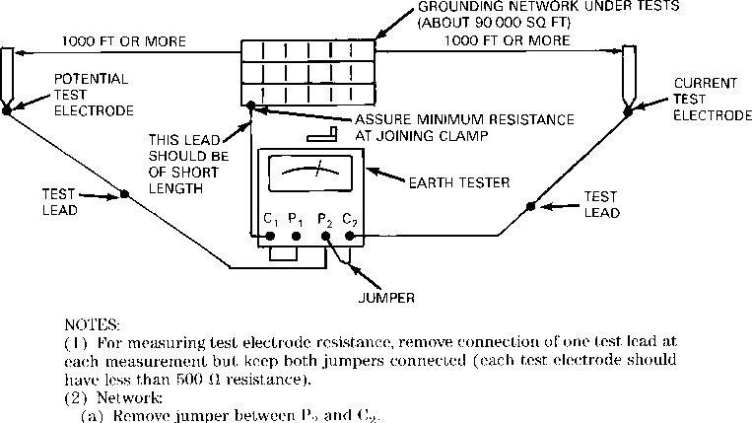
Figure 7-6—Test circuit for measuring test electrode resistances
and resistance of the large grounding network
grounds), should be driven at several points. Resistance readings are then plotted for each point as a function of distance from the grounding network, and a curve is drawn. The value in ohms at which the plotted curve appears to level off is taken as the resistance of the grounding network under test. When it is found that the curve is not leveling off, the current electrode should be moved farther from the grounding electrode under test. However, for a high-resistance ground, there is no preferred placement of electrodes, and the most practical placement of electrodes should be chosen.
The resistance between the ground network (electrode) under test and the auxiliary electrodes should be measured as shown in figure 7-6. The resistance measured should be no more than 500 Ù for increased accuracy in the measurement of low-resistance ground network. To obtain the lowest possible auxiliary electrode resistance, locate the electrodes in moist locations, such as drainage ditches or ponds, or drive two or more rods spaced 3 or 4 ft apart. The test probes need to be driven a foot or two into the earth.
After checking the auxiliary electrodes' resistance, connect test probes to the instrument as shown in figure 7-6 for measuring ground resistance of the grounding network (electrode) under test. Reverse connections at the instrument and take another reading. The difference in both readings should be less than 15%, otherwise auxiliary electrodes should be moved farther away from the ground network (electrode) under test.
This method should be used for large substations, industrial plants, and generating stations where grounding network resistance is usually less than 1 Ù .
For a small ground mat or single-rod-driven electrode, the influence of the ground to be tested is assumed to be negligible about 100 to 125 ft from the rod under test. The current electrode can be placed about 100 to 125 ft from the ground rod under test. To measure earth resistance of a single rod driven electrode or small ground mat, the potential electrode can be placed midway between the current electrode and the ground electrode under test as shown in figure 7-7. The exact distance for the potential probe is 62% of the distance from the point under test to the current probe. Readings with the circuit as connected are taken.
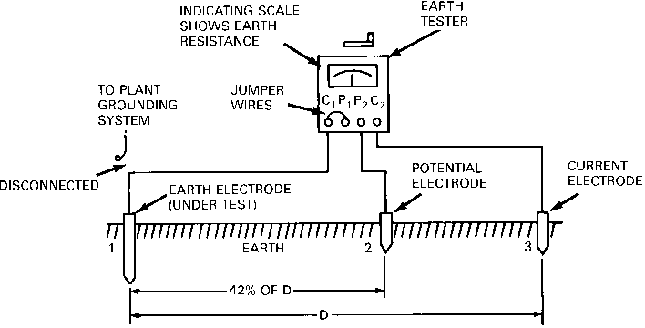
Figure 7-7—Test circuit for measuring earth resistance of
ground rod or small grid—fall of potential method
This method should be used for a single-rod electrode or small ground mat and where the earth electrode under test can be separated from the water-pipe system, which usually has negligible ground resistance.
- Two-point method. The two-point method is usually used to determine the resistance of a single grounding rod driven near a residence where it is necessary to know only that a given grounding electrode's resistance to earth is below a stipulated value, for instance, 25 Ù or less. In this method, the total resistance of the unknown and an auxiliary grounding rod, usually existing metallic water-pipe system (with no insulating joints), is measured. Since the water-pipe system's resistance is considered negligible, the resistance measured by the meter will be that of the grounding electrode under test. (See figure 7-8.)
This method is subject to large errors for low-resistance grounding networks but is very useful and adequate where a go, no-go type of test is required.
- Three-point method. This method involves the use of two auxiliary electrodes as in the case of fall-of-potential method (see figure 7-7). The resistance between each pair of grounding electrodes in series is measured and designated as R ,
1-2 , R ₁₋₃ , and R 2-3
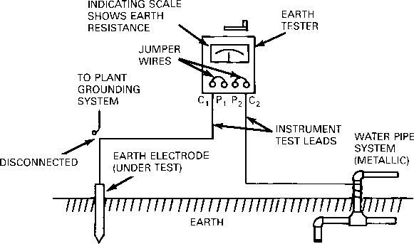
Figure 7-8—Test circuit for measuring earth resistance
of a ground rod—two-terminal method
where R1₋2 is the resistance of the grounding electrode under test and one auxiliary electrode. The resistance of electrode under test can be obtained by solving for R1:
R1Ð2+R1Ð3ÐR2Ð3
R₁ =
2
If two auxiliary electrodes are of higher resistance than the grounding electrode under test, small errors in the individual measurements may result in a large error. For this method the electrodes must be at least 20 ft or more apart, otherwise absurdities may arise in the calculations, such as zero or even negative resistance. Either alternating current of commercial frequency or direct current may be used. When direct current is used, the effect of stray alternating current is eliminated though stray direct current may give a false reading. If alternating current is used, stray alternating current of the same frequency as the test current may introduce an error; however, stray direct currents have no effect. These effects may be minimized by taking a reading with the current flowing in one direction, then reversing the polarity and taking a reading with current flowing in the other direction. An average of these two readings will be an accurate value.
This method is not suitable for large substation grounds, and the fall-of-potential method is recommended.
- Ratio method. This method uses two auxiliary electrodes as in the fall-of-potential method. The resistance of the electrode under test is compared with the known resistance of auxiliary electrodes. This method is not commonly used since it has limitations in measuring low-resistance grounding networks of large area. It is necessary to use the fall-of-potential method for accurate measurements.
It is preferable to measure grounding network resistance before a station is energized. When this is not possible, instruments designed for use at energized stations should be used and necessary precautions should be taken when connecting or disconnecting test leads. Where practical, avoid locations that will cause the test leads to be parallel to transmission lines.
    - Power System Distribution
      - General discussion (White 3.1)
As the medical profession is increasingly more dependent upon complex electrical equipment and instrumentation for patient care and facility operation, the proper design of electrical power distribution systems in health care facilities is most important. The proper selection of the system components, and their arrangement, is critical to providing the health care facility with reliable, safe, and economical electric power.
Total or partial loss of electric power in a health care facility can cause acute operational problems (i.e., power loss to the lighting systems makes it impossible to perform vital medical tasks such as dispensing medicine, performing surgical procedures, or performing precise medical laboratory work). The loss of power to tissue, bone, or blood bank refrigerators can leave the health care facility without these vital resources. Power loss to electrical life support equipment such as heart pumps, medical vacuum pumps, dialysis machines, and ventilators can be fatal. Clearly, continuity of high-quality electric power should be the most important factor in the design of the electrical distribution systems for health care facilities.
Safety is another particularly important design criteria for health care facilities because
- Medical personnel frequently come into contact with electrical apparatus in their daily routines.
- Patients often are very vulnerable to electrical shock hazard because of their weakened condition, because of drugs or anesthesia administered, and/or because of their unconscious state. Electrical shocks that would not severely affect a healthy person could be fatal to a patient.
- It is necessary for maintenance personnel in health care facilities to come in daily or weekly contact with electrical distribution equipment for routine maintenance or minor system additions and renovations.
Maintainability, expandability, and flexibility are also very important design criteria. Hospitals are under increasing financial pressures, and the ability to spend capital dollars wisely is crucial to their overall health. Investments in electrical infrastructure that support maintainability, expandability, and flexibility can significantly contribute to the financial viability of the health care organization. Electrical systems should allow needed preventive and failure maintenance to be done with little disruption to the operations of the hospital. New technologies are always being presented to the medical profession. These new technologies may require additional power, additional support systems, and often, new building areas. The ability to expand, and the flexibility to change, the distribution system to meet these new technologies are also very important design criteria.
This chapter will develop these basic design criteria as they relate to system planning, electrical power systems, voltage considerations, current considerations, grounding, overcurrent protection and coordination, electrical equipment, and installation and system arrangements.
      - Systems planning (White 3.2)
Basic overall systems planning is the first and probably one of the most important phases in the overall design of an electrical power distribution system for a health care facility. During this phase, preliminary design data is gathered from administrators and staff of the health care facility, the local utility, and authorities having jurisdiction (AHJs) over electrical construction. All relevant national, state, and local codes, and facility design guidelines, should be reviewed. Two national codes having a major affect on health care power distribution design are:

National Electrical Code® (NEC®) (NFPA 70)
NFPA 99

In addition, electrical engineers should examine the architectural plans and existing site conditions from an electrical system perspective to determine potential problems and needs. The following subclauses will discuss some of the issues that should be addressed during the system planning phase of the design.
        - Consult with the project architect (White 3.2)
A vital step in systems planning is early and ongoing coordination with the project architect. A first step is giving input to, and providing review of, the preliminary floor plan and schematics from an electrical design perspective. The electrical engineer should be sure to provide informed input to the planners and architects to ensure that the spaces provided will support the needs of the electrical systems. Examples of early coordination input include the following:
- Provide adequate electrical and communication equipment room sizes
- Orient the spaces to minimize electrical costs and to support future maintenance and expansion of the system
- Provide adequate space in other certain areas having significant electrical equipment such as radiology suites or computer rooms
- Ensure electrical rooms have adequate accessibility to the electrical equipment and devices so as to prevent restrictions on equipment removal and installation after initial construction is complete
- Avoid locating “wet areas” near or above electrical or communication rooms
- Telephone/communications/data room size and location requirements need to provide needed working or maintenance clearances
- Provide adequate ventilation, cooling, and/or exhaust needs of electrical/communication rooms
- Provide space for routing of needed raceways, busways, and cable trays
- Plan space for any temporary installation and use of large electrical testing apparatus such as load banks that may be needed in the future

Electrical designers should locate electrical equipment in rooms dedicated to such equipment. Codes then prohibit piping, ductwork, or any architectural appurtenances not serving that room or space (and only those rooms) from passing over or within working clearances of the equipment. Accordingly, the designer needs to work closely with the architect and mechanical engineer to ensure proper placement and utilization of electrical spaces. A common problem to beware of is the location of toilet rooms or mechanical equipment rooms directly over electrical spaces. Planning these rooms in this way will result in the installation of “forbidden” piping or equipment over the electrical gear.
        - Consult with the health care facility staff (White 3.2)
Engineers designing electrical distribution systems should also consult with various representatives of the facility early in the process.
- Facility users. The designer must know the specific functions to be performed in the facility. This information is needed in order to apply the proper codes and to weigh the importance of reliability, quality of electrical power, safety, and economy. For example, the reliability designed into a distribution system serving a hospital that specializes in open-heart surgery would not be justified in an outpatient clinic with no surgical functions. In addition, a facility that extensively utilizes computerized diagnostic, patient records, and accounting systems would require a higher quality of electric power.
- The facility will usually have some plans for the future. These plans could be in the form of preliminary ideas or may be well documented. It is essential that these plans be analyzed and well incorporated into the electrical system design. Depending on budget constraints, additional capacity should at least “set up” the distribution system for future expansion(s).
- Financial and budget representatives; information. The designer must know the financial expectations of the administrators. The administrators will start a project with a budget for the project that will need to be held to in order to allow the business to operate successfully once the project is complete. This budget must be considered in all phases of design in order to assure satisfaction. Such economic constraints, however, do not allow critical needs to be ignored. If the budget is unrealistic, the designer shall call this to the attention of the hospital administrator as soon as possible.
- Health care administrators are concerned with both the one-time capital costs of the projects and the yearly operating costs of the installed systems. Designers should therefore provide information on poth the initial capital requirements and the relative operating expenses of different possible design options. The administration may decide it is better to increase the capital outlay to reduce the facility’s ongoing expenses.
- Facility operations staff: The maintenance/operational staff often have preferences on the types of systems or equipment to be installed in their building(s). The reasons for these preferences are many and varied, and include availability of replacement parts, prevalence of one vendor over another in an existing building, pricing, and levels of support locally available . Whatever the reason, the designer should keep these preferences in mind throughout the system design. If the designer feels that these preferences are unjustified, he or she should review them with the staff during the design process; and if necessary, with the administrators as to the cost, safety, and/or code implications of the staff’s preference.
- The skill, number (relative to facility size), and 24-hour availability of the facility’s maintenance and operations personnel are an important design consideration. For example, if the maintenance personnel for a particular facility does not include skilled electricians, the designer may consider specifying a system that requires minimum maintenance, is relatively simple to operate, or is automated and supervised from a competently staffed remote location (in real time), compared to a system that requires much more maintenance and/or more ongoing operator involvement. Where the skill level of the maintenance staff may compromise the necessary design of the electrical systems to meet the other goals, then electrical designers should consider designs that are simpler and require less operator intervention.
- Future expansion of the facility.
        - Determine the basic loads and demand data (White 3.2)
The designer should begin to tabulate preliminary load data. The preliminary architectural floor plans can be used effectively by superimposing load data on them. The floor plans should show major equipment loads, block loads based on square footage, and any future loads or buildings that the power system should be designed to accommodate. Always allow for load growth even beyond the defined plans for future expansions. See Chapter 2 of this standard for guidance on determining these loads.
In the initial stages of planning, exact load data will seldom be known. However, the designer can estimate probable loads based on existing, similar, health care facilities. Helpful data is listed in Chapter 2 of this recommended practice and in IEEE Std 241™ (IEEE Gray Book™) (Chapters 2 and 16). Also refer to the electrical load data in the handbooks of the American Society of Heating, Refrigerating, and Air-Conditioning Engineers (ASHRAE) [Bn]. The sum of the electrical ratings of each piece of equipment will provide a total “connected load.” Since most equipment will operate at less than full load, and some intermittently, the “connected demand” on the power source is always less than the “connected load.” Standard definitions for these load combinations have been devised and defined in Chapter 2 of this recommended practice, IEEE Std 141™ (IEEE Red Book™), and the NEC. The projected electrical system’s heat loads should always be reviewed with the mechanical engineer to ensure that the air-conditioning system is sized properly for that load.
        - Consult with the local electric power company (White 3.2)
Electrical designers should discuss the proposed health care facility with the relevant power provider to determine their specific requirements and limitations. The power company will be interested in the size of the load demand, the projected power factor, the load factor, and the need for backup service. They will also be interested in the plans for on-site generation, the size of the largest motors and the method of starting (for voltage drop reasons), and any unusual demands or service requirements.
The designer should clearly determine the following:
- Are there any limitations on the size of load the utility can service?
- Will there be any “up-front” charges for supplying power to the facility?
- What type of service does the utility plan to provide? What are their requirements? What is the service history?
  - Single phase (two or three wire), or three phase (three or four wire)
  - Voltage level
  - One circuit or two circuits
  - Overhead or underground services
  - Termination details for their cables and/or overhead lines (phase rotation, circuit labeling, etc.)
  - Space requirements for their equipment (including landscaping, set backs, roadways, etc.)
  - Metering requirements, details, and space requirements. Also are there any loads needing separate meters, etc.?
  - Outage histories of proposed services to evaluate reliability (also confirm “outage” definitions as used in those histories)
- What components of the electrical service will the owner be required to furnish?
  - Primary conduit(s)
  - Primary trenching, backfill, and “markers”
  - Primary cables
  - Transformer(s)
  - Transformer vault(s)
  - Concrete pad(s)
  - Metering and metering conduit
  - Surge arresters and transient voltage surge suppression
  - Environmental protection (noise abatement from transformers, oil spill systems, fire protection, etc.)
  - What is the physical “break line” between utility-supplied and owner-supplied equipment (e.g., property line, last pole, underground vault)?
- What are the utility’s billing rates and rate structure? Following are some general considerations (see Chapter 2 for more details).
- How reliable will the power source be? (Obtain a copy of the utility outage record for the past several years.)
- What will be the maximum and minimum voltage to be expected at their power supply point? (Will voltage regulating equipment be required?) If possible, get a copy of the voltage meter chart.
- May internal generation, if it will exist in the proposed system, be allowed to operate in parallel with the utility? If yes, what are their requirements on relaying, control, metering, and communications?
- What is the maximum short-circuit current available? Ask them to supply three-phase and single-phase-to-ground duties (with the respective X/R ratios) for today’s system, and as expected 5 years into the future.
- What are their protective device coordination requirements?
- Please note that the utility is not required to follow the NEC in providing an electrical service. The utility does normally, however, follow the National Electrical Safety Code® (NESC®) (Accredited Standards Committee C2). The designer in any case should stress the utility’s responsibility to work with the designer in order to provide the health care facility with safe, reliable service.
        - Reliability issues (White 3.2)
Life support and high-value continuity uses may merit the redundancy offered by secondary- selective systems, radial systems with secondary voltage transfer switches, and other similar systems. The system designer should plan to perform the increased engineering analysis that accompanies these higher reliability systems, and compare the value of improved continuity of service, reduction in false outages, and the improved level of equipment protection—all balanced against cost and simplicity of operation. IEEE Std 493™ (IEEE Gold Book™) describes the reliability of radial systems and other systems.
        - Consult with the local authorities having jurisdiction over new electrical construction (White 3.2)
The designer should also meet with the local AHJs over electrical construction and discuss their special requirements and interpretations of the relevant Codes. The designer should incorporate the effects of these interpretations during the system planning stage. The local authorities can also provide input on any local natural phenomena that may affect the electrical design, such as the presence of frequent violent electrical storms, seismic conditions, or a corrosive environment. These authorities include the electrical inspector, fire marshal (chief), Department of Health (city, state, and/or federal), Occupational Safety and Health Administration (OSHA), insurance underwriters, etc.
      - Electrical power systems basics (White 3.3)
Power systems for health care facilities require a high degree of safety, operability, maintainability, expandability, flexibility, and reliability. Some areas of health care facilities require electrical design similar to that documented in IEEE Std 241™ (IEEE Gray Book™) (Chapter 2 and Chapter 16). However, most areas will require additional considerations as dictated by the following:
- The numerous governing codes and standards
- The use of complex and electrically sensitive medical equipment
- Most importantly, the fact that patients and medical personnel must be guarded against electrical hazards
        - Power sources (White 3.3)
Generally, the electric utility provides power to the facility. Codes require the owner to also supply an alternate power source, such as an on-site generator set, uninterruptible power supply (UPS), or battery/inverter system. However, when the normal source consists of an on-site power generator(s), the alternate power source required can be another power generator unit or the electric utility. A battery/inverter system can be applied as the principal alternate power source for nursing homes, residential custodial care facilities, and other health care facilities provided they meet the conditions outlined in the NEC, Article 517, and NFPA 99. Many facilities will require a UPS for computing centers, communication systems, or other critical, sensitive loads.
Additional data pertaining to generator units and batteries can be found in Chapter 5 of this recommended practice, as well as the NEC (Articles 517 and 700), NFPA 99, NFPA 110 [Bn], NFPA 111, and IEEE Std 446™ (IEEE Orange Book™).
        - Distribution circuits (White 3.3)
Distribution systems for health care facilities are basically divide into two categories—the normal (“nonessential”) electrical system and the essential electrical system. The normal source supplies both systems, but the essential electrical system can transfer to the alternate power supply whenever the normal power source experiences a power failure.
- Nonessential electrical system. The non-essential electrical system consists of distribution equipment and circuits that supply electrical power from the normal power supply to loads that are not deemed essential to life safety, or the effective and essential operation of the health care facility.
- Essential electrical system. The essential electrical system consists of the transfer equipment, distribution equipment, and circuits required to assure continuity of electrical service to those loads deemed as essential to life safety, critical patient care, and the effective operation of the health care facility. NFPA 99 and the NEC cover these topics in great detail and should be carefully reviewed. The information given here summarizes much of that data.
Codes require that hospital essential electrical systems be subdivided into two systems—the emergency system and the equipment system. The emergency system consists of two branches defined as the life safety branch and the critical branch. These branches include distribution equipment and circuitry, including automatic transfer devices required to enable emergency loads to be transferred from normal to emergency power sources automatically. To increase the reliability of the system, circuits from each of these two branches are required to be installed separately from each other and from all other types of circuits. NFPA 99 and the NEC require that the hospital’s emergency system automatically restore electrical power within 10 seconds of power interruption. The NEC also defines the types of electrical loads to be served by the life safety branch and the critical branch. The NEC allows the designer to install “other equipment and devices necessary for the effective operation of the hospital” on the critical branch of the emergency system. This gives some flexibility in tailoring the design to the specific needs of the health care facility. The designer should use his/her experience, hospital staff input, and good engineering judgment in applying this article to the design.
The equipment system consists primarily of three-phase distribution equipment and circuits, including automatic, delayed-automatic, or manual transfer devices to serve equipment loads essential to the effective operation of the facility as defined by NFPA 99 and NEC Article 517. In addition, the Joint Commission on Accreditation of Health Organization (JCAHO) requires that if a hospital has a fire pump it must be connected to the equipment system via an automatic transfer switch.
For nursing homes and residential custodial care facilities, which provide care requiring electromechanical sustenance and/or surgical or invasive treatment requiring general anesthesia, the essential electrical system also consists of two systems, but these two systems are the emergency system and the critical system. The emergency system in these cases is limited to those loads defined for the life safety branch for hospitals, plus sufficient illumination to exit ways in dining and recreation areas. These emergency system circuits are required to be installed separately and independent of nonemergency circuits and equipment. The NFPA standards require that this emergency system branch be designed to permit automatic restoration of electrical power within 10 seconds of power interruption. The critical system is limited to critical receptacles, task illumination, and equipment necessary for the effective operation of the facility.
For other health care facilities (excluding hospitals, nursing homes, and residential custodial care facilities where the facility administers inhalation anesthetics or requires electromechanical life support devices), the essential electrical system consists of one system supplying a limited amount of lighting and power considered essential for life safety and orderly cessation of procedure whenever normal electrical service is interrupted for any reason. The type of system selected should be appropriate for the medical procedures performed in the facility.
NFPA 99 requires the emergency power source, typically standby generators, to meet the requirements defined for Type I, Type II, and Type III installations as noted in NFPA 99. These “type” designations define maximum start times, maximum run times, etc.
      - System protection and coordination (White 3.7)
The system and equipment protective devices guard the health care facility power system from the ever present threat of damage caused by overcurrents that can result in equipment loss, system failure, and hazards to patients and other people All protective devices should be applied within their ratings of voltage, frequency, current interrupting rating, and current withstand rating. In addition, the site where they will serve needs to be taken into account (i.e., if it is at a higher altitude, if seismic activity is common, if temperatures are extreme, if humidity is high, etc.). Many references and standards provide guidelines as to the various device descriptions, their ratings and application limits, and rating factors if required. These requirements are best documented in IEEE Std 141, IEEE Std 241, and the other ANSI, NEMA, and IEEE standards listed in 3.x. The reader should refer to these for details. The following summarizes some of the information in those references.

        - Protection system basics (White 3.7)
Protection, in an electric system, is designed to minimize hazards due to the high energy released during short-circuit conditions. Other hazards may include overvoltage, undervoltage, or under-frequency. The protective features built into a system are on standby until called upon to clear a fault or some other unplanned or unintentional disturbance. They are designed to reduce the extent and duration of the power interruptions and the hazards of property damage and personnel injury.
It is not possible to build a practical, fault-proof power system. Consequently, modern systems provide reasonable insulation, physical and electrical clearances, etc., to minimize the possibility of faults. However, even with the best designs, materials will deteriorate and the likelihood of faults will increase with age. Every system is subject to short circuits and ground faults. Engineers should develop a knowledge of the effects of those faults on system voltages and currents in order to better design suitable protection.
          - Protection requirements (White 3.7)
The design of a protective system involves the following two separate, interrelated, steps:
a) Selecting the proper device to protect the intended system or device.
b) Selecting the correct ampere rating and setting for each device so that each device will operate selectively with other devices (i.e., to disconnect only that portion of the system that is in trouble, or faulted, and with as little effect on the remainder of the system as possible).
Select protective devices to ignore normal operating conditions such as full-load current, permissible overload current, and starting (or inrush) currents. Choose them to detect abnormal currents and to operate quickly. Many such devices operate in an inverse-time manner on sustained overloads or short circuits (i.e., the higher the fault current level, the shorter the operating time to open the circuit).
Protective devices should be “coordinated” so that the protective device closest to the fault opens before “line-side” devices open. This arrangement can help to limit outages to affected equipment. Coordination can also be improved by system topography. That is, systems designed with many devices, distribution panels, lighting panels, etc., serving each other in series prove more complicated and difficult to coordinate. A flatter topography distribution with fewer pieces of equipment in series improves the ability to coordinate the system.
Determining the ratings and settings for protective devices requires familiarity with the NEC requirements for the protection of cables and motors, and with IEEE Std C57.12.59 and IEEE Std C57.12.00 for transformer magnetizing inrush current and transformer thermal and magnetic stress damage limits. Determining the size or setting for the overcurrent protective device in a power system can be a formidable task that is often said to require as much art as technical skill. Continuity of health care facility electrical service requires that interrupting equipment operates selectively as stated in NFPA 99 and the NEC. NEMA PB 2.2 provides information on the overcurrent tolerances of various classes of equipment.
As selectivity and maximum safety to personnel are critical, engineers should always perform a total short-circuit, coordination, and component protection study for a project. This study first determines the available short-circuit currents at each major component throughout the system. Then it will include time vs. current coordination curves to be drawn and to coordinate time intervals to determine if the overcurrent devices are selectively coordinated at the various available fault currents. Then the study will examine the component withstand ratings to ensure that the device can actually protect the components at the fault current levels that may be present during a fault. This method of analysis is useful when designing the protection for a new power system, when analyzing protection and coordination conditions in an existing system, or as a valuable maintenance reference when checking the calibration of protective devices. The coordination curves provide a permanent record of the time-current operating relationship of the entire protection system.
          - Current-sensing protectors (White 3.7)
The current sensing (overcurrent and short-circuit) detectors in the circuit protectors (circuit breakers, fuses, etc.) need to detect all types of faults that may be present in the distribution system. The current magnitude of those faults depend upon the system’s overall impedance (from the utility) and upon the method of system grounding.
          - Types of faults (White 3.7)
For the bolted or arcing fault, the solution involves a two-step approach.
First, minimize the probability of fault initiation by
- Selecting equipment that is isolated by compartments within grounded metal enclosures.
- Selecting equipment with drawout, rack-out, or stab-in features where available to reduce the necessity of working on energized components. Such equipment should have “shutters” that automatically cover the energized bus when the device is withdrawn.
- Providing isolated bus.
- Providing insulated bus to prevent the occurrence of ground faults, especially on the line side of mains where the utility does not provide ground-fault protection.
- Providing proper installation practices and supervision including arc flash protective requirements for personnel.
- Protecting equipment from unusual operating or environmental conditions.
- Insisting on a thorough cleanup and survey of tools and instruments immediately before initial energization of equipment.
- Executing regular and thorough maintenance procedures.
- Maintaining daily good housekeeping practices.
Second, sense and remove the defective circuit quickly so that damage will be minimized.

  - Pay careful attention to system design, monitoring equipment, and to the settings of protective devices.
  - Pay careful attention to component withstand ratings and fault clearing capabilities.
          - Ground-fault protection (White 3.7)
The load requirements will normally determine the phase overcurrent devices settings. Engineers should set these devices to be insensitive to full-load and inrush currents and to provide selectivity between load-side and line-side devices. Accordingly, the phase overcurrent device cannot distinguish between normal load currents and low-magnitude, ground-fault short-circuit currents of the same magnitude. Therefore, ground-fault detection is added to supplement the phase overcurrent devices to provide arcing ground-fault protection.
The application of ground-fault protection requires additional careful attention (i.e., the fault currents from the generator normally are much lower than from the utility).
            - Equipment selection (White 3.7)
When choosing ground-fault protective devices, engineers must consider the system ground currents and system wiring configuration.
            - Types of ground currents (White 3.7)
Several types of ground currents can exist in any power system, including:
- Insulation leakage current from appliances, portable cleaning equipment and/or tools, etc. Normally, the magnitude of this current is very low (in the order of micro-amperes in small systems to several amperes in extensive systems). Line-isolating power supplies, or ground-fault circuit-interrupters (GFCIs) (serving patient or staff functions) will be appropriate for these lower current values.
- Bolted-fault ground current commonly caused by improper connections or metallic objects wedged between phase and ground. For this type of fault, the current magnitude may even be greater than the three-phase fault current.
- Arcing fault ground current commonly caused by broken phase conductors touching earth, insulation failure, loose connections, construction accidents, rodents, dirt, debris, etc. The current magnitude may be very low in relation to the three-phase fault current. The expected level is 35% to 40% of the single-phase-to-ground fault current, but may be only one half of this magnitude.
- Lightning discharge through a surge arrester to ground. The magnitude of current could be quite large depending on the energy in the lightning stroke; however, the duration is extremely short, measured in microseconds. Protective overcurrent devices within a building’s distribution system are not ordinarily affected by direct lightning strokes.
- Static discharge.
- Capacitive charging current.
          - Cost vs. equipment safety (White 3.7)
System designers should balance economics against cost of equipment damage to arrive at a practical ground-fault protection system, keeping in mind that the extent of equipment damage can increase the extent of power service loss, thus increasing risk to patients. Consider the following:
- Power system selection. The type of ground-fault detection scheme applied is a function of voltage level and system arrangement. Most health care distribution systems are low voltage with a radial arrangement. These systems are the easiest to analyze and protect. The problem becomes more difficult with secondary-selective and spot-network circuit arrangements.
- Neutral circuit
  - A three-phase, three-wire or three-phase, four-wire power system with radial feeders (and associated neutrals) presents few problems.
  - Power systems with neutrals used as load conductors and where those neutrals are looped, or continuous, between alternate power sources require extreme care in applying ground-fault protection.
- Ground return path. Design the ground return path to present a low-impedance path and to provide adequate ground-fault current-carrying capability to hold the voltage gradients along its path to less than shock hazard threshold values. This kind of design will also permit sensitive detection of ground-fault currents. IEEE Std 142 provides details on the design of low-impedance, higher current grounding systems.
        - Ground-fault detection schemes (White 3.7)
The following are two basic methods of applying ground-fault sensing devices to detect ground faults:
- Ground return method. The ground-fault sensing device is placed to detect the total ground current flowing in the grounding electrical conductor and the main bonding jumper. This method can only be used at the main disconnect point of services or for separately derived systems.
- Outgoing current method. The ground-fault sensing device is placed to detect the vectorial summation of the phase and neutral (if present) currents. The sensing device is located load side (downstream) from the point at which the distribution system is grounded. This is the only method that can be used for feeders. It can also be used for the incoming main disconnect, for multiple mains, and for ties.

The ground-fault relay pickup level is adjustable and may be equipped with an adjustable time-delay feature. Operation of the relay releases the stored energy (spring) holding mechanism on the interrupting device. Selectivity in substations can be achieved either through a time delay, and/or current setting or blocking function/ zone selectivity. The “blocking function” or “zone selective interlocking” are systems that restrain main breaker tripping when the same fault is also seen on a feeder breaker. In these cases the main breaker should only trip if the feeder breaker failed to trip properly.

Take care to selectively coordinate load-side levels at ground-fault protection with line-side levels and also to coordinate ground-fault protection with both line-side and load-side phase overcurrent devices. (It is easy and dangerous to design a system with ground-fault devices that coordinate with one another, but do not coordinate with the phase overcurrent devices.) A carefully designed and coordinated ground-fault detection system is an important component of a reliable, safe, and economic power distribution system.

Electronic ground-fault trip devices may have a “memory circuit.” Consult with the manufacturer of the device to determine if adjustments must be made to avoid memory-circuit, nuisance trips for cycle loads, pulsating loads, loads generating nonsinusoidal waveshapes, or other “unusual” loads.
          - Medium-voltage systems (White 3.7)
As previously discussed , medium-voltage systems for health care facilities are generally three-phase, three-wire systems with the neutrals solidly grounded or resistance grounded.
If a system has a solidly grounded neutral, the resulting ground-fault current magnitude will be relatively high, requiring a residual connected ground-fault relay. This relay, shown in Figure 3-3, monitors the outgoing ground-fault current.
If the system has a resistance grounded neutral, the ground-fault current magnitude will be relatively low, 1200 A or less. To detect these currents, use a ground sensor with a secondary connected ground-fault relay as shown in Figure 3-4.

  - – Residually connected ground-fault relay

  - – Ground-fault sensor and ground-fault relay

The ground sensor relay shown in Figure 3-5 monitors the returning ground-fault current.

  - – Ground sensor monitoring returning ground fault current
          - Low-voltage systems
As previously discussed, low-voltage systems for health care facilities are generally three-phase, four-wire systems. These systems usually contain effectively grounded normal power source neutrals. Here the alternate power source neutral may, or may not be, effectively grounded at the alternate source. The ground-fault schemes applicable will depend on how the alternate power supply is grounded.
For feeder circuits having no neutral conductor requirements (three-phase, three-wire loads), or for three-phase, four-wire loads where the neutral conductors are not electrically interconnected between power source on the load side of the feeder breaker, residually connected, ground-fault relay, or integral ground-fault relays (see Figure 3-6, Figure 3-7, and Figure 3-8) may be applicable for the feeder overcurrent device.

  - – Residually connected ground-fault relay with shunt trip circuit breaker

  - – Ground sensor fault relay

  - – Integral ground-fault relay

  - – Dual source electrically interconnected

For feeder circuits with neutral conductor requirements where the neutral conductors are electrically interconnected between power sources on the load side of the overcurrent device, “outgoing current method” schemes will be applicable. Figure 3-9 is an example of such a circuit.
Typical ground-fault relaying systems are shown (see Figure 3-10 and Figure 3-11) for a health care facility power system that consists of normal and alternate power supplies. The power systems shown in Figure 3-10 have an electrical power conductor interconnection between power supplies. Note the vectorial summation of ground-fault currents (outgoing current method) in the relaying scheme required for the power system shown in Figure 3-10. In both Figure 3-10 and Figure 3-11, ground-fault relay R2 is optional.

  - – Ground-fault scheme for a normal and alternate power supply
having an electrical power conductor (neutral) interconnection between supplies

  - – Ground-fault scheme for a normal and alternate power supply
with no electrical power conductor interconnection between supplies

      - System arrangements (Red 2.4.2)
Investigate the various types of plant distribution systems and select the system or systems best suited to the requirements of the plant. A variety of basic circuit arrangements is available for industrial plant power distribution. Selection of the best system or combination of systems will depend upon the needs of the manufacturing process. In general, system costs increase with system reliability if component quality is equal. Maximum reliability per unit investment can be achieved by using properly applied and well-designed components.
The first step is the analysis of the manufacturing process to determine its reliability need and potential losses and costs in the event of power interruption. Some plant processes are minimally affected by interruption. Here a simple radial system may be satisfactory. Other plant processes may sustain long-term damage or experience excessive cost by even a brief interruption, therefore, a more complex system with an alternate power source for critical loads may be justified.
Circuit redundancy may be needed in continuous-process industries to allow equipment maintenance. Although the reliability of electric power distribution equipment is high, optimum reliability and safety of operation still requires routine maintenance. A system that cannot be maintained because of the need to serve a continuous process is improperly designed.
Far more can be accomplished by the proper selection of the circuit arrangement than by economizing on equipment details. Cost reductions should never be made at the sacrifice of safety and performance by using inferior apparatus. Reductions should be obtained by using a less expensive distribution system with some sacrifice in reserve capacity and reliability.
        - Simple radial system(Red 2.4.2)
(See figure 2-1.) Distribution is at the utilization voltage. A single primary service and distribution transformer supply all the feeders. There is no duplication of equipment. System investment is the lowest of all circuit arrangements.
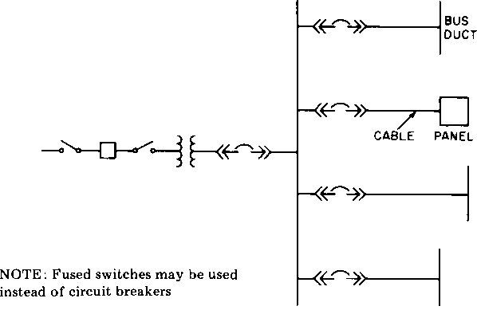
Figure 2-1 —Simple radial system
Operation and expansion are simple. When quality components and appropriate ratings are used reliability is high. Loss of a cable, primary supply, or transformer will cut off service. Equipment must be shut down to perform routine maintenance and servicing.
This system is satisfactory for small industrial installations where process allows sufficient down time for adequate maintenance and the plant can be supplied by a single transformer.
        - Expanded radial system(Red 2.4.2)
(See figure 2-2.) The advantages of the simple radial system may be applied to larger loads by using an expanded radial primary distribution system to supply a number of unit substations located near the load, which in turn supply the load through radial secondary systems.
The advantages and disadvantages are the same as those described for the simple radial system.
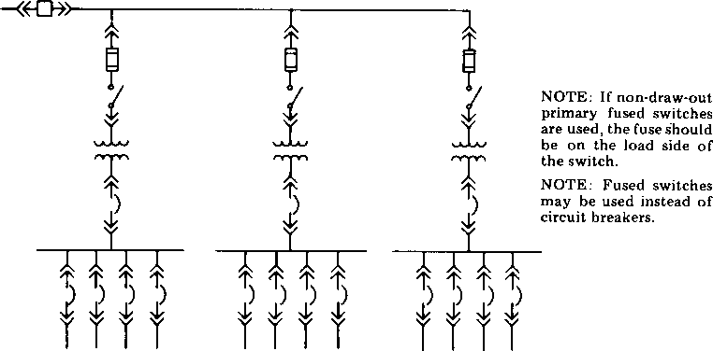
Figure 2-2—Expanded radial system
        - Primary selective system(Red 2.4.2)
(See figure 2-3.) Protection against loss of a primary supply can be gained through use of a primary selective system. Each unit substation is connected to two separate primary feeders through switching equipment to provide a normal and an alternate source. Upon failure of the normal source, the distribution transformer is switched to the alternate source. Switching can be either manual or automatic, but there will be an interruption until load is transferred to the alternate source.
If the two sources can be paralleled during switching, some maintenance of primary cable and switching equipment, in certain configurations, may be performed with little or no interruption of service. Cost is somewhat higher than a radial system because of duplication of primary cable and switchgear.
        - Primary loop system(Red 2.4.2)
(See figure 2-4.) A primary loop system offers improved reliability and service continuity in
comparison to a radial system. In typical loop systems, power is supplied continuously from
two sources at the ends of the loop. Such a system, if properly designed and operated, can
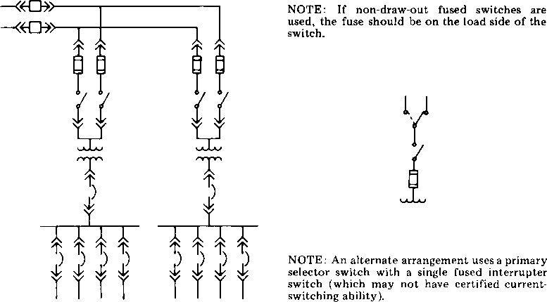
Figure 2-3—Primary selective system
quickly recover from a single cable fault with no continuous loss of power to utilization equipment. It is unlikely that a fault will occur within the area of the closely coupled isolation devices and the bus to the fuse protecting the transformer.
A second important feature of loop systems is that a section of cable may be isolated from the loop for repair or maintenance while other parts of the system are still functioning. However, it is important to analyze the isolation provided with this arrangement.
Since electrical power can flow in both directions in a loop system, it is essential that detailed operating instructions be prepared and followed. These instructions must take into account the fact that the industrial facility may not always be staffed with trained electrical personnel on a 24-hour basis. Additionally, if the two supply points for the loop originate from different buses, the design must consider available short-circuit capacity from both buses, the ability of both buses to supply the total load, and the possibility of a flow of current from one bus to the other bus over the loop.
          - Closed-loop operation(Red 2.4.2)
To realize optimum service reliability of a primary loop system, the system should be operated with all series switches in figure 2-4 closed (closed-loop mode). When designing a system that is expected to be operated in the closed-loop mode, circuit breakers typically are selected in lieu of fused or nonfused isolation switches.
When the loop switches consist of circuit breakers with interconnected directional overcur-
rent or pilot wire relays, a cable fault within the loop may be automatically isolated without
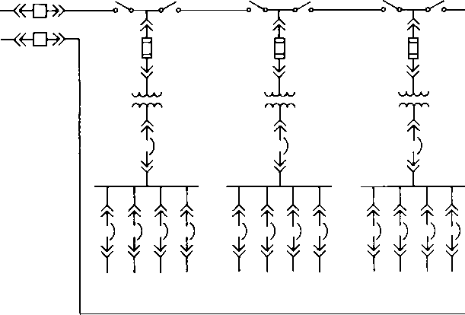
Figure 2-4—Primary loop system
loss of transformer capacity. No loss of power will occur, although the system will experience a voltage dip until the circuit breakers clear the fault. Whenever a section of the loop is faulted, either in the cable of the loop or in the taps from the loop, both circuit breakers feeding that section must trip. If the taps are taken from nonadjacent sections, then the two circuit breakers feeding the portion of the loop between the taps must trip, de-energizing the entire section. When a circuit breaker trips and is not remotely indicated or alarmed, a portion of the loop may unknowingly remain out of service for an extended period of time even though all loads remain energized. To prevent this from happening, an alarm point derived from the overcurrent detection system at both ends of the loop should be installed.
          - Open-loop operation(Red 2.4.2)
A primary loop system may be operated with one of the series switches in figure 2-4 open. Fused or non-fused isolation switches, or circuit breakers, may be used in this open-loop operation. A disadvantage of open-loop operation is that a cable failure will result in the temporary loss of service to some portion of the system.
          - Fault isolation(Red 2.4.2)
One method for locating a fault in a loop system is the dangerous practice of isolating a section of the loop and then re-energizing the power source. If the system trips again, another section is isolated and the power is re-applied. Such action is repeated until the fault is isolated. This method of fault location is not recommended. It is unsafe practice and may cause
equipment failure as a result of the stress placed on system components and cable insulation. The reclosing of any power protection device into a known fault in order to locate the faulty equipment, or to restore the system power without ascertaining the problem, is not recommended.
          - Primary loop system economics(Red 2.4.2)
An initial cost saving may be achieved by designing a loop system with isolation switches instead of circuit breakers. The loop system may be designed with non-fused switches for the greatest initial cost savings. However, the selection of non-fused switches for isolating an open loop system provides no overcurrent protection to individual sections of the loop, nor a reduction of the faulted section. Some portion of the loop will lose power whenever any fault occurs.
Many times fused isolation switches will be applied in lieu of circuit breakers in a loop system. Since it is not possible to selectively coordinate such a system for faults on a closed loop, the loop should be operated in the open loop mode. The use of fused switches also introduces the potential for single-phasing in the system. Consequences of single-phasing may include motor failure, loss of one-third of the lighting, and partial voltage to an additional one-third of the lighting. Phase failure protection systems are available. If the need for a form of single-phasing protection is established, some of the cost savings of using fused switches over circuit breakers is lost.
One possible disadvantage of the system in figure 2-4 is that there is no disconnecting means ahead of the fuse protecting the transformer. At an additional cost, a disconnect switch would add convenience for the maintenance of the equipment, and if a problem should occur with the transformer it can be isolated without opening the loop. Good safety practice for industrial installations will almost always dictate the inclusion of such a switch-fuse combination or circuit breaker ahead of the transformer.
The economics of the variations in design of primary loop systems can be found in Chapter 16.
        - Double-ended system arrangement (White Ch. 3)
Engineers should consider a double-ended substation for larger facilities, especially if two utility sources are present.
For example, Figure 3-17 utilizes a normally open circuit breaker that is interlocked with the main circuit breaker so that all three circuit breakers cannot be closed simultaneously. Upon loss of a single transformer or its feeder, the facility operator can automatically (or manually) close the tie circuit breaker and add its load to the remaining transformer. Additional benefits of the double-ended substation are lower fault currents than with a single, larger transformer. They also create opportunities to normally separate motor loads from lighting and X-ray loads that require a higher degree of voltage regulation.

  - – Normally open tie protector interlocked with the main protectors

When double-ended substations are installed, each transformer must safely carry the full load of the entire substation. Since core losses are a continuous power cost, it is important to minimize the “spare” capacity as long as safety, reliability, and good practice are maintained. During the time of outage of a single transformer, the increased voltage drop, the increased transformer losses, and the possible loss of transformer life (if overloaded) must be taken into account. Usually the outage time is minimal, but in the event of a transformer failure, replacement time may be in the order of weeks. Transformers can be safely overloaded in accordance with ANSI C57 standards with little or no loss of life; fans can be added to increase the emergency load capability of the transformer; and when transformers are purchased they can be specified with a higher temperature insulation rating than is required for the normal full-load rating. “Oversized” transformers not only increase core-loss costs, but also usually increase the available fault current at their secondary and possibly require increased switchgear sizes.
Liquid-immersed power transformers rated 55/65 °C rise have a higher overload rating than units rated 55 °C rise. Dry-type power transformers rated 80 °C rise and with 220 °C insulation have a higher overload rating than 115 °C rise units with 220 °C insulation. For example, dry-type power transformers 500 kVA and over should be specified with a temperature rise of 80 °C (preferred) or 115 °C (alternate).
Liquid-immersed power transformers should be specified to include controls to start the auxiliary cooling system (fans and pumps) when the temperature at the bottom of the tank reaches the predetermined temperature.
If the double-ended substation scheme uses a normally open electrically operated tie circuit breaker that will automatically close upon loss of an incoming feeder, then additional control and protective relaying needs to be added to prevent the bus tie protector for closing when a main protector has tripped due to overload or short-circuit conditions.
In rare instances, a utility may permit a double-ended substation to be operated with a closed tie and main protectors. The advantages of using a double-ended substation with mains and tie normally closed are better voltage regulation and flickerless transfer upon loss of one power source. The disadvantages are greater complexity, greater fault current, greater cost, and loss of isolation between sensitive loads and high inrush loads. Also, reliability can be less since one failure, a bus fault, may cause loss of both buses. The greater complexity requires that the design engineer carefully coordinates and specifies the required additional protection to assure proper operation. Also refer to the NEC for reverse-current relaying requirements.
      - Secondary selective system (Red 2.4.2)
[See figure 2-5(a)]. If pairs of substations are connected through a secondary tie circuit breaker, the result is a secondary selective system. If the primary feeder or transformer fails, supply is maintained through the secondary tie circuit breaker. The tie circuit breaker can be operated in a normally opened or a normally closed position. If operated opened, the supply is maintained by a manual or automatic opening of the affected transformer's circuit breaker followed by a closing of the tie circuit breaker. If the tie is operated closed, the supply is maintained by the automatic opening of the affected transformer circuit breaker (by reverse power or reverse current detection); automatic reclosing upon restoration of the faulted circuit is recommended. In case of the normally opened tie circuit breaker, voltage is maintained to the unaffected transformer's circuits. In the case of the normally closed tie, a voltage depression occurs on the bus until the affected transformer's circuit breaker opens.
Figure 2-5—Typical configurations load center substations

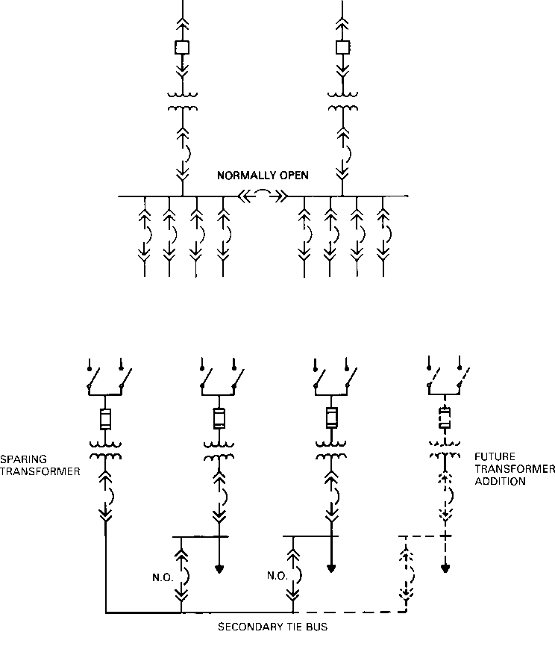
- Secondary selective system
- Sparing transformer scheme
Normally the systems operate as radial systems. Maintenance of primary feeders, transformer, and main secondary disconnecting means is possible with only momentary power interruption, or no interruption if the stations can be operated in parallel during switching, although complete station maintenance will require a shutdown. With the loss of one primary circuit or transformer, the total substation load may be supplied by one transformer. To allow for this condition, one (or a combination) of the following should be considered:
- Oversizing both transformers so that one transformer can carry the total load;
- Providing forced-air cooling to the transformer in service for the emergency period;
- Shedding nonessential load for the emergency period;
- Using the temporary overload capacity in the transformer and accepting the loss of transformer life.
A distributed secondary selective system has pairs of unit substations in different locations connected by a tie cable and a normally open disconnecting means in each substation. The designer should balance the cost of the additional tie disconnecting means and the tie cable against the cost advantage of putting the unit stations nearer the load center.
The secondary selective system may be combined with the primary selective system to provide a high degree of reliability. This reliability is purchased with additional investment and addition of some operating complexity.
In figure 2-5(a), while adhering to the firm capacity concept, the total load allowed to the substation will be equal to or less than the capability of one transformer or one load side overcurrent device, whichever is the most restrictive.
The sparing transformer scheme offers some particular advantages for achieving first contingency capacity in a cost-effective manner in the distribution system. Available transformer capacity is utilized at a higher level than in a simple redundant configuration (where utilization is 50%), and transformers can be readily added to existing substations as the need arises (if physical space and load requirements allow). In the sparing case [figure 2-5 (b)] the first contingency capacity is equal to (n-1) transformers or load side overcurrent devices. This scheme has been successfully used in industry, although there may occasionally be some personnel reluctant to accept it since the sparing transformer typically remains essentially unloaded, and the idea of an unloaded unit may seem to represent nonutilization of equipment.
Operations, protection, etc., for configurations shown by figure 2-5(a) and (b) are the same with two exceptions:
- Automatic transfer initiated by loss of voltage on a low side bus is not applicable in the sparing transformer scheme;
- Feeder overcurrent device fault duty requirements are almost always greater in the double-end scheme due to the additional motor fault current contribution during the emergency condition when the tie is closed.
      - Secondary spot network (Red 2.4.2)
(See figure 2-6.) In this system two or more distribution transformers are each supplied from a separate primary distribution feeder. The secondaries of the transformers are connected in parallel through a special type of device, called a network protector, to a secondary bus. Radial secondary feeders are tapped from the secondary bus to supply utilization equipment.
If a primary feeder fails, or a fault occurs on a primary feeder or distribution transformer, the
other transformers start to feed back through the network protector on the faulted circuit. This
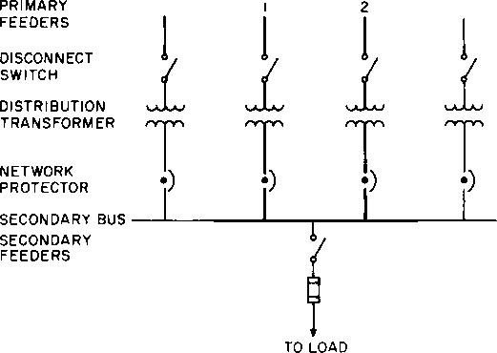
Figure 2-6—Secondary spot network
reverse power causes the network protector to open and disconnect the supply circuit from the secondary bus. The network protector operates so fast that there is a minimal exposure of secondary equipment to the associated voltage drop.
The secondary spot network is the most reliable power supply for large loads. A power interruption can only occur when there is a simultaneous failure of all primary feeders or when a fault occurs on the secondary bus. There are no momentary interruptions caused by the operation of the transfer switches that occur on primary selective, secondary selective, or loop systems. Voltage sags caused by large transient loads are substantially reduced.
Networks are expensive because of the extra cost of the network protector and duplication of transformer capacity. In addition, each transformer connected in parallel increases the short-circuit-current capacity and may increase the duty ratings of the secondary equipment. This scheme is used only in low-voltage applications with a very high load density. Also, it requires a special bus construction to reduce the potential of arcing fault escalation.
The packaged protector used by the utilities and preferred by some industrial users is not in itself adequately protected to meet the National Electrical Code (NEC) (ANSI/NFPA 70- 1993) requirements, and also should not be regarded as equivalent to draw-out switchgear from a safety standpoint. Either supplementary protection should be added or, preferably, standard switchgear should be used, suitable for the purpose with proper protective relaying.
      - Ring bus (Red 2.4.2)
(See figure 2-7.) The ring bus offers the advantage of automatically isolating a fault and
restoring service. Should a fault occur in Source 1, Devices A and D would operate to isolate
the fault while Source 2 would feed the loads. A fault anywhere in the ring results in two interrupting devices opening to isolate the fault.
Figure 2-7—Ring bus system
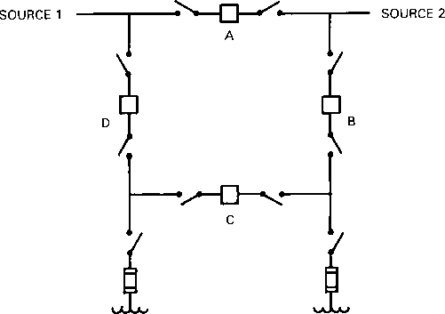
The ring bus scheme is often considered where there are two (2) or more medium voltage (i.e., 4.16, 4.8, or 13.2/13.8 kV) distribution services to the facility and the utmost in flexibility and switching options are desired. Care must be taken that allowable fault duties are not exceeded with closed bus tie breaker operation in this scheme.
Manual isolating switches are installed on each side of the automatic device. This allows maintenance to be performed safely and without interruption of service. This will also allow the system to be expanded without interruption.
    - Distribution Protection with Metering Capabilities

[New Material]

      - Distribution Circuit Arrangements (Gray 4.8)
Many factors should be considered in the design of the electric power distribution system for a modern commercial building. Some of the most important factors that will influence system design and circuit arrangement are the characteristics of the electric service available at the building site, the characteristics of the load, the quality of service required, the size and configuration of the building, and costs.
Electric service for commercial buildings is available from secondary-network systems in the downtown areas of many large cities in the United States. This service is usually provided from the general distributed street network at a nominal voltage of 208Y/120 V. In cases where the kVA demand of the building load is sufficiently high to justify the establishment of a spot-network system, service may be available at 480Y/277 V instead of 208Y/120 V. When the building is very large, the electric utility may establish spot-network substations on intermediate floors in she building as well as at the basement level.
When a commercial building is small enough to be supplied from a single transformer station, the recommended practice is to allow the utility to install the transformer and then purchase power at utilization voltage. Commercial building personnel are often not qualified to operate and maintain medium-voltage equipment, and any option to provide the transformer in return for a reduction in the rate should justify the expense and risk involved in owning the transformer. When the building is too large to be supplied from a single transformer station located at a point suitable to the supplying utility, power may be purchased at the utility distribution voltage and taken through or around the building to supply the transformers stepping down to utilization voltage. The NEC [6] and utility policy, with some exceptions, provide for only one service to a building; utilities, as a general rule, will not provide transformers that are suitable for installation indoors unless the transformers are installed in utility-approved vaults. In cases where commercial buildings have more than one tenant, some utilities will furnish the medium-voltage system and transformers in return for the right to sell power direct to the tenants, and for buildings supplied from a utility network.
Five basic circuit arrangements are used for medium- and low-voltage distribution in commercial facilities: radial- circuit, primary-selective, secondary-selective, secondary-network, and loop-circuit. The reader should recognize that the medium-voltage circuits and substations may be owned by either the utility company or the building owner, depending upon the electric tariffs, rates, local practices, and requirements of the particular electric utility serving the specific building site.
In the remainder of this chapter, where circuit breakers are shown in the figures, fused equipment may be the design choice. In this case, proper design considerations, including fault protection, safety interlocking, automatic or manual control, training, experience, availability, and capabilities of operating and maintenance personnel, should be fully evaluated when developing a safe and reliable system. See Chapter 9. for a discussion of electrical protection.
        - Radial Feeders (Gray 4.8)
When power is brought into a commercial building at the utilization voltage, the simplest and the lowest cost way of distributing the power is to use a radial-circuit arrangement. Since the majority of commercial buildings are served at utilization voltage, the radial-circuit arrangement is used in the great majority of commercial buildings. The low- voltage, service entrance circuit comes into the building through service entrance equipment and terminates at a main switchgear assembly, switchboard, or panelboard. Feeder circuits are provided to the loads or to other switchboards, distribution cabinets, or panelboards.
When power is purchased at a medium voltage, one or more transformers may be located to serve low-voltage radial circuits. Circuit breakers or fused switches are required on both the medium- and low-voltage circuits in this arrangement except when the NEC [6] permits the medium-voltage device to serve for the secondary protection.
Figure 20 shows the two forms of radial-circuit arrangements most frequently used in commercial buildings. Under normal operating conditions, the entire load is served through the single incoming supply circuit, and, in the case of medium-voltage service, through the transformer. A fault in the supply circuit, the transformer, or the main bus will cause an interruption of service to all loads. A fault on one of the feeder or branch circuits should be isolated from the rest of the system by utilizing selectively coordinated main, feeder, and branch-circuit protective devices. Under this condition, continuity of service is maintained for all loads except those served from the faulted branch circuit.
Continuity of service to the loads in commercial buildings is very important from a safety standpoint as well as with regard to the normal activities of the occupants of the building. The safety aspect becomes more critical as the height of the building and number of people in the building increase. This requirement for continuity of service often requires multiple paths of power supply as opposed to a single path of power supply in the radial-circuit arrangement. However, modern distribution equipment has demonstrated sufficient reliability to justify the use of the radial-circuit arrangement in many commercial buildings. When the risk is slight and the consequence of service loss is unimportant, branch circuits and feeders are almost invariably radial feeders. As the demand or the size of the building, or both, increase, several smaller secondary substations rather than one large secondary substation may be required to maintain adequate voltage at the utilization equipment. Each of the smaller substations may be located close to the center of the load area that it is to serve. This arrangement, shown in Figs 21 and 22, will provide better voltage conditions, lower system losses, and offer a less expensive installation cost than the arrangement using relatively long high-amperage, low-voltage feeder circuits.
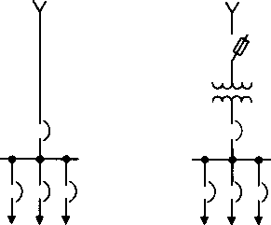
Figure 20—Radial-Circuit Arrangements in Commercial Buildings
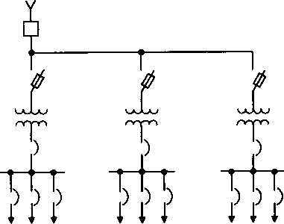
Figure 21—Radial-Circuit Arrangement Ñ Common Primary Feeder to Secondary-Unit Substations
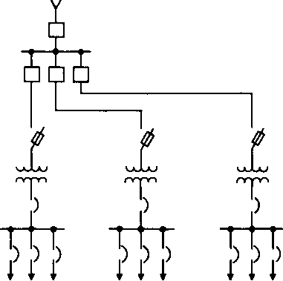
Figure 22—Radial-Circuit Arrangement Ñ Individual Primary Feeders to Secondary-Unit
Substations
The relative economics of radial-circuit arrangements using low- or medium-voltage feeders will vary with building size, demand, cost of floor space, and utility tariffs. Medium-voltage systems require investment in transformers, medium-voltage protective devices, medium-voltage cable, and, possibly, some rentable floor space for substation locations. On the other hand, the investment in feeder and riser circuits for a low-voltage system of the same capacity may become excessive when voltage-drop limitations are to be met.
A fault in a primary feeder, as shown in the arrangement in Fig 21, will cause the main protective device to operate and interrupt service to all loads. If the fault were in a transformer, service could be restored to all loads except those served from that transformer. If the fault were in a primary feeder, service could not be restored to any loads until the source of the trouble has been eliminated and repairs completed. Since it is to be expected that more faults will occur on the feeders than in the transformers, it becomes logical to consider providing individual circuit protection on the primary feeders as shown in Fig 22. This arrangement has the advantage of limiting outages, due to a feeder or transformer fault, to the loads associated with the faulted equipment. The cost of the arrangement in Fig 22 will usually exceed the cost of the arrangement in Fig 21.
        - Primary-Selective Feeders (Gray 4.8)
The circuit arrangements of Fig 23 provide a means of reducing both the extent and duration of an outage caused by a primary feeder fault. This operating feature is provided through the use of duplicate primary feeder circuits and load interrupter switches that permit connection of each secondary substation transformer to either of the two primary feeder circuits. Each primary feeder circuit should have sufficient capacity to carry the total load in the building. Suitable safety interlocks for each pair of fused switches or circuit breakers are usually required to avoid closing both switches at the same time. Under normal operating conditions, the appropriate switches are closed in an attempt to divide the load equally between the two primary feeder circuits. Should a primary feeder fault occur, there will be an interruption of service to only half of the load. Service can be restored to all loads by switching the de-energized transformers to the other primary feeder circuit. The primary-selective switches are usually manually operated and outage time for half the load is determined by the time it takes to accomplish the necessary switching. An automatic throwover switching arrangement can be used to reduce the duration of interruption of service to half of the load. The additional cost of this automatic feature may be justified in many applications. If a fault occurs in a secondary substation transformer, service can be restored to all loads except those served from the faulted transformer.
The higher degree of service continuity afforded by the primary-selective arrangement is realized at a cost that is usually 10%-20% above the cost of the circuit arrangement of Fig 21 because an additional primary circuit and the primary switching equipment at each secondary substation is needed. The cost of the primary-selective arrangement, using manual switching, will sometimes be less than the radial-circuit arrangement.
A variation of the circuit arrangements shown in Fig 23 utilizes three primary-selective feeders and one standby feeder. Each feeder is sized between one-half and two-thirds of the total load and supplies one-third of the total load under normal conditions. Under emergency conditions, with a primary cable fault, the load on the faulted cable can be transferred to the standby feeder. Depending on the capacity of the standby feeder, the load can be transferred to the remaining normal feeder or left on the standby feeder until the cause of the failure is corrected.
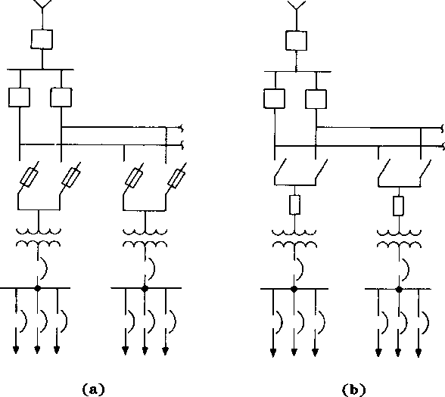
Figure 23—Primary-Selective Circuit Arrangements
(a) Dual Fused Switches
(b) Duplex Load Interrupter Switches with Transformer Primary Fuse
        - Secondary-Selective Feeders (Gray 4.8)
Under normal conditions, the secondary-selective circuit arrangement in Fig 24 is operated as two separate radial systems. The secondary bus-tie circuit breaker or switch in the double-ended substation is normally open.
The load served from a secondary substation should be divided equally between the two bus sections. If a fault occurs on a primary feeder or in a transformer, service is interrupted to all loads associated with the faulted feeder or transformer. Service may be restored to all secondary buses by first opening the main secondary switch or circuit breaker associated with the faulted transformer and primary feeder, and then closing the bus-tie device in such a manner that all three cannot be in the closed position simultaneously. This prevents parallel operation of the two transformers and thereby minimizes the service interruptions to all loads on the bus when a fault occurs in either a primary feeder or a transformer. To prevent closing the tie on a faulted switchgear bus, a main tie/main safety interlock scheme may be provided to lock out the tie device whenever a secondary main has interrupted a downstream fault.
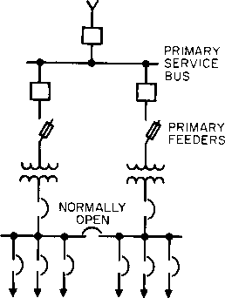
Figure 24—Secondary-Selective Circuit Arrangement (Double-Ended Substation with Single Tie)
The cost of the secondary-selective circuit arrangement will depend upon the spare capacity in the transformers and primary feeders. The minimum transformer and primary feeder capacity will be determined by essential loads that should be served under standby operating conditions. If service is to be provided for all loads under standby conditions, then each primary feeder should have sufficient capacity to carry the total load, and each transformer should be capable of carrying the total load on both substation buses.
This type of circuit arrangement will be more expensive than either the radial or primary-selective circuit arrangement; but it makes restoration of service to all essential loads possible in the event of either a primary feeder or transformer fault. The higher cost results from the duplication of transformer capacity in each secondary substation. This cost may be reduced by load-shedding nonessential feeders.
A modification of the secondary-selective circuit arrangement is shown in Fig 25. In this arrangement, there is only one transformer in each secondary substation; but adjacent substations are interconnected in pairs by a normally open low-voltage tie circuit. When the primary feeder or transformer supplying one secondary substation bus is out of service, essential loads on that substation bus can be supplied over the tie circuit. The operating aspects of this system are somewhat complicated if the two substations are separated by distance. It may not be a desirable choice in a new building because a multiple-key interlock system would be required if it became necessary to avoid tying the two substations together while they were energized.
        - Secondary Network (Gray 4.8)
High-rise and institutional buildings that have concentrated loads that require a power source with high reliability are often supplied from secondary systems. In a modern, large commercial building with heavy electronic and computer loads, the time it takes to operate a mechanical transfer switch or the time required for personnel to close a tie feeder is normally unacceptable. A secondary network is formed when two or more transformers having the same characteristics are supplied from separate feeders, and are connected to a common bus through network protectors. The distributed network and the spot network are the two basic types of secondary-network systems. The distributed network shown in Fig 26 is a widely dispersed system that has multiple transformer/network protector units connected to a cable grid. The grid is tapped to provide takeoffs to utility customers at commercial buildings. The spot network shown in Fig 27 is a localized distribution center consisting of two or more transformer/network protector units connected to a common bus called a "collector bus."
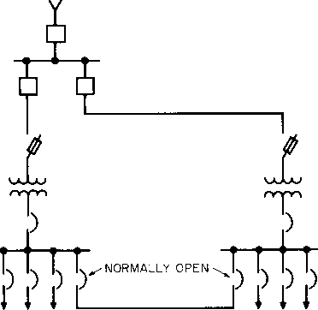
Figure 25—Secondary-Selective Circuit Arrangement
(Individual Substations with Interconnecting Ties)

A typical commercial building spot network is illustrated in Fig 28. Feeders originating at the 13.8 kV service entrance substation are extended throughout the commercial building complex to supply spot networks at four locations. The feeders terminate at the transformer primary disconnecting device. In this particular design, the device is a fused load interrupter with a grounding switch located within the same enclosure. Although the grounding switch has a fault closing rating, it cannot be operated until the safety requirements of a key interlock scheme have been satisfied. The key interlocks prevent closing the grounding switch until all possible sources of supply to the feeder have been isolated.
In network system design, protection for the transformer primary is usually provided by the substation feeder breaker overcurrent relays. Since the substation breaker often feeds a group of transformers, the protection should be set high enough to prevent tripping on the sum of the individual transformer currents during contingency loading and inrush conditions. The application of primary fusing, as shown in Fig 28, offers a significant improvement over the limited protection provided by the substation breaker overcurrent relays alone. The requirements of the NEC, Article 450 [6] call for primary protection by a circuit breaker to be set no higher than 400% of transformer rated current. In this case, the requirement would effectively limit the maximum setting of the primary protector to an average of 100% of transformer rating, which is impractical for operational and system coordination purposes. The circuit breaker overcurrent protection would have to be set much higher than the 400% value to prevent unnecessary tripping. Consequently, compliance with the NEC, Article 450 [6] could not be met.
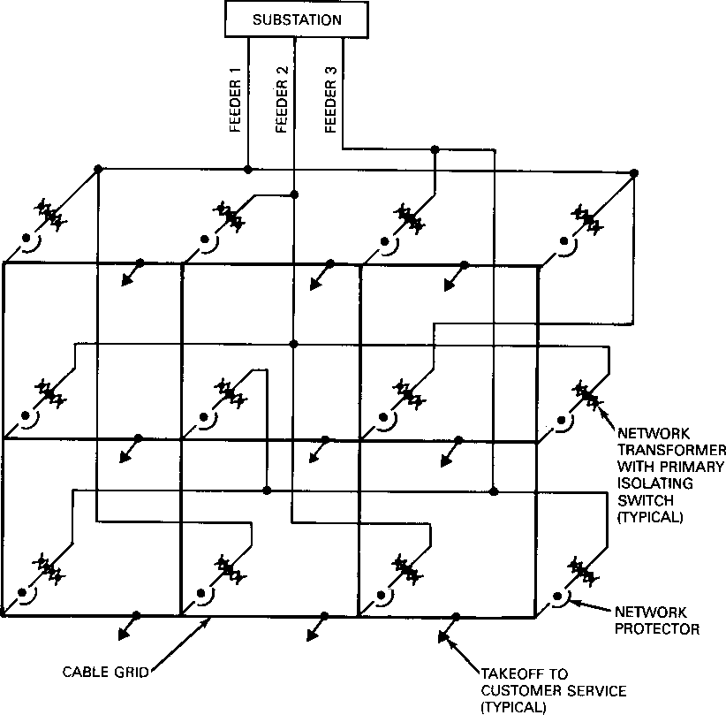
Figure 26—Distributed Secondary Network
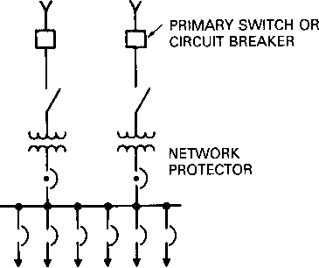
Figure 27—Basic Spot Network

Primary fusing provides a more sensitive level of protection, especially to liquid filled transformers in which tank rupture and serious fire are possible. In the case of liquid filled transformers, current-limiting fuses are recommended. There are limitations on the use of current-limiting fuses on large transformers because of their high cost and need for parallel fusing.
Transformers of the illustrated design in Fig 28 are the ventilated-dry-type with forced-air cooling. The transformers are each rated 1500 kVA on a self-cooled basis and collectively supply a peak load of 4500 kVA. Under normal peak loading conditions, the transformers are loaded to 75% of capacity. The system that is designed for first contingency operation provides full system load capacity with one transformer out of service. Under this condition, the remaining three transformers with cooling fans operating have a 33% increased capacity that maintains the transformer loading at 75% of its forced-air rating. Had liquid filled transformers been used in this design, the loading would have been at 75% of capacity with all transformers in service and at 87% capacity with cooling under first contingency operation. For 65 °C (149 °F) rise liquid filled transformers of this size, fan cooling provides a 15% increase above the self-cooled rating. For liquid filled transformers of this size with a dual rating of 55 °C (131 °F)/65 °C (149 °F) rise with fan cooling, a 28% increase above the self-cooled rating is available.
The electric characteristics of network transformers are essentially the same as secondary substation transformers. The one characteristic difference is the preferred impedance voltage rating. Secondary substation transformers have a typical rating of 5.75%, while network transformers similar to the 1500 kVA units in the illustrated system have a typical impedance rating of 7%. The higher rating provides a reduction in short-circuit current under fault conditions.
Conventional network protectors are self-contained units consisting of an electrically operated circuit breaker, special network relays, control transformers, instrument transformers, and open-type fuse links. The protector will automatically close when the oncoming transformer voltage is greater than the collector bus voltage and will open when reverse current flows from the collector bus into the transformer. Reverse current flow can be the result of a fault beyond the line side of the protector, supplying load current back into the primary distribution system when the collector bus voltage is higher than the individual transformer voltage, or the opening of the transformer primary feeder breaker, which causes the collector bus to supply transformer magnetizing current via the transformer secondary winding.

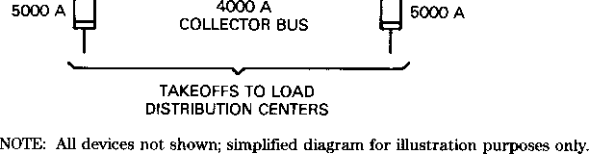
Figure 28—Four-Unit Spot Network
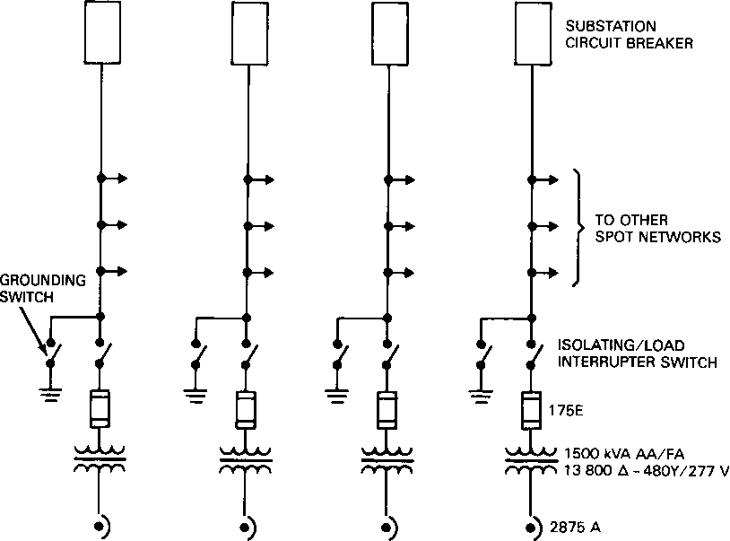
Network protectors are not designed to provide overcurrent protection in accordance with the NEC [6], and, therefore, do not meet the requirements for customer-owned services, unless supplementary protection is added.
Fuses of a special alloy are included in the protector package. Their primary function is to protect the transformer under severe short-circuit conditions in the event the protector fails to open. The application of separately mounted current-limiting fuses offer several improvements over standard network protector fuse links. The fuse links have a less inverse time current characteristic, which allows fault currents to persist for an extended length of time. Conversely, the Class L current-limiting fuse has an extremely inverse characteristic, which provides a much faster clearing time for moderate level faults and current limitation when the prospective fault current is above a specific value.
Unlike open-type fuse links, the interruption of fault current by the Class L fuse takes place within an insulated tube where the released thermal energy and arcing are contained. With open-type fuse links, the protector's internal components are subjected to the effects of the rupturing element, which may cause flashover and result in serious damage to the protector. Additionally, mounting the fuse outside the network protector enclosure removes a significant heat source, which allows the protector to operate at a lower temperature.
Low-voltage power circuit breakers may be applied with separate network protection relays and used as network protectors. When so employed, circuit breakers offer some advantage. Racking-in and withdrawal procedures do not require physical contact with energized components. Greater fault interrupting capacity is provided, and integral overcurrent protection, which can meet the NEC [6] requirements for customer-owned services, is available. Ground- fault protection is also available; however, careful study is advised prior to application. Integral groundfault protection applied singularly and not in conjunction with downstream protection may compromise the intended reliability of network system design.
In comparison to network protectors, power circuit breakers do have one disadvantage. The number of permissible mechanical operations for a breaker is far fewer than the number allowed for a protector. This limitation should be especially noted when large frame size breakers are considered for network application.
Instead of using cable in the distributed-type network, collector buses in modern commercial building spot-network design are usually metal-enclosed busway or a specially designed high-integrity bus structure preferred by utilities. Protection for the utility preferred bus is provided through the physical design, which utilizes an open-type construction with insulated bus bars widely spaced between phases and mounted overhead on insulated supports. The physical construction, which varies among utilities, affords excellent protection against electrical faults and the mechanical stresses imposed by short-circuit currents as high as 200 000 A.
When a metal-enclosed bus is used, several options are possible. Greater electrical integrity may be provided by the use of a bus manufactured to 5 kV design standards. Construction in the 5 kV design mandates a larger physical spacing between phases and a higher grade of bus insulation. Regardless of the type when any form of metal-enclosed bus is specified, the application of ground-fault protection is recommended.
Relay protection is the most common method of ground-fault protection. The fault current may be sensed by the ground return method, by the residual method, or by the zero-sequence method. Each of the methods have proved successful where appropriately applied; but they share a common limitation in that they cannot distinguish between in- zone and thru-zone ground faults unless incorporated in a complex protection scheme.
One particular method of ground-fault detection that is not prone to unnecessary tripping is enclosure monitoring. This method offers the distinct advantage of not requiring coordination with other protective devices. Enclosure monitoring is a simple concept that has been employed on various electric system components, such as motors, transformers, switchgear, and busways. When the collector bus is metal enclosed, it may be protected against arcing ground-fault damage using the scheme in Fig 29. As shown, the enclosure is grounded by a conductor, which is monitored by a current transformer. The enclosure is insulated at all termination points that are connected to other enclosures that are not in the same zone of protection. Additional protection can be provided by the use of thermal protectors above the busway and switchgear.
Secondary-network systems were originally designed to operate so that faults at the grid were allowed to burn clear rather than incur a disruption of service. This design philosophy may be acceptable for 216 V cable grids; however, when the common connection for the network protector/transformer units is a 480 V collector bus in a commercial building with an available short-circuit current in excess of 100 000 A, additional protection is advised. With emergency and standby generators and uninterruptible power supplies included in commercial building power system design, accepting the risk of serious electrical faults with an extended period of system downtime is not justified. Properly applied protection will significantly reduce fault damage and allow system restoration in minimal time.
Protection for spot-network systems is a subject that has received increased attention in recent years. Many engineers now believe that it is unwise to apply the same design concepts for commercial building spot networks as traditionally provided for utility-type distributed secondary-network systems. In response to a number of serious spot-network burndowns, a variety of protective schemes and devices not normally applied to secondary distributed networks have been developed and employed in spot-network systems. They include
  - Transformer primary protection
  - Network protector current-limiting fuses
  - Ground-fault relaying
  - Enclosure fault current monitoring
  - High-integrity bus structures
  - Thermal sensors
  - Ultraviolet light detectors
  - Infrared detectors
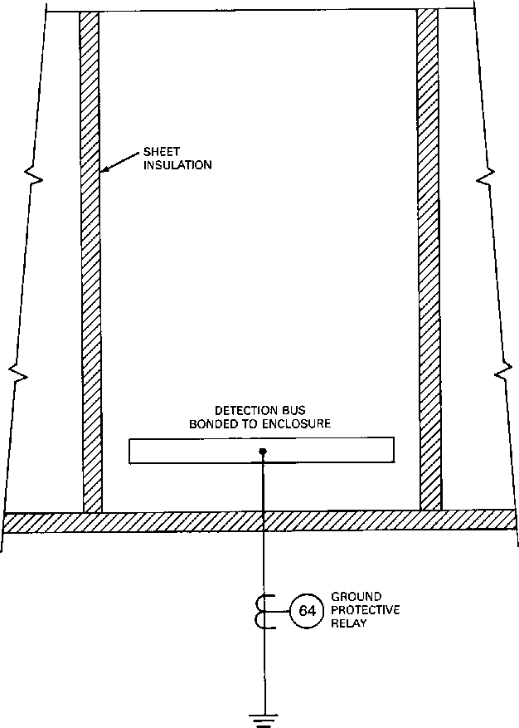
Figure 29—Enclosure Monitor
  - Smoke detectors
  - Radio-frequency interference and audible noise detectors
  - Current-limiting cable limiters installed on each end at each cable where three or more cables per phase are utilized
While the application of the listed protective schemes and devices are not suggested for all spot networks, there is a minimum level of spot-network protection that is recommended for commercial buildings.
Spot networks are employed to provide a reliable source of power to important electrical loads. To ensure service continuity in the event a utility feeder is lost, spare capacity is built in to allow for at least one contingency. Planning for service continuity should be extended beyond the consideration of losing a utility feeder. The consequences of severe equipment damage, including the resulting system downtime, should also be considered. Spot-network systems, which incorporate transformer primary protection, improved network protector protection, and groundfault protection judiciously applied, will enhance system reliability and, therefore, are recommended.
        - Looped Primary System (Gray 4.8)
The looped primary system (see Fig 30) is basically a two-circuit radial system with the ends connected together to form a continuous loop. Early versions of the closed-loop system, as shown in Fig 30(a), were designed to be operated with all loop isolating switches closed. Although it is relatively inexpensive, this system has fallen into disfavor because its apparent reliability advantages are offset by the interruption of all service by a fault occurring anywhere in the loop, by the difficulty of locating primary faults, and by safety problems associated with the nonload break, or "dead break,' isolating switches.
Newer open-loop versions shown in Fig 30(b), which are designed for modern underground commercial and residential distribution systems, utilize fully rated air, oil, and vacuum interrupters. Equipment is available in voltages up to 34.5 kV with interrupting ratings for both continuous load and fault currents to meet most system requirements. Certain equipment can close in and latch on fault currents, equal to the equipment interrupting values, and still be operational without maintenance.
With the elimination of the major disadvantages of the older closed-loop systems and the present demand for decentralized systems with low profile pad-mounted equipment and greater reliability than the simple radial system, the open-loop primary system has become a viable distribution solution.
The major advantages of the open-loop primary system over the simple radial system is the isolation of cable or transformer faults, or both, while maintaining continuity of service for the remaining loads. With coordinated transformer fusing provided in the loop-tap position, transformer faults can be isolated without any interruption of primary service. Primary cable faults will temporarily drop service to half of the connected loads until the fault is located; then, by selective switching, the unfaulted sections can be restored to service, which leaves only the faulted section to be repaired.
Disadvantages of the loop system are the increased costs to fully size cables, protective devices, and interrupters to total capacity of the load (entire load on one feeder), and the time delay necessary to locate the fault, isolate the section, and restore service. The safety considerations in maintaining a loop system are more complex than for a radial or a primary-selective system.
Figure 30—Looped Primary-Circuit Arrangement
(a) Closed Loop (Obsolete)
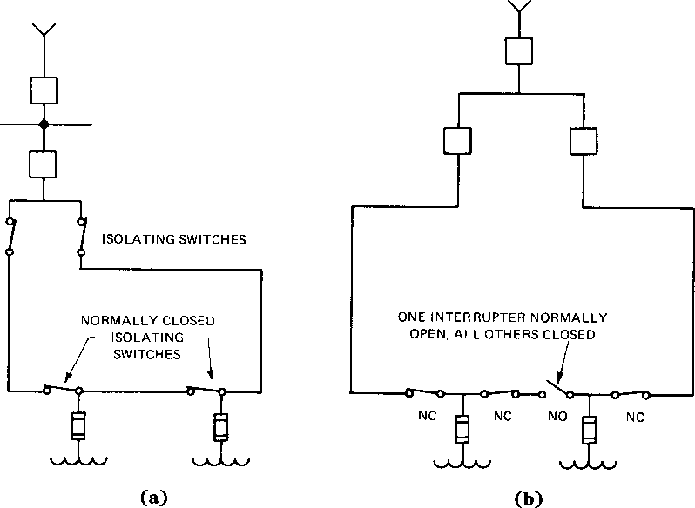
(b) Open Loop
The development of load break cable terminators and the regulatory requirements for total underground utility distribution have led to the use of loop-loop primary distribution circuit arrangements.
For systems that have a large quantity of small capacity transformers, the 1oop-loop design has the lowest cost of the loop-circuit arrangements. It has the same disadvantages as the old designs because it is still possible to connect a cable terminator into a cable fault.
Figure 31 shows a loop-loop system in which pad-mounted loop manually operated load break sectionalizing switches are provided in the main loop and load break cable terminators are provided in the secondary loops. The main loop is designed to carry the maximum system load, whereas secondary loops are fused to handle load concentrations smaller than the total system capacity. For additional discussion on looped systems, see Chapter 7.
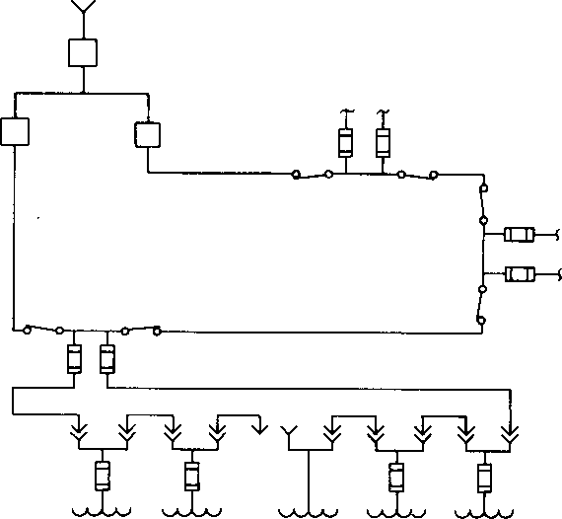
Figure 31—Loop-Loop Primary-Circuit Arrangement
      - Medium- and High-Voltage Fuses (Gray 5.3-5.6)
Medium- and high-voltage fuses are a part of many commercial power distribution systems. Applicable standards are ANSI C37.46-1981 (Reaff. 1988), Specifications for Power Fuses and Fuse Disconnecting Switches [4] and NEMA SG2- 1986, High-Voltage Fuses [36].⁴⁹
Modern fuses that are suitable for the range of voltages encountered fall into the following two general categories:
  - Distribution Fuse Cutouts Ñ According to the ANSI definition, thedistribution fuse cutout has the following characteristics:
- Dielectric withstand (BIL) strengths at distribution levels
- Application primarily on distribution feeders and circuits
- Mechanical construction basically adapted to pole or crossarm mounting except for the distribution oil cutout
- Operating voltages correspond to distribution system voltages
Characteristically, a distribution fuse cutout consists of a mounting (insulating support) and a fuseholder. The fuseholder, normally a disconnecting type, engages contacts supported on the mounting and is fitted with a simple, inexpensive fuse link. The fuseholder is lined with an organic material, usually horn fiber. Interruption of an overcurrent takes place within the fuseholder by the action of de-ionizing gases, which are liberated when the liner is exposed to the heat of the arc that is established when the fuse link melts in response to the overcurrent.
2) Power Fuses Ñ According to the ANSI definition, the power fuse is identified by the following characteristics:
- Dielectric withstand (BIL) strengths at power class levels
- Application in stations, substations, distribution feeders, and in metal-enclosed switchgear
- Mechanical construction is adapted to mountings for use in all applications.
Power fuses have other characteristics that differentiate them from distribution fuse cutouts in that they are available in higher voltage, current, and interrupting-current ratings, and in forms suitable for indoor and enclosure applications as well as all types of outdoor applications.
⁴⁹NEMA publications are available from the National Electrical Manufacturers Association, 2101 L Street, N.W., Washington, DC 20037.

A power fuse consists of a mounting plus a fuseholder or end fittings, which accept, respectively, a refill unit or fuse unit, or fuse. Many power fuses are available with blown fuse indicators, which provide a visual indication that a fuse has operated. Indoor mountings for use with fuse units rated up to 29 kV maximum can be furnished with an integral hookstick operated, load current interrupting device, thus providing for single-pole live switching in addition to the fault interrupting function provided by the fuse.
Power fuses are typically classified as either expulsion-type or current-limiting-type, depending on such factors as construction, interrupting medium, and the method used to interrupt overcurrents. However, new developments in the area of medium-voltage fuses may not readily fit within either class. Such a new development is the electronic fuse.
  - Expulsion-Type Power Fuses Ñ The earliest forms of power fuses, being outgrowths of distribution fuse cutouts, were fiber lined, and circuit interruption was also like that of cutouts. However, such fuses had limited interrupting capacity and could not be used within buildings or in enclosures, and thus led in the '30s to the development of solid material, boric acid power fuses. These fuses utilize densely molded solid boric acid powder as a lining for the interrupting chamber. This solid material lining liberates non-combustible, highly de-ionized steam when subjected to the arc established by the melting of the fusible element. Solid material, boric acid power fuses have higher interrupting capacities than fiber lined power fuses of identical physical dimensions, produce less noise, need less clearance in the path of the exhaust gases, and, importantly, can be applied with normal electrical clearances indoors, or in enclosures when equipped with exhaust control devices. (Exhaust control devices provide for quiet operation and contain all arc interruption products.) These advantages, plus their availability in a wide range of current and interrupting ratings, and time current characteristics have led to the wide use of solid material, boric acid power fuses in utility, industrial, and commercial power distribution systems.
  - Current-Limiting Power Fuses Ñ Introduction of current-limiting fuses in the United States occurred almost simultaneously with the development of solid material, boric acid power fuses. Current-limiting power fuses operate without expulsion of gases because all the arc energy of operation is absorbed by the powder or sand filler surrounding the fusible element. They provide current limitation if the overcurrent value greatly exceeds the fuse ampere rating, thereby reducing the stresses and possible damage in the circuit up to the fault. But, for lower overcurrent values, current limitation is not achieved. These fuses can be applied indoors or in enclosures, and require only normal electrical clearances. In addition to the protection of transformers, certain current-limiting fuses are for use with high-voltage motor starters.
  - Electronic Power Fuses Ñ Recently, another type of power fuse, the electronic power fuse, has been introduced. This latest technological development combines many of the features and benefits of fuses and relays to provide coordination and ratings that are not obtainable with other power fuses. Electronic power fuses generally consist of two separate components: an electronic control module that provides the time current characteristics and the energy to initiate tripping; and an interrupting module that interrupts the current when an overcurrent occurs. The electronic control module makes it possible to provide a variety of time current characteristics, such as instantaneous tripping or time delay tripping. Only the interrupting module is replaced following fuse operation.
        - Fuse Ratings (Gray 5.3-5.6)
- High-Voltage, Fiber Lined Power Fuses Ñ This category has its principal usage in outdoor applications at the subtransmission voltage level. This fuse is available in current ratings and three-phase symmetrical short- circuit interrupting ratings as shown in Table 39.
- High-Voltage, Solid Material, Boric Acid Fuses Ñ High-voltage, solid material, boric acid fuses are available in two styles.
- The end fitting and fuse unit style, in which fusible element, interrupting element, and operating element are all combined in an insulating tube structure called the "fuse unit,' which is the replaceable section.
- The fuseholder and refill unit style, in which only the fusible element and interrupting element are combined in an epoxy tube called the "refill unit,' which is the only section replaced following operation.
Solid material, boric acid fuses in the end fitting and fuse unit styles are used universally: outdoors at subtransmission and distribution voltages in poletop or station-style mountings, as well as indoors at distribution voltages in mountings installed in metal-enclosed interrupter switchgear, indoor vaults, and pad- mounted switchgear. Indoor mountings incorporate an exhaust control device that contains most of the arc interruption products and virtually eliminates the noise accompanying a fuse operation. These exhaust control devices do not require a reduction of the interrupting ratings of the fuse. Outdoor mountings with exhaust control devices are also becoming available at distribution voltages.
Solid material, boric acid fuses in the end fitting and fuse unit style are available with current and interrupting ratings as shown in Table 40.
The solid material, boric acid fuses in the fuseholder and refill unit style can be used either indoors or outdoors at medium- and high-voltage distributions.
Indoor mountings for use with fuseholders and refill units rated up to 29 kV maximum are also available with integral load current interrupting devices for single-pole live switching. The fuses are available in current and interrupting ratings as shown in Table 41.
Table 39—Maximum Continuous Current and Interrupting Ratings for Horn Fiber Lined, Expulsion-
Type Fuses
Rated  Maximum  Voltage  (kV) | Continuous Current  Ratings  A (Maximum) |  |  |  | Maximum Interrupting Rating*  kA rms Symmetrical
8.3 | 100 | 200 | 300 | 400 | 12.5
15.5 | 100 | 200 | 300 | 400 | 16.0
25.8 | 100 | 200 | 300 | 400 | 20.0
38.0 | 100 | 200 | 300 | 400 | 20.0
48.3 | 100 | 200 | 300 | 400 | 25.0
72.5 | 100 | 200 | 300 | 400 | 20.0
121 | 100 | 200 |  |  | 16.0
145 | 100 | 200 |  |  | 12.5
169 | 100 | 200 |  |  | 12.5

*Applies to all continuous current ratings.
3) Current-Limiting Power Fuses Ñ Current-limiting power fuses that are suitable for the protection of auxiliary power transformers, small power transformers, and capacitor banks are available with current and interrupting ratings as shown in Table 42.
Current-limiting fuses for the protection of medium-voltage transformers are available with interrupting ratings to 80 kA (symmetrical) at 5.5 kV, 120 kA at 15.5 kV, and 44 kA at 25.8 kV and 38 kV. Current-limiting fuses that are suitable only for use with high-voltage motor starters are available with current and interrupting ratings as shown in Table 43.
Table 40-Maximum Continuous Current and Interrupting Ratings for Solid Material, Boric Acid Fuses (Fuse Units)
Rated  Maximum  Voltage  (kV) | Continuous  Current Ratings  A (Maximum) | Corresponding  Maximum  Interrupting  Ratings  kA rms  Symmetrical

5.5 |  |  | 400 | 25.0
17 |  | 200 | 400 | 14.0 | 25.0
27 |  | 200 | 400 | 12.5 | 20.0
38 | 100 | 200 | 300 | 6.7 | 17.5 | 33.5
48.3 | 100 | 200 | 300 | 5.0 | 13.1 | 31.5
72.5 | 100 | 200 | 300 | 3.35 | 10.0 | 25.0
121 | 100 | 250 |  | 5.0 | 10.5
145 | 100 | 250 |  | 4.2 | 8.75

Table 41-Maximum Continuous Current and Interrupting Ratings for Solid Material, Boric Acid Fuses (Refill Units)
Rated  Maximum  Voltage  (kV) |  |  | Continuous  Current Ratings  A (Maximum) |  |  |  | Corresponding  Maximum  Interrupting  Ratings  kA rms  Symmetrical
 | 2.75 | 200 |  | 400 | 720* | 7.2 |  | 37.5 | 37.5
 | 4.8 | 200 |  | 400 | 720* | 17.2 |  | 37.5 | 37.5
 | 8.25 | 200 |  | 400 | 720* | 15.6 |  | 29.4 | 29.4
 | 15.5 | 200 |  | 400 | 720* | 14.0 |  | 34.0 | 25.0
 | 25.8 | 200 |  | 300 |  | 12.5 |  | 21.0
 | 38 | 200 |  | 300 |  | 6.25 |  | 17.5

*Parallel fuses
4) Electronic Power Fuses Ñ Electronic power fuses are suitable for service entrance protection and the coordination of commercial distribution circuits because they have high current-carrying capability and unique time current characteristics designed for coordination with source-side overcurrent relays and load- side feeder fuses. They are ideally suited for load feeder protection and coordination because of their high continuous and interrupting ratings. Electronic fuses are available in current and interrupting ratings as shown in Table 44.
        - Fuse Applications (Gray 5.3-5.6)
1) Power Supply Ñ When a commercial project is served by a utility at medium or high voltage and a transformer substation provides in-plant service at utilization voltage or primary distribution voltage, power fuses can be used as an economical primary-side overcurrent protective device for transformer banks rated to 161 kV with a 15 000 kVA maximum rating.

With their high short-circuit interrupting capability and high-speed operation, power fuses will protect the circuit by clearing faults at the transformer.
In addition, power fuses can provide backup protection in the event of a transformer secondary overcurrent protective device malfunction.
In addition to providing overcurrent protection to the main power transformers, power fuses are used to provide protection for instrument transformers and for capacitor banks.
Table 42-Maximum Continuous Current and Interrupting Ratings for Current-Limiting Fuses
Rated Maximum  Voltage  (kV) |  | Continuous Current Ratings  A (Maximum) |  |  | Corresponding Maximum  Interrupting Ratings  kA rms Symmetrical
2.75 | 225 | 450* | 750* | 1350* | 50.0 | 50.0 | 40.0 | 40.0
2.75/4.76 |  | 450* |  |  |  | 50.0
5.5 | 225 | 400 | 750* | 1350* | 50.0 | 62.5 | 40.0 | 40.0
8.25 |  | 125 | 200* |  |  | 50.0 | 50.0
15.5 | 65 | 100 | 125* | 200* | 85.0 | 50.0 | 85.0 | 50.0
25.8 |  | 50 | 100* |  |  | 35.0 | 35.0
38 |  | 50 | 100* |  |  | 35.0 | 35.0

*Parallel fuses
Table 43-Maximum Continuous Current and Interrupting
Ratings for Current-Limiting Fuses (Motor Starters)
Rated  Maximum  Voltage  (kV) | R  Designation | Continuous Current  Ratings  A (Maximum) | Corresponding Maximum  Interrupting Ratings  kA rms Symmetrical
2.54 | 50 R | 700 | 50.0
2.75/5.5 | Ñ | 750 | 50.0
5.0 | 50 R | 700 | 50.0
7.2 | 18 R | 390 | 50.0
8.3 | 6 R | 170 | 50.0

Table 44-Maximum Continuous Current and Interrupting Ratings for Electronic Fuses
Rated Continuous Corresponding
Maximum Current Maximum
Voltage Ratings Interrupting Ratings
(kV) A (Maximum) kA rms Symmetrical
5.5 | Ñ | 600 | Ñ | 40.0
17.0 | 400 | 600 | 14.0 | 40.0
29 | 200 | 600 | 12.5 | 40.0
2) Power Distribution Ñ The principal functions of overcurrent protective devices at these primary voltages are
- To interrupt high values of overcurrent
- To act as backup protection in the event of a malfunction of the next downstream protective device
- To open circuits under overcurrent conditions
- To coordinate with the next upstream and downstream protective device
Modern medium-voltage power fuses can be used to provide this protection and coordination for virtually all types and sizes of distribution systems. Such fuses used with properly coordinated and designed load interrupter switches may be applied outdoors in vaults, or in metal-enclosed interrupter switchgear.
      - Metal-Enclosed 5-34.5 kV Interrupter Switchgear (Gray 5.3-5.6)
Metal-enclosed interrupter switchgear can be used to provide switching capability and overcurrent protection through the use of interrupter switches and power fuses. An interrupter switch is an air switch equipped with an interrupter that makes or breaks specified currents. Interrupter switches depend on high operating speed to divert the arc from the main contacts during opening onto enclosing materials within the interrupters, which confine the arc and evolve gases to suppress it. Interrupter switchgear can also be used for ground-fault protection of resistance-grounded systems, if properly applied. Rated maximum voltages are 4.8 kV, 8.25 kV, 15.0 kV, 15.5 kV, 17.0 kV, 25.8 kV, 29.0 kV, and 38.0 kV with main bus ratings of 600 A, 1200 A, or 2000 A. Interrupting ratings are determined by the power fuses, for which maximum ratings are given in Tables 40Ð44. Power fuses are available in a wide range of current ratings and are offered in a selection of time current characteristics to provide proper coordination with other protective devices and with the thermal characteristics of the power transformer.
The interrupter switches, which may be manually or automatically operated, are rated 200 A, 600 A, or 1200 A, continuous and interrupting. Interrupter switches are also available with a vacuum or SF6 gas as the interrupting medium. Generally, these have limited fault ratings and are used primarily for switching. They are compatible with automatic or remote control schemes, but may have the disadvantage of lacking a visible break as is available with most air-type interrupter switches. SF6 interrupter switches are available for all ranges of medium-voltage applications, and vacuum switches are available up to 35 kV.
Interrupter switches of all types can be applied in combination with power fuses (including current-limiting fuses) to achieve greater ratings than may be possible when the interrupter switch is used alone. An applicable standard for metal-enclosed interrupter switchgear is IEEE C37.20.3-1987, IEEE Standard for Metal-Enclosed Interrupter Switchgear (ANSI) [20] and NEMA SG6- 1990, Power Switching Equipment [37].
Metal-enclosed interrupter switchgear does not incorporate a reclosing feature because reclosing is rarely desirable in power systems for commercial buildings where the conductors are, commonly arranged in cable trays or enclosed in raceways or busways. The rare faults that do occur in such installations require significant repair before reenergization.
Metal-enclosed interrupter switchgear can be used in high-continuity distribution circuits, such as the conventional
(two-switch) and the split bus (three-switch) primary-selective systems. Furthermore, the switches can be manually
operated or power operated (with either automatic or remote operation), depending on system operating requirements.
Interrupter switchgear is usually less expensive than metal-clad power switchgear (see 5.5). This permits the engineer to improve service continuity by providing more radial feeders per dollar of equipment cost with the use of interrupter switchgear.
        - Automatic Control Devices (Gray 5.3-5.6)
Automatic control devices can be incorporated in metal-enclosed interrupter switchgear, in conjunction with motor- powered switch operators, to provide high service continuity through primary-selective systems by initiating the automatic transfer of sources that provide service to the main bus (or buses) in the event of a fault or outage on one of the sources. Optional features include provisions for manual or automatic back transfer (with open or closed transition), time delay on transfer, and lockout on faults.
Switch operators can typically be disconnected from the associated switches to permit the checking of the automatic transfer scheme without requiring a power interruption to the load.
Interrupter switch manufacturers can also provide an open phase or overcurrent relay system, which initiates circuit interruption to protect loads from single phasing that may occur as a result of broken conductors or fuse operations in the source-side circuit. These relays can also be applied to protect against single phasing due to load circuit fuse operations.
        - Auxiliary Equipment and Features (Gray 5.3-5.6)
Metal-enclosed interrupter switchgear may include (in addition to interrupter switches and power fuses) instrument transformers, voltage and current sensors, meters, and other auxiliary devices, including motor powered switch operators for remote operation of the interrupter switches (or operation of the switches in an automatic transfer scheme, when used in conjunction with an automatic control device). The power fuses may be equipped with blown fuse indicators (for positive visual checking of fuses while in their mountings).
        - Capability Required (Gray 5.3-5.6)
Metal-enclosed interrupter switchgear should comply with the NEC, Article 710-21(e) [9], which requires that interrupter switches, when used in combination with fuses or circuit breakers, safely withstand the effects of closing, carrying, or interrupting all possible currents up to the assigned maximum short-circuit rating. (See also IEEE C37.20.3-1987, 6.4.8 (ANSI) [20].) Fault interrupting ratings are not required for interrupter switches because the associated fuses should be selected to interrupt any faults that may occur.
      - Metal-Clad 5-34.5 kV Circuit Breaker Switchgear (Gray 5.3-5.6)
Metal-clad switchgear is available with voltage ratings of 4.16Ð34.5 kV and with circuit breakers having interrupting ratings from 8.8 kA at 4.16 kV to 40 kA at 34.5 kV as standard. Continuous current ratings are 1200 A, 2000 A, 3000 A, and 3750 A. Applicable standards include IEEE C37.20.2-1987, IEEE Standard for Metal-Clad and Station-Type Cubicle Switchgear (ANSI) [19], IEEE C37 .04-1979 (Reaff. 1988), IEEE Standard Rating Structure for AC High- Voltage Circuit Breakers Rated on a Symmetrical Current Basis (ANsi) [16], IEEE C37.09-1979, IEEE Test Procedure for AC High-Voltage Circuit Breakers Rated on a Symmetrical Current Basis (ANSI) B4, IEEE C37.010-1979, IEEE Application Guide for AC High-Voltage Circuit Breakers Rated on a Symmetrical Current Basis (ANSI) (Includes Supplement IEEE C37 .010d-1984 [ANSI]) B5, IEEE C37.01 1-1979, IEEE Application Guide for Transient Recovery Voltage for AC High-Voltage Circuit Breakers Rated on a Symmetrical Current Basis (ANSI) B6, IEEE C37.012- 1979, IEEE Application Guide for Capacitance Current Switching of AC High-Voltage Circuit Breakers Rated on a Symmetrical Current Basis (ANSI) B7, IEEE C37.1-1987, IEEE Standard Definition, Specification, and Analysis of Systems Used for Supervisory Control, Data Acquisition, and Automatic Control (ANSI) B8, IEEE C37.2-1979, IEEE Standard Electrical Power System Device Function Numbers (ANSI) B9, and IEEE C37.100-1981 (Reaff. 1989), IEEE Standard Definitions for Power Switchgear (ANSI) [22] for power circuit breakers.
Metal-clad switchgear has a circuit breaker as the main circuit interrupting and protective device. Major parts of the primary circuit, such as circuit switching or interrupting devices, buses, potential transformers, and control power transformers, are completely enclosed by grounded metal barriers. Circuit instruments, protective relays, and control switches are mounted on a hinged control panel or occasionally on a separate switchboard remote from the switchgear. The power circuit breaker is readily removable and has self-coupling disconnecting primary and secondary contacts. Potential transformers and control power transformer fuses may be provided in drawout assemblies to permit the safe changing of fuses.
Automatic shutters to shield the stationary primary contacts when the circuit breaker is removed are provided, as well as other necessary interlocking features to ensure a proper sequence of operation. The drawout feature facilitates inspection and maintenance of the circuit breaker. In addition, it permits the quick replacement of any circuit breaker with a spare and, therefore, provisions for bypassing it during circuit breaker maintenance periods are generally not required. The circuit breaker compartments have separable main and secondary (or control) disconnect contacts to achieve connected, test, and disconnect positions. The test position provides a feature whereby the circuit breaker may be electrically exercised while disconnected from the main power circuit. The disconnect position allows the circuit breaker to be disconnected from the main power and control supply, locked, and stored in its cubicle.
Metal-clad switchgear can provide the switching, isolation, protection, and instrumentation of all the incoming, bus tie, and feeder circuits. All parts are housed within grounded metal enclosures, thereby providing a high degree of safety for both personnel and equipment. All line conductors are opened simultaneously in the event of circuit breaker tripping. A wide variety of parameters can be programmed into the tripping function.
The insulation used in the vital points of the metal-clad switchgear is of the potential tracking-resistant-type and may be flame-retardant. Thus, the equipment presents a very minimum fire hazard and is suitable for indoor installations without being placed in a vault. For outdoor equipment, a weatherproof enclosure is provided over the same switchgear components as is used for the indoor switchgear assemblies. Protected aisle construction, which permits maintenance in inclement weather, can also be provided.
        - Circuit Breakers (Gray 5.3-5.6)
Medium-voltage power circuit breakers may be of the following types:
  - Minimum-oil-type circuit breaker, which are no longer manufactured for medium-voltage applications
  - Air-type circuit breaker, which was the standard for medium voltage until recently and, therefore, constitutes the greatest number in use today. But, it now has limited availability.
  - SF6-type circuit breaker
  - Vacuum-type circuit breaker
The two latter types are readily available in metal-clad switchgear through 15 kV. Manufacturers can provide current information on the availability of the vacuum-type and SF6-type at all other medium voltages.
The air-type circuit breaker has, in certain ratings, the disadvantage of having very large and heavy arc extinguishing "chutes,' which enclose the contacts. The SF6-type and vacuum-type are typically lighter than the air-type of the same rating. Both the vacuum-type and SF6-type contain the arcs, which do not permit the arc products to exhaust to the atmosphere. The failure rate of the vacuum interrupter has been so low that it is not normally considered an operating problem; mechanical indicators associated with the vacuum interrupters indicate when contact wear requires replacement. The SF6-type circuit breaker, in frequent usage, may require periodic service of the gas system, which should be performed by properly trained specialists because the arcing products sealed in gas chambers may be toxic and also because the gas should not become contaminated.
Any device that interrupts a reactive load at high speed (and almost all fault currents reflect a significant X/R ratio) can introduce transient overvoltages into a circuit. These transients may be dangerous to insulation, may increase as "traveling waves," may cause restrike within the interrupting device, and may damage or cause interference with sensitive electronic equipment. Very high speed circuit interruption by current-limiting devices (e.g., current-limiting fuses, circuit breakers, static switches) may introduce such transients. Vacuum switches and circuit breakers have, in the past, been a source of high-speed interruption. However, with newer contact design, the problem has been somewhat reduced. The design engineer should evaluate the need for the protection of system insulation (particularly solid-state equipment, motors, and dry-type transformers) by properly selecting insulation levels (BIt), by inserting surge capacitors and suppressors (where required), and by selecting interrupting devices that will avoid damaging transients.
Vacuum-type and SF6-type circuit breakers offer the advantage of faster clearing time than air-magnetic-type breakers. The SF6-type does this without the potential transient voltage surge effects of vacuum breakers. For a tabulation of standard ratings of circuit breakers for metal-clad switchgear, see ANSI C37.06-1987, Prefected Ratings and Related Required Capabilities for AC High-Voltage Circuit Breakers Rated on a Symmetrical Current Basis [2].
        - Instrument Transformers and Protective Relaying (Gray 5.3-5.6)
All of these circuit breakers utilize relays, which are operated by current and voltage transformers. This combination provides a wide range of protection that is field adjustable. With protective relaying, full tripping selectivity can usually be obtained between all of the circuit breakers in the equipment in case of faults.
        - Control (Gray 5.3-5.6)
Circuit breakers are electrically operated devices and should be provided with a source of control power. Control power can be obtained from a battery or from a control power transformer located within the switchgear.
        - Main Bus Current Selection (Gray 5.3-5.6)
Main bus continuous current and momentary ratings are available to match the ratings of the associated circuit breakers. By the proper physical arrangement of the source and load circuit breakers or bus taps, it is possible to engineer the lowest bus current requirements consistent with the system capacity. For example, it may be necessary to have a 2000 A source circuit breaker (or breakers), yet only require a 1200 A main bus. Regardless of the lower bus capacity at different points, the bus is designed and rated for the present and future current capacity at the maximum point. It would not be tapered for reducing current capacity. The bus should also be properly braced to withstand system momentary requirements.
        - Ground and Test Devices (Gray 5.3-5.6)
Ground and test devices are drawout-modified circuit breakers, which temporarily replace a normal circuit breaker for grounding the load (and sometimes the line) circuits for safety purposes while they are maintained. These devices also permit the insertion of probes for measuring voltage, assuring that the circuit is not energized, fault location, and cable testing. Ground and test devices should be purchased for any major power circuit breaker installation.
      - 5.6 Metal-Enclosed, Low-Voltage 600 V Power Switchgear and Circuit Breakers (Gray 5.3-5.6)
        - 5.6.1 Drawout Switchgear (Gray 5.3-5.6)
Metal-enclosed, drawout switchgear using air-type circuit breakers is available for the protection and control of low- voltage circuits. Rigid ANSI Standards dictate the design, construction, and testing of switchgear to assure reliability to the user. Industry standards are IEEE C37.20.1-1987, IEEE Standard for Metal-Enclosed Low-Voltage Power Circuit Breaker Switchgear (ANSI) [18] and IEEE C37.13-1981, IEEE Standard for Low-Voltage AC Power Circuit Breakers Used in Enclosures (ANSI) [17].
Unlike distribution switchboards where a broad variety of protective devices or panelboards can be incorporated, the main, tie, and feeder positions in low-voltage power switchgear are limited to drawout circuit breakers. Drawout switchgear is more adaptable and procurable with complex control circuitry, such as sequential interlocking, automatic transfer, or complex metering. This type of switchgear is often used in multiple-bus arrangements, such as the double- ended substation consisting of two buses, each with a feeder breaker and a tie breaker; so that in the event of a feeder failure, one feeder can automatically be switched to serve both buses. Various arrangements are discussed in Chapter 4.
This class of switchgear is available in both indoor and outdoor construction. The latter usually is constructed to provide a sheltered aisle with an overhead circuit breaker removal device. An integral roof-mounted circuit breaker removal device is also available for indoor construction.
The individual air-type circuit breakers are in compartments isolated from each other and from the bus area. Compartments accommodate circuit breakers in ANSI sizes of 225 A, 600 A, 1600 A, 2000 A, 3000 A, and 4000 A, arranged in multiple high construction. Some manufacturers offer 800 A, 2500 A, and 3200 A, instead of 600 A, 2000 A, and 3000 A ratings. The air-type circuit breakers can be electrically or manually operated and equipped with added devices, such as shunt trip, undervoltage, auxiliary switches, etc. They are available either with electromagnetic overcurrent direct-acting tripping devices or static tripping devices.
The drawout circuit breakers and compartments have separable main and secondary disconnect contacts to achieve connected, test, disconnnect, and fully withdrawn positions. The test position provides a feature whereby the circuit breaker may be exercised while disconnected from the main power circuit. The disconnect position allows the circuit breaker to be disconnected from the main power and control supply, and then locked and stored in its compartment. In the fully withdrawn position, the circuit breaker is exposed for inspection and adjustments and may be removed from the switchboard for replacement or inspection.
Separate compartments are provided for required meters, relays, instruments, etc. Potential and control power transformers are usually mounted in these compartments so that they will be front accessible. Current transformers may be mounted around the stationary power primary leads within the circuit breaker compartment (front accessible) or in the rear bus area.
The rear section of the switchboard is isolated from the front circuit breaker section and accommodates the main bus, feeder terminations, small wiring, and terminal blocks. Bus work is usually aluminum, designed for an allowable temperature rise of 65 °C above an average 40 °C ambient. A copper bus is available at an added cost. Circuit breaker terminals are accessible from the rear of the switchboard. Cable lugs or busway risers are provided for top or bottom exits from the switchgear. Control wiring from the separable control contacts of the circuit breaker is extended to terminal blocks mounted in the rear section. These blocks accommodate remote control and intercompartment and frame wiring by the manufacturer.
        - Low-Voltage Power Air-Type Circuit Breakers (Gray 5.3-5.6)
Low-voltage power air-type circuit breakers are long-life, quick-make (via a stored energy manual or electrical closing mechanism), quick-break switching devices with integral inverse time overload or instantaneous trip units. These circuit breakers also have a short-time (30 Hz) rating, which permits the substitution of short-time tripping devices in place of the instantaneous tripping feature. Interrupting ratings for each circuit breaker depend on the voltage of the system to which it is applied (that is, 240 V, 480V, 600 V, alternating-current, 60 Hz) and whether it is equipped with an instantaneous or short-time tripping feature as part of the circuit breaker assembly or equivalent panel-mounted protective relays. It is this short-time rating of the circuit breakers that permits the designer to develop selective systems. These circuit breakers are open construction assemblies on metal frames, with all parts designed for accessible maintenance, repair, and ease of replacement. They are intended for service in switchgear compartments or other enclosures of deadfront construction at 100% of their rating in a 40 °C ambient without compensation or de- rating. Tripping units are field-adjustable over a wide range and are completely interchangeable within their frame sizes.
Static-type tripping units are available from most manufacturers. Static trip units may provide an additional degree or number of steps in selectivity when only a small margin of spread exists between optimum protective settings for connected loads downstream and utility or other existing protective device settings upstream. Static devices readily permit the inclusion of ground-fault protection as part of the circuit breaker assembly.
A low-voltage power circuit breaker can be used by itself or with integral current-limiting fuses in drawout construction or separately mounted fuses to meet interrupting current requirements up to 200 000 A symmetrical rms. When part of the circuit breaker, the fuses are combined with an integral mounted blown fuse indicator and breaker trip device to open all three phases.
Air-type circuit breakers may be used for the control and protection of large low-voltage motors. They can be equipped to provide disconnect, running overload, and short-circuit protection, and are generally not suitable when operation is highly repetitive. (See Chapter 6 for more information.)
        - Selection of Circuit Breaker Tripping Characteristics (Gray 5.3-5.6)
The degree of service continuity available from a low-voltage distribution system depends on the degree of coordination between circuit breaker tripping characteristics. The method of tripping coordination will be a factor in determining the degree of service continuity and of initial cost.
All circuit breakers should have adequate interrupting capacity for the fault current at the point of application. It may not be possible, because of cost or other limitations, to obtain full selectivity; however, a fully selective system should be the design goal. In a selective system, the main circuit breaker is equipped with overcurrent trip devices that have long- and short-time delay functions. The feeder circuit breakers are equipped with overcurrent trip devices that have long-time delay and instantaneous functions, unless they are required to be selective with other protective devices nearer the load. In this case, the feeders are equipped with trip devices that have both long- and short-time delay.
In a selective system, only the circuit breaker nearest the fault trips. Service continuity is thus maintained through all other circuit breakers. The selective system offers a maximum of service continuity, with a slightly higher initial cost for the short-time functions instead of the standard instantaneous function.
    - System protection and coordination (White 3.7)
The system and equipment protective devices guard the health care facility power system from the ever present threat of damage caused by overcurrents that can result in equipment loss, system failure, and hazards to patients and other people All protective devices should be applied within their ratings of voltage, frequency, current interrupting rating, and current withstand rating. In addition, the site where they will serve needs to be taken into account (i.e., if it is at a higher altitude, if seismic activity is common, if temperatures are extreme, if humidity is high, etc.). Many references and standards provide guidelines as to the various device descriptions, their ratings and application limits, and rating factors if required. These requirements are best documented in IEEE Std 141, IEEE Std 241, and the other ANSI, NEMA, and IEEE standards listed in 3.x. The reader should refer to these for details. The following summarizes some of the information in those references.

      - Protection system basics (White 3.7)
Protection, in an electric system, is designed to minimize hazards due to the high energy released during short-circuit conditions. Other hazards may include overvoltage, undervoltage, or under-frequency. The protective features built into a system are on standby until called upon to clear a fault or some other unplanned or unintentional disturbance. They are designed to reduce the extent and duration of the power interruptions and the hazards of property damage and personnel injury.
It is not possible to build a practical, fault-proof power system. Consequently, modern systems provide reasonable insulation, physical and electrical clearances, etc., to minimize the possibility of faults. However, even with the best designs, materials will deteriorate and the likelihood of faults will increase with age. Every system is subject to short circuits and ground faults. Engineers should develop a knowledge of the effects of those faults on system voltages and currents in order to better design suitable protection.
        - Protection requirements (White 3.7)
The design of a protective system involves the following two separate, interrelated, steps:
- Selecting the proper device to protect the intended system or device.
- Selecting the correct ampere rating and setting for each device so that each device will operate selectively with other devices (i.e., to disconnect only that portion of the system that is in trouble, or faulted, and with as little effect on the remainder of the system as possible).
Select protective devices to ignore normal operating conditions such as full-load current, permissible overload current, and starting (or inrush) currents. Choose them to detect abnormal currents and to operate quickly. Many such devices operate in an inverse-time manner on sustained overloads or short circuits (i.e., the higher the fault current level, the shorter the operating time to open the circuit).
Protective devices should be “coordinated” so that the protective device closest to the fault opens before “line-side” devices open. This arrangement can help to limit outages to affected equipment. Coordination can also be improved by system topography. That is, systems designed with many devices, distribution panels, lighting panels, etc., serving each other in series prove more complicated and difficult to coordinate. A flatter topography distribution with fewer pieces of equipment in series improves the ability to coordinate the system.
Determining the ratings and settings for protective devices requires familiarity with the NEC requirements for the protection of cables and motors, and with IEEE Std C57.12.59 and IEEE Std C57.12.00 for transformer magnetizing inrush current and transformer thermal and magnetic stress damage limits. Determining the size or setting for the overcurrent protective device in a power system can be a formidable task that is often said to require as much art as technical skill. Continuity of health care facility electrical service requires that interrupting equipment operates selectively as stated in NFPA 99 and the NEC. NEMA PB 2.2 provides information on the overcurrent tolerances of various classes of equipment.
As selectivity and maximum safety to personnel are critical, engineers should always perform a total short-circuit, coordination, and component protection study for a project. This study first determines the available short-circuit currents at each major component throughout the system. Then it will include time vs. current coordination curves to be drawn and to coordinate time intervals to determine if the overcurrent devices are selectively coordinated at the various available fault currents. Then the study will examine the component withstand ratings to ensure that the device can actually protect the components at the fault current levels that may be present during a fault. This method of analysis is useful when designing the protection for a new power system, when analyzing protection and coordination conditions in an existing system, or as a valuable maintenance reference when checking the calibration of protective devices. The coordination curves provide a permanent record of the time-current operating relationship of the entire protection system.
        - Current-sensing protectors (White 3.7)
The current sensing (overcurrent and short-circuit) detectors in the circuit protectors (circuit breakers, fuses, etc.) need to detect all types of faults that may be present in the distribution system. The current magnitude of those faults depend upon the system’s overall impedance (from the utility) and upon the method of system grounding.
        - Types of faults (White 3.7)
For the bolted or arcing fault, the solution involves a two-step approach.
First, minimize the probability of fault initiation by
- Selecting equipment that is isolated by compartments within grounded metal enclosures.
- Selecting equipment with drawout, rack-out, or stab-in features where available to reduce the necessity of working on energized components. Such equipment should have “shutters” that automatically cover the energized bus when the device is withdrawn.
- Providing isolated bus.
- Providing insulated bus to prevent the occurrence of ground faults, especially on the line side of mains where the utility does not provide ground-fault protection.
- Providing proper installation practices and supervision including arc flash protective requirements for personnel.
- Protecting equipment from unusual operating or environmental conditions.
- Insisting on a thorough cleanup and survey of tools and instruments immediately before initial energization of equipment.
- Executing regular and thorough maintenance procedures.
- Maintaining daily good housekeeping practices.
- Second, sense and remove the defective circuit quickly so that damage will be minimized.
- Pay careful attention to system design, monitoring equipment, and to the settings of protective devices.
- Pay careful attention to component withstand ratings and fault clearing capabilities.
        - Ground-fault protection (White 3.7)
The load requirements will normally determine the phase overcurrent devices settings. Engineers should set these devices to be insensitive to full-load and inrush currents and to provide selectivity between load-side and line-side devices. Accordingly, the phase overcurrent device cannot distinguish between normal load currents and low-magnitude, ground-fault short-circuit currents of the same magnitude. Therefore, ground-fault detection is added to supplement the phase overcurrent devices to provide arcing ground-fault protection.
The application of ground-fault protection requires additional careful attention (i.e., the fault currents from the generator normally are much lower than from the utility).
          - Equipment selection (White 3.7)
When choosing ground-fault protective devices, engineers must consider the system ground currents and system wiring configuration.
          - Types of ground currents (White 3.7)
Several types of ground currents can exist in any power system, including:
- Insulation leakage current from appliances, portable cleaning equipment and/or tools, etc. Normally, the magnitude of this current is very low (in the order of micro-amperes in small systems to several amperes in extensive systems). Line-isolating power supplies, or ground-fault circuit-interrupters (GFCIs) (serving patient or staff functions) will be appropriate for these lower current values.
- Bolted-fault ground current commonly caused by improper connections or metallic objects wedged between phase and ground. For this type of fault, the current magnitude may even be greater than the three-phase fault current.
- Arcing fault ground current commonly caused by broken phase conductors touching earth, insulation failure, loose connections, construction accidents, rodents, dirt, debris, etc. The current magnitude may be very low in relation to the three-phase fault current. The expected level is 35% to 40% of the single-phase-to-ground fault current, but may be only one half of this magnitude.
- Lightning discharge through a surge arrester to ground. The magnitude of current could be quite large depending on the energy in the lightning stroke; however, the duration is extremely short, measured in microseconds. Protective overcurrent devices within a building’s distribution system are not ordinarily affected by direct lightning strokes.
- Static discharge.
- Capacitive charging current.
        - Cost vs. equipment safety (White 3.7)
System designers should balance economics against cost of equipment damage to arrive at a practical ground-fault protection system, keeping in mind that the extent of equipment damage can increase the extent of power service loss, thus increasing risk to patients. Consider the following:
- Power system selection. The type of ground-fault detection scheme applied is a function of voltage level and system arrangement. Most health care distribution systems are low voltage with a radial arrangement. These systems are the easiest to analyze and protect. The problem becomes more difficult with secondary-selective and spot-network circuit arrangements.
- Neutral circuit
  - A three-phase, three-wire or three-phase, four-wire power system with radial feeders (and associated neutrals) presents few problems.
  - Power systems with neutrals used as load conductors and where those neutrals are looped, or continuous, between alternate power sources require extreme care in applying ground-fault protection.
- Ground return path. Design the ground return path to present a low-impedance path and to provide adequate ground-fault current-carrying capability to hold the voltage gradients along its path to less than shock hazard threshold values. This kind of design will also permit sensitive detection of ground-fault currents. IEEE Std 142 provides details on the design of low-impedance, higher current grounding systems.
      - Ground-fault detection schemes (White 3.7)
The following are two basic methods of applying ground-fault sensing devices to detect ground faults:
- Ground return method. The ground-fault sensing device is placed to detect the total ground current flowing in the grounding electrical conductor and the main bonding jumper. This method can only be used at the main disconnect point of services or for separately derived systems.
- Outgoing current method. The ground-fault sensing device is placed to detect the vectorial summation of the phase and neutral (if present) currents. The sensing device is located load side (downstream) from the point at which the distribution system is grounded. This is the only method that can be used for feeders. It can also be used for the incoming main disconnect, for multiple mains, and for ties.

The ground-fault relay pickup level is adjustable and may be equipped with an adjustable time-delay feature. Operation of the relay releases the stored energy (spring) holding mechanism on the interrupting device. Selectivity in substations can be achieved either through a time delay, and/or current setting or blocking function/ zone selectivity. The “blocking function” or “zone selective interlocking” are systems that restrain main breaker tripping when the same fault is also seen on a feeder breaker. In these cases the main breaker should only trip if the feeder breaker failed to trip properly.

Take care to selectively coordinate load-side levels at ground-fault protection with line-side levels and also to coordinate ground-fault protection with both line-side and load-side phase overcurrent devices. (It is easy and dangerous to design a system with ground-fault devices that coordinate with one another, but do not coordinate with the phase overcurrent devices.) A carefully designed and coordinated ground-fault detection system is an important component of a reliable, safe, and economic power distribution system.

Electronic ground-fault trip devices may have a “memory circuit.” Consult with the manufacturer of the device to determine if adjustments must be made to avoid memory-circuit, nuisance trips for cycle loads, pulsating loads, loads generating nonsinusoidal waveshapes, or other “unusual” loads.
      - Medium-voltage systems (White 3.7)
As previously discussed , medium-voltage systems for health care facilities are generally three-phase, three-wire systems with the neutrals solidly grounded or resistance grounded.
If a system has a solidly grounded neutral, the resulting ground-fault current magnitude will be relatively high, requiring a residual connected ground-fault relay. This relay, shown in Figure 3-3, monitors the outgoing ground-fault current.
If the system has a resistance grounded neutral, the ground-fault current magnitude will be relatively low, 1200 A or less. To detect these currents, use a ground sensor with a secondary connected ground-fault relay as shown in Figure 3-4.
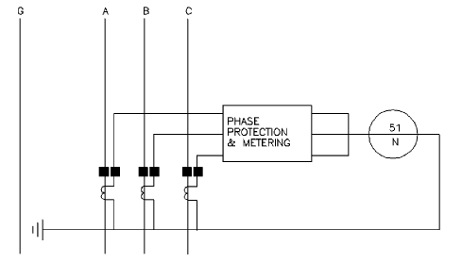
  - – Residually connected ground-fault relay

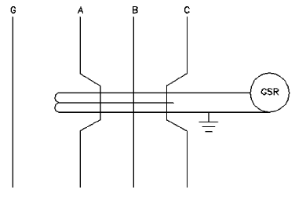
  - – Ground-fault sensor and ground-fault relay

The ground sensor relay shown in Figure 3-5 monitors the returning ground-fault current.
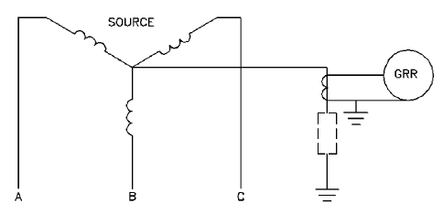
  - – Ground sensor monitoring returning ground fault current
      - Low-voltage systems (White 3.7)
As previously discussed, low-voltage systems for health care facilities are generally three-phase, four-wire systems. These systems usually contain effectively grounded normal power source neutrals. Here the alternate power source neutral may, or may not be, effectively grounded at the alternate source. The ground-fault schemes applicable will depend on how the alternate power supply is grounded.
For feeder circuits having no neutral conductor requirements (three-phase, three-wire loads), or for three-phase, four-wire loads where the neutral conductors are not electrically interconnected between power source on the load side of the feeder breaker, residually connected, ground-fault relay, or integral ground-fault relays (see Figure 3-6, Figure 3-7, and Figure 3-8) may be applicable for the feeder overcurrent device.
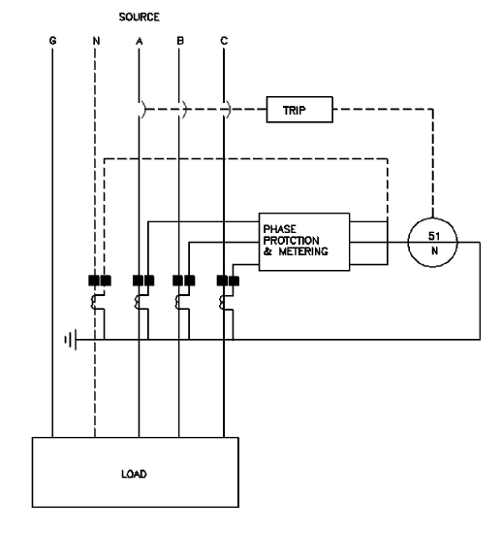
  - – Residually connected ground-fault relay with shunt trip circuit breaker
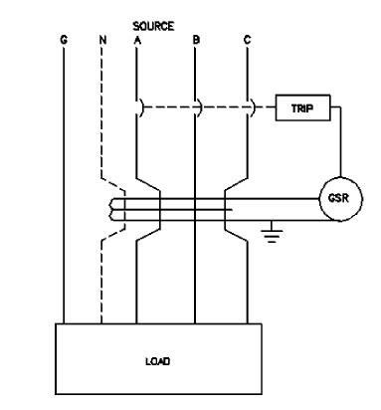
  - – Ground sensor fault relay

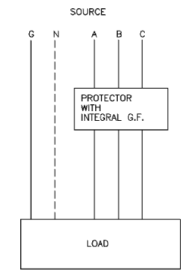

  - – Integral ground-fault relay
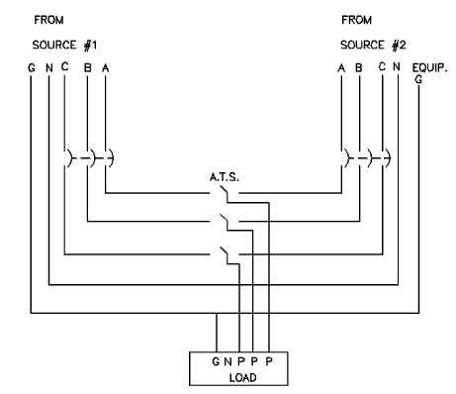
  - – Dual source electrically interconnected

For feeder circuits with neutral conductor requirements where the neutral conductors are electrically interconnected between power sources on the load side of the overcurrent device, “outgoing current method” schemes will be applicable. Figure 3-9 is an example of such a circuit.
Typical ground-fault relaying systems are shown (see Figure 3-10 and Figure 3-11) for a health care facility power system that consists of normal and alternate power supplies. The power systems shown in Figure 3-10 have an electrical power conductor interconnection between power supplies. Note the vectorial summation of ground-fault currents (outgoing current method) in the relaying scheme required for the power system shown in Figure 3-10. In both Figure 3-10 and Figure 3-11, ground-fault relay R2 is optional.

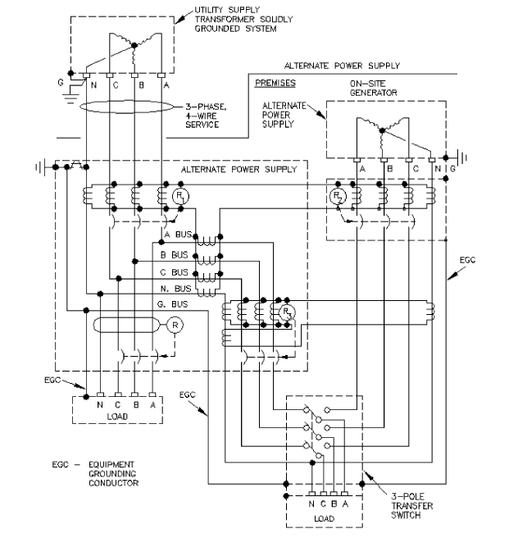
  - – Ground-fault scheme for a normal and alternate power supply
having an electrical power conductor (neutral) interconnection between supplies

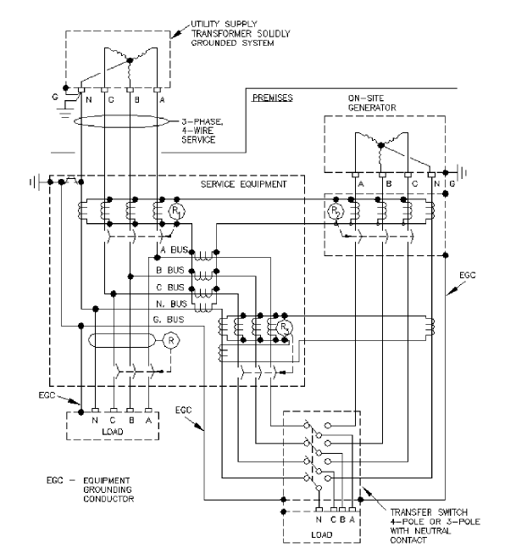

  - – Ground-fault scheme for a normal and alternate power supply
with no electrical power conductor interconnection between supplies

      - Circuit Breaker Trips

      - Protective Relays
        - Principles of protective relay application [B23], [B43], [B65] (Red 5.5)
Fault-protection relaying can be classified into two groups: primary relaying, which should function first in removing faulted equipment from the system, and backup relaying, which functions only when primary relaying fails.
To illustrate the areas of protection associated with primary relaying, figure 5-16 shows the various areas, together with circuit breakers, that feed each electric element of the system. Note that it is possible to disconnect any piece of faulted equipment by opening one or more circuit breakers. For example, when a fault occurs on the incoming line Ll, the fault is within a specific area of protection (area A) and should be cleared by the primary relays that operate circuit breakers 1 and 2. Likewise, a fault on bus 1 is within a specific area of protection, area B, and should be cleared by the primary relaying actuating circuit breakers 2, 3, and 4. If circuit breaker 2 fails to open and the faulted equipment remains connected to the system, the backup protection provided by circuit breaker 1 and its relays must be depended upon to clear the fault.
Figure 5-16 illustrates the basic principles of primary relaying in which separate areas of protection are established around each system element so that each can be isolated by a separate interrupting device. Any equipment failure occurring within a given area will cause tripping of all circuit breakers supplying power to that area.
To assure that all faults within a given zone will operate the relays of that zone, the current transformers associated with that zone should be placed on the line side of each circuit breaker so that the circuit breaker itself is a part of two adjacent zones. This is known as overlapping. Sometimes it is necessary to locate both sets of current transformers on the same side of the circuit breaker. In radial circuits the consequences of this lack of overlap are not usually very serious. For example, a fault at X on the load side of circuit breaker 3 in figure 5-16 could be cleared by the opening of circuit breaker 3 if there were any way to cause it to open circuit breaker 3. Since the fault is between the circuit breaker and the current transformers, the relays of circuit breaker 3 will not see it, and circuit breaker 2 will have to open and consequently interrupt the other load on the bus. When the current transformers are located immediately at the load bushings of the circuit breaker, the amount of circuit exposed to this problem is minimized. The consequences of lack of overlap become more serious in the case of tie circuit breakers between differentially protected buses and bus feeders protected by differential or pilot-wire relaying.
In applying relays to industrial systems, safety, simplicity, reliability, maintenance, and the degree of selectivity required should be considered. Before attempting to design a protective relaying plan, the various elements that make up the distribution system, together with the operating requirements, should be examined.
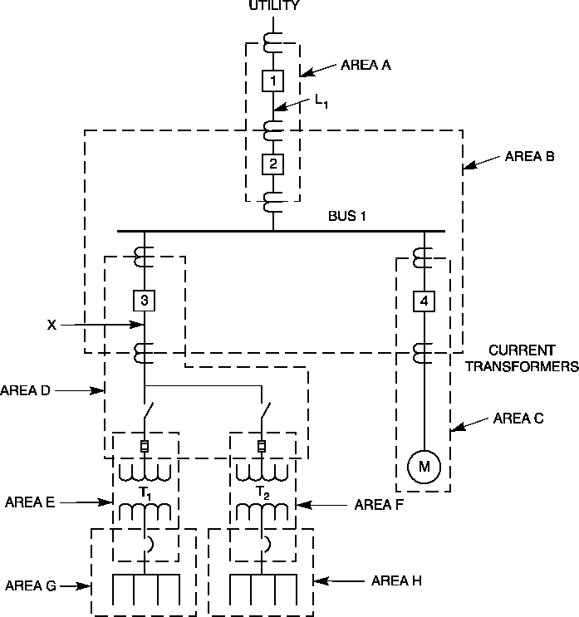
Figure 5-16—One-line diagram illustrating zones of protection
        - Typical small-plant relay systems (Red 5.5)
One of the simplest industrial power systems consists of a single service entrance circuit breaker and one distribution transformer stepping the utility's primary distribution voltage down to utilization voltage, as illustrated in figure 5-17. There would undoubtedly be several circuits on the secondary side of the transformer, protected by either circuit breakers or combination fused switches.
Protection for the feeder circuit between the incoming line and the devices on the transformer secondary would normally consist of conventional overcurrent relays, Devices 50/51. Preferably, the relays should have the same time–current characteristics as the relays on the utility system, so that for all values of fault current the local service entrance circuit breaker can be programmed to trip before the utility supply line circuit breaker. The phase relays should also have instantaneous elements, Device 50, to promptly clear high-current faults.

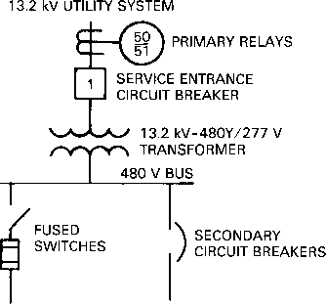
Figure 5-1 7—Typical small industrial system
This simple system provides both primary and backup relay protection. For instance, a fault on a secondary feeder should be cleared by the secondary protective device; however, if this device should fail to trip, the primary relays will trip circuit breaker 1. Where the secondary voltage is 600 V or less, local code authorities may require a main secondary device to be installed to protect the incoming conductors and provide back-up protection to the feeder protective devices. This simple industrial system can be expanded by tapping the primary feeder and providing fuse protection on the primary of each distribution transformer, as shown in figure 5-18.
This provides an additional step or area of protection over the simpler system shown in figure 5-17. All secondary feeder faults should be cleared by the secondary overcurrent devices as before, while faults within the transformer should now be cleared by the transformer primary fuses. The fuses may also act as backup protection for the faults that are not cleared by the secondary feeder overcurrent devices. Primary feeder faults will, as before, be cleared by circuit breaker 1, and it, in turn, will act as backup protection for the transformer primary fuses.
      - Protective relaying for a large industrial plant power system [B63], [B80], [B81] (Red 5.5)
As an electric system becomes larger, the number of sequential steps of relaying also increases, giving rise to the need for a protective relaying scheme that is inherently selective within each zone of protection. Figure 5-19 shows the main connections of a large system.
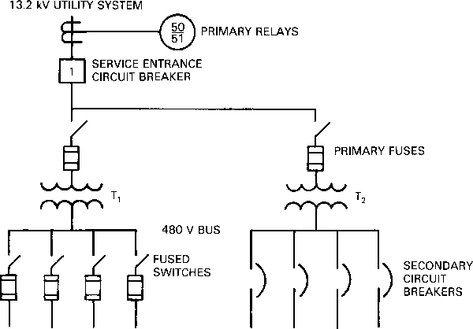
Figure 5-18—System of figure 5-17 expanded by addition of
a transformer and associated secondary circuits
        - Primary protection (Red 5.5)
The relay selectivity problem is of great concern to the utilities because their 69 kV supply lines are paralleled and their transformers are connected in parallel with the plant's local generation. The utility company should participate in the selection of relays applied for operation of either incoming circuit breaker in case of a disturbance in the 69 kV bus or transformers. Due to the 69 kV bus tie, a fault in either a bus or a transformer cannot be cleared by the opening of circuit breaker A or B alone, but will require the opening of circuit breakers A or B as well as AB and C or D.
When 69 kV tie breaker is open and a fault occurs on utility line 1, fault current will flow from line 2 back through the two industrial supply transformers. Three overcurrent relays having inverse-time characteristics should be installed at circuit breaker positions A and B as backup protection for faults that may occur on or immediately adjacent to the 69 kV buses. The connection of these overcurrent relays (Devices 50/5 1), shown in figure 5-19 as being energized from the output of two current transformers in a summation connection at the incoming 69 kV lines and bus tie, provides the advantage of isolating only the faulted bus section in a shorter time than would be possible if individual circuit breaker relays were used. This is commonly called a partial differential scheme.
Three directionally controlled overcurrent relays (Device 67) should be installed for circuit breakers C and D and connected to trip for current flow toward the respective 69 kV transformer. Directionally controlled overcurrent relays are ideal for interrupting this current, since their sensitivity is not limited by the magnitude of load current in the normal or nontrip direction.
The next zones of protection are the 13.8 kV buses 1 and 2. Fault currents are relatively high for any equipment failure on or near the main 13.8 kV buses. For this reason a differential protective relay scheme (Device 87B) is recommended for each bus. Differential relaying is instantaneous in operation and is inherently selective within itself. Without such relaying, high-current bus faults should be cleared by proper operation of overcurrent devices on the several sources. This usually results in long-time clearing since the overcurrent devices have pickup and time settings determined by other than bus fault considerations. General practice is to use separate current transformers with the same ratio and output characteristics for the differential relay scheme. A multicontact auxiliary relay (Device 86B) is used with the differential relays to trip all the circuit breakers connected to the bus whenever a bus fault occurs. To realize maximum sensitivity, the time-delay ground relays (Device 51N) at the 69Ð13.8 kV source transformers are connected to the output of current transformers measuring the current in the neutral connection to ground. The 87TN relay is differentially connected to provide sensitive tripping on faults between the transformer secondary and the 13.8 kV main circuit breaker. Auxiliary current transformers will normally be required to provide equal currents to the relay. Unlike the time-delay relays 51N-1 and 51N-2, this relay does not have to be set to be selective with other downstream ground-fault relays. Selective tripping of breakers C and D is achieved by the use of the partial differential relays scheme (Device 51).
Superior protection for the cable tie between buses 2 and 3 is provided by pilot-wire differential relays (Device 87L). In addition to being instantaneous in operation, pilot-wire schemes are inherently selective within themselves and require only two pilot wires if the proper relays are used. Backup protection provided by overcurrent relays should be installed at both ends of the tie line. Nondirectional relays can be applied at circuit breaker M, but at circuit breaker N directional relays are more advantageous since the 10 MVA generator represents a fault source at bus 3.
Separate current transformers are used for the pilot-wire differential relaying to provide reliability and flexibility in the application of other protective devices.
The 9000 hp 13.8 kV synchronous motor is provided with a reactor-type reduced-voltage starting arrangement using metal-clad switchgear. Overload protection is provided by a thermal relay (Device 49) whose sensor is a resistance temperature detector (RTD) imbedded in the stator windings. This relay can be used to either trip or alarm. Internal fault protection is provided by the differential relay scheme (Device 87M). Backup fault protection and locked- rotor protection is provided by an overcurrent relay (Device 5 1/50) applied in all three phases. Undervoltage and reverse-phase rotation protection are provided by the voltage-sensitive relay (Device 47) connected to the main bus potential transformers.
Ground-fault protection is provided by the instantaneous zero-sequence current relay (Device 50GS). The current-balance relay (Device 46) protects the motor against damage from excessive rotor heating caused by single phasing or another unbalanced voltage condition.
The motor rotor starting winding can be damaged by excessive current due to loss of excita-
tion or suddenly applied loads, which cause the motor to pull out of step. Rotor damage could
also result from excessive time for the motor to reach synchronous speed and lock into step.
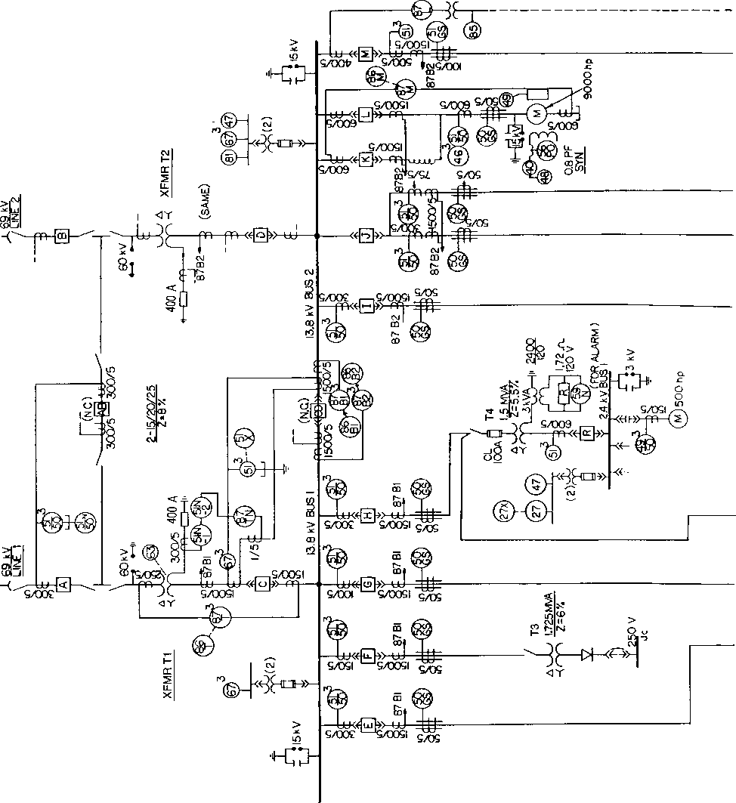
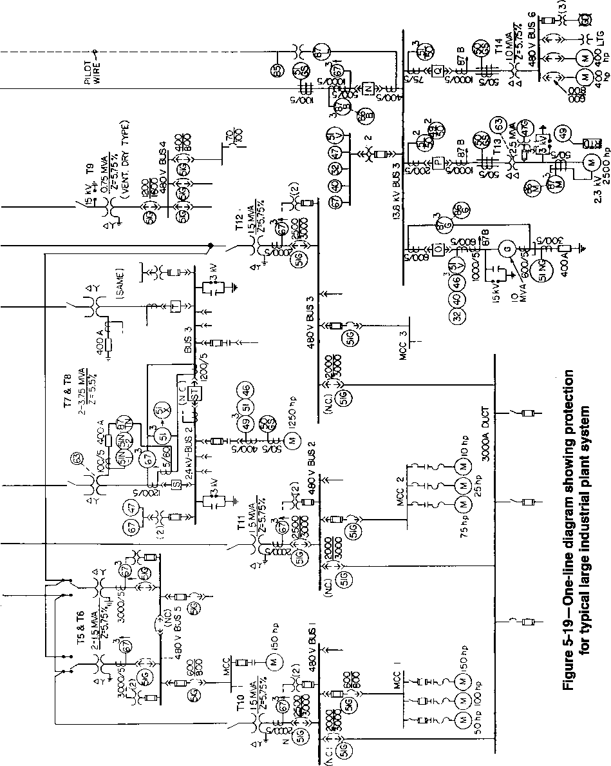
Protective device legend for Figure 5-19
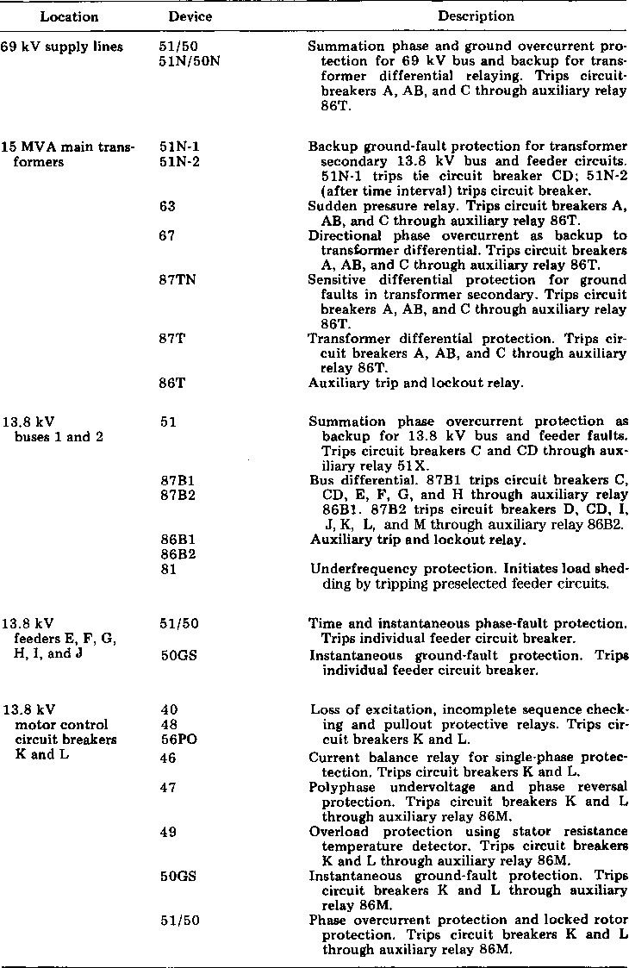
Protective device legend for Figure 5-19 (continued)
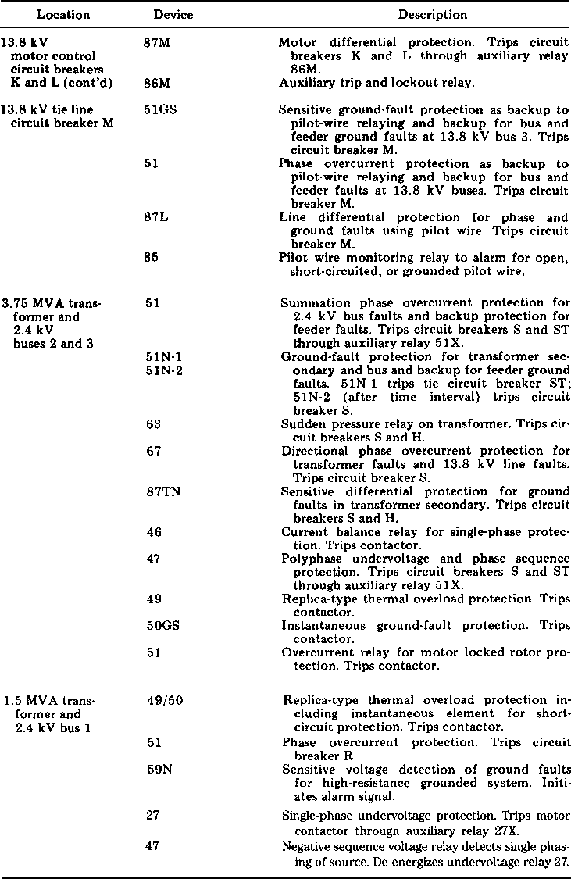
Protective device legend for Figure 5-19 (continued)
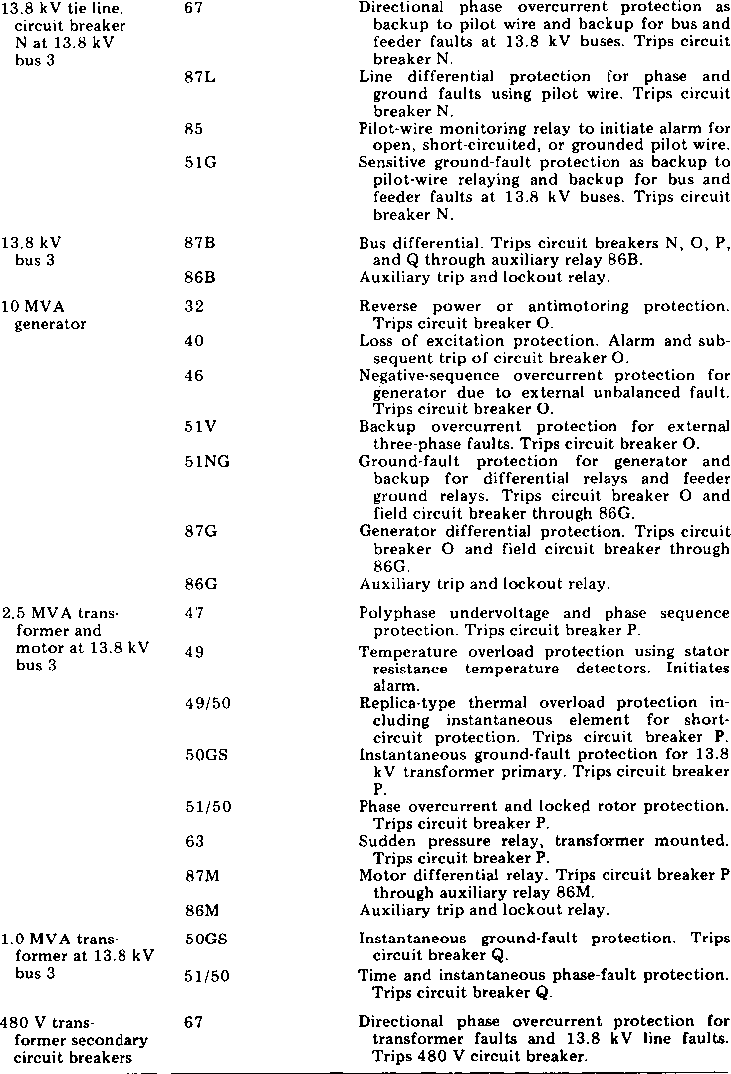
To protect against damage from these causes, loss of excitation (Device 40), pull-out (Device 56PO), and incomplete sequence (Device 48) relays should be provided. Multifunction motor protection relays, (Device 11) which combine many of the above functions, e.g., Device 49, 50LR, 50GS, 46, 48, in a single enclosure may be used. These are microprocessor-based devices that provide sensitive levels of protection and are easily programmable to meet the characteristics of the motor.
The 10 MVA generator connected to bus 3 is protected against internal faults by a percentage differential relay (Device 87G) and against ground faults by the overcurrent relay in the generator neutral (Device 51NG) where the current is limited by the 400 A neutral grounding resistor. Loss of excitation protection is provided by Device 40, and negative phase sequence protection caused by unbalanced loading or unbalanced fault conditions is provided by Device 46. The generator must also be protected from being driven as a motor (anti- motoring) when the prime mover can be damaged by such operation using a reverse power relay, Device 32. Backup overcurrent protection should be capable of detecting an external fault condition that corresponds to the minimum level of generator contribution with fixed excitation. This can be accomplished by three voltage-restraint or voltage-controlled overcurrent relays, Device 5 1V [B 57].
It is good practice for transformers of the size shown on the incoming service, where a circuit breaker is used on both the primary and secondary sides, to install percentage differential relays and inverse characteristic overcurrent relays for backup protection. To prevent operation of the differential relays on magnetizing inrush current when energizing the transformer, the large proportion of currents at harmonic multiples of the line frequency contained in the magnetizing inrush current are filtered out and passed through the restraint winding so that the current unbalance required to trip is made much greater during the excitation transient than during normal operation.
        - Medium-voltage protection (Red 5.5)
The medium-voltage (2.4 kV) substations shown in figure 5-19 are designed primarily for the purpose of serving the medium- and large-size motors. Buses 2 and 3 fed by the 3750 kVA transformers are connected together by a normally closed tie circuit breaker, which is relayed in combination with each main circuit breaker by means of a partial differential or totalizing relaying scheme (Device 51). The current transformers are connected with the proper polarity so that the relay sees only the total current into its bus zone and does not see any current that circulates into a bus zone through either main and leaves through the tie. The relay backs up the feeder circuit breaker relaying connected to its respective bus or operates on bus faults to trip the tie and appropriate main circuit breakers simultaneously, thereby saving one step of relaying time over what is required when the tie and main circuit breakers are operated by separate relays. One possible disadvantage to this scheme occurs when a directional relay or main circuit breaker malfunctions for a transformer fault or when a bus feeder circuit breaker fails to properly clear a downstream fault. The next device in the system that can clear is the opposite primary feeder circuit breaker. If this occurs, a total loss of service to the substation will result. As a result, additional overcurrent relays (Device 51) are sometimes added to the tie circuit breaker on systems where the possibility of this occurrence cannot be tolerated, although they are not shown on the system in figure 5-19. These relays can be set so as not to
extend any other relay operating time, while providing the necessary backup protection to afford proper circuit isolation for faults upstream from either main circuit breaker.
The source ground relaying for the double-ended 2.4 kV primary unit substation is similar to that described for the 13.8 kV transformer secondary. The single-ended 1500 kVA 2.4 kV primary unit substation on bus1 illustrates a method for high-resistance grounding utilizing an isolation transformer in the neutral circuit. This scheme limits the magnitude of ground current to a safe level, while permitting the use of a lower voltage rated resistor stack. The remainder of the 2.4 kV relaying shown in figure 5-19 is, in one form or another, provided for protection of the motor loads.
The application of a combination motor and transformer as shown connected to the 13.8 kV bus 3 is referred to as the unit method. This is done to take advantage of the lower cost of the motor and the transformer at 2.4 kV, as compared to the motor alone at 13.8 kV. Motor internal fault protection is provided by instantaneous overcurrent relays, arranged to provide differential protection (Device 87M), by the use of zero-sequence (doughnut-type) current transformers located either at the motor terminals or, preferably, in the starter. The latter current transformer location will also afford protection to the cable feeder. Three current transformers and three relays are applied in this form of differential protection. Thermal overload protection is provided by Device 49 using an RTD as the temperature sensor. Surge protection is provided by the surge arrester and capacitor located at the motor terminals, while undervoltage and reverse-phase rotation protection is provided by Device 47 connected to the bus potential transformers. The sudden pressure relay (Device 63) is used for detection of transformer internal faults. Branch circuit phase and ground-fault protection is provided by Devices 51/50 and 50GS, respectively.
The 500 hp induction motor served from the 2.4 kV bus 1 is provided with a nonfused class E1 contractor. The maximum fault duty on this 2.4 kV bus is well within the 50 000 kVA interrupting rating of the contractor and, therefore, fuses are not required. Motor overload protection is furnished by the replica-type thermal relay (Device 49) with the instantaneous overcurrent element (Device 50) applied for phase-fault protection. Separate relaying for motor locked-rotor protection is normally not justified on motors of this size. Undervoltage and single-phasing protection is provided for this and the other motors connected to this bus by Device 27, an undervoltage relay, and by Device 60, a negative-sequence voltage relay connected to the bus potential transformers. Due to the essential function of the motors applied on this bus, a high-resistance grounding scheme is utilized. A line-to-ground fault produces a maximum of two amperes as limited by the 1.72 Ù resistor applied in the neutral transformer secondary. A voltage is developed across the overvoltage relay (Device 59N), which initiates an alarm signal to alert operating personnel.
The 1250 hp induction motor connected to 2.4 kV bus 2 is provided with a fused class E2 contractor for switching. The R-rated fuse provides protection for high-magnitude faults. Motor overload protection is furnished by a replica-type thermal relay (Device49). Locked- rotor and circuit protection for currents greater than heavy overloads is furnished by Device 51. Protection against single-phasing underload is provided by the current-balance relay (Device 46). Instantaneous ground-fault protection is provided by Device 50GS, which is connected to trip the motor contractor since the ground-fault current is safely limited to 800 A maximum. Undervoltage and reverse-phase rotation protection is provided by Device 47.
        - Low-voltage protection (Red 5.5)
Figure 5-19 illustrates several different types of 480 V unit substation operating modes. Buses 1, 2, and 3, for example, represent a typical low-voltage industrial spot network system that is often used where the size of the system and its importance to the plant operation require the ultimate in service continuity and voltage stability. Multiple sources operating in parallel and properly relayed provide these features. The circuit breakers are provided with solid-state trip devices as the overcurrent protection means. Ground-fault protection is also indicated and would be supplied either as an optional modification to the trip device on the respective circuit breaker, or as a standard zero-sequence relaying scheme on feeder circuits. For tripping of transformer secondary main circuit breakers and protecting the secondary winding, a relay located in the transformer neutral provides another convenient approach.
Since the trip devices of the three main circuit breakers supplying 480 V buses 1, 2, and 3 would normally be set identically to provide selectivity with the tie circuit breakers feeding the 3000 A bus and the other 480 V feeder circuit breakers for downstream faults, directional relays should be provided on these circuit breakers. This will permit selective operation between all 480 V feeder circuit breakers and the main circuit breaker during reverse current flow conditions for transformer or primary faults. Directional relays might also be applied to each of the service-tie circuit breakers feeding the 3000 A bus duct so as to provide selective operation between these interrupters for transformer secondary bus faults.
To protect the 800 A frame size feeder circuit breakers from the high level of available fault current at secondary buses 1, 2, 3, and 5, current-limiting fuses should be applied in combination with each circuit breaker. Since the tie circuit breaker at bus 5 is normally closed, the main circuit breakers are also provided with directional relays to ensure selective operation between mains for upstream faults.
The unit substation feeding 480 V bus 4 is a conventional radial arrangement and, except for the addition of ground-fault protection, the circuit breakers shown are equipped with standard trip devices. Bus 6 is fed from a delta-connected transformer and is provided with a ground- fault detection system with both a visible and an audible signal. The small low-current frame- size circuit breakers at this bus have standard trip devices only and do not require the assistance of current-limiting fuses as a result of the lower fault duty on the load side of the 1000 kVA transformer.
      - Relaying for an industrial plant with local generation [B59], [B66], [B76], [B77] (Red 5.5)
When additional power is required in a plant that has been generating all its power, and a parallel-operated tie with a utility system is adopted, the entire fault-protection problem should be reviewed, together with circuit breaker interrupting capacities and system component withstand capabilities. In figure 5-20 the following assumptions are made:
- All circuit breakers in the industrial plant are capable of interrupting the increased short-circuit current.
- Each plant feeder circuit breaker is equipped with inverse-time or very inverse-time overcurrent relays with instantaneous units.
- Each of the generators is protected by differential relays and also has external fault backup protection in the form of generator overcurrent relays with voltage-restraint or voltage-controlled overcurrent relays, as well as negative-sequence current relays for protection against excessive internal heating for line-to-line faults.
- The utility company end of the tie line will be automatically reclosed through synchronizing relays following a trip-out.
- The utility system neutral is solidly grounded and the neutrals of one or both plant generators will be grounded through resistors.
- The plant generators are of insufficient capacity to handle the entire plant load; there-
fore, no power is to be fed back into the utility system under any condition.
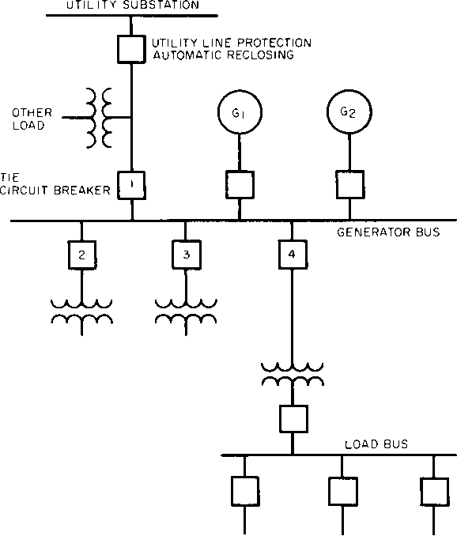
Figure 5-20—Industrial plant system with local generation
Protection at the utility end of the tie line might consist of three distance relays or time over- current relays without instantaneous units. If the distance relays were used, they would be set to operate instantaneously for faults in the tie line up to 10% of the distance from the plant, and with time delay for faults beyond that point in order to allow one step of instantaneous relaying in the plant on heavy faults. If time overcurrent relays were used, they would be set to coordinate with the time delay and instantaneous relays at the plant. At the industrial plant end of the tie at circuit breaker 1, there should be a set of directional overcurrent relays for faults on the tie line, or reverse power relaying to detect and trip for energy flow to other loads on the utility system should the utility circuit breaker open, or both.
The directional overcurrent relays are designed for optimum performance during fault conditions. The tap and time dial should be set to ensure operation within the short-circuit capability of the plant generation, and also to be selective to the extent possible with other fault-clearing devices on the utility system.
The reverse power or power directional relay is designed to provide maximum sensitivity for flow of energy into the utility system where coordination with the utility protective devices is not a requisite of proper performance. A sensitive tap setting can be used, although a small time delay is required to prevent nuisance tripping that may occur from load swings during synchronizing.
Due to this time delay a reverse power relay trip of circuit breaker 1 alone may be too slow to prevent generator overload in the event of loss of the utility power source. Further, the amount of power flowing out to the other utility loads may not at all times be sufficient to ensure relay pickup. A complete loss of the plant load can only be prevented by early detection of generator frequency decay to immediately trip not only circuit breaker 1, but also sufficient nonessential plant load so that the remaining load is within the generation capability. An underfrequency relay to initiate the automatic load shedding action is considered essential protection for this system. For larger systems, two or more underfrequency relays may be set to operate at successively lower frequencies. The nonessential loads could thereby be tripped off in steps, depending on the load demand on the system.
The proposed relay protection for a tie line between a utility system and an industrial plant with local generation should be thoroughly discussed with the utility to ensure that the interests of each are fully protected. Automatic reclosing of the utility circuit breaker with little or no delay following a trip-out is usually normal on overhead lines serving more than one customer. To protect against the possibility of the two systems being out of synchronism at the time of reclosure, the incoming line circuit breaker l can be transfer-tripped when the utility circuit breaker trips. The synchro-check relaying at the utility end will receive a dead-line signal and allow the automatic reclosing cycle to be completed. Reconnection of the plant system with the utility supply can then be accomplished by normal synchronizing procedures.
Generator external-fault protective relays, usually of the voltage-restraint or voltage-
controlled overcurrent type, and negative-sequence current relays provide primary protection
in case of bus faults and backup protection for feeder or tie line faults. These generator relays will also operate as backup protection to the differential relays in the event of internal generator faults, provided there are other sources of power to feed fault current into the generator.
  - Electrical Faults
    - Types of faults (Violet 2.11)
In a three-phase power system, the type of faults that can occur are classified by the combination of conductors or buses that are faulted together. In addition, faults may be classified as either bolted faults or faults that occur through some impedance such as an arc. Each of the basic types of faults will be described and shown in Figure 2-10, but it should be noted that in a majority of cases, the fault current calculation required for the selection of interrupting and withstand current capabilities of equipment is the three-phase bolted fault with zero impedance.
A three-phase bolted fault describes the condition where the three conductors are physically held together with zero impedance between them, just as if they were bolted together. For a balanced symmetrical system, the fault current magnitude is balanced equally within the three phases. While this type of fault does not occur frequently, its results are used for protective device selection, because this fault type generally yields the maximum short-circuit current values. Figure 2-10(a) provides a graphical representation of a bolted three-phase fault.
Table 2-1−Differences in per-unit peak currents based on Equation (2.11), Equation (2.12), and Equation (2.13) (one per-unit equals ac peak)
EXACT |  |  |  | IEC |  | HALF CYCLE |  | VIOLET APPROX
 | Time to |  | Maximum | Maximum | Percent | Maximum | Percent | Maximum | Percent
X/R | Peak(CY) | DC | Peak | Peak | Error | Peak | Error | Peak | Error
0.5 | 0.3213 | 0.0078 | 1.0078 | 1.0224 | 1.45 | 1.0019 | -0.59 | 1.0061 | -0.16
1.0 | 0.3635 | 0.0694 | 1.0694 | 1.0688 | -0.06 | 1.0432 | -2.45 | 1.0722 | 0.26
1.5 | 0.3891 | 0.1571 | 1.1571 | 1.1526 | -0.39 | 1.1231 | -2.94 | 1.1656 | 0.73
2.0 | 0.3977 | 0.2418 | 1.2418 | 1.2387 | -0.25 | 1.2079 | -2.73 | 1.2521 | 0.83
2.5 | 0.4063 | 0.3157 | 1.3157 | 1.3152 | -0.04 | 1.2846 | -2.36 | 1.3255 | 0.75
3.0 | 0.4282 | 0.3786 | 1.3786 | 1.3805 | 0.14 | 1.3509 | -2.01 | 1.3870 | 0.61
3.5 | 0.4357 | 0.4319 | 1.4319 | 1.4359 | 0.28 | 1.4075 | -1.70 | 1.4388 | 0.48
4.0 | 0.4417 | 0.4774 | 1.4774 | 1.4829 | 0.37 | 1.4559 | -1.45 | 1.4827 | 0.36
6.0 | 0.4575 | 0.6057 | 1.6057 | 1.6144 | 0.54 | 1.5924 | -0.83 | 1.6072 | 0.09
8.0 | 0.4665 | 0.6842 | 1.6842 | 1.6935 | 0.56 | 1.6752 | -0.53 | 1.6843 | 0.01
10.0 | 0.4735 | 0.7368 | 1.7368 | 1.7460 | 0.53 | 1.7304 | -0.37 | 1.7367 | -0.01
14.0 | 0.4795 | 0.8027 | 1.8027 | 1.8110 | 0.46 | 1.7990 | -0.20 | 1.8029 | 0.01
20.0 | 0.4852 | 0.8566 | 1.8566 | 1.8635 | 0.37 | 1.8546 | -0.11 | 1.8574 | 0.04
25.0 | 0.4880 | 0.8832 | 1.8832 | 1.8892 | 0.32 | 1.8819 | -0.07 | 1.8841 | 0.05
30.0 | 0.4899 | 0.9015 | 1.9015 | 1.9067 | 0.27 | 1.9006 | -0.05 | 1.9025 | 0.05
40.0 | 0.4923 | 0.9250 | 1.9250 | 1.9292 | 0.22 | 1.9245 | -0.03 | 1.9259 | 0.05
50.0 | 0.4938 | 0.9395 | 1.9395 | 1.9429 | 0.18 | 1.9391 | -0.02 | 1.9403 | 0.04
75.0 | 0.4958 | 0.9591 | 1.9591 | 1.9616 | 0.12 | 1.9590 | -0.01 | 1.9598 | 0.03
100.0 | 0.4969 | 0.9692 | 1.9692 | 1.9710 | 0.09 | 1.9691 | -0.00 | 1.9697 | 0.03
250.0 | 0.4987 | 0.9875 | 1.9875 | 1.9883 | 0.04 | 1.9875 | -0.00 | 1.9878 | 0.01
500.0 | 0.4994 | 0.9937 | 1.9937 | 1.9941 | 0.02 | 1.9937 | -0.00 | 1.9939 | 0.01
1000. | 0.4997 | 0.9969 | 1.9969 | 1.9971 | 0.01 | 1.9969 | -0.00 | 1.9969 | 0.00

Table 2-2−Per-unit rms currents at peak ac current based on Equation (2.15), Equation (2.16), and Equation (2.17) (one per-unit equals ac rms)
EXACT |  |  |  | IEC |  | HALF CYCLE |  | VIOLET APPROX
 | Time to |  | Maximum | Maximum | Percent | Maximum | Percent | Maximum | Percent
X/R | Peak(CY) | DC | RMS | RMS | Error | RMS | Error | RMS | Error
0.5 | 0.3213 | 0.0110 | 1.0001 | 1.0005 | 0.04 | 1.0000 | -0.01 | 1.0000 | -0.00
1.0 | 0.3635 | 0.0981 | 1.0048 | 1.0047 | -0.01 | 1.0019 | -0.29 | 1.0052 | 0.04
1.5 | 0.3891 | 0.2222 | 1.0244 | 1.0230 | -0.13 | 1.0151 | -0.91 | 1.0270 | 0.26
2.0 | 0.3977 | 0.3419 | 1.0568 | 1.0554 | -0.13 | 1.0423 | -1.37 | 1.0616 | 0.45
2.5 | 0.4063 | 0.4464 | 1.0951 | 1.0948 | -0.03 | 1.0780 | -1.57 | 1.1009 | 0.53
3.0 | 0.4282 | 0.5354 | 1.1343 | 1.1356 | 0.11 | 1.1164 | -1.58 | 1.1400 | 0.50
3.5 | 0.4357 | 0.6108 | 1.1718 | 1.1747 | 0.25 | 1.1542 | -1.50 | 1.1769 | 0.43
4.0 | 0.4417 | 0.6751 | 1.2066 | 1.2110 | 0.36 | 1.1899 | -1.38 | 1.2108 | 0.35
6.0 | 0.4575 | 0.8566 | 1.3167 | 1.3248 | 0.61 | 1.3045 | -0.93 | 1.3181 | 0.10
8.0 | 0.4665 | 0.9676 | 1.3915 | 1.4007 | 0.66 | 1.3827 | -0.63 | 1.3916 | 0.01
10.0 | 0.4735 | 1.0420 | 1.4442 | 1.4536 | 0.65 | 1.4377 | -0.45 | 1.4441 | -0.01
14.0 | 0.4795 | 1.1352 | 1.5128 | 1.5216 | 0.58 | 1.5089 | -0.26 | 1.5131 | 0.02
20.0 | 0.4852 | 1.2114 | 1.5709 | 1.5784 | 0.48 | 1.5687 | -0.14 | 1.5717 | 0.05
25.0 | 0.4880 | 1.2491 | 1.6001 | 1.6066 | 0.41 | 1.5986 | -0.09 | 1.6011 | 0.06
30.0 | 0.4899 | 1.2750 | 1.6203 | 1.6261 | 0.36 | 1.6193 | -0.07 | 1.6214 | 0.06
40.0 | 0.4923 | 1.3082 | 1.6466 | 1.6513 | 0.28 | 1.6460 | -0.04 | 1.6476 | 0.06
50.0 | 0.4938 | 1.3286 | 1.6629 | 1.6668 | 0.24 | 1.6625 | -0.02 | 1.6638 | 0.06
75.0 | 0.4958 | 1.3564 | 1.6852 | 1.6880 | 0.16 | 1.6850 | -0.01 | 1.6859 | 0.04
100.0 | 0.4969 | 1.3706 | 1.6966 | 1.6988 | 0.13 | 1.6965 | -0.01 | 1.6972 | 0.03
250.0 | 0.4987 | 1.3966 | 1.7177 | 1.7186 | 0.05 | 1.7177 | -0.00 | 1.7179 | 0.02
500.0 | 0.4994 | 1.4054 | 1.7248 | 1.7253 | 0.03 | 1.7248 | -0.00 | 1.7250 | 0.01
1000. | 0.4997 | 1.4099 | 1.7285 | 1.7287 | 0.01 | 1.7284 | -0.00 | 1.7285 | 0.00

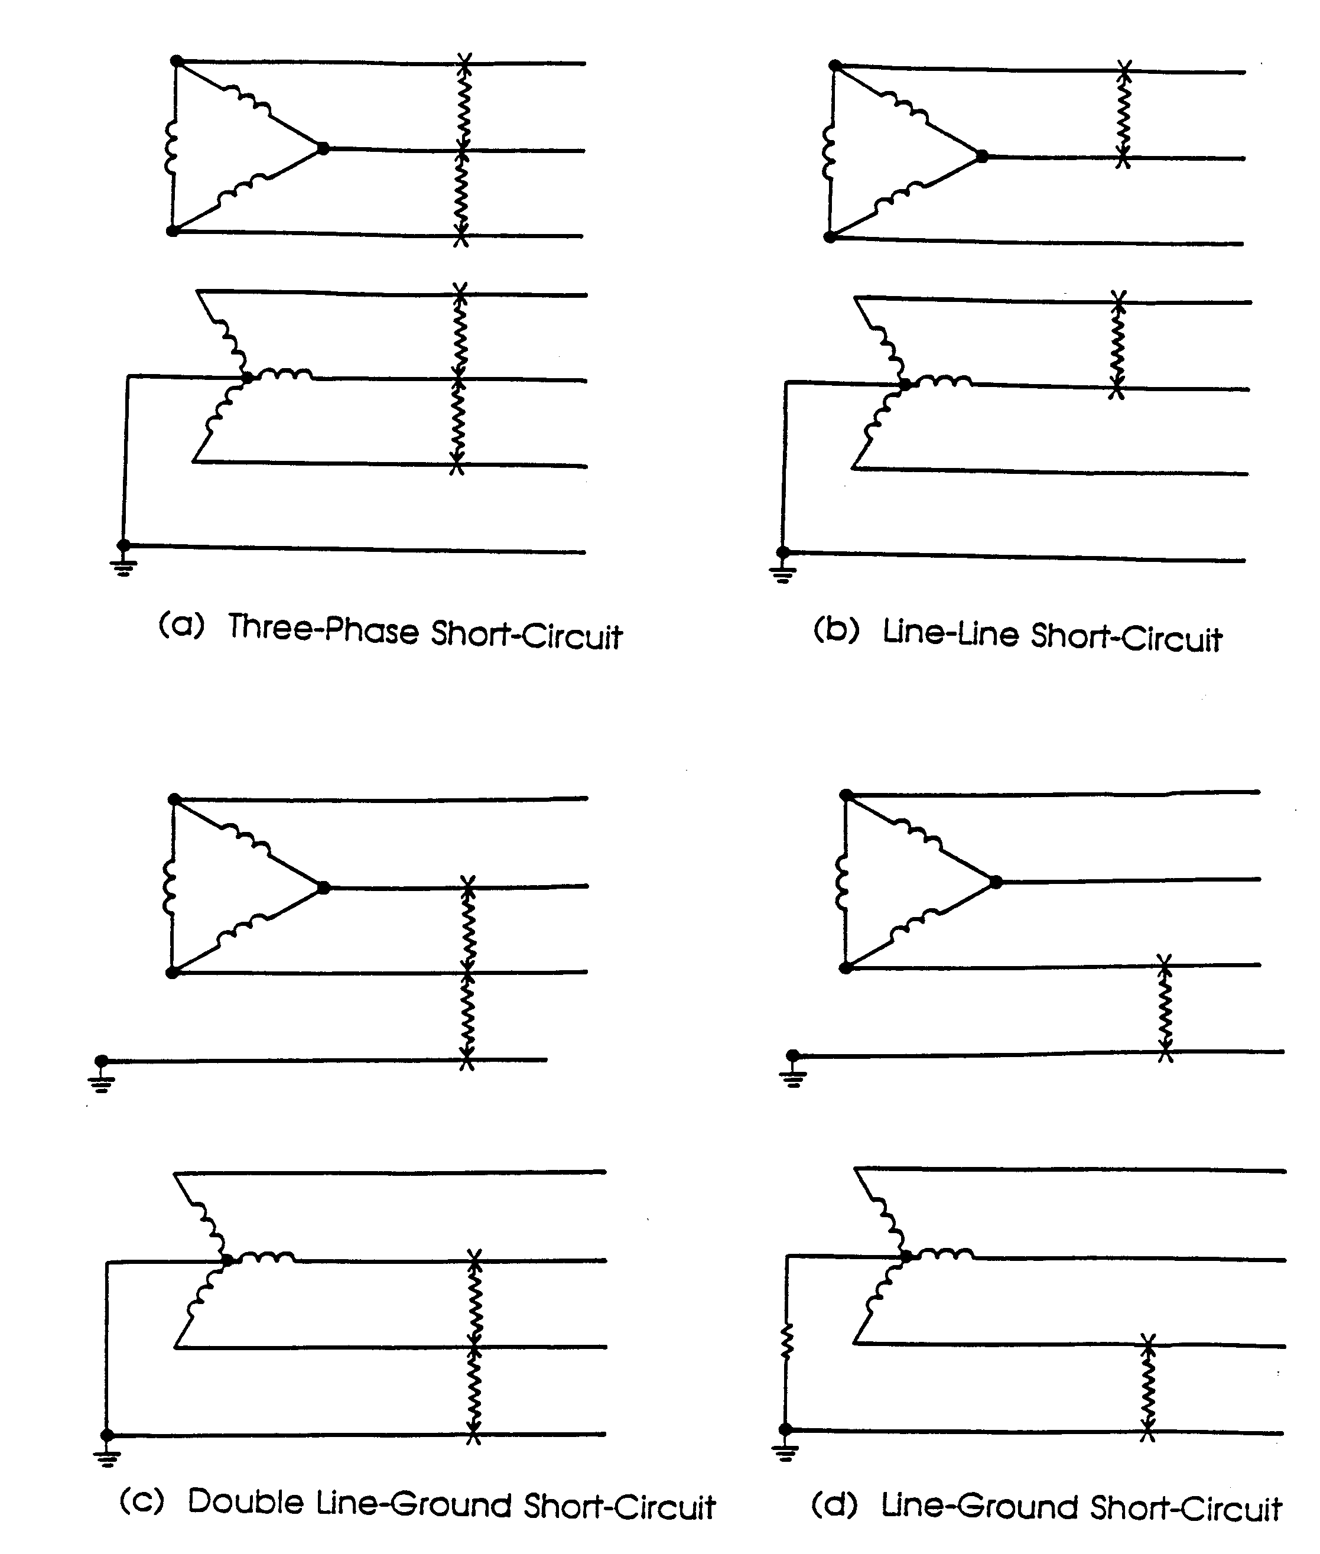
Figure 2-10−Designation of short-circuit categories
Bolted line-to-line faults, Figure 2-10(b), are more common than three-phase faults and have fault currents that are approximately 87% of the three-phase bolted fault current. This type of fault is not balanced within the three phases and its fault current is seldom calculated for equipment ratings because it does not provide the maximum fault current magnitude. The line-to-line current can be calculated by multiplying the three-phase value by 0.866, when the impedance Z₁ = Z₂. Special symmetrical component calculating techniques are not required for this condition.
Line-to-line-to-ground faults, Figure 2-10©, are typically line-to-ground faults that have escalated to include a second phase conductor.This is an unbalanced fault. The magnitudes of double line-to-ground fault currents are usually greater than those of line-to-line faults, but are less than those of three-phase faults. Calculation of double line-to-ground fault currents requires the use of symmetrical components analysis. The impedance of the ground return path will affect the result, and should be obtained if possible.
Line-to-ground faults, Figure 2-10(d), are the most common type of faults and are usually the least disturbing to the system. The current in the faulted phase can range from near zero to a value slightly greater than the bolted three-phase fault current. The line-to-ground fault current magnitude is determined by the method in which the system is grounded and the impedance of the ground return path of the fault current. Calculation of the exact line-to-ground fault current magnitudes requires the special calculating techniques of symmetrical components. However, close approximations can be made knowing the method of system grounding used. On ungrounded distribution systems, the line-to-ground fault currents are near zero. Line-to-ground fault current magnitudes in distribution systems with resistance grounded system neutrals can be estimated by dividing the system line-to-neutral system voltage by the total value of the system ground-to-neutral resistance. Line-to-ground fault current magnitudes in distribution systems with a solidly grounded system will be approximately equal to the three-phase fault current magnitudes. Determining line-to-ground fault currents on long cable runs or transmission lines will require detailed ground return path impedance data and detailed calculation techniques.
    - Types of Faults
      - Ground Faults
Ground faults on electric systems can originate in many ways, have a wide range of magnitudes, and cause varying amounts of damage. The most serious faults from the standpoint of rate of eroded material are arcing faults, both phase to phase and phase to ground.
        - Origin of ground faults (Buff 8.3)
Ground faults originating from insulation breakdown can be classified, roughly, as follows:
- Reduced insulation (e.g., due to moisture, atmospheric contamination, foreign objects, insulation deterioration)
- Physical damage to insulation system (e.g., due to mechanical stresses, insulation punctures)
- Excessive transient or steadystate voltage stresses on insulation
Good installation and maintenance practices ensuring adequate connections and the integrity of the insulation of the equipment have a significant effect in reducing the probability of ground faults. However, insulation breakdowns to ground can occur at any point in the system where phase conductors are in close proximity to a grounded reference. The contact between the phase conductor and ground is usually not a firm metallic contact, but rather usually includes an arcing path in air or across an insulating surface, or a combination of both. In addition to these arcing ground faults, certain bolted faults occur, usually during installation or maintenance, when an inadvertent firm metallic connection is made from phase to ground.
        - Magnitude of ground-fault currents (Buff 8.3)
Groundfault current magnitudes can vary greatly. Using the method of symmetrical components (see Chapter 2), the single linetoground fault current I_{GF} is calculated by the formula:
where
Z₁ is the positivesequence impedance,
Z₂ is the negativesequence impedance,
Z₀ is the zerosequence impedance.
Z_{G} is the combined impedance of the ground return circuit, including the fault arc impedance, the grounding circuit impedance, and the intentional neutral impedance, when present.
To illustrate how groundfault currents can vary greatly in magnitude, consider a solidly grounded system with a bolted ground fault close to the generator terminals. In this example, ZG could approach zero; and, assuming Z1 = Z2 = Z0, then,
which is actually the formula for a bolted three-phase fault. In fact, with many generators, because Z₀ is smaller than Z₁, it is necessary to add an intentional neutral impedance Z_{N} to reduce the bolted groundfault current to the magnitude of the bolted three-phase fault current.
For a ground fault in a highresistance-grounded system, the neutral resistance R_{N} is large compared to Z₁, Z₂, Z₀, and the remainder of Z_{G}. Then, I_{GF} is approximately equal to V_{L–N} divided by R_{N}.
For example, in a highresistance-grounded 480 V system with a neutral resistance of 20 Ω, the groundfault current is
This approximation is true because the fault arc impedances and the groundcircuit impedances are negligible when compared to 20 Ω.
Precise calculation of lowvoltage groundfault current magnitudes in solidly grounded systems is much more difficult than the previous example. The reason is that the circuit impedances, including the fault arc impedance, that were negligible in the highresistance example play an important part in reducing groundfault current magnitudes. This applies even in most cases where a sizable grounding conductor is carried along with phase conductors.
The primary consideration in applying groundfault protection is whether a selectively coordinated system can be achieved and, if not, to establish the extent to which lack of selectivity is acceptable.
The two main setting characteristics that need to be determined for ground-fault relays are
- Minimum operating current
- Speed of operation
Selection of the minimum operating current (or pickup) setting is based primarily on the characteristics of the circuit being protected. If the circuit serves an individual load (e.g., a motor, transformer, heater circuit), then the pickup setting can be low, such as 5 A to 10 A. If the protected circuit feeds multiple loads, each with individual overcurrent protection [e.g., a panelboard, feeder duct, motor control center (MCC)], the pickup settings are higher. These higher settings (in the order of 200 A to 1200 A) are selected to allow the branch phase-overcurrent devices to clear lowmagnitude ground faults in their respective circuits, if coordination is possible. Furthermore, lowlevel faults in some parts of the system may be selfextinguishing and, therefore, allow uninterrupted operation of other equipment.
        - Damage due to arcing faults (Buff 8.3)
The arcing fault causes a large amount of energy to be released in the arcing area. The ionized products of the arc spread rapidly. Vaporization at both arc terminals occurs, and the erosion at the electrodes is concentrated when the arc does not travel. While the arc tends to travel away from the source, this movement does not necessarily occur at low levels of fault current or at higher levels of current in circuits with insulated conductors. If an arcing fault is allowed to persist indefinitely, it is a potential fire hazard, causes considerable damage, may result in a more extended power outage, and subjects nearby employees to burns from arc flash.
Shunt trip fusible switches can be equipped with antisingle-phasing provisions that consist of installing small actuator fuses in parallel with the line fuses in the switch. When a line fuse opens, these fuses also open and subsequently close a contact to actuate a signal or switchopening circuit to open all three poles of the switch. Figure Error: Reference source not found shows this particular scheme, which can also be used in conjunction with groundfault protective relaying. Other equipment utilizes voltage relays in place of the actuator fuses to trip interrupter switches. These antisingle-phasing devices are often specified to clear a ground fault that may cause only one fuse to open. If the fault remains and is of such high impedance that it does not open any fuses in any other phases, the opening of the first fuse causes all three poles of the switch to open and the fault is cleared.
Fused circuit breakers and service protectors, as well as circuit breakers, have antisingle-phasing devices incorporated in their basic designs.
The basic need for groundfault protection in lowvoltage grounded systems is illustrated in Figure Error: Reference source not found and Figure Error: Reference source not found . A 1000 kVA transformer, with a 1600 A main circuit breaker and typical longtime and shorttime characteristics, optionally with a fused switch, is shown.
A 1500 A ground fault (Point I) on the 480Y/277 V grounded neutral system would not be detected by the main circuit breaker or fuse. A ground relay set at 0.2 s time delay would cause the circuit breaker or bolted pressure switch to clear the fault in about 0.33 s. A 4000 A ground fault (Point II) could persist for about 33 s, even if the circuit breaker’s minimum longtime band were used. The fuse would require up to 5 min to clear this fault. The ground-relayed circuit breaker or bolted pressure switch would clear the fault in about 0.25 s. An 8000 A ground fault (Point III) would be cleared within about 0.2 s to 0.4 s by the circuit breaker shorttime device, assuming it is present; otherwise, between 8 s to 20 s would elapse before the longtime device clears the fault.
Arc energies for these assumed faults are tabulated in Table Arc energies for assumed faults of Figure Error: Reference source not found . Arc voltages are assumed to be 100 V. Because the arc voltage tends to have a flat top characteristic (nonlinear arc resistance), the energy of the arc in watts per second can be estimated by obtaining the product of the current in rms amperes, the arc voltage in volts, and the clearing time in seconds. Approximate calculation of the energy required to erode a certain amount of electrode material shows that 50 kWs of energy divided equally between conductor and enclosure vaporizes about 2.05 cm³ of aluminum or 0.82 cm³ of copper. The calculation assumes that most of the arc energy goes into the electrodes, while the energy lost to the surrounding air is neglected. Comparisons were made from several arcing fault tests (see Conrad and Dalasta Error: Reference source not found; Fisher Error: Reference source not found), and good correlation was obtained between calculated energy from test data and measured conductor material eroded.
- Arc energies for assumed faults of Figure Error: Reference source not found
Figure Error: Reference source not found points | Fault  (A, rms) | Main device | Clearing time  (s) | Arc energy  (kWs)
I | 1500 | Relay  Circuit breaker  Fuse | 0.33  ×  × | 50  ×  ×
II | 4000 | Relay  Circuit breaker  Fuse | 0.25  33.00  300.00 | 100  13 200  120 000
III | 8000 | Relay  Circuit breaker  Fuse | 0.25  0.4  10.00 | 200  320  8000
IV | 20 000 | Relay  Circuit breaker  Fuse | 0.25  0.20  0.01 | 500  400  20
For the assumed 8000 A fault, even though the current values are the calculated result using all source, circuit, and arc impedances, the actual rms current values passing through the circuit breaker can be considerably lower. The reason is the spasmodic nature of the fault caused by
- Arc-elongating blowouts effects
- Physical flexing of cables and some bus structures due to mechanical stresses
- Selfclearing attempts and arc reignition
- Shifting of the arc terminals from point to point on the grounded enclosures (and on the faulted conductors for noninsulated construction)
All of these effects tend to reduce the rms value of arcing fault currents. Therefore, a ground fault that would normally produce 8000 A under stabilized conditions might well result in an effective value of only 4000 A and would have the arc energies associated with Point II in Table Arc energies for assumed faults of Figure Error: Reference source not found .
Expressing acceptable damage in terms of kWs, or kW cycle units, with an assumption of 100 V arc drop in 480Y/277 V circuits has been proposed.
Investigations show that damage in standard switchboards at normal arc lengths is proportional to time and 1.5 power of groundfault current magnitude (see Stanback Error: Reference source not found). Thus, the arc voltage magnitude question at varying and unpredictable fault currents may be excluded and damage prediction simplified.
According to the study, specific damage or burning rate
with
k_{s} is 1.18 × 10–⁵ cm³/A^{1.5}s for copper,
k_{s} is 2.49 × 10–⁵ cm³/A^{1.5}s for aluminum,
k_{s} is 1.08 × 10–⁵ cm³/A^{1.5}s for steel.
Because selection of conductors is often based on nearly uniform current densities (e.g., 125–155 A/cm²), acceptable damage could then be based on conductor or disconnect ratings or on cross-sectional area.
Thus, if based on
I_{F}^{1.5}t = k_{e}I_{R}
where
I_{F} is fault current,
I_{R} is disconnect or bus rating,
the acceptable damage V_{D} = k_{s}k_{e}I_{R} can be used as a constant for a given system and disconnect rating. Acceptable damage could then be held by appropriate selection of current and time settings for groundfault protective devices.
For example, if I_{R} = 1000 A and k_{e} = 250 [A^{0.5} s] (as assumed in NEMA PB 2.21999) acceptable damage,
I1.5t = 250 × 1000 = .025 × 10+6 [A1.5 s], or
VD = 1.18 × 10–5 × 0.25 × 106 = 2.95 cm3 for copper,
conductors are not exceeded for faults between 800 A and 10 000 A, with relay settings as shown in Figure Error: Reference source not found if clearing time of the circuit breaker or bolted pressure switch does not exceed 200 ms.
The above computations are based on 277 V singlephase test results and the assumption that the damage would be proportional to the arcing fault current. Therefore, some discretion should be used when referencing the example in Figure Error: Reference source not found (see Love Error: Reference source not found).
        - Selection of lowvoltage protective device settings (Buff 8.3)
Maximum protection against ground faults can be obtained by applying ground protection on every feeder circuit from source to load. The minimum operating current for all series devices may be set at about the same pickup setting, but the time curves are selected so that each circuit protective device is opened progressively faster, moving from the source to the load. The load switching device can be opened instantaneously or with brief delay upon occurrence of a ground fault.
The delay required between devices is determined by the addition of
- The trip-operating time of the overcurrent device
- The clearing time of the overcurrent device
- A margin of safety
The trip-operating time of today’s moldedcase circuit breakers (MCCBs), service protectors, power circuit breakers, or shunt-tripped switches is usually about 3 cycles. Current-limiting fuses clear in about .004 s when operating in their current-limiting range.
This coordination by time delay is similar to other overcurrent coordination. However, another method of coordination, called zone selective interlocking (ZSI), is available for groundfault protection using solidstate relays and electronic trip devices. Ground faults, for minimum damage, should be cleared as quickly as possible regardless of their magnitude. Zone coordination assures instantaneous tripping of all groundfault relays for faults within their zone of protection, with upstream devices restrained to a time delay in response to ground faults outside their zone. This restraining signal requires as few as one pair of wires from the downstream zone to the upstream relay to carry the interlocking signal. ZSI provides the fastest tripping, for minimum damage, with full coordination so that only the affected part of the system is shut down on ground fault. ZSI is discussed further in Error: Reference source not found.
Boltedpressure and high-pressure contact fused switches using the groundfault protection schemes can be shunt tripped to open quickly.
From the standpoint of damage alone, speed of clearing is paramount. However, in some situations, delay is desirable, primarily to obtain coordination between main and feeder circuits and branch currents. Consider a typical 480Y/277 V application consisting of a 3000 A main, an 800 A feeder, and a 100 A branch circuits. If the branch circuits do not have groundfault protection, then the feeder groundfault protection should be set with a time delay to allow the branch circuit phase-overcurrent device to clear moderately highmagnitude ground-fault currents without opening the feeder through its ground-fault protection. When full coordination is essential, setting the feeder groundfault pickup above and to the right of the branch circuit devices is desirable. While infrequent loss of coordination may be acceptable between feeders and branch circuits, full coordination should be maintained between main and feeder overcurrent protective devices. Setting main service ground-fault protection at less than 0.1 s (or 6 cycle) response time is generally not recommended. Proper settings reduce effects of inrush, startups, and switching currents and prevent nuisance openings.
Another reason for delayed clearing of ground faults on main or large feeder circuits is the threat of circuit interruption where the power outage itself is of greater consequence than the incremental difference in fault damage.
In summary, the sensitivity (or minimum operating current setting) of ground-fault protection in solidly grounded lowvoltage systems is determined by the following considerations:
- When the groundfault protection is used on devices protecting individual loads, such as motors, the lowest available settings can be used, providing the devices do not cause false opening from inrush currents.
- For the main and feeder circuits, the setting for groundfault protective devices is normally in the range of 10% to 100% of the circuit trip rating or fuse rating. If downstream devices do not have groundfault protection, then the circuit groundfault protection may have to be set higher than the downstream phaseprotective device opening characteristics to ensure full coordination. Many times, the main ground-fault protection needs to be set at the code maximum of 1200 A in order to selectively coordinate with the downstream phase- and ground-fault protection.
        - Sensing, relaying, and trip devices (Buff 8.3)
The signal for groundfault protective devices may be derived from the residual of phase CTs, window CTs, or sensors. The CTs or sensors provide isolation between main busses and relaying equipment and should be located in a specific path to detect proper groundfault currents under all operating conditions.
Sensors are often designed with other than 5 A or 1 A nominal secondary rating and for use with specific relays or trip devices as a system. If part of such a system, the relays normally have dials marked in terms of primary groundfault current amperes.
Groundfault relays or trip devices may be either selfpowered (i.e., fault current) or externally powered (i.e., operation or trip power), or incorporate both methods. Outputs may be contact or solidstate (e.g., thyristors).
AC control power, derived from an auxiliary transformer of proper capacity, is frequently used in systems of 600 V and below and is sometimes supplemented by capacitor trips. The primaries of control power transformers should be connected line to line to reduce effects of voltage dips during ground faults, and the trip device should be capable of operating at 0.866 times rated voltage. The need for overcurrent protection and transfer to an alternate control power source should be evaluated.
Supplementary or backup groundfault protection may be accomplished by monitoring the equipment environment. Such systems detect ionized gases and other fault-current byproducts, such as abnormal light and heat. By early detection of one or more of the byproducts of a groundfault current and prompt opening of the interrupting device serving the fault, the magnitude of the damage may be reduced. Supplementary sensing is particularly desirable when the primary means of groundfault sensing is set relatively high to prevent nuisance opening or to satisfy coordination requirements. To maximize the effectiveness of environmental detectors, care should be exercised in the selection, proper installation within the equipment enclosure, and setting of the detectors (see Neuhoff Error: Reference source not found).
      - Short Circuits
        - Types of short-circuit currents (Buff 2.2)
From the point of view of functional application, four or more distinct types of short-circuit current magnitudes exist. The current of greatest concern flows in the system under actual short-circuit conditions and could (at least theoretically) be measured using some form of instrumentation. In reality, it is not practical to attempt to predict by calculation the magnitude of actual current because it is subject to a great many uncontrollable variables. Power system engineers have developed application practices, some of which are discussed in the following paragraphs, that predict worst-case magnitudes of current sufficient for application requirements.
The analyst or engineer may have several objectives in mind when a short-circuit current magnitude is calculated. Obviously, the worst-case current should be appropriate to the objective, and a set of assumptions that leads to a worst-case calculation for one purpose may not yield worst-case results for another purpose.
Short-circuit current magnitudes often must be calculated in order to assess the application of fuses, circuit breakers, and other interrupting devices relative to their ratings. These currents have labels (e.g., interrupting duty, momentary duty, close and latch duty, breaking duty), which correlate those magnitudes with the specific interrupter rating values against which they should be compared to determine whether the interrupting device has sufficient ratings for the application. ANSI standard application guides define specific procedures for calculating duty currents for evaluating fuses and circuit breakers rated under ANSI standards. Likewise, the International Electrotechnical Commission (IEC) publishes a calculation guide for calculating duty currents for IEC-rated interrupting devices. In either case, the important thing is that the basis for calculating the current be consistent with the basis for the device rating current so that the comparison is truly valid.
Related to interrupter rating currents are the currents used to evaluate the application of current-carrying components. Transformers, for example, are designed to have a fault withstand capability defined in terms of current, and transformer applications should be evaluated to assure that these thermal and mechanical limitations are being observed. Likewise, bus structures should be designed structurally to withstand the forces associated with short circuits, and this requires knowledge of the magnitude of available fault currents. Similarly, ground grids under electrical structures should be designed to dissipate fault currents without causing excessive voltage gradients. In each case, it is necessary to calculate a fault magnitude in a fashion that is consistent with the purpose for which it is needed.
Another type of short-circuit current magnitude is used by protection engineers to assess the time-current performance of protective devices. Here, again, consistency is needed between the calculated currents and the currents that the protective devices measure. No universally accepted standards define how protective devices make measurements, and in fact measurable differences exist among manufacturers, among technologies, and even among design vintages of the same manufacturer and technology. However, protection engineers have evolved a series of generally accepted guidelines for which currents apply to which kinds of protective devices, and these guidelines are detailed in subsequent chapters.
Other references in the IEEE Color Book Series™ treat the application of interrupting devices. Accordingly, this chapter discusses only the calculation of short-circuit currents for evaluating the time-current performance of relays, fuses, low-voltage circuit breaker trip devices, and other protective equipment.
Another way of looking at short circuits is to consider the geometry of faults. Most modern power systems are three-phase and involve three power-carrying conductors. A fourth conductor, the neutral, may or may not carry load current depending upon the nature of the loads on the system. The number of conductors involved in the short circuit has a bearing on the severity of the fault as measured by the magnitude of short-circuit current; normally, a fault involving all three-phase conductors (called the three-phase fault) is considered the most severe. Other geometries include single phase-to-ground faults, phase-to-phase faults, double phase-to-ground faults, and open conductors.
        - The nature of short-circuit currents(Buff 2.3)
Under normal system conditions, the equivalent circuit of Figure Error: Reference source not found may be used to calculate load currents. Three impedances determine the flow of current. Zs and Zc are the impedances of the source and circuit, respectively, while Z_{l} is the impedance of the load. The load impedance is generally the largest of the three, and it is the principle determinant of the current magnitude. Load impedance is also predominantly resistive, with the result that load current tends to be nearly in phase with the driving voltage.
A short circuit may be thought of as a conductor that shorts some of the impedances in the network while leaving others unchanged. This situation is depicted in Figure Error: Reference source not found. Because Zs and Zc become the only impedances that restrict the flow of current, the following observations may be made:
- The short-circuit current is greater than load current.
- Because Zs and Zc are predominately inductive, the short-circuit current lags the driving voltage by an angle approaching the theoretical maximum of 90°.
The change in state from load current to short-circuit current occurs rapidly. Fundamental physics demonstrate that the magnitude of current in an inductor cannot change instantaneously. This conflict can be resolved by considering the short-circuit current to consist of two components:
- A symmetrical ac current with the higher magnitude of the short-circuit current
- An offsetting dc transient with an initial magnitude that is equal to the initial value of the ac current, but which decays rapidly
The initial magnitude of the dc transient is directly controlled by the point on the voltage wave at which the short circuit occurs. If the short circuit occurs at the natural zero crossing of the driving voltage sinusoid, the transient is maximized. However, the transient is a minimum if the fault occurs at the crest of the voltage sinusoid. At any subsequent time, the magnitude of the dc transient is determined by the time constant of the decay of the dc, which is controlled by the ratio of reactance to resistance in the impedance limiting the fault. Equation can be used to calculate the instantaneous magnitude of current at any time. For the protection engineer, the worst case initial current includes the full dc transient.

The driving voltage depicted in Figure Error: Reference source not found and Figure Error: Reference source not found is the Thevenin equivalent open-circuit voltage at the fault point prior to application of the short circuit. This voltage includes sources such as remote generators with voltage regulators that maintain their value regardless of the presence of a short circuit on the system as well as nearby sources whose voltages decay when the short circuit is present. The amount of decay is determined by the nature of the source. Nearby generators and synchronous motors with active excitation systems sustain some voltage, but because the short circuit causes their terminal voltage to drop, the current they produce is gradually reduced as the fault is allowed to persist. At the same time, induction motors initially participate as short-circuit current sources, but their voltages decay rapidly as the trapped flux is rapidly drained. Figure Error: Reference source not found shows the generic tendencies of various kinds of short-circuit current sources and a composite waveform for the symmetrical ac current decay. Figure Error: Reference source not found depicts the most realistic case of the decaying symmetrical ac current combined with the decaying dc transient. From this figure, a generalized short-circuit current may be described in the following terms:
- High initial magnitude dc transient component of current, which decays with time
- High initial magnitude symmetrical ac current, which diminishes gradually with time
- Symmetrical ac current lags driving voltage by a significant angle, approaching 90°

        - Short-circuit calculations(Violet 2.4)
The calculation of the precise magnitude of a short-circuit current at a given time after the inception of a fault is a rather complex computation. Consequently, simplified methods have been developed that yield conservative calculated short-circuit currents that may be compared with the assigned (tested) fault current ratings of various system overcurrent protective devices. Figure 2-6 provides a means of understanding the shape of the fault current waveform, and consequently the fault current magnitude at any point in time. The circuit consists of an ideal sinusoidal voltage source and a series combination of a resistance, an inductance, and a switch. The fault is initiated by the closing of the switch. The value of the rms symmetrical short-circuit current I, is determined through the use of the proper impedance in Equation (2.1):
(2.1)
where

E is the rms driving voltage,
Z (or X) is the Thevenin equivalent system impedance (or reactance) from the fault point back to and including the source or sources of short-circuit currents for the distribution system.

Figure 2-6−Circuit model for asymmetry
One simplification that is made is that all machine internal voltages are the same. In reality, the equivalent driving voltages used are the internal voltages of the electrical machines where each machine has a different voltage based on loading and impedance. During a fault, the machine's magnetic energy or its internal voltage is reduced faster than it can be replaced by energy supplied by the machine's field. This results in a decay (gradual reduction) of driving voltage over time. The rate of decay differs for each source. The resistance and reactance of machines is a fixed value based on the physical design of the equipment. Solving a multi-element system with many varying voltage sources becomes cumbersome. The same current can be determined by holding the voltage fixed and varying the machine impedance with time. This interchange helps to simplify the mathematics. The value of the impedance that must be used in these calculations is determined with regard to the basis of rating for the protective device or equipment under consideration. Different types of protective devices or equipment require different machine impedances to determine the fault current duty. Equipment evaluated on a first cycle criteria would use a lower machine impedance and hence a higher current than equipment evaluated on an interrupting time basis (1.5–8 cycles), which uses a higher impedance.
The determination of how the fault current behaves as a function of time involves expansion of Equation (2.1) and the solution of Equation (2.2) for current i:
$\text{Ri}+L\frac{\text{di}}{\text{dt}}=\sqrt{2}E\text{sin}\left(\text{ωt}+φ\right)$ (2.2)
where

E is the rms magnitude of the sinusoidal voltage source
i is the instantaneous current in the circuit at any time after the switch is closed
R is the circuit resistance in ohms
L is the circuit inductance in Henries (=circuit reactance divided by ω)
t is time in seconds
φ is the angle of the applied voltage in radians when the fault occurs
ω is 2πf where f is the system frequency in hertz (Hz)
The details of the solution of Equation (2.2) are well covered in the references listed at the end of this chapter and in electric power textbooks, so only the solution of the equation will be stated here. Assuming the pre-fault current through the circuit to be zero (i.e., load current = 0), then the instantaneous current solution to Equation (2.2) is
(2.3)
$i=−i_{\text{dc}}\text{sin} (α−φ) e^{−\frac{ω\text{Rt}}{X}}+\sqrt{2}I_{\text{ac},\text{rms}}\text{sin} (ωt+α−φ )$ (2.4)
where

$$\begin{aligned}φ={\text{tan}}^{−1} (\frac{ωL}{R})={\text{tan}}^{−1} (\frac{X}{R}) \\ X=ωL \\ Z=\sqrt{R^{2}+X^{2}}\end{aligned}$$
if time t is expressed in cycles Equation (2.4) becomes
$i=−i_{\text{dc}}\text{sin} (α−φ) e^{−\frac{2π\text{Rt}}{X}}+\sqrt{2}I_{\text{ac},\text{rms}}\text{sin} (2πt+α−φ )$ (2-5)

The first term in Equation 2-3 represents the transient dc component of the solution. The initial magnitude $\sqrt{2}$E/Z × sin (α-φ) decays in accordance with the exponential expression. This dc component eventually disappears. The second term represents the steady-state ac component of the solution. The second term is a sinusoidal function of time whose crest value is simply the maximum peak value of the supply voltage divided by the magnitude of the Thevenin equivalent system impedance ($\sqrt{2}$E/Z) as viewed from the fault. The difference between the initial fault current magnitude and the final steady-state fault current magnitude depends only on the X/R ratio of the circuit impedance and the phase angle α of the supply voltage when the fault occurs. Note that at time zero the dc component of fault current is exactly equal in magnitude to the value of the ac fault current component but opposite in sign. This condition must exist due to the fact that the initial current in the circuit is zero and the fact that current cannot change instantaneously in the inductive circuit of Figure 2-6.
The significance of the transient and steady-state components of the fault current is best illustrated by considering an actual example. Figure 2-5 shows the response of a specific circuit with an X/R ratio of 7.5. The circuit is supplied by a 60 Hertz source (ω = 377), with the fault occurring (switch closes) when the voltage is at α = 58 degrees. The plot of the current is obtained from the general solution of Equation (2.3).
        - Total short-circuit current(Violet 2.5)
The total short-circuit current available in a distribution system is usually supplied from a number of sources, which can be grouped into three main categories. The first is the utility transmission system supplying the facility, which acts like a large, remote generator. The second includes "local" generators either in the plant or nearby in the utility. The third source category is synchronous and induction motors, which are located in many plants and facilities. All these are rotating machines; those of the second and third categories have machine currents that decay significantly with time due to reduction of flux in the machine during a short circuit. For a short circuit at its terminals, the induction motor symmetrical current disappears entirely after one to ten cycles while the current of a synchronous motor is maintained at a lower initial value by its energized field. Networks having a greater proportion of induction motors to synchronous motors will have quicker decays of ac short-circuit current components. The fault current magnitude during the first few cycles is further increased by the dc fault current component (Figure 2-4). This component also decays with time, increasing the difference in short-circuit current magnitude between the first cycle after the short circuit occurs and a few cycles later.
The total short-circuit current that has steady state ac, decaying ac, and decaying dc current components can be expressed as shown in Equation (2.6). Figure 2-7 shows the circuit diagram and Figure 2-8 shows the response curve corresponding to Equation (2.6). Note that ac decaying sources cannot be specifically included in the equivalent circuit but are assumed to be present.
$i=i_{\text{dc} \text{decay}}+i_{\text{ac} \text{steady} \text{state}}+i_{\text{ac} \text{decay}}$ (2-6)
With $i_{\text{dc} \text{decay}}=(I_{\text{ac} \text{steady} \text{state}})\text{sin} (α−φ)e^{− \frac{Rωt}{X}}$
$$i_{\text{ac} \text{steady} \text{state}}=\sqrt{2}I_{s}\text{sin} (ωt+α−φ)$$
$$i_{\text{ac} \text{decay}}=\sqrt{2}I_{\text{ds}}\text{sin} (ωt+α−φ)e^{−\text{kt}}$$
where

I_{s} is the symmetrical steady state rms current magnitude
I_{ds} is the decaying symmetrical rms current magnitude
k is a variable depending upon the mix and size of rotational loads
t is in seconds
The magnitude and duration of the asymmetrical current depends upon the following two parameters:
- The X/R ratio of the faulted circuit
- The phase angle of the voltage waveform at the time the short circuit occurs.
The greater the fault point X/R ratio, the longer will be the asymmetrical fault current decay time. For a specific X/R ratio, the angle of the applied voltage at the time of short-circuit initiation determines the degree of fault current asymmetry that will exist for that X/R ratio.
Figure 2-7−Circuit model with steady-state and decaying ac current sources
In a purely inductive circuit, the maximum dc current component is produced when the short circuit is initiated at the instant the applied voltage is zero (α = 0º or 180º when using sine functions). The current will then be fully offset in either the positive or negative direction. Maximum asymmetry for any circuit X/R ratio often occurs when the short-circuit is initiated near voltage zero. The initial dc fault current component is independent of whether the ac component remains constant or decays from its initial value.
For any circuit X/R ratio, the voltage and current waveforms will be out of phase from each other by an angle corresponding to the amount of reactance in the circuit compared to the amount of resistance in the circuit. This angle is equal to tan⁻¹(2πf × L/R). For a purely inductive circuit, the current waveform will be displaced from the voltage waveform by 90º (lagging). As resistance is added to the circuit this angular displacement will decrease to zero. In a purely resistive circuit, the voltage and current will be completely in-phase and without an offset.
Instantaneous Current
DC Current
Maximum First Half-Cycle Peak
Figure 2-8−Asymmetrical ac short-circuit current made up of dc, decaying ac, and symmetrical ac current
        - Why short-circuit currents are asymmetrical(Violet 2.6)
If a short circuit occurs at the peak of the voltage waveform in a circuit containing only reactance, the short-circuit current will start at zero and trace a sine wave that will be symmetrical about the zero axis (Figure 2-1). If a short-circuit occurs at a voltage zero, the current will start at zero but cannot follow a sine wave symmetrically about the zero axis because in an inductive circuit the current must lag the applied voltage by 90º. This can happen only if the current is displaced from the zero axis as shown in Figure 2-2. The two cases shown in Figure 2-1 and Figure2-2 represent the extremes. One represents a totally symmetrical fault current; the other represents a completely asymmetrical current. If the fault occurs at any point between a voltage zero and a voltage crest, the current will be asymmetrical to some degree depending upon the point at which the short-circuit occurs on the applied voltage waveform. In a circuit containing both resistance and reactance, the degree of asymmetry can vary between zero and the same fully offset limits as a circuit containing only reactance. However, the point on the applied voltage waveform at which the short circuit must occur to produce maximum fault current asymmetry depends upon the ratio of circuit reactance to circuit resistance.
        - DC component of short-circuit currents(Violet 2.7)
Short-circuit currents are analyzed in terms of two components—a symmetrical current component and the total current that includes a dc component as shown in Figure 2-1 and Figure 2-4, respectively. As previously discussed, the asymmetrical fault current component is at a maximum during the first cycle of the short circuit and decays to a steady state value due to the corresponding changes of the magnetic flux fields in the machine. In all practical circuits containing resistance and reactance, the dc component will also decay to zero as the energy represented by the dc component is dissipated as I²R heating losses in the circuit. The rate of decay of the dc component is a function of the resistance and reactance of the circuit. In practical circuits, the dc component decays to zero in one to 30 cycles.

      - Overloads (Buff 9.5)
Overload protection cannot be applied until the currenttime capability of a cable is determined. Protective devices can then be selected to coordinate cable rating and load characteristics.
        - Normal currentcarrying capacity (Buff 9.5)
          - Heat flow and thermal resistance (Buff 9.5)
Heat is generated in conductors by I²R losses. It must flow outward through the cable insulation, sheath (if any), the air surrounding the cable, the raceway structure, and the surrounding earth in accordance with the following thermal principle (see AIEE Committee Report Error: Reference source not found; Neher and McGrath Error: Reference source not found; Shanklin and Buller Error: Reference source not found; WisemanError: Reference source not found):
The conductor temperature resulting from heat generated in the conductor varies with the load. The thermal resistance of the cable insulation may be estimated with a reasonable degree of accuracy, but the thermal resistance of the raceway structure and surrounding earth depends on the size of the raceway, the number of ducts, the number of power cables, the raceway structure material, the coverage of the underground duct, the type of soil, and the amount of moisture in the soil. These considerations are important in the selection of cables.
          - Ampacity (Buff 9.5)
The ampacity of each cable is calculated on the basis of fundamental thermal laws incorporating specific conditions, including type of conductor, ac/dc resistance of the conductor, thermal resistance and dielectric losses of the insulation, thermal resistance and inductive ac losses of sheath and jacket, geometry of the cable, thermal resistance of the surrounding air or earth and duct or conduits, ambient temperature, and load factor. The ampacities of the cable under the jurisdiction of the NEC are tabulated in its current issue or amendments. The currentcarrying capacity of cables under general operating conditions that may not come under the jurisdiction of the NEC are published by the Insulated Cable Engineers Association (ICEA). In its publications, the ICEA describes methods of calculation and tabulates the ampacity for 1 kV, 8 kV, 15 kV, and 25 kV cables (see ICEA S1981 or NEMA WC 31993, ICEA61402 or NEMA WC 51992, ICEA S65375 or NEMA WC 41988). The ampacities of specific types of cables are calculated and tabulated by manufacturers. Their methods of calculation generally conform to ICEA P54440 or NEMA WC 511986.
          - Temperature derating factor (TDF) (Buff 9.5)
The ampacity of a cable is based on a set of physical and electrical conditions and a base ambient temperature defined as the noload temperature of a cable, duct, or conduit. The base temperature generally used is 20 ûC for underground installation, 30 ûC for exposed conduits or trays, and 40 ûC for medium-voltage cables.
TDFs for ambient temperatures and other than base temperatures are based on the maximum operating temperature of the cable and are proportional to the square root of the ratio of temperature rise, that is,
          - Grouping derating factor (Buff 9.5)
The noload temperature of a cable in a group of loaded cables is higher than the base ambient temperature. To maintain the same maximum operating temperature, the currentcarrying capacity of the cable should be derated by a factor of less than 1. Grouping derating factors are different for each installation and environment. Generally, they can be classified as follows:
- For cable in free air with maintained space
- For cable in free air without maintained space
- For cable in exposed conduits
- For cable in underground ducts
NEC Table 3189 and Table 31810 list fill limits for low-voltage cables in cable trays. NEC Article 318-11 covers the ampacity of low-voltage cables in trays. Article 318-12 and Article 318-13 cover ratings and fills of medium-voltage cables in cable trays.
          - Frequency and harmonic derating factors (Buff 9.5)
Chapter 9 and Chapter 12 of IEEE Std 141-1993 contain information pertaining to the derating of cables as the result of harmonics and frequency considerations. (Six-pulse harmonic current distribution is covered in 9.8.2.3, and Figure 12-7 treats 400 Hz and 800 Hz systems.)
        - Overload capacity (Buff 9.5)
          - Normal loading temperature (Buff 9.5)
Cable manufacturers specify for their products the normal loading temperature, which results in the most economical and useful life of the cables. Based on the normal rate of deterioration, the insulation can be expected to have a useful life of about 20 years to 30 years. Normal loading temperature of a cable determines the cable’s currentcarrying capacity under given conditions. In regular service, rated loads or normal loading temperatures are reached only occasionally because cable sizes are generally selected conservatively in order to cover the uncertainties of load variations. Table Typical normal and emergency loading of insulated cable shows the maximum operating temperatures of various types of insulated cables.
          - Cable current and temperature (Buff 9.5)
The temperature of a cable rises as the square of its current. The cable temperature for a given steady load may be expressed as a function of percent full load by the formula
T_{X} = T_{a} + (T_{N} – T_{a}) (I_{X} / I_{N})²
Figure Error: Reference source not found shows this relation for cables rated at normal loading temperatures of 60 °C, 75 °C, 85 °C, and 90 ûC.
          - Intermediate and long-time zones (Buff 9.5)
Taking into account the intermediate and long-time ranges from 10 s out to infinity, the definition of temperature versus current versus time is related to the heat dissipation capability of the installation relative to its heat generation plus the thermal inertias of all parts. The tolerable temperatures are related to the thermal degradation characteristics of the insulation. The thermal degradation severity is, however, related inversely to time. Therefore, a temperature safely reached during a fault could cause severe life reduction if it were maintained for even a few minutes. Lower temperatures, above the rated continuous operating temperature, can be tolerated for intermediate times.

- Typical normal and emergency loading of insulated cables
Insulation | Cable type | Normal voltage | Normal loading  (°C) | Emergency loading  (°C)
Thermoplastic | T, TW | 600 V | 60 | 85
 | THW | 600 V | 75 | 90
 | THH | 600 V | 90 | 105
 | Polyethelene | 0–15 kV | 75 | 95
 |  | >15 kV | 75 | 90
Thermosetting | R, RW, RU | 600 V | 60 | 85
 | XHHW | 600 V | 75 | 90
 | RHW, RH-RW | 0–2 kV | 75 | 95
 | Cross-linked  polyethylene | 5–15 kV | 90 | 130
 | Ethylene-propylene | 5–15 kV | 90 | 130
Varnished polyester |  | 15 kV | 85 | 105
Varnished cambric |  | 0–5 kV  15 kV | 85  77 | 102  85
Paper lead |  | 15 kV | 80 | 95
Silicone rubber |  | 15 kV | 125 | 150

The ability of a cable to dissipate heat is a factor of its surface area, while its ability to generate heat is a function of the conductor cross section, for a given current. Thus, the reduction of ampacity per unit crosssection area as the wire sizes increase tends to increase the permissive shorttime current for these sizes relative to their ampacities. It may be seen in Figure Error: Reference source not found that the extension of the intermediate characteristic, on a constant I²t basis, protects the smallest wire sizes and overprotects the largest sizes, as shown in Figure Error: Reference source not found . Constant I²t protection is readily available and is actually the most common; therefore, a simplification of protection systems is possible.
The continuous current, or ampacity, ratings of cable have been long established and pose no problems for protection. The greatest unknown in the cable thermal characteristic occurs in the intermediate time zone, or the transition from shorttime to longtime or continuous state.
          - Development of intermediate characteristics (Buff 9.5)
Cable, with the thermal inertia of its own and of its surroundings, takes from 1 h to 6 h to change from initial to final temperature as the result of a current change. Consequently, overloads substantially greater than its continuous rating may be placed on a cable for this range of times.
Additionally, all cables except polyethylene (not crosslinked) withstand, for moderate periods, temperatures substantially greater than their rated operating temperatures. This is a change recently developed from work done within ICEA and published by that organization (see Error: Reference source not found). For example, EPR and XLP cables have emergency ratings of 130 ûC, based on maximum time per overload of 36 h, three such periods per year maximum, and an average of one such period per year over the life of the cable. Thermoplastic cables degrade in this marginal range by progressive evaporation of the plasticizer and can operate for several hours at the next higher grade operating temperature (90 ûC for 75 ûC rating, and so forth) with negligible loss of life. Therefore, emergency operating overloads may reasonably be applied to cables within the time and temperature ratings. This capability should be the basis of application of protection of the cables.
The complete relationship for determining intermediate overload rating is as follows:
Percent overload capability =
where
I_{E} is emergency operating current rating,
I_{N} is normal current rating,
I_{O} is operating current prior to emergency,
T_{E} is conductor emergency operating temperature,
T_{N} is conductor normal operating temperature,
T_{O} is ambient temperature,
K is a constant, dependent on cable size and installation type (see Table K factors for equations in ),
230 is zero-resistance temperature value (234 for copper, 228 for aluminum),
e is base for natural logarithms.
- K factors for equations in Development of intermediate characteristics
Cable size | Air |  | Underground duct | Direct buried
Cable size | No cond | In cond | Underground duct | Direct buried
<#2 | 0.33 | 0.67 | 1.00 | 1.25
#2–#4/0 | 1.00 | 1.50 | 2.50 | 3.00
≥250 kcmil | 1.50 | 2.50 | 4.00 | 6.00

If the cable has been operated at its rated current prior to the excursion, then I_{O} / I_{N} = 1 so the relation is simplified to:
This equation is the basic formula used in this chapter as representing the maximum safe capability of the cable.
While many medium-voltage cables are operated at substantially less than full rated capacity, most lowvoltage cables are operated near their rated ampacity. Even for mediumvoltage cable, full loading is occasionally impressed. Regardless of preloading, protection should be coordinated with cable characteristics, not loading. Therefore, data presented in this subclause are based on 100% preloading, by the preceding equation. Factors are developed for approximating the characteristic for lower preloadings. For such preloadings, the data presented in this subclause are even more conservative.
Intermediate zone characteristics of medium-voltage cables and 75 °C and 90 ûC thermoplastic cables are tabulated in Table Emergency overload current with the characteristics of medium-voltage cable illustrated graphically in Figure Error: Reference source not found . These factors all apply to preloading at rated ampacity at 40 ûC ambient temperature. For lower ambient temperatures and when cable ampacities have been increased to take this into account, the intermediate overload current percent should be reduced by the following factors for each degree decrease in ambient temperature below 40 ûC:
Cable | Factor
EPR-XLP | 0.004
THH | 0.002
THW | 0.0037

For preloading less than 100% of rating, emergency overload percentages can be increased by the following factors:
 | Preloading
 | 75% | 80% | 90%
All insulation types | 1.33 | 1.25 | 1.11

- Emergency overload current IE,
percent of continuous rating at 40 ûC ambient temperature
Time |  | Values of K
s | h | 0.5 | 1 | 1.5 | 2.5 | 4 | 6
 |  | EPR-XLP | TN = 90 °C |  | TE = 130 °C
10 | 0.00278 | 1136 | 1602 | 1963 | 2533 | 3200 | 3916
100 | 0.0278 | 374 | 518 | 629 | 807 | 1018 | 1244
1000 | 0.278 | 160 | 195 | 226 | 277 | 339 | 407
10 000 | 2.78 | 126 | 128 | 132 | 140 | 152 | 168
18 000 | 5.0 | 126 | 127 | 128 | 131 | 137 | 147
 |  | THH | TN = 90 °C |  | TE = 105 °C
10 | 0.00278 | 725 | 1020 | 1248 | 1610 | 2033 | 2487
100 | 0.0278 | 250 | 338 | 407 | 518 | 651 | 794
1000 | 0.278 | 127 | 146 | 163 | 192 | 229 | 270
10 000 | 2.78 | 111 | 112 | 114 | 118 | 124 | 131
18 000 | 5.0 | 111 | 111 | 112 | 113 | 116 | 121
 |  | THW | TN = 75 °C |  | TE = 95 °C
10 | 0.00278 | 987 | 1390 | 1703 | 2197 | 2275 | 3396
100 | 0.0278 | 329 | 452 | 548 | 702 | 884 | 1080
1000 | 0.278 | 148 | 117 | 202 | 245 | 298 | 357
10 000 | 2.78 | 121 | 123 | 125 | 132 | 142 | 154
18 000 | 5.0 | 121 | 121 | 122 | 125 | 130 | 137

NOTE—This may safely be done only for permanent preloadings of these percentages.

Intermediate time-current overload curves such as in Figure Error: Reference source not found can also be determined by use of Table Emergency overload current and Table Emergency overload current . An example of the use of the tables follows:
- Emergency overload current IK,
percent of continuous rating at 20 ûC ambient temperature, direct buried,
TN = 65 ûC, TE = 80 ûC
Time |  | Values of K
(s) | (h) | 1.5 | 3 | 6
10 | 0.00278 | 1313 | 1853 | 2616
100 | 0.0278 | 427 | 594 | 834
1000 | 0.278 | 168 | 213 | 282
10 000 | 2.78 | 115 | 121 | 134
18 000 | 5.0 | 113 | 116 | 123

Example
Determine the intermediate time-current emergency overload curve for three, single-conductor, #2 AWG copper, 5 kV EPR cables in conduit in air in an ambient temperature of 40 ûC.
For #2 AWG EPR cables in conduit in air, the K factor is 1.5 (see Table K factors for equations in ). NEC Table 310-73 lists an ampacity of 130 A for #2 AWG, 5 kV copper cables in conduit in air. Incorporation of these data into Table Emergency overload current is tabulated below:

From Table Emergency overload current
Percent of continuous-current capability for EPR-XPL at K = 1.5 | Time  (s) | Allowable emergency overload amperes based on 130 A continuous-current rating (40 °C ambient temperature)
1963 | 10 | 2552
629 | 100 | 818
226 | 1000 | 294
132 | 10 000 | 172
128 | 18 000 | 166

          - Direct buried cables (Buff 9.5)
With direct buried cables, the conductor operating temperature needs to be kept at no more than 65 ûC to keep the outside surface temperature below 60 ûC, unless the supply of moisture in the soil is ample. For higher surface temperature, moisture in the normal soil migrates away from the cable, raising the soil thermal resistivity and resulting in overtemperature of the cables. Therefore, for intermediate emergency overload, a maximum conductor temperature of 80 ûC has been selected as suitable to preserve this thermal resistivity condition for the times involved. Consequently, the tables and curves shown for air and duct use are not applicable. Table Emergency overload current lists values applicable for direct buried installations. The shorttime ratings for 250 ûC are still applicable for this service because the times involved do not cause moisture migration.
          - Additional observations (Buff 9.5)
The absolute values of the shorttime temperature and the emergency operating loading temperature are not precise. They are values selected and proven to apply to the respective cable types without undue deterioration. For example, tests by Georgia Power Company Error: Reference source not found of fault conditions imposed on medium-voltage cable showed no appreciable degradation even where the nominal shorttime temperature was exceeded by about 50 ûC. Likewise, the 130 ûC emergency operating temperature has an applicable time value of 36 h for no undue deterioration. Deducing that this insulation can tolerate a somewhat higher temperature (e.g., 150 °C to 175 ûC) for a time shorter than 36 h is only logical. This condition is undoubtedly true, but its inclusion in calculations would complicate them unduly.
A compensating factor exists in the intermediate range. An overcurrent of from 10 s to 100 s range, for example, would not have sufficient time to cause heat to be dissipated by earth that was in contact with the cable. Times of over 100 s, and certainly 1000 s, would see this region of the heat dissipation chain contributing to the action. Therefore, attributing the surrounding medium’s heat dissipation characteristics in the shorter portion of the intermediate zone is illogical. Yet, a rigorous mathematical consideration would again substantially complicate the analysis.
Therefore, a trade-off exists: the ability of insulation to withstand higher than nominal operating temperatures for shorter periods is considered adequate compensation for the lack of contribution of the surrounding media in absorbing heat during the shorter portion of the intermediate zone. Without this convention, establishing both varying allowable temperatures and K factors over the whole range of the intermediate zone would be necessary, and such calculations would be an undue burden when the present method yields satisfactory results.
Even the 36 h nominal limit for 130 ûC operation for medium-voltage cable does not mean that lower operating temperatures cannot be tolerated for longer periods. For example, to illustrate the nature of the situation, 120 ûC might be tolerated for 75 h, 110 ûC for 150 h, and 100 ûC for 500 h. Setting a continuous protective device to trip at precisely the 80 ûC ampacity is almost certain to result in nuisance tripping on power surges. Therefore, the device would be set at, in all likelihood, something like 110% of rated cable ampacity, or an operating temperature of 100 ûC. Visual or similar monitoring would be used to keep the continuous loading of a cable from exceeding its rated ampacity for long periods of time.
        - Overload protective devices (Buff 9.5)
          - TCCs (Buff 9.5)
The timecurrent overload characteristics (see Figure Error: Reference source not found and Figure Error: Reference source not found ) of the cables differ from the shortcircuit current characteristic (see Figure Error: Reference source not found and Figure Error: Reference source not found ). The overloads can be sustained for a much longer time than the shortcircuit current, but the principle of protection is the same. A protective device provides maximum protection if its TCC closely matches the TCC of the cable overload characteristic. Thermal overcurrent relays generally offer better protection than overcurrent relays because thermal relays operate on a longtime basis and their response time is proportional to the temperature of the cable or the square of its current.
          - Overcurrent relays (Buff 9.5)
Very inverse or extremely inverse relays of the induction disk and solid-state types provide better protection than moderately inverse relays. However, all induction overcurrent relays can be set to afford the cables sufficient protection. View (b) of Figure Error: Reference source not found shows the cable protection given by overcurrent relays (Device 51) and by thermal overcurrent relays (Device 49).
          - Thermal overcurrent relays or bimetallic devices (Buff 9.5)
Thermal overload relays or bimetallic devices more closely resemble the cable’s heating characteristic, but they are generally not as accurate as an overcurrent relay. View (b) of Figure Error: Reference source not found shows the cable protection given by thermal overcurrent relays (Device 49); and View (b) of Figure Error: Reference source not found , protection given by bimetallic heaters.
          - Fuses (Buff 9.5)
Where selected to match the ampacity of the cable, fuses provide excellent protection against high-magnitude short circuits. Additionally, at 600 V and below, fuses provide protection for overloads or low-current faults. Figure Error: Reference source not found and Figure Error: Reference source not found illustrate these applications. Figure Error: Reference source not found illustrates a combination of fastacting 400 A fuse and motor overload relays. Had a 225 A dualelement fuse (selected for the ampacity) been used, the fuse alone would have provided overload protection.
Detailed treatment of fuses is given in Chapter 5 of this recommended practice, in Chapter 5 of IEEE Std 1411993, in Chapter 5 of IEEE Std 2411990, and in IEEE Committee Report JH 2112-1.
          - Magnetic trip device or static sensor on 480 V switchgear (Buff 9.5)
The magnetic trip devices have a wide range of tripping tolerances. Their longtime characteristics match the cable overload curves for almost three quarters of an hour (see Figure Error: Reference source not found). Static trip devices provide better protection than magnetic directacting trip devices. However, for safe cable protection, the long-time pickup should be set below the heating curves of the cable by sizing the cable with normal loading current slightly greater than the trip device pickup current.
          - Thermal magnetic trip devices on MCCBs (Buff 9.5)
The characteristics of the thermal magnetic trip devices resemble the characteristics of magnetic trip devices. They do not provide adequate thermal protection to cables during the longterm overloads [see View (a) in Figure Error: Reference source not found]. The cable should be selected and protected in the same manner as described in Magnetic trip device or static sensor on 480 V switchgear.
        - Application of overload protective devices (Buff 9.5)
          - Feeder circuits to panels (Buff 9.5)
A single- or multiple-cable feeder leading to a panel with or without an intermediate pull box should be protected from excessive overload by a thermal overcurrent device. If there are splice joints and a different type of installation, such as from an exposed conduit to an underground duct, the cable segment with the lowest currentcarrying capacity should be used as the basis for protection [see View (e) of Figure Error: Reference source not found].
A single-cable feeder with taps to individual panels cannot be protected from excessive overload by a single protective device at the sending end, unless the cable is oversized. Therefore, overload protection of the tap cable should be provided at the receiving end. The protection should be based on the currentcarrying capacity of the cable supplying power to the panel [see View (f) of Figure Error: Reference source not found]. A multiple-cable feeder with only a common protective device does not have overload protection for each cable feeder. In this case, overload protection should be provided at the receiving end [see View (g) of Figure Error: Reference source not found]. See NEC Article 24021.
          - Feeder circuit to transformers (Buff 9.5)
A feeder circuit to one or more transformers should be protected in a similar manner as for feeder circuits to the panels. However, a protective device selected and sized for transformer protection also provides protection for the primary cable because the cables sized for a full transformer load have higher overload capability than the transformer. [See View (a) of Figure Error: Reference source not found for a comparison of the timecurrent curves between cable and transformer.]
          - Cable circuit to motors (Buff 9.5)
A cable circuit to one or more motors should be protected in a similar manner as for cable circuits to panels. Again, a protective device selected and sized for motor overload protection also provides cable protection because the cable has a higher overload capability than the motor [see View (b) of Figure Error: Reference source not found].
          - Protection and coordination (Buff 9.5)
Protective devices should be selected and cables sized for coordinated protection from shorttime overload. The method of coordination is the same as for the shortcircuit protection, that is, the timecurrent curve of the protective device should be below and to the left of the cable overload curve (see Figure Error: Reference source not found and Figure Error: Reference source not found ). Figure Error: Reference source not found through Figure Error: Reference source not found illustrate the protective characteristics of relays and devices commonly used in cable circuits for overload protection
  - Power Quality (Emerald 3.2)
    - General discussion (Emerald 3.2)
Power systems operate with a constant line voltage, supplying power to a wide variety of load equipment. Power levels range from a few watts to megawatts, and the voltages at which the energy is generated, transported, and distributed range from hundreds of volts to hundreds of kilovolts. Transmission and primary distribution of this power are made at high voltages, tens to hundreds of kilovolts, in order to provide efficient and economic transportation of the energy over long distances. Final utilization is generally in the range of 120 V (typical residential) to less than one thousand volts (industrial), and a few thousands of volts for larger loads.
At all these voltage and power levels, no matter how high, the equipment is dependent upon maintenance of a normal operating voltage range. At higher than normal levels, there is limited capability for component voltage withstand. At lower than normal levels, the equipment performance is generally unsatisfactory or there is a risk of equipment damage. These two disturbances, excessive voltage and insufficient voltage, are described with different names depending on their duration. There are also types of disturbances, as described in 3.2.2, that involve waveform distortion and other deviations from the expected sine wave.
    - Classification of disturbances (Emerald 3.2)
Four power system parameters—frequency, amplitude, waveform, and symmetry—can serve as frames of reference to classify the voltage and power disturbances according to their impact on the quality of the normal sine wave of system voltage. A brief discussion of the need for evaluation of their impact on sensitive loads follows.
- Frequency variations are rare on utility-connected systems, but engine-generator-based distribution systems can experience frequency variations due to load variations and equipment malfunctions.
- Amplitude variations can occur in several forms; their description is inextricably associated with their duration. They range from extremely brief duration to steady-state conditions, making the description and definition difficult, even controversial at times. Their causes and effects need close examination to understand the mechanisms and to define an appropriate solution.
- Voltage waveform variations occur when nonlinear loads draw a current that is not sinusoidal. One could also describe an amplitude variation as momentary voltage waveform variation, but the intended meaning of the term is a steady variation of the voltage waveform or lasting at least over several cycles. This type of disturbance may be described as harmonic distortion because it is easy to analyze as the superposition of harmonics to the nominal frequency of the power system.
- Dissymmetry, also called unbalance, occurs when unequal single-phase loads are connected to a three-phase system and cause a loss of symmetry. This type of disturbance primarily concerns rotating machines and three-phase rectifiers and, as such, is not receiving broad attention. It is important, however, for machine designers and users. The percentage by which one-phase voltage differs from the average of all three is the usual description of this type of disturbance. A detailed definition of various measures of voltage and power quality by magnitude, duration, and spectral content is provided in IEEE Std 1 159TM.
    - Origin of disturbances (Emerald 3.2)
The term origin of disturbances can be understood in at least two different contexts or interpretations. According to one interpretation, the concern is for the source of the disturbance and whether it is external or internal to the particular power system. Typically, the boundary of a power system is defined as the watthour meter, and reference is made to the “utility side” of the meter (utility source side) or to the “user side” of the meter (user load side). According to another interpretation, the concern is for the nature of the disturbance source and is then described in technical terms, such as lightning, load switching, power system fault, and nonlinear loads. Depending on local conditions, one can be more important than the others, but all need to be recognized. The mechanism involved in generating the disturbance also determines whether the occurrence will be random or permanent, and unpredictable or easy to define.
The first interpretation is motivated by the goal of assigning responsibility for the problem and possibly liability for a remedy. The second interpretation is motivated by the goal of understanding the problem and developing a technically sound remedy. When discussing the problem among the parties involved, the different points of view must be recognized, lest misunderstandings occur. In the following paragraphs, the second interpretation leads to a description of mechanisms producing the disturbances.
The general tendency of users is to attribute most of their equipment upset problems to the utility source. Many other sources of disturbances, however, are located within the building and are attributable to operation of other equipment by the end user. Finally, there are sources of disturbances—or system errors— not associated with the power input of the equipment, such as electrostatic discharges to the equipment enclosure or cables, radiated electromagnetic interference (EMI), ground potential differences, and operator errors (see Figure 3-1).
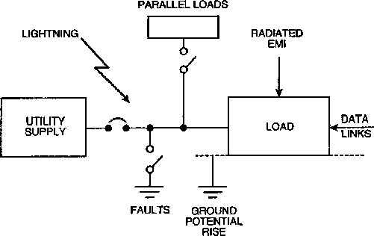

Figure 3-1—Sources of load disturbances (both internal and external)
    - Expectation of voltage sag disturbance (Emerald 3.2)
Power system faults occur on both sides of the meter, resulting from power system equipment failure or external causes (vehicle collisions, storms, human errors). These disturbances can range from a momentary voltage reduction to a complete loss of power lasting for minutes, hours, or days. Their accidental origin makes them unpredictable, although the configuration of a power system and its environment can make it more or less prone to this type of disturbance (see Key [12]).² Figure 3-2 shows the typical number of sag events per year by severity level, from a monitoring study conducted in the U.S.
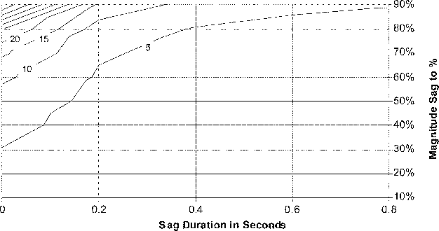
Reprinted with permission from EPRI [B5].
Figure 3-2—Sags per year for 222 sites (from 6/1/93 to 6/1/95). Example data:
Not intended to represent typical performance.
²The numbers in brackets correspond to those of the bibliography in 3.10.
    - Prediction of sag-related upset and damage (Emerald 3.2)
Low-voltage conditions are primarily upsetting to the equipment that cannot ride through periods of reduced available voltage. However, some automated processes may be disturbed at a critical time where either the processing equipment or the end product may be damaged. For example, a data processing system or network communication loss can corrupt the information, while low-voltage trip of an automobile glass processing line may leave overheated windows sized to rollers or rough finished windows with blemishes or scars.
Typical low-voltage trip times based on lab testing for several different types of equipment are as follows:
- Digital clocks: 1 s to 10 s
- Microprocessor-controlled equipment (PLC, PC, TV, VCR, etc.): 1 to 20 cycles
- Induction motors: 10 cycles to seconds
- Motor starters and contactors: 1 to 2 cycles
- Adjustable-speed drives: 1 cycle to seconds (control dependent)
    - Expectation of surge disturbance (Emerald 3.2)
Some disturbances occur at random and are not repeatable or predictable for a given site although statistical information may be available on their occurrence (see IEEE Std C62.41TM). Other disturbances, especially those associated with the operation of other equipment, can be predicted, are repeatable, and can be observed by performing the operating cycle of that equipment.
Lightning surges are the result of direct strikes to the power system conductors as well as the result of indirect effects. Direct strikes inject the total lightning current into the system. The current amplitudes range from a few thousand amperes to a few hundred thousand amperes. However, the rapid change of current through the impedance of the conductors produces a high voltage that causes secondary flashover to ground, diverting some current even in the absence of an intentional diverter. As a result, equipment connected at the end of overhead conductors are rarely exposed to the full lightning discharge current. Indirect effects include induction of overvoltages in loops formed by conductors and ground-potential rises resulting from lightning current in grounding grids or the earth.
A lightning strike to the power system can activate a surge arrester, producing a severe reduction or a complete loss of the power system voltage for one half-cycle. A flashover of line insulators can trip a breaker, with reclosing delayed by several cycles, causing a momentary power outage. Thus, lightning can be the obvious cause of overvoltages near its point of impact, but also a less obvious cause of voltage loss at a considerable distance from its point of impact. Clearly, the occurrence of this type of disturbance is unpredictable at the microscopic level (e.g., specific site). At the macroscopic level (e.g., general area), it is related to geography, seasons, and local system configuration.
Induction of surges by nearby lightning discharges is a less dramatic but more frequent event. The resulting surge characteristics are influenced not only by the driving force—the electromagnetic field—but also by the response of the power system—its natural oscillations. This dual origin makes a general description of the occurrence impractical; nevertheless a consensus exists on representative threats for various environments. Figure 3-3, the classic isokeraunic map of the U.S., shows the average number of days that thunder is heard.
Thunder heard indicates that a lightning discharge has occurred. It may be either from cloud to ground (CG) or within a thundercloud. Most discharges occur within thunderclouds. CG lightning occurs less frequently than lightning within clouds, but the CG is the primary hazard to people or objects on the ground. Figure 3-4 shows a map of the average annual ground flashes per square kilometer in the U.S. between 1989 and 1995.

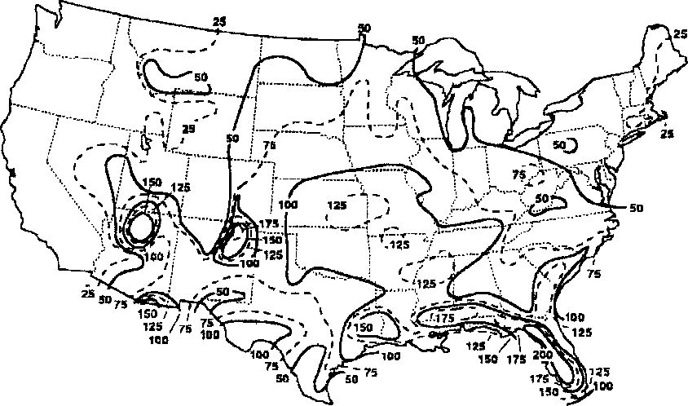
Reprinted with permission from MacGorman, Maier, and Rust [B13].
Figure 3-3—Isokeraunic map showing number of thunderstorm days
Note that most of the continental U.S. experiences at least 2 CG flashes/km²/y. About one-half of the area will see 4 CG flashes/km²/y, which is equivalent to about 10 discharges/mi²/y. The maximum flash densities are found along the southeastern Gulf Coast and the Florida peninsula, where the values approach 20 CG flashes/km²/y. Overall, about 20 million CG flashes strike the U.S. each year, and lightning is clearly among the nation’s most severe weather hazards.
It is useful to estimate how often a normal-sized structure, such as a house, will be struck by lightning. For this, case data from the national lightning detection network are used to identify the typical number of CG flashes. We assume that the house is located in a geographic region with an average of 4 CG flashes/km²/y (see Figure 3-4). We also assume that the area of the house is about 10 ⋅ 20 m² and that there will be a direct strike any time a stepped leader comes within about 10 m of this area. In this case, the effective area of the house is about 30 ⋅ 40 = 1200 m², and the house is predicted to be struck, on average, (1200 ⋅ 4)/1 000 000 = 4.8 ⋅ 10^{–3} times a year, or approximately once every 200 years. Another way to think of this hazard is that, in the 4 CG flashes/km² region, 1 of 200 houses is predicted to be struck each year, on average.
Load switching is a common cause of surges in power wiring. Whenever a circuit containing capacitance and inductance is being switched on or off, a transient disturbance occurs because the currents and voltages do not reach their final value instantaneously. This type of disturbance is inescapable and its severity depends on the relative power level of the load being switched and on the short-circuit current of the power system in which the switching takes place. Switching large loads on or off can produce long-duration voltage changes beyond the immediate transient response of the circuit. Whether the switching is done by the utility or by the user is immaterial from a technical point of view, although the responsibility may be the subject of a contractual dispute.
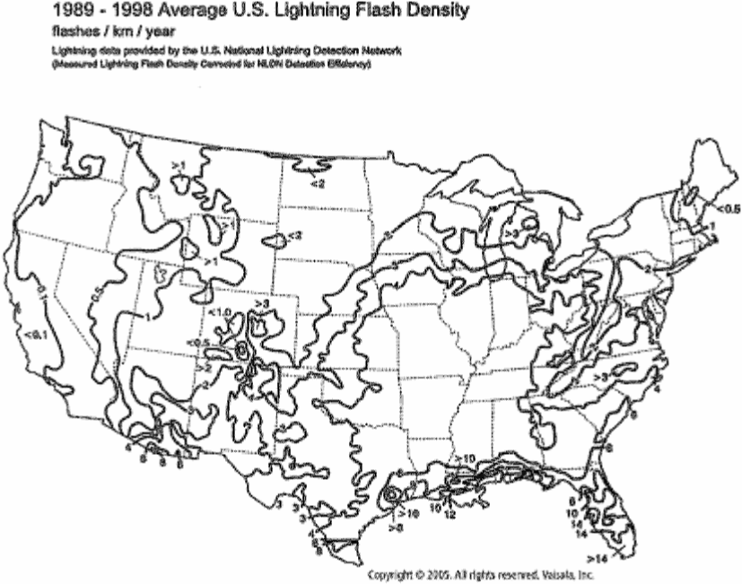
Reprinted with permission from Vaisala, Inc.
Figure 3-4—Average annual CG flashes per km² per year
More complex circuit phenomena, such as current chopping, prestrikes, and restrikes, can produce surge voltages reaching ten times the normal circuit voltages, involving energy levels determined by the power rating of the elements being switched. These complex surges can have very destructive effects, even on rugged equipment, and must be controlled at the source as well as mitigated at the loads.
The occurrence of load switching disturbances is somewhat predictable, but not necessarily under controlled conditions. The introduction of power conversion equipment and voltage regulators that operate by switching on and off at high frequency has created a new type of load switching disturbance. These disturbances occur steadily, although their amplitude and harmonic content will vary for a given regulator as the load conditions vary.
Electrostatic discharge (ESD) is a well-known phenomenon, responsible for interference and damage to electronic components and circuit boards when handled in a careless manner. However, from the point of view of a power system engineer, ESDs do not represent a significant threat because the high frequencies involved, just like in the case of the fast transient bursts, quickly attenuate the surge with distance. The discharge of electrostatic charges built upon the human body or objects can also inject unwanted voltages or currents into the circuits. This phenomenon is associated with operator contact with the equipment (e.g., keyboards, panel switches, connectors) rather than with the quality of the incoming power. Thus, it is not included in the scope, but should of course not be ignored when troubleshooting equipment problems.
      - Nature of lightning strike damage (Emerald 3.2)
Most lightning strikes cause damage as a result of the large current that flows or the heat that is generated by this and the continuing current. If lightning strikes a person, for example, the current can damage the central nervous system, heart, lungs, and other vital organs. Also, many types of electronic circuits can be damaged or destroyed when exposed to an excess current or to an excess voltage produced by that current.
If lightning strikes on or near an overhead electric power or telephone line, a large current will be injected into or induced in the wires, and the current can do considerable damage both to the power and telecommunications equipment and to anything else that is connected to the system. If a lightning surge enters an unprotected residence by way of a power circuit, the voltages may be large enough to cause sparks in the house wiring or appliances. When such flashovers occur, they short-circuit the power system, and the resulting ac power arc can sometimes start a fire. In these cases, the lightning does not start the fire directly but causes a power fault; the power system itself does the damage.
When a building or power line is struck by lightning, or is exposed to the intense electromagnetic fields of a nearby flash, the currents and voltages that appear on the structure are determined by the currents and fields in the discharge and by the electrical response of the object that is struck. The grounding system of the structure is a critical part of the equation in determining what the response to the transient will be. For example, the voltages that appear on the electronics inside a grounded metal building are frequently produced by the fastest rising part of the return stroke current. This fast current excites resonant oscillations on the exterior of the building (like the resonance of a bell) that then couple into the structure via apertures in the metal, such as doors and windows.
The damage caused by lightning is wide and varied. In the case of metals, large currents heat the surface of the conductor by interactions between the air arc and the surface, and the interior of the conductor by electron collisions with the metal lattice. If this heat is large enough, the metal melts or evaporates (see Figure 3-5).
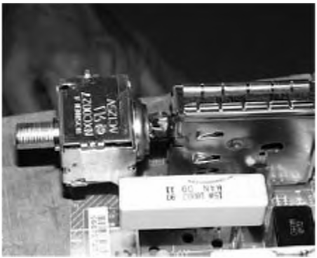

Figure 3-5—Lightning damage to electronic circuits on a circuit board
      - Nature of surge effects in power and communication systems (Emerald 3.2)
Power line surges, whether caused by lightning, circuit switching, or other events, typically represent the biggest threat because of larger exposure areas than, for example, a lightning strike. Although damage in the electrical wiring may occur, interactions between power line surges and victim equipment is the main concern. Consider the devices and equipment that may become the victims of a surge and their failure mechanisms. After-the-fact investigations and experimental data show a wide range of surge-related upset and failure mechanisms. These include insulation breakdown, flashover, fracture, thermal and instantaneous peak power overloads, and dV/dt and dI/dt limits being exceeded. The following list gives some generic types of surge victims and the typical failure or upset mechanisms:
- Electrical insulation breakdown or sparkover
The failure mechanism (breakdown or sparkover) is principally a function of the surge voltage and rise time of the leading edge. Failure rate increases as surge magnitude and/or rise time increases. Insulation is to be taken in the broadest sense of solid or liquid material separating energized conductors in equipment, clearances on a printed circuit board (PCB), edges of semiconductor layers, etc. A distinction must be made between the initial breakdown of insulation, related to voltage only, and the final appearance of the damaged insulation, related to the total energy dissipated in the breakdown path. In another situation, the insulation of the first turns of a winding may be subjected to higher stress than the others as the result of the uneven voltage distribution resulting from a steep front rather than only the peak value of the surge.
- Surge protective device (SPD) failure
Normally, the voltage across the device is essentially constant, and the energy is a function of the surge current level and duration. One failure mode of such a device will occur when the energy dissipated in the bulk material raises the temperature above some critical level. Failure modes associated with the current level, such as flashover on the sides of a varistor disc, failure at the boundary layers of the varistor grains, or fracture of large discs, have also been identified and may not be related to energy.
- Semiconductor device damage
Inadvertently, devices such as thyristors responding to the rate of voltage change can be turned on by a surge, resulting in failure of the device or hazardous energizing of the load they control. In a similar way, a triac may be turned on by a voltage surge without damage, but still fail by exceeding the peak power limit during a surge-induced turn-on with slow transition time.
- Power conversion equipment nuisance trip
An example of this is a front-end dc link where the filter-capacitor voltage can be boosted by a surge, resulting in premature or unnecessary tripping of the downstream inverter by on-board overvoltage or overcurrent protection schemes.
- Data-processing equipment malfunction
In this case, the malfunction (data errors), not damage, may be caused by fast rate of voltage changes (capacitive coupling) or fast rate of current changes (inductive coupling) that reflect the initial characteristic of the surge event.
- Light bulbs fail prematurely
Lamps may withstand the short burst of additional heating caused by a few microseconds of surge- caused overcurrent. However, they also fail under surge conditions when a flashover occurs within the bulb, triggering a power frequency arc that melts the filament at its point of attachment. This is another failure mechanism originating with insulation breakdown.
Table 3-1 presents a matrix of surge parameters and types of equipment, showing for each type of victim which surge parameter is significant or insignificant. The authors have sought to identify all types of potential victims (and invite additions to this list).
    - Measurement of power quality (Emerald 3.2)
There has been a tendency to attribute disturbances and failures to power surges, a term often used by the media but rather ill defined. The ambiguity results in part from an unfortunate dual definition of the word surge.
a) To some people, a surge is indeed the phenomenon being discussed here, that is, a transient voltage or current lasting from microseconds to at most a few milliseconds, involving voltages much higher than the normal (two to ten times).
b) To other people, a surge is a momentary overvoltage, at the frequency of the power system, and lasting for a few cycles, with voltage levels slightly exceeding the 5% to 10% excursions that are considered normal occurrences.
The term swell has been adopted by this recommended practice to describe this second type of overvoltage; perhaps one day it will supplant the usage of surge for that meaning. It would be a mistake to attempt protection against these long-duration power frequency swells with an SPD that is designed to absorb large but short impulses of energy. There is a growing recognition that the horror tales of SPD failures are more likely to be caused by swells rather than by large surges.
Table 3-1—Surge parameters affecting equipment failure modes
Type of equipment | Surge parameters
 | Source  impedance | Peak  amplitude | Maximum  rate of rise | Tail  duration | Repetition  rate | I²t in  deviceª
Insulation  —Bulk  —Windings —Edges |  | X  X  X | X  X | X
Clamping SPDs —Bulk  —Boundary layer Crowbar SPDs | X  X | X  X |  | X | X  X | X  X
Semiconductors —Thyristors  —Triacs  —IGBTs | X | X  X  X | X  X  X |  |  | X  X  X
Power conversion —DC level  —Other | X | X | X | X  X | X
Data processing malfunction |  | X | X |  | X

a The I²t in the device is actually the result of the combination of surge parameters and device response to the surge. Like other power- and energy-related equipment stress, I²t is not an independent parameter of the surge.
Nonlinear loads draw nonsinusoidal currents from the power system, even if the power system voltage is a perfect sine wave. These currents produce nonsinusoidal voltage drops through the system source impedance that distort the sine wave produced by the power plant generator. A typical nonlinear load is a dc power supply consisting of rectifiers and a capacitor-input filter, such as used in most computers, drawing current only at the peaks of the voltage sine wave. This current has a high third harmonic content that has also created a new concern, that of insufficient ampacity of the neutral conductor in a three-phase system feeding power supplies (see Chapter 4 for a discussion of this problem).
    - Power quality survey data (Emerald 3.2)
Power quality site surveys have been performed and reported by a number of investigators. However, the reports are difficult to compare because the names of the disturbances and their thresholds vary among the reports. Manufacturers of disturbance recorders have defined the events reported by their instruments at some variance with other sources of definitions. To help resolve the confusion, IEEE Std 1159 provides unique definitions for each type of disturbance. The results of this effort, however, will take some time to be generally recognized and accepted. In the meantime, terms used by different authors might have different meanings, leaving on authors the burden of defining their terms and leaving for readers the burden of being alert for possible ambiguities.
One example of such ambiguities occurs when attempting to summarize data from different surveys. For instance, two surveys have been widely cited (Allen and Segall [B1] and Goldstein and Speranza [B7]); each was aimed at defining the quality of power available for the equipment of concern to the authors. As a result, each author categorized the disturbances according to the criteria significant to that equipment, including the threshold below which disturbances are not recorded by the instrument. With hindsight, it is not surprising that the criteria were different; when comparing the data from the two surveys expressed in percentages (leading to pie chart representations by some authors of application papers), a puzzling difference was found. By analyzing the detail of the survey premises and definitions, the differences can be reconciled to some extent (see Martzloff and Gruzs [B1 5]).
Advancements in power line monitoring technologies enable sophisticated analyses of the electrical environment. Among the developments that cleared the way for comprehensive, geographically dispersed power line surveys are automated data-acquisition software and remote programming capability of multiple monitoring units. Three of the most recent comprehensive power quality surveys include those conducted by the Canadian Electrical Association (CEA) (see Hughes et al. [B9]), the National Power Laboratory (NPL) (see Dorr [B3]), and the Electric Power Research Institute (EPRI) (see Sabin et al. [B20]), all conducted in North America. The information collected during these three surveys provides a detailed picture of the expected electrical environment in which end-use appliances are intended to be used. The scope of each survey is described in the following paragraphs. (For a detailed description of how the results of these surveys are being presented, see Dorr et al. [B4].)
- CEA Survey
In 1991, the CEA began a 3-year survey of power quality. The objective of the survey was to determine the general levels of power quality in Canada. The results would serve as a baseline against which future surveys could be compared to determine trends. The results would also familiarize utilities with making power quality measurements and interpreting the data gathered. Twenty-two utilities throughout Canada participated in the survey, with a total of 550 sites monitored for 25 days each.
Residential, commercial, and industrial customer sites were monitored at their 120 V or 347 V service entrance panels. Monitoring was done at the service entrance panel because it was considered to offer a blended average of the power quality throughout the customer’s premises. CEA decided that monitoring further into the premises could have made the results unduly influenced by electrical loads on an individual branch circuit. Monitoring at the distribution feeder would not have shown disturbances originating within the customer’s own premises. Only line-toneutral voltages were monitored. Neutral-to-ground voltages were not monitored because neutral is bonded to ground at the service entrance panel.
- NPL Survey
In 1990, NPL initiated a 5-year survey of single-phase, normal-mode electrical disturbances. The objective of the survey was to provide a large, well-defined database of recorded disturbances that profiles power quality at typical points of power usage. Single-phase, line-to-neutral data was collected at the standard wall receptacle. The disturbances found at this point of utilization are often coupled into computers and other electronic appliances. Data was collected from 130 sites within the continental U.S. and Canada.
The sites included a broad range of building locations, building types, building ages, and population areas. Included were locations where participants felt they had power quality problems and also those where no problems were perceived. The diversity of locations yielded a representative climatic and geographic cross section of the U.S. and Canada as well as a representative cross section of the major types of utility loads (heavy industry, light industry, office and retail stores, residential, and mixed).
c) EPRI Survey
In 1992, EPRI conducted a survey to determine the quality of power on ac distribution feeders in the U.S. This project was intended to monitor and then to simulate the electrical disturbances recorded at the selected feeders. Twenty-four geographically dispersed U.S. utilities participated in the survey. The objective of the monitoring portion of the survey was intended to provide a statistically valid set of data reflecting the number and types of electrical disturbances typically found at ac distribution feeders. The survey includes monitoring at 300 locations. Table 3-2 summarizes the parameters of the three surveys.
Table 3-2—Summary overview of the CEA, NPL, and EPRI power quality surveys
Survey | Monitor period | Quantity of data  (monitor months)ª | Number  of sites | Measured  parameters
CEA | 1991 to 1994 | 530 | 550 | Voltage
NPL | 1990 to 1995 | 1200 | 130 | Voltage
EPRI | 1992 to 1995 | 5400 | 300 | Voltage and current

a One monitor month is 30.4 days of data from one monitor.

    - Voltage Sags
    - Overvoltages
Cables rated up to 35 kV that are used in power distribution systems have insulation strengths well above that of other electrical equipment of similar voltage ratings. This is to compensate for installation handling and possibly a deterioration rate greater than for insulation that is exposed to less severe ambient conditions. This high insulation strength may or may not exist in splices or terminations, depending on their design and construction. Except for deteriorated points in the cable itself, the splices or terminations are most affected by overvoltages of lightning and switching transients. The terminations of cable systems not provided with surge protection may flashover due to switching transients. In this event, the cable would be subjected to possible wave reflections of even higher levels, possibly damaging the cable insulation; however, this is a remote possibility in medium-voltage cables.
Like other electric equipment, the means employed for protection from these overvoltages is usually surge arresters. These may be for protection of associated equipment as well as the cable. Distribution or intermediate class arresters are used, applied at the junctions of open wire lines and cables, and at terminals where switches may be open. Surge arresters are not required at intermediate positions along the cable run in contrast to open wire lines.
It is recommended that surge arresters be connected between the conductor and the cable shielding system with short leads to maximize the effectiveness of the arrester. Similarly recommended is the direct connection of the shields and arrester ground wires to a substantial grounding system to prevent surge current propagation through the shield.
Fully insulated aerial cables that are messenger supported and spacer cables are subject to direct lightning strokes, and a number of such cases are on record. The incidence rate is, however, rather low, and, in most cases, no protection is provided. Where, for reliability, such incidents must be guarded against, a grounded shield wire, similar to that used for bare aerial circuits, should be installed on the poles a few feet above the cable. Grounding conductors down the pole need to be carried past the cable messenger with a lateral offset of approximately 18 in to guard against side flashes from the direct strokes. Metal bayonets, when use to support the grounded shielding wire, should also be kept no less than 18 in clear of the cables or messengers.
    - Harmonics
      - Importance of understanding effects of harmonics (Red 9.2)
As a result of the thrust for more efficient use and control of electrical energy, several new harmonic sources have been created, of which the static power converter is the most important. This device is used in a variety of adjustable-speed drives, switched-mode power supplies, frequency changers for induction heating, and other applications. In addition to these new and additional applications, semiconductor devices are used in static switches that modulate the voltage applied to loads. Examples of these are soft starters for motors, static var compensators (SVC), light dimmers, electronic ballasts for arc-discharge lamps, etc. It has been estimated that by the year 2010, 50% of the power produced will be modified by semiconductors, especially silicon-based technologies, to alter its sinusoidal characteristic in order to improve the efficiency of its use. However, when the power is modified by these semiconductors, the resulting current requirements on the power system are nonsinusoidal.
In addition to these new nonsinusoidal loads, more power factor improvement capacitors are being applied in industrial systems and in electric utility transmission and distribution systems for both voltage control and release of system capacity. With the addition of each new capacitor bank, the system's resonant frequency is lowered (see 9.6). With the resonant frequency lowered, the systems become more susceptible to natural resonance with nonsinusoidal loads. With the lowering of the system resonance, power systems are now becoming more and more impacted by the flow of the characteristic harmonic currents produced by these loads.
Harmonic currents flowing in power circuits can induce harmonic voltages and/or currents in adjacent signal circuits. The present-day use of microprocessors for control of processes and power systems results in equipment using low-level signals that are subject to noise or interference from outside sources.
This is but one instance in which harmonics have had an impact. They can be dealt with, however, as shown by the use of fiber optics to reduce the influence of this noise on control and communication circuits. Also, proper shielding of components in the low-level circuits, and isolation of these circuits from power circuits, can minimize the effect of noise, including harmonics.
      - History of harmonic problems and solutions (Red 9.3)
As previously stated, loads that require nonsinusoidal current have been used since electrical energy came into use. Early arc lamps are one example. Transformers are another type of device that required nonfundamental currents to excite and magnetize the cores. The currents taken by these loads were apparent, but were such a small part of the total currents that they were not a problem in power systems.
Early in the twentieth century, use of the mercury arc rectifier increased for a variety of applications. Some loads served by these devices were large enough and the harmonic current they drew was significant enough that problems arose. Two notable problems involved interference with communication lines. The first concerns the application of these rectifiers to a copper refining process west of Salt Lake City. When that installation was energized, transcontinental telephone conversations occurring at the time were interrupted. The problem was that the ac power system feeding the rectifiers at the plant paralleled the open-wire transcontinental telephone lines passing between the mountain range and the Great Salt Lake. The harmonics caused by the rectifiers induced large voltages in the telephone lines, creating enough noise on the telephone circuits to interrupt conversations.
The second event happened at a mine in Eastern Canada where a rectifier power supply was installed on a mine hoist. When the rectifier was energized, the noise induced into the telephone lines sharing the right-of-way with the power lines was so large that telephone communication was totally disrupted.
These are only two instances of problems relating to the troubles caused by harmonic currents on power systems. In these two instances, current drawn by the static power converter induced currents into the communication lines that produced unequal voltages in the two conductors of the telephone circuit, resulting in the noise.
In the late 1920s and early 1930s, a task force of those impacted by the harmonic currents, manufacturers and utility and telephone representatives, studied the problems caused by harmonic currents. Standards were established for measurement of the noise. In addition, task force members suggested limiting exposure between the utility power lines and the communication lines as a means of eliminating noise produced on the communication lines. This effort is documented by the Edison Electric Institute and AIEE. Between 1930 and 1970, electrochemical and electrometallurgical producers, who were the largest users of static power converters, developed technology for minimizing induced noise and limiting harmonic currents being reflected into the utility system. They did this by multiphasing the power converter to eliminate the major portion of the harmonic currents causing the trouble in the communication circuits.
By those actions, the relatively few large users of static power converters were able to control these harmonic currents to the satisfaction of all concerned. Since 1965, however, the introduction of low-cost, high-efficiency semiconductor devices has increased the use of static power converters throughout industry in the form of adjustable speed drives for all types of machinery. Resulting harmonic currents produced in the power system for these many relatively small drives had little effect on the total power system, and caused no problems. However, after the 1973 oil embargo and the rapid increase in energy costs, it has been economical and, in many cases, essential, to utilize these conversion devices on larger systems, as well as to apply power factor improvement capacitors to the system to minimize the increased cost of energy. The widened use of static power converters and the increased use of power factor capacitors have led to problems of capacitor fuse-blowing and increased noise or amplified disturbances on control and power systems.
Of additional concern is the fact that the design of new types of equipment and controllers using solid-state devices assume the existence of a nearly pure sinusoidal voltage source. At distribution and utilization voltage levels, providing a pure sine wave voltage is becoming especially difficult as the propagation of nonlinear loads increases. Thus, as the use and propagation of harmonic sources within the power system becomes more widespread, efforts to control and/or mitigate the impact is of concern to the engineer within the electric utilities and in industry.
      - Definition and sources of harmonic currents and voltages (Red 9.4)
The first step toward understanding how to deal with the problems caused by the interaction of harmonics with power systems or power systems equipment was to settle on a definition of harmonics and a useful means of evaluating them. Over the past few decades this has been done.
        - Definition of harmonics (Red 9.4)
A harmonic is defined as a sinusoidal component of a periodic wave or quantity having a fre-
quency that is an integral multiple of the fundamental frequency. Note that, for example, a
component of frequency twice that of the fundamental frequency is called the second harmonic (IEEE Std 100-1992 [B 14]) .
Thus, on a 60 Hz power system, a harmonic component, h, is a sinusoid having a frequency expressed by the following:
h = n ⋅ 60 Hz
where n is an integer.
Figure 9-1 illustrates the fundamental frequency (60 Hz) sine wave and its second, third, fourth, and fifth harmonics.
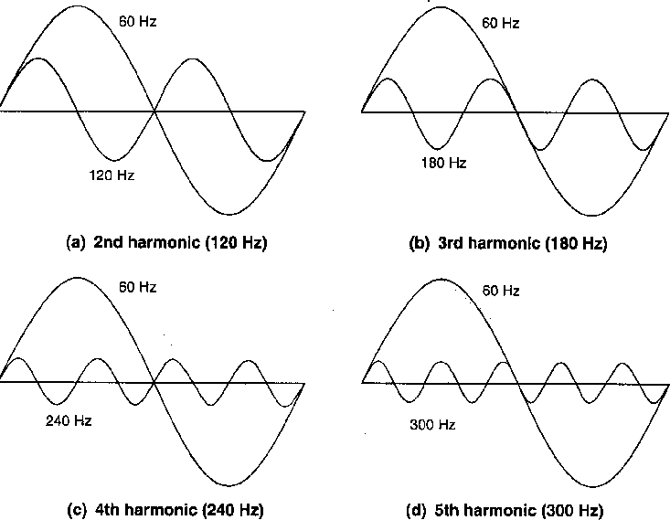
Figure 9-1 —Fundamental frequency (60 Hz) sine wave and harmonics
Sinusoidal waves that are not an integral multiple of the fundamental are not harmonics but are defined in terms of the fundamental as per-unit frequencies.
        - Sources of harmonic current (Red 9.4)
Harmonic currents are a result of loads that require currents other than a sinusoid. The most common of these are static power converters, although several other loads are nonsinusoidal, such as the following:
Ñ Arc furnaces and other arc-discharge devices, such as fluorescent lamps
Ñ Resistance welders (impedance of the joint between dissimilar metals is different for the flow of positive vs. negative current)
Ñ Magnetic cores, such as transformer and rotating machines that require third harmonic current to excite the iron
Ñ Synchronous machines (winding pitch produces fifth and seventh harmonics) Ñ Adjustable speed drives used in fans, blowers, pumps, and process drives
Ñ Solid-state switches that modulate the current-to-control heating, light intensity, etc. Ñ Switched-mode power supplies, used in instrumentation, PCs, televisions, etc.
Ñ High-voltage dc transmission stations (rectification of ac to dc, and dc to ac invertors) Ñ Photovoltaic invertors converting dc to ac
      - Characteristics of harmonics (Red 9.5)
Major issues, next few sections:
Any periodic wave shape can be broken into or analyzed as a fundamental wave and a set of harmonics. This separation or analysis for the purpose of studying the wave shape's effect on the power system is called harmonic analysis.
        - Harmonic analysis (Red 9.2)
Figure 9-2 illustrates one period of a distorted wave that has been resolved into its fundamental and two in-phase harmonic components (the third and fifth). The decomposition of a periodic wave in this manner is referred to as Fourier Analysis, after the French mathematician Jean-Baptiste Fourier (1768Ð1830).
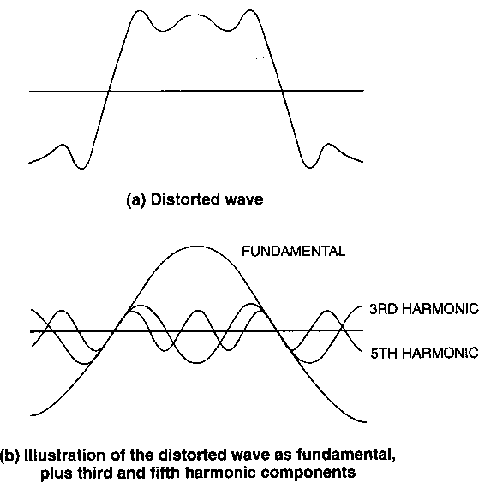
Figure 9-2—Decomposition of a distorted wave
        - Harmonic distortion factor (Red 9.5)
After the periodic wave has been broken into its sinusoidal components, a quantitative analysis of its parts can be made. The term distortion factor is used in this analysis. IEEE Std 100- 1992 [B 14] defines distortion factor in the following way:
df sum of squares of amplitudes of all harmonics  ⎛ ⎞  = ⎝ square of non-sinusoidal quantity ⎠ | 1/2  ⋅ 100%

The distortion factor can refer to either voltage or current. A more common term that has come into use is total harmonic distortion (THD).
IEEE Std 519-1992 [B 15] makes recommendations for limits within which current and voltage harmonics should be kept. This standard is a system standard and not an equipment standard, and contains application information. Tables 9-6 and 9-7, which list current and voltage limits for general distribution systems, are provided in 9.11.
        - Relationship between harmonics and symmetrical components (Red 9.5)
In balanced three-phase circuits where the currents are equal and in 120° relationship, the harmonics can be considered sequence components. The second harmonic has 240° (60 Hz base) between the phasers, the third 180°, etc. Table 9-1 lists the lower harmonics and their respective sequence.
Table 9-1 —Harmonic sequences in a balanced three-phase system
Sequence
Positive | Negative | Zero
1 | 2 | 3
4 | 5 | 6
7 | 8 | 9
10 | 11 | 12
13 | 14 | 15
16 | 17 | 18
19 | 20 | 21
22 | 23 | 24
 | etc.

If the currents are not balanced, as in an arc furnace, each harmonic has its own set of sequence qualities. For example, the third harmonic, 180 Hz, will have its own set of sequence currents and the third-harmonic currents in each phase will not be additive in the neutral circuit.
        - 9.5.4 Fundamental and harmonic power (Red 9.5)
Power is the product of inphase current times the voltage, or
P è
fundamental = V _{fundamental} á I _{fundamental} cos 1
In the case of harmonics, it is also the in-phase harmonic current times the harmonic voltage, or
P è
harmonic = Vharmonic ^{á} _{Iharmonic} cos harmonic
Nonsinusoidal currents can be analyzed by considering the load as a current source for harmonic currents. As these harmonic currents flow through the harmonic impedance of the circuit, they cause a harmonic voltage drop. Since the majority of the impedance is reactive, the amount of harmonic current in phase with the harmonic voltage (harmonic power) is small. The harmonic currents flowing through the resistance of the circuit represent a power loss as
P R
h = I 2 harmonic á harmonic
Rh can vary with applied harmonics because of skin effect, stray currents, eddy currents, etc.
In rotating machinery, the harmonic flux in the air gap produces torques in the rotor. These torques can either add (positive sequence) or subtract (negative sequence) from the fundamental torque, depending upon the phase sequence of the harmonic. In general, the harmonic fluxes are small and their effects tend to cancel.
      - 9.6 Static power converter theory (Red 9.6)
It is not the purpose of this section to give a complete tutorial on static power converter theory; however, two basic circuits are discussed: single-phase and three-phase bridge (full- wave) circuits. These two circuits are the basic building blocks for all applications of static power converters in today's equipment. The single-phase circuit is used in electronic devices, personal computers (PCs), television sets, etc. The three-phase circuit is used in power applications such as adjustable speed drives, frequency changers, etc.
These devices can use either diodes or thyristors. Each will be discussed as the loads on the converters and the effect of different types of load on the power system are discussed. The loads can be capacitive, inductive, or resistive.
Triplens are multiples of the third harmonic, including the third. Such currents can exist only when a zero sequence return path, such as a neutral, exists.
        - Single-phase converters (Red 9.6)
The importance of single-phase converters cannot be underestimated. Figure 9-3 shows the basic circuit, current, and voltage waveforms with a resistive load.
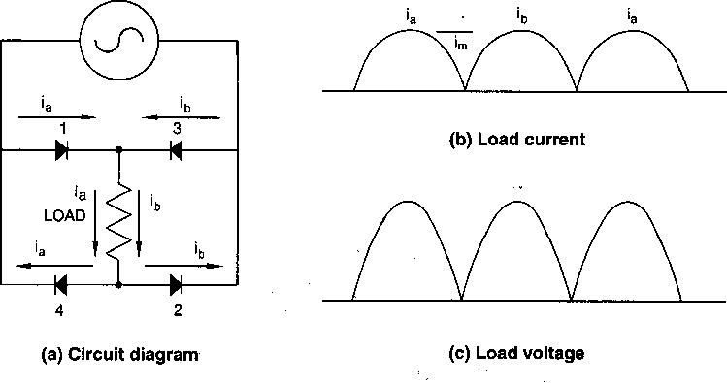
Figure 9-3—Single-phase, full-wave rectifier with resistive load
In the past decade, an adaptation of this circuit has been used in almost all electronic equipment used in residential, commercial, industrial, and military applications. The resistive load illustrated in figure 9-3(a) has been replaced with a capacitive element. When the load seen by the converter (rectifier) circuit is an energy-storage or voltage-regulating capacitive device, it becomes a "switched-mode" power supply. This adaptation has proven to be an effective means of providing a power supply for electronic equipment that uses silicon chips and/or transistors.
The current drawn by this type of power supply is shown in figure 9-4. Note that the current is discontinuous; that is, there is a period of time when no current is flowing in the ac circuit. The capacitor only draws current when it needs to be charged to its rated voltage output. There is an almost constant dc voltage available to the power supply, even though the current flow is discontinuous.
The advantages of this type of power supply are that it is lightweight, efficient, and economical, and that it will provide full voltage output with a wide range of voltage input.
The disadvantage of this type of power supply is that the ac system sees a current that has a
high third-harmonic component. Table 9-2 lists the components of harmonic current for a
typical switch-mode power supply. Depending upon the load on the capacitor, it could have
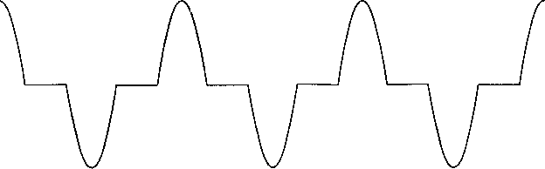
Figure 9-4—AC current feeding a switched-mode power supply
over 80% third-harmonic content. Additionally, but to a much lesser degree, it also contains all the odd harmonic currents.
Table 9-2—Spectrum of a typical switched-mode power supply
Harmonic | Magnitude | Harmonic | Magnitude
1 | 1.00 | 9 | 0.157
3 | 0.81 | 11 | 0.024
5 | 0.606 | 13 | 0.063
7 | 0.370 | 15 | 0.079

        - Three-phase, six-pulse converters (Red 9.6)
The three-phase bridge circuit is the basic building block in all three-phase adjustable speed drives and constant voltage rectifier units. The "rectifier" portion of the circuit can be made up of diodes or thyristors. Depending upon whether or not the level of dc bus voltage is to function as an output control, the type of invertor used to convert the dc to variable frequency ac will thus determine if diodes or thyristors are to be used in the rectifier. Figure 9-5 shows the rectifier bridge circuit and the ac and dc voltage output from the rectifier.
The voltage on the dc bus varies around the reflected neutral point of the ac circuit, as shown in figure 9-5(b). This dc voltage is a sixth-harmonic voltage with respect to the neutral of the circuit and, if the neutral is grounded, it is a third-harmonic voltage with respect to ground. This fact is important when there is a machine, such as a dc motor connected to the dc output bus, or an ac machine connected to the invertor which is fed from the dc bus. Impressing this ac ripple voltage on either the dc or the ac machine can produce current through their bearings if proper precautions are not taken. Those precautions include grounding the shaft of the dc machine or adequately grounding the ac machine in order to bleed off this 360 Hz ripple.
Figure 9-5—Three-phase, six-pulse rectifier
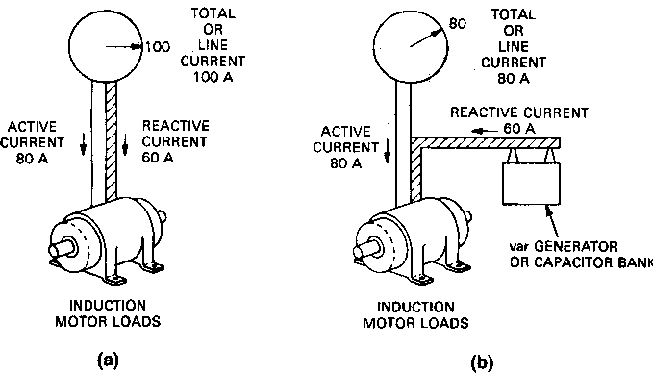
When the load connected to the three-phase rectifier is inductive, then there will be an almost constant dc current flowing from the rectifier. The rectifier elements switch this constant dc current among the three phases of the ac circuit so that for 120° the current is flowing through element #1, positive phase a. For the first 60° of that period, the negative current is flowing through element #6, negative phase b, and for the last 60° through element 2, negative phase c. At the end of the 120° the positive current commutates from phase a to phase b, element #3, which carries the positive current for the next 120°. Again the negative current continues to flow in element #2 for 60° and then commutates to element #4 in negative phase a. This process continues with the current in each phase for 120° of positive conduction followed by 60° of no conduction and the 120° of negative conduction as shown in figure 9-6.
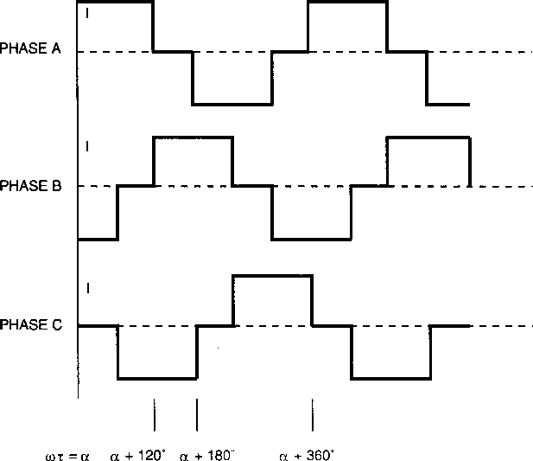
Figure 9-6—Current waveforms in the ac system from an inductive load
on a three-phase bridge rectifier circuit
If a Fourier Analysis were made on this square wave, it would contain all the odd harmonic currents except the triplets; that is, those divisible by three.
h = kq ± 1
'fund
---------
h
where
h is the harmonic order
q is the pulse number of the circuit (six in the case of three-phase bridge)
k is an integer, 1, 2, 3 . . . etc.
'h =
' is the amplitude of the harmonic current (rms) of order h
h
' is the amplitude of the fundamental current (rms value)
fund
The theoretical magnitudes of these harmonic currents would be the reciprocal of the harmonic. For example, the fifth harmonic would be 0.20 per unit of the value of the fundamental current. Because of the inductance in the circuit that is being commutated, the current does not transfer between phase a and b instantaneously so the current wave is more trapezoidal in
shape and the theoretical amplitudes of the harmonic currents are a little less than the equation would show. Table 9-3 lists typical values of a six-pulse rectifier circuit.
Table 9-3—Spectrum of a typical three-phase angle, six-pulse rectifier
based on a commutating angle of 12¡ and a firing angle of 30¡
Harmonic | Magnitude  (%)
5 | 19.2
7 | 13.3
11 | 7.3
13 | 5.7
17 | 3.5
19 | 2.7
23 | 2.0
25 | 1.6

        - Non-characteristic harmonics (Red 9.6)
The discussions above assume that the harmonic currents drawn by static power converter loads are supplied from a balanced system; that is, systems in which the phase relationship of the voltages is 120¡ apart and the magnitudes of the voltages are equal. In unbalanced systems, that is, where the supply voltages are not 120¡ apart or their magnitudes are not equal, other harmonics can be present. Additionally, if the static power converter is not operating correctly, other harmonics can be present. For example, if one phase of the rectifier bridge is not operating, then even order harmonics will be present, particularly the second, eighth, fourteenth, twentieth, etc. These even harmonics are all negative sequence harmonics and, if the converter represents a large portion of the system load served by an isolated generator, these harmonics could cause overheating of the generator rotor.
While the effect is seldom serious, large amounts of even harmonics can saturate transformers or other devices. As indicated in IEEE Std C57 .110-1986 [B 12], as long as the value of second harmonic current is below the value of the exciting current, no adverse effect on the transformer is to be expected.
      - System response characteristics (Red 9.7)
The amount of harmonic voltage distortion occurring on any distribution system will depend on the impedance vs. frequency characteristic seen by nonlinear current sources and by the magnitude of those currents. When high nonlinear currents are drawn through system impedances, voltage distortion occurs. For analysis purposes, the nonlinear devices described above can generally be represented as current sources of harmonics.
        - System short-circuit capacity (Red 9.7)
The short-circuit capacity which exists at some point in a power system is a very good indicator of the fundamental frequency system impedance at that point. For simple inductive feeders, this is also a measure of the system impedance at harmonic frequencies when that short- circuit capacity is multiplied by the harmonic order. Stiffer systems (those with higher short- circuit capacities) have lower voltage distortion for the same magnitude of harmonic current source than does a weaker system (a system with lower short-circuit capacities).
        - Capacitor banks and insulated cables (Red 9.7)
Capacitor banks used for voltage control and/or power factor improvement, as well as insulated cables, are components that have a major effect on power system frequency response characteristics. The manner in which capacitors are connected can cause resonance conditions (both series and parallel) that can magnify harmonic current levels. Capacitor banks are used as a means of supporting voltage for commutation of static power converters. They can be considered in parallel with the system when calculating the commutating reactance, and thus increase the di/dt of commutation.
The line charging capacitance of transmission lines and insulated cables are also in parallel with the system inductance. Therefore, they are similar to shunt capacitors (power factor improvement capacitors), with respect to affecting system frequency response characteristics. Usually, capacitor banks are dominant in industrial and overhead distribution systems.
        - Load characteristics (Red 9.7)
The system load has two important effects on the frequency response characteristics of a system. First, the resistive portion of the load provides damping, which affects the system impedance near resonant frequencies. The resistive load reduces the magnification of, and thus attenuates, harmonic current levels near parallel resonance frequencies.
As a second effect, motor loads and other dynamic loads that contribute to the short-circuit capacity of the system can shift the frequencies at which system resonances occur. These loads appear in parallel to the system short-circuit inductances when calculating resonant frequencies. Motor loads do not provide significant damping of resonant peaks.
        - Balanced vs. unbalanced system conditions (Red 9.7)
When an industrial system's conditions, such as source impedance, capacitor banks, loading, line characteristics, and harmonic sources, are completely balanced, positive sequence models can be employed to evaluate system frequency response characteristics. Under these balanced conditions, the harmonic currents will have the sequence characteristics shown in Table 9-1.
        - Resonance conditions (Red 9.7)
A system resonance condition is the most important factor affecting system harmonic levels. Parallel resonance is a high impedance to the flow of harmonic current, while series resonance is a low impedance to the flow of harmonic current. When resonance conditions are not a factor, a power system has the capability to absorb a significant amount of harmonic current. It is only when these currents see a high impedance due to a condition of parallel resonance that a significant voltage distortion and current amplification will occur. Therefore, it is important to be able to analyze a system's frequency response characteristics in order to avoid having system resonance problems.
        - Normal flow of harmonic currents (Red 9.7)
Harmonic currents tend to flow from the nonlinear loads (harmonic sources) toward the point of lowest impedance, usually the utility source, figure 9-7. The impedance of the utility source is usually much lower than parallel paths offered by loads. However, the harmonic current will split depending on the impedance ratios of available paths. Higher harmonic currents will, therefore, flow to capacitors that offer low impedance to high frequencies.
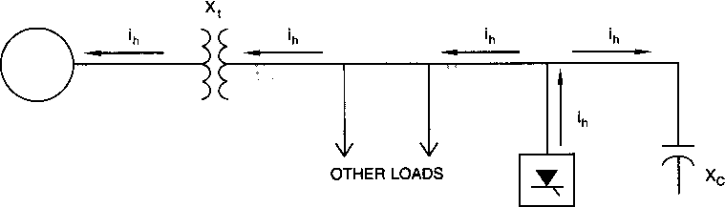
Figure 9-7—Normal flow of harmonic currents
        - Parallel resonance (Red 9.7)
Parallel resonance (figure 9-8) occurs when the system inductive reactance and capacitive reactances are equal at some frequency. If the combination of capacitor banks and system inductance result in a parallel resonance near one of the characteristic harmonics generated by a nonlinear load, that harmonic current will excite the "tank" circuit, causing an amplified
current to oscillate between the energy storage in the inductance and the energy storage in the capacitance. This high oscillating current can cause excessive voltage distortion.
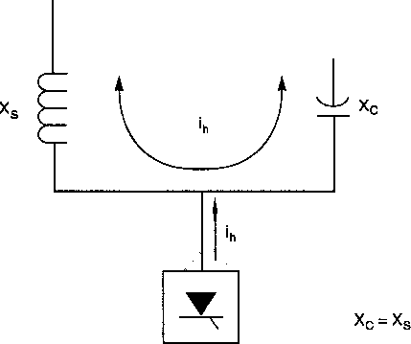
Figure 9-8— Parallel resonance conditions
Frequency at which parallel resonance occurs can be estimated by the following simple equation:

short circuit MVA
Hresonance = =
capacitor bank size in MVA
X_{C}
------
X_{L}

where H is the harmonic order. X _{C} and XL are reactances at the fundamental frequency.
        - Series resonance (Red 9.7)
Series resonance occurs when an inductive reactance and capacitive reactance that are in series are equal at some frequency. This condition occurs as a result of the series combination of capacitor banks and line or transformer inductances. Series resonance presents a low impedance path to harmonic currents and tends to draw in, or "trap," any harmonic current to which it is tuned. Series resonance can result in high voltage distortion levels between the inductive and the capacitive elements in the series circuit. One example of a possible series resonance circuit is a load center transformer that has capacitors connected to its secondary bus (figure 9-9). This circuit appears as a series circuit when viewed from the primary side of the transformer.

Figure 9-9—Capacitor bank resulting in series resonance 9.7.9
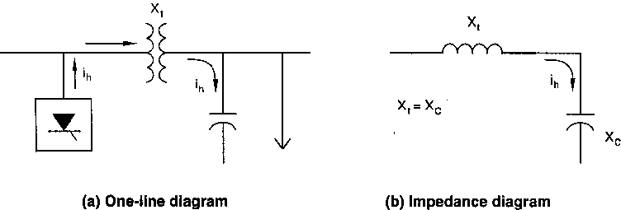

Effect of system loading
The level of load of a power system does not have a significant effect on system frequency response characteristics, except when the system is operating near the resonant frequencies. The resistive component of the load becomes very important as a damping factor at a system resonance. The resistance path (which offers lower impedance) is taken by harmonic currents when a parallel resonance condition exists. Therefore, higher loading levels on the system tend to lower impedance near a point of parallel resonance. Power system response at varying load levels is illustrated in figure 9-10 for a system that has a parallel resonance point near the fifth harmonic.
      - 9.8 Effects of harmonics (Red 9.8)
The intent of this section is to provide a broad understanding of the types of problems that can develop when harmonics are present, and the system configurations and operating conditions that may set the stage for harmonic problems. The effects of harmonics can be divided into three general categories:
- Effects on the power system
- Effects on loads
- Effects on communication
        - Effect on power systems (Red 9.8)
The most significant impact that harmonics have on power systems is that they can cause additional losses due to heating and can cause control and monitoring equipment to register improperly. Additionally, they can cause voltage distortions. These effects occur mainly as a result of situations of parallel and/or series resonance that have been discussed in 9.7.7 and 9.7.8. When there is no condition of resonance present, the harmonic currents that might exist will flow to the power system's source which, in most cases, is a rotating machine (the utility generator). If the power source is an isolated static device, such as a photovoltaic array with
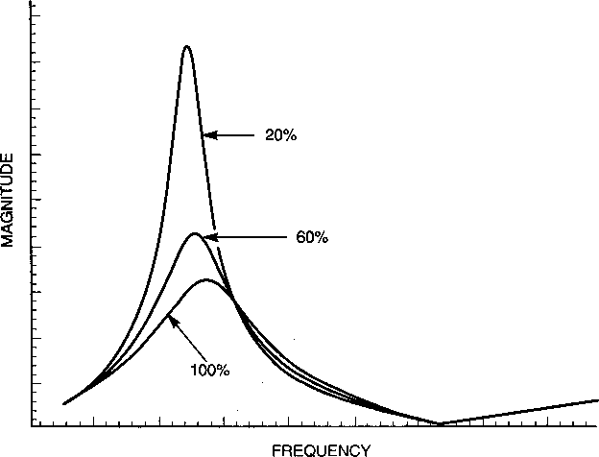
Figure 9-10—System response illustrating effect
of load on parallel resonance peak
an invertor or some other source using a static invertor, then the source itself will contribute to the harmonic content.
        - Effects on loads (Red 9.8)
Harmonic currents flowing through the power system impedances produce a harmonic voltage drop that results in the harmonic voltages seen in other loads. If any other loads on the power system are a low impedance to any particular harmonic, that load will provide a path for that harmonic current. In general, most loads are a high impedance path to harmonics, so very little harmonic current will flow to loads.
          - Motors and generators (Red 9.8)
The major effect of serving induction and synchronous rotating machines from power sources that have harmonic voltages is increased heating due to iron and copper losses in the machines at the higher frequencies. The harmonic components of voltage thus affect the machine efficiency, and also can affect the torque developed.
Harmonic currents in a motor can give rise to higher audible noise emission as compared with sinusoidal excitation. The harmonic currents also produce a resultant flux distribution in the air gap, which can cause or enhance phenomena called cogging (the refusal to start smoothly) or crawling (very high slip) in induction motors.
Harmonic current pairs, such as the fifth and seventh, have the potential of creating mechanical oscillations in a turbine-generator combination or in a motor-load system. Mechanical oscillations result when oscillating torques, caused by an interaction between harmonic currents and the fundamental frequency's magnetic field, excite a mechanical resonant frequency. For instance, the fifth and seventh harmonics can combine to produce a torsional stimulus on a generator rotor at the sixth harmonic frequency. If a mechanical resonance exists that is close to that frequency of electrical stimulus, high mechanical force can be developed on parts of the rotor.
Additionally, the flow of harmonic currents in the stator produce losses that add to the temperature rise on the stator and in the rotor. The sum effect of harmonics is a reduction in efficiency and life of the machine. Neither reduction is pronounced for normally encountered harmonic content, but this harmonic heating typically reduces performance to 90Ð95% of that which would be experienced with pure fundamental sine waves applied.
          - 9.8.2.2 Transformers (Red 9.8)
With the exception that harmonics applied to transformers may result in increased levels of audible noise, the main effect of harmonics on transformers arises from parasitic heating. The harmonic current causes additional copper losses and stray flux losses, and voltage harmonics cause an increase in iron losses. Subclause 10.4.1.1.1 of Chapter 10 deals with these effects in additional detail.
IEEE Std C57.12.00-1987 [B 10] and IEEE Std C57.12.01-1989 [B11] propose a limit on harmonics in transformer current with the upper limit of the current distortion factor set at 5% of rated current. These standards also give the maximum rms overvoltages that the transformer should be able to withstand in steady state: 5% at rated load and 10% at no load. The harmonic current at the applied voltage must not result in the total rms voltage exceeding these ratings.
Since many loads today exceed the harmonic current limit of 0.05 per unit specified for "usual service conditions" of liquid and dry transformers, as specified in IEEE Std C57.12.00-1987 [B10] and IEEE Std C57.12.01-1989 [B11], IEEE developed IEEE Std C57.110-1986 [B12]. This recommended practice establishes a method for evaluating the effects of the higher eddy current loss. An equation developed in IEEE Std C57 .110-1986 produces a value referred to as the K factor and has helped in rating a transformer's ability to carry harmonic currents.
          - Power cables (Red 9.8)
Cables involved in system resonances, as described in 9.7.7, may be subjected to voltage stress and corona which can lead to dielectric (insulation) failure. Cables which are subjected to "ordinary" levels of harmonic current are prone to parasitic heating.
Figure 9-11 shows typical capacity derating curves for a number of cable sizes for a six-pulse harmonic distribution.
Figure 9-11—Cable derating vs. harmonic
with six-pulse harmonic current distribution

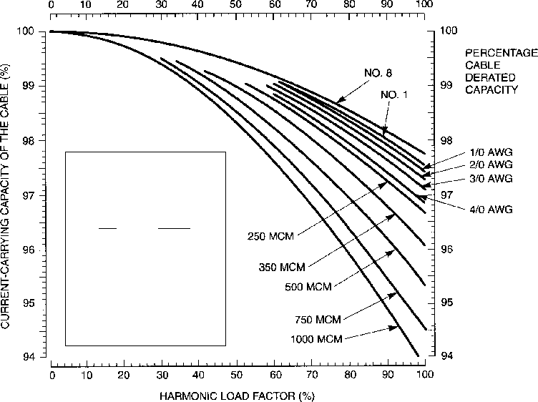
CURRENT BASED ON
FOLLOWING HARMONIC
CURRENT DISTRIBUTION
h Ih (pu)
5 0.175
7 0.110
11 0.045
13 0.029
17 0.015
19 0.010
23 0.009
25 0.008
Note from the curves the effect on cable current capacity in the sizes used in typical commercial and industrial building distribution systems is small (typical cable sizes less than 500 MCM and THD less than 5-15%). This, of course, is not the case for higher fundamental frequencies such as 400 Hz where the inductive and capacitance factors become more significant.
The flow of nonsinusoidal current in a conductor will cause additional heating over and above that expected for the rms value of the waveform. This is due to phenomena known as skin effect and proximity effect, both of which vary as a function of frequency as well as conductor size and spacing. As a result of these two effects, the effective alternating-current resistance ( R ), especially for larger conductors.
AC ) is raised above the direct-current resistance ( R DC
When a current waveform rich in high-frequency harmonics is flowing in a cable, the equivalent R loss.
AC for the cable is raised even higher, increasing the I 2 R AC
          - Capacitors (Red 9.8)
A major concern arising from the use of capacitors in a power system is the possibility of system resonance. This effect imposes voltages and currents that are considerably higher than would be for the case with no resonance.
The reactance of a capacitor bank decreases with frequency, and so the bank acts as a sink for higher harmonic currents. This effect increases the dielectric stresses and heating within the capacitor. Heating is not a problem because of the low-loss capacitor design that uses film and foil. The dielectric stresses are of concern because the harmonic voltages in the capacitor are additive to the fundamental voltage peak. As a result, the dielectric film in the capacitor is subjected to higher voltages than allowed by the design of the capacitor. This causes loss of life. Dielectric failure is a result of fatiguing of the insulation over a period of time.
          - Electronic equipment (Red 9.8)
Power electronic equipment is susceptible to misoperation caused by harmonic distortion. This equipment often is dependent on accurate determination of voltage zero crossings or other aspects of the voltage waveshape. Harmonic distortion can result in a shifting of the voltage zero crossing or the point at which one phase-to-phase voltage becomes greater than another phase-to-phase voltage. These are both critical points for many types of electronic circuit controls and misoperation can result from these shifts.
Other types of electronic equipment can be affected by transmission of ac supply harmonics through the equipment power supply or by magnetic coupling of harmonics into equipment components. Computers and allied equipment, such as programmable controllers, frequently require ac sources that have not more than 5% harmonic voltage distortion factor, with the largest single harmonic being no more than 3% of the fundamental voltage. Higher levels of harmonics result in erratic, sometimes subtle, malfunctions of the equipment, which can, in some cases, have serious consequences. Instruments can be affected similarly, giving erroneous data or otherwise performing unpredictably. Perhaps the most serious of these are malfunctions of medical instruments. Consequently, many medical instruments are provided with line-conditioned power. Less dramatic interference effects of harmonics can occasionally be observed in radio and television equipment as well as in video recorder and audio reproduction systems.
Since most electronic equipment is located at the low-voltage level of its associated power distribution system, it is frequently exposed to the effects of voltage notching. (Notching occurs during commutation of static power converters when two phases are short-circuited.) Voltage notches frequently introduce frequencies, harmonic and nonharmonic, that are much higher than normally exhibited in 5 kV and higher voltage distribution systems. These frequencies can be in the radio frequency range and, as such, can introduce harmful effects associated with spurious radio frequency (RF). These effects usually are those of signal interference, introduced into logic or communication circuits. Occasionally, the notching effect has sufficient power to overload electromagnetic interference (EMI) filters and similar high-frequency sensitive capacitive circuits.
          - Metering (Red 9.8)
Metering and instrumentation are affected by harmonic components, particularly if resonant conditions exist that result in high harmonic voltages and currents. Induction disk devices, such as watthour meters, normally see only fundamental current that is in phase with the fundamental voltage. Harmonic currents in phase with harmonic voltage also will register on the
meter. Since most harmonic voltage is out-of-phase with the harmonic current, the harmonic power is small. Studies have shown that both positive and negative errors are possible with harmonic distortion present, depending on the type of meter under consideration and the harmonics involved. In general, the distortion factor must be severe (>20%) before significant errors are detected. Instrument transformers of 60 Hz, used in both metering and relaying, are not affected by harmonic levels normally encountered (<5 kHz).
          - Switchgear and relaying (Red 9.8)
As with other types of equipment, harmonic currents can increase heating and losses in switchgear, reducing steady-state carrying capability and shortening the life of some insulating components.
Fuses that are true rms-sensing devices may require a derating because of heat generated by harmonics during "normal" operation. Currently there are no standards for the level of harmonic currents that switching devices or fuses are required to interrupt or to carry. All tests are performed at rated supply frequency.
The Power System Relay Committee of the Power Engineering Society has prepared a report entitled, "Sine Wave Distortions on Power Systems and the Impact on Protective Relaying." The report states the following:
"Protective relays generally do not respond to any one identifiable parameter such as the rms value of a primary quantity or the fundamental frequency component of that quantity. As a related consideration, the performance of a relay to a range of single frequency inputs is not an indication of how that relay will respond to distorted wave containing those frequencies. Superposition does not apply. Multi-input relays may be more unpredictable than single input relays in the presence of wave distortion. Relay response under distorted conditions may vary among relays having the same nominal fundamental frequency characteristics, not only among different relay manufacturers, but also among different vintages of relays from the same manufacturer."
In general, harmonic levels required to cause the mis-operation of relays are greater than the levels recommended by standards. Distortion factors of 10Ð20% are generally required to cause problems in relay operation.
The bimetal strip of standard thermal-magnetic molded case breakers, like fuses, also responds to true rms current. As with the perceived "nuisance" opening of fuses, the perceived "nuisance" opening of thermal-magnetic breakers is often actually the desired response to protect equipment from thermal damage.
First- and second-generation solid-state tripping devices on low-voltage circuit breakers responded to peak currents. Since about 1978, these devices have been designed to respond to rms current values. Earlier models may cause nuisance tripping in circuits carrying harmonic currents.
          - Static power converters (Red 9.8)
Converters that use diodes usually are not affected by harmonics. However, converters that use thyristors can be affected when enough distortion is present to interfere with the firing circuits that control the output of the converter. Mitigation techniques discussed below can minimize the interference.
        - Telephone interference (Red 9.8)
The harmonic currents and voltages associated with nonlinear loads can induce currents and voltages in communication circuits that parallel the power conductors. Harmonic currents induce currents in the two conductors of communication circuits. When these induced currents flow in the communication circuits they produce voltages. If these voltages are not equal (currents in the two conductors are not equal because of spacing or other differences), they will not cancel and the resultant is noise in the circuit. Communication circuits that have twisted pairs, and/or are shielded, minimize the problem. The problem is most likely to appear when distribution lines and telephone circuits share the same pole line.
          - TIF weighing (Red 9.8)
The interference can be quantified by the use of telephone influence factor (TIF) weighing. Table 9-4 lists the TIF values based on the 1960 values.
Table 9-4Ñ1960 single-frequency TIF values
Freq | TIF | Freq | TIF | Freq | TIF | Freq | TIF
60 | 0.5 | 1020 | 5100 | 1860 | 7820 | 3000 | 9670
180 | 30 | 1080 | 5400 | 1980 | 8330 | 3180 | 8740
300 | 225 | 1140 | 5630 | 2100 | 8830 | 3300 | 8090
360 | 400 | 1260 | 6050 | 2160 | 9080 | 3540 | 6730
420 | 650 | 1380 | 6370 | 2220 | 9330 | 3660 | 6130
540 | 1320 | 1440 | 6650 | 2340 | 9840 | 3900 | 4400
660 | 2260 | 1500 | 6680 | 2460 | 10 340 | 4020 | 3700
720 | 2760 | 1620 | 6970 | 2580 | 10 600 | 4260 | 2750
780 | 3360 | 1740 | 7320 | 2820 | 10 210 | 4380 | 2190
900 | 4350 | 1800 | 7570 | 2940 | 9820 | 5000 | 840
1000 | 5000

Evaluation of the problem can be stated in either current or voltage terms. The current term is IáT Product. It is calculated by taking the root sum squared (rss) value of the sum of the squares of the IáT Products. I is the individual harmonic current, and T is the TIF weighing value of that frequency. IáT Products of less than 10 000 should not be a problem. The exception to that is in some Canadian Provinces where the value is limited to 1500. The equivalent voltage value is kVá T Product. It is calculated in a similar fashion. Figure 9-12 is a curve of the TIF weighing values.
H = 50
IT Product = [ I h ⋅ ( TIF ) _{h} ] 2
⋅ ∑
H = 1
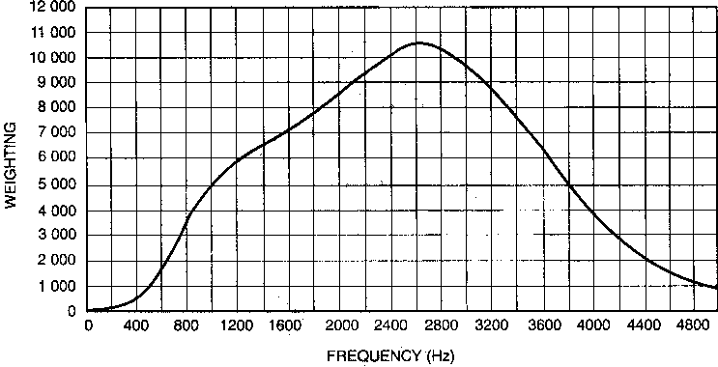
Figure 9-12Ñ1960 TIF weighing values
Notice that the curve peaks at 2600 (43rd harmonic). What this says is that the lower harmonics associated with static power converters usually are not a problem in telephone interference. The curve is based on the value of 1000 Hz having a TIF of 5000.
          - Residual or ground return currents (Red 9.8)
Telephone circuits are particularly susceptible to the influence of ground return currents. In rural areas when power or telephone circuits use a ground return, the large inductive loop can have a large influence on the noise produced in telephone circuits. Particular care should be used to minimize nonlinear loads in this case.
          - Commutation effects (Red 9.8)
Commutation notches can produce harmonics that are near the 43rd harmonic where the TIF values peak. Good practice is to isolate communication circuits from power circuits.
      - Harmonic analysis (Red 9.9)
In the analysis of a power system with respect to harmonic currents, it is important to determine if parallel resonance exists between the power system inductance and the capacitance in the circuit. This condition can consist of either power factor improvement capacitors and/or the capacitance of lines and cable. Harmonic analysis is also used to determine the effectiveness of filters.
        - Harmonic load flow (Red 9.9)
The harmonic load flow program is the basic analysis tool used in performing harmonic studies. It has the capability of calculating the distribution of harmonic currents in the power system and determining harmonic voltage on the buses. The program's greatest use is in calculating the system impedance at any point and at any frequency in the network, specifically at those locations at which harmonic current will be generated. Most harmonic load flow programs are similar to familiar load flow and short-circuit programs. There are some important differences, however. They are as follows:
- The harmonic load flow program must provide solutions over a range of frequencies. These frequencies should not be limited to integer harmonics, but should include intermediate points. It is necessary to "sweep" a range of frequencies to clearly identify resonant frequencies that might be close to characteristic orders of harmonic-producing loads. Frequencies every 6Ð10 Hz should be used.
- The network elements—transmission lines, transformers, reactors, capacitors, cable, etc.—will have impedances that change with frequencies. The program must cater to this requirement by constructing the network model at each frequency of interest during the solution. Both the reactance and the resistance should be modeled as a function of frequency to get an accurate result. Long line equations for distribution and transmission lines should be used if telephone interference or the effect of higher frequencies is to be studied.
- Industrial power systems normally are balanced within their three phases. A simple, positive-sequence, single-phase representation can therefore give satisfactory answers. However, if there is unbalanced loading or impedances in the system, a full three-phase representation must be used.
The program should be able to handle several harmonic sources simultaneously. Depending on the particular program, the output will include the following:
Ñ Harmonic voltages and distortion factors on each bus Ñ Branch IáT Products
Ñ Bus kV áT Products (TIF)
Ñ Branch harmonic current and distortion factors Ñ Capacitor bank or filter loading
Ñ System impedance vs. frequency characteristic
The quality of current filtering will be a function of the system impedance relative to the filter impedance.
        - Useful "rules of thumb" (Red 9.9)
Except for the possibility that they might excite parallel resonant network configurations, harmonic currents produced by static power converter and other nonlinear loads are not troublesome. The parallel resonance of a circuit can be quickly estimated by the following:
MVASC ------------------ Mv ar_{C}
H p | =

where
H is the harmonic order (per-unit frequency) at parallel resonant frequency
p
MVA is the system short-circuit capacity
SC
Mvar is the power factor improvement capacitor
C
Likewise, the harmonic current level or size of the nonlinear load with respect to the power system can be calculated as follows:
SCR | = |  | MVASC
SCR | = | MWconverter

If the SCR (short-circuit ratio) is less than 20, and there is a parallel resonance condition near a characteristic harmonic of the nonlinear load, there will probably be a problem. A study should be made to determine the possible addition of harmonic filters to eliminate any problem.

      - Harmonic standards (Brown 10.8)
In the United States, the Industry Application Society (IAS) of IEEE began a standards development project on harmonics in 1973. The first publication resulting from this project was IEEE Std 519-1981, entitled “IEEE Guide to Harmonic Control in Electrical Power Systems.” The IEEE publishes a hierarchy of Standards from the least to the most prescriptive, which are referred to as Guides, Recommended Practices, and Standards. In 1986, the Power Engineering Society (PES) joined the IAS to upgrade IEEE Std 519-1981 to the status of a Recommended Practice, and in 1992, IEEE Std 519-1992, entitled “IEEE Recommended Practices and Requirements for Harmonic Control in Electrical Power Systems,” was published. Since then this document has acquired nearly the status of a Standard. It is widely used by the utilities and by industrial, commercial, and residential users in North and South America and around the world. It has become the basis for all new power system designs and for the interface between the utilities and their customers.
The key prescriptions of IEEE Std 519-1992 are provided in Chapter 10 (Recommended Practices for Individual Consumers) and in Chapter 11 (Recommended Practices for Utilities). These two chapters address the harmonic current distortion and harmonic voltage distortion, respectively, and with maintaining the power quality by both the supplier and the user. The document also provides limits for notching and IT values for converter applications.
IEEE Std 519-1992 primarily deals with odd harmonics; even harmonics are limited as a percentage of adjacent odd harmonics. It does not deal with the continuous spectrum of harmonics or interharmonics that may fall between the odd and even harmonics. Often, inter- harmonics are treated by engineers in the same manner as even harmonics. However, the subject of non-integer harmonics is being pursued by two task forces of the Working Group on Harmonics of the Power Engineering Society (Task Force on Application of the IEEE Standard 519 and Task Force on Interharmonics). It is expected that the publications of these task forces will highlight the application issues and interpretations of IEEE Std 519-1992 for different systems and users.
IEEE Std 519-1992 emphasizes the two following points in applying the harmonic indices: The point of interface or PCC between the supplier and the user, and the ratio of the system short-circuit (SC) MVA and the maximum demand load MVA. The PCC is a point mutually agreeable to the utility and the consumer and, in general, can be considered as the point of metering or any other point of interface. Within an industrial plant, the PCC is the point between the nonlinear load and other loads (IEEE Std 519-1992, 10.1). The SC ratio determines the total harmonic current distortion that can be injected into the system and allows higher limits for higher ratios. For current distortion limits, the fundamental current is calculated from the maximum demand load current, calculated over any 15 or 30 min period and then averaged over the preceding 12-month period (if the data are available). Note that the actual fundamental current at any particular time is likely to be less than the maximum demand fundamental current, so the latter helps to reduce the TDD percentage for any load less than the maximum demand load.
In conclusion, IEEE Std 519-1992 is a Recommended Practice and not a Standard. The limits should indeed be a matter of mutual agreement between the supplier and the utility. Further, strict compliance with IEEE Std 519-1992, within the industrial facility (as compared to the PCC) can require expenditure that may not be justifiable either technically or economically, and the effects of harmonics should be evaluated. It is expected that the future revision of IEEE Std 519-1992 will address the issue of limits for even harmonics and interharmonics more clearly. Also, it is expected that the future revision will clarify the application and interpretation of the document with several real-life examples.

    - Transients
      - Switching transients analysis (Brown 2.7)
Switching transients severe enough to cause problems in industrial power systems are most often associated with inadequate or malfunctioning breakers or switches and the switching of capacitor banks and other frequently switched loads. The arc furnace system is most frequently studied because of its high frequency of switching and the related use of capacitor banks.
By properly using digital computer programs or a TNA, these problems can be detected early in the design stage. In addition to these types of switching transient problems, digital computer programs and the TNA can be used to analyze other system anomalies, such as lightning arrester operation, ferroresonance, virtual current chopping, and breaker transient recovery voltage.
      - Power system switching transients (Brown 1.1)
Major errors below:
          - Introduction (Brown 1.1)
An electrical transient occurs on a power system each time an abrupt circuit change occurs. This circuit change is usually the result of a normal switching operation, such as breaker opening or closing or simply turning a light switch on or off. Bus transfer switching operations along with abnormal conditions, such as inception and clearing of system faults, also cause transients.
The phenomena involved in power system transients can be classified into two major categories:
- Interaction between magnetic and electrostatic energy stored in the inductance and capacitance of the circuit, respectively,
- Interaction between the mechanical energy stored in rotating machines and electrical energy stored in the inductance and capacitance of the circuit.
Unlike the first category, which consists solely of electromagnetic transients, the latter deals with electromechanical transients and will not be treated in this chapter. Electromechanical transients are considered in Chapters 7 and 8.
Most power system transients are oscillatory in nature and are characterized by their transient period of oscillation. Despite the fact that these transient periods are usually very short when compared with the power frequency of 50 Hz or 60 Hz, they are extremely important because at such times, the circuit components and electrical equipment are subjected to the greatest stresses resulting from abnormal transient voltages and currents. While overvoltages may result in flashovers or insulation breakdown, overcurrent may damage power equipment due to electromagnetic forces and excessive heat generation. Flashovers usually cause temporary power outages due to tripping of the protective devices, but insulation breakdown usually leads to permanent equipment damage.
For this reason, a clear understanding of the circuit during transient periods is essential in the formulation of steps required to minimize and prevent the damaging effects of switching transients.
          - Circuit elements (Brown 1.1)
All circuit elements, whether in utility systems, industrial plants, or commercial buildings,
possess resistance, R, inductance, L, and capacitance, C. Ohm’s law defines the voltage across a time-invariant linear resistor as the product of the current flowing through the resistor and its ohmic value. That is,
v(t) = Ri(t) (11-1)
The other two elements, L and C, are characterized by their ability to store energy. The term “inductance” refers to the property of an element to store electromagnetic energy in the magnetic field. This energy storage is accomplished by establishing a magnetic flux within the ferromagnetic material. For a linear time-invariant inductor, the magnetic flux is defined as the product of the inductance and the terminal current. Thus,
φ(t) = Li(t) (11-2)
where ö(t) is the magnetic flux in webers (Wb), L is the inductance in henries (H), and i(t) is the time-varying current in amperes (A). By Faraday’s law, the voltage at the terminals of the inductor is the time derivative of the flux, namely,
v(t) dö
(11-3)
= -----
dt
Combining this relationship with Equation (11-2) gives the voltage-current relation of a time- invariant linear inductor as
v(t) L di
(11-4)
= ----
dt
Finally, the term “capacitance” means the property of an element that stores electrostatic energy. In a typical capacitance element, energy storage takes place by accumulating charges between two surfaces that are separated by an insulating material. The stored charge in a linear capacitor is related to the terminal voltage by
q(t) = Cv(t) (11-5)
where C is the capacitance in farads (F) when the units of q and v are in coulombs (C) and volts (V), respectively. Since the electrical current flowing through a particular point in a circuit is the time derivative of the electrical charge, Equation (11-5) can be differentiated with respect to time to yield a relationship between the terminal current and the terminal voltage. Thus,
i ( t ) dq  = = -----  ----- or i ( t ) C dv  dt dt | (11-6)

Under steady-state conditions, the energy stored in the elements swings between the inductance and capacitance in the circuit at the power frequency. When there is a sudden change in the circuit, such as a switching event, a redistribution of energy takes place to accommodate the new condition. This redistribution of energy cannot occur instantaneously for the following reasons:
- The electromagnetic energy stored in an inductor is . For a constant induc-
E LI2
= -------
2
tance, a change in the magnetic energy requires a change in current. But the change
in current in an inductor is opposed by an emf of magnitude . For the
v ( t ) L di
= ----
dt
current to change instantaneously (dt = 0), an infinite voltage is required. Since this is unrealizable in practice, the change in energy in an inductor requires a finite time period.
- The electrostatic energy stored in a capacitor is given by and the current-
E C V2
= ---------
2
voltage relationship is given by . For a capacitor, an instantaneous
i ( t ) C dv
= ----
dt
change in voltage (dt = 0) requires an infinite current, which cannot be achieved in
practice. Therefore, the change in voltage in a capacitor also requires finite time. These two basic concepts, plus the recognition that the rate of energy produced must be equal to the sum of the rate of energy dissipated and the rate of energy stored at all times (principle
of energy conservation) are basic to the understanding and analysis of transients in power systems.
          - Analytical techniques (Brown 1.1)
The classical method of treating transients consists of setting up and solving the differential equation or equations, which must satisfy the system conditions at every instant of time. The equations describing the response of such systems can be formulated as linear time-invariant differential equations with constant coefficients. The solution of these equations consists of two parts:
- The homogeneous solution, which describes the transient response of the system, and
- The particular solution, which describes the steady-state response of the system to the forcing function or stimulus.
As discussed and described in Chapter 3, the analytical solution of linear differential equations can also be obtained by the Laplace transform method. This technique does not require the evaluation of the constants of integration and is a powerful tool for complex circuits, where the traditional method can be quite difficult.
          - Transient analysis based on the Laplace transform method (Brown 1.1)
Although they do not represent the types of problems regularly encountered in power systems, the transient analysis of the simple RL and RC circuits described in Chapter 3 of this book are useful illustrative examples of how the Laplace transform method can be used for solving circuit transient problems. Real-life circuits, however, are far more complicated and often retain many circuit elements in series-parallel combination even after simplification. These circuits will require several differential or integro-differential equations to describe transient behavior and must be solved simultaneously to evaluate the response. To do this efficiently, the Laplace transform method is often used.
            - LC transients (Brown 1.1)
In this chapter, the more general types of circuits that are described by higher-order differential equations are discussed. The double-energy transient, or LC circuit, is the first type of circuit to be considered. In double-energy electric circuits, energy storage takes place in the magnetic field of inductors and in the electric field of the capacitors. In real circuits, the interchange of these two forms of energy may, under certain conditions, produce electric oscillations. The theory of these oscillations is of great importance in electric power systems.
In the circuit shown in Figure 11-1 the circuit elements are represented with Laplace transform impedances as described in Chapter 3. The response of the circuit to a step input of voltage due to the closing of the switch at t = 0 will be examined, assuming the capacitor is initially charged to the potential of V_{c} (0–) as shown.

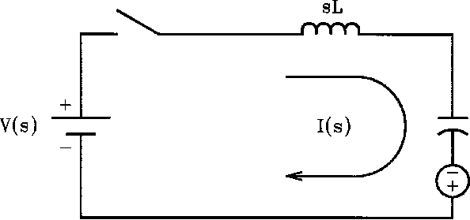 | 1 -  sC  Vc0– ( ) -- s

Figure 11-1—Double energy network
I(s) | = | V(s) + V_{c} (0)  L |  | 1 |  |  |  |  | (11-8)
( + )
s ² ω0 2

According to Kirchoff’s voltage law, the sum of the voltages across all the circuit elements must equal the source voltage at all times. In equation form this is stated as
V(s) I ( s )s  = + ------- – V_{c} ( 0 )  2L – sLI ( 0 ) I ( s )  C | (11-7)

Since there could be no current flowing in the circuit before the switch closes, the term LI(0) = 0. Solving for the current I(s) in Equation (11-7),

where ù0² is the natural frequency of the circuit, namely . From the table of inverse
-----------
LC
Laplace transforms (see table in Chapter 3), the transient response in the time domain is
i(t) | = | V(s) + V_{c} (0)  Z₀ | [sin(ω₀t)] | (11-9)

where Z0 is the surge impedance of the circuit defined by
L
Z0= --- C
(11-10)

Clearly, the transient response indicates a sinusoidal current with a frequency governed by the circuit parameters L and C only.
Another interesting feature about the time response of the current in the circuit is that the magnitude of the current is inversely proportional to the surge impedance of the circuit Z0, which is a function of the circuit parameters of L and C. The importance of this parameter to the analysis of transient problems will be demonstrated later in the chapter.
In power system analysis, we are often interested in the voltage across the capacitor. Referring to Figure 11-1, the capacitor voltage is
Vc(s) I ( s )  = --------  sC | V_{c} (0)  – -------------  s | (11-11)

where V_{c}(0) is the initial voltage of the capacitor. Solving for I(s) in the above equation results in
I(s) = sCV_{c} (s) + CV_{c} (0) (11-12)
But because the current I(s) is common to both elements L and C, we can substitute Equation (11-12) into Equation (11-8) to obtain the voltage across the capacitor. After rearranging the terms,

s V_{c} (0)
=
2
V( s) ω0
+
V_{c} ( s)
(11-13)
s s
(
2 + )
2
ω₀
( + )
2 2
s ù₀

From the table of inverse Laplace transforms (see Chapter 3), the transient response is
v_{c} (t) = V(s)[1 – cos(ω0t)] + V_{c} (0)cos(ω0t) (11-14)
The above equation is plotted in Figure 11-2 for various values of initial capacitor voltage V_{c}(0).

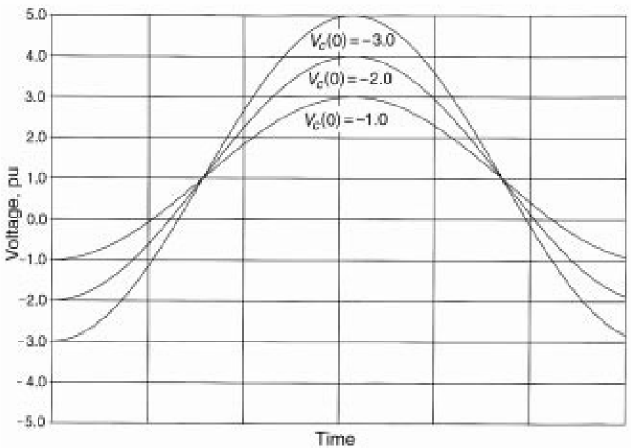
Figure 11-2—Capacitor voltage for various initial voltages
Examination of these curves indicates that, without damping, the capacitor voltage swings as far above the source voltage V as it starts below. In a real circuit, however, this will not be the case, since circuit resistance will introduce losses and will damp the oscillations. Treatment of the effects of resistance in the analysis of circuits is presented next.
            - Damping (Brown 1.1)
Nearly every practical electrical component has resistive losses (I²R losses). To simplify the calculations and to ensure more conservative results, resistive losses are usually neglected as a first attempt to a switching transient problem. Once the behavior of the circuit is understood, then system losses can be considered if deemed necessary.
A parallel RLC circuit is depicted in Figure 11-3, in which the circuit elements are represented by their Laplace transform admittances. Many practical transient problems found in power systems can be reduced to this simple form and still yield acceptable results. With a constant current source, I(s) and zero initial conditions, the equation describing the current in the parallel branches is
I(s) sV ( s )G s  = + + ----------  ²CV ( s ) V ( s )  L | (11-15)

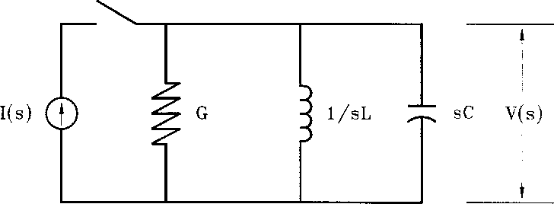
Figure 11-3—Parallel RLC circuit
Solving for the voltage results in

⎞ ⎟ ⎟ ⎠
⎝ s-------
RC
1
+ + ------
LC
⎛
V(s) I ( s )
-------- 1
⎜
= C ⎜ 2 s
(11-16)

Equation (11-16) can be written as

V ( s ) I ( s )  =-------- 1  C ( s + r ₁ ) ( s + r2 ) |  | (11-17)

where r1 and r2 are the roots of the characteristic equation defined as follows:

1 ⎛ ⎞ 2 4
1 ⎛ ⎞
= ---------- +– and r₂
₂-- ------ ------ =
2RC ⎝ ⎠
RC ⎝ ⎠
LC
⎛ ⎞ 2 4
1 ⎛ ⎞
------- – ------
⎝ ⎠
RC⎝ ⎠
LC
r₁
1
(11-18)
1
1
--
----------
–
2
2RC

At the natural resonant frequency ù0, the reactive power in the inductor is equal to the power in the capacitor but opposite in sign. The source has to supply only the true power PT required by the resistance in the circuit. The ratio between the magnitude of the reactive power, PR, of either the inductance or the capacitance at the resonant frequency, and the magnitude of true power, PT of the circuit, is known as the quality factor of the circuit, or Q. Therefore, for the parallel circuit,

P_{R} V²B
= =
----- or Q_{P} ----------
PT V2G
R
or Q_{P} = --- X
Q_{P}

(11-19)

where B is the susceptance of either the inductor or capacitor, G is the conductance, and V is the voltage across the element. But, since in a parallel circuit the voltage is common to all elements, substituting ù0L for and R for in Equation (11-19), the result is
-- 1
1 --
B G
R  Q_{P}= ---------  ω₀L  Furthermore, since the natural frequency of the circuit is | (11-20)

(11-21)

1
=
----------
ω0
LC

then, substituting Equation (11-21) into Equation (11-20) yields
(11-22)
Rearranging Equation (11-18), we have

R
Q_{P}= -------
L
---
C

1 4R^{2C}
– ---
L
1
and r₂ = – ---
--------- – ---------- 1 4R^{2C} 1
2RC 2RC L
(11-23)
1
1
=
----------
+
2RC
2RC
r₁

Substituting Equation (11-22) into Equation (11-23), the result is

r1 | = | 1  ----------  2RC | 1 1  + = –  --------- 1 4Q P 2  – and r2 --------- 1 4QP 2  ---------- – 1  2RC 2RC 2RC | (11-24)

Depending on the values of the circuit parameters, the quantity under the radical in Equation (11-24) may be positive, zero, or negative.
For positive values, that is 4QP² < 1, the roots are real, negative, and unequal. In this case, the inverse Laplace transform of Equation (11-17) is

⎛ ⎞
t
– ---------
⎝ ⎠
2RC
2
1 4Q_{P} –
v ( t ) IRe
=
ω_{D}t –ù_{D}t
[ – ]
e e
(11-25)

where

ω_{D} | = |  | 2  1 4Q_{P} – |  | (11-26)
ω_{D} |  |  | 2RC |  | (11-26)

is the damped natural angular frequency. Substituting 2sinh (ùDt) for the exponential function, the result is

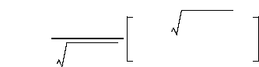
v ( t ) 2IRe
=
⎛ ⎞
t
– ---------
⎝ ⎠
2RC
⎛ ⎞
2
1 4Q_{P} –
⎜ ⎟
t
⎝ ⎠
2RC
sinh
2
1 4Q_{P} –
(11-27)

For the case where the quantity 4QP² = 1, the roots are equal, negative, and real. Therefore, the solution of Equation (11-25) is
v ( t ) I  = ---e  C | ⎛ ⎞  t  – ⎝ ⎠  ---------  2RC | (11-28)

Finally, when the quantity under the radical sign in Equation (11-4) is less than zero, that is, 4QP² > 1, the roots are unequal and complex. The solution in this case is

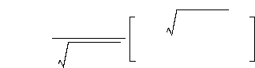
v ( t ) 2IRe
=
⎛ ⎞
t
– ---------
⎝ ⎠
2RC
⎛ ⎞
4QP ² –1
⎜ ⎟
t
⎝ ⎠
2RC
sin
2
4Q_{P}–1
(11-29)

Consider the series RLC circuit shown in Figure 11-4.
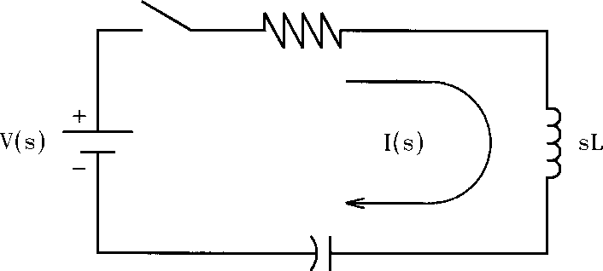
1
-
sC
Figure 11-4—Series RLC circuit

With V(s) as a constant source, the equation describing the current in the circuit is
I(s) V ( s )  = ---------  s | ⎛ ⎞  ⎜ ⎟  1  ⎜ ⎟  ⎝ ⎠  R sL 1  + + -----  sC | (11-30)

Rearranging the terms results in

⎞ ⎟ ⎟ ⎠
⎝ s s-- L
1
+ + ------
LC
⎛
I ( s ) V ( s )
--------- 1
⎜
= L ⎜ 2 R
(11-31)

The expression inside the brackets is similar to the expression for the parallel RLC circuit shown in Equation (11-16). The only difference is the coefficient of s. Rewriting, as in Equation (11-17) gives

I ( s ) V ( s )  =--------- 1  L ( s + r ₁ ) ( s + r₂ ) |  | (11-32)

where r1 and r2 are the roots of the characteristic equation defined as

R ----- 1 4L
R
= ----- + ⎛ ⎞ and r2
– -------- =
2L 2L ⎝ ⎠
R²C
r1
(11-33)
⎛ ⎞
1 4L
⎝ ⎠
– --------- R²C
R
–
-----
---- R
2L
2L

Again, we define the quality factor of the series RLC circuit, Q_{s}, as the ratio of the magnitude of the reactive power of either the inductor or the capacitor at the resonant frequency to the magnitude of the true power in the circuit. Stated in equation form, results in

P_{R}
-----
P_{T}
Qs =
(11-34)
With the reactive power PR = I²X and the true power as PT = I²R, then
I²X
Q_{s}= --------
I²R
(11-35)
But since, in a series circuit, the current is common to all elements, then

Qs | = | ω0L  ---------  R | (11-36)

where ù0L = X. Also, since , then Equation (11-36) can be written as

L
C
= =
------- or Q_{s}
R
Qs
Z₀
R
(11-37)

Note that the above expression is the ratio of the surge impedance to the resistance in the circuit. This is the reciprocal of the expression developed for the parallel RLC circuit and described by Equation (11-22). That is,
1  Q_{s}= ------  Q_{P} | (11-38)

Substituting Equation (11-37) into Equation (11-33) results in  R ----- R  R  r1 = + = ( – )  R  ----- ----- 1 4Qs 2  ( – ) and r2 – ----- 1 4Qs 2  2L 2L 2L 2L | (11-39)

Above expressions have already been solved for the parallel RLC circuit. To obtain the expression as a function of time, simply substitute Q_{s} for QP and V/R for IR and R/L for 1/RC in Equation (11-26) and Equation (11-28) and V/L for I/C and R/L for 1/RC in Equation (11-29). Thus, when the quantity under the radical sign is less than 1, namely, 4Q_{s}²< 1, the result is

i(t) 2V e
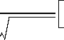
⎛ ⎞
Rt
– ⎝ ⎠
----
2L
2
R 1 4Q_{s}
–
=
⎛ ⎞
R
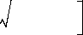
(11-40)
sinh ⎝ ⎠
----- 1 4Qs 2
–
2L

For the case where the quantity 4Q_{s}² = 1, then the roots are equal, negative, and real and the solution of Equation (11-39) is
i ( t ) V  = ---e  L | ⎛ ⎞  R  ⎝ ⎠  -----t 2L | (11-41)

Finally, when the quantity 4Q_{s}² > 1, the roots are complex and unequal. Therefore, the solution is

– ⎛ ⎞
Rt
----
⎝ ⎠
2L
i ( t ) 2V e R
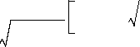
(11-42)

= sin ⎛ ⎞
2 – 1
⎝ ⎠
----- 4Q_{s} R 4Qs 2 – 1 2L

          - Normalized damping curves (Brown 1.1)


⎛ ⎞
θ
– ⎝ ⎠
--------
2Q_{P}
⎛ ⎞
2
θ 1 4Q_{P}
–
⎜ ⎟
⎝ ⎠
2Q_{P}
sinh
=
2
1 4Q_{P} –
f( Q_{P},è)
2 Q_{P}e
and, for ,
4QP 2 = 1
f(Q_{P},è) èe
⎛ ⎞
θ
– --------
⎝ ⎠
2Q_{P}
(11-46)
(11-47)
The response of the parallel and series RLC circuits to a step input of current or voltage, respectively, can be expressed as a family of normalized damping curves, which can be used to estimate the response of simple switching transient circuits to a step input of either voltage or current. To develop a family of normalized damping curves, proceed as follows:
a) To per-unitize the solutions, we use the undamped response of a parallel LC circuit as the starting point. Thus, for the voltage,
v(t) 1  = ----------sin(ω₀t)  ω ₀C  and, for the current,  i(t) 1  = --------sin(ω₀t)  ω₀L | (11-43)  (11-44)

The maximum voltage or current occurs when the angular displacement .
ω₀t = ð /2
Thus,
v ( t ) 1  = ---------  ω0C | i ( t ) 1  and = --------- (11-45)  ω0L

- Setting the angular displacement , the quantity in Equations (11-26)
ω0t = è t
----------
2RC
θ
through (11-28) can be substituted with the expression .
--------
2Q_{P}
- Finally, dividing Equations (11-26) through (11-28) by the right side of the expression for v(t) in Equation (11-45) produces a set of normalized curves for the voltage on the parallel RLC circuit as a function of the dimensionless quantities QP and the displacement è.
Thus, for ,
4QP 2 < 1
and, for , the result is
4 Q_{P}
( 2 > 1 )

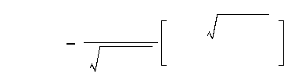
⎛ ⎞
θ
– --------
⎝ ⎠
2Q_{P}
⎛ ⎞
θ 4QP 2 – 1
⎜ ⎟
⎝ ⎠
2Q_{P}
sin
2 Q_{P}e
=
4QP ² –1
f( Q_{P},è)
(11-48)

Equations (11-46) through (11-48) are plotted in Figure 11-5 and Figure 11-6 for various values of QP. For series RLC circuits, divide the same equations in step c) by the right side of the expression for i(t), and substitute Q_{s} for QP.
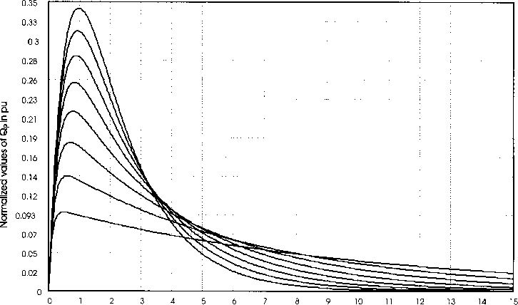
Displacement, è
Figure 11-5—Normalized damping curves, 0.10 ≤ QP ≤ 0.45
in steps of 0.05, with QP (0.45) = 0.34 pu
          - Transient example: Capacitor voltage (Brown 1.1)
Very often, in power systems analysis, the form and magnitude of the transient voltage developed across the capacitor during switching is significant. To develop generalized expressions for capacitor voltage, start with Equation (11-31), which describes the transient current in the series RLC circuit. The voltage across the capacitor is simply the product of the current and the capacitor impedance, that is,
V_{c}(s) = I(s)Z_{c}(s) (11-49)

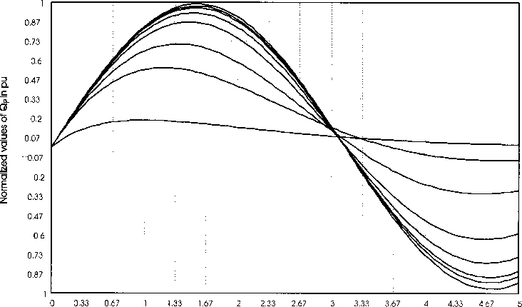
Displacement, è
Figure 11-6—Normalized damping curves, 0.50 ≤ QP ≤ 75.0
0.50, 1.0, 2.0, 5.0, 10.0, 15.0, 30.0, and 75.0, with QP (75) = 1.00 p.u.
or | Vc(s) I ( s )  = --------  sC | (11-50)

Substituting Equation (11-30) into Equation (11-50), yields the expression for the voltage across the capacitor in a series RLC circuit. Thus,
V_{c} ( s ) V ( s )  = ----------  LC |  | 1 |  | (11-5 1)
V_{c} ( s ) V ( s )  = ----------  LC |  | 2 1  s s  ⎛ ⎞  R  ⎝ ⎠  + + ------  s--  L LC |  | (11-5 1)

Equation (11-51) is similar to the Equation (11-30), developed for the current, except that it has an extra s term in the denominator. The expression can be rewritten as follows:

Vc(s) V ( s )  =---------- 1  LC s(s+r1)(s+r2) |  | (11-52)

where the roots of the equation are the same as those defined by Equation (11-39). Again, the solution of Equation (11-52) will depend on the values of Q_{s}.
Equation (11-14) shows the voltage across a capacitor due to a step input of voltage when the
resistance in the circuit is zero. For zero initial conditions, that is, no charge in the capacitor,

the last term in Equation (11-14) can be neglected. Then, the maximum voltage occurs when
ω0t = ð.
Therefore, the voltage is simply
V_{c}(t) = 2 (11-53)
Following exactly the same procedures outlined in 11.1.5, Equation (11-51) has three possible solutions.
For the case in which ,
4 Q_{s}
( 2 < 1 )

⎛ ⎞
2
θ 1 4Q_{s}
–
⎜ ⎟
⎝ ⎠
2Q_{s}
⎛ ⎞
θ 1 4Qs 2
–
⎜ ⎟
⎝ ⎠
2Q_{s}
f(Q_{s},è) 1 e
= –
⎛ ⎞
θ
– ⎝ ⎠
--------
2Q_{s}
sinh
+ cosh
2
1 4Q_{s} –
(11-54)

When the solution is
4Qs 2 = 1 ,

⎛ ⎞
θ
– ⎝ ⎠
-------
2Q_{s}
f(Q_{s},è) 2Q_{s}  = | 1 e  – | ⎛ ⎞  θ  – ⎝ ⎠  -------  2Q_{s} | ⎛ ⎞  1 è  ⎝ ⎠  + -------- 2Q_{s} | (11-55)

Finally, when the solution takes the form of
⎛ ⎞
θ
– -------
⎝ ⎠
2Q_{s}
+ cos
4Qs 2 > 1 ,
(11-56)

⎛ ⎞
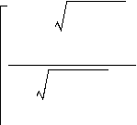
⎛ ⎞
θ 4Qs ² –1
⎜ ⎟
⎝ ⎠
2Q_{s}
4Qs ² –1
sin
f(Q_{s},è) 1 e
= –
θ 4Qs 2 – 1
⎜ ⎟
⎝ ⎠
2Q_{s}

Equations (11-54) through (11-56) are plotted in Figure 11-7 for various values of Q_{s}.
          - Switching transient examples (Brown 1.1)
In the previous subclauses, some simple circuits were examined that can be used to model many switching problems in electrical power systems. Very often, practical switching transient problems can be reduced to either parallel or series RLC circuits for the purpose of evaluating the response of the network to a particular stimuli on a first-trial basis. To gain familiarity with the normalized damping curves developed in the previous subclauses, some typical switching problems in power systems will be examined. Consider, for example, a

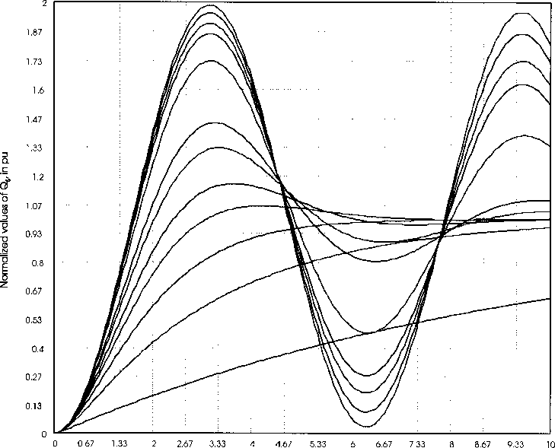
Displacement, è
Figure 11-7—Normalized damping curves, 0.10 ≤ Q_{s} ≤ 100
0.10, 0.30, 0.50, 0.75, 1.0, 1.5, 2.0, 5.0, 10.0, 15.0, 30.0,
and 100.0 with Q_{s} (100) = 1.99
1000 kVA unloaded transformer that, when excited from the 13.8 kV side with its rated voltage of 13.8 kV, draws a no-load current of 650 mA with a power factor of 10.4%. A test circuit for the transformer is shown in Figure 11-8. The battery voltage, V, and the resistance, R, are chosen such that, with the switch closed, the battery delivers 10 mA. For this example, a shunt capacitance of 2.8 nF per phase is assumed. The goal is to find the voltage across the capacitance to ground, when the switch is suddenly opened and the flow of current is interrupted.
From the information provided, the no-load current of the transformer is INL = 0.067794 – j0.64644 A
The magnetizing reactance XM and inductance LM per phase are, respectively,
13.8 kV
X_{M} = = 12.325 kÙ
3 × 0.64644

L_{M}
12.325 kÙ
X_{M}
= =
= 32.693 H
2ðf 377

With a shunt capacitance of CSH = 2.8 nF, the shunt capacitive reactance is
1 1
XSH = = = 947.33 k Ù
-----------------
2ðf C_{SH} 377 × 2.8 nF
Since XSH > XM, the effects of the shunt capacitive reactance at the power frequency are negligible. The resistance RC is
R_{C} = = 117.524 k Ω
13.8 kV
3 0.067794
×
Using delta-wye transformation impedance conversion, the circuit in Figure 11-8 can be redrawn as shown in Figure 11-9. In the Laplace transform notation, the equation describing the circuit at t = 0⁺ is

IL 0–
( )
-------------
sL
---------- sCV_{c}(s) CVc 0– V_{c}(s)
+ + +
– ( )
s
O =
V_{c}(s)
-----------
R

where
V_{c}(s) | = | IL 0–  ( )  -------------  C | ⎛ ⎞  ⎜ ⎟  1  ⎜ ⎟  2 s 1  ⎝ ⎠  s+ + ------  -------  RCLC

3L_{M}
L = -------- = 49.035 H
2
²CSH
C = ----------- = 1.867 nF
3
3R_{c}
R = ------ -- = 176.286 kÙ 2
Assuming that dc steady-state was obtained before the switch opened, the term CV_{c} (0–) = 0 and the initial current in the inductor at t = 0⁺ is IL (0–) = 10 mA. Solving for V_{c}(s) and after rearranging the terms, gives

Figure 11-8—Test setup of unloaded transformer

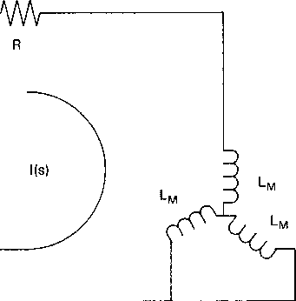
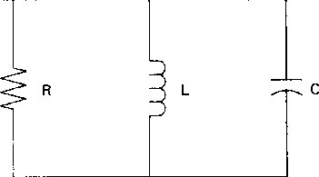
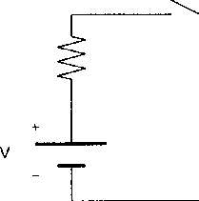
Figure 11-9—Equivalent RLC circuit for unloaded transformer
The time-response solution for this expression has already been obtained and, depending on the values of the circuit parameters, is shown in Equations (11-26), (11-27), and (11-28). The values for R, L, and C could be inserted into one of those equations to obtain the capacitor voltage for this problem. But this has also been done through the normalized damping curves shown in Figure 11-5. Therefore, the answers for this particular problem are obtained as follows:
a) The surge impedance of the circuit is
Z₀ = --- = 162.07 k Ω
L
- Without damping, the peak transient voltage would be
Vpeak = I(0– ) Z0 = –10mA×162.076 kÙ – 1.621 kV
=
- But since there is damping, the quality factor of the parallel circuit QP is R 176.286 k Ù
Q_{P} = = = 1.087
-----
Z₀ 162.076 k Ù
- From the curves shown in Figure 11-5 and with QP ≈ 1.0, the maximum per unit voltage is 0.57. Therefore, from step b), the maximum voltage developed across the capacitor is
Vmax = –1.621 kV×0.57 = –924V
- The maximum peak occurs at approximately è = 1.2 radians. Since ù0t = è and

1
ω0
=
or
----------
LC

ω 0 = 3305 rad/s
Figure 11-10 depicts the actual voltage across the capacitance to ground as calculated by a computer program.
Another practical case will be examined, which concerns capacitor bank switching as depicted in Figure 11-11. Capacitor C1 is rated 30 Mvar, three-phase, at 13.8 kV. C2 is initially uncharged and is rated 10 Mvar, three-phase, also at 13.8 kV. The cable connecting capacitor C2 to the bus has an inductance L of 35 ìH. The following procedure is used to determine the magnitude of the inrush current and the size of the resistor required to limit this current to a maximum of 5800 A (peak) during energization.
From the problem statement, the capacitive reactance of the capacitors is
kV² 13.8²
Xc1 = = ---------- = 6.348 Ω
-------
C₁ 30
kV² 13.8²
Xc2 = = ---------- = 19.044 Ω
--------
C2 10
and the capacitance is
1 1
C₁ = = = 417.861 μF
----------------
2ðf X_{c1} 2ð × 60 × 6.348 Ω C1 = 139.287 μF

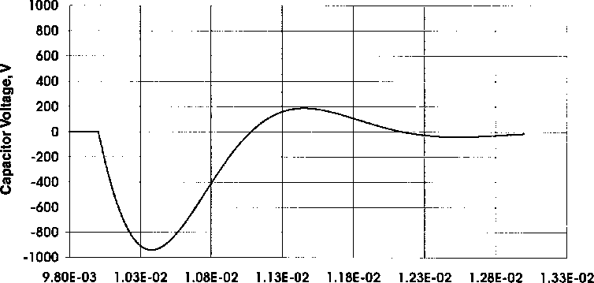
Time, s
Figure 11-10—Actual capacitor voltage


V_{c} (0–)

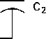
Figure 11-11—Capacitor bank switching Assuming worst-case conditions, that is, C1 charged to peak system voltage or

kV × 2
V_{c1}= ------------------
3
13.8 × 2
= = 11.268kV
3

and with a surge impedance of
L(C1 + C2)
Z0 = = 0.579 Ω
( C1C2 )

Then, with no damping, the inrush current would be

ipeak | Vc (0 )  = =  ----------- 11.268 kV  Z₀ 0.579 Ω | = 19.467 kA

Redrawing the circuit of Figure 11-11 to show the necessary addition of a resistor to limit the inrush current yields the circuit as shown in Figure 11-12.
Figure 11-12—Equivalent circuit for capacitor switching
with pre-insertion resistor

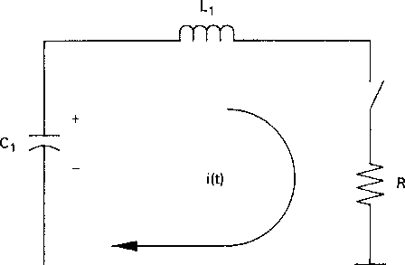
V_{c} (0–)
The problem requires that the inrush current should not exceed 5800 A. This represents a per- unit value of
Ipu | Imax  = =  ---------  Ipeak | 5800 A  19467 A | = 0.30

Referring to Figure 11-5, since the current problem concerns a series circuit, Q_{s} replaces QP. With a per-unit value requirement of 0.30 (vertical axis), Figure 11-5 shows that a QP = 0.30 will reduce the current to 5800 (19467 × 0.30) A or less. Now, since
Q_{s} = 0.30 and
Z0
= ----- = 0.30 R

then

R | Z0  = =  -----  Qs | 0.579 Q  ------------------ =1.93 Q 0.30

Therefore, to limit the inrush current to 5800 A a 1.9 Q resistor must be placed in series with capacitor C2 as shown in Figure 11-12.
The results of a computer simulation are depicted in Figure 11-13 and Figure 11-14. While Figure 11-13 shows the current without the pre-insertion resistor, Figure 11-14 reflects the current with the 1.9 Q resistor.
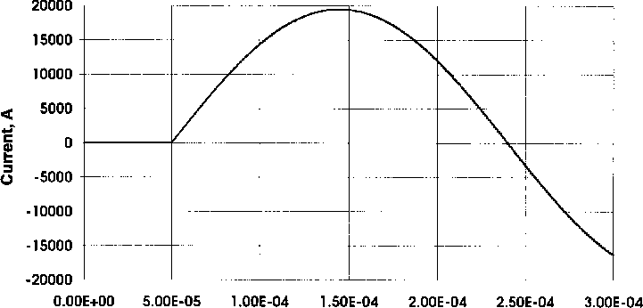
Time, s
Figure 11-13—Current in circuit without damping resistor
          - Transient recovery voltage (Brown 1.1)
Circuit breakers provide the mechanism to interrupt the short-circuit current during a system fault. When the breaker contacts open, the fault current is not interrupted instantaneously. Instead, an electric arc forms between the breaker contacts, which is maintained as long as there is enough current flowing. Since the fault current varies sinusoidally at the power frequency, the arc will extinguish at the first current zero. However, at the location of the arc, there are still hot, ionized gases and, if voltages exceeding the dielectric capability of the contact gap develop across the open contacts of the circuit breaker, it is possible that the arc will re-ignite. Circuit interruption is a race between the increase of dielectric strength of the contact gap of the circuit breaker or switch and the recovery voltage. The latter is essentially a characteristic of the circuit itself.
For inductive circuits, we know that the current lags the voltage by an angle less than ninety
electrical degrees. Thus, when the current is zero, the voltage is at its maximum. This means

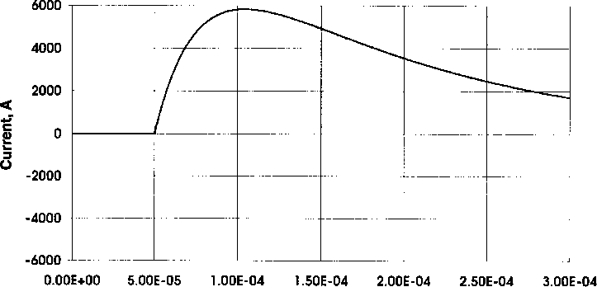
Time, s
Figure 11-14—Current in circuit with damping resistor
that, immediately after interruption of the arc, a rapid buildup of voltage across the breaker contacts may cause the arc to re-ignite and re-establish the circuit. The rate by which the voltage across the breaker rises depends on the inductance and capacitance of the circuit.
The simplest form of single-phase circuit that is useful to illustrate this phenomenon is that shown in Figure 11-15.
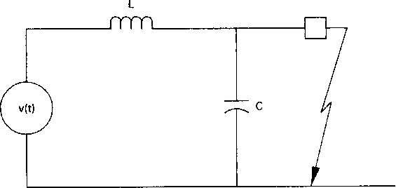
Figure 11-15—Simplified diagram to illustrate TRV
In the circuit, L is the inductance of the source and C is the natural capacitance of the circuit
in the vicinity of the circuit breaker. It may include capacitance to ground through bushings,
current transformers, etc. The voltage source is assumed to vary sinusoidally and, since it is at its peak at the time the short-circuit current is interrupted, it can be expressed as

v(t) = 2×V×cos(ωt)
(11-57)

where ù is the power frequency in radians per second (rad/s). If the switch opens, the flow of current is interrupted at the first current zero and a voltage known as the transient recovery voltage (TRV) will appear across the breaker contacts. This voltage is essentially the voltage across the capacitance. It is zero during the fault but, when the circuit breaker opens to clear the fault, the voltage across the contacts builds up to approximately twice the peak of the voltage at the power frequency.
The equivalent circuit of Figure 11-15 may be analyzed by means of the Laplace transform. The network equation in the s-domain for t = 0⁺ is

V(s) I(s)sL LI 0–  = – ( ) | + | I(s)  --------  sC | (11-58)

Solving the current I(s) with I(0–) = 0 (current interruption assumed to occur at zero current, no current chopping) yields the following:


I ( s ) V ( s ) s
= ---------------
---------
L s2 ù0 2
+
(11-59)

Substituting sCV_{c}(s) for I(s), the result is

2
ω0
---------------
2
V_{c}(s) V ( s )
=
(11-60)
2
s
+
ω₀

The Laplace transform of the driving function described by Equation (11-57) is

s²ù²
+

s
V(s) Vmax
= ---------------
(11-61)

Combining Equations (11-60) and (11-61), the recovery voltage or the voltage across the capacitor is
 | 2
V_{c} ( s ) Vmax  = | sù₀ |  | (11-62)
V_{c} ( s ) Vmax  = | ( + ) s ² ω0 s 2 ù2 ( + )  2 |  | (11-62)

From the table of the inverse Laplace transforms, the transient response is
Vmax  V_{c} (t) =------------- [ cos ( ωt ) – cos ( ω₀t ) ] 2 | (11-63)

2
1 ù
– -----
ω₀

The events before and after the fault are depicted in Figure 11-16 with damping. However, without damping as described by Equation (11-63), the recovery voltage reaches a maximum of twice the source voltage (the peak occurs at one half cycle of the natural frequency, after the switch is opened). This is true when the natural frequency is high as compared with the fundamental frequency and when losses are insignificant. Losses (damping) will reduce the maximum value of V_{c}, as shown in Figure 11-16.
Time, s

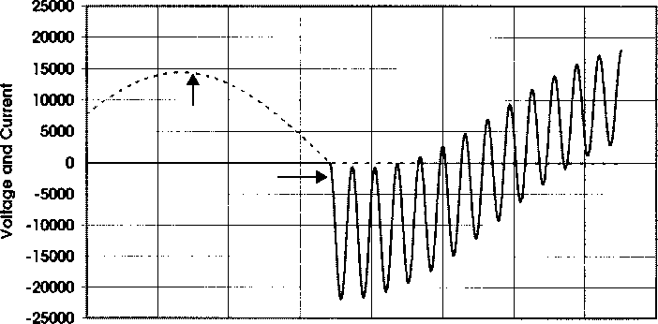
'fault
TRV,V
Figure 11-16—Transient recovery voltage
Upon interruption of the fault current by the circuit breaker, the source attempts to charge the capacitor voltage to the potential of the supply. As a matter of fact, without damping, the capacitor voltage will overshoot the supply voltage by the same amount as it started below. If the natural frequency of the circuit is high (L and C very small), the voltage across the breaker contacts will rise very rapidly. If this rate-of-rise exceeds the dielectric strength of the medium between the contacts, the breaker will not be able to sustain the voltage and re-ignition will occur.
          - Summary (Brown 1.1)
The material covered thus far is by no means an exhaustive discussion of electrical transients
in power systems. The objective of the foregoing material is to provide the reader with the

basic techniques required to perform simple switching transient calculations. We have seen that, even for simple series or parallel RLC circuits, the mathematical expressions can be quite cumbersome and very difficult to solve analytically. It is evident that any slight increase in circuit complexity will result in expressions very difficult to handle and solve by conventional methods.
Typical industrial power distribution systems will involve many series and parallel circuit combinations with very complex relationships. To set down and solve analytically the equations representing such a system would be a formidable task. This is when solutions by computer methods are most appropriate. Two of the most common computer methods are analog and digital. The analog computer makes use of scaled-down components, i.e., resistors, inductors, and capacitors, to model a particular system. The digital computer, on the other hand, utilizes computer programs (software packages) developed especially for the purpose of transient analysis.
        - Switching transient studies (Brown 1.2)
          - Introduction (Brown 1.2)
Unlike classical power system studies, i.e., short circuit, load flow, etc., switching transient studies are conducted less frequently in industrial power distribution systems. Capacitor and harmonic filter bank switching in industrial and utility systems account for most of such investigations, to assist in the resolution of certain transient behavioral questions in conjunction with the application or failure of a particular piece of equipment.
Two basic approaches present themselves in the determination and prediction of switching transient duties in electrical equipment: direct transient measurements (to be discussed later in this chapter) and computer modeling. The latter can be divided into transient network analyzer (TNA) and digital computer modeling.
In 11.1, some useful insights regarding the physical aspects prevailing in a circuit during a transient period were obtained with a minimum of mathematical complications. In fact, experienced transient analysts use known circuit-response patterns, based on a few basic fundamentals, to assess the general transient behavior of a particular circuit and to judge the validity of more complex switching transient results. Indeed, simple configurations consisting of linear circuit elements can be processed by hand as a first approximation. Beyond these relatively simple arrangements, the economics and effective determination of electrical power system transients require the utilization of TNAs or digital computer programs. These two approaches to the solution of complex switching transients in power systems are the subject of 11.2. Excerpts from actual switching transient studies are included.
          - Switching transient study objectives (Brown 1.2)
The basic objectives of switching transient investigations are to identify and quantify
transient duties that may arise in a system as a result of intentional or unintentional switching
events, and to prescribe economical corrective measures whenever deemed necessary. The
results of a switching transient study can affect the operating procedures as well as the equipment in the system. The following include some specific broad objectives, one or more of which are included in a given study:
- Identify the nature of transient duties that can occur for any realistic switching operation. This includes determining the magnitude, duration, and frequency of the oscillations.
- Determine if abnormal transient duties are likely to be imposed on equipment by the inception and/or removal of faults.
- Recommend corrective measures to mitigate transient overvoltages and/or overcurrents. This may include solutions such as resistor pre-insertion, tuning reactors, appropriate system grounding, and application of surge arresters and surge- protective capacitors.
- Recommend alternative operating procedures, if necessary, to minimize transient duties.
- Document the study results on a case-by-case basis in readily understandable form for those responsible for design and operation. Such documentation usually includes reproduction of waveshape displays and interpretation of, at least, the limiting cases.
          - Control of switching transients (Brown 1.2)
The philosophy of mitigation and control of switching transients revolves around the following:
- Minimizing the number and severity of the switching events
- Limitation of the rate of exchange of energy that prevails among system elements during the transient period
- Extraction of energy
- Shifting the resonant points to avoid amplification of particular offensive frequencies
- Provision of energy reservoirs to contain released or trapped energy within safe limits of current and voltage
- Provision of discharge paths for high-frequency currents resulting from switching
In practice, this is usually accomplished through one or more of the following methods:
- Temporary insertion of resistance between circuit elements; for example, the insertion of resistors in circuit breakers
- Synchronized closing control for vacuum and SF6 breakers and switches
- Inrush control reactors
- Damping resistors in filter and surge protective circuits
- Tuning reactors
- Surge capacitors
- Filters
- Surge arresters
- Necessary switching only, with properly maintained switching devices
- Proper switching sequences
          - Transient network analyzer (TNA) (Brown 1.2)
            - Introduction (Brown 1.2)
Through the years, a small number of TNAs have been built for the purpose of performing transient analysis in power systems. A typical TNA is made of scaled-down power system component models, which are interconnected in such a way as to represent the actual system under study. The inductive, capacitive, and resistive characteristics of the various power system components are modeled with inductors, capacitors, and resistors in the analyzer. These have the same oersted ohmic value as the actual components of the system at the power frequency. The analyzer generally operates in the range of 10–100 V_{rms} line-to-neutral, which represents 1.0 per-unit voltage on the actual system.
The model approach of the TNA finds its virtue in the relative ease with which individual components can duplicate their actual power system counterparts as compared with the difficulty of accurately representing combinations of nonlinear interconnected elements in a digital solution. Furthermore, the switching operation that produces the transients is under the direct control of the operator, and the circuit can easily be changed to show the effect of any parameter variation. TNA simulation is also faster than digital simulation especially for larger systems with many nonlinear elements to model.
            - Modeling techniques (Brown 1.2)
Typical hardware used in a TNA to model the actual system components will be described now. However, it should be fully recognized that any specific set of components can be modeled in more than one way, and considerable judgment on the part of the TNA staff is necessary to select the optimum model for a given situation. Also, it should be recognized that, while there is a great similarity among the components of the various TNAs in existence today, there are also unique hardware approaches to any given system. The following is a general description of some of the hardware models.
- Transmission lines are modeled basically as a four-wire system, with three wires associated with the phase conductors and the fourth wire encompassing the effects of shield wire and earth return.
- Circuit breakers consist of a number of independent mercury-wetted relay contacts or solid-state electronic circuitry. The instant of both closing and opening of each individual switch can be controlled by the operator or the computer system. The model has the capability of simulating breaker actions like pre-striking, re-striking, and re-ignition.
- Shunt reactors can be totally electronic or analog with variable saturation characteristics and losses.
- Transformers are a critical part of the TNA. This is because many temporary overvoltages include the interaction of the nonlinear transformer magnetizing branch with the system inductance and capacitance. Modeling of the nonlinear magnetic representation of the transformer is very critical to analyzing ferroresonance and dynamic overvoltages. The model consists of both an array of inductors, configured
and adjusted to represent the linear inductances of the transformer, and adjustable
saturable reactors, representing the nonlinear portion of the saturation characteristics.
- Arresters of both silicon carbide and metal oxide can be modeled. The models for both types of arresters can be totally electronic and provide energy dissipation values to safely size the surge arresters.
- Secondary arc, available in some TNA facilities, is a model that can simulate a fault
arc and its action after the system circuit breakers are cleared.
- Power sources can be three-phase motor-generator sets or three-phase electronic frequency converters. The short-circuit impedance of these sources is such that they appear as an infinite bus on the impedance base of the analyzer.
- Synchronous machines can be either totally electronic or analog models, and are used to study the effects of load rejection or other events that could be strongly affected by the action of the synchronous machine.
- Static var systems include an electronic control circuit, a thyristor-controlled reactor,
and a fixed capacitor with harmonic filters. The control logic circuit monitors the three-phase voltages and currents and can be set to respond to either the voltage level, the power factor, or some combination of the two.
- Series capacitor protective devices are used in conjunction with series compensated
ac transmission lines. When a fault occurs, the voltage on the series capacitor rises to a high value unless it is bypassed by protective devices, such as power gap or metal- oxide varistors. The TNA can represent both of these devices.
          - Capacitor bank switching—TNA case study (Brown 1.2)
            - Introduction (Brown 1.2)
The following describes a case study in which a customer planned to install a total of 75 Mvar of switched capacitor banks at a 115 kV substation. The design called for two separately switched 37.5 Mvar banks to compensate for var loading and voltage drop that would occur in the system when power was being imported from other sources. Since this was the customer’s first experience with capacitor bank installation above 34.5 kV, a request was made for a TNA study to determine the transient overvoltages that could result during energization of the capacitor banks.
            - Study objectives (Brown 1.2)
The primary objective of this investigation was to determine if any switching surge overvoltage problems could be experienced when the proposed capacitor banks are added to the 115 kV substation. The system was modeled in the TNA to determine the switching surge voltages that can be generated during normal and abnormal switching conditions for the specific purpose of determining the following:
- The influence of the capacitor banks on the existing surge arresters and the application of protective devices at the buses where the capacitors will be located (see Figure 11-17)
- If pre-insertion resistors are required for the capacitor bank circuit breakers
- Current-limiting reactor requirements for both capacitor banks
- If any magnification of the capacitor switching transient voltages at remote system locations is a possibility
- If the system is susceptible to resonance due to added capacitor banks
- Traveling wave voltage effects at transformer terminated lines
            - Study results (Brown 1.2)
The system being investigated is depicted in Figure 11-17. The proposed capacitor banks are connected to the 115 kV bus through the circuit breakers A and B. The entire investigation consisted of thirty-two different system configurations and switching operations. Due to space limitations, however, only the results of two of these cases will be presented here, namely the energization of both capacitor banks. The results of three-phase re-strike, fault initiation, line energization, etc., which were part of the study, will not be presented.
There are two or more output pages for each case investigated. The first page tabulates the system voltages recorded for the various system conditions as identified by the headings. They include both the temporary pre-switching, energizing, and post-switching voltages, as shown in Figure 11-18 (a), (b), and (c).
The succeeding pages display the statistical distribution curves of the transient voltages and/ or the oscillograms of the voltage, current, and/or waveforms taken during the investigation, as shown in Figures 11-19, 11-20, and 11-21 for case 1. The results of case 2, that is, energization of capacitor bank 2, are shown in Figure 11-22 (a), (b), and (c), through Figure 11-26.
            - Discussion (Brown 1.2)
A maximum transient voltage of 1.38 pu and 1.64 pu was calculated during energization of each of two 37.5 Mvar banks at the 115 kV bus (66.5 kV line-to-ground), locations 4 and 5. The 1.64 pu (154 kV peak line-to-neutral) was recorded in case 1, where the first of the two banks was energized. In case 2, the 1.38 pu (130 kV peak line-to-neutral) transient voltage was recorded as a result of energizing the second bank. In each of the two cases, the system was operating under normal conditions and the capacitor switches did not include any closing resistors or current-limiting reactors. Transient voltages of these magnitudes are generally not considered to be of sufficient magnitude to cause a 96 kV rated conventional gapped-type arrester to operate or to cause any undue stress to either a 90 kV or 96 kV rated metal-oxide type arrester, connected at the line-to-ground system voltage of 66.5 kV.
The switching operations of both capacitor banks did not cause any serious transient overvoltages at remote locations in the system and no resonant conditions were detected.
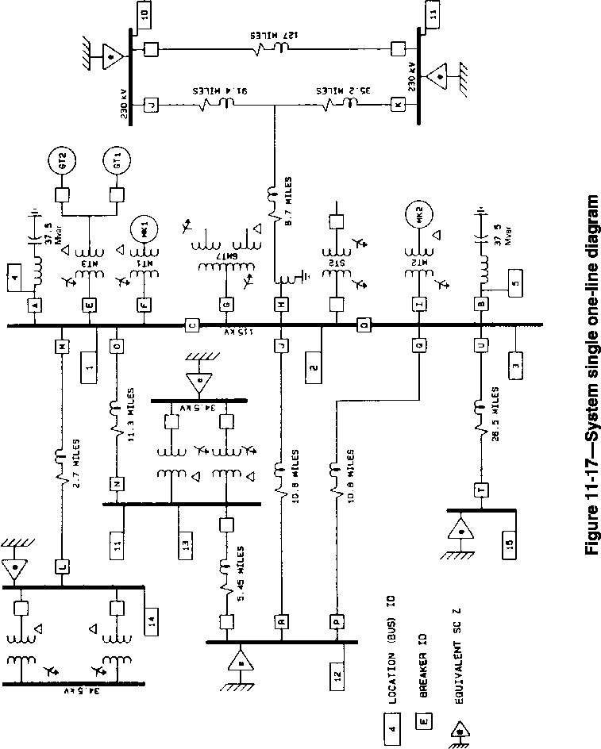
(a) Pre-switching voltages (b) Energizing voltages
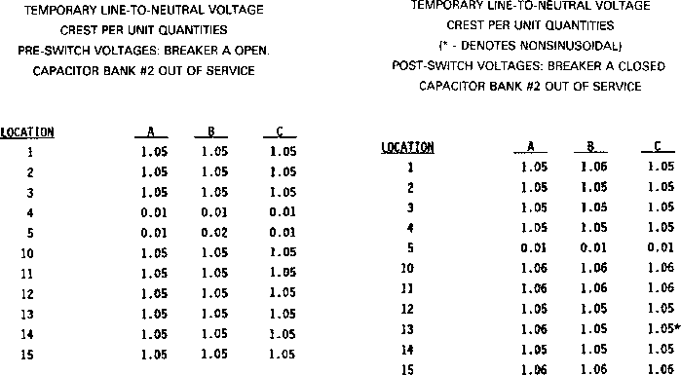
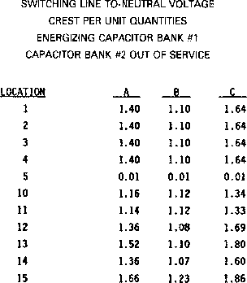
(c) Post-switching voltages
Figure 11-18—System voltages—Case 1
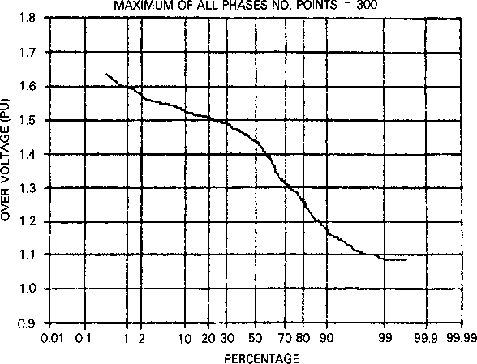
Figure 11-19—Probability distribution—Case 1
          - Electromagnetic transients program (EMTP) (Brown 1.2)
            - Introduction (Brown 1.2)
EMTP is a software package that can be used for single-phase and multiphase networks to calculate either steady-state phasor values or electromagnetic switching transients. The results can be either printed or plotted.
            - Network and device representation (Brown 1.2)
The program allows for arbitrary connection of the following elements:
- Lumped resistance, inductance, and capacitance
- Multiphase (ð) circuits, when the elements R, L, and C become symmetric matrixes
- Transposed and untransposed distributed parameter transmission lines with wave propagation represented either as distortionless, or as lossy through lumped resistance approximation
- Nonlinear resistance with a single-valued, monotonically increasing characteristics
- Nonlinear inductance with single-valued, monotonically increasing characteristics
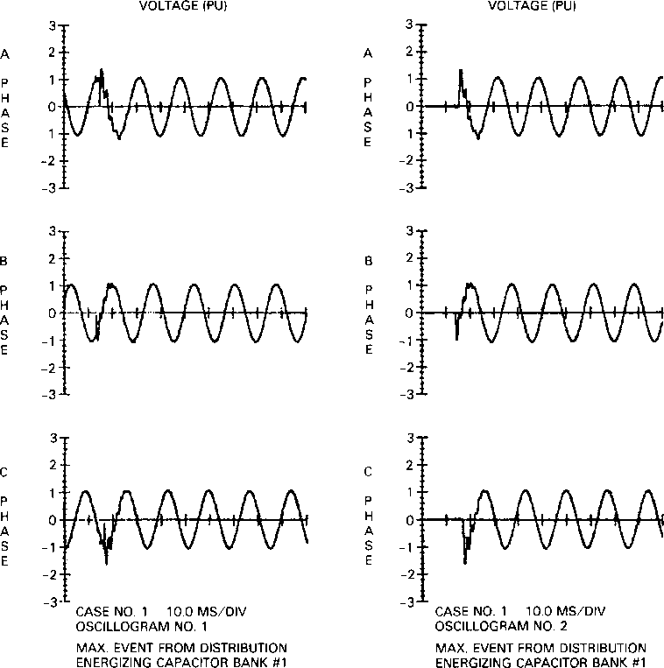
Figure 11-20—Voltage oscillations, locations 1 and 4—Case 1
- Time-varying resistance
- Switches with various switching criteria to simulate circuit breakers, spark gaps, diodes, and other network connection options
- Voltage and current sources representing standard mathematical functions, such as sinusoidals, surge functions, steps, ramps, etc. In addition, point-by-point sources as a function of time can be specified by the user.
- Single- and three-phase, two- or three-winding transformers
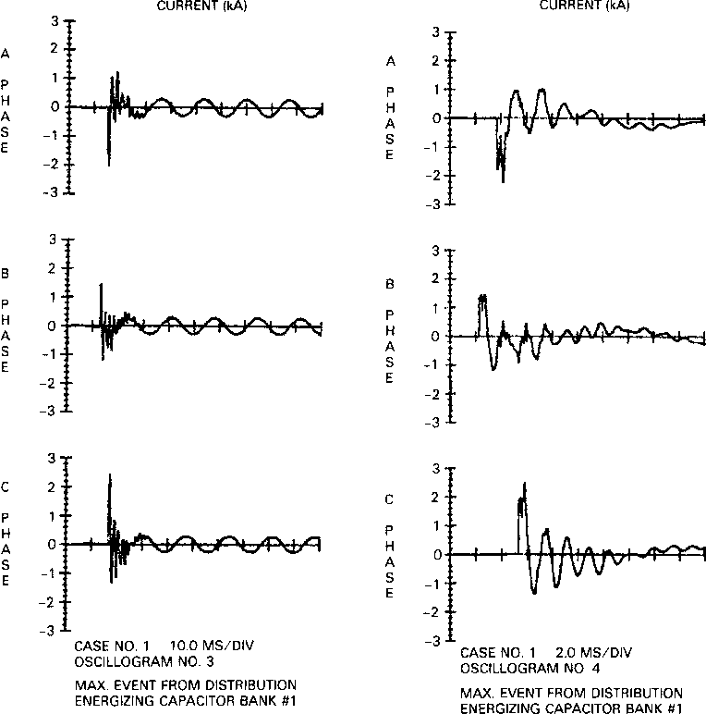
Figure 11-21—Current oscillograms, location 4—Case 1
          - Capacitor bank switching—EMTP case study (Brown 1.2)
            - Introduction (Brown 1.2)
As part of a modernization program that included the addition of two paper machine drives to the existing system, it was determined that a 10 Mvar capacitor bank was required to improve the plant power factor and the system voltage profile. Further analysis also indicated the need for a tuning reactor in series with the capacitor bank in order to minimize the effects of harmonic resonance problems. Because of recent plant outages caused by what appeared to be normal switching operations, and because the proposed capacitor bank would require
(a) Pre-switching voltages (b) Energizing voltages
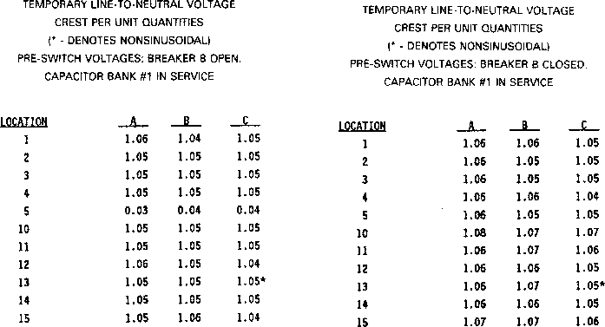
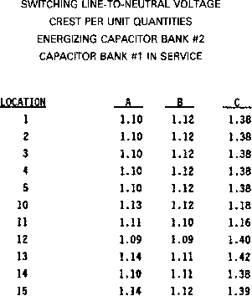
(c) Post-switching voltages
Figure 11-22—System voltages—Case 2
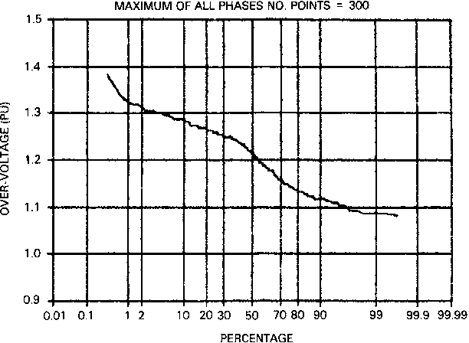
Figure 11-23—Probability distribution—Case 2
frequent switching to meet system voltage and power factor requirements, the customer requested that a switching transient investigation be conducted to determine the voltage and current waveforms associated with the switching of the proposed capacitor bank.
            - Study objectives (Brown 1.2)
The objectives of the study were to assist the customer in evaluating the effect of filter bank switching transients and in determining the solution to minimize these effects on the electrical system and equipment. Specifically, the study addressed the transient voltages and current waveforms during energization of the filter bank and the effects that these transients might have on the slip energy recovery drive and on the proposed dc drives for the new paper machines.
            - Circuit model and cases studied (Brown 1.2)
The study circuit and pertinent system parameters used in the study are depicted in Figure 11-27.
Table 11-1 describes the cases studied. Various system configurations were investigated to determine the transient voltage waveforms associated with the energization of the filter bank. The switching operation for the cases investigated (as listed in Table 11-1) was initiated when the phase-to-phase voltage _{(Va–b)} at the STPT bus was at its peak (t = 8.4 ms). When resistor pre-insertion is used, it remains in the circuit for a period of three cycles and then is shorted
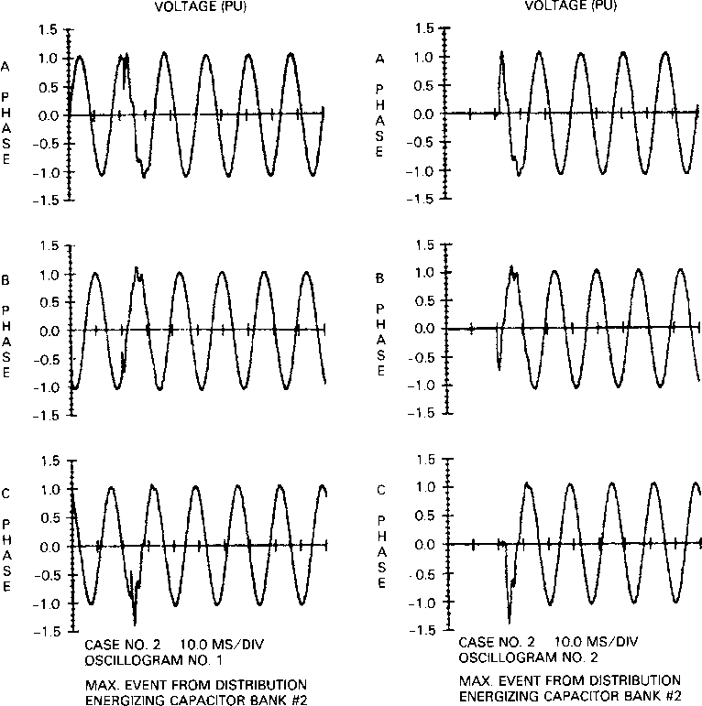
Figure 11-24—Voltage oscillograms, locations 3 and 5—Case 2
out by a second switching operation, as depicted in the single-line diagram shown in Figure 11-27.
            - Study results and discussion (Brown 1.2)
Selected transient voltage waveforms that were calculated and plotted by the program for cases 1, 8, and 9 are shown in Figure 11-28 through Figure 11-33.
Tables 11-2 and 11-3 summarize the results of all cases, for the worst peak overvoltages calculated, in kilovolts and in per units, respectively.
Figure 11-25—Current oscillograms, locations 4 and 5—Case 2
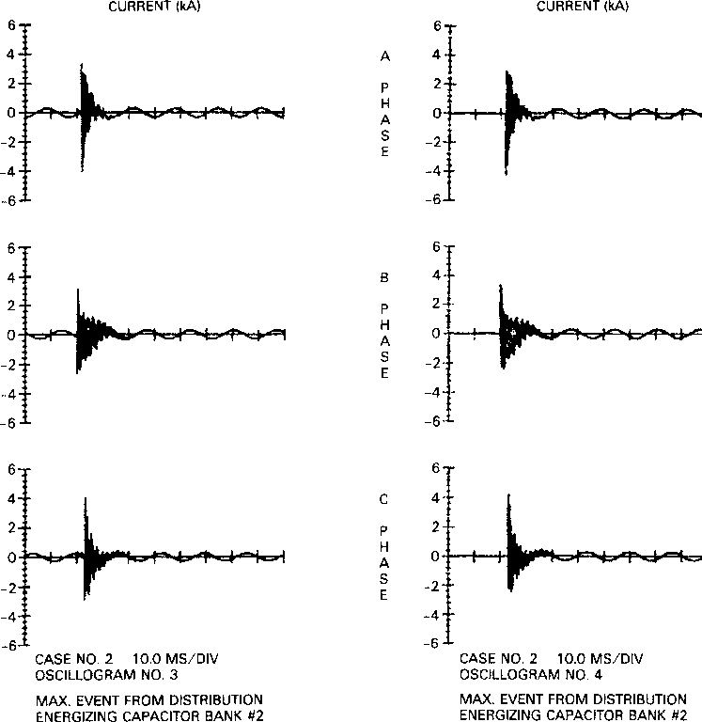
The following are some observations:
- Removal of the 325 kvar capacitor bank on bus L135 (case 2) eliminates the high frequency oscillations (1000 Hz) experienced in case 1.
- The transients are substantially reduced when the 10 Mvar filter bank is divided into two 5 Mvar banks (cases 4 and 5).
- The transient decay is faster when pre-insertion resistors are used (cases 5, 8, and 9).
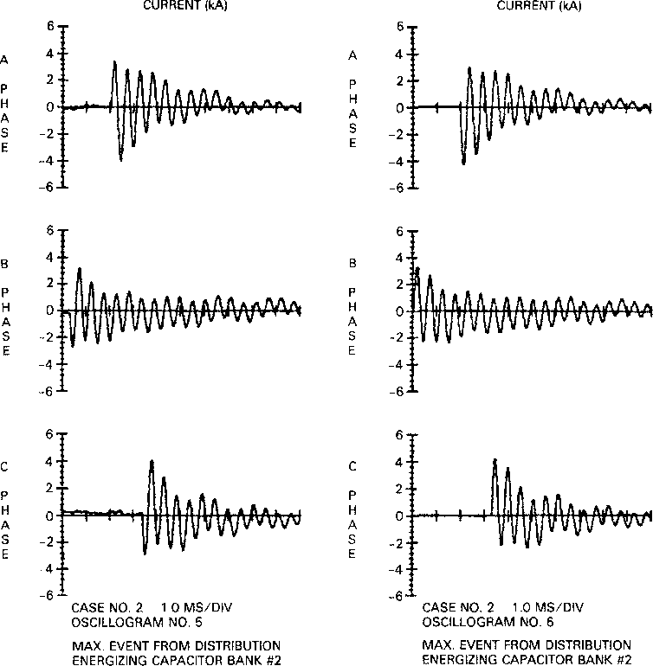
Figure 11-26—Current oscillograms, locations 4 and 5—Case 2
expanded time scale
d) The magnitude of the transient overvoltages is greatly reduced when the 10 Mvar bank is divided into two 5 Mvar banks and when resistor pre-insertion (5.2 Ù) is used during energization (cases 8 and 9).
          - Summary (Brown 1.2)
Complete switching transient study documentation includes not only detailed individual case
study results for transient responses associated with various arrangements and conditions
surveyed, but also analysis, recommendations, and conclusions of the study. The study report
Table 11-1—Filter energization—Cases studied
Case | Description
1 | Energization of 10 Mvar filter bank
2 | Energization of 10 Mvar filter bank, with 325 kvar capacitor bank disconnected
3 | 10 Mvar filter bank divided into two 5 Mvar banks, energization of first 5 Mvar filter bank
4 | Energization of second 5 Mvar filter bank
5 | Energization of 10 Mvar filter bank with resistor pre-insertion; (R = 2.6 Ù for 3 cycles)
6 | Energization of 10 Mvar filter bank with resistor pre-insertion; (R = 26 Ù for 3 cycles)
7 | Energization of 10 Mvar filter bank with resistor pre-insertion; (R = 13 Ù for 3 cycles)
8 | 10 Mvar filter bank divided into two 5 Mvar banks, energization of first 5 Mvar filter bank, with resistor pre-insertion; (R = 5.2 Ù for 3 cycles)
9 | Energization of second 5 Mvar filter bank; with resistor pre-insertion; (R = 5.2 Ù for 3 cycles)

also includes a complete listing of parameters (R, L, and C) of various system components, characteristics of protective devices, and a description of any unusual or special- representations used in the study.
          - Switching transient problem areas (Brown 1.2)
Switching of predominantly reactive equipment represents the greatest potential for creating excessive transient duties. Principal offending situations are switching capacitor banks with inadequate or malfunctioning switching devices and energizing and de-energizing transformers with the same switching deficiencies. Capacitors can store, trap, and suddenly release relatively large quantities of energy. Similarly, highly inductive equipment possesses an energy storage capability that can also release large quantities of electromagnetic energy during a rapid current decay. Since transient voltages and currents arise in conjunction with energy redistribution following a switching event, the greater the energy storage in associated system elements, the greater the transient magnitudes become.
Generalized switching transient studies have provided many important criteria to enable system designers to avoid excessive transients in most common circumstances. The criteria for proper system grounding to avoid transient overvoltages during a ground fault are a prime example. There are also several not very common potential transient problem areas that are
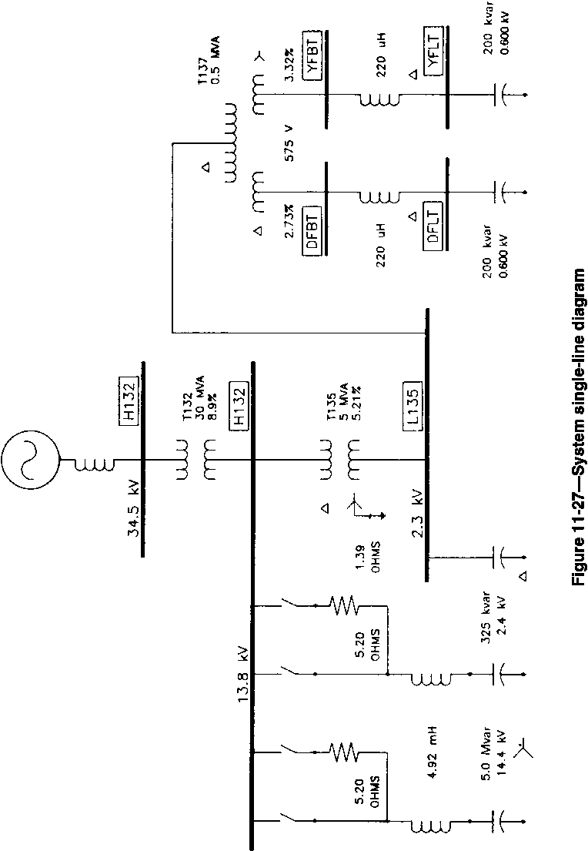
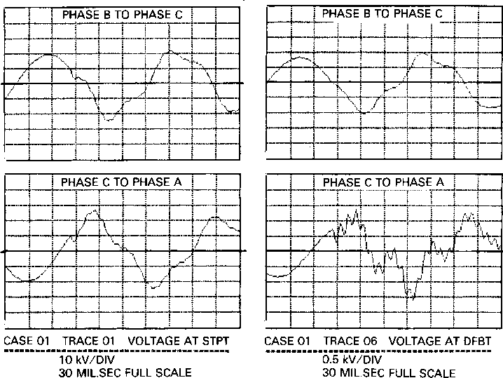
Figure 11-28—Voltage oscillograms at STPT and DFBT buses—Case 1
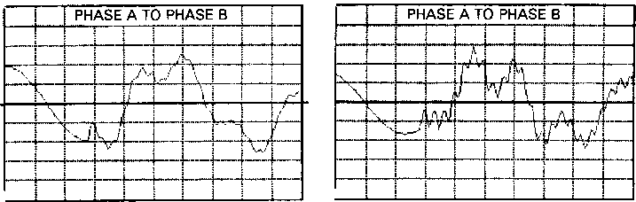
analyzed on an individual basis. The following is a partial list of transient-related problems, which can and have been analyzed through computer modeling:
- Energizing and de-energizing transients in arc furnace installations
- Ferroresonance transients
- Lightning and switching surge response of motors, generators, transformers, transmission towers, cables, etc.
- Lightning surges in complex station arrangements to determine optimum surge arrester location
- Propagation of switching surge through transformer and rotating machine windings
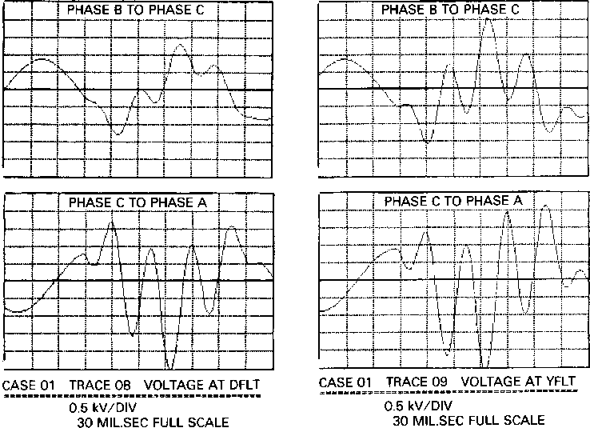
Figure 11-29—Voltage oscillograms at DFLT and YFLT buses—Case 1
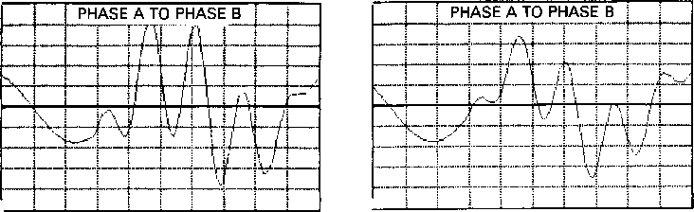
- Switching of capacitors
- Restrike phenomena during line dropping and capacitor de-energization
- Neutral instability and reversed phase rotation
- Energizing and reclosing transients on lines and cables
- Switching surge reduction by means of controlled closing of circuit breaker, resistor pre-insertion, etc.
- Statistical distribution of switching surges
- Transient recovery voltage on distribution and transmission systems
- Voltage flicker
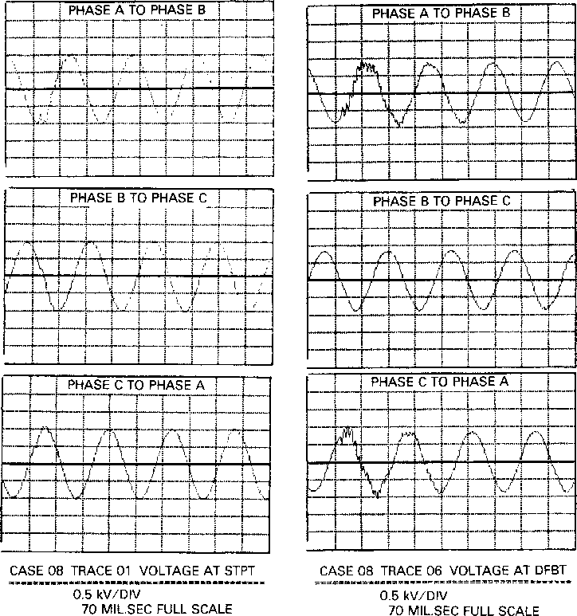
Figure 11-30—Voltage oscillograms at STPT and DFBT buses—Case 8
The studies presented in this chapter have been primarily based on closing or opening of electrical circuits and, therefore, are not generally applicable to transfer switching in emergency and standby power systems. Here, significant transients often occur when inductive loads are rapidly transferred between two out-of-phase sources. Transients can also occur when four-pole transfer switches are both used for line and neutral switching, as may be necessary for separately derived systems. Typical solutions for such problem areas often require transfer switch designs that include in-phase monitors and overlapping neutral conductor switching. For further reading on this subject, see IEEE Std 446-1995.¹
¹Information on references can be found in 11.5.
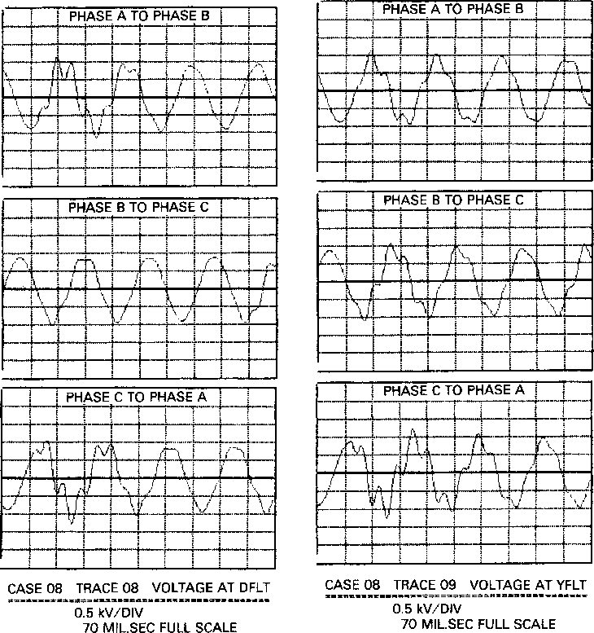
Figure 11-31—Voltage oscillograms at DFLT and YFLT buses—Case 8
The behavior of transformer and machine windings under transient conditions is also an area of great concern. Due to the complexities involved, it would be almost impossible to cover the subject in this chapter. For those interested, Chapter 11 of Greenwood [B 5]² covers the subject in greater detail. Mazur [B6] and White [B11] also cover transients in transformers and rotating machines.
²The numbers in brackets correspond to those of the bibliography in 11.6.
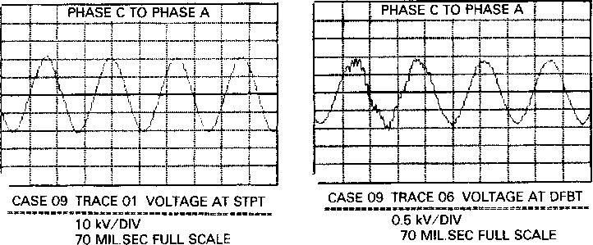
Figure 11-32—Voltage oscillograms at STPT and DFLT buses—Case 9
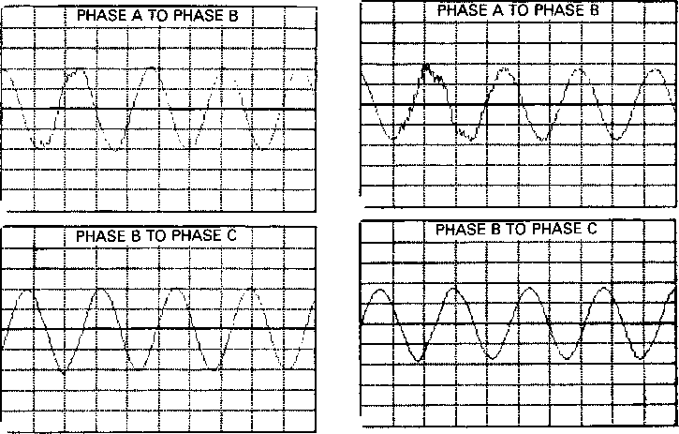
      - Switching transients—field measurements (Brown 1.3)
        - Introduction (Brown 1.3)
The choice of measuring equipment, auxiliary equipment selection, and techniques of setup and operation are in the domain of practiced measurement specialists. No attempt will be made here to delve into such matters in detail, except from the standpoint of conveying the depth of involvement entailed by switching transient measurements and from the standpoint of planning a measurement program to secure reliable transient information of sufficient scope for the intended purpose.
Figure 11-33—Voltage oscillograms at DFLT and YFLT buses—Case 9
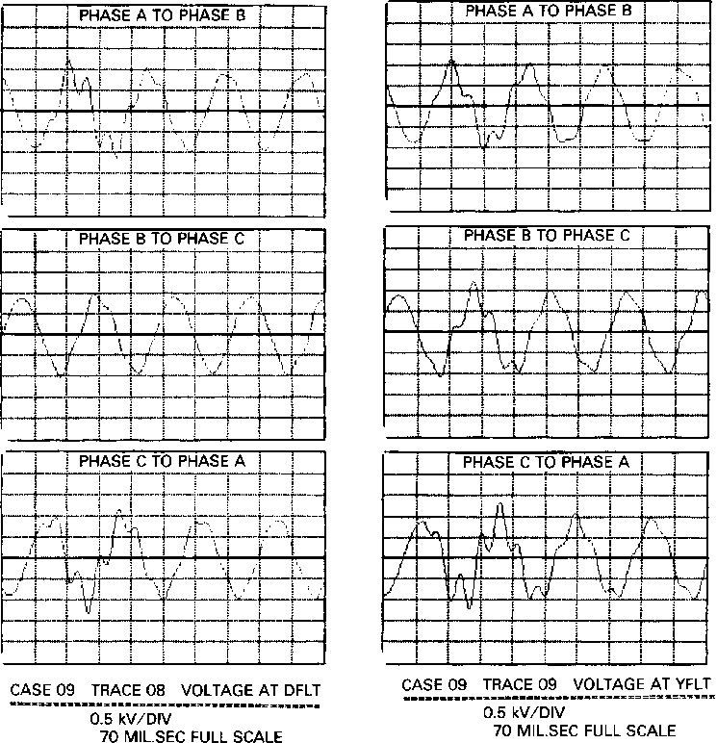
Field measurements seldom, if ever, include fault switching, and often, recommended corrective measures are not in place to be used in the test program except on a followup basis. For systems still in the design stage or when fault switching is required, the transient response is usually obtained with the aid of a TNA or a digital computer program. There are basically three types of transients to consider in field measurements:
- Switching
- Recurrent
- Random
Table 11-2—Summary of maximum calculated voltage in kilovolts
Bus | Study case
Bus | 1 | 2 | 3 | 4 | 5 | 6 | 7 | 8 | 9
STPT | 26.57 | 25.71 | 25.22 | 22.92 | 22.30 | 26.73 | 25.30 | 21.45 | 22.11
L135 | 5.70 | 4.79 | 4.83 | 4.29 | 5.02 | 5.43 | 4.71 | 4.40 | 3.95
L135G | 3.70 | 2.54 | 2.78 | 2.07 | 2.62 | 2.96 | 2.74 | 2.25 | 2.20
L136 | 0.95 | 0.93 | 0.89 | 0.81 | 0.86 | N/A | 0.87 | 0.80 | 0.98
L136G | 0.53 | 0.49 | 0.47 | 0.47 | 0.45 | N/A | 0.52 | 0.43 | 0.44
DFBT | 1.62 | 1.43 | 1.33 | 1.14 | 1.15 | N/A | 1.25 | 1.04 | 1.06
YFBT | 1.53 | 1.40 | 1.39 | 1.17 | 0.96 | N/A | 1.28 | 0.98 | 1.02
DFLT | 2.57 | 2.52 | 2.37 | 1.75 | 1.52 | N/A | 1.89 | 1.27 | 1.32
YFLT | 2.70 | 2.64 | 2.74 | 1.73 | 1.51 | N/A | 2.00 | 1.26 | 1.34

Table 11-3—Summary of maximum calculated voltage in per units
Bus | Study case
Bus | 1 | 2 | 3 | 4 | 5 | 6 | 7 | 8 | 9
STPT | 1.36 | 1.32 | 1.29 | 1.17 | 1.14 | 1.37 | 1.30 | 1.10 | 1.13
L135 | 1.75 | 1.47 | 1.49 | 1.32 | 1.54 | 1.67 | 1.45 | 1.35 | 1.21
L135G | 1.63 | 1.35 | 1.48 | 1.10 | 1.39 | 1.58 | 1.46 | 1.20 | 1.17
L136 | 1.39 | 1.36 | 1.31 | 1.19 | 1.27 | N/A | 1.28 | 1.18 | 1.44
L136G | 1.36 | 1.25 | 1.20 | 1.20 | 1.14 | N/A | 1.32 | 1.10 | 1.13
DFBT | 1.99 | 1.76 | 1.63 | 1.40 | 1.41 | N/A | 1.53 | 1.28 | 1.31
YFBT | 1.88 | 1.72 | 1.71 | 1.43 | 1.18 | N/A | 1.57 | 1.20 | 1.25
DFLT | 3.16 | 3.10 | 2.92 | 2.15 | 1.87 | N/A | 2.32 | 1.56 | 1.62
YFLT | 3.33 | 3.25 | 3.37 | 2.13 | 1.86 | N/A | 2.46 | 1.55 | 1.65

The first category includes transients incurred when switching a device on or off. The second category covers the transients occurring regularly, for example, commutation transients. The final category refers to transients are those of usually unknown origin, generated by extraneous operations on the system. These may include inception and interruption of faults, lightning strikes, etc. To detect and/or record random transients, it is necessary to monitor the system continuously.
        - Signal derivation (Brown 1.3)
The ideal result of a transient measurement, or for that matter, any measurement at all, is to obtain a perfect replica of the transient voltage and current as a function of time. Quite often, the transient quantity to be measured is not obtained directly and must be converted, by means of transducers, to a voltage or current signal that can be safely recorded. However, measurements in a system cannot be taken without disturbing it to some extent. For example, if a shunt is used to measure current, in reality, voltage is being measured across the shunt to which the current gives rise. This voltage is frequently assumed to be proportional to the current, when, in fact, this is not always true with transient currents. Or, if the voltage to be measured is too great to be handled safely, appropriate attenuation must be used. In steady- state measurements, such errors are usually insignificant. But in transient measurements, this is more difficult to do. Therefore, since switching transients involve natural frequencies of a very wide range (several orders of magnitude), signal sourcing must be by special current transformers (CTs), non-inductive resistance dividers, non-inductive current shunts, or compensated capacitor dividers, in order to minimize errors. While conventional CTs and potential transformers (PTs) can be suitable for harmonic measurements, their frequency response is usually inadequate for switching transient measurements.
        - Signal circuits, terminations, and grounding (Brown 1.3)
Due to the very high currents with associated high magnetic flux concentrations, it is essential that signal circuitry be extremely well shielded and constructed to be as interference-free as possible. Double-shielded low loss coaxial cable is satisfactory for this purpose. Additionally, it is essential that signal circuit terminations be made carefully with high-quality hardware and assure proper impedance match in order to avoid spurious reflections.
It is desirable that signal circuits and instruments be laboratory-tested as an assembly before field measurements are undertaken. This testing should include the injection of a known wave into the input end of the signal circuit and comparison of this waveshape with that of the receiving instruments. Only after a close agreement between the two waveshapes is achieved should the assembly be approved for switching transient measurements. These tests also aid overall calibration.
All the components of the measurement system should be grounded via a continuous conducting grounding system of lowest practical inductance to minimize internally induced voltages. The grounding system should be configured to avoid ground loops that can result in injection of noise. Where signal cables are unusually long, excessive voltages can become
induced in their shields. Industrial switching transient measurement systems have not, as yet, involved such cases.
        - Equipment for measuring transients (Brown 1.3)
The complement of instruments used depends on the circumstances and purpose of the test program. Major items comprising the total complement of display and recording instrumentation for transient measurements are one or more of the following:
- One or more oscilloscopes, including a storage-type scope with multichannel switching capability. When presence of the highest speed transients (that is, those with front times of less than a microsecond) is suspected, a high speed, single trace surge test oscilloscope with direct cathode ray tube (CRT) connections is sometimes used to record such transients with the least possible distortion.
- Multichannel magnetic light beam oscillograph with high input impedance amplifiers.
- Peak-holding digital readout memory voltmeter (sometimes called “peakpicker”) that is manually reset.
The occurrence of most electrical transients is quite unpredictable. To detect and/or record random disturbances, it is necessary to monitor the circuit on a continuous basis. There are many instruments available in the market today for this purpose. Most of these instruments are computer based; that is, the information can be captured digitally and later retrieved for display or computer manipulation. These instruments vary in sophistication depending on the type and speed of transient measurements that are of interest.
      - 11.4 Typical circuit parameters for transient studies (Brown 1.4)
        - Introduction (Brown 1.4)
Tables 11-4 through 11-11 and Figures 11-34 through 11-39 depict typical parameters used in switching transient analysis. Compared to conventional power system studies, switching transient analysis data requirements are often more detailed and specific. These requirements remain basically unchanged regardless of the basic analysis tools and aids that are employed, whether they are digital computer or transient network analyzers.
To determine the transient response of a circuit to a specific form of excitation, it is first necessary to reduce the network to its simplest form composed of Rs, Ls, and Cs. After solving the circuit equations for the desired unknown, values must be assigned to the various circuit elements in order to determine the response of the circuit.
        - System and equipment data requirements (Brown 1.4)
The following generalized data listed encompass virtually all information areas required in an industrial power system switching transient study:
Table 11-4—Approximate positive sequence reactance values for standard
25- to 60-cycle, self-cooled, two-winding power transformers
 |  | Percent reactance
 |  |  |  |  |  | Reduced one
 |  |  |  |  |  | insulation
Rated | Rated |  |  | With reduced |  | class with
high | low | Fully insulated |  | neutral |  | reduced
voltage | voltage |  |  | insulation |  | neutral
 |  |  |  |  |  | insulation
 |  | Min. | Max. | Min. | Max. | Min. | Max.
2 400–15 000 | 440–15 000 | 4.5 | 7.0
15 001–25 000 | 440–15 000 | 5.5 | 8.0
25 001–34 500 | 440–15 000 | 6.0 | 8.0
 | 15 001–25 000 | 6.5 | 9.0
34 501–46 000 | 440–15 000 | 6.5 | 9.0
 | 25 001–34 500 | 7.0 | 10.0
46 001–69 000 | 400–34 500 | 7.0 | 10.5
 | 34 501–46 000 | 8.0 | 11.0
69 001–92 000 | 440–34 500 | 7.5 | 10.5 | 7.0 | 10.0
 | 34 501–69 000 | 8.5 | 12.5 | 8.0 | 11.5
92 001–115 000 | 440–34 500 | 8.0 | 12.0 | 7.5 | 10.5 | 7.0 | 10.0
 | 34 501–69 000 | 9.0 | 14.0 | 8.5 | 12.5 | 8.0 | 11.5
 | 69 001–92 000 | 10.0 | 15.5 | 9.5 | 14.0 | 9.0 | 13.0
115 001–138 000 | 440–34 500 | 8.5 | 13.0 | 8.0 | 12.0 | 7.5 | 10.5
 | 34 501–69 000 | 9.5 | 15.0 | 9.0 | 14.0 | 8.5 | 12.0
 | 69 001–115 000 | 10.5 | 17.0 | 10.0 | 16.0 | 9.5 | 14.0
138 001–161 000 | 440–46 000 | 9.0 | 14.0 | 8.5 | 13.0 | 8.0 | 12.0
 | 46 001–92 000 | 10.5 | 16.0 | 9.5 | 15.0 | 9.0 | 14.0
 | 92 001–132 000 | 11.5 | 18.0 | 10.5 | 17.0 | 10.0 | 16.0
161 001–196 000 | 400–46 000 | 10.0 | 15.0 | 9.0 | 14.0 | 8.5 | 13.0
 | 46 001–92 000 | 11.5 | 17.0 | 10.5 | 16.0 | 9.5 | 15.0
 | 92 001–161 000 | 12.5 | 19.0 | 11.5 | 18.0 | 10.5 | 17.0
196 001–230 000 | 400–46 000 | 11.0 | 16.0 | 10.0 | 15.0 | 9.0 | 14.0
 | 46 001–92 000 | 12.5 | 18.0 | 11.5 | 17.0 | 10.5 | 16.0
 | 92 001–161 000 | 14.0 | 20.0 | 12.5 | 19.0 | 11.5 | 18.0

Table 11-5—Outdoor bushing capacitance to ground

kV | A Rating | Range in pF | kV | A Rating | Range in pF
15.0 | 600 | 160–180 | 115.0 | 800 | 250–450
 | 1200 | 190–220 |  | 1200 | 250–430
 |  |  |  | 1600 | 250–430
23.0 | 400 | 200–450
 | 600 | 280 | 138.0 | 800 | 250–450
 | 1200 | 190–450 |  | 1200 | 250–420
 | 2000 | 280–650 |  | 1600 | 250–460
 | 3000 | 370–560
 | 4000 | 500–620 | 161.0 | 800 | 260–440
 |  |  |  | 1200 | 260–440
34.5 | 400 | 200–390 |  | 1600 | 260–440
 | 600 | 150–220
 | 1200 | 170–390 | 196.0 | 800 | 350–550
 | 2000 | 240–360 |  | 1200 | 350–550
 | 3000 | 350–620 |  | 1600 | 350–550
46.0 | 400 | 180–330 | 330.0 | 1600 | 530
 | 600 | 150–280
 | 1200 | 170–330 | 345.0 | 820–2000
 | 2000 | 200–330 |  | BIL:1050 | 550
 |  |  |  | 1175 | 500
69.0 | 400 | 180–270 |  | 1300 | 450
 | 600 | 250
 | 1200 | 160–290 | 500.0 | 800–2000
 | 2000 | 210–320 |  | BIL:1425 | 500
 |  |  |  | 1550 | 500
 |  |  |  | 1675 | 520

a) Single-line diagram of the system showing all circuit elements and connection options
b) Utility information, for each tie, at the connection point to the tie. This should include
- Impedances R, XL, XC, both positive and zero sequence representing minimum and maximum short-circuit duty conditions
- Maximum and minimum voltage limits
- Description of reclosing procedures and any contractual limitations, if any
c) Individual power transformer data, such as rating; connections; no-load tap voltages; LTC voltages, if any; no-load saturation data; magnetizing current; positive and zero sequence leakage impedances; and neutral grounding details
d) Capacitor data for each bank, connections, neutral grounding details, description of switching device and tuning reactors, if any
e) Impedances of feeder cables or lines, that is, R, XL, and XC (both positive and zero sequence)
f) Information about other power system elements, such as 1) Surge arrester type, location and rating
Table 11-6—Synchronous machine constants

 |  | Approximate reactances in percentage of machine  kVA rating |  |  |  |  |  | Opencircuit time constant T _{do} (s)
 |  | X_{d} | X′_{d} | X″_{d} | X₂ | X0 | Xeq | Opencircuit time constant T _{do} (s)
Turbine generators, two-pole | Average Range | 115  95–145 | 15  12–21 | 9  7–14 | 11  9–16 | 3  1–8 | 75  60–100 | 4  3–7
Turbine generators, four-pole | Average Range | 115  95–145 | 23  20–28 | 14  12–17 | 16  14–19 | 5  1.5–14 | 75  60–100 | 6  4–9
Waterwheel generator, without amortisseur windings | Average Range | 100  60–145 | 35  20–45 | 30  17–40 | 50  30–65 | 7  4–25 | 65  40–100 | 5  2–10
Waterwheel generators, with amortisseur windings | Average Range | 100  60–145 | 35  20–45 | 22  13–35 | 22  13–35 | 7  4–25 | 65  40–100 | 5  2–10
Synchronous | Average | 180 | 40 | 25 | 25 | 8 | 70 | 8
condensers | Range | 150–220 | 30–60 | 20–35 | 20–35 | 2–15 | 60–90 | 5–12
Salient-pole motors, high-speed | Average Range | 80  65–90 | 25  15–35 | 18  10–25 | 19  10–25 | 5  2–15 | 50  40–60 | 2.5  1–4
Salient-pole motors, low-speed | Average Range | 110  80–150 | 50  40–70 | 35  25–45 | 35  25–45 | 7  4–27 | 70  50–100 | 2.5  1–4
NOTE—With the exception of for turbine generators and the column, the above figures
X″d Xeq
represent the approximate average and range of machine constants for both rated voltage and rated
current conditions. The figures given for for turbine generators represent rated voltage values. The
X″_{d}
values given for are representative figures for machines of normal design operating at their full-
Xeq
load ratings.

- Grounding resistors or reactors, rating and impedance of buffer reactors
- Rating, subtransient and transient reactance of rotating machines, grounding details, etc.
g) Operating modes and procedures
The material presented in the following pages is a compendium of parameter values, such as Rs, Ls, and Cs, for typical power system components that can be used in lieu of actual values. Most of the tabulated values were obtained from IEEE Std C37.01 1-1994. (This standard is in the process of being updated by the TRV Working Group of the IEEE Switchgear Committee.)
Table 11-7—Instrument transformer capacitance (primary winding to ground
and to secondary with its terminals shorted and grounded)
Insulation  class kV | Capacitance in pF
Insulation  class kV | Potential transformers |  | Current  transformers
Insulation  class kV | Line-to-line | Line-to-neutral | Current  transformers
15 | 260 | — | —
25 | 250–440 | 270–800 | 180–260
34.5 | 310–440 | 270–900 | 160–250
46 | 350–430 | 300–970 | 170–220
69 | 360–440 | 340–1300 | 170–260
115 | 470–520 | 480–610 | 210–320
138 | 490–550 | 530–660 | —
161 | 510–580 | 510–700 | 310–380
196 | — | 580–820 | 330–390
230 | 600–680 | 600–810 | 350–420
345 | — | 920 | —

  - Electrical Safety
    - Safety (Red 1.10)
Safety of life and preservation of property are two of the most important factors in the design of the electric system. This is especially true in commercial buildings because of public occupancy, thoroughfare, and high occupancy density. In many commercial buildings, the systems operating staff have very limited technical capabilities and may not have any specific electrical training.
Various codes provide rules and regulations as minimum safeguards of life and property. The electrical design engineer may often provide greater safeguards than outlined in the codes according to his or her best judgment, while also giving consideration to utilization and economics.
Personnel safety may be divided into two categories:
Safety for maintenance and operating personnel
Safety for the general public
Safety for maintenance and operating personnel is achieved through the proper design and selection of equipment with regard to enclosures, key-interlocking, circuit breaker and fuse-interrupting capacity, the use of high-speed fault detection and circuit-opening devices, clearances, grounding methods, and identification of equipment.
Safety for the general public requires that all circuit-making and circuit-breaking equipment, as well as other electrical apparatus, be isolated from casual contact. This is achieved by using dead-front equipment, locked rooms and enclosures, proper grounding, limiting of fault levels, installation of barriers and other isolation (including special ventilating grills), proper clearances, adequate insulation, and similar provisions outlined in this recommended practice.
The U.S. Department of Labor has issued the "Rule on LockoutJTagout" published in the Federal Register (53 FR 1546) [18], January 2, 1990, which is concerned with procedures for assuring the safety of workers who are directly involved in working with or near energized conductors or conductors that, if energized, could be hazardous.
²⁰IAEI publications are available from the International Association of Electrical Inspectors, 930 Busse Highway, Park Ridge, IL 60068. ²¹This publication is available from Andrews Communications, Inc., 5123 West Chester Pike, P.O. Box 556, Edgemont, PA 19028. ²²NSPE publications are available from the National Society of Professional Engineers, 1420 King Street, Alexandria, VA 22314.
23 This publication is available from Cahners Publishing Company, Cahners Plaza, 1350 East Touhy Avenue, P.O. Box 5080, Des Plaines, IL 60017-8800.
ANSI C2-1990, National Electrical Safety Code (NESC) [1] is available from the IEEE. It covers basic provisions for safeguarding from hazards arising from the installation, operation, or maintenance of (1) conductors in electric supply stations, and (2) overhead and underground electrical supply and communication lines. It also covers work rules for construction, maintenance, and operation of electrical supply and communication equipment. Part 4 of the NESC deals specifically with safe working methods.
Circuit protection is a fundamental safety requirement of all electric systems. Adequate interrupting capacities are required in services, feeders, and branch circuits. Selective, automatic isolation of faulted circuits represents good engineering practice. Fault protection, which is covered in Chapter 9, should be designed and coordinated throughout the system. Physical protection of equipment from damage or tampering, and exposure of unprotected equipment to electrical, chemical, and mechanical damage is necessary.
      - Appliances and Equipment (Red 1.10)
Improperly applied or inferior materials can cause electrical failures. The use of appliances and equipment listed by
the Underwriters Laboratories (UL), Inc., or other approved laboratories is recommended. The Association of Home
25
Appliance Manufacturers (AHAM) 24 and the Air-Conditioning and Refrigeration Institute (ARI)specify the manufacture, testing, and application of many common appliances and equipment. High-voltage equipment and power cable is manufactured in accordance with IEEE, UL, NEMA, and ANSI Standards, and the engineer should make sure that the equipment he or she specifies and accepts conforms to these standards. Properly prepared specifications can prevent the purchase of inferior or unsuitable equipment. The lowest initial purchase price may not result in the lowest cost after taking into consideration operating, maintenance, and owning costs. Value engineering is an organized approach to identification of unnecessary costs utilizing such methods as life-cycle cost analysis, and related techniques.
      - Operational Considerations (Red 1.10)
When the design engineers lay out equipment rooms and locate electrical equipment, they cannot always avoid having some areas accessible to unqualified persons. Dead-front construction should be utilized whenever practical. Where dead-front construction is not available (as in existing installations), all exposed electrical equipment should be placed behind locked doors or gates or otherwise suitably "guarded."
In commercial buildings of modern design, the performance of work on live power systems should be prohibited unless absolutely necessary, and then only if qualified personnel are available to perform such work.
A serious cause of failure, attributable to human error, is unintentional grounding or phase-to-phase short circuiting of equipment that is being worked upon. By careful design, such as proper spacing and barriers, and by enforcement of published work safety rules, the designer can minimize this hazard. Unanticipated backfeeds through control circuitry from capacitors, instrument transformers, or test equipment presents a danger to the worker.
Protective devices, such as ground-fault relays and ground-fault detectors (for high-resistance or ungrounded systems), will minimize damage from electrical failures. Electrical fire and smoke can cause staff to disconnect all electric power, even if there is not direct danger to the occupants. Electrical failures that involve smoke and noise, even though occurring in nonpublic areas, may panic occupants. Nuisance tripping can be minimized by careful design and selection of protective equipment.
    - Electrical Hazards
    - Electric Shock
    - Arc Flash
    - Qualified Worker Criteria

Information on references …
The numbers in brackets …

