IEEE 2888 Working Group

Meeting Minutes May 21st 2020
Session #3 Meeting, Seoul, Korea

Chair: Kyoungro Yoon
Secretary: Sangkwon Peter Jeong

Meeting minutes are Written by Sangkwon Peter Jeong

4:00pm-4:50pm, May 21, 2020: Gangnam 2nd ToZ meeting room, Baekam Bldg. 459 Gangnamdaero Seocho-gu, Seoul, Korea With Video Conference

IEEE 2888 WG Opening Plenary: Meeting is called to order at 4:00pm by Kyoungro Yoon, Chair of IEEE 2888 WG with opening notes

Meeting is called to order at 4:00pm by Kyoungro Yoon, Chair of IEEE 2888 WG

Roll Call

Establish Quorum

10/10, quorum achieved

IEEE 2888 Session #3 Opening Plenary Notes (2888-20-0016-00-0000- Session-3-WG-Opening-Plenary)

All submitted documents can be found on https://mentor.ieee.org/2888/documents

Attendance procedures, logistics, breaks

Duty to inform slides 1-4, etc.

Request to make Intellectual Property declaration

Introducing each attendant

May 2020 Meeting Agenda (2888-20-0017-00-0000-Session-03-Agenda)

Agenda bashing:

Motion #1: Agenda confirm to approve the ‘2888-20-0017-00-0000-Session-03-Agenda.

Motioned by: Sangkwon Peter Jeong

Seconded by: Taebeom Lim

Motion Vote:

For agree: 10

Against: 0

Abstentions: 0

Outcome: Approved

Review meeting minutes of February 2020 (DCN: 2888-20-0015-00-0000-Session-2-WG-Meeting minutes)

Motion #2: Meeting minutes confirm of February 2020 approve the ‘2888-20-0015-00-0000-Session-2-WG-Meeting minutes.

Motioned by: Sangkwon Peter Jeong

Seconded by: Sang-Kyun Kim

Motion Vote:

For agree: 10

Against: 0

Abstentions: 0

Outcome: Approved

Motion #2: Opening Plenary confirm to approve the ‘2888-20-0016-00-0000-Session-03- WG-Opening-Plenary

Motioned by: Sangkwon Peter Jeong

Seconded by: Dong Soo Choi

Motion Vote:

For agree: 10

Against: 0

Abstentions: 0

Outcome: Approved

5:00pm-5:50pm, May 21, 2020: Gangnam 2nd ToZ meeting room, Baekam Bldg. 459 Gangnamdaero Seocho-gu, Seoul, Korea With Video Conference

Session called to order by Kyoungro Yoon

Present the ‘Introducing IEEE 2888’

Kyoungro Yoon Presented “Introducing IEEE 2888” (DCN 2888-19-0013-00-0000- Introducing IEEE 2888).

Review & Discuss the ‘IEEESTD-2888.1D1’

Kyoungro Yoon Presented “IEEESTD-2888.1D1” (DCN 2888-20-0014-00-0000-IEEESTD-2888.1D1)

Discuss
  - Marius: He was worried that the IEEE 2888 standard would overlap with MPEG-V.
  - Kyoungro Yoon: MPEG-V has a scope limited to media, but IEEE 2888 solves this limitation. This standard is an extension to digital twins.
  - Kawamori: He works in the field of Smart City and expressed interest as this standard looks very relevant to Smart City.
  - Taebeom Lim: He is interested in a little bit different standard scope of Digital Twin. It was recommended to propose the technology with different scope as a new standard project.

5:50pm-6:00pm), May 21, 2020: Gangnam 2nd ToZ meeting room, Baekam Bldg. 459 Gangnamdaero Seocho-gu, Seoul, Korea With Video Conference

Session called to order by Kyoungro Yoon

Closing Plenary

Meeting was adjourned at 6:00 PM

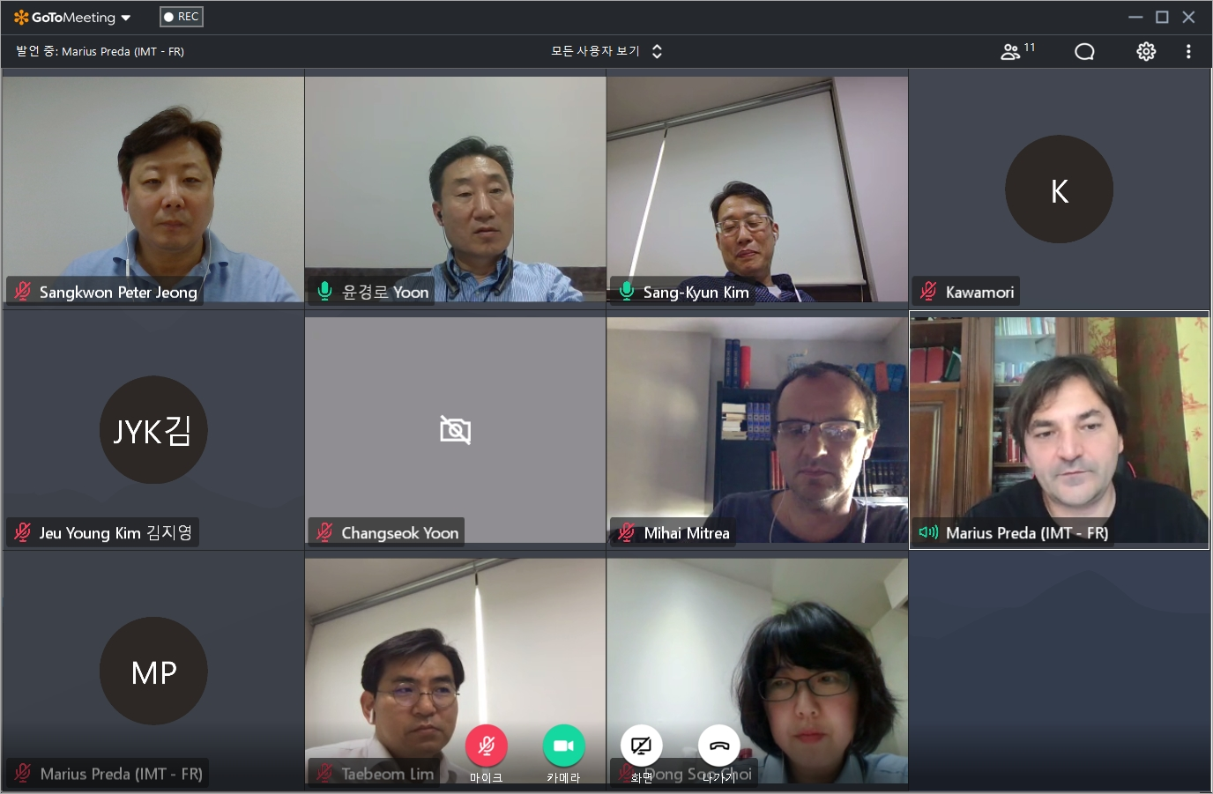

Attendees

Name | Affiliation
Kyoungro Yoon | Konkuk University
Sang-Kyun Kim | Myoungji University
Sangkwon Peter Jeong | JoyFun Inc.
Taebeom Lim | Korea Electronics Technology Institute (KETI)
Dong Soo Choi | Dong-A University
Kawamori Masahito | Keio University (Japan)/ ITU-T
Marius Preda | Institut Mines-Telecom (France)
Mihai Mitrea | Institut Mines-Telecom (France)
Changseok Yoon | LG CNS (?)
Jeu Young Kim | Foundation of Agricultural Technology Commercialization and Transfer

