|  |  |  |
| --- | --- | --- |
| an Working Group | **IEEE DYSPAN-SC 1900.5** |  |
| Title | ***Meeting minutes 0256 for the P1900.5 Meetings of July 12-16, 2021*** |  |
| DCN | ***5-21-0014-00-mins*** |  |
| Date Submitted | ***8/31/2021*** |  |
| Source(s) | ***Carlos***  ***Caicedo (Syracuse University)***  ***email:*** [***ccaicedo@syr.edu***](mailto:ccaicedo@syr.edu) |  |
|  |  |  |
| Abstract | ***Minutes for the IEEE 1900.5 meetings held on July 12-16, 2021*** |  |
|  |  |  |
| Notice | This document has been prepared to assist the IEEE DYSPAN-SC. It is offered as a basis for discussion and is not binding on the contributing individual(s) or organization(s). The material in this document is subject to change in form and content after further study. The contributor(s) reserve(s) the right to add, amend or withdraw material contained herein. |  |
| Release | The contributor grants a free, irrevocable license to the IEEE to incorporate material contained in this contribution, and any modifications thereof, in the creation of an IEEE Standards publication; to copyright in the IEEE’s name any IEEE Standards publication even though it may include portions of this contribution; and at the IEEE’s sole discretion to permit others to reproduce in whole or in part the resulting IEEE Standards publication. The contributor also acknowledges and accepts that IEEE DYSPAN SC may make this contribution public. |  |
| Patent Policy | The contributor is familiar with IEEE patent policy, as outlined in [Section 6.3 of the IEEE-SA Standards Board Operations Manual](http://standards.ieee.org/guides/opman/sect6.html#_blank) <<http://standards.ieee.org/guides/opman/sect6.html#6.3>> and in *Understanding Patent Issues During IEEE Standards Development* <<http://standards.ieee.org/board/pat/guide.html>>. |  |

**>.**

**1. Administrivia**

**1.a Roll Call**

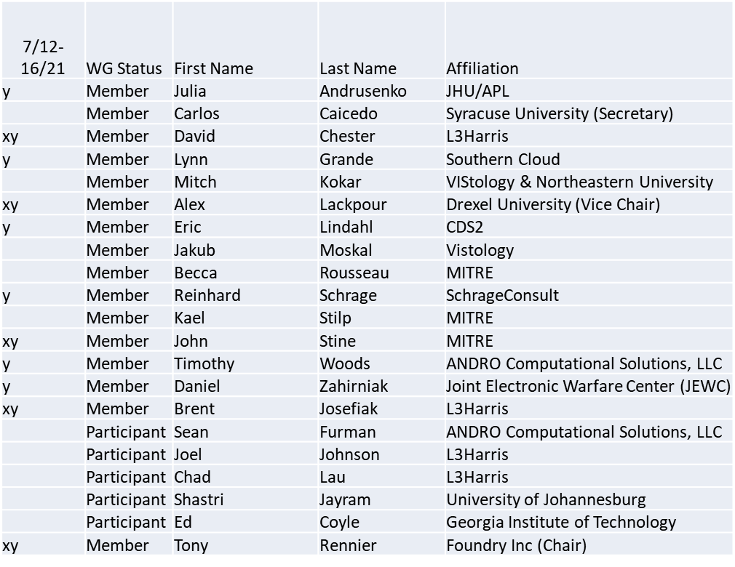

x = attendance to WG meeting of 7/12

y = attendance to WG meeting of 7/16

No Quorum on 7/12

Quorum achieved on 7/16

**1.b. Approval of Agenda**

Approval of Agenda from 5-21-0011-00

* Mover: Tim

Second: Dan

Vote: UC

**1.c. Copyright slides**

Copyright policy slides were presented. No comments came forward.

**1.d. Patent slides / Notes on status**

Patent related slides were presented, no issues came forward

**1.e. Approval of recent minutes**

*Postponed to next meeting*

**2. Status on 1900.5a**

* 7/12/21
  + Continued Black box discussion
    - Tentative consensus
  + Taking up White box description
  + Dave working on a description of what makes a cognitive system truly cognitive
* 7/16/21
  + PAR to be reviewed for scope in the future
  + Strawman outline from 1900.5-2011
  + Continue to populate the iMeet Wiki
  + Ad-hoc on 7/14/21
    - More details on Black-box description
    - Support for Dynamic Policy Management in addition Dynamic Spectrum Access (from P1900.5-2011)
    - Details around QoS being discussed embedded or external of the black-box
      * Dave Initiating an email discussion to explore the concept

**3. Status of 1900.5.1**

* Planned ad-hocs had to be cancelled
  + Looking for an ad-hoc after next WG monthly meeting
* Working on a procedural approach
  + Starting from John Stine contribution as an exemplar
  + Addressing compatibility amongst SCMs
  + Exploring Cellular Automata – more capable

**4. Status on 1900.5.2a**

* 6/4/21
  + Ready to submit to MEC and DySPAN-SC
* 7/12/21
  + Ad-hoc this week
  + Making comments for submission to IEEE SA Ballot
* 7/16/21
  + Lots of interest in 1900.5.2-2022
  + Working or fix the PAR to a revision target 10/1/21 Ballot (or earlier if permitted)
  + Will update draft to reflect change to revision

Comment resolution was discussed

Comment resolution group membership to be defined in a future meeting.

**5. Review of other DySPAN-SC activities**

* + N/A

**6. 1900.5 marketing inputs**

* 6/4/21
  + Discussed with NIEM to meet with DSO rep
  + Still scheduling an opportunity. If someone would like to join.
* 7/16/21
  + Tim met with IEEE EMC (Silicon and chipsets)
    - Call to arms across IEEE WGs to cross pollinate and bring expertise

**7. 1900.5 meeting planning and review**

* 1900.5a Ad- hoc 7/14/21 900-1030 ET
  + Meeting took place as scheduled
* 1900.5.1 Ad- hoc 7/14/21 1300-1430 ET
  + Cancelled
* 1900.5.2a Ad- hoc 7/15/21 1100-1230 ET
  + Meeting took place as scheduled
* 1900.5 WG 7/16/21 0900-1030 ET
  + Meeting took place as scheduled
* 1900.5 Rev 8/6/21 1300-1430 ET
  + Future meeting
* 1900.5 WG 9/3/21 0900-1100 ET
  + Future meeting

**8. AoB**

None