April 23, 2004

R. A. Alexander | K. I. Gray | J. H. Nelson
J. H. Brunke | S. R. Lambert | D. F. Peelo
T. Burse | D. J. Lemmerman | T. E. Royster
R. L. Capra | G. N. Lester | M. D. Sigmon
A. Dixon | R. W. Long | S. Slattery
P. W. Dwyer | L. V. McCall | C. L. Wagner
M. T. Glinkowski | A. C. Monroe
Colleagues:

The following is the Reclosers and Other Distribution Equipment (RODE) Subcommittee written report to ADSCOM for the May 4, 2004 meeting in Galveston, Texas.

Current membership of the Subcommittee is 26 members. Please see attached membership roster.

Standard C37.60 (Recloser) was published by IEEE in August, 2003. To correct some technical errors discovered after the standard was approved, a corrigendum is being developed for this document. The WG Chairman for this standard is Dave Stone.

Two working groups and one task force are currently active: (1) Revision to the sectionalizer standard C37.63 is being revised for a second re-ballot, Chaired by Marcel Fortin, (2) Revision to the capacitor switch standard C37.66 is out for re-ballot, Chaired by Harry Hirz, and (3) TF on distribution line controls, Chaired by Bill Hurst. Please see the attached Status Report for more details.

The RODE Subcommittee meeting will be held on Tuesday, May 4, 2004 at 2:00PM.

Sincerely,
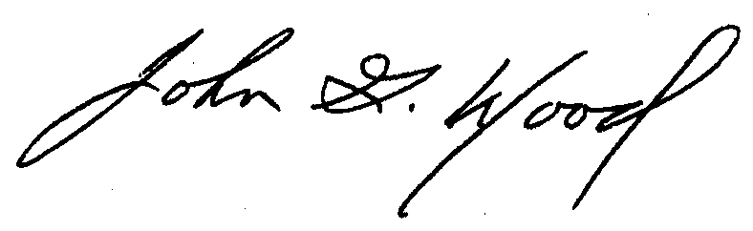
John G. Wood, P.E.
RODE Subcommittee Chairman

Attachments

