May 1, 2003

R. A. Alexander | K. I. Gray | J. H. Nelson
J. H. Brunke | S. R. Lambert | D. F. Peelo
T. Burse | D. J. Lemmerman | T. E. Royster
R. L. Capra | G. N. Lester | M. D. Sigmon
A. Dixon | R. W. Long | N. H. Simon
P. W. Dwyer | L. V. McCall | C. L. Wagner
M. T. Glinkowski | A. C. Monroe
Colleagues:

The following is the Reclosers and Other Distribution Equipment (RODE) Subcommittee written report to ADSCOM for the May 6, 2003 meeting in St. Pete Beach, Florida.

Current membership of the Subcommittee is 28 members. Please see attached membership roster.

Revised standard C37.60 (Recloser) was approved by the Standards Board on March 20, 2003. Standard C37.61 (Recloser application and M&O guide) is to be withdrawn by the WG Chairman. The WG Chairman for these standards is Dave Stone.

New standard C37.74 (Underground Switchgear) was approved by the Standards Board on March 20, 2003. This new standard obsoletes standards C37.71, .72, and .73. The WG Chairman will withdraw these obsolete standards. The WG Chairman for C37.74 is Dave Stone.

Two working groups and one task force are currently active: (1) Revision to the sectionalizer standard C37.63, Chaired by Marcel Fortin, (2) Revision to the capacitor switch standard C37.66, Chaired by Harry Hirz, and (3) TF on distribution line controls, Chaired by Bill Hurst. Please see the attached Status Report for more details.

The RODE Subcommittee meeting will be held on Tuesday, May 6, 2003 at 2:00PM.

Sincerely,
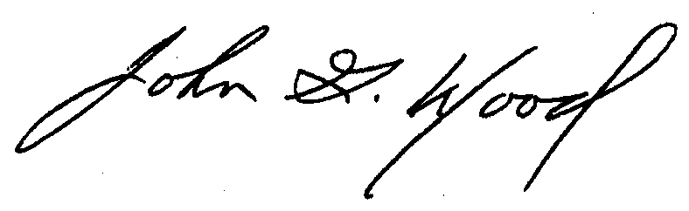
John G. Wood, P.E.
RODE Subcommittee Chairman

Attachments

