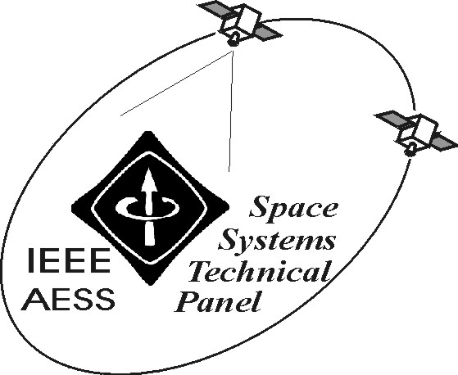

REPORT OF IEEE/AESS “SPACE SYSTEMS” PANEL
April 2006

The activities of the Panel have been effectively integrated with those of the AESS Operations Directorate for Italy-Western Europe that the Panel Chair is coordinating. Since October 26, 2005, when the first AESS event in the frame of the new Directorate took place in Roma, Italy, a number of new and interesting exchanges, proposals and activities are being understaken in the Panel-related topics with industries and political institutions.

The following activities have been carried out in the period October 2005–March2006:

- Organisation of the AESS event in Roma (October 2006, 2005), with key topics in GEOSS, System of Systems, Network Centric Operations, GALILEO, Cosmoskymed, Enabling technologies and speakers from industry, scientific, military and political institutions.

- Activities related to the co-Chairing of Track 2 Space Missions, Systems and Architecture of the 2006 IEEE Aerospace Conference, that took place in Big Sky in March 2006. The event is involving an increasing number of papers and attendees from Europe as well as more volunteers from Italy for organising sessions in the following editions.

- Activities related to the co-Chairing of Track 2 Space Missions, Systems and Architecture of the 2007 IEEE Aerospace Conference, that will take place in Big Sky next year in March. The Track is being optimised, also including new topics and new volunteers.

- Organisation of two events in Roma for next May and next June related to dual use, global systems and NCO.

- Organisation of the 2006 Tyrrenian Workshop on Satellite Communications and Navigation for next September in Italy (Ponza)

- Intense activities related to the role of Editor of Space Systems of the AES Transactions.

- Organisation of training and thesis activities of students at the University of Roma Tor Vergata in the field of space systems.

- Deployment of the 3rd edition of the Master Course in “Advanced Satellite and Communications Systems” at the University of Roma Tor Vergata.

- Development of successful proposal for research projects in the field of satellite navigation, EHF (Q/V and W) payloads, NavCom systems, advanced satellite constellations and related applications.

- Development of a special issue as coeditor with F.Niovi Pavlidou, M. Gerla and R. Miura, on “Communications via High Altitude Platforms: Technologies and Trials”, Springer International Journal of Wireless Information Networks, 2005.

- Development and publication of several papers about space systems in conference proceedings and journals.

Among the envisaged activities:

- Activities related to the role of Editor of Space Systems of the AES Transactions.
- Activities related to the various mentioned Conferences, that will be held this year and in 2007.
- Activities related to the mentioned projects, publications and teaching in the space system related topics.

Prepared on April 5, 2006 by: Marina Ruggieri

