MEMORANDUM

To: AESS Board of Directors
From: Edward Reedy
Vice President of Publications
Subject: Vice President for Publications Report for Fall 2005 AESS Board Meeting
(2005 IEEE Sections Congress, Tampa, Florida)
Date: October18, 2005

- General: Several issues are currently being addressed in the publications area. A number of these are summarized below. More detail and additional items are included in the Transactions and Magazine Reports included as Attachments.
  - IEEE 5-Year Reviews
Our Publications Review report was generally well received by the TAB Publications Review Committee. (Our report with PRC comments and our responses has now been completed and can be made available to any interested Board member.) By and large, their comments on the report represented a fair and balance summary with a reasonable set of recommendations. There was nothing in their comments that surprised us. In addition, they commented positively on several aspects of the two publications. The biggest negative and concern was the low impact factor of the two AESS publications. The PRC also included some positive recommendations for improving our publications. Dale and Evelyn are currently evaluating the committee recommendations with respect to their plans for the Transactions and Magazine and reflecting theses recommendations in their respective plans and goals for the next 3-5 years.
  - Web-Based Manuscript Review Both the Transactions and Magazine are now effectively utilizing the E-Journal Press manuscript review process. The Magazine intentionally waited until the process was established and running smoothly with the Transactions before proceeding, but the process is now functioning well with the Magazine also. This new process has greatly streamlined the manuscript review process and reduced the administrative workload on our editors. In addition, Dale Blair estimates, AESS is saving about $5000 per year over what the same service would cost through the IEEE. More information and publication statistics are included in Dale Blair’s Transactions Report, which is attached.
  - Publications Management and Editorial Changes
After six years of outstanding service to AESS, Dr Dale Blair has elected to retire from his position as Editor in Chief of the Transactions, effective at the end of 2005. The Magazine experienced significant improvement and growth under Dale’s leadership, including a sizable expansion of the number and breadth of the Associate Editors and the successful introduction and use of Electronic Manuscript Review and Editing. Dale has been especially sensitive to leadership succession and transition and has trained well several Associate Editors. We are extremely fortunate to have one of those well-trained and experienced Editors to step in as Dale’s replacement. Dr Peter Willett has agreed to serve as EIC for the Magazine starting in January on Dale retirement. Since Dale and Peter have been working closely for several years, we expect to have a smooth and seamless transition. On behalf of all the members of the Society, I extent our sincere thanks to Dale for his hard work and dedication and a job well done.
Unfortunately, Peter’s transition to EIC leaves the Editor of our very successful Tutorials vacant. We have developed a process to guide the search for a replacement for Peter, and already have one very good candidate. Joel and Evelyn are leading the search for a new Tutorials Editor. If any member of the Board has a recommendation, please pass the name along to Joel or Evelyn.
Dale Dobson has been an AESS Institution for several decades, serving as the Administrative Editor of our publications. However, Dave has again reminded me that the clock continues to march forward and that one of these days he will retire. Dave and I have developed a general plan for coordinating and easing the transition of Administrative Editors on his retirement. Our plans involve the appointment of an Assistant Administrative Editor to work closely with Dave for a year or so prior to his retirement with the intent that that person would move to the Administrative Editor position on Dave’s retirement. This process would involve some expense for AESS to pay for the services of the assistant; however, I believe the expense would be a good investment in insuring a smooth transition of editors.
  - Other Matters
AESS and the I&M Societies have agreed to a combined mailing of their two Magazines to take place sometime this year. The AESS Board approved funds for this at our last Board meeting. Plans for this are proceeding.
IEEE has approved and established a new Systems Council, with AESS and SMC as two key sponsoring societies. Some concern has been raised about the potential for overlap and possible competition between the Council and Societies publications and conferences. All involved need to work to insure that we have carefully thought out and clear distinctions between our publications and conferences. This will be a subject for Board discussion at this meeting.

- Administrative Editor Report Dave Dobson, Administrative Editor, reports that AESS will close the year with a page count slightly exceeding our target of 1500 for the Transactions, but well within the 5% allowed. Included well be a combined index of all publications (Transactions, Systems, and Tutorials) issued during the year as was done last year. Transactions backlog remains steady at about 750 pages or approximately two issues. Publication delay of the Transactions is slowly being reduced.
Systems Magazine issues (48 pages) continue to roll off the line monthly, with the usual variances in the mailing at or near the first of the month. In 2005, we published Tutorial II and an additional insert to the Magazine, both of which were well received. Dave still needs help (from Chapters, Education, etc.) in identifying where copies of our Tutorials should be distributed. Tutorial III is currently being assembled for publication early in 2006 and the first paper for Tutorial VI is in hand. Dave, Evelyn, and Joel Walker continue to express concerns about the lack of any significant inputs from the various AESS entities (from Board members on down) for the “Systems” Magazine. Are there suggestions for improving this situation?
- “Transactions” Dr Dale Blair, Editor-in-Chief of the “Transactions” continues to make new Editor and Associate Editor appointments. His most recent are summarized in his report at Attachment I. Other items of interest, including the M. Barry Carlton Best Paper Award, the new web-based editorial procedures and manuscript review process, and some very interesting manuscript tracking data are also presented and discussed in Dale’s report.
- “Systems” Magazine Under Evelyn Hirt’s leadership as Editor in Chief, the “Systems” Magazine continues its steady improvement. As previously indicated, news and information inputs to the magazine have improved. However, more inputs from AESS Officers and Chapters are still needed. Also, the Magazine is rapidly moving to the same web based manuscript review process as that used by the Transactions. The Magazine has received some very positive feedback on the inserts and the “historical” articles published this year. One reader commended that he “ripped our the insert article and took it along to the doctor’s office.” I have included some additional activities and items related to the Magazine that were prepared by Evelyn as Attachment II.

In summary, the past several months have been very busy for members of the AESS publications team, and, at the same time, very productive. Our publications continue to expand and improve.
Attachments

Attachment I
Status of the IEEE Transactions on Aerospace and Electronic Systems

By

Dale Blair, Editor-In-Chief
- October 8, 2005 The quality of content in Systems is improving. We have gotten some real positive feedback on the improvements to the content. Dave and I are working on the overall organization of the magazine to see what improvements we can make. I'm working to get some invited articles for Systems (e.g., one on Systems of Systems by Mo Jamshidi).
- IEEE HQ is currently scanning Systems into IEL. The quality of these scans is poor. Dave and I are working to prepare an electronic file of the Systems issues to be given to IEEE HQ. I'll work getting IEEE HQ to accept our electronic files. In 2006 I plan to survey what is currently in IEL and replace anything that is very bad quality. This problem was brought to our attention by an author.
- The new electronic review system is starting to be used more frequently, but we have a ways to go. I'll be discussing at the Publications Committee meeting my plans to bring on-board an Assistant Administrative Editor to improve the author-to-IEEE interface so that we can go from on-line submission for review to total on-line capability (e.g., include final submission electronically). I currently have a Masters candidate with a BS in computer science and working on a masters in electronic communications who is willing to work this effort into her masters work.
- There will be a thank you to Peter in the December editorial for his service as Associate Editor.
- I'll be looking to bring on a new Tutorials Editor and Associate Editor in 2006. I'll be reviewing the Sectors and the performance of the existing Sector Editor to determine what, if any, changes need to be made. There is be an announcement in the January issue requesting suggestions for potential new editors to fill any open positions.
- In 2006 I'll be establishing a process for proposing special series, issues, etc. to Systems. This is intended to avoid problems in the future based on some of the confusion that was created when Systems received a proposal to create a space education special issue.

Transactions Management
Lance Kaplan and Peter Willett continue to serve as Associate Editor-In-Chief. This structure helps us to provide a better product to our customers and improve the transition to a new Editor-In-Chief. The EIC transitions to Peter Willett in January 2006.
Lance Kaplan attended the IEEE Panel of Editors Meeting in New Orleans, April 8-9, 2005.

Editors
- Appointed Yaakov Oshman as Editor for Guidance and Control Systems. This a new technical area for the transactions. Papers in this area had been previously handled by the Editor for Command and Control Systems.
- Appointed Thomas Robertazzi as Editor for Intelligent Systems.
- Appointed Vikram Krishnamurthy as Associate Editor for Power Conversion Systems
- Need Editors for Large-Scale Systems and Fault-Tolerant Systems
- A new editor is needed for Avionic Systems. Myron Kayton is having difficulty dealing with web-based review system. He is introducing significant delays into the review process.
M. Barry Carlton Award
- 2003 M. Barry Carlton Award winner is:
- “Spatial Adaptive Subspace Detection in OTH Radar,” by Giuseppe Fabrizio, Alfonso Farina, and Mike Turley, October 2003, pp. 1407-1428.
- Articles announcing the awards appeared in IEEE AES Magazine.

Editorial Procedures
- Continued web-based review process hosted by E-Journal Press rather than the IEEE endorsed Manuscript Central. We have had good service from E-Journal Press and saved at least $5000 per year.
- Manuscript submission at http://taes.msubmit.net
- 341 New manuscripts were received electronically in September 2004 through August 2005.
- 173 Revised manuscripts were received electronically in September 2004 through August 2005.
- Average review time is 118 days with a standard deviation of 43 days.

Other
- New pdfs for Vol. 35, 3 to 39, 1 (15 issues) prepared and delivered to IEEE HQ to replace scanned pdfs that are currently available on IEEE Xplore. New pdfs are word searchable, provide much better illustrations, and require less memory. IEEE HQ has agreed to replace the pdf files. We are waiting on IEEE HQ to install the new pdf files on IEEE Xplore. $2500 of the $15,000 approved are available and will be used to prepare new pdfs for Vol. 35, No. 1-2. Preparing these new pdf files require additional work and the estimated cost per issue is $1200.
- Special Section in cooperation with the 2004 IEEE Radar Conference entitled “Innovative Radar Technologies – Expanding System Capabilities.” Dr. Pierfrancesco Lombardo, Associate Editor for Radar Systems, will be overseeing/managing the review process. The status of this special section is not clear at this time.
- Special Section on “Knowledge-Based Signal Processing” is in progress and should be ready for April 2006. Guest editors are Dr. Joe Guerci and Dr. Bill Melvin.

Manuscript Tracking Report
IEEE Transactions on Aerospace and Electronic Systems
Manuscript Tracking Report
Report generated on October 9, 2005

 | 2004 |  |  |  | 2005
 | Sep | Oct | Nov | Dec | Jan | Feb | Mar | Apr | May | Jun | Jul | Aug | Total
Original Manuscripts Submitted | 13 | 29 | 27 | 32 | 37 | 30 | 37 | 26 | 34 | 24 | 30 | 22 | 341
Revised Manuscripts Resubmitted | 11 | 16 | 15 | 9 | 13 | 9 | 18 | 19 | 12 | 13 | 18 | 20 | 173
Manuscripts Accepted Without Revisions | 2 | 2 | 2 | 0 | 1 | 1 | 0 | 1 | 0 | 0 | 0 | 0 | 9
Return with Minor Revisions | 15 | 20 | 23 | 7 | 20 | 16 | 16 | 6 | 16 | 30 | 11 | 39 | 219
Return with Major Revisions | 0 | 0 | 0 | 0 | 0 | 0 | 0 | 0 | 0 | 0 | 0 | 0 | 0
Manuscripts Rejected | 3 | 6 | 3 | 7 | 19 | 20 | 14 | 10 | 8 | 17 | 10 | 26 | 143
Rejected With Review | 3 | 5 | 2 | 6 | 11 | 9 | 4 | 4 | 5 | 14 | 8 | 22 | 93
Rejected Without Review | 0 | 1 | 1 | 1 | 8 | 11 | 10 | 6 | 3 | 3 | 2 | 4 | 50
Rejected After Revisions | 0 | 0 | 0 | 0 | 0 | 0 | 0 | 0 | 0 | 0 | 0 | 0 | 0
Requires Another Revision | 2 | 2 | 2 | 1 | 5 | 3 | 8 | 4 | 4 | 6 | 3 | 14 | 54
Accepted After Minor Revisions | 7 | 12 | 8 | 5 | 11 | 5 | 13 | 12 | 7 | 7 | 1 | 14 | 102
Accepted After Major Revisions | 0 | 0 | 0 | 0 | 0 | 0 | 0 | 0 | 0 | 0 | 0 | 0 | 0
Manuscripts Withdrawn | 2 | 0 | 0 | 1 | 10 | 1 | 5 | 1 | 2 | 1 | 1 | 0 | 24
Original Manuscripts Not Withdrawn | 11 | 29 | 27 | 31 | 27 | 29 | 32 | 25 | 32 | 23 | 29 | 22 | 317
Total Manuscripts Submitted  (originals + revisions) | 24 | 45 | 42 | 41 | 50 | 39 | 55 | 45 | 46 | 37 | 48 | 42 | 514

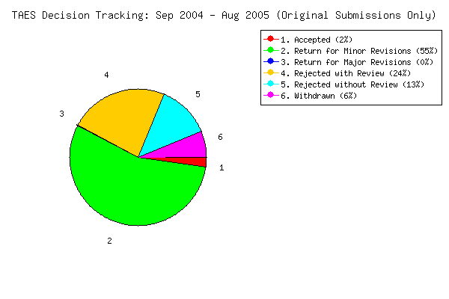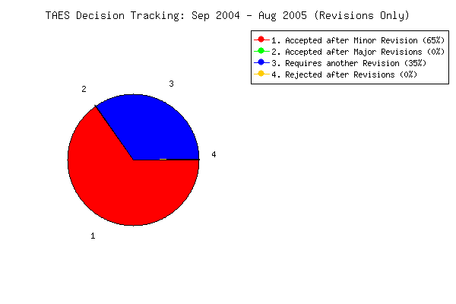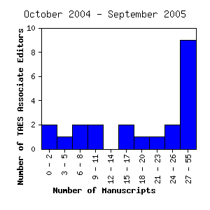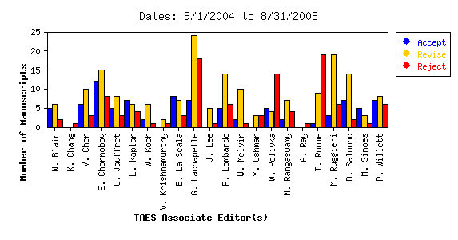

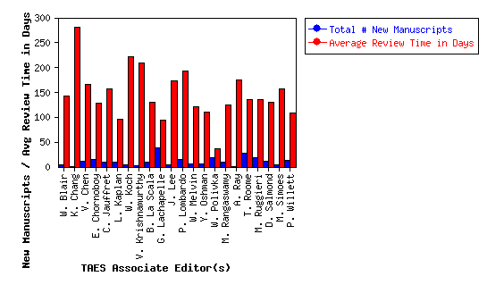
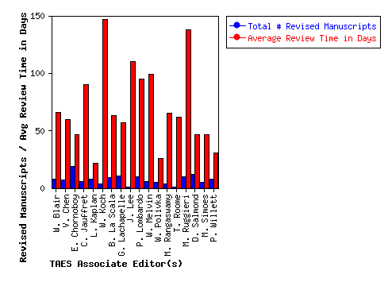
Attachment II
- The quality of content in Systems is improving. We have gotten some real positive feedback on the improvements to the content. Dave and I are working on the overall organization of the magazine to see what improvements we can make. I'm working to get some invited articles for Systems (e.g., one on Systems of Systems by Mo Jamshidi).
- IEEE HQ is currently scanning Systems into IEL. The quality of these scans is poor. Dave and I are working to prepare an electronic file of the Systems issues to be given to IEEE HQ. I'll work getting IEEE HQ to accept our electronic files. In 2006 I plan to survey what is currently in IEL and replace anything that is very bad quality. This problem was brought to our attention by an author.
- The new electronic review system is starting to be used more frequently, but we have a ways to go. I'll be discussing at the Publications Committee meeting my plans to bring on-board an Assistant Administrative Editor to improve the author-to-IEEE interface so that we can go from on-line submission for review to total on-line capability (e.g., include final submission electronically). I currently have a Masters candidate with a BS in computer science and working on a masters in electronic communications who is willing to work this effort into her masters work.
- There will be a thank you to Peter in the December editorial for his service as Associate Editor.
- I'll be looking to bring on a new Tutorials Editor and Associate Editor in 2006. I'll be reviewing the Sectors and the performance of the existing Sector Editor to determine what, if any, changes need to be made. There is be an announcement in the January issue requesting suggestions for potential new editors to fill any open positions.
- In 2006 I'll be establishing a process for proposing special series, issues, etc. to Systems. This is intended to avoid problems in the future based on some of the confusion that was created when Systems received a proposal to create a space education special issue.

