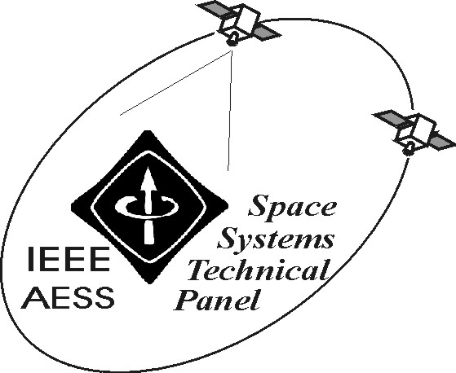

REPORT OF IEEE/AESS “SPACE SYSTEMS” PANEL
September 2005

The following activities have been carried out in the period April–September 2005:

- Activities related to the co-Chairing of Track 2 Space Missions, Systems and Architecture of the 2006 IEEE/AIAA Aerospace Conference, to be held in Big Sky (March 2006). In particular, the number of European experts involved in the Conference (as session organisers and co-chairs), covering the areas of RF and optical technology, payload optimisation, International Space Station, future space missions, launch and orbit transfer issues as well as education in space topics has been confirmed. Conference has been as usual promoted in the European space community, yielding to the submission of various abstracts. Also, Italian experts in the field of insurance and regulations related to space missions have been involved in the Conference and invited to submit abstracts. The group in Tor Vergata has produced various abstracts for the Conference, co-authored by national and international experts from the scientific and industrial world.

- Intense activities related to the role of Editor of Space Systems of the AES Transactions, where the number of manuscripts submitted in the area is continuously increasing Manuscripts are at present mostly submitted through the web-site-based electronic procedure, even if some submissions are still performed in “analogue” form.

- Organisation of training and thesis activities of students at the University of Roma Tor Vergata in the field of space systems and of Ph.D students’ work in the field.

- The thrid edition of the Master Course in “Advanced Satellite and Communications Systems” at the University of Roma Tor Vergata is being deployed. In the meantime, the highly qualified students with degrees in Engineering and Physics, that are undertaking the second edition, have performed the exams of the four teaching cycles envisaged. The teaching modules have gathered experts from space industries and institutions, including also the space experts of the University Roma Tor Vergata. Visits to the major space enterprises and technological poles devoted to space have been organised for the M.Sc students. Some of them have been then included in working teams for active space projects and integrated in the research group. The students are presently undertaking a project work on application-related topics and have started or will start shortly their stages in national and international enterprises or institutions.

- A book on satellite navigation has been published (April 2005) by Artech House.

- Development of the technical and scientific activities of national and European research projects in the field of EHF satellite system architectures (W-band and V-band), heterogeneous networks with satellite and HAP components, toll-related applications for the European augmentation system for navigation EGNOS, novel constellation architectures.

- Deployment of an MoU between the University of Texas A&M (College Station, TX, USA) and the University of Roma Tor Vergata for activities in the field of novel satellite constellations and related applications.

- Intense activities in issueing proposals about satellite navigation and communications for the ARES Consortium, that has been recently established (August 2004) between the University of Roma Tor Vergata and a small enterprise for activities in the space field and development of the related research and application goals with the national space actors.

- Activties for preparing an event in Roma about the "International Convergence and Perspectives of Aerospace and Electronic Systems", where the President of AES will meet the main aerospace scientific and industrial actors of the Italian and European scenario as well as the local Chapter (October 26, 2005).

- Nomination at sector Editor for Space Systems in the Systems Magazine.

- Publication of various papers in journals and conference proceedings about integrated satellite-HAP-terrestrial systems and satellite experiments.

- Activities for preparing a Special Issue of the International Journal of Wireless Information networks (Kluwer) on “Communications via High Altitude Platforms: Technologies and Trials”.

Among the envisaged activities:

- Activities related to the role of Editor of Space Systems for the AES Transactions and soon for the AES System Magazine.
- Activities related to projects, teaching and co-operations in the space field.

Prepared on September 22, 2005 by: Marina Ruggieri

