George F. McClure

Candidate for Region 3 Director- Elect

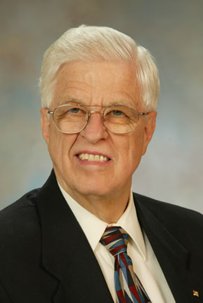
Concerned – Dedicated - Experienced

Region 3, with nearly 9 percent of Institute membership, has been in the forefront of innovation with cost-effective electronic conferencing. It can also be a leader in applying the benefits of IEEE Virtual Communities for better communications and governance, and in streamlining operations with guidance from the RAB/ TAB Section/Chapter Support Committee.

Recently, with a quarter-million unemployed engineers, engineering managers, and computer scientists in the United States, there has been a decline in the enrollments of U.S. students in engineering schools. Steps should be taken to restore engineering to a challenging and rewarding long-term career path for our members and future students. The message for lawmakers is to grow engineering excellence with support for engineering education and R&D*, and not to eat the seed corn – our technological competitiveness as well as our own national security depend on this.

With volunteer experience in IEEE regional, technical, and professional activities, and with a 35-year background in industry, in both engineering and engineering management, I have the credentials and motivation to make a difference here for our present and future members – to push for sound management practices in your Institute, to facilitate reforms that will provide affordable, coordinated services for our members, and to press for better understanding of engineering by the public at large.

The IEEE exists for you, the member. With your vote and your help, as your representative, I want us to make it the best possible organization in respecting your interests and in delivering the services you need for a satisfying life-long career.

* See “R&D funding levels: how they affect engineering opportunities,” George F. McClure, IEEE Potentials, Volume: 21, Issue: 3, Aug/Sep 2002, Page(s): 26- 31.

