

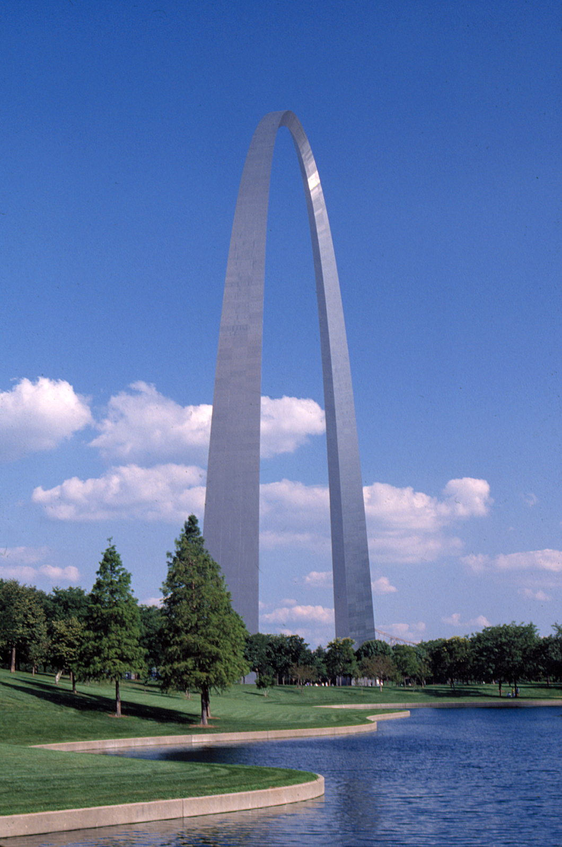

2006 IEEE-USA Annual Meeting

& Leadership Workshop

Is It True “The World Is Flat?”
3 -5 March 2006

Hyatt Regency St. Louis at Union Station
One St. Louis Union Station, St. Louis MO 63103

http://www.ieeeusa.org/calendar/conferences/2006workshop
General Information
Who Should Attend?
Section/Chapter PACE Chairs
Section/Chapter Chairs
PACE Coordinators and Society PACE Chairs
Region and Division Directors and their Society Presidents.
IEEE-USA Committee Chairs & Committee Members
Why Should I Attend?
The 2006 IEEE-USA Leadership Workshop will:
Help you to gain a better understanding of IEEE and IEEE-USA missions, visions and goals.
Increase your understanding of the roles and activities of the IEEE-USA committees and volunteers in order to help you do your job better.
Train volunteers how to develop new and innovative Professional Activities Project plans to be implemented within your local section, chapter or society.
Provide participants with information on the IEEE-USA's current legislative priorities, and information on how to develop an effective grassroots lobbying network.
Provide skills and tools for your own professional development, job search and networking as well as your members at home.
Teach you new ways to improve dissemination of information, products and services to members through local sections and chapters through the PACE Network.
What Do I Need to Know?
The IEEE-USA Leadership Workshop will open on Friday, 3 March 2006 with a 5:30 pm buffet reception. An IEEE President's Forum is planned for 6:30 pm After the forum, their will be a PACE Training starting at 7:30 pm - 8:30 pm Following the PACE Training all participants will meet with their home regions (1-6) for discussion and to prepare for the upcoming day of programs and individual workshops.
We will resume on Saturday, 4 March 2006 at 8:00 am, following breakfast (served from 6:30 am-7:45 am). That evening, you are invited to attend the IEEE-USA Awards Banquet and Ceremony at 7:00 pm.
The Workshop continues with breakfast on Sunday, 5 March 2006 at 6:30 am.
The entire workshop will end by 12 noon to allow you to catch your flight home that day.
Suggested attire for the workshop is casual with the exception of the Awards Banquet which will be business attire. We are looking forward to seeing you there.
All registrations must be received no later than 30 January, 2006.

