IEEE Section Student Activities Committee

*Name of IEEE Section*

*___________________________________________________________________________* Presentation

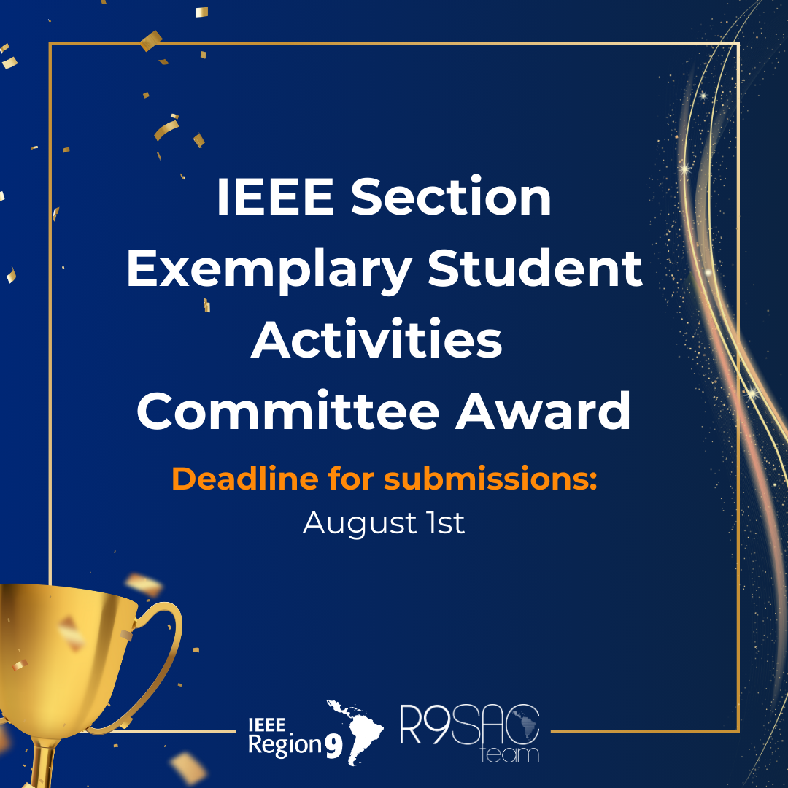

**Figure 1- Put a photo that represents your Student Activities Committee** [1].

*Here you will summarize your Student Activities Committee in a summarized way. You can place, for example, the year of foundation, the areas of action of the committee, the number of volunteers, the internal organization of the committee, and the results obtained with the management since August 2023.*

*The summary must be done sequentially, that is, it is not allowed to list the topics. This element* ***should have 200 words or less****.*

***__________________________________________________________________________________***

INITIAL ORIENTATIONS

The article aims to be a compilation of good methodologies that the Student Activities Committee has. Remember that one of the contest's objectives is to spread good practices and ideas.

The document is divided into seven (7) sections: goals, activities, development, partnerships, applicability to other organizational units, compliance of the activity with the mission of the organization, and the impact it has on students in their section.

It is advised that in each section, the committee presents the methodologies used and, whenever possible, **exalt the results obtained**. Some of these questions can be answered during the development of the text. The use of figures and tables helps in visualization and are important ally.

You may use the maximum number of twelve (12) pages in the way that best suits you. Be clear and objective!

Information added to the article that cannot be verified will decrease the confidence of the reader about the data presented. Make sure that you add evidence in the Reference section about the facts described. During the evaluation, it will be very consulted.

Good writing and success!

# Goals

The goals are the basis of any committee. The definition of mission, vision, and values helps all volunteers have a clear idea of the objectives of the institution. In addition, having documents where the values of the Student Activities Committee are established is essential to perpetuate the culture of the committee.

Here you will explain how your committee works internally. How does the board of directors or committees you have had work? Write the main functions of each position. You can place an image of the organization chart to illustrate better.

Another important point is the documentation. Does the committee have a statute or a similar document that makes this operation official?

# Activities

A good planning of the activities that will be carried out throughout the year can avoid a lot of headaches. Does the committee develop a Strategic Planning considering the objectives of the institution for each year? Do they use any specific methodology? Is there a calendar of activities? Do you report the activities? Reporting is important to keep the student activities committee active to IEEE.

In this section, you will explain to the reader what strategies the committee uses to keep the institution's activities documented. Does the committee produce annual activity reports? Are the meetings documented through minutes? Does the institution make reports of lessons learned from the activities?

# Development

The main objective of a Student Activities Committee is the union and collaboration of people who have an ideal in common. The development of projects and activities related to the theme of the Student Activities Committee is an excellent way to make the purpose of the institution reach the community.

Here you will briefly describe the activities developed by your Student Activities Committee from August 2023 to July 2024. Does your committee use any project management methodology? How do the activities developed align with the objectives of your Student Activities Committee? What was the social impact caused? Do you know how many people benefited from the activities? In addition to the activities related to the theme of its Student Activities Committee, does the institution seek to promote humanitarian activities and thus promote the mission of the IEEE?

# Partnerships

For the development of activities it is necessary to count on the collaboration of other institutions to increase the impact and efficiency of the projects carried out. Place the alliances made here to improve the promotion of your activities. Did the committee make any association with other student institutions, companies, NGOs, or other Sections?

In addition to external cooperation, you should also think about the importance of union with the Student Branches, Student Chapters, and Affinity Groups of the Section.

# Applicability to other organizational units

Understanding the applicability of strategies and processes to other organizational units is essential for ensuring consistency and enhancing overall efficiency. Does the group assess the potential for adopting successful practices across different units? Is there a structured approach for implementing these practices in other units?

In this section, you will explain to the reader how the committee ensures that effective strategies and processes are evaluated for their applicability to other organizational units. Does the committee conduct regular reviews to identify best practices that can be shared across the organization? Are there documented procedures for adapting these practices to fit the specific needs of other units? Does the committee provide training or resources to support the implementation of their strategies in different contexts?

# Compliance of the activity with the mission of the organization

Ensuring that all activities align with the mission of IEEE is crucial for maintaining focus and achieving long-term goals. Does your committee regularly review its mission statement to guide activity planning? Are there specific criteria or methodologies used to evaluate whether proposed activities are mission-aligned?

In this section, you will describe the strategies employed by the committee to ensure compliance with the IEEE mission. Do you have a process for assessing the relevance and impact of each activity on the mission? How frequently are activities reviewed and adjusted to stay on course with the mission?

# The impact it has on students in their section

Understanding the impact of the student activities committee on the students within their section is crucial for fostering a positive and productive educational environment. Do the students feel supported in their academic and extracurricular pursuits? How does the committee measure the impact on student satisfaction and performance? Are there regular feedback mechanisms in place to assess student needs and concerns?

In this section, you will outline the strategies employed by the committee to assess and enhance the impact on students. Does the committee conduct annual surveys or feedback sessions? Are there specific metrics used to gauge student success and engagement? How does the committee address the feedback and implement changes? Ensuring that the impact on students is continuously monitored and improved upon is essential for maintaining a thriving community.

# External communication strategies

How the institution is shown towards the external environment is decisive so that it can efficiently pass on its values and the purpose of the group.

Cite the strategies used for communication with other institutions and/or communities. How do you communicate with authorities from your Section? Do you have a complete and updated website? The use of social networks has become increasingly important. Does the institution have social networks? Do you often update them?

Having an IEEE institutional e-mail can give the group more credibility. Have you created an @ ieee.org alias?

__________________________________

# References

[1] R9 SAC Team, "Contests", 2024 [Online]. Available at: [https://r9.ieee.org/sac/competition/regional-awards](https://r9.ieee.org/sac/competition/regional-awards/)/ . [Accessed: June 19, 2024].

__________________________________

# Contacts

| Resultado de imagem para icon website png | Website |
| --- | --- |
| Resultado de imagem para icon email png | e-mail |
| Imagem relacionada | Fanpage |
| Resultado de imagem para icon instagram png | Instagram |
| . | . |

IMPORTANT: This contact board has been created so that other IEEE institutions can contact your SAC if this article is published in the Links. The contacts posted here are just suggestions. You can add or withdraw according to the reality of your SAC.