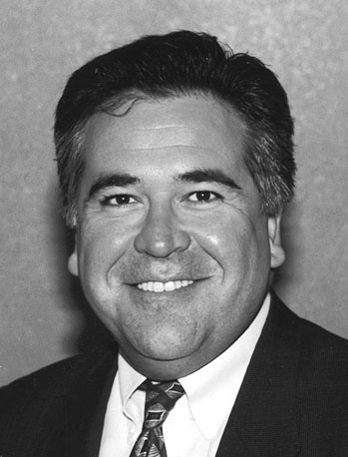
Caio A. Ferreira, Fellow, IEEE
President & C.E.O.
Mechatronic Systems LLC

Mr. Caio A. Ferreira received the B.S. degree in electrical engineering from the University of Missouri, Columbia, MO, in 1979 and the M.S. degree in systems engineering from Case Western Reserve University, Cleveland, OH, in 1985.
In 1979, he joined the Aerospace Electrical Systems Department, General Electric Company, Erie, PA, as a Design and Development Engineer. His responsibilities included the design and development of electrical machines for aircraft electric power generating systems. From 1985 to 1997, he was with the Research Department, Sundstrand Aerospace, Rockford, IL, where he was Program Manager and Principal Investigator of a number of programs to develop advanced electric power systems for military aircraft. From 1997 to 1998, he was with Northrop Grumman Corporation, El Segundo, CA, where he was Principal Engineer in the Integrated Systems & Aerostructures Sector, Vehicle Systems Group. He was Program Manager and Principal Investigator for programs on research, development and integration of electric power technologies for aerospace vehicles. In 1999 he become President of Mechatronic Systems LLC, Huntington Beach, CA. He is the holder of six patents.
Mr. Ferreira is Past President of the Institute of Electrical and Electronic Engineers (IEEE) Industry Applications Society (IAS) and member of the IEEE Technical Activities Board. He was Vice President & President Elect of IAS in 1999. He was Secretary of the IAS in 1998. He was Chapters & Membership Department Chair of the IAS from 1995 to 1997 and held other offices in the Chapters Department from 1992 to 1994. He is a Reviewer for the IEEE Transactions on Power Electronics and IEEE Transactions on Industry Applications. He is a member of the IAS Electric Machines, Industrial Drives, and Power Electronics Devices and Components Committees. He served on the IEEE Applied Power Electronics Conference (APEC) program committee from 1995 to 1997. He was Professional and Technical Tutorials Chair for APEC’95 and Rap Sessions Chair for APEC’97. He was Section Chair of the IEEE Rock River Valley Section from 1989 to 1994. From 1992 to 1994, he was founding Chair of the Rock River Valley IAS Chapter, which received the IEEE IAS Outstanding Small Chapter Award in 1993. He is a member of the IEEE Aerospace & Electronic Systems Society, the IEEE Power Electronics Society, the IEEE Electromagnetic Society, the IEEE Electromagnetic Compatibility Society, the IEEE Dielectrics and Electrical Insulation Society.
Mr. Ferreira is a member of the Society of Automotive Engineers (SAE). He is a member of the SAE Aerospace Electrical Power and Equipment Technical Committee (AE-7). He is also the recipient of the Society of Automotive Engineers (SAE) Excellence in Oral Presentation Award for the 1993 SAE Aerotech Conference.
Mr. Ferreira is a member of the American Institute of Aeronautics and Astronautics (AIAA). He is member of the Aerospace Power Systems Technical Committee.

