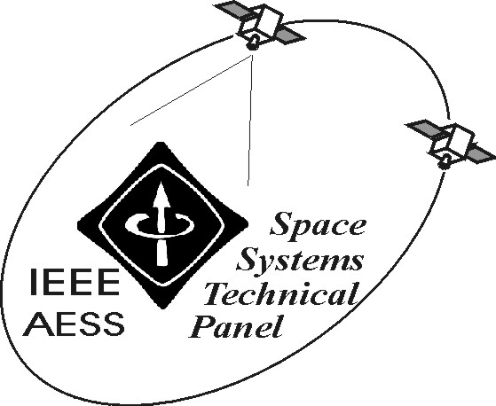

REPORT OF IEEE/AESS “SPACE SYSTEMS” PANEL
February 2005

The following activities have been carried out in the period October 2004-February 2005:

- Activities related to the co-Chairing of Track 2 Space Missions, Systems and Architecture of the 2005 IEEE Aerospace Conference, to be held in Big Sky in a few weeks from now. In particular, the number of European experts involved in the Conference (as session organisers and co-chairs), has been increased. Conference has been as usual promoted in the European space community, yielding to the submission of various abstracts. Also, Italian experts in the field of insurance and regulations related to space missions have been involved in the Conference and invited to submit abstracts. Benefits to IEEE, AES and, in particular, to the Panel derive from this wider and wider involvement of European experts in the Conference. The group in Tor Vergata has produced 8 papers for the Conference, co-authored by national and international experts form the scientific and industrial world.

- Intense activities related to the role of Editor of Space Systems of the AES Transactions, where the number of manuscripts submitted in the area is continuously increasing Manuscripts are at present mostly submitted through the web-site-based electronic procedure, even if some submissions are still performed in “analogue” form.

- Organisation of training and thesis activities of students at the University of Roma Tor Vergata in the field of space systems and of Ph.D students’ work in the field.

- The second edition of the Master Course in “Advanced Satellite and Communications Systems” at the University of Roma Tor Vergata has been deployed. Teaching activities have started on January 24, 2005, directed towards a class of 15 brilliant students. The presentation of the second edition of the Master to students and industries has taken place in December 2004, in the beautiful Villa Mongragone, and ancient location belonging to the University of Roma Tor Vergata. About 40 institutions and industries are partners of the Master this year. The iniative has been also very appreciated in the regional area around Roma (Lazio), where space activties are taken in the due importance by politicians and managers Press communications and an management.

- The students of the first edition of the Master have taken their degree in January, in the premises of the regional administration. All students are being or have been offered job position., most of them have already strated their job in 2004!

- A book on satellite navigation has been written and will be published shortly (April) by Artech House.

- Development of the technical and scientific activities of national and European research projects in the field of EHF satellite system architectures (W-band and V-band), heterogeneous networks with satellite and HAP components, toll-related applications for the European augmentation system for navigation EGNOS.

- Deployment of a teaching module on “Satellite Systems and Applications” in the frame of the CNIT TeleDoctorate Project for the years 2004-2005, implemented on an heterogeneous terrestrial-satellite network.

- Deployment of the ARES Consortium in the space field and development of the related research and application activities with the national space actors.

Among the envisaged activities:

- Activities related to the role of Editor of Space Systems for the AES Transactions and soon for the AES System Magazine.
- Activities related to projects, teaching and co-operations in the space field.

Prepared on February 11, 2005 by: Marina Ruggieri

