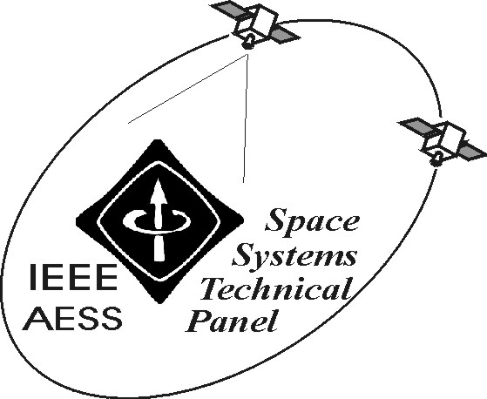
Attachment 1.A

REPORT OF IEEE/AESS “SPACE SYSTEMS” PANEL
March 2002

The following activities have been carried out in the period October 2001-March 2002:

- Activities related to the co-Chairing of Track 2 Space Missions, Systems and Architecture of the 2002 IEEE Aerospace Conference, held in Big Sky (March 2002).

- Appointed co-Chair of Track 2 Space Missions, Systems and Architecture of the 2003 IEEE Aerospace Conference. In this frame, a promotion of AES and of the Conference in Europe and solicitation of abstracts will be performed, as for the 2002 edition.

- Appointed in the Technical Scientific Program Committee of the Symposium on Satellite Communications for the IEEE GLOBECOM 2002, that will be held in Taipei (November 2002). In this frame, a promotion of AES and the Panel can be performed.

- Participation in PhD defence Committee for thesis in the field of satellite communications (TeSA, France) and related promotion of AES.

- Appointed general vice chair of the 5th European Workshop on Mobile/Personal Satcoms (EMPS 2002), that will be held in Italy (September 2002), where promotion of AES and the Panel can be also performed.

- Given (as speaker) a Seminar on Space Systems and the DAVID Mission at NTNU (Norway), together with information about the Panel.

- Appointed Mentor of the Student Branch at the University of Roma Tor Vergata, Italy, particularly for space-related activities. In this frame the organisation of a seminar (to be given as speaker) on the DAVID satellite mission of the Italian Space Agency is in progress.

- Activities related to the role of Editor of Space Systems of the AES Transactions. Six manuscripts and a correspondence are being handled at the moment.

- Organisation of training and thesis activities of students at the University of Roma Tor Vergata in the field of space systems (ISS, Mars communications, satellites).

- Appointed Chair of a Panel on the role of satellites in the future mobile and multimedia scenario, to be organised at WPMC 2002 Conference (Hawaii, October 2002). In this frame promotion of AES and the Panel can be also performed.

- Appointed member of the Technical Program Committee of 2002 IEEE VTC Fall, that will be held in Vancouver (September 2002). In that frame, promotion of AES and the Panel can be also performed.

- Session chair at AIAA ICSSC 2002, that will be held in Montreal (May 2002). In this frame promotion of AES and the Panel can be also performed.

- Organisation and teaching of a tele-course cycle on Satellite Systems, given - through a dedicated network - to Ph.D telecommunication students located in Italian Universities.

- Organisation of Seminars to students of the University of Tor Vergata in the frame of my teaching modules of Digital Signal Processing 1 (more than 300 students) and Information and Coding (more than 100 students) about: 1) Applications of the Digital Signal Processing to Radar Systems (IEEE seminar, speaker: Prof. G.Galati); 2) cryptography (speaker: Prof. G. Galati); 3) coding in satellite systems (speaker: A. De Luise).

- Proposal acceptance, Call for paper issuing and starting of the manuscript review handling for a Special Issue of the Wireless Personal Communications Journal (Kluwer) on Broadband Mobile Terrestrial-Satellite Integrated Systems (editors: G.Maral, ENST-France; S.Ohmori, CRL-Japan; and myself).

Among the envisaged activities:

- Activities related to the role of Editor of Space Systems of the AES Transactions.
- Activities related to the various mentioned Conferences, that will be held this year and in 2003.
- Development of a Meeting of the Panel participants at 2003 Aerospace Conference.

Prepared on March 29, 2002 by: Marina Ruggieri

