XPLORE-ENABLED LEARNING LIBRARY (XELL)
SUBJECT MATTER EXPERT (SME) GUIDELINES

INTRODUCTION

Because the development of Educational Online Learning Modules involved unique presentation techniques, this guide is intended as a tutorial for prospective Subject Matter Experts (SMEs) of IEEE Educational Course Online Learning Modules.

In an effort to make the program convenient, accessible, and supportive of the student undertaking independent study, we urge the use of unique perspectives, techniques and materials.

Toward that end, this guide:

- Provides suggestions for formulating your expertise into an online learning module
- Outlines the student’s awareness, and
- Gives a brief overview of successful formats and structures.

The most important part of an online learning module, however, is the innovation and energy brought to the project by you, the SME. Through your expertise, your materials will guide students undertaking a rewarding, but difficult form of study—independent learning.

Recognizing the practicing engineer's continual need for knowledge and skills as dictated by the rapid changes and advances in technology, the Educational Activities Board of the IEEE mandated the development of online learning modules in 2003. These modules strive to supply the engineer with an accessible means to continuing education and professional updates, while providing an alternative to conventional classroom instruction.

WHAT IS AN ONLINE LEARNING MODULE?

These are cutting-edge learning experiences derived from tutorials and short courses presented at IEEE Technical Conferences. XELL reflects the best of over 500 conference tutorials and short courses and is delivered on the IEEE Xplore platform to corporate customers. Each interactive learning module is approximately 1 hour long.

INDEPENDENT STUDY

It is helpful to remember that an independent study program, such as online learning modules, depends almost entirely on the quality of the learning materials and the motivation of the student. Unlike a formal classroom situation, the online module student has no instructor or fellow students with whom to discuss and clarify elements of the course, an inevitable shortcoming in this method of study. Well-constructed online learning modules, however, can anticipate student frustration and compensate for lack of classroom interaction by providing frequent feedback and review throughout the program.

COMPONENTS OF AN ONLINE LEARNING MODULE

For an online learning module to be successful, it must offer exceptional instruction and accessible materials. Incorporating a combination of various multimedia features helps to provide an effective learning environment. PowerPoint presentations, graphics, charts and quizzes are typical elements in an online learning module.

The online learning module should be divided into attainable sections, like chapters in a text or lessons in a classroom. Each unit of the online learning module should contain the following elements.

Suggested Elements

- PowerPoint presentation—Slides are a clear and easy way to organize your materials. (You may already have a presentation that can be modified for use in an online learning module.) When developing slides, the following guidance may assist you:

- Slides should be clear and easy to read. They should contain no more than 3-5 bullets each. Below is an example of a clearly formatted slide:

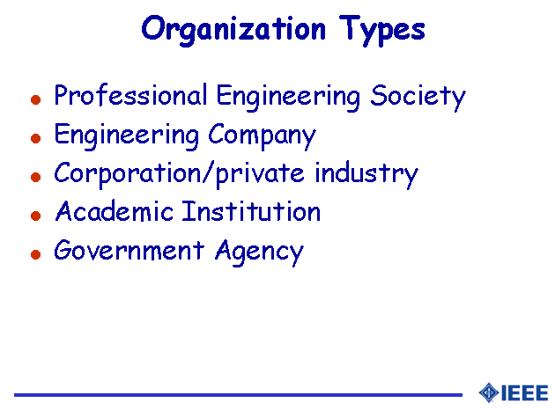

- When using visuals, any graphics should be large, and very clear. Avoid the use of small details—unless absolutely necessary—as they may be difficult to read. Below is an example of a clearly formatted graphic slide:
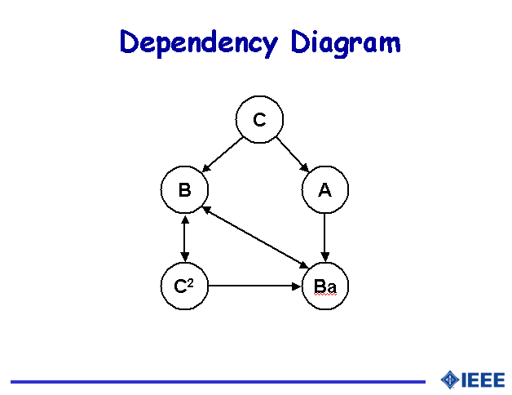

- When developing slides, it is helpful to use the PowerPoint ‘Notes’ feature to point out the key elements on the slide. This can also be an important aid during audio and or video recording.

- A set of learning objectives—Statements that clearly tell what the student will learn from your online learning module. A staff member can assist in reviewing your materials and developing suggested learning objectives, however, if you would like to provide them, the following information may be helpful:
- Use action words to clearly state these objectives. This can begin with the statement: “After completing this online learning module, you will be able to:” Then begin the descriptions with terms such as: explain, develop, determine, demonstrate an understanding of, list, etc. For more information on developing learning objectives, visit http://www.ieee.org/organizations/eab/tutorials/refguide/mms01.htm#3.

- Practice problems/Self-tests— Problems/questions and/or mini-exams you assign based on the material presented within each section. These serve to provide student feedback, check understanding, and give review of key topics. Often, these are formatted as true/false, multiple-choice, fill in the blanks, or a combination of any/all of these.

- Answers—You will need to provide answers for the practice problems/self-tests. Whenever possible, offer a full explanation of the answer to help the user clearly understand how it was derived.

- Photograph and short biography—Please provide a picture in a .JPG format (or send an original to the course developer for scanning) and a short biography to be included in the introduction of your online learning module. This serves to introduce the student to presenter and provides them some background information.

The following are optional elements that may be contained in your online learning module:

Optional Elements

- Audio/video—Depending on the complexity of the material you are presenting, it might be helpful to include audio and/or video elements to your online learning module. (Be sure to advise the course developer if audio and/or video already exist from previous presentations of this material.)
- If you and the course developer decide that audio and/or video would be a desired element in your online learning module, you will be asked to develop an audio script based on your slides. Your script should contain clear, easily understood language. Since these online learning modules will be viewed worldwide, providing an electronic copy of the audio script can be especially helpful.

- References—Reference materials are a valuable addition to an online learning module. If at all possible, you should include references such as:

- Key URLs—These can be links to any websites that will further expand on the material you are presenting.
- Articles—You are encouraged to provide recommended articles within the IEEE IEL or other external providers.
- Supplementary charts, diagrams, etc.—Any additional materials that may not be directly covered in the course, but would be helpful to the student can be included.

- Glossary—You will be asked to provide a list of appropriate key terms (10 maximum) that should be included and defined in a glossary.

- Illustrations, diagrams, applets and charts—You can accelerate learning and increase understanding by including graphic elements in your online learning module. The course developer will work with you to identify where graphics may be useful in illustrating points, and can work with your existing graphics or help with developing graphics where appropriate.

As previously noted, practice problems/self-test questions should appear at various points in the material. These practice problems can range from 3-5 questions. A final quiz consisting of no more than 10 questions that cover all of the material addressed can be included at the end of the online learning module. If the student achieves a passing grade on the final quiz, IEEE awards Continuing Education Units (CEUs).

COURSE DEVELOPMENT

The course developer will review all of your existing materials and will work with you to determine which features will help make your online learning module a success. Since these online learning modules are designed to be approximately 1 hour, the course developer will advise you if your material fits this length. (Often you may find you have enough material to break into more than one module!)

PRODUCTION AND TIME COMMITMENT

The amount of time required to develop an online learning module depends heavily on the quality and availability of material that you already have. You can expect to have several phone conversations with the course developer over a period of a few weeks. Also, depending on the elements that will be included in your online learning module, you may be asked to go to a local studio for anywhere from a half to a full day to capture audio and video. In all cases, we will work closely with your schedule. Once all of the materials have been gathered, the course developer will create a storyboard to show the layout and design of your course. You will be asked to review and approve this. The course developer will also ask you to point out the key sections of your course that should be stressed for the student. Finally, you will be asked to review the final course.

CONCLUSION

Our goal is to maintain the highest standards of instruction in our online learning modules. You, too, will find that producing an online learning module can be extremely rewarding because this type of project gives you the opportunity to instruct students anywhere in the world. Through your online learning module, you essentially become the teacher of a larger number of students than the average classroom ever sees!

We attempt to provide as much support and assistance as possible during development and, therefore, urge you to call with any questions, problems, or concerns.

We hope that you will consider becoming an online learning module SME and look forward to working with you.

