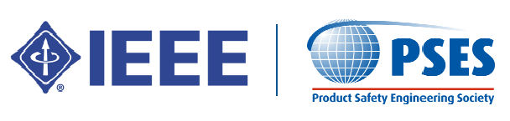
Orange County
Product Safety Engineering Society
Meeting

WEBSITE - http://ewh.ieee.org/r6/ocs/pses/

(Open to all – you do not need to be a member of IEEE)
+ FREE FOOD!!!!!
Provided by Element Corp.

Tuesday, February 25, 2020 – 6 PM
Element Corp. (Formerly Northwest EMC)
41 Tesla
Irvine, CA 92618
- INTRODUCTIONS

- COMMITTEE REPORTS
- Program Committee –
- Treasurer Report – Paul Herrick

- PRESENTATION – " Electrical Safety and Component Testing with Automated High Voltage, High channel count, 100ms/point demo"

- PRESENTER – Glen Broderick, Western Regional Sales Manager, Vitrek
Glen Broderick started his career in the Navy as an electronics technician. After three years on the USS Monticello, he was promoted to Lead Petty Officer in charge of Electronics and was responsible for maintenance, calibration, troubleshooting, and repair of radar systems, HF and UHF communications systems, and crypto equipment.

Glen worked his way through college while working as a test engineer, test engineering supervisor, and QA supervisor.

Glen completed his BA and MBA at Cal State Fullerton then held these roles: Account Manager, Strategic Account Manager, Western Regional Sales Manager, Product Manager, Director of Product Marketing, Senior Director for Sales, US Business Development Manager

Glen has spent his entire career in test and measurement and has worked for Trig Tek (Vibration), Fluke (scopes and calibrators), Spirent Communications (ethernet switch and router ATE), Tektronix (scopes, arbs, spec ans.), Absolute Analysis (high speed-serial cross domain traffic generation and analysis), United Electronic Industries (ruggedized data acquisition and control), Electro Rent (oscilloscopes, spectrum analyzers, phase-noise analyzers), Vitrek (hipots, power analyzers, HV switches and meters, Load Measure Units (LMU’s), calibrators).

Glen has traveled world-wide (50 countries) consulting on test applications. Much of his career has been spent as Western Regional Sales Manager. In that role he has visited and consulted with an estimated 4,000 companies.

- DISCUSSION ITEMS - General Discussion of other Product Safety/Certification issues
