
IEEE SoutheastCon 2012
Innovating for a Better Tomorrow
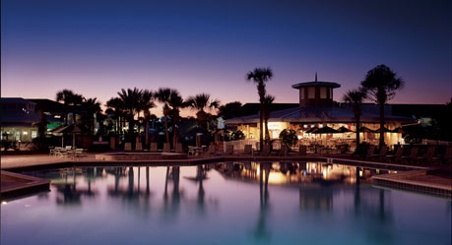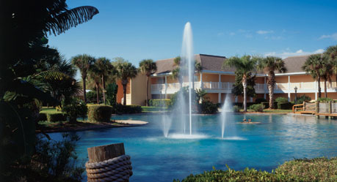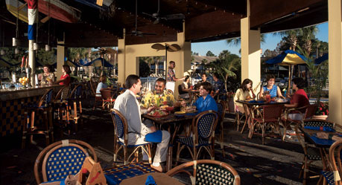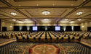

March 14 – 17, 2012 Wyndham Orlando Resort Hotel, Orlando, Florida
First CALL FOR PAPERS
The annual IEEE SoutheastCon conferences promote all aspects of the theories and applications of the engineering disciplines. Sponsored by the IEEE Region-3, this event will attract researchers, professionals, and students from the Southeast region of the U.S. This year’s SoutheastCon 2012 event will be held in Orlando, Florida, at the heart of Central Florida’s high-tech corridor. SoutheastCon 2012 will feature tutorial sessions and workshops along with the Technical Program. Questions of a general nature should be directed to the Technical Program Chair Dr. Kalpathy Sundaram at sundaram@mail.ucf.edu.
Scope of the Technical Program
IEEE SoutheastCon 2012 invites prospective authors to submit their technical work on all aspects of engineering, science, and technology of current interest to the conference. The conference technical program includes, but is not limited to the following technical categories:
- Power and Sustainable Energy  - Health Informatics and Healthcare | - Military and Security Applications  - Data Mining and Machine Learning |  | - Robotics and Computer Vision  - Simulation and Games Development
- Communications and Networking | - Applications and Interdisciplinary |  | - Bioengineering and Bioinformatics
- Control and Automation | - Software Engineering |  | - Optics and Optoelectronics
- Embedded Systems | - Sensor Networks |  | - Remote Sensing
- Nanotechnology and Materials | - Electromagnetics and Microwaves |  | - Instrumentation & Measurements
- Signal and Image Processing | - Devices and Semiconductors |  | - Topics on Technical Education
IMPORTANT DUE DATES  Paper Submission: December 9, 2011  Tutorial Submission: December 19, 2011  Notification to Authors: January 20, 2012  Camera-Ready Papers: February 6, 2012  For more details please visit conference Website:  http://www.southeastcon2012.org |  | General Chair: Dr. Donghui Wu, Elsevier/MEDai Inc.,  do.wu@elsevier.com, Tel: 321-281-4561  Vice Chair: George McClure, g.mcclure@ieee.org,  Tel: 407-647-5092  Technical Program Chair: Dr. Kalpathy Sundaram, University of Central Florida, sundaram@mail.ucf.edu, Tel: 407-823-5326  Sponsorship Chair: Dr. William Hortos, ACERT, w.hortos@ieee.org, Tel: 407-876-1026

