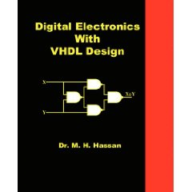
Digital Electronics With VHDL Design
Author: M. H. Hassan, Ph.D.
ISBN-13: 978-0-9816194-1-5
ISBN-10: 0-9816194-1-X
Perfect Binding, 312 pp, $29.98 or less.
To order on Amazon:
http://www.amazon.com/dp/098161941X

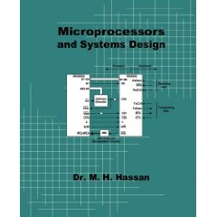
Microprocessors and Systems Design
Author: M. H. Hassan, Ph.D.
ISBN-13: 978-0-9816194-3-9
ISBN-10: 0-9816194-3-6
Perfect Binding, 440 pp, $29.95 or less.
(Free Instructor’s Manual, Please email to request an electronic copy)
To order on Amazon:
http://www.amazon.com/dp/0981619436

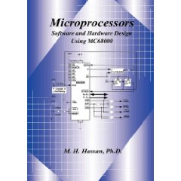
Microprocessors
Software and Hardware Design Using MC68000
Author: M. H. Hassan, Ph.D.
ISBN-13: 978-0-9816194-0-8
ISBN-10: 0981619401
Hardcover, 352 pp, $49.95 or less.
(Free Instructor’s Manual, Please email to request an electronic copy)
To order on Amazon:
http://www.amazon.com/dp/0981619401

Wholesale orders: Ingram, Baker & Taylor, Bertrams, Blackwell Bookservices, Coutts, Gardners, Dawson Library Supplier, Holt Jackson, Nielsen Bookdata, paperbackshop.co.uk, and The Book Depository.

