Jill I. Gostin, GTRI/SEAL
7220 Richardson Rd.
Smyrna, GA 30080

Address Correction Required
Earn PDH credits!
The tutorials presented at SoutheastCon 2009 have been chosen to offer a wide selection of continuing education opportunities for engineers in several different specialty areas. The material presented has been reviewed for its content and usefulness. Certificates will be presented to attendees, identifying the course, number of classroom hours and Professional Development Hours (PDHs) earned.
The 8-hour tutorials include Engineering Innovation; an Industrial Applications Society Seminar entitled Industrial Power System Protection; Basic Radar; Alternative Energy; and Artificial Intelligence in C++. All presenters are accomplished speakers and experts in their subject matter.
Tutorials will be offered on Thursday, March 5, from 8 am until 5 pm. Lunch and snacks will be provided. Register by February 22 to avoid a late fee.

To register, go to www.southeastcon.org/2009

Space is limited; sign up soon!

Sponsored by
IEEE Atlanta Section and the Georgia Tech IEEE Student Branch

Web site: www.southeastcon.org/2009
SoutheastCon 2009 Tutorials
SoutheastCon 2009
Crowne Plaza Ravinia,
Dunwoody, GA

March 5, 2009: Conference Registration and Tutorials

March 6, 2009: Conference Registration, Student Competition Preparation, Professional Development Fair Preparation, Technical Paper Sessions, TISP Workshop, Professional Development Seminar, Region 3 Area Meetings, and Welcome Reception

March 7, 2009: Conference Registration, Technical Paper Sessions, Student Competitions, SPAC, Professional Development Fair, Region 3 Meetings, K-12, and Awards Banquet

March 8, 2009: Region 3 Meetings, Student Leadership Training, and Student Branch Counselor Meetings
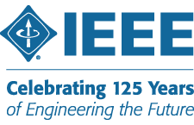
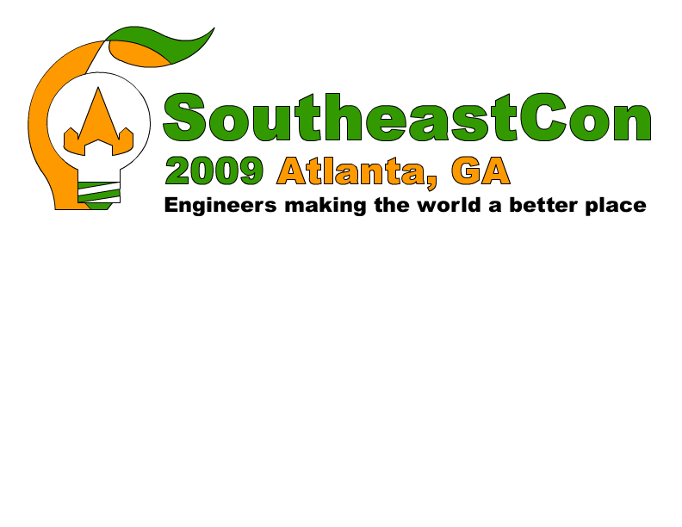

IAS Seminar: Industrial Power System Protection This tutorial provides the attendee with a review of industrial power systems analysis, with an emphasis on protection fundamentals including transformer protection and grounding. Topics: Analyze power systems for balanced and unbalanced conditions using symmetrical components; Apply the selection and coordination rules of conventional distribution circuit overcurrent protection devices; Additional Control considerations for improved electrical safety; Review neutral grounding methods; Determine the protection schemes and settings for transformers; Apply differential, overcurrent, and mechanical protection elements to provide complete protection of power transformers; Calculate settings for thermal and overcurrent protection for medium-size induction motors; and Apply overcurrent protection and relay coordination concepts to medium-voltage radial lines and cables.
Speakers: Mr. Jon Steinmetz has over 28 years of experience in the power industry, and currently works for Schweitzer Engineering Laboratories where he is currently an Application Engineer for the Eastern United States. His work at SEL includes product support, customer training and participation in SEL University activities. Mr. Mike Collum has over 21 years of Protection and Control experience in the Electric Power Industry. Mike also works for Schweitzer Engineering Laboratories where he is currently a Senior Application Engineer for the Eastern United States. His work at SEL includes product support, customer training, participation in SEL University, and coordination of regional activities.

Alternative Energy: Exploring the Possibilities and the Overall Global Impact Diversification of our energy sources has never been more important for the world in general and the US in particular than it is right now. This workshop will provide an overview on energy generation technologies and will explore the most promising alternative energy solutions available for us today. The course will be conducted with numerous in-class exercises to help reinforce the concepts and much of the presentation will emphasize participant involvement.
Speaker: Mr. Scott Tippens has taught at Southern Polytechnic State University in the Electrical and Computer Engineering Technology department since 1993. His primary teaching and research areas encompass alternate energy and advanced digital design. Scott has recently acquired funding for solar photovoltaic and solar thermal collectors and is in the process of developing laboratories and research experiences for undergraduate students.

Engineering Innovation, Parts 1 and 2 Are you an innovator? Have you had ideas for new technology, but you weren’t sure whether your idea was worth pursuing… or perhaps you just weren’t sure how to proceed? This exciting two-part tutorial will discuss current innovative technology successes and failures, and will then walk through the process of developing your idea and acquiring a patent.
Part 1: IEEE Spectrum Magazine 2009: Winners, Losers, Dreamers (morning)
IEEE Spectrum Magazine's editors will present a few technology projects they believe have a real future and a few that are headed for the dumpyard. They'll also talk about engineers and technologists they've met who have managed to find a way to live for their work, not just work for a living. The editors will also discuss how a technology magazine like Spectrum works.
Speakers: Ms.Susan Hassler is the Editor-in-Chief of IEEE Spectrum Magazine. She has more than 20 years of experience as an editor and journalist dealing with scientific and technical topics ranging from developmental neurobiology to computer engineering. Mr. Glenn Zorpette is the Executive Editor of IEEE Spectrum Magazine. Mr. Zorpette works closely with staff editors on feature articles and with the senior art director on covers and article illustrations. In 1993 he won a National Magazine Award for an article on Iraq’s efforts to build an atomic bomb.
Part 2: Small Team Innovation (afternoon)
Engineering Innovation: Part 2 will focus on the process of small team innovation, recognizing patentable innovations and the process of submitting and obtaining a patent. The workshop will be group based and highly interactive allowing attendees the ability to participate in the brainstorming process through the submission with a lawyer.
Speakers: Matt Trevathan is an IBM master inventor and Senior Solutions Architect with over ten years experience in the IT industry with a focus on telecommunications. He has over 80 patents pending or granted. He currently co-chairs two of IBM's invention disclosure teams that focus on reviewing inventions for patentability. Andrew Calderon has more than ten years of experience prosecuting patents and counseling clients at intellectual property boutiques and general practice firms. Mr. Calderon also has experience as a mechanical engineer in the defense contracting industry.

SoutheastCon 2009 Tutorials
Visit www.sec09.com for complete details and bios

Artificial Intelligence Programming Using C++ This tutorial includes an introduction to artificial intelligence (AI) in the context of video game programming. The primary focus will be describing and developing AI entities (characters) using finite state machines (FSMs). The relevant key elements of the C++ language will be reviewed. The extent of this review will be determined by the relevant backgrounds of the attendees. The coding of FSMs will be described in detail. New categories of behavior will be added to existing FSMs. AI entity Steering Behaviors will be covered if time permits.
Speaker: Dr. Warren Moore’s Ph. D. training included a specialty emphasis on Artificial Intelligence. For the past 6 years he has been a full professor in both Game and Simulation Programming and Computer Information Systems at DeVry University, Atlanta.

Basic Radar This tutorial provides a complete overview of radar technology, beginning with basics and fundamentals, and slowly progressing to more detailed concepts, with a minimum amount of arithmetic presented. Course topics include basic radar concepts, radar operation, advanced functions, engineering concepts, target detection, search and track, radar subsystems, phased array radars and antennas, example applications, waveforms, and signal processing.
Speaker: Mr. James A. Scheer is an engineer with over 40 years of hands-on experience in the design, development, and analysis of radar systems. He currently provides consulting services, works part time for GTRI, and teaches in radar-related short courses offered by the Distance Learning and Professional Education (DLPE) Department at Ga. Tech.

SoutheastCon 2009 Tutorials Chair, Jill Gostin
7220 Richardson Road
Smyrna, GA 30080
Phone: 404-407-7417 Fax: 404-407-7883
E-mail: tutorials@sec09.com
Attendees will receive a color printed copy of presentation material along with a CD of the slides.

