“Sensing Front-Ends and RF Technologies for Wireless Sensors”

IEEE MTT/AP Orlando Chapter Meeting
DATE/TIME: Tuesday, December 1st, 2009, 3:00-4:00 PM
SPEAKER: Tayfun Özdemir, Virtual EM Inc., Ann Arbor, Michigan, USA

ABSTRACT:
The talk will present ongoing R&D efforts for disruptive technology development involving wireless sensors with emphasis on sensing and RF technologies. Focus will be on stand-off detection of biological/chemical agents and explosives utilizing mesh-networked environment. Sensor prototypes to be covered utilize RFID, ZigBee, and 6LoWPAN communication protocols while sensor front-ends employ a variety of technologies from olfactory sensory neurons to DNA-enabled biological ligands (peptides).

BIOGRAPHY:
Dr. Tayfun Özdemir is the President of Virtual EM Inc. and the Chief Technology Officer of Monarch Antenna, Inc. At Virtual EM, he manages daily operations and leads business development and financing. Virtual EM is an R&D house funded by U.S. Department of Defense, NASA and NSF contracts involving wireless sensors, antennas and microwave circuits, and computational electromagnetics. At Monarch, Dr. Özdemir is responsible for technology development and manages all prototyping efforts. Monarch was spun off from Delphi Corporation to market its patented Self-Structuring Antenna (SSA) technology and is targeting consumer wireless and machine-to-machine (M2M) communications. Dr. Özdemir holds a patent on a planar integrated antenna and has over 20 years of experience in his field of expertise. He published 6 journal papers, made over 40 conference presentations, and serves as the Chair of the AP/MTT/ED Chapter of the Southeast Michigan Section of IEEE. Dr. Özdemir is also the chairman of the organizing committee of the 2010 bi-annual IEEE Great Lakes Technology Symposium to be held in Ann Arbor, Michigan.

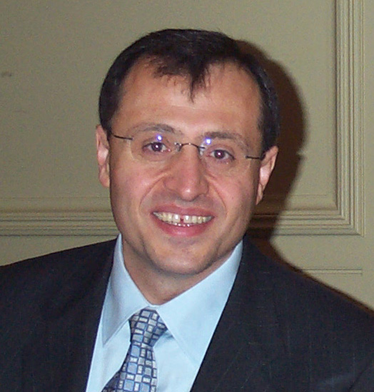

LOCATION: University of Central Florida  HCEC 101 | Organizer: Xun Gong  (407)823-5762, xungong@mail.ucf.edu

