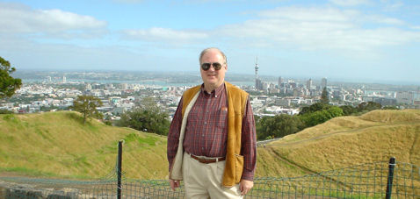
Speaker: Dr. Hal Bergel

Date & Time: Thursday April 7th, 2009. 12:00 noon

Location: HEC building, room 101

Organizer: IEEE Computer Society Chapter - Orlando

Title: Identity Theft and Financial Fraud for the New Millennium

Summary:
The genesis of the problem of identity theft and financial fraud is two inter-related phenomena: fungible credentials, and the technology that creates, validates, and authenticates them. We will explain the origins of modern ID theft and financial fraud and provide several examples of how they are perpetrated my modern e_criminals. Modern criminal exploits will be explained, and details of specific crimes will be given. Technologies that may be used to thwart these activities will be explained, and if possible, demonstrated.

Bio:
Hal Berghel is currently Professor and Director of the School of Informatics and Associate Dean of the Howard R. Hughes College of Engineering, and Professor and past-Director of the School of Computer Science, at the University of Nevada, Las Vegas. He is also founding Director of both the Center for Cyber security Research, and the Identity Theft and Financial Fraud Research and Operations Center. Berghel has held a variety of research and administrative positions in industry and academia during his thirty-year career in computing. His current research focuses on computing and network security, digital forensics, and digital crime. He is also a popular columnist, author, talk show guest, and keynote speaker.

Berghel is a Fellow of both the Institute for Electrical and Electronics Engineers and the Association for Computing Machinery, and serves both societies as ACM Distinguished Lecturer and an IEEE Distinguished Visitor. He has received the ACM Outstanding Lecturer of the Year Award four times and was recognized for Lifetime Achievement in 2004. He has also received both the ACM Outstanding Contribution and Distinguished Service awards. He is also the founder and owner of Berghel.net, a consultancy serving business and industry.

For further info, contact: haddad@ieee.org

