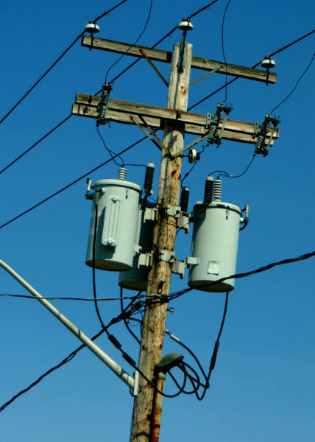

THE MEANING of LIFE – a very short course
© DA Duckett 2006
September 26th, 2006
6:00 pm – 9:00 pm
Dinner at the
Hilton Orlando-Altamonte Springs
350 Northlake Blvd
Altamonte Springs, FL 32701
(407) 830-1985

Cost:
$10 for Members
$15 for Non-members $5 for Student Members

Course Description:
ANSI provides guidelines on the Loading and Application of Dry and Liquid Filled Distribution and Power Transformers.
This discussion will focus first on the design and construction of these transformers with a few transformer basics then will review the basics of Transformer Loading and the history, use, and MEANING of the ANSI Loading Guides (Dry and Liquid Filled).
As time permits, several case studies can be reviewed for a number of Applications including Residential, Commercial, and Power.

RSVP: Please indicate name, number of attendees, and member status by September 22 to
Charlene Rubano at: Charlene.Rubano@pgnmail.com

Menu:

Apple Almond Chicken - Breast of Chicken stuffed with Apples, Almonds, Cranberry and Amaretto Sauce served with Rice Pilaf and Seasonal Vegetables.

Tossed Green Salad with choice of Dressings
Warm Rolls & Butter included with meal.
A Traditional Cheesecake for dessert.
Coffee, Tea, Decaffeinated Coffee, and Iced Tea

