Distribution Grid 2030 – A vision for the future of the SWIS power system
4th November 17:00- 19:00  Lecture Theatre, Central Park Building  152-158 St Georges Terrace, Perth  Dean Sharafi  IEEE PES Governing Board Member | 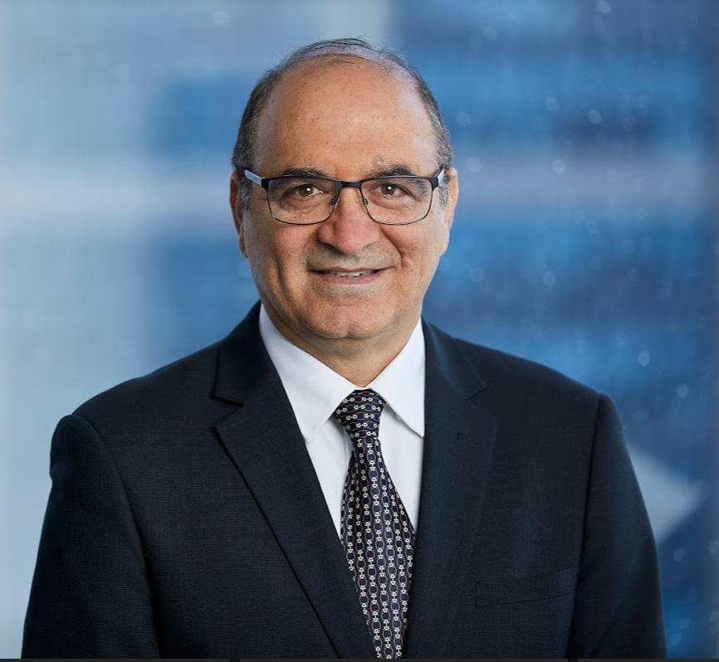

Registration is essential - please follow the link below to register:
https://www.eventbrite.com/e/distribution-grid-2030-a-vision-for-the-future-of-the-swis-power-system-tickets-74931430927
Event fee: no charge

Dean Sharafi is heading System Management, the operator of South-West Interconnected System in Australia. Dean holds a degree in Applied Physics, a degree in Electrical Engineering and a degree in Business Management. He has over 25 years of experience in power system engineering which includes Power System Protection, High Voltage Systems, Asset Management and Power System and Electricity Market Operation.
He is a member of Australian Institute of Management, Cigre, Engineers Australia and a senior member the IEEE. Dean has been actively involved with IEEE Power and Energy Society initiatives and Cigre Working Groups over the last decade and is a member of the Governing Board of the IEEE PES.
Dean has published many papers on power system protection, condition monitoring, asset management and power system operations. He lectured for a decade as a Sessional Academic on Power System Earthing at Curtin University in Western Australia.
Dean is also the author of his memoire “The Unwilling Revolutionary.”

Context
Electricity grids are undergoing a massive transformation. The extend and the timescale of the growth of distributed energy resources (DER) in recent years has continuously exceeded most predictions. This rapid trend is changing the fundamentals of the operation of the power system, as well as the foundations upon which the power system was traditionally designed and operated. There is a need to understand the effects of this transformation on reliability, security and resiliency of the power system and put a blueprint together for future integration of renewables such that they continue to provide a means of decarbonisation of the electricity supply, a secure, reliable and resilient power system, and benefits to the customers. These objectives need a vision for the future evolution of the power system, especially the distribution grid which is the immediate subject of this transformation; a vision which is based on the principles agreeable by customers, policy makers and engineers. In order to ride through this change distribution grid will need to innovate and provide means of participation of players in the electricity eco-system. Distribution operations will need to change, and distribution markets will need to evolve to facilitate such a future. New tools, innovative technologies and novel operational approaches are required. This talk will focus on the vision for electricity grids and what needs to be achieved in the next decade.

Getting There:

The link below will give you a virtual tour of the Central Park Conference Facility. Entry is either via Ground level then stairs, which lead up to the first floor foyer, and in turn the theatrette and other board/seminar rooms. Or if required there is also elevator/disabled access to the first floor from an alternative entry approx. 20m from the main entrance. The main entrance to the Conference facilities is off the arcade/courtyard located behind the main Central Park office tower. This area can be accessed from St. Georges Tce, Hay or William Streets. Several public parking areas are within easy walking distance.

http://www.central-park.com.au/Core/Content/ConferenceCentre/Content3407.aspx

