IEEE P1936.1 & P1937.1 & P1939.1 WGs

The 3rd Face-to-face Meeting To be held from November 26 , 2019, Guangzhou (China)

General Information

1. Meeting Location

The meeting will be held at the Zhujiang Hotel, Guangzhou
会议地点：广州珠江宾馆
广州市越秀区寺右一马路2号
Zhujiang Hotel in Guangzhou
No.2, Siyouyi Road, Yuexiu District, Guangzhou, Guangdong, 510600, China-P.R.C.
Hotel Information:
https://zhujiang.cthy.com/
TEL: +86-20-87379988, +86-13316013136
FAX: +86-20-87389988

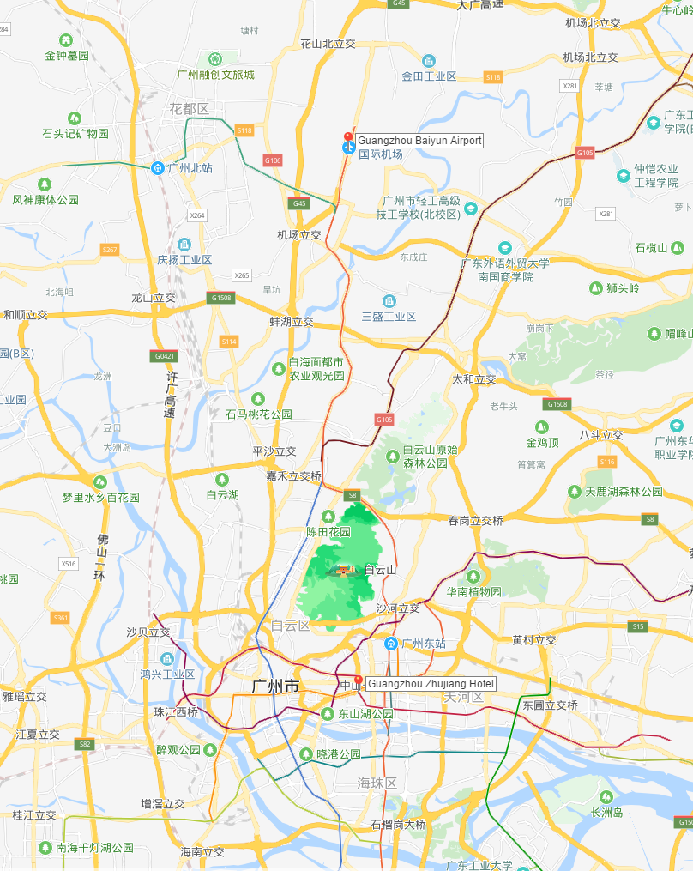
Guangzhou Zhujiang Hotel
广州珠江宾馆
广州白云国际机场
Guangzhou Baiyun International Airport

2. Meeting Hour
The normal meeting hours will be as follows (unless otherwise decided by Chairman or Secretary):
From 9:00am-12:00am
From 1:00pm-5:00pm
There will be official coffee break. Coffee/tea and cold drinks will be available in the meeting room.

3. Transportation

From Guangzhou baiyun International Airport（CAN） to hotel
By car:
42 km from airport to hotel in south direction

By Taxi (Recommended)
It will approximately take about 70 mins, and 140 RMB. Please show the following Chinese address to the Taxi driver.
会议地点：广州珠江宾馆
广州市越秀区寺右一马路2号
By Subway:
Get on Line 3 extension at Airport S station, take 13 stops, change to Line 3 at Tiyu Xilu Station, after 1 stop change to Line 5 at Zhujiang New Town Station, get off at Wuyangcun Station, then walk about 600 meters. It will take about 58 minutes, and 8 RMB.
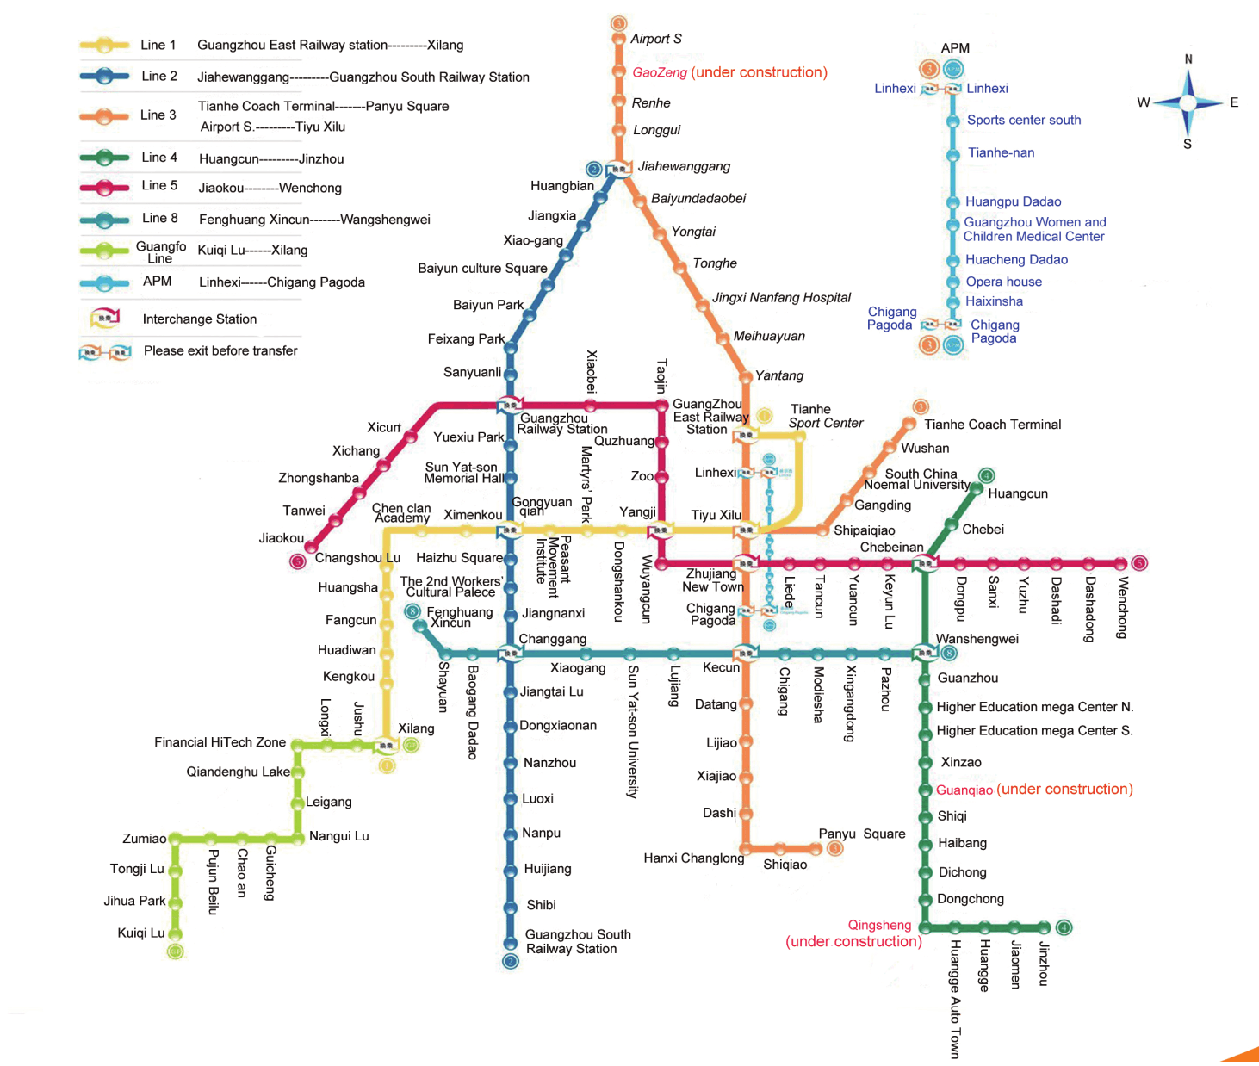
Guangzhou Subway Route Map

4. Meeting Registration
Delegates need to make the registration both on-line and send the Registration Form back to the organization group via
Email: dianliwurenji@126.com
Fax: 8620 85127944
Please download and complete the Registration Form which is attached for your convenience.
The deadline for the registration is March 3rd. Nevertheless, delegates who need to reserve a room are kindly requested to confirm your reservation no later than 2 weeks before the meeting. Please tick at your choice in the Registration Form.

5. Accommodation
Meeting participants can choose to reserve a room in Ramada by Wyndham Pearl Guangzhou or Guangzhou Zhujiang Hotel at a group price which has not been decided yet.It would be adjusted according to the actual situation by then .
Please present the booking code of IEEE 679 Meeting upon check in to enjoy the group price.

6. Climate

From mid October to December, is the best time to visit Guangzhou when the weather is pleasantly cool and the sky is bright and clear. The average low and high temperatures are respectively 16°C (60°F) and 24°C (75°F) in November, and 11°C (52°F) and 20°C (68°F) in December.

A light sweater and a coat is enough at the coolest of times, but a long-sleeve shirt is enough when it is warmer during the day.

7. Electricity

The Chinese standard for electric power is 220 Volts or 50HZ. Most outlets take two flat plugs or three flat plugs

8. Contact
If you have any questions, feel free to touch with the contact of the meeting.
Name: Pingyuan Liu
Affiliation: Patrol Operation Center of Guangdong Power Grid Co., Ltd.
Email: dianliwurenji@126.com
Tel: 86 13925059806
Fax: 8620 85127944

