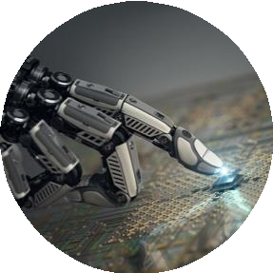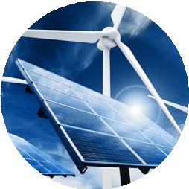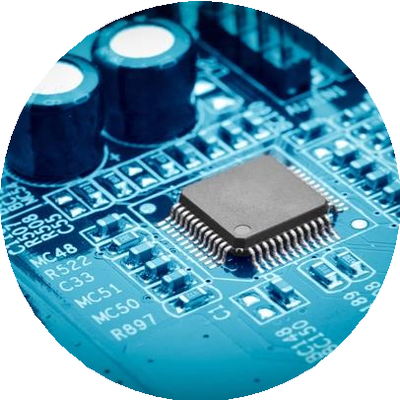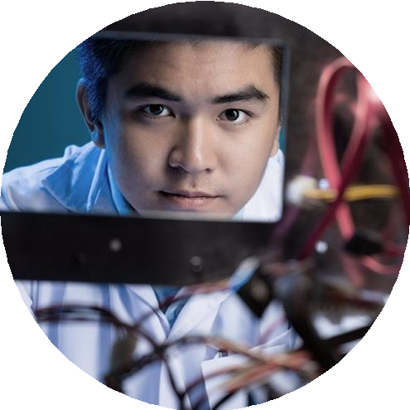

# Event Report

**Field Visit – IMTEX 2025**

Date of Presentation: 29th January 2025



# Table of Contents

1. Poster of the Event (Page 3)
2. Event Flow (Page 4)
3. Event Photos (Page 5,6)
4. Summary of the Event (Page 7)
5. Attended Participants (Page 7,8)
6. Participants Feedback (Page 8,9)

**Poster of the Event:**

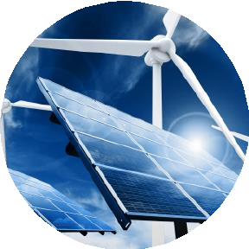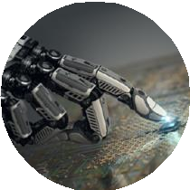

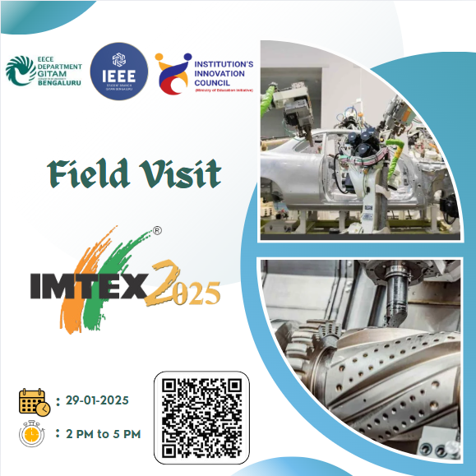

**Event Flow:**

**12:00 PM – Departure from College to IMTEX 2025**

**1:30 PM – Arrival at IMTEX Venue**

**1:30 PM – 2:00 PM – Entry and Registration Process**

**2:00 PM – Visit Starts with Hall 7**

* **Completed the registration and entered the exhibition**
* **Explored various company exhibits and products related to electronics and automation**
* **Engaged with exhibitors for product demonstrations and discussions**
* **Notable companies in Hall 7:**
  + **Siemens – Industrial automation and smart manufacturing solutions**
  + **Schneider Electric – Energy management and industrial IoT solutions**
  + **Texas Instruments – Advanced semiconductor technology for automation**
  + **Bosch Rexroth – Motion control and drive technology**
  + **Mitsubishi Electric – Factory automation and electronic components**

**3:30 PM – 4:00 PM – Visit to Hall 3**

* **Explored Tata Electronics, which was actively hiring**
* **Learned about their job opportunities, roles, and hiring process**
* **Engaged in discussions with company representatives about electronics and semiconductor manufacturing careers**

**4:00 PM – 5:00 PM – Final Exploration and Wrap-up**

* **Briefly explored other halls to check out key innovations**
* **Observed electronics-integrated machinery, AI-driven manufacturing, and sensor technology**
* **Had quick interactions with company representatives for insights on emerging trends in electronics and automation**

**5:00 PM – Departure from IMTEX 2025**

**Event Photos:**

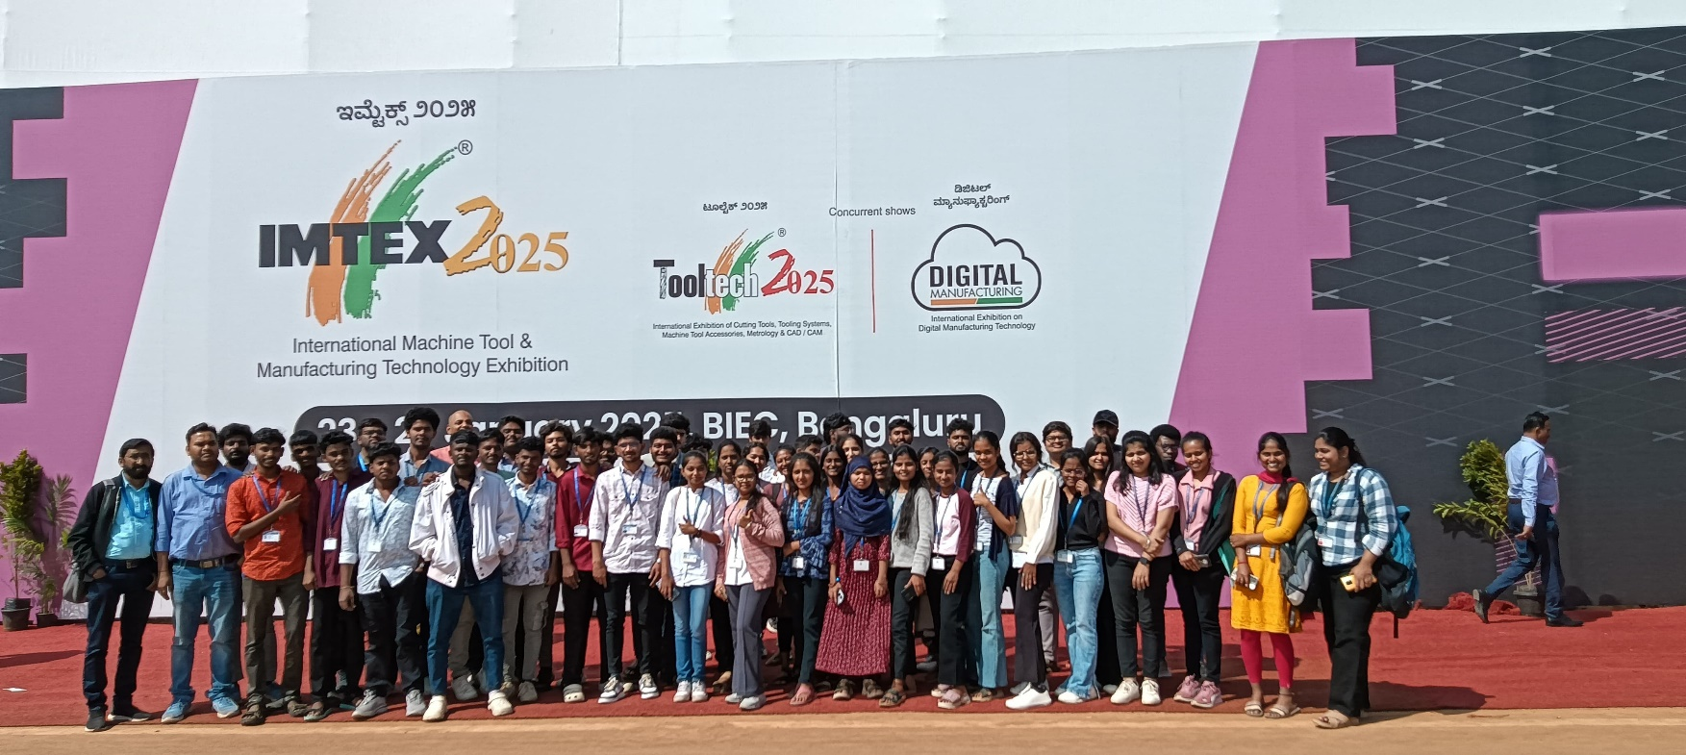

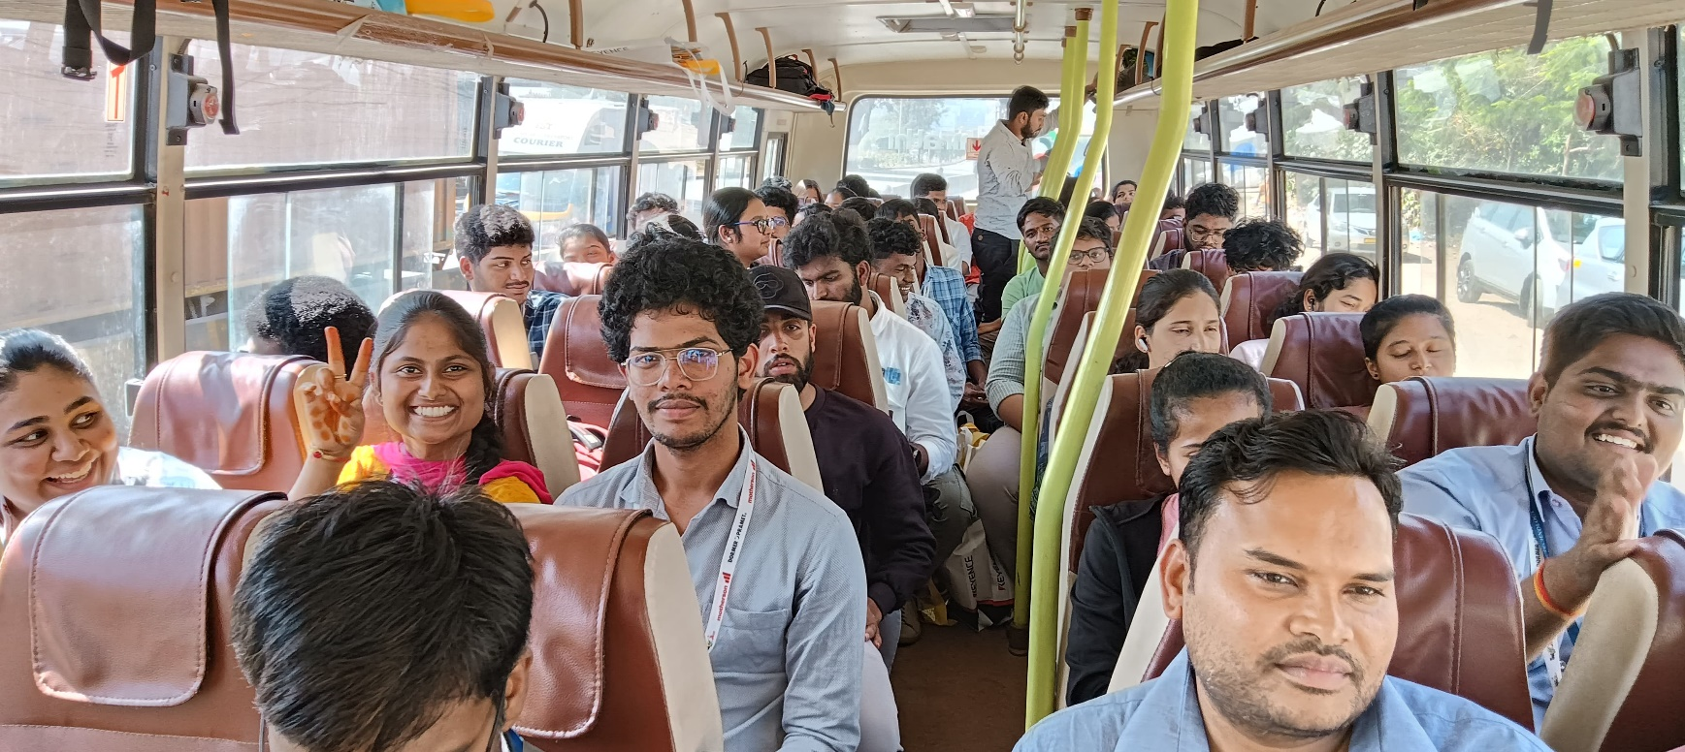

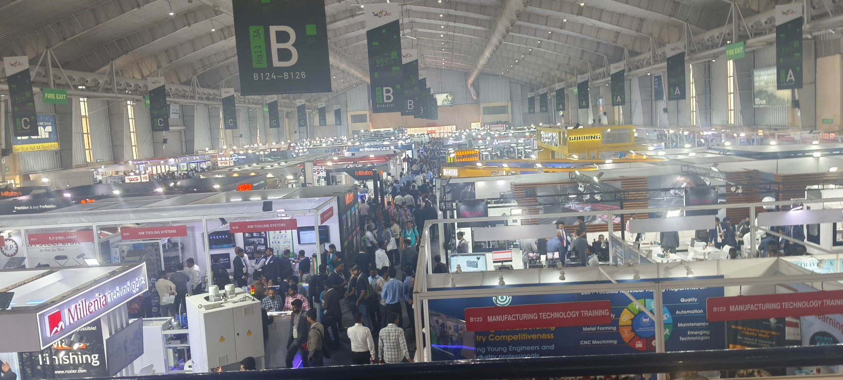

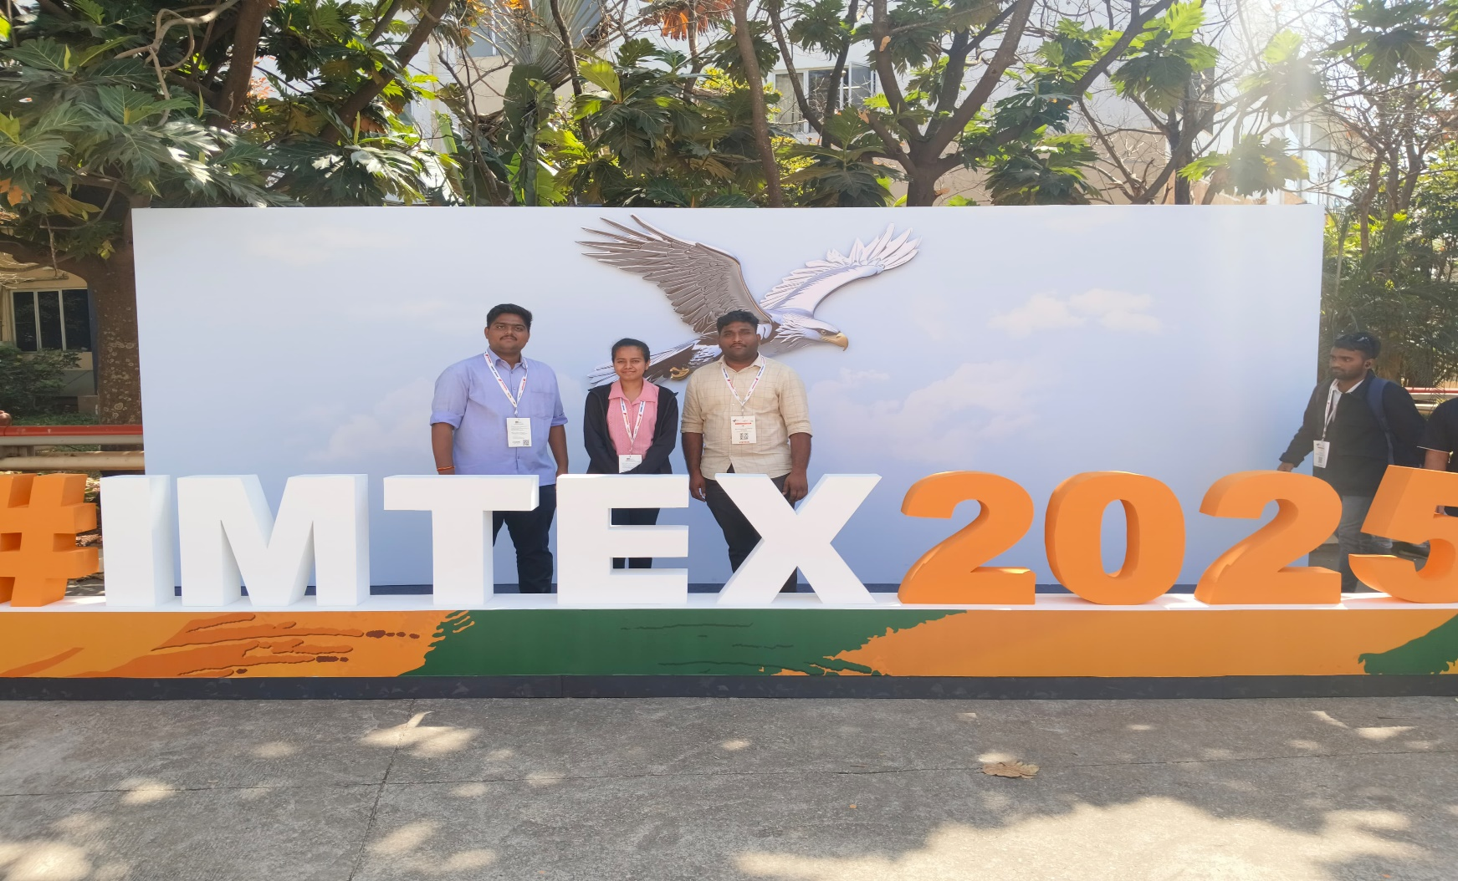

**Summary of the Event:**

IMTEX 2025, held from January 23 to 29 at the Bangalore International Exhibition Centre (BIEC), showcased over 1,000 exhibitors from more than 20 countries, highlighting advancements in machine tools, manufacturing technologies, and digital innovations.

Key Electronics and Automation Companies:

* Siemens: Featured industrial automation and smart manufacturing solutions, emphasizing digitalization in manufacturing processes.
* Schneider Electric: Presented energy management systems and industrial IoT solutions aimed at enhancing operational efficiency.
* Texas Instruments: Showcased advanced semiconductor technologies designed for automation applications.
* Bosch Rexroth: Highlighted motion control and drive technologies integral to modern manufacturing systems.
* Mitsubishi Electric: Displayed factory automation products and electronic components supporting smart manufacturing.
* Tata Electronics: Actively engaged in recruitment efforts, offering career opportunities in electronics and semiconductor manufacturing.

These companies demonstrated the integration of electronics and automation in manufacturing, reflecting the industry's shift towards smarter and more efficient production methodologies

**Attended Participants:**

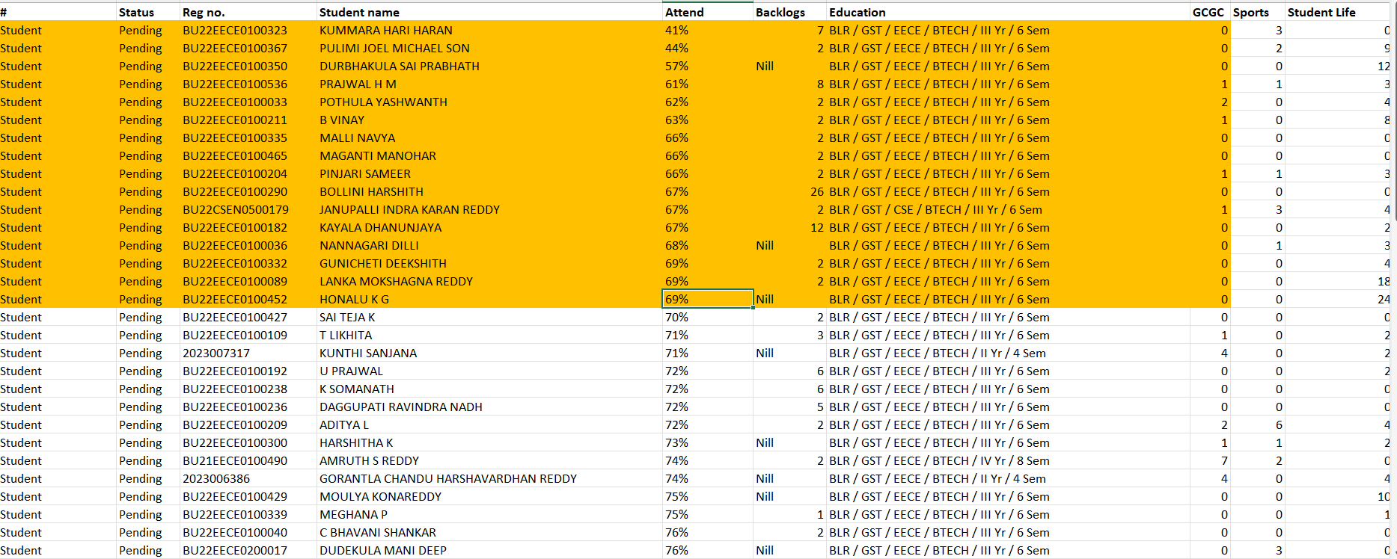

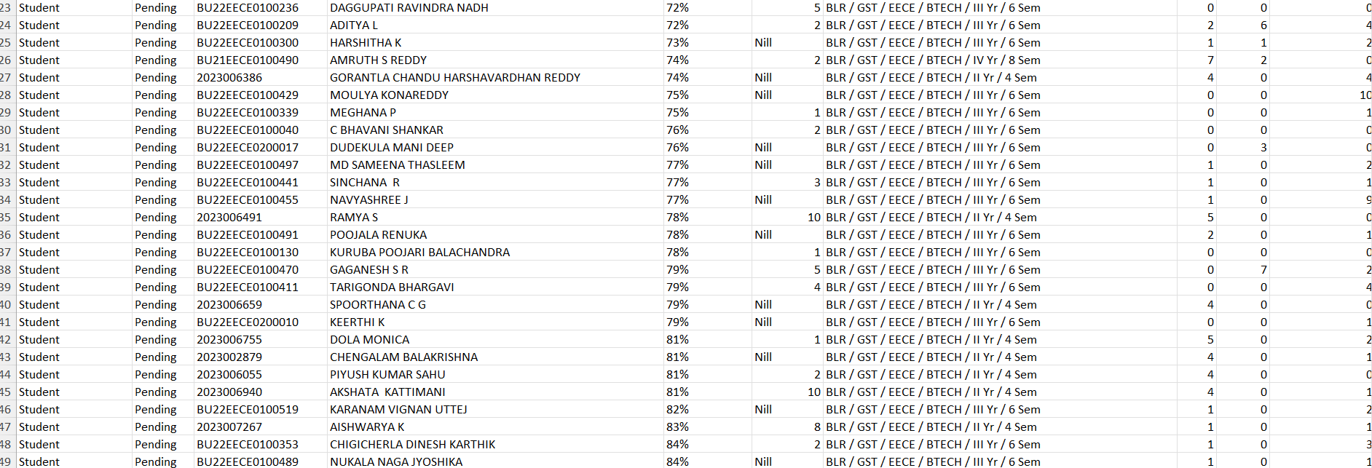

**Feedback :**

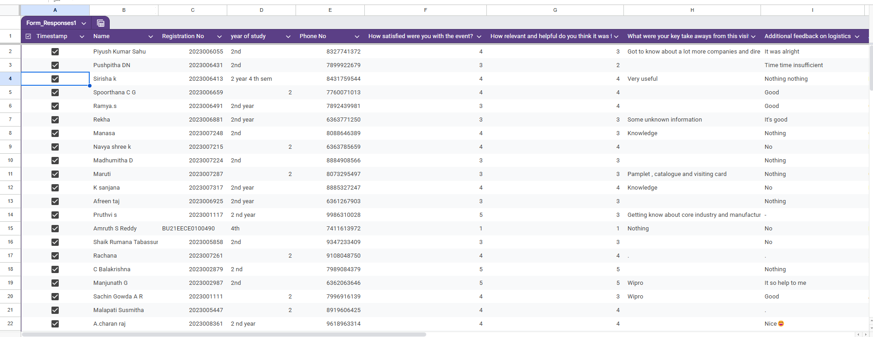

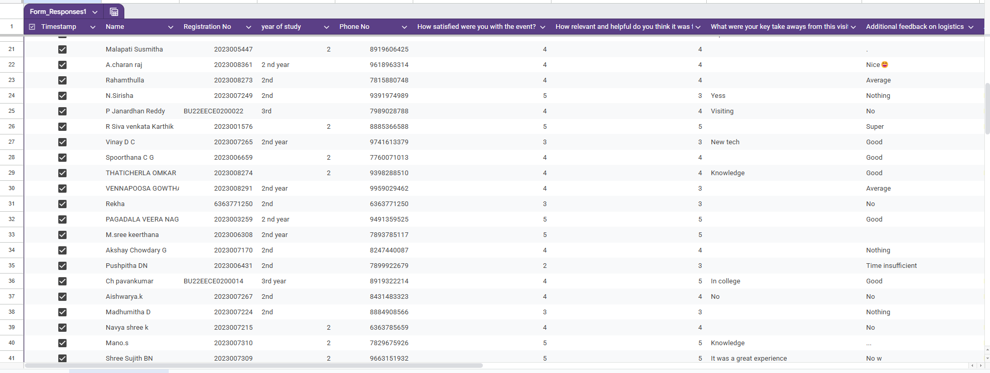

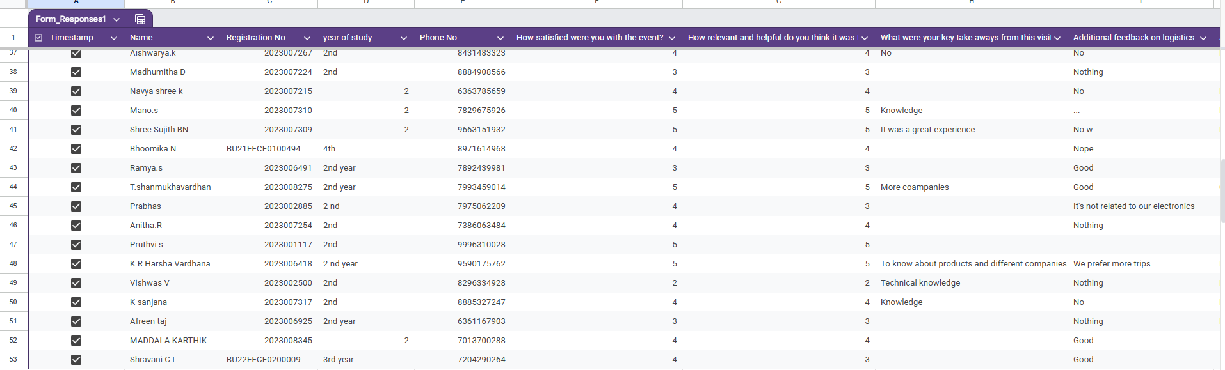

**Faculty Coordinator HOD EECE Department**

**Dr. Karthick S. Dr. Prithvi Sekhar**