All invited
Hybrid Meeting
Wearable sensing for health and performance, by Omer Inan, Ph.D.
Wednesday, November 13, 2024
5:00 PM | (UTC-06:00) Mountain Time (US & Canada) | 2 hrs
WebEx meeting at 5:30 PM (UTC-06:00) Mountain Time (US & Canada)
Join from PC, Mac, Linux, iOS or Android
https://ieeemeetings.webex.com/ieeemeetings/j.php?MTID=m19c2796fa7419666060f0fd838fa7f8d
Meeting number: 2535 871 7404
Meeting password: jdSk7piJ8e8

University of Denver
2155 E Wesley Ave
Denver, Colorado
United States 80208
Building: Daniel Felix Ritchie School of Engineering & Computer Science (ECS)
Room Number: 510

Attendees can find on-street parking or pay for parking in the hourly parking spots ($2/hour). There are hourly spots on the south side of the ECS Building, to the north of the building off E Iliff and in the 1st level of the parking garage on the corner of S University and E Wesley Ave.

https://www.du.edu/site-utilities/maps
https://www.du.edu/sites/default/files/2023-08/parking-map.pdf

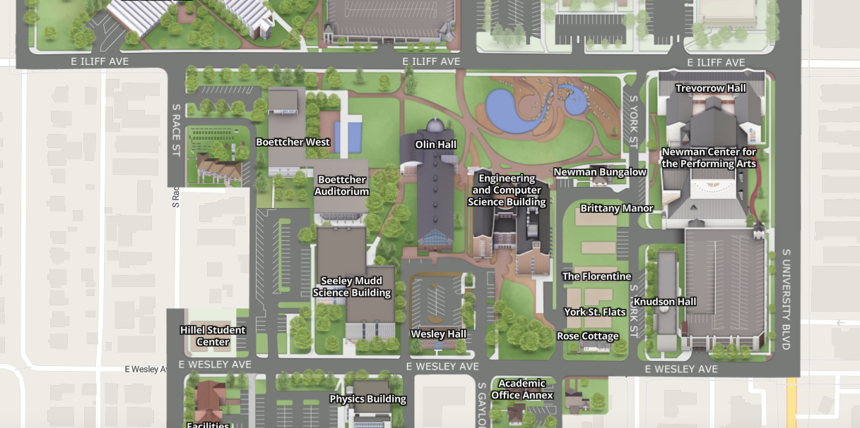
Parking
Garage

